Songstruck Alliances: Harmonizing Votes and Unveiling Secrets in Eurovision 2023

Krzysztof Wieśniakowski 2124849

Thierry Brands 1273992

Vishal Sehgal 2109374

Xavier Paulus 2047901

Ifepe Chigozie 2109365

Table of Contents

**Executive Summary 3**

**Introduction 3**

**Literature Review 3**

**Research questions and hypothesis 5**

**Methodology 6**

**Dataset 6**

**Potential bias in the datasets 7**

**Exploration of the dataset 7**

**Descriptive analysis 7**

**Data analysis (Research Rationale) 8**

**Results 9**

**Conditional Uniform Graph Test 9**

**ERGM 10**

**Conclusion 13**

**Discussion 13**

**Future work 14**

**Appendix A 15**

**Appendix B 16**

**Appendix C 17**

**Appendix D 17**

**Appendix E 18**

**Appendix F 19**

**Appendix G 20**

**Appendix H 21**

**Appendix I 22**

**Appendix J 22**

**Appendix K 23**

**Appendix L 25**

**References 26**

## Executive Summary

This study investigates community formation and voting patterns among Eurovision countries using 2023 public vote data. The research follows up on the idea that voting patterns occur between similarities between countries. Analysis reveals a notable presence of small communities within the Eurovision context, underscoring the intricate social dynamics at play. Contrary to initial hypotheses, factors such as country government systems and language families do not significantly influence voting behavior. This suggests that while smaller communities prevail, traditional socio-political and linguistic ties have limited impact on public voting patterns. These findings prompt a reevaluation of the determinants driving voting behaviors in the Eurovision song contest, emphasizing the need for nuanced exploration of socio-cultural connections and emergent communities within the framework of this global event.

## Introduction

Eurovision, the renowned singing competition featuring countries from across Europe, surpasses a mere display of vocal prowess. It operates as a lively puzzle where diverse nations strive for victory, transcending the notion of merely singing exceptionally well. The intrigue lies in how countries strategically cast their votes, underscoring the necessity to comprehend Eurovision’s intricate voting network. Beyond the song itself, Eurovision resembles a clandestine voting club influenced by factors such as geographical proximity and shared history. Thus, success in Eurovision extends beyond hitting high notes; it involves the unseen friendships backstage. However, the question arises: Is it fair for the prestigious glass microphone trophy to be awarded solely based on a country’s friendships? Does the existence of an international singing contest lose its significance if the winner is predetermined by alliances with other countries?

These international friendships, while adding a unique flavor to Eurovision, introduce potential biases in the voting process, raising questions about the overall fairness of the competition. Substantial research has already delved into the examination of biases within the Eurovision song contest through the analysis of past editions.

### Literature Review

Previous studies analysed the basis of these friendship patterns within the Eurovision voting network. Research has already been conducted in the field of social networks regarding voting patterns which as a consequence leads to creating communities within the Eurovision participants. Research has already been conducted using the Eurovision cast from 2005 where he analysed the friendship network using techniques previously developed for valued networks , which combine network-analysis methods with statistical methods (A. Dekker 2007) , (A. H. Dekker 2005). Dekker’s analysis of the votes cast in the 2005 Eurovision Song Contest revealed that friendship between countries is largely determined by geographical proximity, with a visible five-bloc structure: Western, Eastern, Nordic, Balkan, and Eastern Mediterranean.

D’Angelo et al. (2019) introduced the concept of modeling latent spaces in multidimensional networks, specifically focusing on its application to the exchange of votes within the Eurovision Song Contest. The model was put into practice to analyze voting patterns in the Eurovision Song Contest, spanning from 1998 to 2015. This analysis incorporated cultural and geographical factors. It was discovered that the only significant factor in explaining observed voting patterns was the presence of a shared border between the two countries. Interestingly, the similarities among participants during the 1998-2015 period only partially correlated with their respective geographical locations.

Ginsburgh et al. (2022) suggested that the findings from the 2021 edition indicated a higher tendency for reciprocity among geographically proximate nations. Notable examples included Greece and Cyprus, Bulgaria and Moldova, Moldova and Russia, Russia and Azerbaijan, and Bulgaria and Greece. The analysis also explored the concept of group reciprocity, uncovering voting clusters among countries. An illustrative instance was the Scandinavian nations, including Denmark, Finland, Iceland, Norway, and Sweden, with noteworthy outcomes in the context of the 2021 competition.

Research has demonstrated that the shared characteristics of voting groups play a significant role in shaping the outcomes of voting systems, revealing insights into the potential biases that may arise. Nevertheless, delving further into similar characteristics through additional research has the potential to bring even greater value to our understanding of this topic. Exploring these common features more comprehensively can contribute to a deeper examination of voting bias and its implications.

Research has consistently demonstrated the significant role of language in shaping Eurovision voting behavior (Ginsburgh and Noury 2008). A compelling illustration of this influence is the close bond between Greece and Cyprus. Greek, the primary language in Greece, is spoken by roughly 75% of the Cypriot population, contributing to the evident affinity between the two nations in the Eurovision Song Contest. This example underscores how shared language serves as a pivotal factor influencing voting patterns, reflecting a broader trend across Eurovision-participating countries. Delving further into the influence of language, particularly shared language families, adds depth to the discussion on voting patterns in Eurovision, enriching our understanding of the role linguistic ties play in this dynamic competition.

Countries with the same or similar government system seem to have stronger bonds with each other than the ones that have different internal political structures. Rodriguez et al. (2014) indicated that autocracies exhibiting institutional characteristics resembling those of democracies — such as enhanced leader accountability, restricted policy flexibility, and increased transparency—are more likely to succeed in cooperation. Consequently, these autocracies are more prone to collaborate not only with each other but also with democracies. The expectation is that single-party and military regimes hold an advantage in international cooperation when contrasted with personalist systems. The study examines the cooperative behavior between pairs of states through analysis of the 10 Million International Dyadic Events data from 1990 to 2004 (King and Lowe 2003). The findings are consistent with the core theoretical argument. Single-party regimes, posited to have an advantage in international cooperation, are, indeed, more likely to be actively sought as partners.`

### Research questions and hypothesis

Building on the understanding that shared characteristics shape voting outcomes, this research delves into the influence of language family, and political systems on the Eurovision voting network. Before analyzing the impact of these factors, an examination of the voting network will establish whether distinct voting communities exist. This preliminary analysis will provide the basis for later investigating whether language family and the political system significantly contribute to the formation of these voting groups. This leads to the following set of research questions that will be answered:

* ***RQ1: To what extent do countries form communities in the Eurovision song contest?***
* ***RQ2: What are the primary drivers behind public voting patterns among Eurovision countries?***

The aforementioned research questions lead to the following hypothesis regarding the first research question:

* H0: There is not a significant number of communities within the Eurovision competition.
* H1: There is a significant number of communities within the Eurovision competition.

The aforementioned research questions lead to the following hypothesis regarding the second research question:

* H0: The government system and language family do not have an influence on how countries distribute their votes during the Eurovision competition
* H1: The government system has an effect on how countries distribute their votes during the Eurovision competition,
* H2: Language family has an effect on how countries distribute their votes during Eurovision competition.

Answering the aforementioned research questions and testing hypotheses is going to help us understand to a certain extent whether there are voting patterns inside Eurovision as well as to understand what may cause those phenomena.

To address the first research question and validate the first hypothesis, a Conditional Uniform Graph (CUG) test will be conducted, detecting communities within the network by generating a null model and randomizing it while preserving structural properties. For the second research question and to validate the second hypothesis, an Exponential Random Graph Model (ERGM) will be utilized, providing a robust and flexible approach to assess the impact of exogenous attributes on network structure, considering complex dependencies and configurations within the network.

For this research, only the latest edition of Eurovision (2023) is analyzed. Also, the main interest is whether the forming of these communities led to a biased winner and therefore, one would suggest that the Eurovision voting system should be revised. Moreover, only the votes cast by the public will be used in forming the voting network. This is because public votes are better predictors of the finishing position (Ginsburgh and Moreno-Ternero 2023).

In the subsequent sections of the report, an explanation of the datasets used will be provided, outlining the steps involved in cleaning and preparing the data prior to any analysis. Furthermore, a descriptive analysis will be presented to enhance comprehension of the data. Additionally, the rationale for selecting the Conditional Uniform Graph (CUG) and Exponential Random Graph Model (ERGM) methods for addressing the research questions and testing hypotheses will be discussed.

## Methodology

### Dataset

For this project, the data has been collected from several sources. Using multiple origins of data allowed us to enrich the dataset and run a more comprehensive analysis.

On the Eurovision website (n.d.a) the data is presented in a table which by switching the tab on the top of the page can be easily filtered by jury or public votes. Data is presented in the form of a matrix where columns are created by countries that were giving the points and rows are represented by countries that were receiving scores. Each entry of the matrix is represented by the number of points that were given and received. This data was produced 13th of May 2023 when the final of the tournament took place.

It is crucial to understand that this is a bipartite network. This type of network consists of nodes divided into two separate groups, with connections existing exclusively between nodes from different groups, not within the same group. This structure is often represented graphically as a two-mode network, showcasing relationships between distinct sets of entities. In this case, one set of nodes are the countries that distribute votes and the other countries are the ones that receive votes.

Due to the complexity of bipartite networks and the time constraint for this project, the network has been projected. Projecting a network involves simplifying its structure by focusing on specific connections or relationships within the network. For this project, the network has been projected using a common sender. That means that an edge is created between 2 countries (receivers) when they both receive votes from the same country (sender). For each sender only the top 3 votes were taken into consideration because the top 3 votes in Eurovision hold the highest significance due to their impact on the final results; these votes often heavily influence scoring and determine the leading positions, shaping the overall outcome and perceptions of success in the competition. The process of projecting the network is presented in Appendix A.

To enrich the data, information about each country’s language family and country political system has been collected (Jakub Marian, 2016; Wikipedia, 2023). This data was manually inserted into CSV files.

As a result, the whole dataset contains 2 CSV files. The first CSV file contains information about the countries (which in this paper are also going to be referred to as nodes) such as country name, country language family, and country political system. This file is used to enrich the information about nodes. The second file is the incidence matrix where the votes distributed by the public communities are presented and used to create a network object. It is crucial to mention that the Rest of the world was omitted from the senders column due to the inability to assign specific government systems or language families to this heterogeneous category.

The selection of node attributes has been done after doing the literature review and discovering research gaps. That led to the following attributes for the nodes:

* country_name
* country_language_family
* country_government_system

### Potential bias in the datasets

All data is publicly available online in English thus anyone with access to the internet can view it. Language barrier can be a limitation, however, nowadays a lot of online dictionaries are available to translate the websites immediately. Thus no major biases in the data have been identified.

## Exploration of the dataset

Data exploration in social network analysis is essential as it reveals network structures, identifies influential nodes, and uncovers patterns of interaction. This initial step is pivotal for understanding, interpreting, and drawing meaningful insights from the complex web of relationships within social networks.

### Descriptive analysis

Firstly descriptive analysis needs to be conducted to establish a foundational understanding crucial for informed decision-making and insightful conclusions.

From the descriptive analysis for both networks, it can be observed that there are 37 vertices and 112 edges. Density is 0.14 which is low and the networks can be considered sparse with few connections between nodes in total. Reciprocity is equal to 1 which shows that the likelihood or tendency for two individuals to mutually form connections or relationships is actually 100%. Transitivity is equal to 0.4480519 which shows that there is a relatively low likelihood of the “a friend of my friend is my friend” phenomenon. The mean distance is Infinite since there are 7 isolates in this network and it is not possible to reach every node in this network. Because this network is undirected it is not possible to obtain all possible triad censuses. The ones present in the network are 003, 102, 201, and 300. It does not indicate a diverse and comprehensive set of structural configurations among triplets of nodes in both networks.

* Appendix B shows the plot of the network of Public votes Eurovision.
* Appendix C shows the plot centralities of Public votes Eurovision. An explanation of the centralities terms can be found in Appendix J.
* Appendix D shows descriptive statistics of the network of Public Votes Eurovision

That significant amount of isolates in that network might lead to statistical instability or convergence issues in the model estimation process. ERGMs, especially when including dyadic-dependent terms, the model might struggle with isolated nodes due to their lack of connectivity.

### Data analysis (Research Rationale)

It is important to understand why the CUG test and ERGM model are suitable for this data and how they are going to help to answer the research question as well as what are the potential alternatives for them. As has been already described in the Research Questions and Hypothesis section to answer the first research question, the CUG test is going to be conducted, and to answer the second research question ERGM model is going to be developed.

#### Conditional Uniform Graph using walktrap community detection

To answer the first research question and to test the first hypothesis it will be checked to what extent small communities are formed within the Eurovision contest. Firstly, it needs to be decided which algorithm is suitable for detecting the communities within this network characteristics. Since both networks are relatively small and they are characterized by short-range interactions which can be observed by looking at the mean distance, walktrap community detection has been chosen as the suitable algorithm to detect communities within the networks.

The walktrap community detection algorithm was introduced in the paper by Pascal Pons and Matthieu Latapy in 2005 (Newman 2006). The paper was presented at the International Workshop on Computer Science and its Applications (CSA) in 2005. The primary focus of the algorithm is on detecting community structures in networks by leveraging the concept of random walks. It aims to identify groups of nodes that are likely to be part of the same community based on the tendency of nodes to be frequently visited together in random walks.

There are also other possible algorithms to detect communities such as fast-greedy, Girvan-Newman, and Louvain. However, after analyzing the network structure, it has been decided that the walktrap community is going to be used.

##### Understanding CUG test

The Conditional Uniform Graph (CUG) facilitates community detection in a network by initially creating a null model and randomizing the network while maintaining specific structural characteristics, such as node degrees. Subsequently, it employs a detection algorithm to pinpoint potential clusters of nodes in the original network. Within this test, it is possible to specify which algorithm is going to be used to detect communities and as it has been described above, a walktrap community detection algorithm is going to be applied.

#### Exponential Random Graph Models

Establishing a linkage between the focus of Exponential Random Graph Models (ERGMs) and the research question is pivotal. Aligning ERGMs with the research questions helps measure important network traits, checking if predicted network structures support or contradict hypotheses. Based on the available data the second research question analyzes what are the drivers that influence voting patterns during the Eurovision contest. This model allows dyadic dependent as well as dyadic interdependent terms which allow capturing the structure of the network. ERGMs provide a basis for statistical inference, allowing assessing the significance of the effects of government systems and language families on the network.

## Results

### Conditional Uniform Graph Test

As it has been already described in the section above, a CUG test has been conducted to answer the first research question and test the first hypothesis.

In this CUG test, the walktrap algorithm detects communities in networks. The walktrap algorithm is used in the test to assess the significance. The communities detected by the walktrap algorithm are shown in a graph of the network [[Appendix L](https://docs.google.com/document/d/1KS5ZFIxBFK_oVljs-ZphUNB4yUTItqQQ/edit#bookmark=id.2p2csry)]. This graph displays the communities as certain colors, where nodes within the same community will have the same color. Another notable characteristic is that certain nodes have a high degree while some have a much lower degree. This is also true for the communities themselves. The previously discussed characteristics imply that certain countries have more connections with countries from different communities. In the graph of the network in [[Appendix L](https://docs.google.com/document/d/1KS5ZFIxBFK_oVljs-ZphUNB4yUTItqQQ/edit#bookmark=id.2p2csry)], higher degree nodes are visually represented as larger entities.

Notably, the Univariate Conditional Uniform Graph (CUG) Test can assess whether these detected communities are significant. The histogram and the CUG Test results [Appendix I] relate directly to the research question and hypotheses as follows:

CUG tests allow to test the hypotheses for the first research question. The CUG test can explain whether features of interest of the observed graph, have a high likelihood of being the result of chance. The results of CUG tests can therefore aid in the process of finding p-values, that can explain whether the results are statistically significant. Thus, using the CUG test enables us to reject or not reject the null hypothesis.

In the results, the histogram [Appendix I] visualizes the distribution of the network with the following conditioning: “Dyad.census” and 5000 repetitions. The bars represent how many communities were present in randomly generated networks during the CUG Test. The plot shows that the number of communities ranges from 2 to 11, with 4 and 5 being the most frequent. The red line does not intersect one of the bars representing randomly generated communities. This indicates that a randomly generated network is unlikely to have an equal or greater number of communities than the observed network. The results show that for randomly generated networks with similar attributes, the probability of such a simulated network having an equal or greater number of communities than the observed value is approximately 0. Therefore it can be concluded that the communities are significant.

This indicates that the likelihood of encountering the current amount of observed communities is low when the null hypothesis would be true. The p-value is 0, which implicates a rejection of the null hypothesis. Considering the first research question (To what extent do countries formulate small communities between each other in the Eurovision competition?), the findings indicate that in the Eurovision competition countries do form communities.

From the network graph [Appendix L] it can be observed that there is a network of 26 different countries in the Eurovision competition consisting of 13 different communities when individual isolates are also considered to be single “communities”.

### ERGM

To answer the second research question, ERGM model has been designed. Exponential Random Graph Models (ERGMs) employ network statistics as predictors, encapsulating structural properties as well as dyadic dependent terms. The observed network structure serves as the outcome variable, enabling estimation of tie probability based on these features to model network formation or evolution in social network analysis.

After conducting a literature review this paper would like to investigate which and to what extent exogenous terms influence public voting patterns during the Eurovision contest. However, to fully understand it, it is also crucial to recognize the network characteristic, therefore, after analyzing the network structure the model takes into consideration also dyadic dependent terms. Dyadic-dependent terms account for dependencies between specific pairs of nodes, capturing interactions beyond what simpler terms, like edge or triangle counts, can represent. Including these terms improves the model’s ability to accurately depict and predict the formation of ties between individual nodes based on their specific relationships, enhancing the model’s explanatory power for real-world network dynamics.

All the aforementioned matters were taken into consideration and led to the following model to be run and analyzed. Please find the model in the Appendix E.

The following covariate and dyadic-dependent terms have been inserted:

* nodematch("country_language_family") term assesses homophily among countries based on their respective language family
* nodematch("country_government_system") term assesses homophily among countries based on their respective government systems
* degree(3) term allows the model to capture and reproduce the observed distribution of node degrees equal to 3 while accounting for the tendency of nodes to have more or fewer connections than expected by chance.
* gwesp(decay = 0.001, fixed = TRUE) This term accounts for how likely nodes are to create connections based on the number of mutual connections they share. The decay parameter in gwesp() determines the rate at which the contribution of shared partners decreases as their distance from the focal node increases. A higher decay value results in a quicker decrease in the contribution of shared partners as they are farther away.

The model described above performed relatively well on the MCMC diagnostics. Trace for every term inside the model has a shape that is similar to a “fuzzy caterpillar” which means that the chain mixes well Appendix F. Given this understanding, the next step involves examining the Goodness of Fit in order to see whether the model-generated networks replicate the features and patterns present in the observed network. Looking at the graphs in Appendix G it can be observed that according to all of them model captured most the essential structural characteristics of the Eurovision network. Only the edge-wise shared partner graph has a small deficiency when it comes to capturing the proportion of edges that have 2 edge-wise shared partners.

With the aforementioned knowledge, it is possible to look at the model's statistics. After running the model the following coefficients have been obtained. which are written down in the Probability ratio table.

Looking at them it can be observed that edges, degree3 as well as nodematch.country_government_system have negative estimates and the rest have positive ones. However, the standard error is extraordinarily high for edges and gwesp.fixed.0.001 which could indicate that the model is unstable.

To check how much these variables influence the network, it is necessary to calculate odds ratios. To do that, coefficients have to be exponentiated.

*Probability ratio table*

|  | Estimate | Prob | Std. Error | Pval |
| --- | --- | --- | --- | --- |
| **edges** | -892.56703 | 0.000 | 364.289 | 0.014 |
| **degree3** | -0.68790 | 0.334 | 0.768 | 0.370 |
| **gwesp.fixed.0.001** | 889.61735 | NaN | 363.747 | 0.014 |
| **nodematch.country_government_system** | -0.08231 | 0.480 | 0.606 | 0.892 |
| **nodematch.country_language_family** | 0.46119 | 0.613 | 0.331 | 0.163 |

It can be seen in the table above that there are 2 terms with a very low p-value, namely gwesp.fixed.0001 and edges, and could be considered significant.

edges term considers the tendency for nodes to form edges

gwesp term considers the tendency for nodes to form edges based on the number of shared partners they have. In this specific model, the decay is set to 0.0001 at the fixed rate.

These results can be analyzed with the following formula: *An increase of 1 X1 in increases the log odds with θ1 (log odds) and it makes the odds of the effect taking place exp(01) times larger.*

Nevertheless, the standard errors for these terms are extraordinarily high which does not allow to read these results with statistical confidence.

Applying this formula to our ERGM model results can be transformed to the sentence as follows: - An increase of 1 in the number of edges increases the log odds(-892.6) with and it makes the odds of the effect taking place exp(-892.6) times larger.

* An increase of 1 in geometrically weighted shared partners increases the log odds with 889.6 (log odds) and it makes the odds of the effect taking place exp(889.6) times larger.

Moreover, a probability of 0.000 for the edges term suggests that there is a very low chance of making new edges. A probability of 0.000 suggests that, according to the ERGM being used, the observed number of edges in the network is very unlikely to occur based on the model’s specification. This low probability indicates that the odds of forming an edge in this network are very low.

When it comes to gwesp() term probability of infinity suggests that the observed network structure, which includes this tendency for nodes to share partners, is always true under the ERGM framework. This probability indicates that the network’s pattern of shared connections among nodes, as described by the gwesp() term, is more likely than alternative patterns or structures within the ERGM framework.

Except these this specific dyadic dependent term, the rest of the variables have a very high p-value and therefore, their coefficients are not going to be considered and exponentiated.

With the given model formula the following hypothesis could be verified:

* H2: Government system has an effect on how countries distribute their votes during the Eurovision competition
* H3: Language family has an effect on how countries distribute their votes during the Eurovision competition

As it has been stated none of the structural terms was found to be significant for the network and, therefore, the null hypothesis (H0: The government system and language family do not have an influence on how countries distribute their votes during the Eurovision competition) for the second research hypothesis can not be rejected.

## Conclusion

This study aimed to study the Eurovision context in terms of social network analysis based on the official results from 2023. Literature review in the field of previous Eurovision editions suggested that distributing votes was biased in the past years (D’Angelo, Murphy, and Alfò 2019; Ginsburgh and Noury 2008). Diving more into the literature and discovering research gaps led to the work of Rodriguez et al. (2014) and as a consequence, this paper included in the analysis to what extent the similarities in the political system could be a cause of voting bias. That led to 2 research questions which were stated at the beginning of the study and the CUG test and ERGM model were run to answer them as well as to test the stated hypothesis.

### Discussion

The outcomes of the CUG test suggest that, according to the walktrap algorithm, there are 13 observed communities. This quantity of communities is significant, which leads to a rejection of the null hypothesis. However, it is important to acknowledge that in this case, a higher number of communities corresponds to a higher number of isolates. In this research, the isolates represent countries that did not receive top 3 votes from other countries. This simplification of the voting process might have an impact on the outcome due to oversimplification.

The approach of solely including top 3 votes, could therefore have influenced the number of communities detected by the walktrap algorithm. Thus it could also have influenced the statistically significant outcome. It is plausible that when considering more votes than top 3, the results might be different, leading to larger and fewer communities, which could result in the CUG test being nonsignificant.

Language family and government system turned out to be not statistically significant and as a consequence, the second research question can be answered that these factors do not have an effect on how people vote during the Eurovision context. Moreover, standard errors for edges and gwesp() term make reading the results not trustworthy since they may indicate that the model is unstable. More experiments must be run using either different projections or running the analysis on a bipartite network.

### Future work

As it has been described in the ERGM section MCMC diagnostics and GOF look relatively good but undoubtedly the model can be further improved . Several other models have been run during this research. Some of them scored either very low or did not converge in the given time frame. The list of all the models that have been run together with model specifications are presented in APPENDIX K.

In this research project, the network has been projected based on the common sender. Nevertheless, projecting the network differently could reveal more information. For instance, projecting the network while retaining the points, one could connect two countries if they share a common receiver or sender, and the weight of the edge is the sum or average of the points exchanged between them across multiple events.

Projecting the network always leads to losing certain information from the network. In this particular research, information about how many points were given to the country was lost. As a consequence, running the analysis on the bipartite network could reveal very interesting results since more information will remain inside the network.

# Appendix A

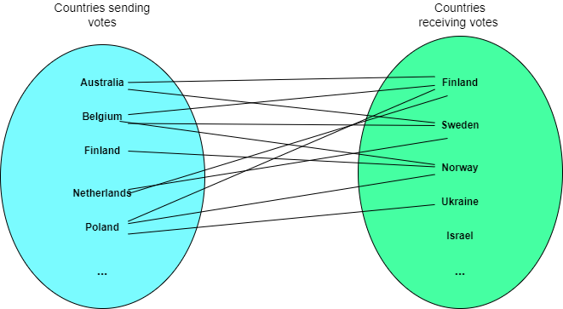

*Process of projecting the network*

The graph in the figure above presents just the sample of the data in what way the network has been projected. Three dots on the bottom of each set represent that there are more countries in each set.

From this sample of data the following edges have been formed:

- Finland - Sweden (both countries received votes from Australia, Belgium, Netherlands)

- Finland - Norway (both countries received votes from Poland, Belgium, Netherlands)

- Sweden - Norway (both countries received votes from Belgium)

- Norway - Ukraine (both countries received votes from Poland)

- Finland - Ukraine (both countries received votes from Poland)

# Appendix B

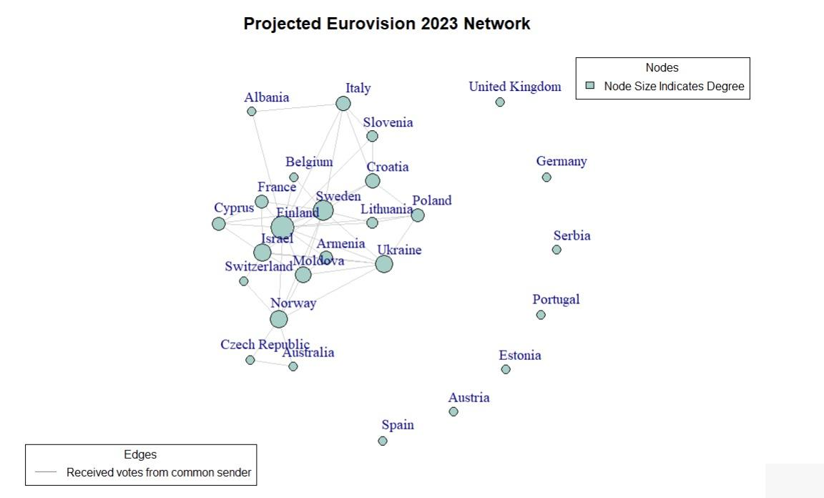

*Eurovision Public Plot*

# Appendix C

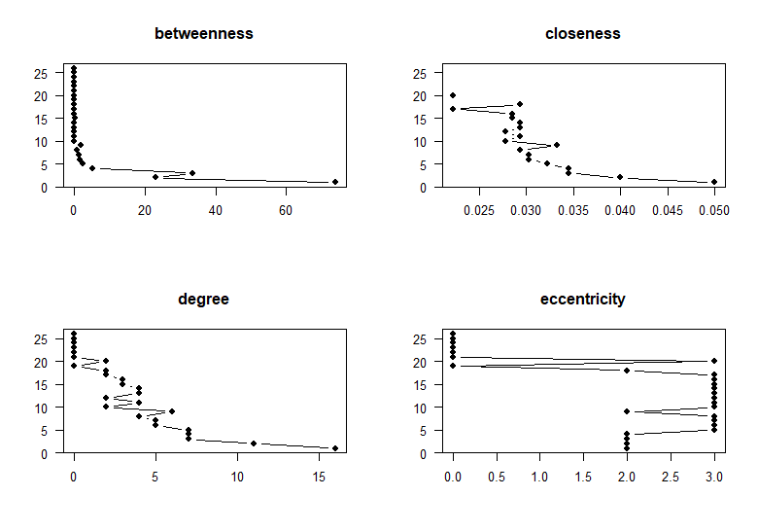

*Eurovision Public Plot Centralities*

# Appendix D

***## Eurovision public***   
  
***## $number of vertices***  
***## [1] 26***  
***## $number_of_edges***  
***## [1] 48***  
***## density***   
***## [1] 0.14769***  
***## reciprocity***  
***## [1] 1***  
***## transitivity***  
***## [1] 0.4480519***  
***## mean_distance***  
***## [1] Inf***  
***## number_of_isolates***  
***## [1] "Estonia" "Austria"***   
***## [3] "Portugal" "Serbia"***   
***## [5] "Germany" "United Kingdom"***  
***## [7] "Spain"***   
***## dyad_census***  
***## Mutual Null***  
***## 7 562***  
***## triad_census***  
***## 003 012 102 021D 021U 021C 111D 111U 030T 030C 201 120D 120U 120C 210 300***   
***## 1710 0 674 0 0 0 0 0 0 0 170 0 0 0 0 46***

# Appendix E

***### ERGM model***  
baseline_model_0.5 <- ergm**::ergm**(distribution_network **~** edges **+**   
 **degree**(3) **+**   
 **gwesp**(decay = 0.001, fixed=TRUE) **+**  
 **nodematch**("country_language_family") **+**  
 **nodematch**("country_government_system"),  
 control = ergm**::control.ergm**(MCMC.burnin = 10000,  
 MCMC.samplesize = 40000,  
 seed = 223451,  
 MCMLE.maxit = 5,  
 parallel = 4,  
 parallel.type = "PSOCK"))  
  
(s5 <- **summary**(baseline_model_0.5))

# Appendix F

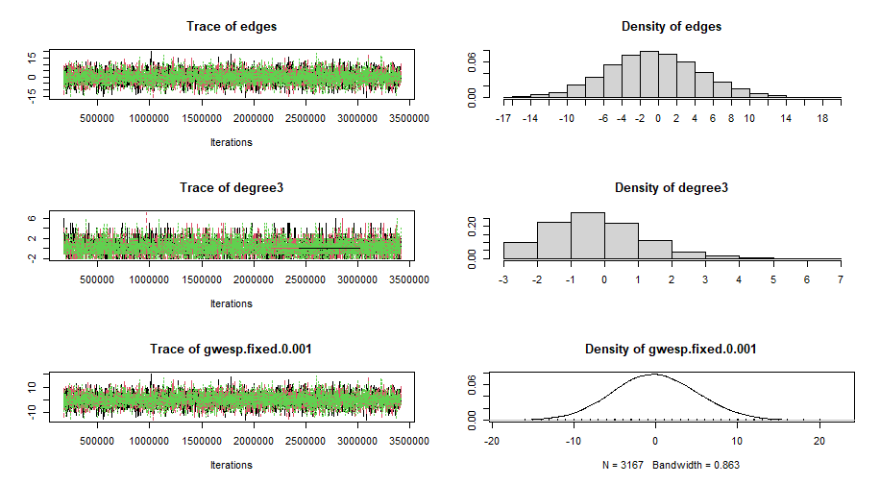 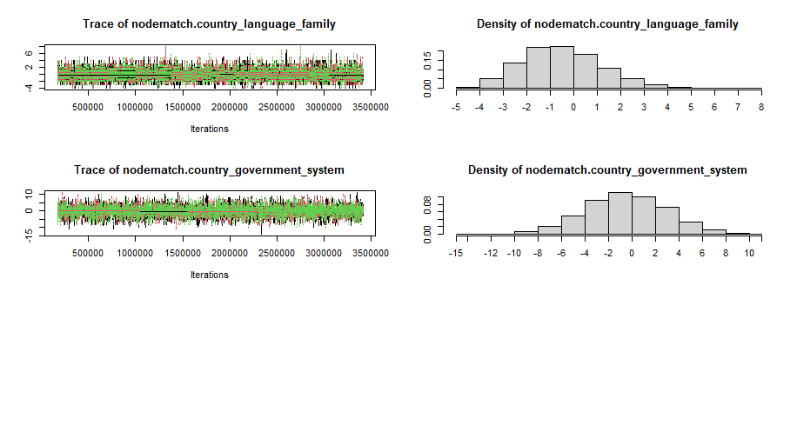

# Appendix G

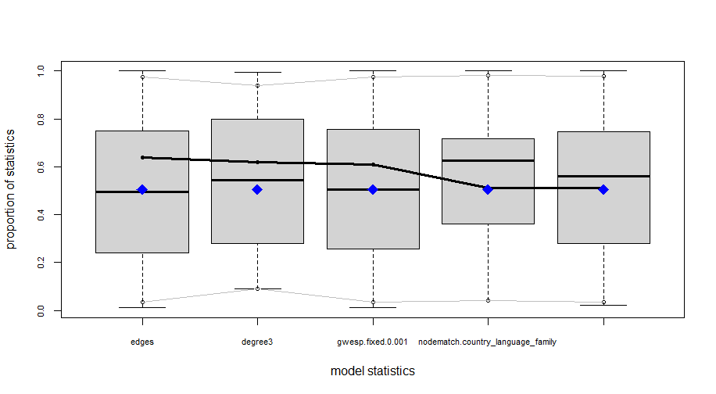 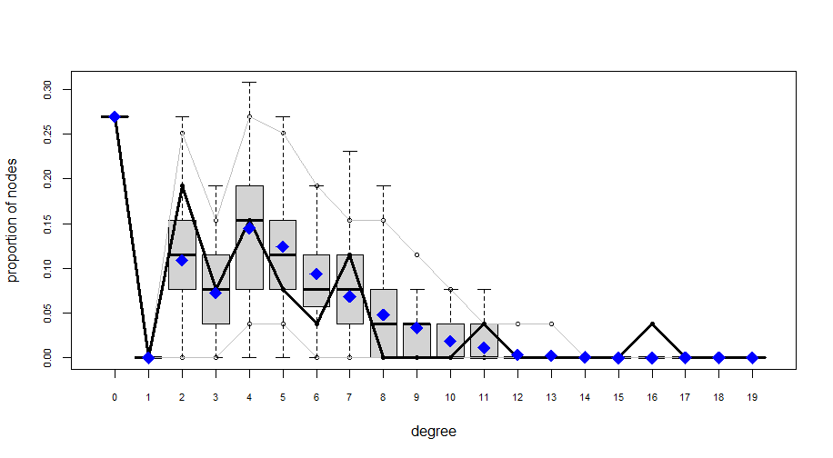

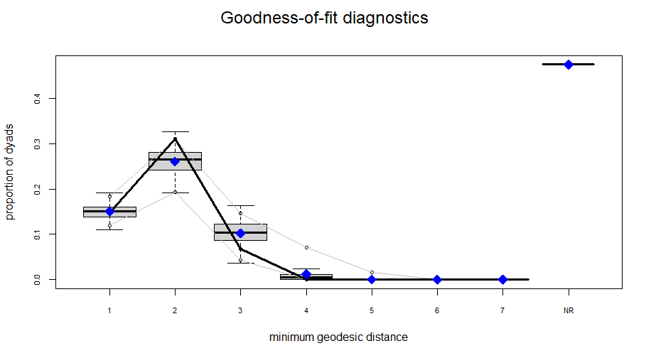 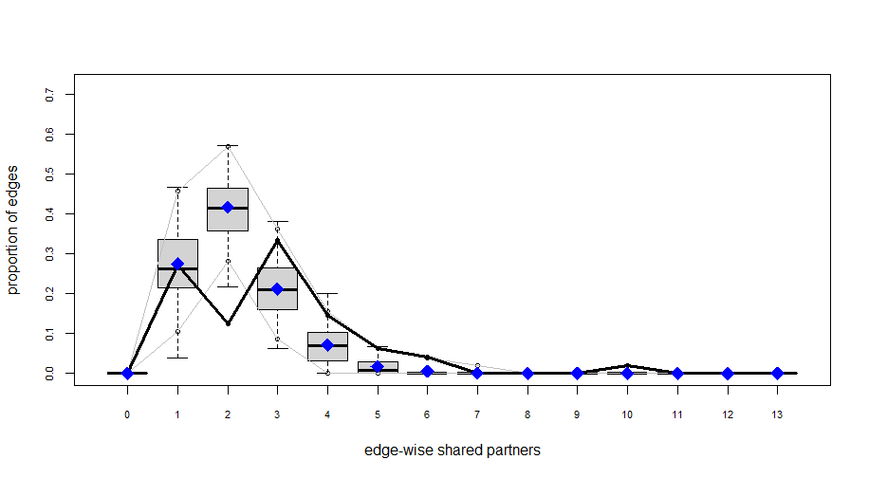

# Appendix H

***## CUG test for detecting communities***  
walktrap <- **function**(x, directed = FALSE) {  
 x <- snafun**::fix_cug_input**(x, directed = directed)  
 snafun**::extract_comm_walktrap**(x) **|>** **length**()   
}  
distribution_coms <- sna**::cug.test**(distribution_network, FUN = walktrap, mode = "graph",  
 diag = FALSE, cmode = "dyad.census", reps = 5000)

# Appendix I

CUG Test 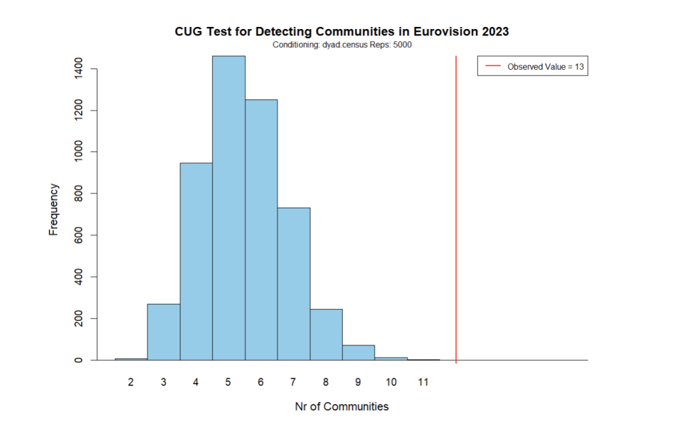

# Appendix J

***Betweenness centrality*** of *i* is the proportion of all shortest paths in the network that pass through *i*. It shows which nodes have information access advantages and which are important to the network’s efficiency. It also shows the relative stress on nodes. Mathematically, it is defined as follows:

$B\left(x\right)=\sum_{s≠x≠t}{}\frac{σ_{st}\left(x\right)}{σ_{st}}$

***Closeness*** measures how much effort it takes to reach all other nodes in the network. Sum the distances from *i* to all other vertices, this is its fairness. Then, the sum is inverted. Mathematically is defined as follows:

$C\left(x\right)=\frac{1}{\sum_{y}{}d\left(x,y\right)}$ where *d(v, i)* equal to the path length between *i* and *v*.

***Degree*** measures a node’s extraversion/outgoingness (“out-degree”), popularity (“in-degree”), or involvement (“total degree”).

In-Degree}(v) = Number of incoming edges to node v

Out-Degree(v) = Number of outgoing edges from node v

Total Degree(v) = In-Degree}(v) + Out-Degree}(v)

***Eccentricity*** measures the maximum distance or shortest path length from a specific node to any other node in the network. In other words, it quantifies how far a node is, on average, from all other nodes in the network. Mathematically, it is defined as follows:

* $E\left(x\right)=\max_{y}d\left(x,y\right)$ where *E(X)* represents the eccentricity of node *x*, and *d(x,y)* is the shortest path distance between nodes *x* and *y*.

# Appendix K

| **Term/Model** | **Model1** | **Model2** | **Model3** | **Model4** |
| --- | --- | --- | --- | --- |
| *edges* | X | X | X | X |
| *kstar(2)* |  |  |  |  |
| *degree(2)* |  |  | X | X |
| *degree(3)* |  | X | X | X |
| *isolates* |  |  |  | X |
| *gwesp(decay, fixed)* |  | X (0.001, True) | X (0.001, True) | X (0.001, True) |
| *gwdsp(decay, fixed)* |  |  |  |  |
| *gwdegree(decay, fixed)* |  |  |  |  |
| *nodematch("country_language_family")* | X | X | X | X |
| *nodematch("country_government_system")* | X | X | X | X |
| *AIC* | 276 | 270.5 | - | - |
| *BIC* | 287.4 | 289.4 | - | - |
| *Converged* | Yes | Yes | No | No |
| *Issue If Not Converged* |  |  | Not converged after 6 hours | Model statistics ‘isolates’ are not varying. Observed data may occupy an extreme point in the sample space or estimation reached dead-end configuration |
| *Additional Information* |  | Estimates and Std. Error values are high. Adjusting the decay parameter does not result in more reliable outcomes. |  |  |

Each model was run for a maximum of 6 to 8 hours (overnight). If the model did not converge within this timeframe, it was stopped. Furthermore, several different values for decay were tested such as 0.25, 0.1 and 0.01.

| **Term/Model** | **Model5** | **Model6** | **Model6** | **Model7** |
| --- | --- | --- | --- | --- |
| *edges* | X | X | X |  |
| *kstar(2)* |  |  |  | X |
| *degree(2)* |  |  | X |  |
| *degree(3)* | X | X | X | X |
| *isolates* | X | X | X |  |
| *gwesp(decay, fixed)* | X (0.001, True) | X (0.001, True) | X | X (0.01, True) |
| *gwdsp(decay, fixed)* |  | X (0.001, True) | X |  |
| *gwdegree(decay, fixed)* |  |  | X |  |
| *nodematch("country_language_family")* | X | X | X |  |
| *nodematch("country_government_system")* | X | X |  |  |
| *AIC* | - | - | - | 328.6 |
| *BIC* | - | - | - | 347.5 |
| *Converged* | No | No | No | Yes |
| *Issue If Not Converged* | Model statistics ‘isolates’ are not varying. This may indicate that the observed data occupies an extreme point in the sample space or that the estimation has reached a dead-end configuration. | Model statistics ‘isolates’ are not varying. This may indicate that the observed data occupies an extreme point in the sample space or that the estimation has reached a dead-end configuration. | Model statistics ‘isolates’ are not varying. May indicate extreme point in sample space, or reached dead-end configuration. ‘nodematch.country_language_family’ are linear combinations of preceding statistics. |  |
| Additional Information |  |  |  | GOF plots do not fit well |

# Appendix L

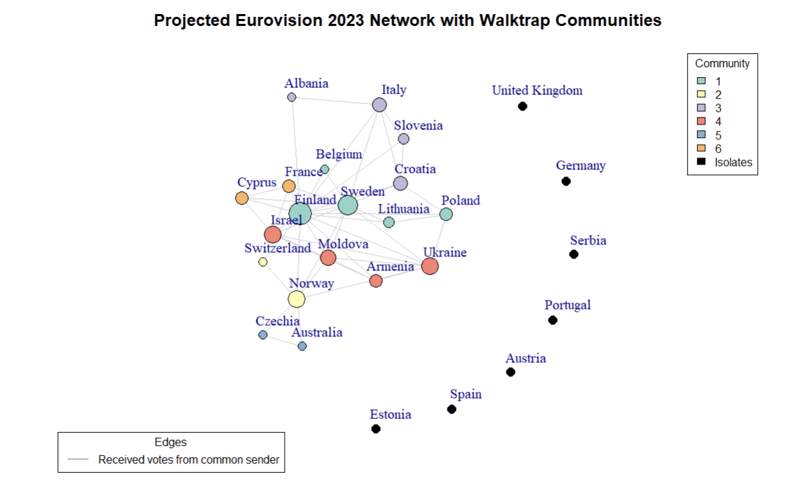

*Graph of the Eurovision Network*

# References

2023. *Wikipedia*. Wikimedia Foundation. <https://en.wikipedia.org/wiki/List_of_countries_by_system_of_government>.

Unknown. “Eurovision 2023 Results: Voting & Points”. Eurovision World. <https://eurovisionworld.com/eurovision/2023> . (2023, May 1)

Unknown . “The Indo-European Family”. UOttawa. <https://www.uottawa.ca/clmc/indo-european-family> . (2021, January )

Marian, J. “Map of languages and language families of Europe”. Jakub Marian. <https://jakubmarian.com/map-of-languages-and-language-families-of-europe/> . (2016, August 11)

D’Angelo, Silvia, Thomas Brendan Murphy, and Marco Alfò. 2019. “Latent Space Modelling of Multidimensional Networks with Application to the Exchange of Votes in Eurovision Song Contest.” *The Annals of Applied Statistics* 13 (2). <https://doi.org/10.1214/18-aoas1221>.

Dekker, A. H. 2005. “Conceptual Distance in Social Network Analysis.” *Journal of Social Structure* 6 (3). <http://www.cmu.edu/joss/content/articles/volume6/dekker/>.

Dekker, Anthony. 2007. “The Eurovision Song Contest as a ‘Friendship’network.” *Connections* 27 (3): 53–58.

Ginsburgh, Victor, and Juan D Moreno-Ternero. 2023. “The Eurovision Song Contest: Voting Rules, Biases and Rationality.” *Journal of Cultural Economics* 47 (2): 247–77.

Ginsburgh, Victor, and Abdul G Noury. 2008. “The Eurovision Song Contest. Is Voting Political or Cultural?” *European Journal of Political Economy* 24 (1): 41–52.

King, Gary, and Will Lowe. 2003. “An Automated Information Extraction Tool for International Conflict Data with Performance as Good as Human Coders: A Rare Events Evaluation Design.” *International Organization* 57 (3): 617–42.

Newman, Mark EJ. 2006. “Finding Community Structure in Networks Using the Eigenvectors of Matrices.” *Physical Review E* 74 (3): 036104.