|  |  |  |
| --- | --- | --- |
| Министерство науки и высшего образования  Российской Федерации | | |
| Федеральное государственное бюджетное  образовательное учреждение высшего образования | | |
| «Новосибирский государственный технический университет» | | |
|  | | |
| Кафедра теоретической и прикладной информатики | | |
|  | | |
| Лабораторная работа № 4 | | |
| по дисциплине «Численные методы» | | |
|  | | |
| **РЕШЕНИЕ СИСТЕМ НЕЛИНЕЙНЫХ УРАВНЕНИЙ****МЕТОДОМ НЬЮТОНА** | | |
|  | | |
|  | Факультет: | ПМИ |
| Группа: | ПМ-81 |
| Бригада: | 14 |
| Студенты: | Редут Анатолий |
|  | Ефремов Артур |
|  |  |
| Преподаватели: | Патрушев Илья Игоревич |
|  | Задорожный Александр Геннадьевич |
|  | | |
| Новосибирск | | |
| 2020 | | |

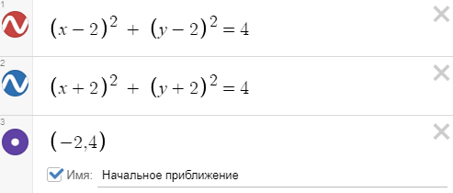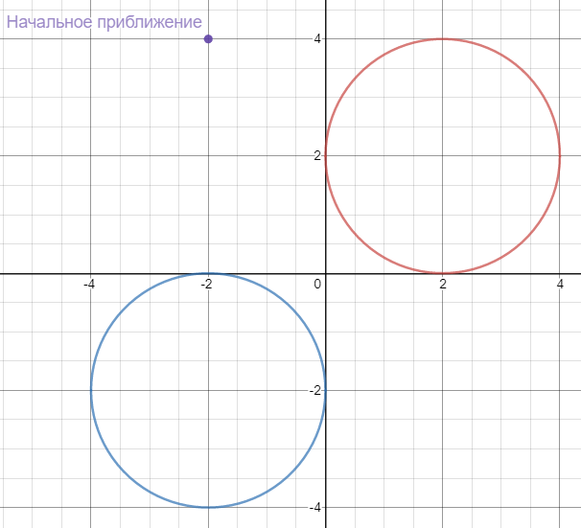

1 вариант

|  |  |  |  |  |
| --- | --- | --- | --- | --- |
| k | beta | x | y | norm |
| 0 | 1 | -1.33333 | 1.33333 | 35.7771 |
| 1 | 1 | 0.0833333 | -0.0833333 | 10.6852 |
| 2 | 0.0078125 | -0.0107422 | 0.0107422 | 5.6765 |
| 3 | 0.00012207 | 0.000622105 | -0.000622105 | 5.65718 |
| . | . | . | . | . |
| 98 | 2.27374e-13 | -2.31288e-07 | 2.31288e-07 | 5.65685 |
| 99 | 5.68434e-14 | 1.44817e-08 | -1.44817e-08 | 5.65685 |

2 вариант

|  |  |  |  |  |
| --- | --- | --- | --- | --- |
| k | beta | x | y | norm |
| 0 | 1 | -1.33333 | 1.33333 | 35.7771 |
| 1 | 1 | 0.0833333 | -0.0833333 | 10.6852 |
| 2 | 0.0078125 | -0.0107422 | 0.0107422 | 5.6765 |
| 3 | 0.00012207 | 0.000622105 | -0.000622105 | 5.65718 |
| . | . | . | . | . |
| 98 | 2.27374e-13 | -2.31288e-07 | 2.31288e-07 | 5.65685 |
| 99 | 5.68434e-14 | 1.44817e-08 | -1.44817e-08 | 5.65685 |

6 вариант

|  |  |  |  |  |
| --- | --- | --- | --- | --- |
| k | beta | x | y | norm |
| 0 | 1 | -1.33333 | 1.33333 | 35.7771 |
| 1 | 1 | 0.0833333 | -0.0833333 | 10.6852 |
| 2 | 0.0078125 | -0.0107422 | 0.0107422 | 5.6765 |
| 3 | 0.00012207 | 0.000622105 | -0.000622105 | 5.65718 |
| . | . | . | . | . |
| 98 | 9.09495e-13 | -1.83996e-07 | 1.83996e-07 | 5.65685 |
| 99 | 5.68434e-14 | 1.24942e-07 | -1.24941e-07 | 5.65685 |

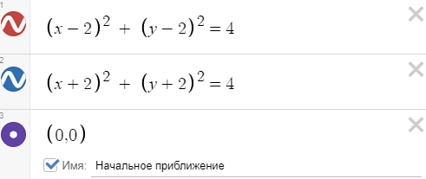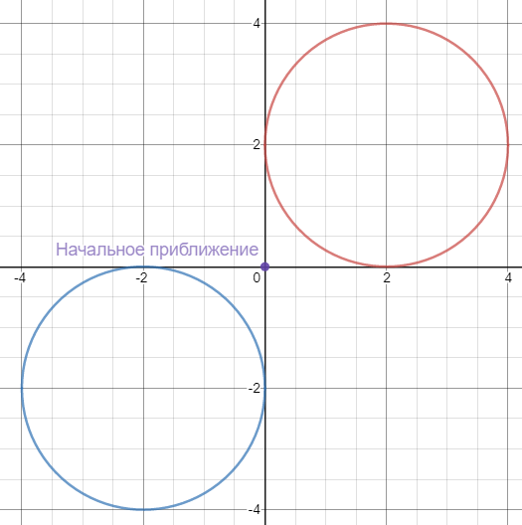

1 вариант

Cant solve!

2 вариант

Cant solve!

6 вариант

Cant solve!

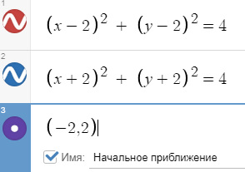 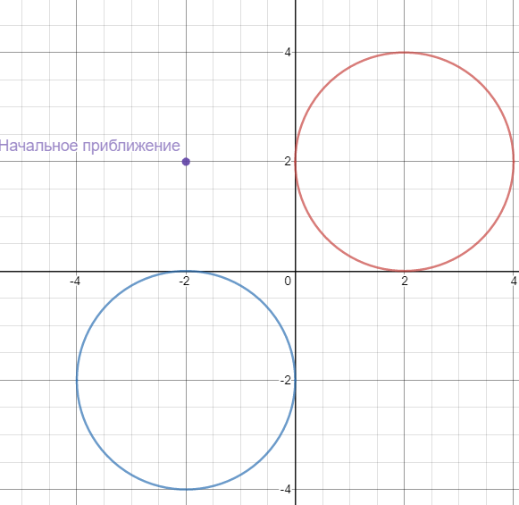

1 вариант

|  |  |  |  |  |
| --- | --- | --- | --- | --- |
| k | beta | x | y | norm |
| 0 | 1 | -0.5 | 0.5 | 16.9706 |
| 1 | 0.25 | 0.0625 | -0.0625 | 6.36396 |
| 2 | 0.00390625 | -0.00012207 | 0.00012207 | 5.6679 |
| 3 | 1.49012e-08 | 9.09189e-13 | -9.09189e-13 | 5.65685 |
| . | . | . | . | . |
| 98 | 9.09495e-13 | -1.04023e-07 | 1.04023e-07 | 5.65685 |
| 99 | 5.68434e-14 | 4.42426e-07 | -4.42426e-07 | 5.65685 |

2 вариант

|  |  |  |  |  |
| --- | --- | --- | --- | --- |
| k | beta | x | y | norm |
| 0 | 1 | -0.5 | 0.5 | 16.9706 |
| 1 | 0.25 | 0.0625 | -0.0625 | 6.36396 |
| 2 | 0.00390625 | -0.00012207 | 0.00012207 | 5.6679 |
| 3 | 1.49012e-08 | 9.09189e-13 | -9.09189e-13 | 5.65685 |
| . | . | . | . | . |
| 98 | 9.09495e-13 | -1.04023e-07 | 1.04023e-07 | 5.65685 |
| 99 | 5.68434e-14 | 4.42426e-07 | -4.42426e-07 | 5.65685 |

6 вариант

|  |  |  |  |  |
| --- | --- | --- | --- | --- |
| k | beta | x | y | norm |
| 0 | 1 | -0.5 | 0.5 | 16.9706 |
| 1 | 0.25 | 0.0625 | -0.0625 | 6.36396 |
| 2 | 0.00390625 | -0.00012207 | 0.00012207 | 5.6679 |
| 3 | 1.49012e-08 | 5.29974e-12 | -5.2892e-12 | 5.65685 |
| . | . | . | . | . |
| 98 | 4.54747e-13 | -1.27425e-07 | 1.27425e-07 | 5.65685 |
| 99 | 5.68434e-14 | 3.18669e-07 | -3.18669e-07 | 5.65685 |

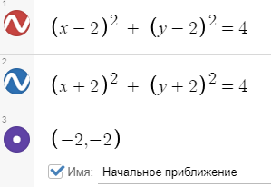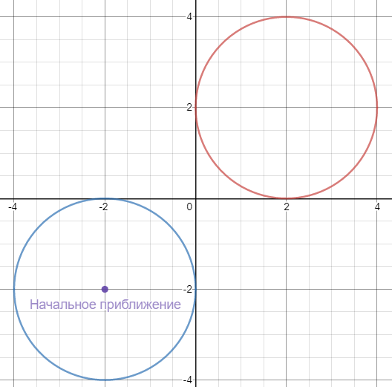

1 вариант

Cant solve!

2 вариант

Cant solve!

6 вариант

Cant solve!

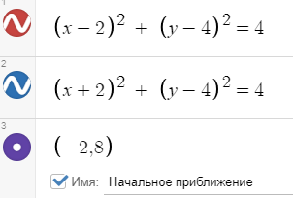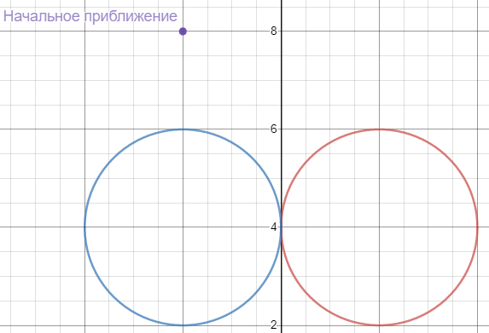

1 вариант

|  |  |  |  |  |
| --- | --- | --- | --- | --- |
| k | beta | x | y | norm |
| 0 | 1 | 0 | 6.5 | 30.4631 |
| 1 | 1 | 0 | 5.25 | 8.83883 |
| 2 | 1 | 0 | 4.625 | 2.20971 |
| 3 | 1 | 0 | 4.3125 | 0.552427 |
| . | . | . | . | . |
| 21 | 1 | 0 | 4 | 8.03887e-12 |
| 22 | 1 | 0 | 4 | 2.00972e-12 |

2 вариант

|  |  |  |  |  |
| --- | --- | --- | --- | --- |
| k | beta | x | y | norm |
| 0 | 1 | 0 | 6.5 | 30.4631 |
| 1 | 1 | 0 | 5.25 | 8.83883 |
| 2 | 1 | 0 | 4.625 | 2.20971 |
| 3 | 1 | 0 | 4.3125 | 0.552427 |
| . | . | . | . | . |
| 21 | 1 | 0 | 4 | 8.03887e-12 |
| 22 | 1 | 0 | 4 | 2.00972e-12 |

6 вариант

|  |  |  |  |  |
| --- | --- | --- | --- | --- |
| k | beta | x | y | norm |
| 0 | 1 | 1.10845e-12 | 6.5 | 30.4631 |
| 1 | 1 | 3.70171e-25 | 5.25 | 8.83883 |
| 2 | 1 | 3.70171e-25 | 4.625 | 2.20971 |
| 3 | 1 | -1.38778e-17 | 4.3125 | 0.552427 |
| . | . | . | . | . |
| 21 | 1 | -1.47451e-17 | 4 | 8.03887e-12 |
| 22 | 1 | -1.47451e-17 | 4 | 2.00972e-12 |

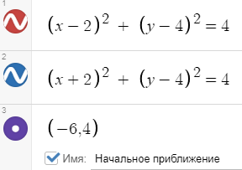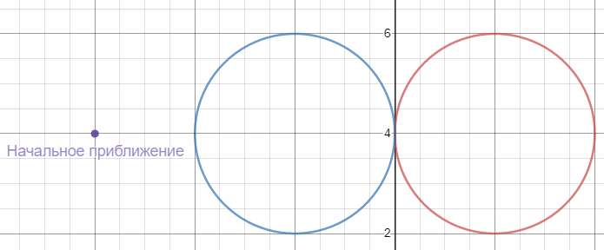

1 вариант

Cant solve!

2 вариант

Cant solve!

6 вариант

Cant solve!

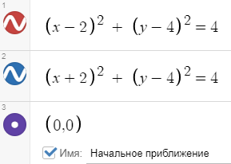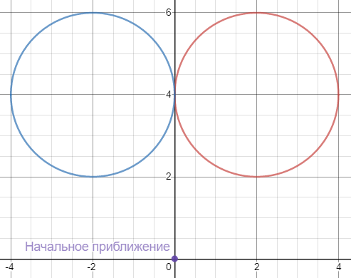

1 вариант

|  |  |  |  |  |
| --- | --- | --- | --- | --- |
| k | beta | x | y | norm |
| 0 | 1 | 0 | 2 | 22.6274 |
| 1 | 1 | 0 | 3 | 5.65685 |
| 2 | 1 | 0 | 3.5 | 1.41421 |
| 3 | 1 | 0 | 3.75 | 0.353553 |
| . | . | . | . | . |
| 21 | 1 | 0 | 4 | 5.14488e-12 |
| 22 | 1 | 0 | 4 | 1.28622e-12 |

2 вариант

|  |  |  |  |  |
| --- | --- | --- | --- | --- |
| k | beta | x | y | norm |
| 0 | 1 | 0 | 2 | 22.6274 |
| 1 | 1 | 0 | 3 | 5.65685 |
| 2 | 1 | 0 | 3.5 | 1.41421 |
| 3 | 1 | 0 | 3.75 | 0.353553 |
| . | . | . | . | . |
| 21 | 1 | 0 | 4 | 5.14488e-12 |
| 22 | 1 | 0 | 4 | 1.28622e-12 |

6 вариант

|  |  |  |  |  |
| --- | --- | --- | --- | --- |
| k | beta | x | y | norm |
| 0 | 1 | 0 | 2 | 22.6274 |
| 1 | 1 | 0 | 3 | 5.65685 |
| 2 | 1 | 0 | 3.5 | 1.41421 |
| 3 | 1 | 0 | 3.75 | 0.353553 |
| . | . | . | . | . |
| 21 | 1 | 0 | 4 | 5.14488e-12 |
| 22 | 1 | 0 | 4 | 1.28622e-12 |

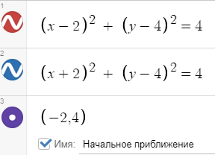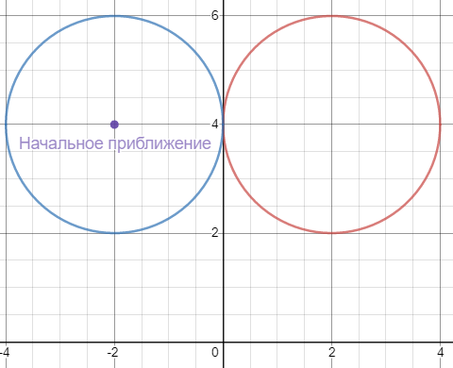

1 вариант

Cant solve!

2 вариант

Cant solve!

6 вариант

Cant solve!

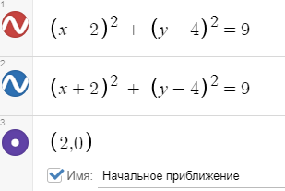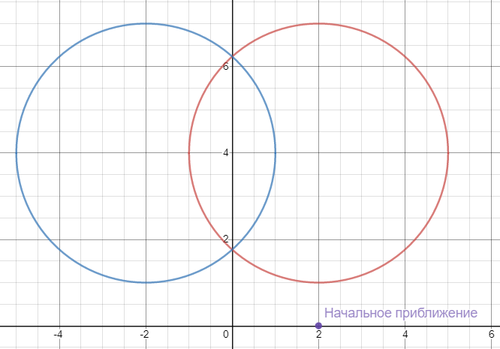

1 вариант

|  |  |  |  |  |
| --- | --- | --- | --- | --- |
| k | beta | x | y | norm |
| 0 | 1 | 0 | 0.875 | 24.0416 |
| 1 | 1 | 0 | 1.6375 | 6.73961 |
| 2 | 1 | 0 | 1.76055 | 0.822233 |
| 3 | 1 | 0 | 1.76393 | 0.0214127 |
| 4 | 1 | 0 | 1.76393 | 1.61616e-05 |
| 5 | 1 | 0 | 1.76393 | 9.23466e-12 |
| 6 | 5.68434e-14 | 0 | 1.76393 | 0 |

2 вариант

|  |  |  |  |  |
| --- | --- | --- | --- | --- |
| k | beta | x | y | norm |
| 0 | 1 | 0 | 0.875 | 24.0416 |
| 1 | 1 | 0 | 1.6375 | 6.73961 |
| 2 | 1 | 0 | 1.76055 | 0.822233 |
| 3 | 1 | 0 | 1.76393 | 0.0214127 |
| 4 | 1 | 0 | 1.76393 | 1.61616e-05 |
| 5 | 1 | 0 | 1.76393 | 9.23466e-12 |
| 6 | 5.68434e-14 | 0 | 1.76393 | 0 |

6 вариант

|  |  |  |  |  |
| --- | --- | --- | --- | --- |
| k | beta | x | y | norm |
| 0 | 1 | -1.10845e-12 | 0.875 | 24.0416 |
| 1 | 1 | -3.70171e-25 | 1.6375 | 6.73961 |
| 2 | 1 | -3.70171e-25 | 1.76055 | 0.822233 |
| 3 | 1 | -3.70171e-25 | 1.76393 | 0.0214127 |
| 4 | 1 | -3.70171e-25 | 1.76393 | 1.61616e-05 |
| 5 | 1 | -3.70171e-25 | 1.76393 | 9.23466e-12 |
| 6 | 5.68434e-14 | -3.70171e-25 | 1.76393 | 0 |

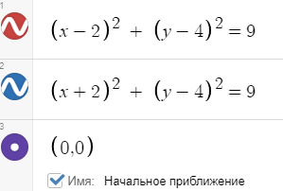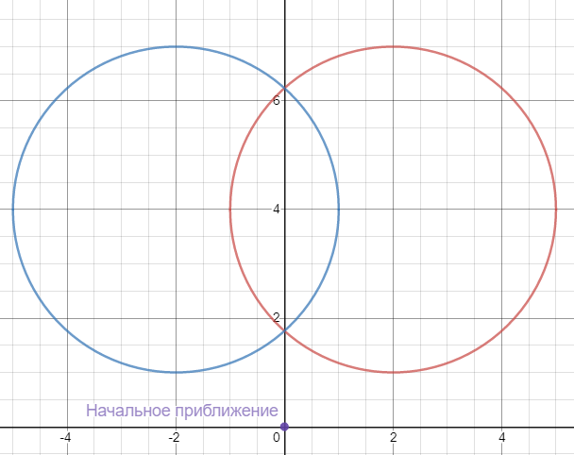

1 вариант

|  |  |  |  |  |
| --- | --- | --- | --- | --- |
| k | beta | x | y | norm |
| 0 | 1 | 0 | 1.375 | 15.5563 |
| 1 | 1 | 0 | 1.73512 | 2.67375 |
| 2 | 1 | 0 | 1.76375 | 0.183403 |
| 3 | 1 | -2.71051e-20 | 1.76393 | 0.00115917 |
| 4 | 1 | -2.71034e-20 | 1.76393 | 4.74986e-08 |
| 5 | 5.68434e-14 | -2.71034e-20 | 1.76393 | 0 |

2 вариант

|  |  |  |  |  |
| --- | --- | --- | --- | --- |
| k | beta | x | y | norm |
| 0 | 1 | 0 | 1.375 | 15.5563 |
| 1 | 1 | 0 | 1.73512 | 2.67375 |
| 2 | 1 | 0 | 1.76375 | 0.183403 |
| 3 | 1 | -2.71051e-20 | 1.76393 | 0.00115917 |
| 4 | 1 | -2.71034e-20 | 1.76393 | 4.74986e-08 |
| 5 | 5.68434e-14 | -2.71034e-20 | 1.76393 | 0 |

6 вариант

|  |  |  |  |  |
| --- | --- | --- | --- | --- |
| k | beta | x | y | norm |
| 0 | 1 | 0 | 1.375 | 15.5563 |
| 1 | 1 | 0 | 1.73512 | 2.67375 |
| 2 | 1 | 0 | 1.76375 | 0.183403 |
| 3 | 1 | 0 | 1.76393 | 0.00115917 |
| 4 | 1 | 1.65436e-24 | 1.76393 | 4.74986e-08 |
| 5 | 5.68434e-14 | 1.65436e-24 | 1.76393 | 0 |

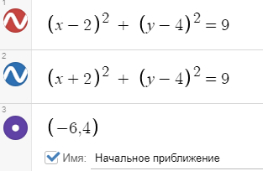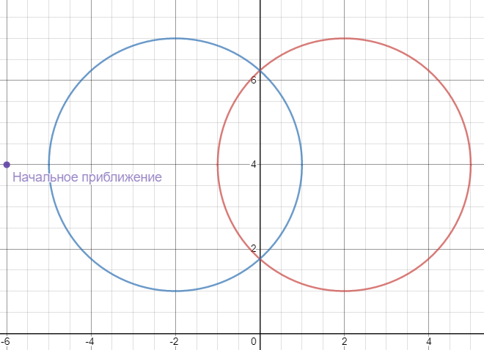

1 вариант

Cant solve!

2 вариант

Cant solve!

6 вариант

Cant solve!

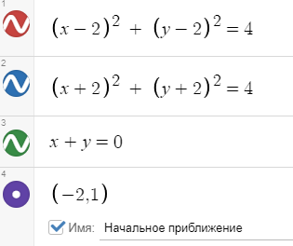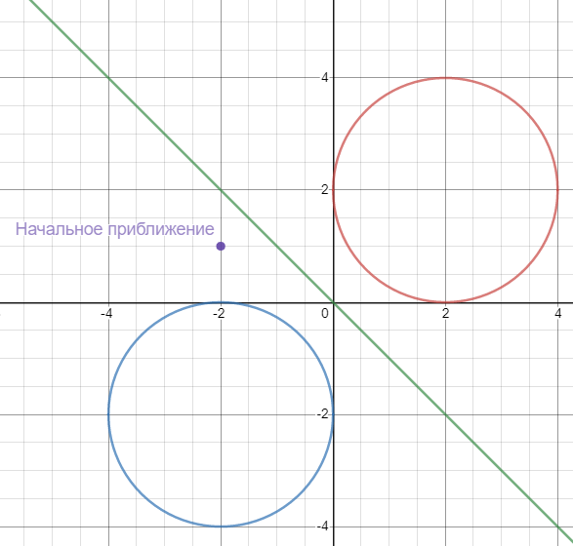

1 вариант

|  |  |  |  |  |
| --- | --- | --- | --- | --- |
| k | beta | x | y | norm |
| 0 | 1 | -0.166667 | 0.166667 | 13.9642 |
| 1 | 0.03125 | 0.0234375 | -0.0234375 | 5.73542 |
| 2 | 0.000976563 | -0.0182406 | 0.0182406 | 5.65841 |
| 3 | 0.000488281 | 0.00853275 | -0.00853275 | 5.6578 |
| . | . | . | . | . |
| 98 | 2.27374e-13 | -1.28835e-08 | 1.28835e-08 | 5.65685 |
| 99 | 5.68434e-14 | 4.39921e-06 | -4.39921e-06 | 5.65685 |

2 вариант

|  |  |  |  |  |
| --- | --- | --- | --- | --- |
| k | beta | x | y | norm |
| 0 | 1 | -0.166667 | 0.166667 | 13.9642 |
| 1 | 0.03125 | 0.0234375 | -0.0234375 | 5.73542 |
| 2 | 0.000976563 | -0.0182406 | 0.0182406 | 5.65841 |
| 3 | 0.000488281 | 0.00853275 | -0.00853275 | 5.6578 |
| . | . | . | . | . |
| 98 | 1.13687e-13 | -5.40388e-08 | 5.40388e-08 | 5.65685 |
| 99 | 5.68434e-14 | 9.97862e-07 | -9.97862e-07 | 5.65685 |

6 вариант

|  |  |  |  |  |
| --- | --- | --- | --- | --- |
| k | beta | x | y | norm |
| 0 | 1 | -0.166667 | 0.166667 | 13.9642 |
| 1 | 0.03125 | 0.0234375 | -0.0234375 | 5.73542 |
| 2 | 0.000976563 | -0.0182406 | 0.0182406 | 5.65841 |
| 3 | 0.000488281 | 0.00853275 | -0.00853275 | 5.6578 |
| . | . | . | . | . |
| 98 | 5.68434e-14 | -1.02281e-06 | 1.02281e-06 | 5.65685 |
| 99 | 1.81899e-12 | 7.55624e-07 | -7.55624e-07 | 5.65685 |

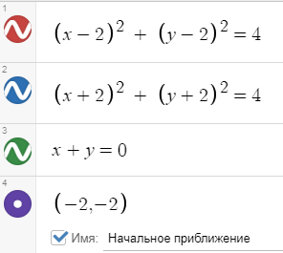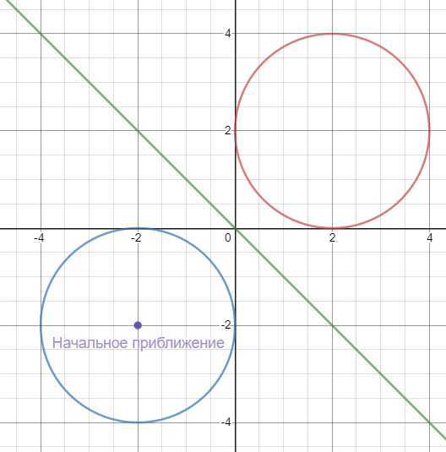

1 вариант

Cant solve!

2 вариант

Cant solve!

6 вариант

Cant solve!

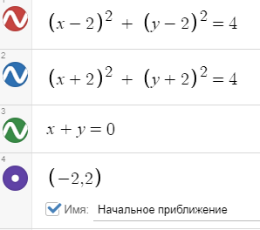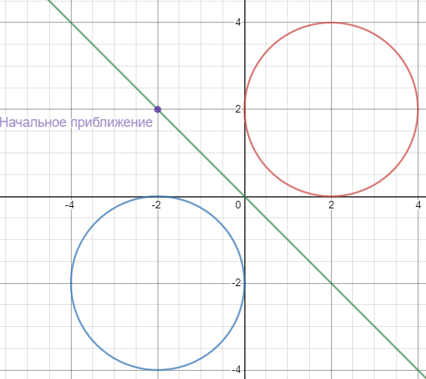

1 вариант

|  |  |  |  |  |
| --- | --- | --- | --- | --- |
| k | beta | x | y | norm |
| 0 | 1 | -0.166667 | 0.166667 | 5.73542 |
| 1 | 0.03125 | 0.0234375 | -0.0234375 | 5.65841 |
| 2 | 0.000976563 | -0.0182406 | 0.0182406 | 5.6578 |
| 3 | 0.000488281 | 0.00853275 | -0.00853275 | 5.65706 |
| . | . | . | . | . |
| 98 | 2.27374e-13 | -1.28835e-08 | 1.28835e-08 | 5.65685 |
| 99 | 5.68434e-14 | 4.39921e-06 | -4.39921e-06 | 5.65685 |

2 вариант

|  |  |  |  |  |
| --- | --- | --- | --- | --- |
| k | beta | x | y | norm |
| 0 | 1 | -0.166667 | 0.166667 | 5.73542 |
| 1 | 0.03125 | 0.0234375 | -0.0234375 | 5.65841 |
| 2 | 0.000976563 | -0.0182406 | 0.0182406 | 5.6578 |
| 3 | 0.000488281 | 0.00853275 | -0.00853275 | 5.65706 |
| . | . | . | . | . |
| 98 | 1.13687e-13 | -5.40388e-08 | 5.40388e-08 | 5.65685 |
| 99 | 5.68434e-14 | 9.97862e-07 | -9.97862e-07 | 5.65685 |

6 вариант

|  |  |  |  |  |
| --- | --- | --- | --- | --- |
| k | beta | x | y | norm |
| 0 | 1 | -0.166667 | 0.166667 | 5.73542 |
| 1 | 0.03125 | 0.0234375 | -0.0234375 | 5.65841 |
| 2 | 0.000976563 | -0.0182406 | 0.0182406 | 5.6578 |
| 3 | 0.000488281 | 0.00853275 | -0.00853275 | 5.65706 |
| . | . | . | . | . |
| 98 | 5.68434e-14 | -1.02281e-06 | 1.02281e-06 | 5.65685 |
| 99 | 1.81899e-12 | 7.55624e-07 | -7.55624e-07 | 5.65685 |

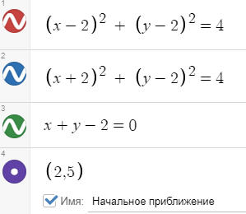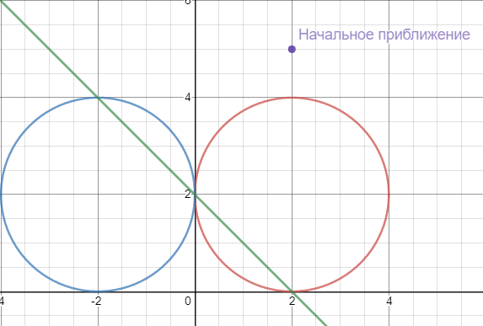

1 вариант

|  |  |  |  |  |
| --- | --- | --- | --- | --- |
| k | beta | x | y | norm |
| 0 | 1 | -2.16667 | 4.16667 | 22.1585 |
| 1 | 1 | -2.0119 | 4.0119 | 18.07 |
| 2 | 1 | -2.00007 | 4.00007 | 16.1432 |
| 3 | 1 | -2 | 4 | 16.0008 |
| 4 | 1 | -2 | 4 | 16 |
| 5 | 5.68434e-14 | -2 | 4 | 16 |

2 вариант

|  |  |  |  |  |
| --- | --- | --- | --- | --- |
| k | beta | x | y | norm |
| 0 | 0.125 | 2.5625 | 3.8125 | 22.1585 |
| 1 | 1 | 1.79119 | 0.208807 | 20.576 |
| 2 | 1 | 2.22045e-16 | 0.208807 | 13.6021 |
| 3 | 1 | 3.33067e-16 | 1.1044 | 4.87808 |
| 4 | 1 | 0.138502 | 1.8615 | 1.44527 |
| 5 | 1 | 2.77556e-17 | 1.8615 | 0.785363 |
| 6 | 1 | 0.00448512 | 1.99551 | 0.141134 |
| 7 | 1 | 1.82146e-17 | 1.99551 | 0.0253717 |
| 8 | 1 | 5.01782e-06 | 1.99999 | 0.00448521 |
| 9 | 1 | 5.08321e-17 | 1.99999 | 2.83851e-05 |
| 10 | 1 | 6.29475e-12 | 2 | 5.01786e-06 |
| 11 | 5.68434e-14 | 6.29475e-12 | 2 | 3.56091e-11 |

6 вариант

|  |  |  |  |  |
| --- | --- | --- | --- | --- |
| k | beta | x | y | norm |
| 0 | 0.125 | 2.5625 | 3.8125 | 22.1585 |
| 1 | 1 | 1.79119 | 0.208807 | 20.576 |
| 2 | 1 | -4.95382e-13 | 0.208807 | 13.6021 |
| 3 | 1 | 1.11022e-16 | 1.1044 | 4.87808 |
| 4 | 1 | 0.138502 | 1.8615 | 1.44527 |
| 5 | 1 | 5.55112e-17 | 1.8615 | 0.785363 |
| 6 | 1 | 0.00448512 | 1.99551 | 0.141134 |
| 7 | 1 | -5.03937e-16 | 1.99551 | 0.0253717 |
| 8 | 1 | -5.04038e-06 | 2.00001 | 0.00448521 |
| 9 | 1 | 7.87571e-18 | 2.00001 | 2.85127e-05 |
| 10 | 1 | 6.35128e-12 | 2 | 5.04032e-06 |
| 11 | 1 | -8.8273e-17 | 2 | 3.59287e-11 |
| 12 | 1 | -8.82729e-17 | 2 | 1.28162e-11 |
| 13 | 5.68434e-14 | -8.82729e-17 | 2 | 0 |

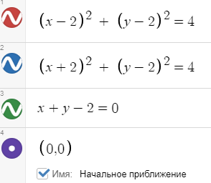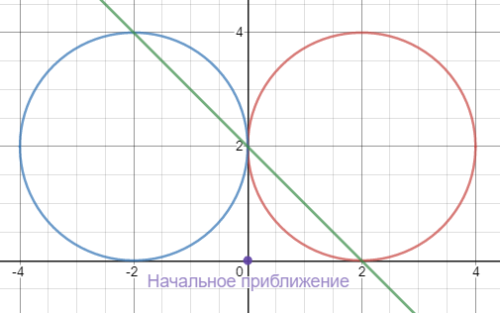

1 вариант

|  |  |  |  |  |
| --- | --- | --- | --- | --- |
| k | beta | x | y | norm |
| 0 | 1 | 0.5 | 1.5 | 6 |
| 1 | 1 | -0.25 | 2.25 | 2.91548 |
| 2 | 1 | 0.0416667 | 1.95833 | 1.42522 |
| 3 | 1 | -0.000905797 | 2.00091 | 0.235753 |
| 4 | 1 | 4.10606e-07 | 2 | 0.00512396 |
| 5 | 1 | -8.41259e-14 | 2 | 2.32274e-06 |
| 6 | 1 | 2.89769e-17 | 2 | 4.75425e-13 |

2 вариант

|  |  |  |  |  |
| --- | --- | --- | --- | --- |
| k | beta | x | y | norm |
| 0 | 1 | 0 | 1 | 6 |
| 1 | 1 | 0.166667 | 1.83333 | 1.73205 |
| 2 | 1 | 2.77556e-17 | 1.83333 | 0.946077 |
| 3 | 1 | 0.00641026 | 1.99359 | 0.171234 |
| 4 | 1 | 1.44849e-16 | 1.99359 | 0.0362621 |
| 5 | 1 | 1.024e-05 | 1.99999 | 0.00641052 |
| 6 | 1 | -8.89317e-17 | 1.99999 | 5.79263e-05 |
| 7 | 1 | 2.62143e-11 | 2 | 1.024e-05 |
| 8 | 5.68434e-14 | 2.62143e-11 | 2 | 1.4829e-10 |

6 вариант

|  |  |  |  |  |
| --- | --- | --- | --- | --- |
| k | beta | x | y | norm |
| 0 | 1 | 0 | 1 | 6 |
| 1 | 1 | 0.166667 | 1.83333 | 1.73205 |
| 2 | 1 | 5.55112e-17 | 1.83333 | 0.946077 |
| 3 | 1 | 0.00641026 | 1.99359 | 0.171234 |
| 4 | 1 | -3.2873e-16 | 1.99359 | 0.0362621 |
| 5 | 1 | -1.03059e-05 | 2.00001 | 0.00641052 |
| 6 | 1 | 8.73443e-17 | 2.00001 | 5.82989e-05 |
| 7 | 1 | 2.65529e-11 | 2 | 1.03059e-05 |
| 8 | 1 | -8.45827e-17 | 2 | 1.50206e-10 |
| 9 | 1 | -8.45813e-17 | 2 | 5.31057e-11 |
| 10 | 5.68434e-14 | -8.45813e-17 | 2 | 0 |

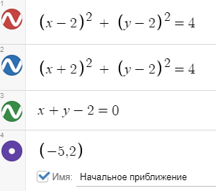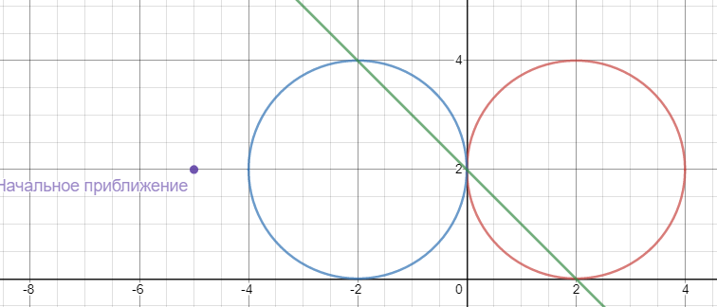

1 вариант

|  |  |  |  |  |
| --- | --- | --- | --- | --- |
| k | beta | x | y | norm |
| 0 | 0.5 | -4.58333 | 4.08333 | 45.5522 |
| 1 | 1 | -2.71577 | 4.71577 | 44.3107 |
| 2 | 1 | -2.1493 | 4.1493 | 25.9073 |
| 3 | 1 | -2.0097 | 4.0097 | 17.8477 |
| 4 | 1 | -2.00005 | 4.00005 | 16.1166 |
| 5 | 1 | -2 | 4 | 16.0006 |
| 6 | 1 | -2 | 4 | 16 |
| 7 | 5.68434e-14 | -2 | 4 | 16 |

2 вариант

|  |  |  |  |  |
| --- | --- | --- | --- | --- |
| k | beta | x | y | norm |
| 0 | 1 | -1.78571 | 3.78571 | 45.5522 |
| 1 | 1 | -2.22045e-16 | 3.78571 | 13.5421 |
| 2 | 1 | 0 | 2.89286 | 4.85029 |
| 3 | 0.5 | 0.180012 | 2.26642 | 1.43813 |
| 4 | 1 | 5.55112e-17 | 2.19402 | 1.12143 |
| 5 | 1 | 0.0104223 | 1.98958 | 0.201195 |
| 6 | 1 | -8.67362e-18 | 1.98958 | 0.0589585 |
| 7 | 1 | 2.70155e-05 | 1.99997 | 0.0104235 |
| 8 | 1 | 8.40595e-18 | 1.99997 | 0.000152823 |
| 9 | 1 | 1.82457e-10 | 2 | 2.70155e-05 |
| 10 | 1 | -1.03915e-16 | 2 | 1.03213e-09 |
| 11 | 1 | -1.03849e-16 | 2 | 3.64914e-10 |
| 12 | 5.68434e-14 | -1.03849e-16 | 2 | 0 |

6 вариант

|  |  |  |  |  |
| --- | --- | --- | --- | --- |
| k | beta | x | y | norm |
| 0 | 1 | -1.78571 | 3.78571 | 45.5522 |
| 1 | 1 | 9.72555e-14 | 3.78571 | 13.5421 |
| 2 | 1 | 1.088e-26 | 2.89286 | 4.85029 |
| 3 | 0.5 | 0.180012 | 2.26642 | 1.43813 |
| 4 | 1 | -2.98928e-14 | 2.19402 | 1.12143 |
| 5 | 1 | -0.00857899 | 2.00858 | 0.201195 |
| 6 | 1 | -9.95731e-16 | 2.00858 | 0.0485306 |
| 7 | 1 | -1.83212e-05 | 2.00002 | 0.00857962 |
| 8 | 1 | 3.90109e-17 | 2.00002 | 0.00010364 |
| 9 | 1 | 8.39174e-11 | 2 | 1.83212e-05 |
| 10 | 1 | 7.6334e-17 | 2 | 4.74708e-10 |
| 11 | 1 | 7.6348e-17 | 2 | 1.67724e-10 |
| 12 | 5.68434e-14 | 7.6348e-17 | 2 | 0 |

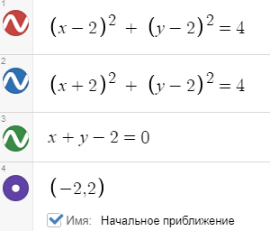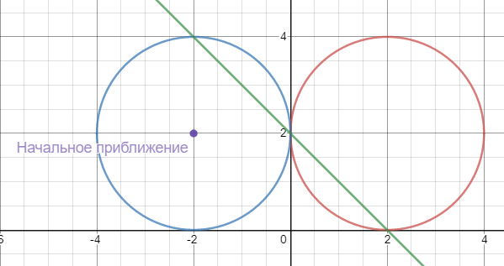

1 вариант

Cant solve!

2 вариант

Cant solve!

6 вариант

Cant solve!