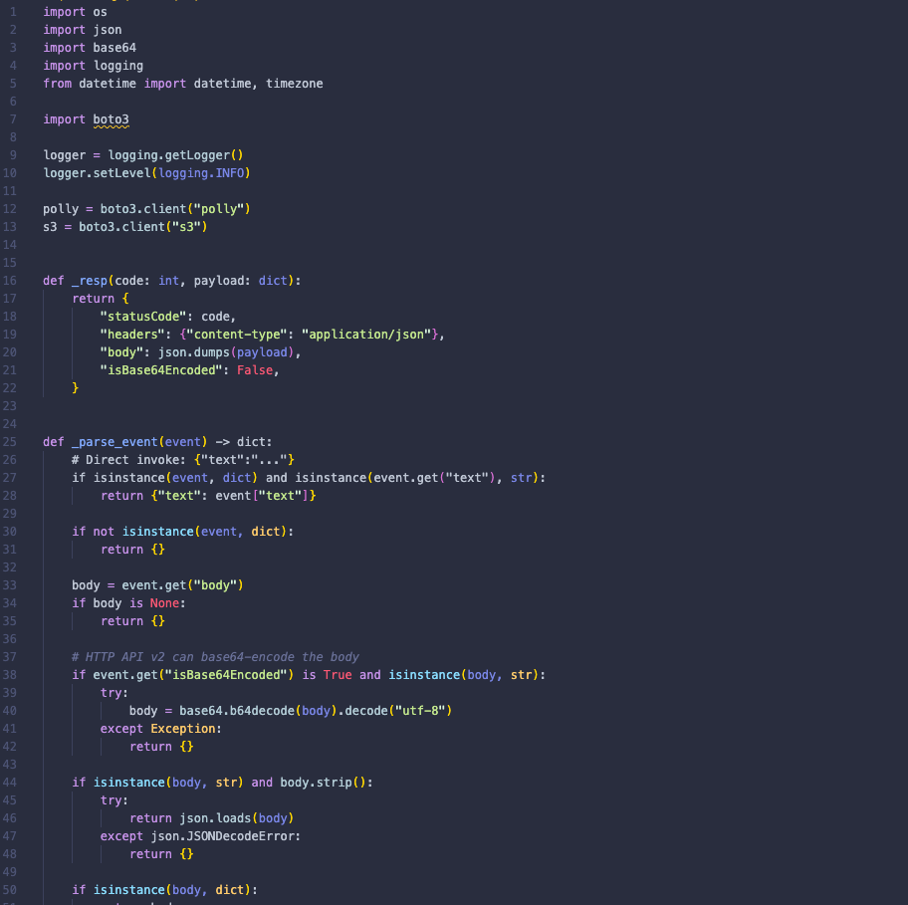

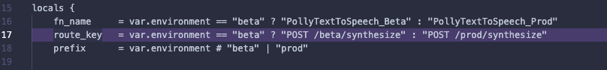

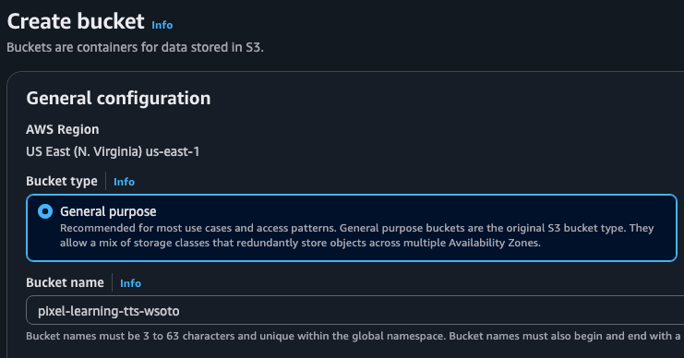

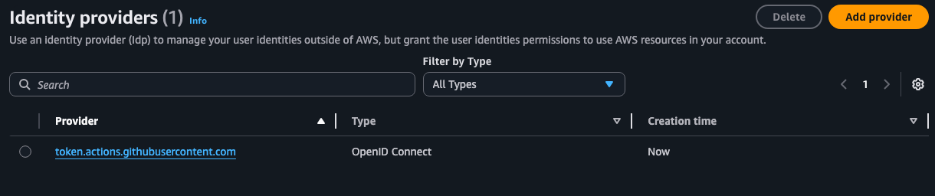

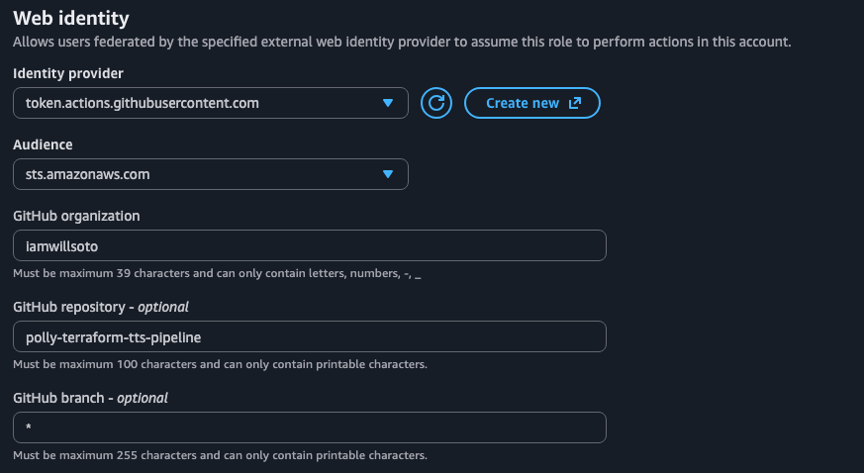

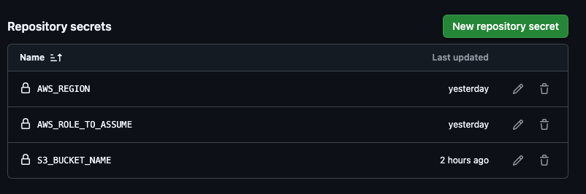

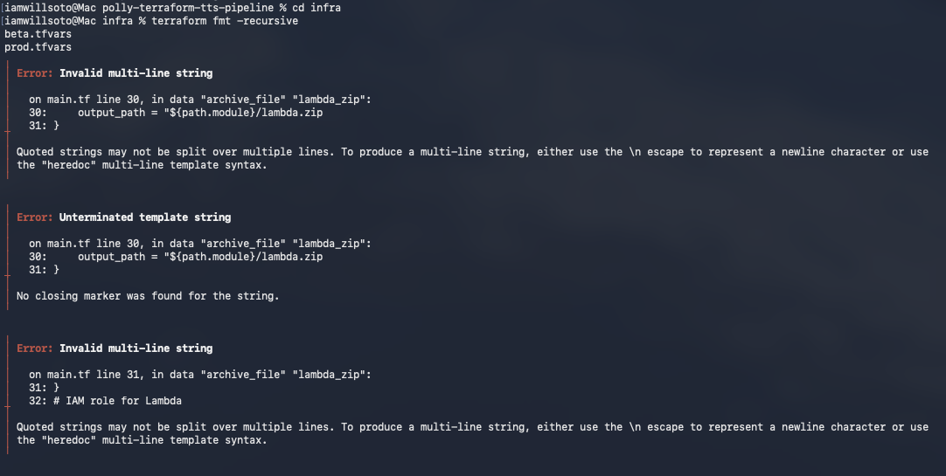
Fixing all errors after running terraform fmt -recursive

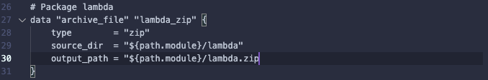

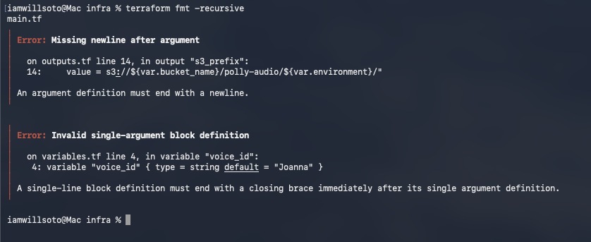

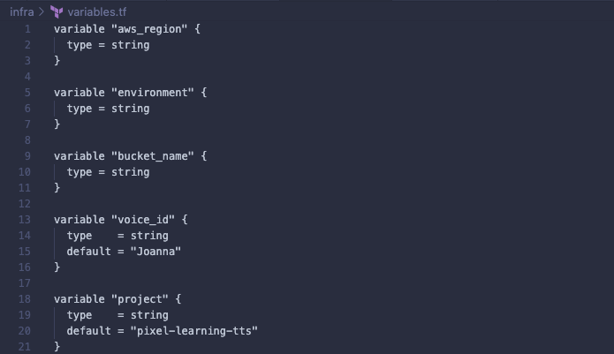

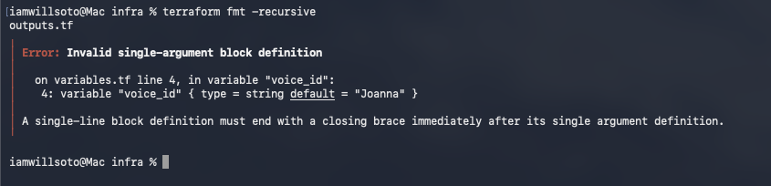

No more syntax issues

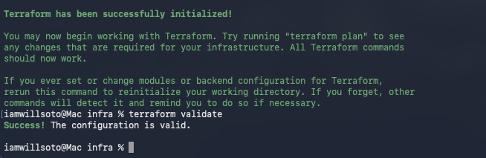

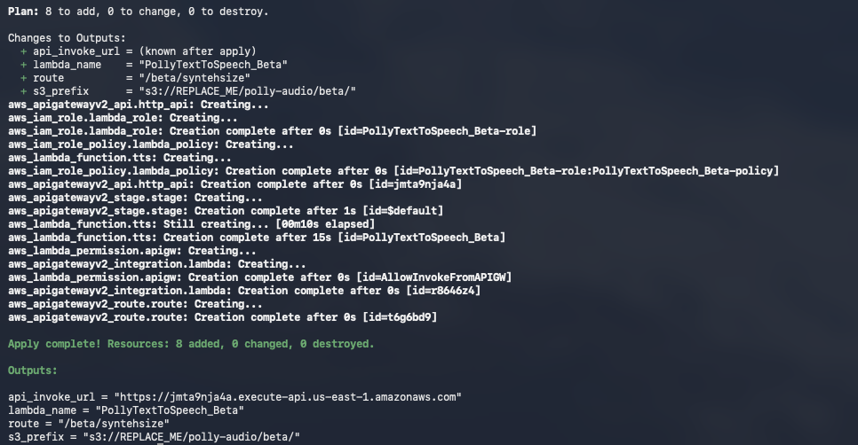

Deployment receipts
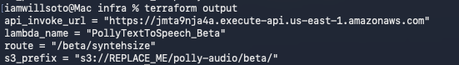

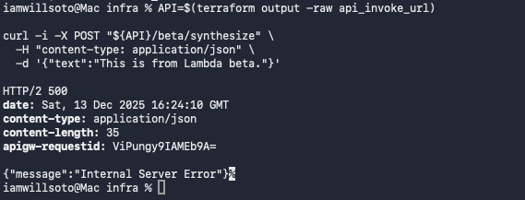

API Gateway successfully reached your Lambda integration, but Lambda errored at runtime (most commonly IAM permissions, bucket/prefix mismatch, or Polly/S3 call failure)

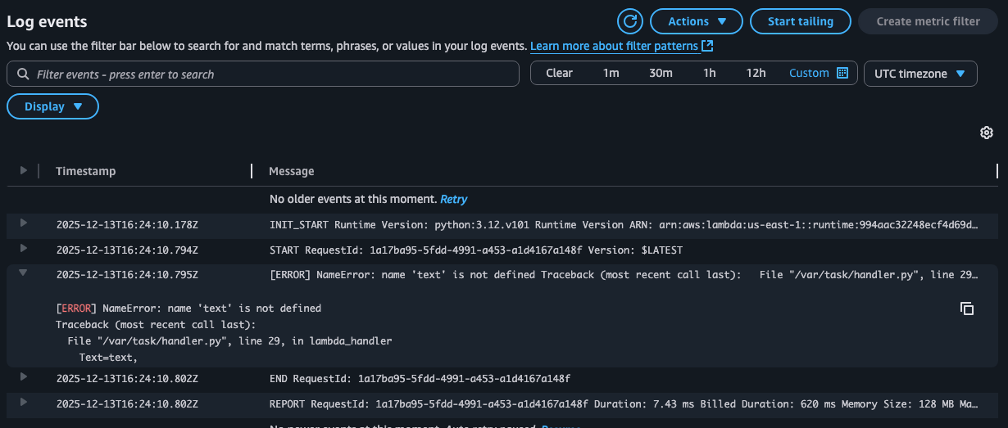

Had to add from datetime import datetime, timezone to handle api gateway event body correctly

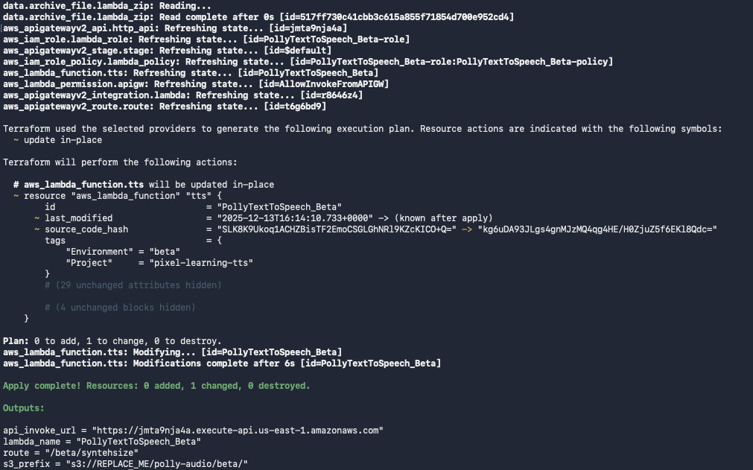

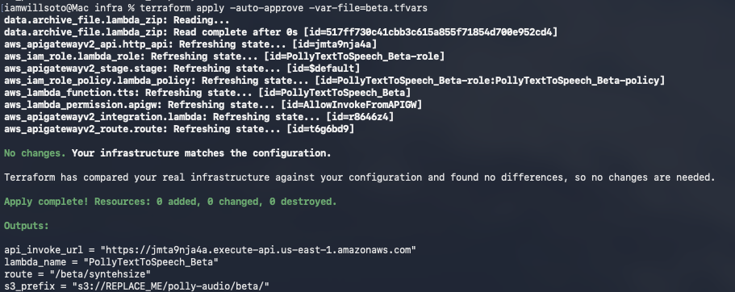

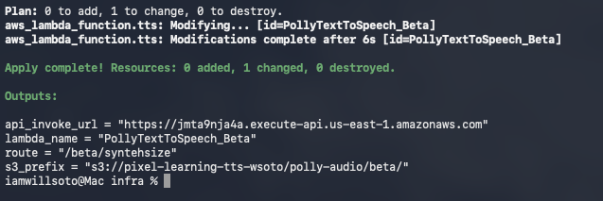

Does it work?
API=$(terraform output -raw api_invoke_url)
curl -i -X POST "${API}/beta/synthesize" \
-H "content-type: application/json" \
-d '{"text":"Pixel Learning beta test: generate audio."}'

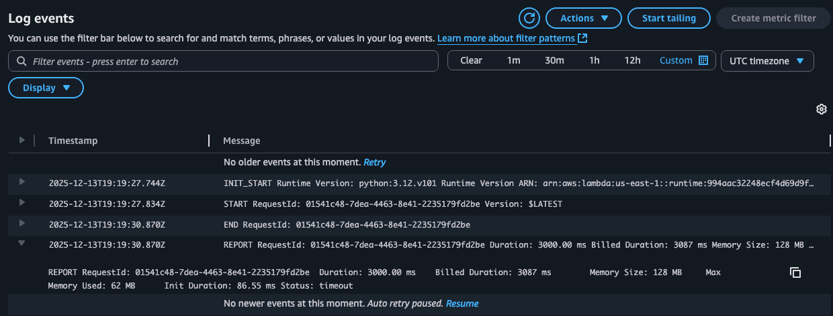
still getting an error over a timeout in lambda function, no longer my code being an issue, added a 15s timeout with a 256 memory size to main.tf

Terraform successful on beta
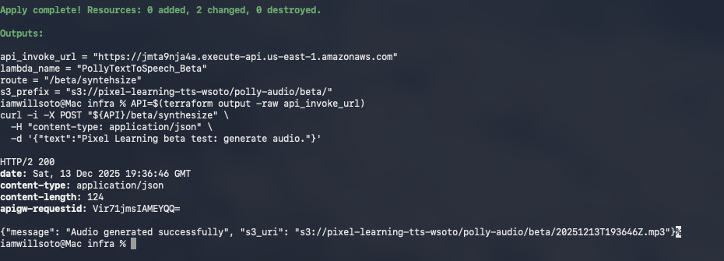


Successful text to speech to prod in S3

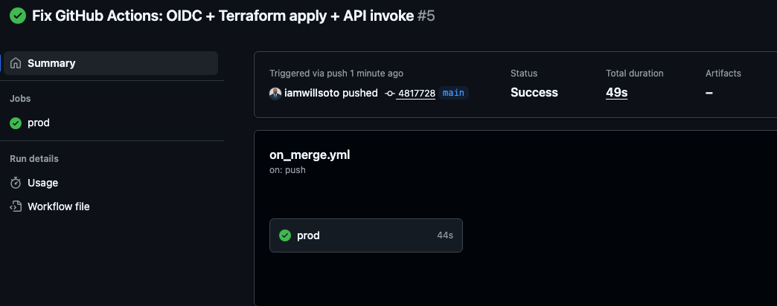

Encountered an issue with beta prod declining over terraform not knowing the iam role already exists, so aws rejects it with EntityAlreadyExists (409). Solution:
Create a terraform-state folder in s3
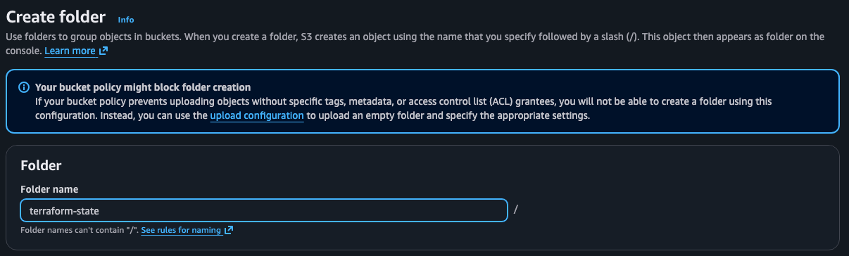

Create a new file called backend.tf in the infra folder with

terraform {
backend "s3" {
bucket = "pixel-learning-tts-wsoto"
key = "terraform-state/polly-tts/terraform.tfstate"
region = "us-east-1"
}
}
this allows terraform state in s3 so local + github actions operate on the same infrastructure
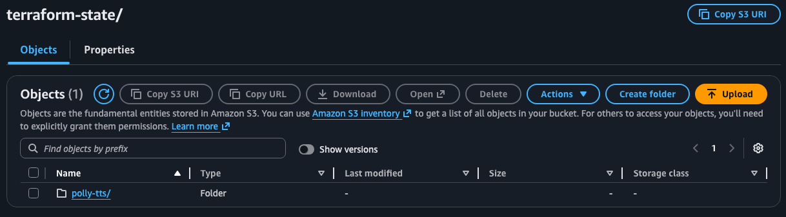
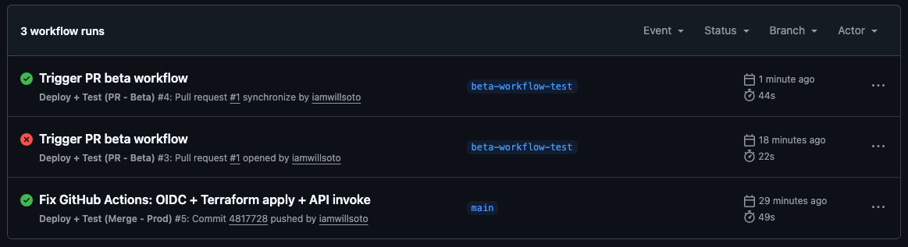
Everything is now working correctly
