Ten: Đinh Lê Thái Dương

Lớp:22SE2

Mã SV:22IT056

Bài 1:

a.

TH:không nhập tên và MK

TH:đã nhập tên và MK

b.

c.

d.

Code:

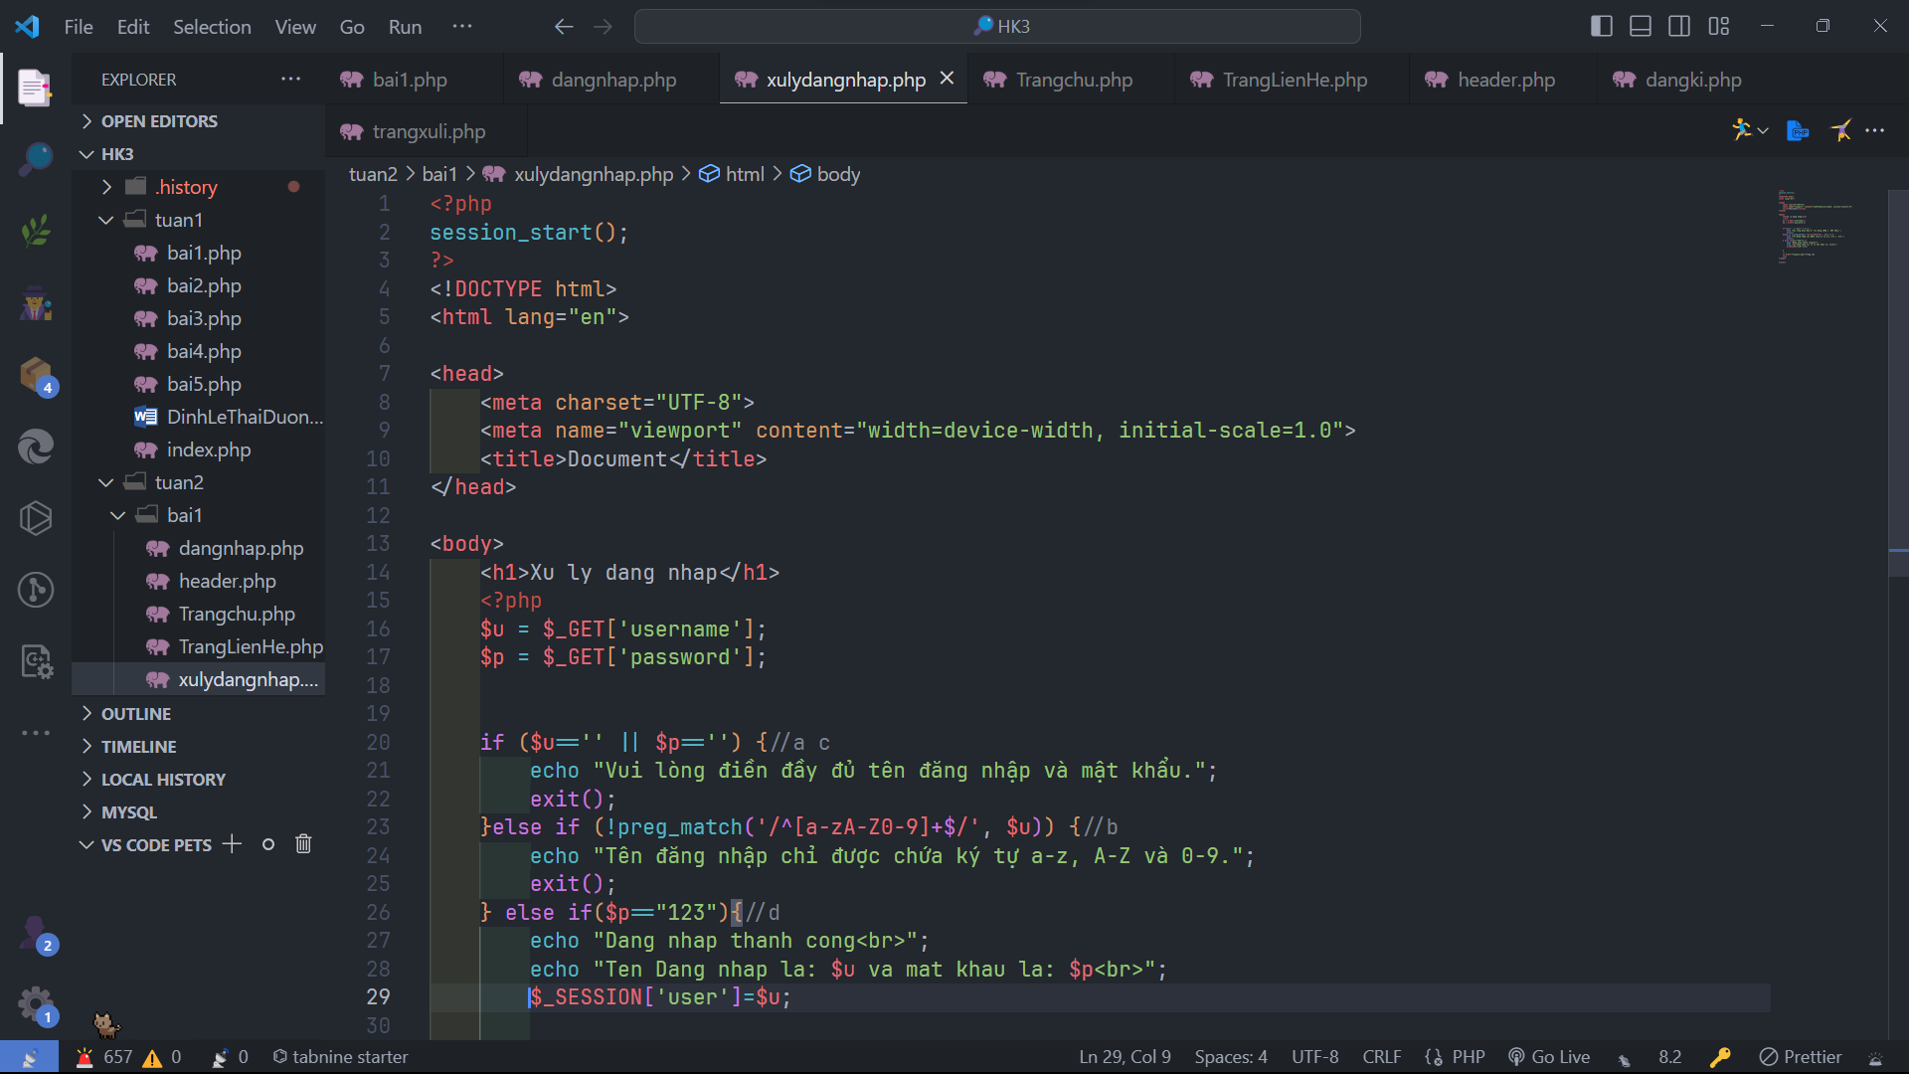

e,f,g:

Code:

Bài 2:

Code:

