What is NumPy?
NumPy is the fundamental package for scientific computing in Python. It is a Python library that provides a multidimensional array object, various derived objects (such as masked arrays and matrices), and an assortment of routines for fast operations on arrays, including mathematical, logical, shape manipulation, sorting, selecting, I/O, discrete Fourier transforms, basic linear algebra, basic statistical operations, random simulation and much more.

At the core of the NumPy package, is the ndarray object. This encapsulates n-dimensional arrays of homogeneous data types, with many operations being performed in compiled code for performance.
Via https://numpy.org/doc/stable/user/whatisnumpy.html

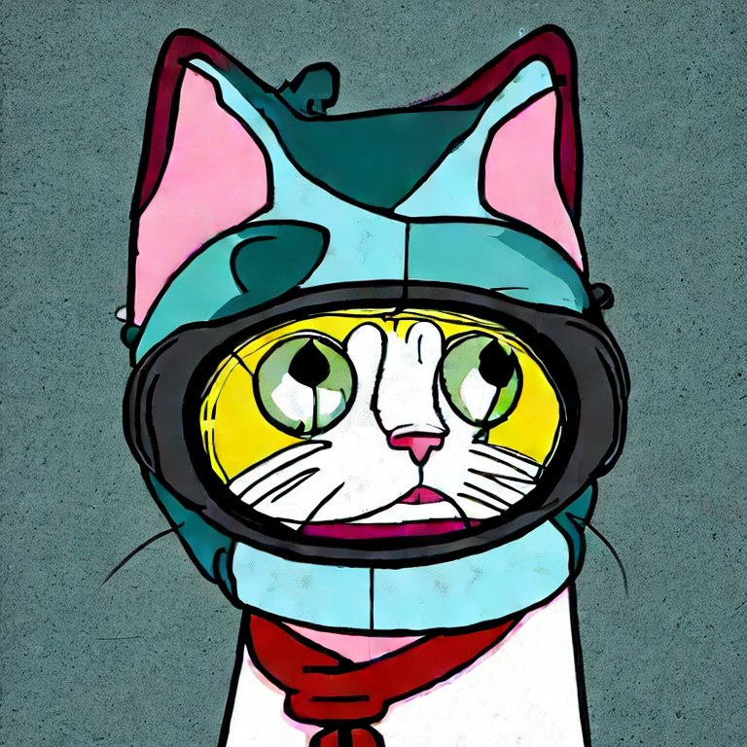

Image generation from:
“A cat thinking hard in the style of Futurama” using Stabliity AI’s Stable Diffusion [1].

What about other random things?
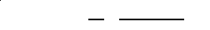

Most competitive neural sequence transduction models have an encoder-decoder structure [5, 2, 35]. Here, the encoder maps an input sequence of symbol representations (x1, ..., xn) to a sequence of continuous representations z = (z1, ..., zn). Given z, the decoder then generates an output sequence (y1, ..., ym) of symbols one element at a time. At each step the model is auto-regressive [10], consuming the previously generated symbols as additional input when generating the next.[2]

22 | 55 | 66
11 | 33 | 44

- Integer gravida turpis a pulvinar dictum.
- Maecenas sollicitudin ipsum quis magna feugiat, eu luctus augue tincidunt.
- Etiam non nunc in leo blandit molestie.
- Etiam ac nisl aliquet, elementum nisl a, mattis turpis.
- Etiam volutpat nibh ut nibh gravida congue.
- Curabitur id turpis sagittis, sollicitudin ex in, rutrum nisl.
- Nam sodales massa a quam condimentum cursus.
- Proin pharetra augue eget sem laoreet sagittis.
- Ut non nisi nec nulla pellentesque viverra sed eget leo.
- Phasellus dignissim ex in turpis mollis, et efficitur ipsum fringilla.
Via https://www.lipsum.com

Works Cited

[1] R. Rombach, A. Blattmann, D. Lorenz, P. Esser, and B. Ommer, “High-resolution image synthesis with latent diffusion models,” in Proceedings of the IEEE/CVF conference on computer vision and pattern recognition (CVPR), Jun. 2022, pp. 10684–10695.
[2] A. Vaswani et al., “Attention Is All You Need,” 2017, doi: 10.48550/ARXIV.1706.03762.

