1. Hello World, I am student of Bsc. CSIT

2.

Enter a year : 2016

2016 is a leap year

Enter a year : 2017

2000 is not a leap year

3.

Enter your age :12

Person cannot get citizenship

4.

Sum of natural number's up to 5 : 15

Factorial of 5 : 4

Reversed of 12345 : 54321

5.

2894316

Even sum: 20

Odd sum: 13

6.

Smallest: 5

Element found

7.

Kilometers per liter: 10

Fuel per 100 km: 10 liters

8.

Attempted to divide by zero.

9.

Data: sita

Data: 1

11.

Content written to example.txt

File Exists

File content: Hello World!

12.

Strings:

Aryan apple banana cat dog

strings containing: 'an':

Aryan banana

10.

1. Add student

2. Display all students

3. Exit

Enter choice:

1

Enter name:

ram

Enter age:

45

Enter grade level:

master

Student added successfully.

1. Add student

2. Display all students

3. Exit

Enter choice:

2

Student List:

Name: ram

Age: 45

Grade Level: master

1. Add student

2. Display all students

3. Exit

Enter choice:

3

Goodbye!

15.

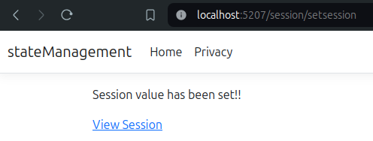

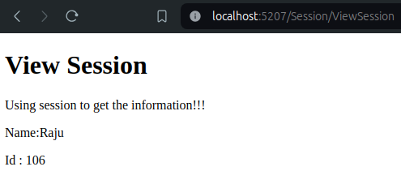

16.

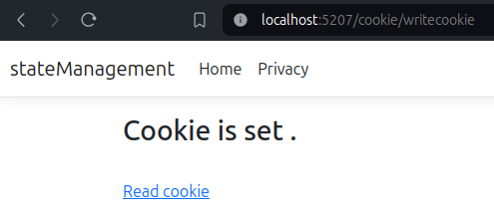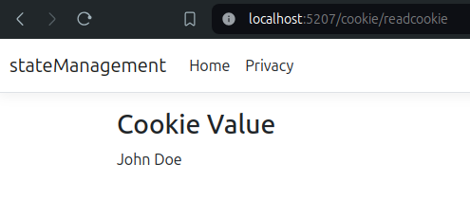17.

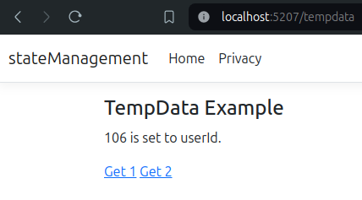

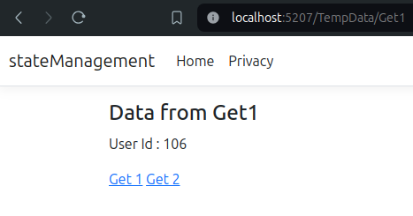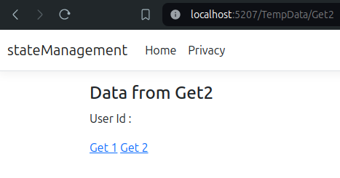

18.

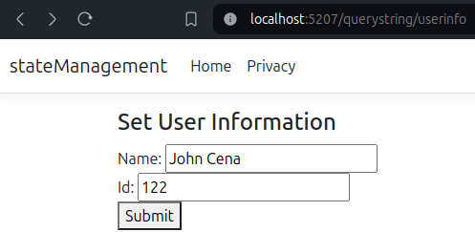After sumbit:

