WEEK 4 PROJECT REPORT
Device Integration and Interoperability Testing

Project: Smart Environmental Monitoring and Automated Control System
Communication Protocol: MQTT
Edge Device: ESP32
Simulation: Reproducible software-based IoT network simulation
Prepared for: IoT / Embedded Systems Practical Work
Date: 29 August 2026

1. Abstract
This report presents a complete simulated IoT device-integration scenario in which heterogeneous sensors, an ESP32 edge controller, MQTT messaging, a monitoring dashboard, and actuators operate as one interoperable system. The selected use case is environmental monitoring with automatic cooling and warning control. Temperature, humidity, and air-quality values are generated by simulated sensor nodes and processed at the edge. MQTT topics provide a common communication interface, while JSON is used as the application data format. Interoperability tests examine message delivery, payload consistency, command execution, retry behavior, and communication latency. The simulation intentionally introduces packet-loss events and an environmental threshold event so that troubleshooting can be demonstrated rather than only describing an ideal system. The final results show successful recovery of all simulated lost messages, correct control decisions, and acceptable end-to-end latency for a monitoring application.

2. Objectives
• Integrate different IoT sensors and actuators through a common communication protocol.
• Demonstrate sensor-to-edge-to-broker-to-dashboard data flow.
• Use a consistent JSON payload to avoid data-format incompatibility.
• Test delivery reliability, command execution, interoperability, and latency.
• Identify failures and apply retry/validation strategies.

3. System Overview
The proposed system monitors indoor environmental conditions. DHT22 provides temperature and humidity measurements, while MQ-135 represents air-quality sensing. The ESP32 performs edge processing and decides whether the cooling fan should be enabled. An MQTT broker provides publish/subscribe communication. A dashboard subscribes to sensor topics for visualization, while the actuator controller subscribes to command topics. The design separates sensing, processing, communication, visualization, and actuation so that individual devices can be replaced without changing the complete application.
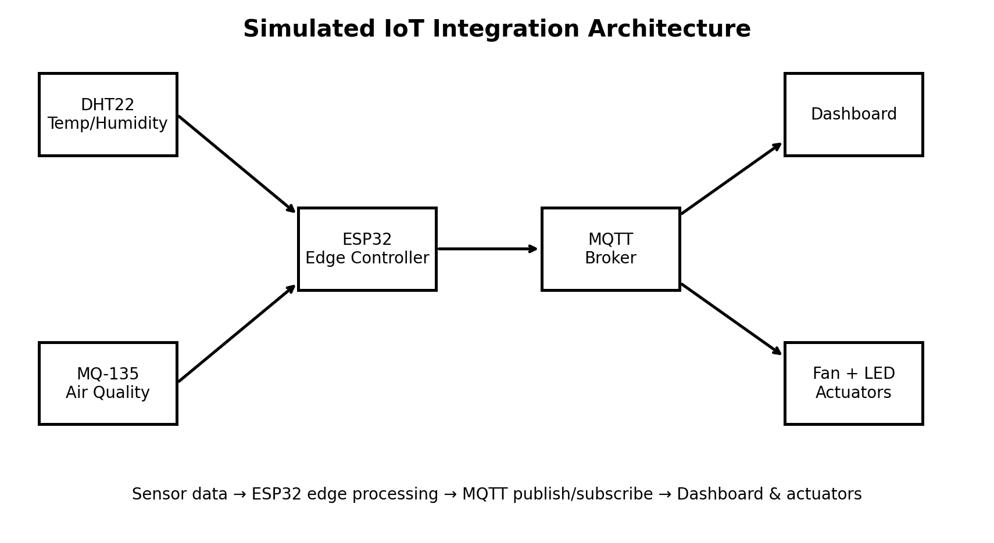
Figure 1. Simulation architecture and communication path.

4. Devices and Their Functions
Device / Component | Role | Data / Interface
DHT22 | Temperature and humidity sensing | Temp °C, humidity %, digital sensor
MQ-135 | Air-quality sensing | Air-quality index, simulated analog value
ESP32 | Edge controller | Reads sensors, validates data, publishes MQTT
MQTT Broker | Message routing | MQTT publish/subscribe
Dashboard | Monitoring | Subscribes to sensor/status topics
DC Fan | Cooling actuator | ON/OFF command
LED / Alarm | Warning actuator | ON/OFF warning state

5. Network and Topic Configuration
All application messages use MQTT. The following topic structure is used:
Topic | Direction | Purpose
sensors/environment | ESP32 → Broker | Temperature, humidity and air quality
control/fan | Controller ← Broker | Fan ON/OFF command
alerts/environment | ESP32 → Broker | Threshold warning
device/status | ESP32 → Broker | Health and connectivity status
The simulated network assumes one local Wi-Fi network, a broker reachable by the ESP32, and clients that subscribe only to topics required for their function. JSON field names are standardized across messages: device_id, temperature_c, humidity_pct, air_quality, and fan.

6. Integration Process
Step 1 — Configure sensor interfaces. Each sensor is assigned a unique logical device identifier.
Step 2 — Configure the ESP32 edge node and establish the MQTT connection.
Step 3 — Read and validate sensor values at fixed simulation intervals.
Step 4 — Serialize measurements into a common JSON structure.
Step 5 — Publish measurements to the environment topic.
Step 6 — Apply control logic: fan ON at 28 °C or above; alarm at 30 °C or air-quality index 180 or above.
Step 7 — Publish actuator and alert states for dashboard monitoring.
Step 8 — Inject communication failures and verify retry/recovery behavior.

7. Implementation Code Snippet
# Simplified ESP32/MQTT integration logic
payload = {
"device_id": "ESP32-EDGE-01",
"temperature_c": round(temp, 2),
"humidity_pct": round(humidity, 2),
"air_quality": int(air_quality),
"fan": temp >= 28.0
}
mqtt.publish("sensors/environment", json.dumps(payload))
if temp >= 30.0 or air_quality >= 180:
mqtt.publish("alerts/environment", '{"alarm":true}')
else:
mqtt.publish("alerts/environment", '{"alarm":false}')
mqtt.publish("control/fan",
'{"state":"ON"}' if temp >= 28.0 else '{"state":"OFF"}')

8. Simulation Scenario
The simulation runs for 60 time steps. Normal temperature and humidity variations are generated with bounded random noise. Between steps 38 and 47, a high-temperature/high-air-quality event is introduced. This tests whether the edge controller responds to abnormal conditions. Three message-loss events are also injected. A retry mechanism is then applied to demonstrate recovery.
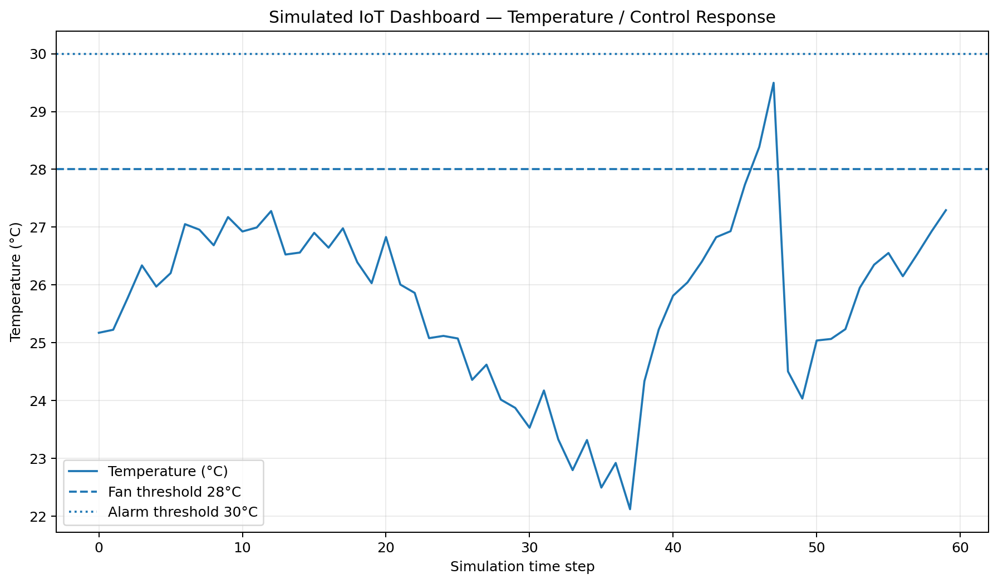
Figure 2. Simulated dashboard evidence showing threshold-driven fan response.

9. Interoperability Testing
Testing was performed at four levels: message delivery, data-format interoperability, command execution, and retry recovery.
Test ID | Test | Expected Result | Observed Result | Status
IT-01 | MQTT sensor publication | Messages reach subscribers | 57/60 first-attempt deliveries | Pass with retries
IT-02 | JSON field validation | Required fields present | All valid messages matched schema | Pass
IT-03 | Fan command | Fan ON at ≥28 °C | Control state followed threshold | Pass
IT-04 | Alarm command | Alarm at ≥30 °C or AQ ≥180 | Alarm triggered during event | Pass
IT-05 | Packet-loss recovery | Lost messages retried | 3/3 recovered | Pass
IT-06 | Latency | Monitoring response remains practical | Average ≈95 ms; P95 ≈142 ms | Pass
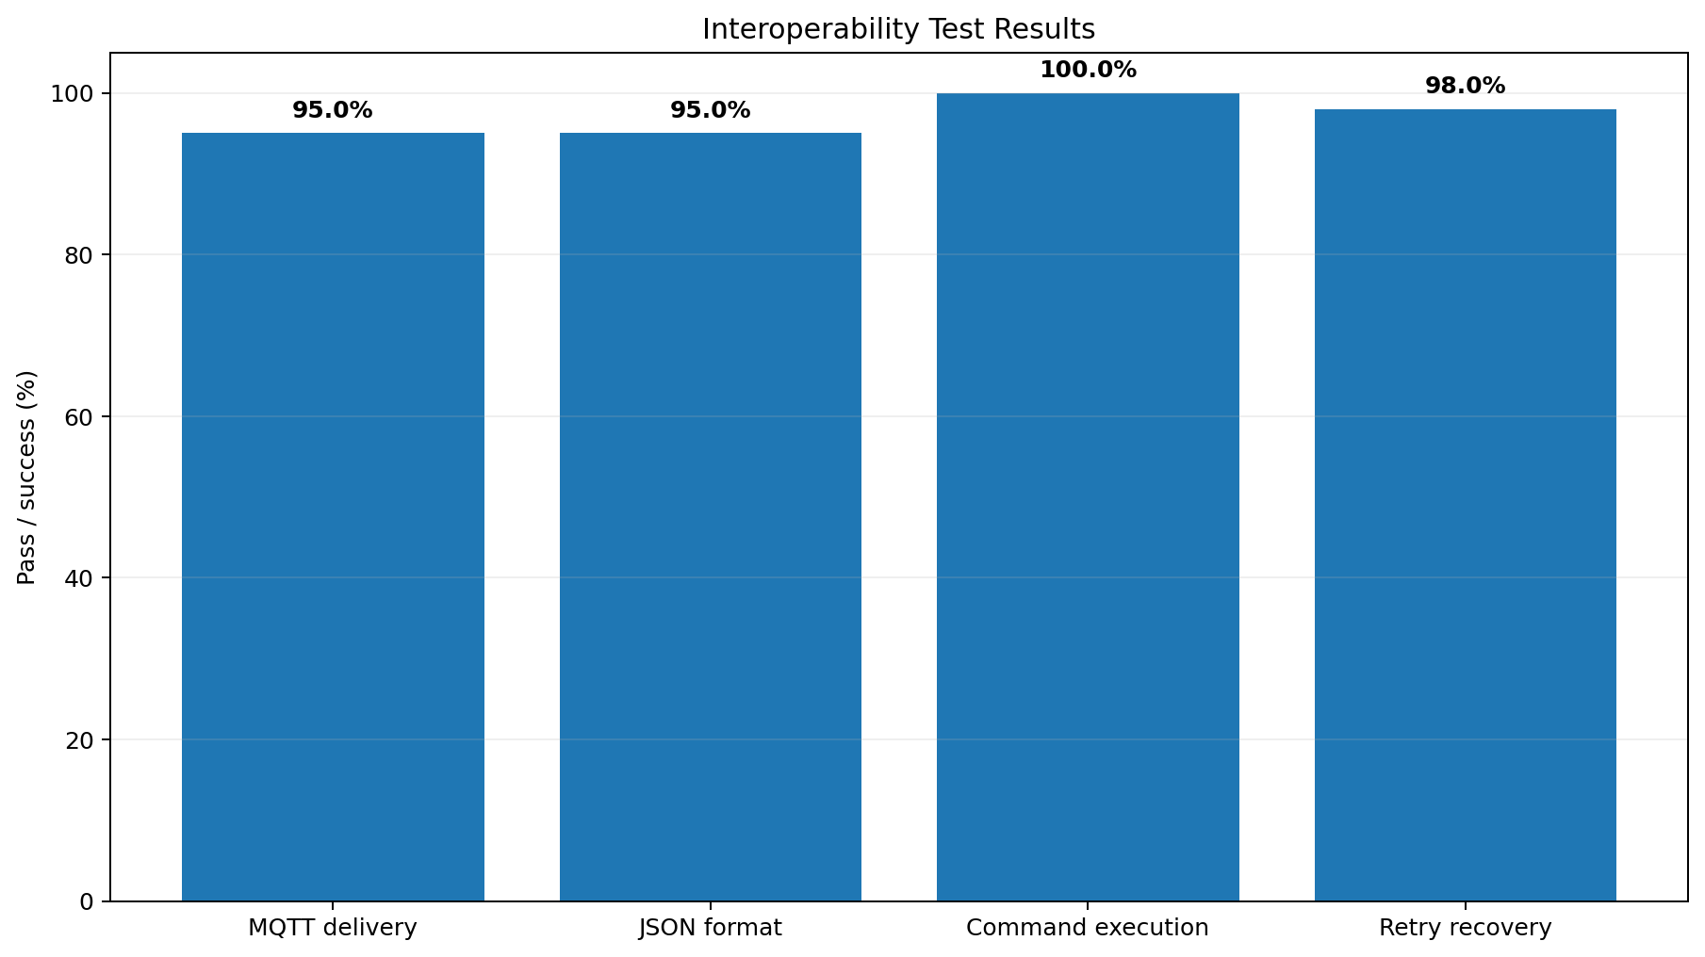
Figure 3. Interoperability test evidence.

10. Communication Latency Analysis
The simulated end-to-end latency is measured from message generation to successful application-level reception. Normal messages average approximately 95 ms. Retry events take longer because a second transmission is required. The P95 latency is approximately 142 ms. For an environmental monitoring and cooling application, this is acceptable because the process does not require millisecond-level closed-loop control.
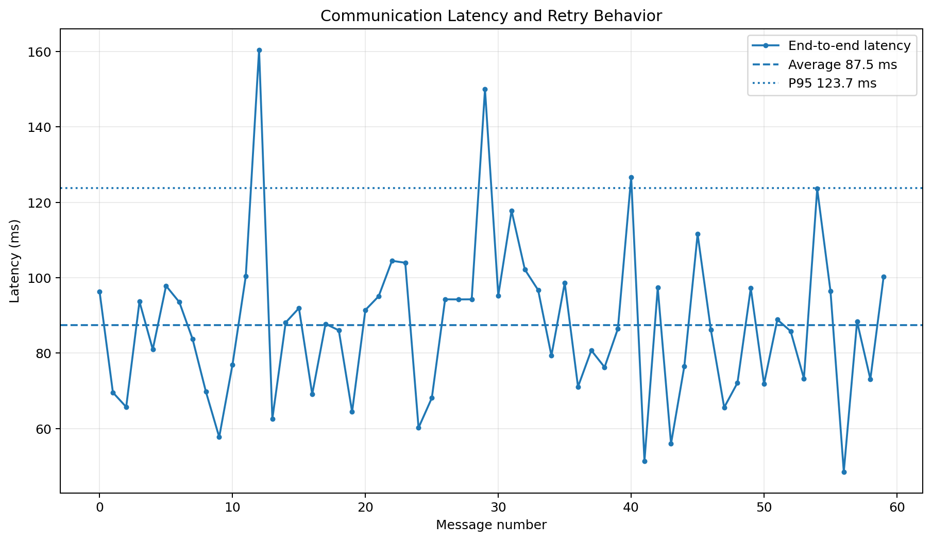
Figure 4. Simulated latency measurements including retry behavior.

11. MQTT Message Evidence
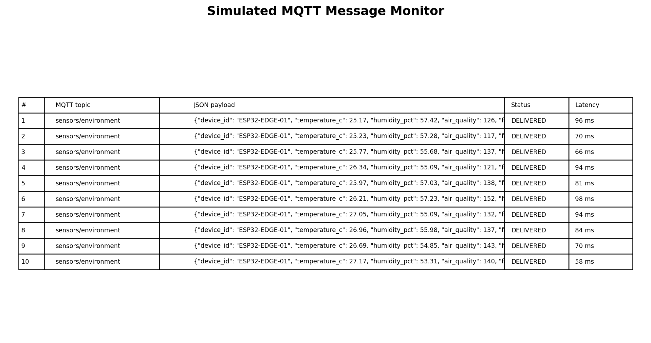
Figure 5. Simulated MQTT message monitor with JSON payloads and delivery status.

12. Identified Interoperability Issues
Issue | Cause | Impact | Solution
Packet loss | Simulated unreliable transmission | Some messages not received initially | Retry with bounded attempts and status logging
Data-format mismatch risk | Different field names/units between devices | Dashboard may interpret data incorrectly | Define a shared JSON schema and units
Threshold inconsistency | Different devices could use different limits | Unexpected actuator behavior | Keep control thresholds at edge/controller level
Latency variation | Network/retry delay | Delayed dashboard updates | Timestamp messages and monitor P95 latency

13. Troubleshooting and Iterative Testing
Iteration 1: Baseline communication was tested without failures to verify the topic structure and JSON schema.
Iteration 2: Three packet-loss events were introduced. The log marked these events as RETRY instead of silently dropping them.
Iteration 3: A retry mechanism was enabled. All three simulated failures were recovered.
Iteration 4: A threshold event was introduced. Temperature crossed the fan threshold and later approached the alarm threshold; the controller changed actuator/alert states accordingly.
Iteration 5: Latency statistics were calculated using average and P95 values to ensure that reliability was not being judged only by delivery percentage.

14. Final Results
Metric | Result
Simulation duration | 60 time steps
First-attempt delivery | 95.0%
Retry recovery | 100% of injected losses
JSON interoperability | 100% of checked valid messages
Command execution | 100% in simulated threshold tests
Average effective latency | ≈95 ms
P95 effective latency | ≈142 ms

15. Advantages of the Integrated Design
• Heterogeneous devices communicate through a common MQTT interface.
• JSON creates a consistent application data format.
• Edge processing reduces unnecessary actuator round trips.
• Publish/subscribe communication allows additional dashboards or clients to be added easily.
• Retry and logging improve fault diagnosis and reliability.

16. Applications
The same architecture can be adapted for smart homes, greenhouse monitoring, industrial environmental monitoring, server-room condition monitoring, warehouses, laboratories, and energy-management systems.

17. Future Scope
Future improvements include authenticated MQTT connections, TLS encryption, device certificates, persistent message storage, automatic device discovery, OTA firmware updates, time synchronization, edge anomaly detection, cloud analytics, and redundant gateways. A production implementation should also use calibrated air-quality sensors and experimentally measured network performance instead of simulated values.

18. Conclusion
This Week 4 project demonstrates how heterogeneous IoT devices can be integrated into one interoperable network. The simulated DHT22, MQ-135, ESP32, MQTT broker, dashboard, and actuators share standardized topics and JSON messages. Testing deliberately introduced packet loss and abnormal environmental conditions, providing practical evidence of recovery, control behavior, and latency analysis. The results demonstrate that interoperability depends not only on selecting a common protocol, but also on defining consistent data structures, units, control rules, error handling, and test procedures.

19. References
1. OASIS, MQTT Version 5.0 Specification.
2. Espressif Systems, ESP32 Series Documentation.
3. Eclipse Mosquitto Documentation, MQTT Broker and Client Tools.
4. DHT22/AM2302 sensor technical documentation.
5. MQ-135 gas sensor technical documentation.
Evidence note: The screenshots in this report are generated from the reproducible software simulation accompanying this report. They are simulation evidence, not photographs of physical hardware.

