Title (Type Title of Paper Here)

L.M. Hfáiea (author’s initials & last name)

University of Colorado, Denver Colorado (author’s affiliation & location)

I.D. Kemdiick (secondary author(s), same as above)

ABC Industries, Anyplace, State

# abstract (EX. OF ABST HEADING)

The manuscript elements have been formatted for you through the “styles” capability of the software. To use the styles, select the text you wish to apply a style to, then, using the mouse, point to the style box on the toolbar. Click once on the downward pointing arrow to the right and select the appropriate style.

Please limit abstract to 250 words. Remember to leave a line of space between paragraphs rather than indenting.

# introduction (EX. OF HEADING1)

The main sections of the text portion should be organized using styles named HEADING1. Do not indent paragraphs. Leave a line of space between paragraphs. Leave only a single space between sentences within a paragraph. Subheadings within a section should be all capital letters (HEADING2). Do not leave a line of space below this heading. Sub-subheadings should be typed in capital and lowercase letters (Heading3 & Heading4). Again, do not leave a line of space below this heading.

# DESIGN OF EXPERIMENTS (EX. OF heading1)

This is an example of a main heading section. This section could include sub-sections. It uses “body” text style and is identified with a HEADING1 style beginning the paragraph, as show here.

## experimental (EX. of Heading2)

Here is a subsection (second level heading-HEADING 2). It uses “body” text style and is identified with a HEADING2 style beginning the paragraph, as show here.

## EFFECT OF CHEMISTRY ON MECHANICAL PROPERTIES (EX. OF HEADING2)

Here is another subsection (second level heading-HEADING2.) You may have several second-level headings and within each second level headings, you may have third level headings (Heading.3). It uses “body” text style and is identified with a HEADING2 style beginning the paragraph, as show here.

### Ultimate Strength (Ex. of Heading3)

Here is a sub-subsection (third level heading-Heading3). You may have several third level headings and within each third level heading, you may have fourth level headings (Heading4). It uses “body” text style and is identified with a Heading3 style beginning the paragraph, as show here.

### Yield Stress (Ex. of Heading3)

#### Correlation (Ex. of Heading4)

Here is another sub-subsection (fourth level heading-Heading4.) You may have several fourth level headings. It uses “body” text style and is identified with a Heading4 style beginning the paragraph, as shown here.

#### Predicted Values (Ex. of Heading4)

Here is another example of Heading4, which would be a subsection of Yield Stress (Heading 3).

This is an **unordered** list using bullets

This is another list item

This is another list item

1. This is an **ordered list,** using numbers
2. This is another list item.
3. This is a list ordered list item

# acknowledgments (optional)

This is the Acknowledgment section. This is an optional section. It uses a HEADING1 style and Body style.

# REFERENCES (Ex. of REF HEAD)

References should be noted as a superscript(s) in the body and the reference(s) at the end of the document under REFERENCES.

(Please Note: Indent the second line of the reference if it is more than one line as indicated in the example reference 3 below.Use Ref style for entries shown below. Runovers will automatically indent.)

1. Researcher, A, Research, B., “Congress Paper Title,” *NADCA Transactions 2004*

2. Brown, J.E., *Heat Treatment of Aluminum Alloys*, 2nd ed., p 256, John Fellows Publishing Co., New York, NY (1940)

3. Hellawell, A., The Growth and Structure of Eutectics with Silicon and Germanium, Progress in Materials Science, vol 15, No. 1 (1970).

4. Norris, J. D., Woods, C., “Fluidity of Silicon-Free Iron,” *AFS Transactions*, vol 20, pp 210-270 (1931)

5. Pasz, A., U. S. Patent No. 11,387,900 (Aug. 12, 1991)

EXAMPLES OF FIGURE:

Each figure caption should appear below the figure.

Do not place the list of figures at the end of your paper.

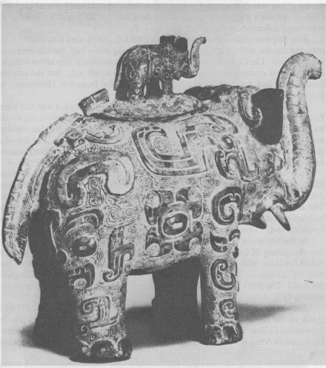

Figure 1- This picture (JPEG) was inserted by pulling down the Insert menu and choosing Picture.

EXAMPLE OF TABLE CAPTION:

Each table caption should appear centered above the table.

Table 1- This table was created by pulling down the table menu and choosing insert table  
To make the gridlines show up, Gridlines has to be checked (chosen))

|  |  |  |  |  |  |
| --- | --- | --- | --- | --- | --- |
| Aluminum | Copper | Zirconium | Zinc | Iron | Chromium |
| 1.00 | 2.00 | 3.00 | 4.00 | 5.00 | 6.00 |
| 7.00 | 8.00 | 9.00 | 12.00 | 2.00 | 3.00 |
| 4.00 | 4.00 | 6.00 | 7.00 | 8.00 | 9.00 |

Please do NOT put a “Header” or “Footer” or page numbers   
on the manuscript pages.

NADCA Transactions Guide to Template Style Pallet

And Template for Congress Papers

Abst Head Abstract heading (10 pt)

Affiliation Place and City/State or Province/Country of Employment (10 pt)

Author Primary and secondary author names (12 pt)

Body General body of technical paper (10 pt)

Copyright NADCA Copyright information (as shown in template below)

Conc Head Conclusion head (10 pt)

Equation All equations, as a graphic or text, in document (10 pt)

Caption Figure and Table captions (bold italics) (9 pt)

HeadING1 bold, all caps, on own line (10 pt)

HeadING2 normal, all caps, on own line (10 pt)

Heading3 Normal, Mixed Case, Underline, On Own Line (10 pt)

Heading4 Normal, Mixed Case, On Own Line (10 pt)

**Header Paper number identification at top of page (8 pt)**

Italic Any italicized text

1. Ord List Ordered List (numerical or alpha)

Refer Head Reference headING

Ref Reference text

Title The Paper Title (14 pt)

Underline Any underlined text

• Unord List Unordered List (bulleted)

Note: Greek letters or symbols used in the text must be applied using the Insert, Symbol menu with the Symbol font.