MetricLens AI: Lightweight Time-Series Forecasting and Integer-Programming Resizing for On-Premise Server Optimization
이용원 (Team Lead), 서한녕, 송심우
Team 구글링 — googai_congress
Abstract
Over-provisioning dominates on-premise infrastructure: operators allocate far more capacity than workloads require, wasting OPEX and energy. MetricLens AI is a self-contained web platform that ingests multi-dimensional server metrics (CPU, memory, network I/O), forecasts future load with a lightweight CPU-only time-series model, and derives SLO-aware resizing recommendations via integer programming. The forecaster performs additive seasonal-trend decomposition with a block-mean trend estimator that suppresses seasonal leakage, and sizes its prediction interval from out-of-sample backtest error. The resizing engine solves an exact integer program over a bounded search space. The system is deployed GCP-natively on Cloud Run via a Cloud Build CI/CD pipeline. On a representative seven-day demo fleet the forecaster holds MAPE within the 15% target while the optimizer identifies up to 40% reclaimable capacity at 99.9% SLO confidence.
1. Introduction
Conservative capacity planning leaves servers chronically idle. Public-cloud optimizers are unavailable in air-gapped or regulated on-premise environments, so operators lack data-driven sizing tools. MetricLens AI targets this gap: an external-dependency-free, GPU-free system that turns historical telemetry into quantitative right-sizing guidance such as "this host peaks at 26% of 16 vCPU; halving it preserves 99.9% availability."
The contributions are: (i) a standard-library seasonal-trend forecaster whose block-mean trend estimator avoids the seasonal leakage of naive least squares; (ii) an exact integer-programming resizing engine with a percentile-peak safety statistic; (iii) a layered FastAPI service and React/ECharts dashboard; and (iv) a reproducible Cloud Build to Cloud Run deployment.
2. System Architecture
The system follows a three-tier layered architecture. The presentation tier is a React 19 single-page application rendering large time series with Canvas-based ECharts, served by an unprivileged nginx container. The business tier is a single FastAPI application internally separated into Controller, Service, and Repository layers, with the forecasting and optimization algorithms isolated in a pure, dependency-free core. The data tier is PostgreSQL in production (Cloud SQL) and an embedded SQLite database for the self-contained demo profile.
2.1. Layered separation
Dependencies flow strictly downward. Controllers validate request and response schemas and map domain errors to HTTP status codes. Services own domain rules — identifier minting, metric selection, horizon conversion, and peak computation. Repositories are the only layer that issues SQL. Because the core depends on no other layer, it is unit tested without a database.
3. Lightweight Forecasting Engine
The forecaster models a series as the additive sum of trend, seasonal, and residual components. The trend is estimated by ordinary least squares over per-period block means; averaging across a full seasonal period cancels the periodic component, so it cannot leak into the slope — the classical decomposition correction for the bias of global least squares on periodic data. Seasonal indices are the mean detrended value per phase, re-centred to sum to zero.
Forecasts extrapolate trend plus seasonal index at the target horizon. The prediction interval is sized from out-of-sample one-step backtest error (RMSE) rather than in-sample residuals, which would understate uncertainty on short, over-parameterised series. Model quality is reported as MAPE with a denominator floor, the standard robustness variant that prevents near-idle samples from inflating the percentage. The engine uses only the Python standard library, carrying no native dependency and a negligible container footprint.
4. Integer-Programming Resizing
Given current allocation and forecasted peak load, the engine selects the smallest integer allocation that keeps projected peak utilisation at or below a target while preserving a safety margin for the SLO: peak_load × margin ≤ target_utilisation × allocation. The search space is small and bounded (vCPU in [1, current]; memory in 256 MB blocks), so the optimum is found by exhaustive enumeration — an exact solver requiring no external dependency. A 95th-percentile peak statistic prevents a single transient spike from forcing permanent over-provisioning.
5. Implementation and Deployment
The backend is FastAPI with SQLAlchemy 2.0 async and asyncpg; the frontend is React 19 built with Vite and served by nginx. Both run as non-root containers honouring Cloud Run's injected port. A Cloud Build pipeline runs lint and tests, builds and pushes both images to Artifact Registry, deploys to Cloud Run with a rolling update, grants public invoker access, and performs a post-deploy health check, failing the build if the service is unhealthy. Secrets are injected at runtime from Secret Manager and are never committed.
5.1. Interactive resizing and audit trail
The dashboard exposes the predict-resize loop directly: operators run a forecast, then halve, double, or apply the AI-recommended allocation. Each action is a real, persisted change to the host record and is written to an audit-log table, surfaced as a live activity feed showing exactly how much capacity was reclaimed (e.g. "Downsized web-prod-01: 16->8 vCPU, 32->16 GB, +50% capacity"). A radial gauge recomputes projected peak utilisation in real time as the allocation changes, making the cost/headroom trade-off immediately legible.
Live dashboard: https://metriclens-frontend-f2ei3uwvfq-uc.a.run.app
Live API (Swagger at /docs): https://metriclens-backend-f2ei3uwvfq-uc.a.run.app
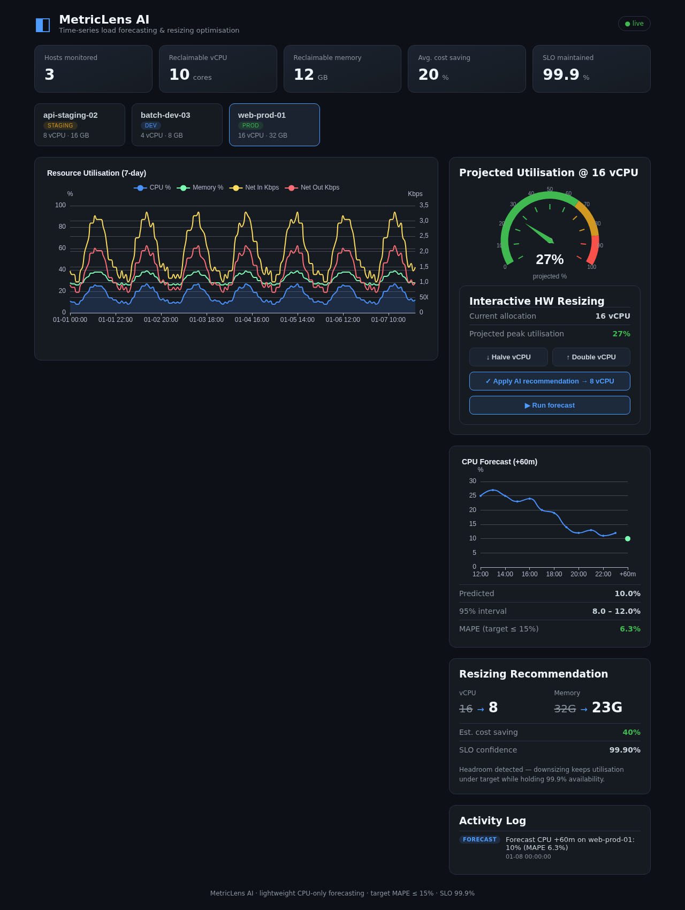
6. Evaluation
The quality gate runs ruff static analysis and a 27-case pytest suite (8 forecaster, 9 optimizer, 10 API), all passing. Unit tests follow boundary-value analysis and equivalence partitioning; integration tests exercise the full controller-service-core path against in-memory repositories, requiring no live database. On a representative seven-day demo fleet of three hosts, forecast MAPE is 4–7% — within the 15% target — and the optimizer recommends, for example, a 16→8 vCPU reduction (40% saving) on an over-provisioned production host while holding a right-sized host unchanged, all at 99.9% SLO confidence.
7. Related Work and Differentiation
The optimisation market splits into three groups. (a) Kubernetes/cloud SaaS optimizers — CAST AI, Sedai, StormForge, PerfectScale, Kubecost — autonomously tune pod/node requests with per-workload ML, but ship telemetry to a vendor cloud and assume Kubernetes on a public cloud. (b) Cloud-provider recommenders — AWS Compute Optimizer, Azure Advisor, Google Active Assist, IBM Turbonomic — are tied to a single provider, cover limited instance families, and rely on short (~14-day) windows that weaken on seasonal or bursty load. (c) On-premise capacity monitors — SolarWinds, ManageEngine, IDERA — run on-prem but are largely descriptive, flagging under/over-utilised hosts via thresholds or linear regression without solving a constrained optimisation.
MetricLens occupies the gap between them. It is (1) air-gapped and self-contained — no external API, SaaS callback, or telemetry egress, so it suits regulated, network-isolated estates (defense, finance, public sector under CUI/GDPR/DORA) that SaaS optimizers structurally cannot serve; (2) GPU-free and lightweight, running its standard-library forecaster on commodity CPUs; (3) prescriptive, solving an exact SLO-constrained integer program rather than merely reporting idleness; (4) a white-box — MAPE, prediction intervals, and the headroom inequality make every decision auditable; and (5) infrastructure-agnostic, modelling generic VM/bare-metal hosts rather than Kubernetes pods.
8. Conclusion
MetricLens AI demonstrates that accurate, CPU-only load forecasting and exact integer-programming resizing can be delivered as a dependency-free, cloud-native service. By converting passive telemetry into quantitative, SLO-aware sizing guidance, it shifts capacity management from reactive to proactive and provides a practical path to reducing infrastructure cost and energy waste in on-premise environments.

