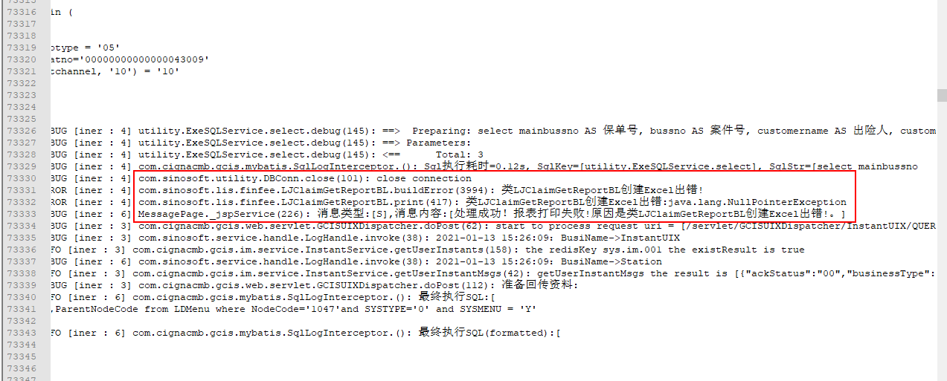

select mainbussno AS 保单号,

bussno AS 案件号,

customername AS 出险人,

customernamemain AS 主被保人,

rdseq AS 原始单据号,

accname AS 领款人,

bankname AS 银行名称,

bankaccno AS 账号,

province AS 开户行所在省,

city AS 开户所在市,

shoulddate AS 应付日期,

money AS 应付金额,

headbankcode AS 银行编码,

accdate AS 出险日期

from (SELECT a.mainbussno AS mainbussno,

a.bussno AS bussno,

b.customername AS customername,

nvl((SELECT k.insuredname

FROM lcinsured i, llclaimpolicy j, lcinsured k

WHERE i.insuredno = j.customerno

and i.contno = j.contno

and j.clmno = b.rgtno

and i.maincustomerno = k.insuredno

and i.contno = k.contno

and i.relationtomain <> '00'

group by k.insuredname),

b.customername) AS customernamemain,

(SELECT D.RDSEQ

FROM PAYMONEYINFO D

WHERE D.Sourcenotecode = a.payno

AND D.transstate IS NULL

AND D.dtcode IS NULL

AND D.ATS_ReturnState = 1

AND D.RowVersion = 1) AS rdseq,

c.accname AS accname,

(SELECT bankname FROM ldbank WHERE bankcode = a.custbankcode) AS bankname,

c.bankaccno AS bankaccno,

(SELECT provincename

FROM ldarea

WHERE provincecode = a.custbankprovince

AND areatype = '0') AS province,

(SELECT cityname

FROM ldarea

WHERE citycode = a.custbankcity

AND areatype = '1') AS city,

a.shoulddate AS shoulddate,

a.money AS money,

d.headbankcode headbankcode,

(select max(accdate)

from llcase

where casestate = '0'

and rgtno = c.otherno) AS accdate

FROM ljgetmanualsub a, llregister b, ljsget c, ldbank d

WHERE a.paycode = c.getnoticeno

AND b.customerno = c.insuredno

AND a.bussno = b.rgtno

and d.bankcode = a.custbankcode

AND a.batstate in ('1', '6')

AND c.state in ('5', '6')

AND c.othernotype = '05'

AND a.applybatno = '00000000000000043009'

and nvl(c.getchannel, '10') = '10'

union

SELECT a.mainbussno AS mainbussno,

a.bussno AS bussno,

b.customername AS customername,

nvl((SELECT k.insuredname

FROM lcinsured i, llclaimpolicy j, lcinsured k

WHERE i.insuredno = j.customerno

and i.contno = j.contno

and j.clmno = b.rgtno

and i.maincustomerno = k.insuredno

and i.contno = k.contno

and i.relationtomain <> '00'

group by k.insuredname),

b.customername) AS customernamemain,

(SELECT D.RDSEQ

FROM PAYMONEYINFO D

WHERE D.Sourcenotecode = a.payno

AND D.transstate IS NULL

AND D.dtcode IS NULL

AND D.ATS_ReturnState = 1

AND D.RowVersion = 1) AS rdseq,

c.accname AS accname,

(SELECT bankname FROM ldbank WHERE bankcode = a.custbankcode) AS bankname,

c.bankaccno AS bankaccno,

(SELECT provincename

FROM ldarea

WHERE provincecode = a.custbankprovince

AND areatype = '0') AS province,

(SELECT cityname

FROM ldarea

WHERE citycode = a.custbankcity

AND areatype = '1') AS city,

a.shoulddate AS shoulddate,

a.money AS money,

d.headbankcode headbankcode,

(select max(accdate)

from llcase

where casestate = '0'

and rgtno = c.otherno) AS accdate

FROM ljgetmanualsub a, cgis_claim_llregister b, ljsget c, ldbank d

WHERE a.paycode = c.getnoticeno

AND b.customerno = c.insuredno

AND a.bussno = b.rgtno

and d.bankcode = a.custbankcode

and b.prodtype <> '04'

AND a.batstate in ('1', '6')

AND c.state in ('5', '6')

AND c.othernotype = '05'

AND a.applybatno = '00000000000000043009'

and nvl(c.getchannel, '10') = '10')

order by money