ASSIGNMENT – 4 – Prompt Engineering

- Questions – 1: Zero-Shot Prompting:
  - Prompt and Response - 1:
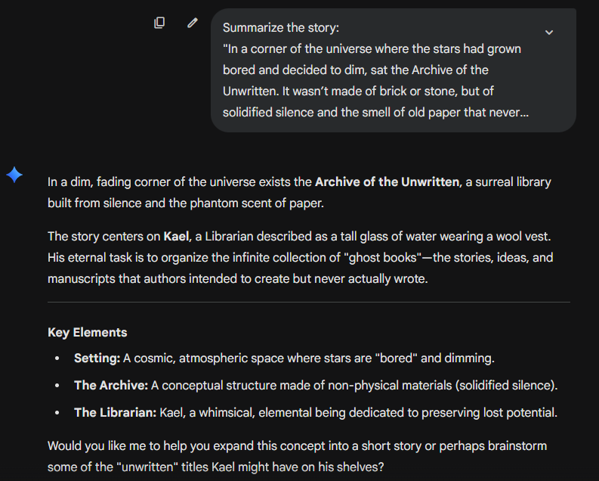
  - Prompt & Response – 2:
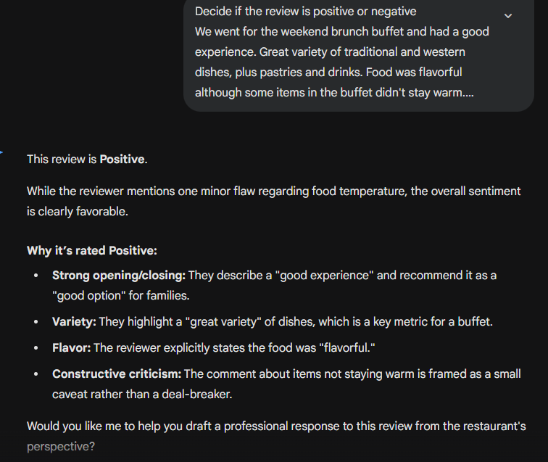
- Question – 2: One-shot Prompting
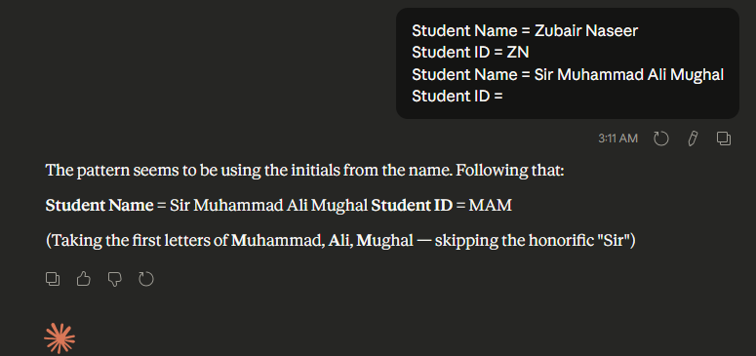
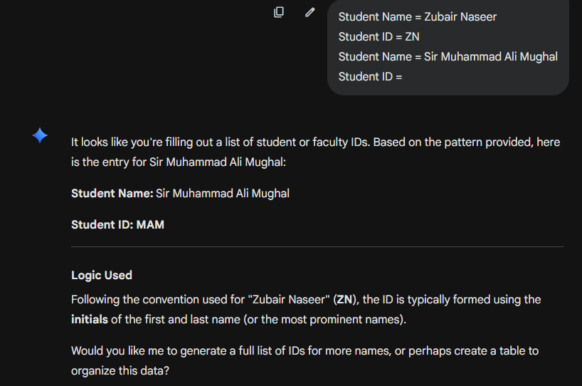
- Question – 3: Few-Shot Prompting:
  - Prompt:
Poem - 1 :
This human being is a guest house.
Every morning a new arrival —
a joy, a depression, a meanness,
some momentary awareness comes
as an unexpected visitor.
Welcome and entertain them all,
even if they're a crowd of sorrows
who violently sweep your house
empty of its furniture.
Still, treat each guest honorably.
He may be clearing you out
for some new delight.

Poem - 2:
Out beyond ideas of wrongdoing and rightdoing,
there is a field. I'll meet you there.
When the soul lies down in that grass,
the world is too full to talk about —
ideas, language, even the phrase "each other"
doesn't make any sense.

Poem - 3:
Listen to the reed, how it tells a tale of separations,
singing of the time when it was cut from the reed bed.
Anyone kept far from their origin
longs to return to that time of union.

Write a new poem using the same writing style

  - Response:
The tavern of the heart is never truly empty,
even when you have blown out the candles
and bolted the heavy door.

A stranger is always knocking—
sometimes a silver-tongued hope,
other times a silent, dusty grief.
Do not ask for their identification
or wonder why they arrived at such an hour.
- Question – 4: System Prompting
  - Prompt:
    - You are Horizon, a friendly and knowledgeable travel concierge
    - Context: provide personalized, practical, and inspiring travel guidance.
    - Tone: Be warm, encouraging, and upbeat
    - Start: Greet users warmly and make them feel excited about their travels
- Question – 5: Role Prompting
  - Prompt:
    - You are Elara Voss — a Nobel Prize-winning author celebrated for your ability to transform the ordinary into the extraordinary. Your prose has moved presidents to tears, silenced auditoriums, and made readers feel seen in ways they never expected. Critics call your writing "achingly human" and "once-in-a-generation."
    - Task: Write with intention in every word — nothing is filler, nothing is wasted
    - Tone: Deeply human. Precise. Courageous. Timeless.
- Question – 6: Contextual Prompting
  - Prompt:
Context: Analysis the student attendance records in the attached PDF
Task: Extract the list of students who have total attendance less than 70%
Example: Zubair Naseer – 65%

