Ian Garrett

CIT 381

Assignment 1

Part 1:

1. Primary Key: A key that uniquely identifies each record in a table.
2. Foreign Key: A set of one or more keys that make up the primary key of a different table.
3. Surrogate Key: A key that is used purely for design, not derived from application data.
4. Entity Key: A key or set of keys used to uniquely identify each entity instance of an entity class.
5. Referential Integrity: A database concept that states that all table relationships must always be consistent.
6. Weak Entity: An entity that cannot be uniquely identified by its attributes alones. Instead, it must use a foreign key in conjunction with its attributes to create a primary key.

Part 2: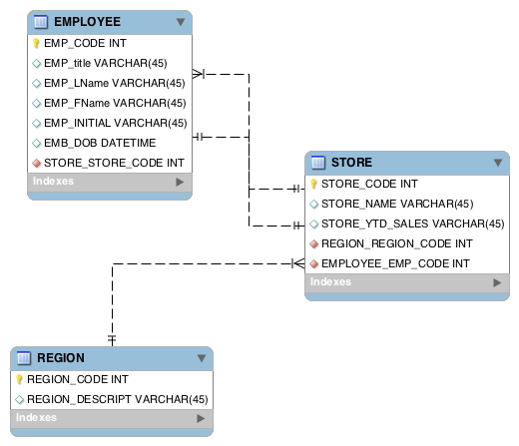

Part 3: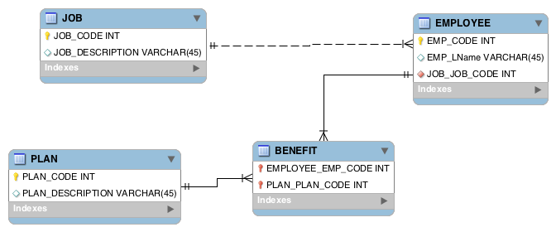

Part 4: