Ian Garrett

CIT 381

Assignment #6

1. SELECT title FROM movie m WHERE m.movieId IN

(SELECT v.movieId FROM rental r JOIN video v ON r.videoId=v.videoId

UNION ALL SELECT v. movieId FROM reservation r JOIN video v ON r.videoId=v.videoId);



1. SELECT title, COUNT(p.videoId) AS "# of times rented"

FROM previousrental p JOIN video v ON p.videoId=v.videoId

JOIN movie m ON v.movieId=m.movieId GROUP BY p.videoId

HAVING COUNT(p.videoId)>=2;



1. SELECT t.storeId, COUNT(DISTINCT(w.ssn)) AS "# of salaried employees", IFNULL(SUM(s.weeklyPayRate),0) AS "total weekly pay rate"

FROM salariedemployee s JOIN employee e USING(ssn)

JOIN worksin w USING(ssn)

RIGHT JOIN store t USING(storeId)

GROUP BY t.storeId;

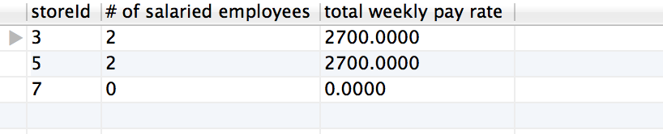

1. SELECT State, COUNT(DISTINCT(m.movieId)) AS "# of movies rented in state" FROM store s JOIN video v ON s.storeId=v.storeId

JOIN previousrental p ON p.videoId=v.videoId

JOIN movie m ON m.movieId = v.movieId

GROUP BY State;

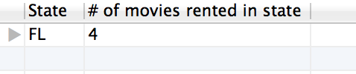

1. SELECT s.supplierId, s.street, GROUP_CONCAT(m.title) AS "movies supplied"

FROM supplier s JOIN purchaseorder p ON s.supplierId=p.supplierId

JOIN purchaseorderdetail d ON d.purchaseOrderId=p.purchaseOrderId

JOIN movie m ON m.movieId=d.movieId

GROUP BY s.supplierId;

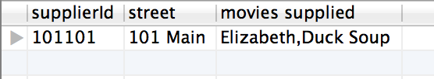

1. SELECT DISTINCT(m.title), AVG(DATEDIFF(p.dateReturned,p.dateRented)) AS "average rental duration (days)"

FROM movie m JOIN video v ON v.movieId=m.movieId

JOIN previousrental p ON p.videoId=v.videoId

GROUP BY m.title;



1. SELECT t.storeId, COUNT(DISTINCT(w.ssn)) AS "# of salaried employees", IFNULL(SUM(s.weeklyPayRate),0) AS "total weekly pay rate"

FROM salariedemployee s JOIN employee e USING(ssn)

JOIN worksin w USING(ssn)

RIGHT JOIN store t USING(storeId)

GROUP BY t.storeId;

