 | Document Number | EDCS-16577059
 | Based on Template | EDCS-228145 Rev 11
 | Created By | Ian Chang/Lenlen Tsai/Ping Doong

Fugazi
Diagnostics Functional Specification
This document describes the diagnostic approach and test methodology of
ASR1K Fugazi platforms. Fugazi XFT is ASR1K next generation fixed 20G services throughput Edge Routing platform.
Fugazi is an ASR1K product that uses software-based forwarding to leverage low-cost hardware components and serve the low-end of the ASR portfolio

Reviewers
Department | Name/Title
Hardware Manager/engineers | Kevin Ye/Niels Jensen, Jeffery Loo
Diagnostic Manager/Engineers | Kwok-Leung Chan/Ping Doong, Ian Chang, LenLen Tsai
Software Manager/Engineers | Talal Jaafar/Daniel Cary
NPI Engineers | Liu Yong
EDVT Engineers | Joseph V. Dinh
Manufacturing Engineers
The departments and/or individuals listed above should be notified in advance and given a sufficient time period to review this document. The Project Team determines requirements for approval according to the scope of the project.

Modification History
Revision | Date | Originator | Comments
0.1 | 2018/12/03 | Ian / Len Len | Initial Draft
0.2 | 2019/04/11 | Ping Doong | Update program PHY firmware/MAC address according to Diag release v0.0.2
0.3 | 2019/05/01 | Lenlen/Ping | Update DFS according to Diag release v0.0.3.
0.4 | 2019/05/15 | Ping | Update DFS according to Diag release v0.0.4.
0.5 | 2019/06/19 | Ping | Update DFS according to Diag release v0.0.5.
0.6 | 2019/08/21 | Ping | Update DFS according to Diag release v0.0.6.
0.7 | 2019/12/11 | Ping | Update DFS according to Diag release v0.0.7.
0.8 | 2020/03/20 | Ping | Update DFS according to Diag release v0.0.9.
0.9 | 2020/06/18 | Ping | Update DFS according to Diag release v0.0.11.
1.0 | 2020/07/21 | Ping | Add LASI section.
2.0 | 2020/09/03 | Ping | Update DFS according to Diag release V1.0.0 and feeback from PRRQ comments.

Table of Contents
1 Overview 6
1.1 SKUs 6
2 Hardware Overview 6
2.1 Fugazi Hardware Block Diagram 7
2.2 Fugazi PHY Address Mapping 7
2.3 Data Flow 8
2.4 Major Component Descriptions 8
2.5 Configurations 9
2.5.1 Fugazi Bezel Side 9
2.5.2 Fugazi Business (I/O Panel) Side 9
3 Diagnostics Design Considerations/Requirements 10
3.1 Hardware Bringup 10
3.2 EDVT 10
3.3 Manufacturing 10
3.4 Test Coverage and Failure Analysis 11
3.5 Field Support 13
4 Diagnostics Design Assumptions 13
5 Items Not Covered By Diagnostics 13
6 Diagnostics Overview 14
6.1 Initialization Sequence 14
7 Tests and Commands 14
7.1 Component Level Tests and Data Path Tests 14
7.1.1 Host CPU Subsystem 15
7.2 Utilities 41
7.2.1 PCIE read Utility 42
7.2.2 System Information 42
7.2.3 Memory Utility 42
7.2.4 FPGA Utility 42
7.2.5 I2C Utility 43
7.2.6 Margin Utility 44
7.2.7 Cookie Utility 45
7.2.8 USB Utility 45
7.2.9 RTC Utility 48
7.2.10 FAN Utility 48
7.2.11 Motherboard LED Utility 50
7.2.12 SyncE PLL Utility 51
7.2.13 BCM57412 Firmware Upgrade 52
7.2.14 BCM57412 MAC Utility 52
7.2.15 BCM54194 Phy Utility 52
7.2.16 BCM82757 Phy Utility 55
7.2.17 LASI Utility 56
7.2.18 Side-Band Utility 56
7.2.19 ACT2 Utility 56
7.3 System Level Tests 57
8 End User Interface 58
9 Configuration and Restrictions 59
10 Regression Testing and Release 59
11 Requirements Traceability Considerations 60
12 References 60
13 Glossary 60
14 Appendix A – Fugazi Diagnostics Images 60
14.1 Checking out the codes 61
14.2 Building the Fugazi Diagnostics Images 61
14.3 Loading Fugazi Diagnostics Images 62
14.3.1 Loading Fugazi Image from TFTP 62
14.3.2 Loading Fugazi Image from USB 63
14.4 Running Fugazi Diagnostics Image 63
14.4.1 Fugazi Diagnostistics Help command 63
14.4.2 Lunch Fugazi Diagnostistics 63
14.4.3 Lunch Fugazi Diagnostistic without PCIe Scan Test 65
14.5 Vendor Libraries 65
14.6 The /Fugazi-diag directory in the root file system 65
15 Apendix B, discussion of diag x86 linux kernel 65
16 Apendix E, BCM57412 CDiag Tool 68
16.1 Location of BCM57412 software kit 68
16.2 Build CDiag tool for Fugazi project 68
16.3 Launch CDiag tool for Fugazi 69
16.4 Build bnxtmt tool for Fugazi project 69
16.5 Lunch bnxtmt tool for Fugazi project 70
17 Apendix F, Program Various Firmware 71
17.1 Upgrade FPGA (EP4CGX5050) Image 72
17.2 Program BCM57412 MAC and I211 MAC Address 74
17.2.1 Program I211 MAC Address Only 76
17.2.2 Program BCM57412 MAC Address Only 77
17.3 Program I211 Firmware 78
17.4 Program BCM57412 MAC Firmware 79
17.4.1 Program From Diag Utility 79
17.4.2 Program From Diag kernel 81
17.5 Program BCM57412 MAC Configure data 81
17.5.1 Program From Diag Utility 82
17.5.2 Program From Diag kernel 83
17.6 BCM82757 PHY firmware 83
17.7 Upgrade SyncE firmware 84
17.8 Upgrade MCU firmware 86
17.9 How to Format eMMC 87
17.10 Program Aikido FPGA 88
17.11 ROMMON Upgrade Using IOS 91
17.11.1 Copy ROM upgrade package to USB or bootflash 92
17.11.2 Upgrading with ROM package in USB or bootflash 92
18 Apendix G, Margin Voltage and Clock Frequency 95
18.1 How to Margin Voltage 95
18.1.1 Margin Voltage From Diag Utility 95
18.1.2 Margin Voltage From Rommon Promt 96
18.2 How to Margin Frequency 96
Checkout/Build/Load/Run Personnel 98
19 Attachments 98
19.1 Review Action Items 98

List of Tables
Table 1. Fugazi High level Hardware Feature List 6
Table 1 Components coveraged on each subsystem. 13
Table 2 Memory Test Pattern 17
Table 5 Reviewers list 98

List of Figures

Figure 1 Fugazi Hardware Block Diagram 7
Figure 1. Fugazi Bezel Side View. (Not to scale.) 9
Figure 2. Fugazi Business Side View. (Not to scale.) 10
Figure 2 CPU Test Path Block Diagram 16
Figure 3 Main Memory Test Path Block Diagram 18
Figure 4 IO FPGA Test Path Block Diagram 19
Figure 5 USB Test Path Block Diagram 20
Figure 6 eMMC Test Path Block Diagram 21
Figure 7 eUSB Test Path Block Diagram 22
Figure 8 I2C Bus Scan Test Path Block Diagram 23
Figure 9 PCIE Lane Scan Test Path Block Diagram 24
Figure 10 NVME Test Path Block Diagram 25
Figure 11 GE PHY I211 Test Path Block Diagram 26
Figure 12 BCM57412 Test Path Block Diagram 28
Figure 13 BCM54194 Test Path Block Diagram 30
Figure 14 BCM82757 Test Path Block Diagram 32
Figure 15 Rommon Flash Test Path Block Diagram 34
Figure 16 SyncE PLL Test Path Block Diagram 35
Figure 17 USB Consol Test Path Block Diagram 46
Figure 18 FAN Test Path Block Diagram 50
Figure 19 LED Test Path Block Diagram 51

Overview
Fugazi is a low-end ASR platform with ASR feature set and licensing model, with the key difference compared to previous ASR platforms is that theres is no Network Processor NPU on the board, it uses a multi-core SoC (System on a Chip) architecture with the Control Plane and Services running on dedicated cores of the SoC.
Project ID: 8P0V36
Product ID: C8500L-8S4X

SKUs
No SKUs as current status.

Hardware Overview
The Fugazi program is a low-end ASR platform that leverages the software-based forwarding technology targeting 20Gbps performance on low-cost System on a Chip (SoC) CPUs and fills a space between the high-end ISR products and the ASR hardware-based forwarding platforms.

High-level designs features are shown in Error: Reference source not found. The table is copied from the Error: Reference source not found Refer to the SFS for any discrepancies.

Table 1. Fugazi High level Hardware Feature List

Feature
Form Factor | 1RU
Data Plane CPU/Memory | Single SoC with shared CPU and memory between control and data plane
System CPU | Intel Skylake-D 2.5G+ 12C
System Memory Default | 2xDIMM slots, 1x16GB DDR4 default
System Memory Upgrade Options | 32GB and 64GB
Boot Flash | 16GB soldered down.
SSD | M.2 (600GB NVME, 2TB NVME, 16GB USB, or 32GB USB)
Front Panel Ports | 4x10G SFP+  8x1GE SFP
Management GE Port | 1 x RJ45 10/100/1000Mbps
Console Port | 1xRJ45 and  1xUSB micro type-B
Aux Port | Support via micro-USB (Star dongle) without modem control signals
USB Port | 1xUSB 3.0 Type-A (1100mA)  1xUSB 3.0 Type-C (1500mA)
Fans | Internal
NEBS | Yes
Removable Main PSU  (Redundant Mode) | 2x 500W AC  2x 437W DC  2x 400W HVDC/AC

Fugazi Hardware Block Diagram

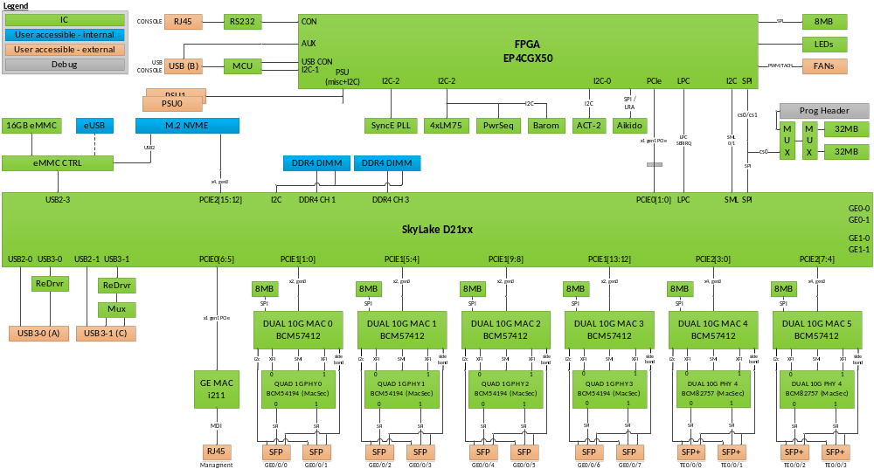

Figure 1 Fugazi Hardware Block Diagram

Fugazi PHY Address Mapping

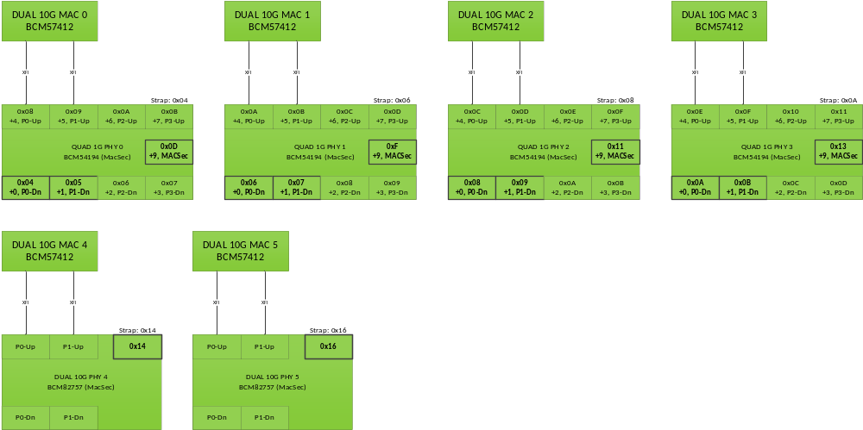

Data Flow
Fugazi hardware integrates control plane to Intel SkyLake D21xx CPU. The CPU needs to process system software.

Major Component Descriptions
Fugazi platform contains the following major hardware components:
- 1 PID with 12 Core 2.6G Skylake-D Intel SOC
- Secure boot and FPGA development similar to ISR Platforms
- 1RU Chassis with Dual PSU
- AC and DC PSUs
- Storage slot to support M.2 NVME or M.2 USB custom modules.
- Onboard eMMC storage for boot images.
- Broadcom BCM57412 MAC Dual-Port 10G Ethernet Controller for BCM82757 PHY 4x10GE interfaces
- Broadcom BCM57412 MAC Dual-Port 1G Ethernet Controller for BCM54194 PHY 8x1GE Interfaces.
- Broadcom BCM54194 Quad SGMII/QSGMII Copper/Fiber 1G Ethernet Transciver
- Broadcom BCM82757 Dual-channel SFI-XFI 10G PHY
- Intel Quad GE PHY I211
- DASH FPGA
  - PCIe end point
  - NIOS core
  - I2C cores
  - UART cores
- Aikido to achieve Trust 2.0

Refer to Fugazi Hardware Fucntional Specifications (EDCS-15612474) for more detail information of the Fugazi hardware design.

Configurations

Fugazi Bezel Side
The side where the fans are located is referred to as the bezel side – even though there is no separate bezel present on this box. The bezel side has the 4fans (numbered left to right) and access to 2 PSU power supply bays can be found. The On/Off switch is used to turn on and gracefully turn off the system; no separate on/off switch exists on the power supplies. One power supply can be removed while the system is powered by another power supply; however, the AC cable must be removed before power supply removal latch can be disengaged.

The bezel side has the following interfaces:
- 2 PSU Slots
- System Power On/Off switch
- Fan exhaust

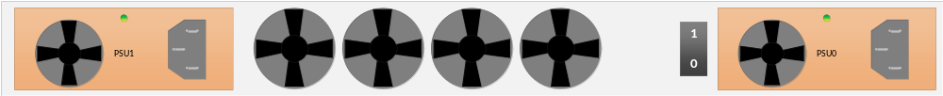
Figure 2. Fugazi Bezel Side View. (Not to scale.)

Fugazi Business (I/O Panel) Side
The business side has access to Ethernet ports. The following interfaces are available:
- 1 USB 3 Type A host ports
- 1 USB 3 Type C host ports
- 1 USB micro-Type B Console port
- 1 RJ45 Console port
- 1 10/100/1000 RJ-45 Management Ethernet port
- 8 1G SFP Ethernet ports (labeled “GE0/0/0-GE0/0/7”)
- 4 1G/10G SFP/SFP+ Ethernet ports (labeled “TE0/1/0-TE0/1/3”)
- M.2 Flexible NVME / USB slot
- LEDs for Ethernet and console status
- Status/Alarm LEDS and backlit Cisco Logo

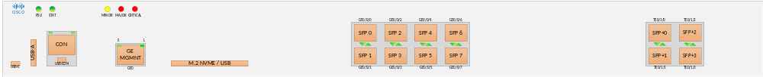
Figure 3. Fugazi Business Side View. (Not to scale.)

Diagnostics Design Considerations/Requirements
Fugazi diagnostics supports engineering bring-up, EDVT, and manufacturing. The current plan is to have one package of image(s) to support all SKU of the platforms and meet all the requirements. Not like others ASR1K platform, which diagnostic software is built from IDS architure, the Fugazi diagnostics software is built on the Linux stock kernel, version 4.14.86, from kernel.org, and it relies on the BIOS and ROMMON to boot up the HW and setup the environment for the Linux kernel to run properly. The kernel used by the diagnostics will include the minimal set of device drivers to avoid touching too much HW. If the kernel does not boot up, vender standalone tests and kernel debugging technique will be required to bringup the HW.

Hardware Bringup
The deliverable requirement from hardware team is a diagnostics software package that can facilitate hardware bring up and effectively validate the hardware design. Hence, the primary goal for diagnostics during hardware bring-up is to provide test code which can sufficiently verify hardware functionality while also providing the ability to detect and isolate any hardware design problem. Diagnostics team offer a Linux-based diagnostics image (a.k.a diaglinux) to do all of the motherboard bring up. Utility routines, which are not part of the normal diagnostic test suite, will be included to aid debugging efforts at different phases of hardware bring-up process.

EDVT
The primary requirement for EDVT is a diagnostics software package that can verify that the hardware still functions correctly under stressed conditions such as combinations of high, low, normal margine of temperature, voltage, and frequency. Test coverage, not the test time, is their utmost concern. Besides providing good hardware test coverage, diagnostics image will have margin utility to aid EDVT testing.

Manufacturing
The requirement for manufacturing is a diagnostics software package that can quickly and reliably verify the correctness of the hardware assembly and functionality of the complete system. Minimal test time with acceptable coverage is their primary goal. See section 10.2, Error: Reference source not found, of this document for specific manufacturing requirements and whether they are addressed by this diagnostic test suite.

Test Coverage and Failure Analysis
The Fugazi diagnostic test suite is Intel system, since there is no GE switch. The following table lists the tests that Fugazi diagnostics team will implement for each component in Intel system and whether they test the component explicitly, implicitly, or if the component can only be verified manually. The table also indicates if the test is part of the default diagnostic test suite. Details of the individual tests are provided in section 6.
There will be additional tests and utilities included in the diagnostics which do not get executed under normal testing conditions, but are provided for failure isolation, debugging, and HW support purposes. While providing some ndebugging capabilities, the main purpose of the diagnostic software is to indicate which component has failed. It is the responsibility of hardware engineers to further analyze the failure and find out the root cause, most likely using other means and/or equipments in addition to this diagnostic software.

Subsystem | Diagnostics Tests and Utilities | Interface | Component | Coverage | Default Test | Comment
SkyLake  subsystem | Intel SkyLake CPU
SkyLake  subsystem | CPU Internal Test | X | CPU | Implicitly | Yes | Linux kernel detects and log errors
SkyLake  subsystem | CPU Cache Test | X | Internal cache | Implicitly | Yes | Memory test with cache on
SkyLake  subsystem | CPU Multi-core Test | X | CPU cores | Explicitly | Yes | CPU multi core test
SkyLake  subsystem | Main Memory Test | DDR4 | CPU←→DDR4 RAM | Explicitly | Yes
SkyLake  subsystem | ECC Error Detection | DDR4 | CPU←→DDR4 RAM | Implicitly | Yes | Kernel detect and report
SkyLake  subsystem | DIMM cookie access | I2C (pin) | CPU←→DIMM | Explicitly | Yes | I2c scan test
SkyLake  subsystem | I211 PHY Test | PCIE | CPU←→Intel I211 PHY | Implicitly | Yes | Used in boot from network
SkyLake  subsystem | USB Type A Test | USB2.0  USB3.0 | CPU(USB2.0 CTRL)←→USB  CPU(USB3.0 CTRL)←→ReDrvr←→Mux←→USB | Explicitly | Yes | Kernel driver  plug-in module
SkyLake  subsystem | USB Type C Test | USB2.0  USB3.0 | CPU(USB2.0 CTRL)←→USB  CPU(USB3.0 CTRL)←→ReDrvr←→MUX←→USB | Explicitly | Yes | plug-in module
SkyLake  subsystem | eMMC Test | USB | CPU←→eMMCCTRL←→eMMC | Explicitly | Yes
SkyLake  subsystem | I2C Bus Scan Test | I2C | CPU←→SPD(DDR4) | Explicitly | Yes
SkyLake  subsystem | M.2 NVME Test | USB2  PCIE(NVME) | CPU←→MUX←→M.2 NVME  CPU←→eMMC CTRL←→M.2 NVME  CPU←→M.2 NVME | Explicitly | Yes | plug-in module
SkyLake  subsystem | Rommon Flash Test | SPI | CPU←→MUX←→SPI FLASH | Explicitly | Yes
SkyLake  subsystem | PCIE Scan Test | PCIE | CPU←→FPGA/I211 PHY/BCM57412 | Explicitly | Yes
 | FPGA EP4CGX50
FPGA | IO FPGA Test(EP4GX50) | PCIE  LPC | CPU←→IO FPGA | Explicitly | Yes
FPGA | Console Port | CON | CPU←→FPGA←→RS232←→RJ45 | Implicitly | Yes | Cover by console log(RJ45 console)
FPGA | Aikido FPGA Test | PCIE  SPI | CPU←→IO FPGA←→Aikido FPGA | Explicitly | Yes
FPGA | USB Console | AUX  USB CON | CPU←→FPGA←→USB  CPU←→FPGA←→MCU←→USB | Manually | Yes | Cover by console log(USB console)
FPGA | I2C Bus Scan Test | PCIe/I2C | CPU←→FPGA←→SyncE/LM75/PwrSeq/Barom/MCU/PSU/USB Redriver/SMLink | Explicitly | Yes
 | MAC/PHY/SFP+/SFP
Broadcom MAC/PHY  Subsystem | BCM57412 Test | PCIE  I2C | CPU←→BCM57412  BCM57412←→SFP | Explicitly | Yes
Broadcom MAC/PHY  Subsystem | BCM54194 1G PHYTest | PCIE  SGMII  MDIO | CPU←→BCM57412←→BCM54194←→SFP | Explicitly | Yes
Broadcom MAC/PHY  Subsystem | BCM82757 10G PHY Test | PCIE  XFI  MDIO | CPU←→BCM57412←→BCM82757←→SFP+ | Explicitly | Yes
Broadcom MAC/PHY  Subsystem | BCM54194 1G PHY side-band Test | Side-band | BCM54194←→SFP  BCM57412←→SFP | Explicitly | Yes | Tx_disable/sfp-abs/tx_fault/rx_los
Broadcom MAC/PHY  Subsystem | BCM82757 10G PHY side-band Test | Side-band | BCM82757←→SFP+  BCM57412←→SFP+ | Explicitly | Yes | Tx_disable/sfp-abs/tx_fault/rx_los
Broadcom MAC/PHY  Subsystem | LASI Test | LASI | BCM82757/BCM54194→BCM57412 | Explicitly | Yes
Broadcom MAC/PHY  Subsystem | SyncE Test | I2C  REC_CLK | CPU←→FPGA←→ SyncE←→  BCM82757/BCM54194 | Explicitly | Yes
System Utilities | Utilities
System Utilities | Memory Utility | DDR | DDR4 DRAM | Manually | No
System Utilities | USB Utility | USB | CPU←→USB | Manually | No
System Utilities | FPGA Utility | PCIE | CPU←→FPGA | Manually | No
System Utilities | Aikido Cookie Utility | SPI | CPU←→IO FPGA←→Aikido FPGA | Manually | No
System Utilities | PCIe Utility | PCIE | PCIe rd/wr | Manually | No
System Utilities | Temperature sensor: Utility | PCIE  I2C | CPU←→FPGA←→LM75 | Manually | No
System Utilities | Barometer Utility | PCIE  I2C | CPU←→FPGA←→Barom | Manually | No
System Utilities | Pwrseq Utility | PCIE  I2C | CPU←→FPGA←→Pwrseq | Manually | No
System Utilities | Aikido (SUDI, WDC) program | PCIE  SPI | CPU←→FPGA←→ Aikido FPGA | Manually | No
System Utilities | PSU Utility | PCIE  I2C | CPU←→FPGA←→PSU | Manually | No
System Utilities | Margin Utility | PCIE  I2C | CPU←→FPGA←→PCIe CLK  CPU←→FPGA←→MCU | Manually | No
System Utilities | FAN Utility | PCIE  PWM | CPU←→FPGA←→FANs | Manually | No
System Utilities | LEDs Utility | PCIE  GPIO | CPU←→FPGA←→LEDs | Manually | No
System Utilities | RTC Utility | RTC | RTC | Manually | No | BST Test
System Utilities | EEPROM - SPD Utility | I2C | DDR4 | Manually | No
System Utilities | SFP Cookie Utility | PCIE  I2C (SFP) | CPU←→BCM57412←→SFP  CPU←→BCM57412←→SFP+ | Manually | No
System Utilities | FPGA Upgrade Utility | SPI | CPU←→FPGA←→8MB SPI Flash | Manually | No
System Utilities | BCM57412 Firmware Upgrade Utility | PCIE  SPI | CPU←→BCM57412←→Flash | Manually | No
Table 2 Components coveraged on each subsystem.

Field Support
This diagnostic does not provide field support outside the scope of manufacturing testing.

Diagnostics Design Assumptions
Diagnostics requires a working BIOS and ROMMON with the ability to load the Linux kernel image that built via GNU’s compiler tool chain, from boot flash, USB, or from network (TFTP, FTP…etc) to memory and transfer the control over to the Linux kernel. The BIOS/ROMMON enumerates the system PCIe buses during bootup and the bus structure will be passed to the Linux kernel.

Items Not Covered By Diagnostics
Diaglinux is an application running on Linux. It does not intend to test any internal function of the CPU chipset and the memory required to support the Linux operating system. If the system failed to boot up Linux, kernel debugging technique and standalone tests provided by vendor software toolkit will be used to trouble shoot the HW problem. This effort requires special tools and software, so it will only be supported in the engineering lab.

Diagnostics Overview
Fugazi diagnostics is run as a linux application. This Linux based diagnostics package consists of Linux kernel (aka the bzImage) with code signing, root file system, executables, and script files. The executables are diagnostics or tests run as Linux application, while script files may be used to batch test commands that will exercise hardware components. When the system is powered up, it is booted to the ROMMON. The Linux kernel (bzImage) is booted from ROMMON (usually from a TFTP server via the management Ethernet port). The kernel has a build-in root file system which contains a dedicated directory hierarchy for supporting the diagnostics. When the x86 diagnostics program (aka fugazilnx) is launched, the top level diagnostics user menu will be displayed. From this menu, the user can run the Fugazi tests.

Initialization Sequence
After system powered up, BIOS and ROMMON will boot up the intel CPU, and take PCI devices out of reset for PCIe enumeration. The PCIe bus hierarchy will be passed to the Linux kernel when it is launched. At this point the Intel CPU and the DASH FPGA are fully initialized.

Tests and Commands

Component Level Tests and Data Path Tests
This section describes the component level testing of the active components on the platform. All tests in this section are component’s internal tests. Any failure in any of these tests indicates a bad component rather than the system hardware design.
The following is an example of what the Main Diagnostic Menu looks like:

Main Diagnostic Menu
a: alter diag flags
b: basic utilities
c: do all diags in this menu
d: do group of diags in this menu
e: ACT-2 utilities and programming
f: Motherboard tests
FLAGS: Continuous OFF Stop on error OFF Ext. loopback ON Min test time OFF
ge-Int loopback OFF
enter Main Diagnostic Menu item >
The following is the motherboard tests submenu display, entered by typing “ff” from the main menu prompt:

Motherboard Subtest Menu
a: alter diag flags
b: basic utilities
c: do all diags in this menu
d: do group of diags in this menu
e: CPU core test
f: Main Memory test with cache on and ECC checking
g: USB Type A test (need USB3.0 drive)
h: USB Type C test (need USB3.0 drive)
i: eMMC test
j: M.2 slot NVMe/USB test
k: PCIe lane scan test
l: I2C scan test
m: FPGA test
n: I211 Test
o: Boot flash test
p: SyncE PLL test
q: BCM57412 test
r: BCM82757 test
s: BCM54194 test
t: LASI test
u: Side Band test

FLAGS: Continuous OFF Stop on error OFF Ext. loopback ON Min test time OFF
ge-Int loopback OFF
enter Motherboard Subtest Menu item >

Host CPU Subsystem

CPU Internal/Cache/Core Numbers Test
Diagnostics assumes the Intel CPU is extensively tested by vendor before shipping to Cisco. ROMMON, Linux kernel and drivers require the CPU to be fully functional. With the system architecture tailored to run Linux, the internal caches, interrupt, PCIe are all implicitly verified by the kernel when the diagnostics runs other explicit tests on the devices on the DDR, USB, and NVME interfaces by the device drivers. Linux kernel logs any error during boot up. Diagnostics will detect and report the kernel errors.
Diagnostic would also check the actual amount of CPU cores and compare to expected CPU cores numbers. It will create multiple threads and assign to each CPU core. Each thread will write specific memory pattern for different CPU core. In the end, Diagnostic will check the memory pattern to make sure each CPU core is activated.
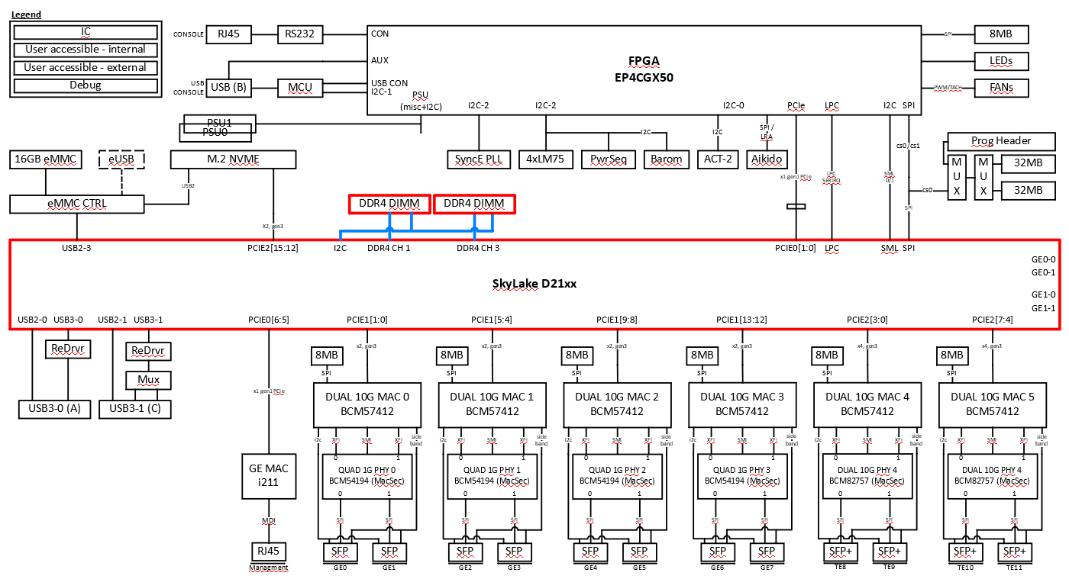
Figure 4 CPU Test Path Block Diagram
Failure Analysis:
If there is any error indication during the boot process, the problem most likely is in the Intel Skylake CPU. The kernel error message usually will pin point the problematic internal block of the CPU. If any failure occurs in this test, try the Debugging Steps to narrow down the issue.
1. Used linux “dmesg” command to display the error information.
2. Reference the kernel messages and contact the CPU vendor

Main Memory Test
This memory test tests the free memory made available by Linux kernel. Memory that is in use or reserved by the OS that can not be explicitly tested.
The memory is test with the MARCH C- algorithms. The MARCH C algorithm will increment and decrement through the entire memory, first reading and verifying the current contents and then writing with the complement value. After read and compare of the complement value, then writes again, complementing the current value in memory or writing with a new data value. This continues until all data patterns are tested. Any location in physical memory can be tested and debugged using the memory debug utilities.
This test will detect stuck-at and transition faults because all cells are read in states 0, 1, 0 … This test also satisfies the conditions for detecting address decoder faults and unlinked idempotent (state transition in an aggressor cell forces the contents of a victim cell to a certain value, 0 or 1) and unlinked inversion coupling faults (state transition in an aggressor cell inverts the contents of a victim cell). An unlinked fault links one aggressor cell to one victim cell whereas a linked fault links 2 or more aggressor cells to one victim cell.
Linux runs with the ECC turned on in the CPU, so ECC is enabled when the memory test is executed. Single bit ECC error is corrected and flagged in the Linux system error log and kernel message is printed out. The error information can be displayed with the linux dmesg command. ECC messages are not displayed by diagnostics program. Manufacturing script must be able to capture output messages from diagnostics software as well as from Linux kernel. Double bit error is not corrected and will cause the memory test to fail.
The algorithm of the memory test is as follows:
Direction | Reading pattern | Writing pattern |  | Phase
Increment |  | 0x5a5aa5a5 |  | 1
Increment | 0x5a5aa5a5 | 0xa5a55a5a |  | 2
Increment | 0xa5a55a5a | 0x5a5aa5a5 |  | 3
Decrement | 0x5a5aa5a5 | 0xa5a55a5a |  | 4
Decrement | 0xa5a55a5a | 0x5a5aa5a5 |  | 5
Increment | 0x5a5aa5a5 | 0x3c3cc3c3 |  | 6
Decrement | 0x3c3cc3c3 | 0xc3c33c3c |  | 7
Increment | 0xc3c33c3c | 0x3c3cc3c3 |  | 8
Decrement | 0x3c3cc3c3 | 0xf0f0f0f0 |  | 9
Increment | 0xf0f0f0f0 | 0x0f0f0f0f |  | 10
Decrement | 0x0f0f0f0f | 0xf0f0f0f0 |  | 11
Increment | 0xf0f0f0f0 | 0x00ff00ff |  | 12
Decrement | 0x00ff00ff | 0xff00ff00 |  | 13
Increment | 0xff00ff00 | 0x00ff00ff |  | 14
Decrement | 0x00ff00ff | 0x0000ffff |  | 15
Increment | 0x0000ffff | 0xffff0000 |  | 16
Decrement | 0xffff0000 | 0x0000ffff |  | 17
Increment | 0x0000ffff | 0xffffffff |  | 18
Decrement | 0xffffffff | 0x00000000 |  | 19
Increment | 0x00000000 | 0xffffffff |  | 20
Decrement | 0xffffffff | 0x00000000 |  | 21
Table 3 Memory Test Pattern

Test Path Block Diagram

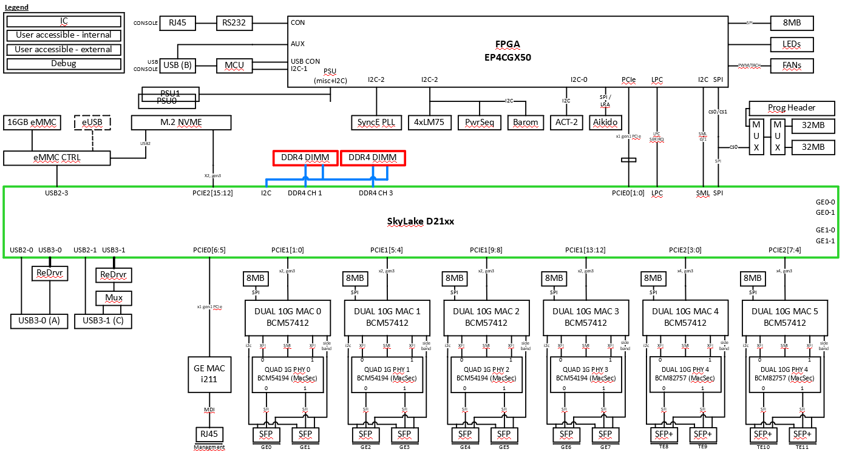
Figure 5 Main Memory Test Path Block Diagram

Failure Analysis:
Check the read and expected data to see if the error is due to bit picks or drops. The picking or dropping of bits may indicate a bad memory array. An addressing problem may be indicated if the read data is the foreground pattern when the background pattern is expected or vice versa.
If any failure occurs in this test, try the Debugging Steps to narrow down the issue.
1. Check the interface between the Host Soc and the DDR4.
2. If there is no problem for these interfaces, replace one DDR4 and redo the test.

FPGA Test

DASH FPGA Subtest Menu
a: alter diag flags
b: basic utilities
c: do all diags in this menu
d: do group of diags in this menu
e: DASH FPGA register test
f: FPGA intr test
g: Aikido FPGA register test

FLAGS: Continuous OFF Stop on error OFF Ext. loopback ON Min test time OFF
ge-Int loopback OFF
enter DASH FPGA Subtest Menu item >
Test Path Block Diagram

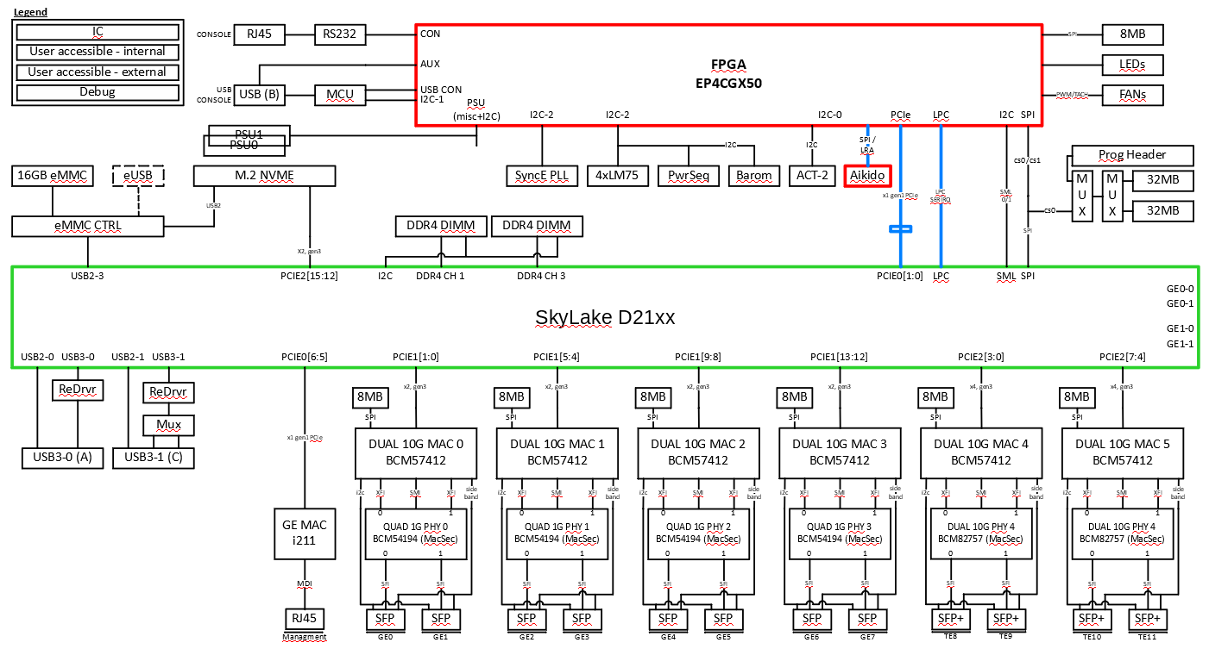
Figure 6 IO FPGA Test Path Block Diagram

DASH FPGA Register Test
The DASH IO FPGA connects to Intel CPU’s PCIe and LPC serial bus interfaces. The PCIe bus connects to the majority of the FPGA registers while the LPC bus is mainly connected to UART 0 and 1 for console and AUX port. Register write and read tests will be conducted on certain areas such as the scratch pad area to check the accessibility to the FPGA. Functional blocks such as I2C and UART will be tested with specific tests described below.

Failure Analysis:
A failure in this test indicates that PCIe or LPC buses between host CPU and IO FPGA may be faulty, possibly shorted or disconnected.
If any failure occurs in this test, try the Debugging Steps to narrow down the issue.
1. Check the corresponding devices. For example, check the PHY device if PHY reset function test fail.
2. Check the LPC interface between host CPU and FPGA.
3. If there is no problem for these interfaces replace a new FPGA chip.

FPGA interrupt Test
This test will test FPGA interrupt signals which receives the buld of the interrupts in the systems and aggregates these interrupts to CPU.
Failure Analysis:
A failure in this test indicates that interrup signal between FPGA and subsystem devices may be faulty, possibly shorted or disconnected.
If any failure occurs in this test, use FPGA utility menu to test each subsystem interrup one by one to narrow which cause the failure.

Akido FPGA Register Test
The Aikido FPGA connects to DASH FPGA with SPI interfaces. Register read and write tests will be conducted on certain areas such as the mailbox area to check the accessibility to the FPGA.
Failure Analysis:
A failure in this test indicates that SPI interface between DASH FPGA and Aikido FPGA may be faulty, possibly shorted or disconnected.
If any failure occurs in this test, try the Debugging Steps to narrow down the issue.
1. Check the corresponding devices. For example, check the DASH FPGA test first.
2. Check the SPI interface between DASH FPGA and Aikido FPGA via register r/w utility.
3. If there is no problem for these interfaces replace a new FPGA chip.

USB Type A / Type C Test
USB functionality is provided by the Intel CPU.

Test Path Block Diagram

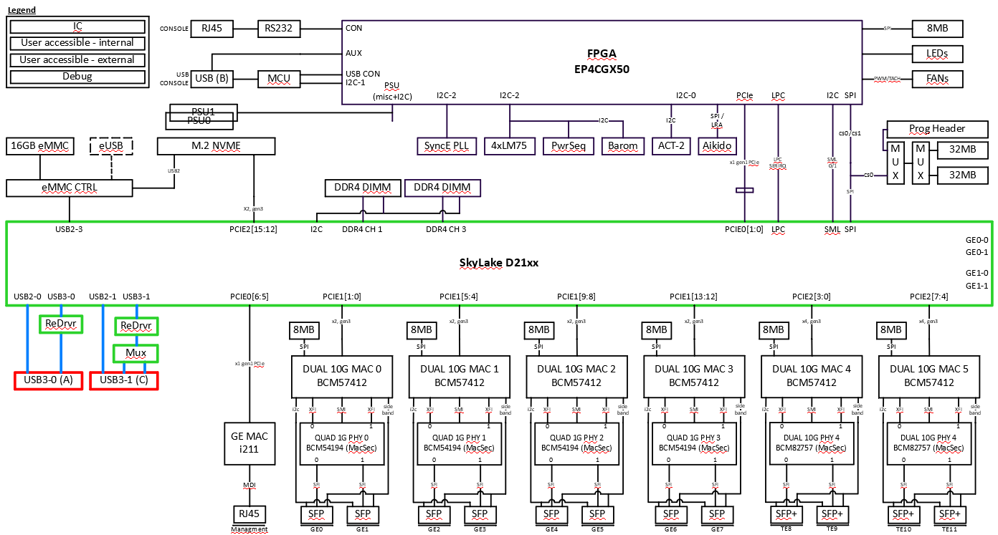
Figure 7 USB Test Path Block Diagram

USB Device Access Test
This test requires an external USB 3.0 flash is plugged into the USB external ports. Presence of the flash is detected and firstly read/write access to a section of the device is performed on USB 3.0 speed to make sure the external USB 3.0 path is functional, continuously reduce to the USB 2.0 speed and start to verify the external USB 2.0 path. Aproximately 1K bytes of incremental data pattern is written to and read back from the flash.
Failure Analysis:
A failure in this test indicates that the trace between the USB plug and the USB XHCI controller or EHCI controller maybe faulty, possibly shorted or disconnected. The presence-detect test relies on current flow to detect an external flash plugged in.
If any failure occurs in this test, try the Debugging Steps to narrow down the issue.
1. Check the interface between the Host SoC and the USB port.
2. If there is no problem for these interfaces, replace one USB device and redo the test.

eMMC Test
eMMC is the default boot flash device for IOS when the plug-in eUSB module is not installed. If eUSB module is installed, IOS will use it as the boot flash. Diagnostics program performs simple write/read to the device. Aproximately 1K bytes of incremental data pattern is written to and read back from the flash. Failure is detected if data in the write and read buffer do not match.

Test Path Block Diagram

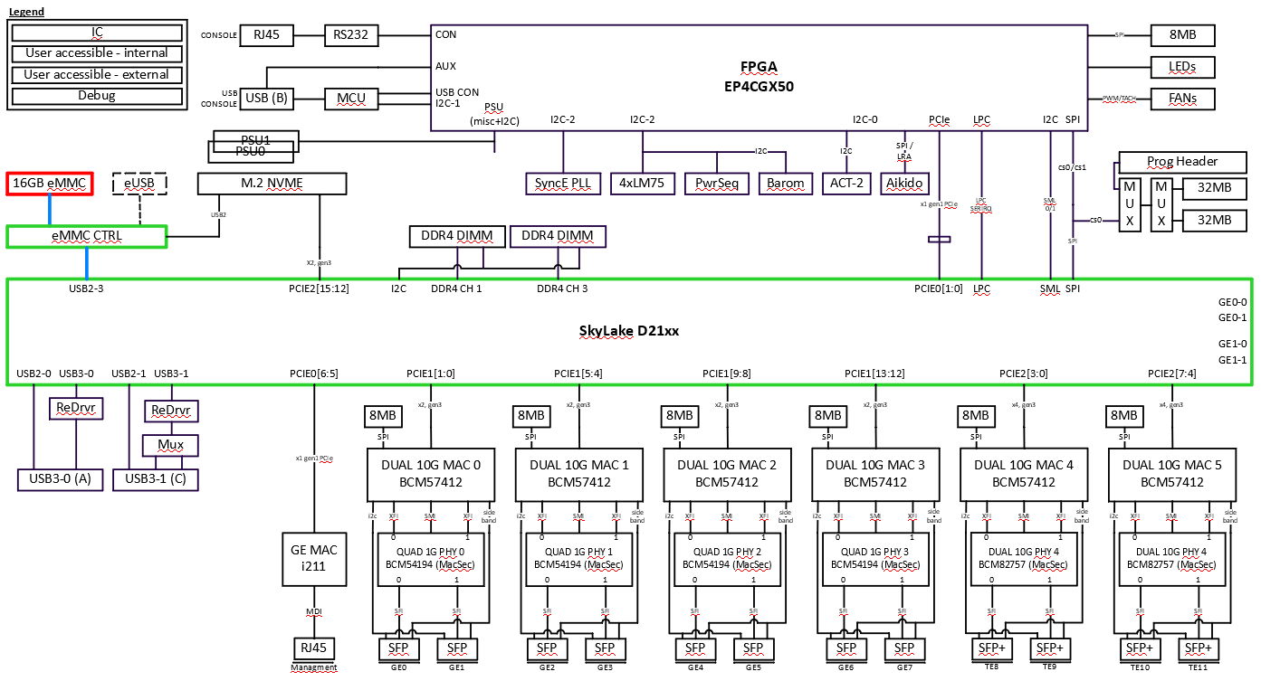
Figure 8 eMMC Test Path Block Diagram

Failure Analysis:
Check if the data and address signals to the flash are OK. If everything is correct, it is probably due to a bad component.
If any failure occurs in this test, try the Debugging Steps to narrow down the issue.
1.Run eUSB or M.2NVME Test to check whether the interface and eMMC CTRL is ok.
2.Check the interface between the CTRL and the eMMC.
3.If there is no problem for these interfaces, replace one eMMC and redo the test

eUSB Test
If eUSB module is installed, IOS will use it as the boot flash. Diagnostics program performs simple write/read to the device. Aproximately 1K bytes of incremental data pattern is written to and read back from the flash. Failure is detected if data in the write and read buffer do not match.

Test Path Block Diagram

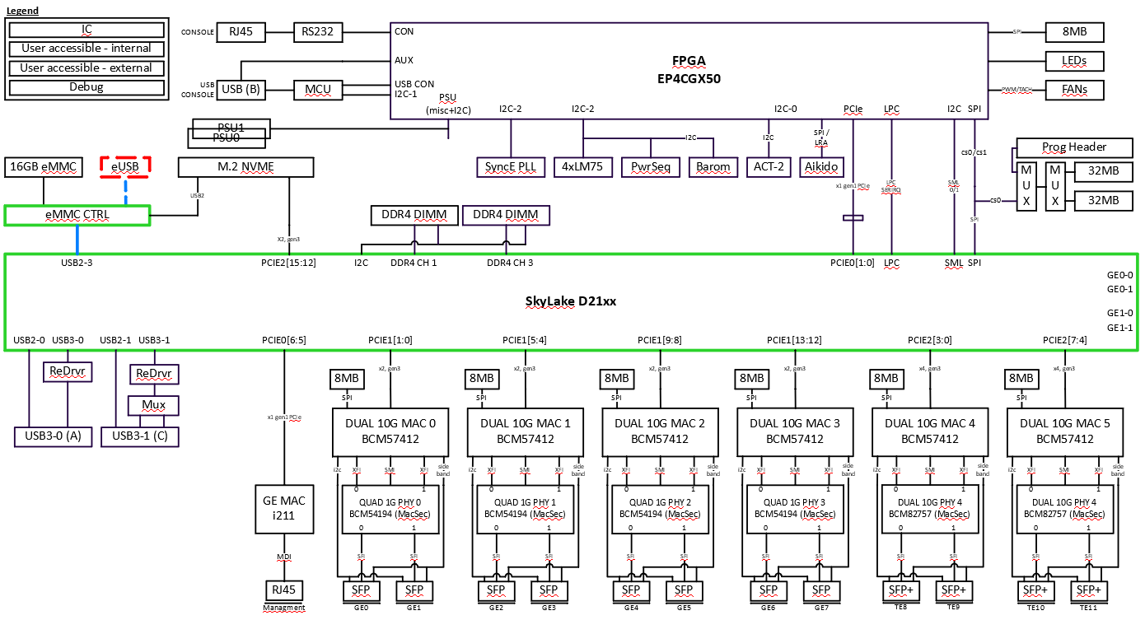
Figure 9 eUSB Test Path Block Diagram

I2C Bus Scan Test
There are two I2C blocks in the Intel CPU subsystem: Intel CPU I2C and DASH FPGA I2C buses. The Intel I2C is used to access the DIMM SPD only. The DASH FPGA I2C buses connect many devices such as SyncE PLL, ACT2, USB Redriver, LM75 temperature sensor, power sequencer, barometer, PSU1, PSU2, etc. For the complete list, please refer to the HW functional spec.
During I2C scan test, software programs the FPGA to initiate read transaction to every device that sits on the i2c bus connected to the FPGA. Software also programs the Intel CPU to initiate read transaction to every device that sits on the I2C bus connected to the CPU.
This section intends to verify just the devices and data path of the CPU I2C Subsystem and FPGA I2C subsystem. All I2C devices and data path that are not covered by the tests described in this section can be verified using the utility menu. ACT2 utility gives access and program the ACT2 device; Margin utility allows access to the Power Sequencer.

Test Path Block Diagram

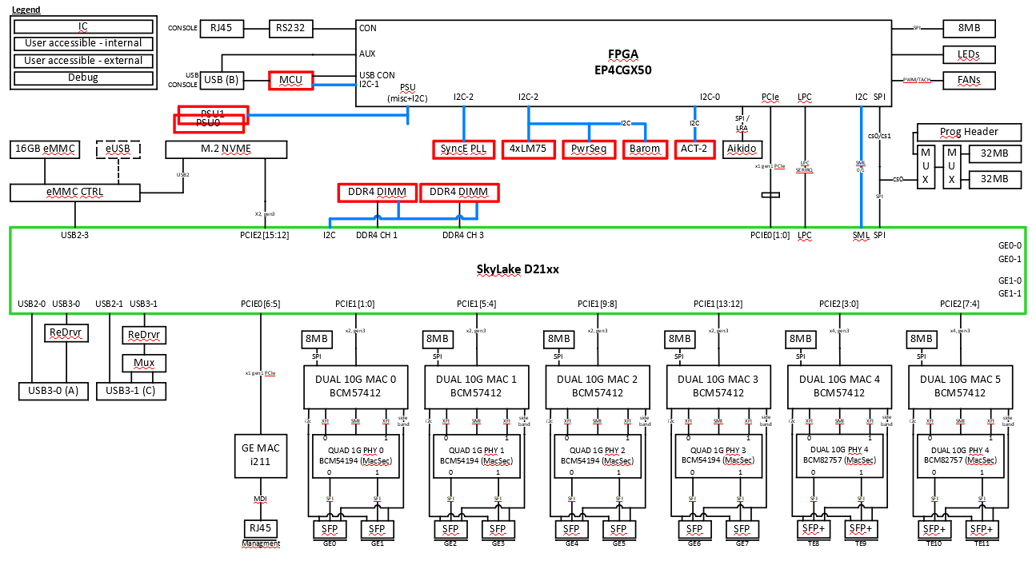
Figure 10 I2C Bus Scan Test Path Block Diagram

Failure Analysis:
A failure most likely means that the device itself is defective. The data bus could also be bad, but this is rare. Check to see if any other i2c devices on the same I2C controller (please see hardware spec for I2C controller mapping of i2c devices) also fail. If yes, this could point to the ashorted trace which causes other devices on the bus to fail to acknowledge during I2C scan test. If a single I2C device fails, most likely the device itself is defective.
If any failure occurs in this test, try the Debugging Steps to narrow down the issue.
1.Check the interface between the Host SoC and the failed I2C devices.
2.If there is no problem for these interfaces, replace one I2C device and redo the test.

PCIE Lane Scan Test
There are many PCIe device connected to Intel CPU, diagnostics checks their PCIe link is up and link width is correct to make sure these devices are available, and ROMMON configures them properly. The devidces are M.2, I211, BCM57412 and Dash FPGA, their link widths are x2, x4 and x1, respectively. Failure is detected if one of them is not link up or the link width is not correct.

Test Path Block Diagram
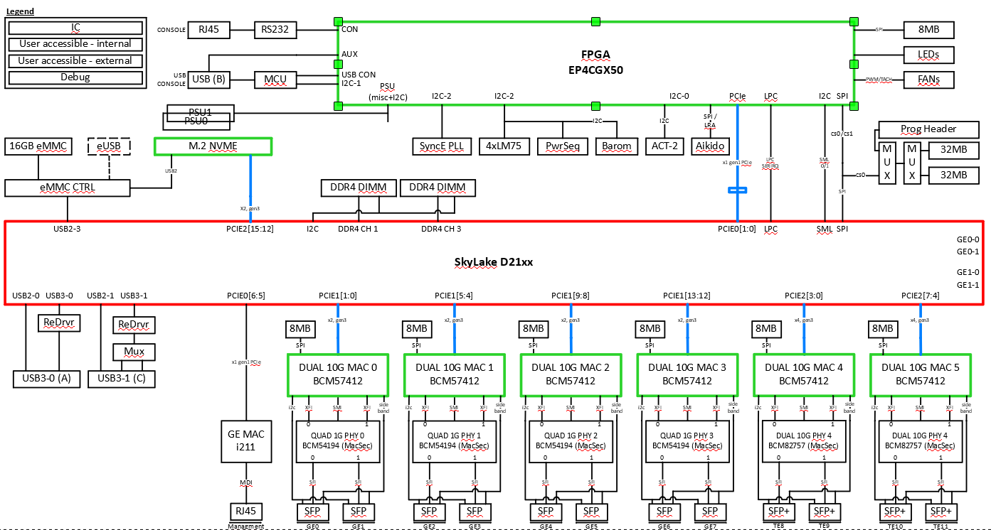
Figure 11 PCIE Lane Scan Test Path Block Diagram

Failure Analysis:
1. If the PCIe lane scan test is failed, it could be the link is down or the link width is not correct.
2. Check the devices status via lspci command.
3. Check the pin connection status.

M.2 NVME Test
Diagnostics program performs simple write/read to the device via PCIe or USB interfaces. Aproximately 1K bytes of incremental data pattern is written to and read back from the drive. Failure is detected if data in the write and read buffer do not match.

Test Path Block Diagram

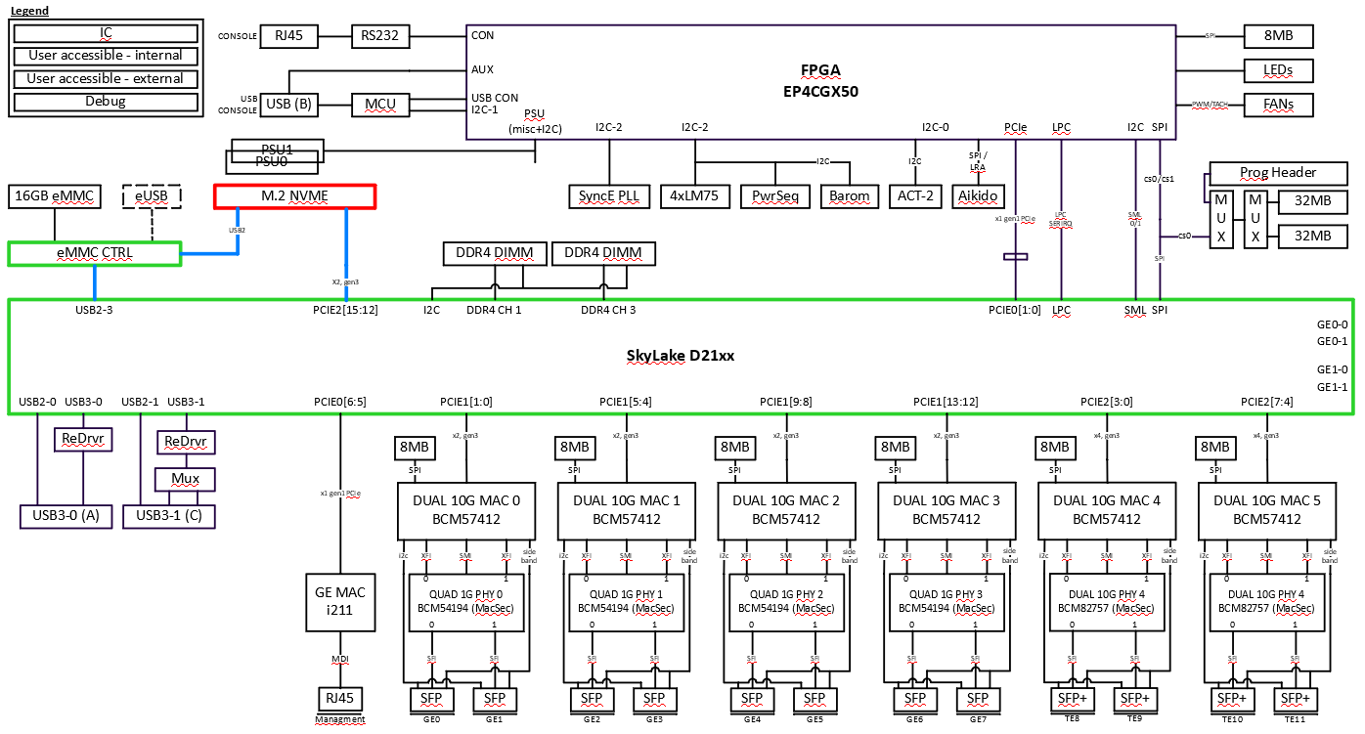
Figure 12 NVME Test Path Block Diagram

Failure Analysis:
1. plug-in other path M.2 module to verify .
2.If the NVME is not detected, check to make sure that the drive is installed and seated properly.
3. If test still fails, then, check if the data and address signals to the drive are OK.
4.If everything is correct, it is probably due to a bad drive. Insert a new drive and retest.

GE PHY I211 Test
This is test for Intel CPU connect through PCIe interface to Intel i211 and run the Register and Loopback test for Copper interface type. The test is using Intel’s celo64e tools for verified Register, EEPROM, Internal, and external loopback.

1G NIC I211 Subtest Menu
a: alter diag flags
b: basic utilities
c: do all diags in this menu
d: do group of diags in this menu
e: I211 Register Test
f: I211 Int/External Loopback Test
g: I211 Utility

FLAGS: Continuous OFF Stop on error OFF Ext. loopback ON Min test time OFF
ge-Int loopback OFF
enter 1G NIC I211 Subtest Menu item >

Test Path Block Diagram
This is test for Intel CPU connect through PCIe interface to manage port, I211 MAC, and run the Register and Internal/External Loopback test. The I211 Internal/External loopback are not in default test. We assume people use this port to tftp download image. You need to goto I211 submenu to run these two tests manaually if you need to.

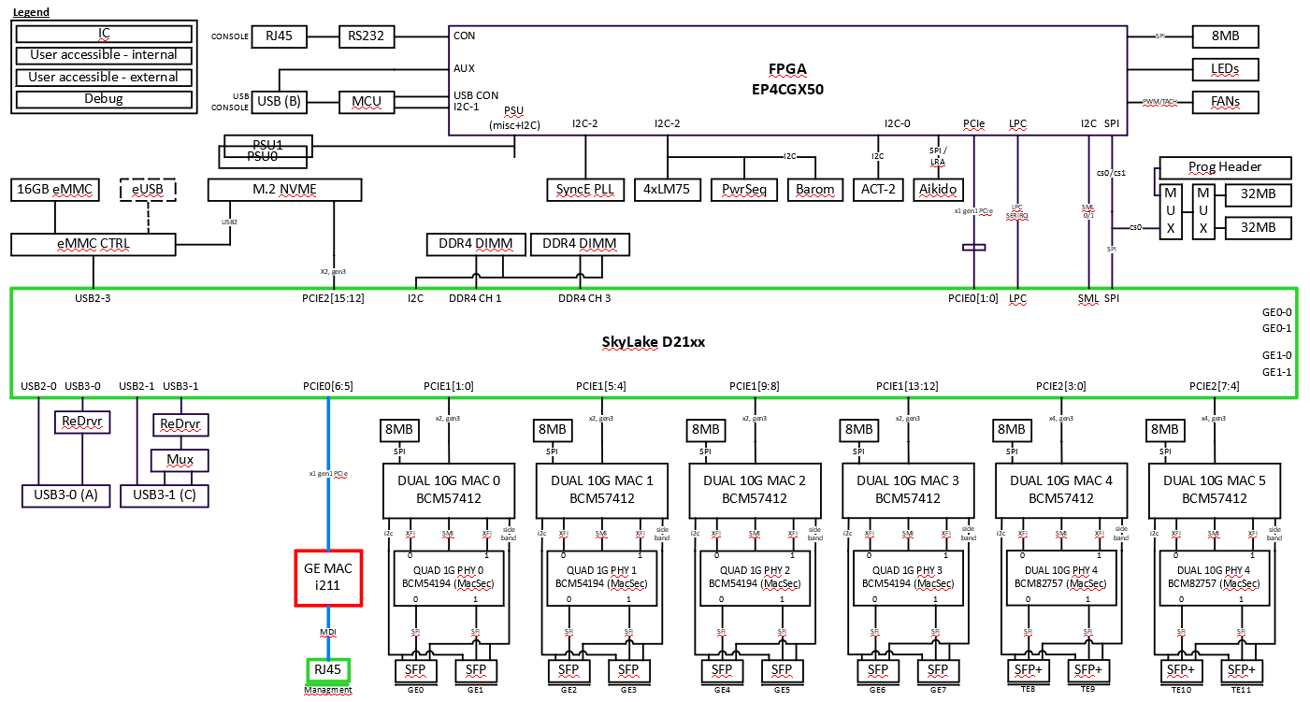
Figure 13 GE PHY I211 Test Path Block Diagram

GE PHY I211 Register Test
This test performs write, read and verify on GE PHY I211 register .
Failure Analysis:
If any failure occurred in this register test then using Intel tools such as lanconf64e or eeupdate to make sure the accessibility..

GE PHY I211 External Loopback Test (option)
This test expects the external loopback connectors are inserted to I211 RJ-45, and the diagnostics external loopback flag is on. The test will be skipped if the flag is off. Packet is TX and RX on the same port. This test will not be test as default test due to it is mangament port.
Failure Analysis:
If any failure occurred in this loopback test, the problem could be at the external loopback connection. To further isolate the problem, the PHY internal loopback should be run.

GE PHY I211 Internal Loopback Test
This test sets the GE PHY in internal loopback mode, and packets are TX and RX on the same port. The test is skipped if the external loopback flag is on. This test will not be test as default test due to it is mangament port.
Failure Analysis:
If any failure occurred in this loopback test, the problem could be at the I211. To further isolate the problem, Intel tool’s loopback test should be run.

10G BCM57412 MAC Test
This is test for Intel CPU connect through PCIe interface to BCM57412 MAC, and run the Register and Loopback test. There are total six BCM57412 MAC are involed in this test.

10G MAC BCM57412 Subtest Menu
a: alter diag flags
b: basic utilities
c: do all diags in this menu
d: do group of diags in this menu
e: BCM57412 SFP i2c Test
f: BCM57412 Register Test
g: BCM57412 Internal Loopback Test
h: BCM57412 Utility

FLAGS: Continuous OFF Stop on error OFF Ext. loopback ON Min test time OFF
ge-Int loopback OFF
enter 10G MAC BCM57412 Subtest Menu item >

Test Path Block Diagram

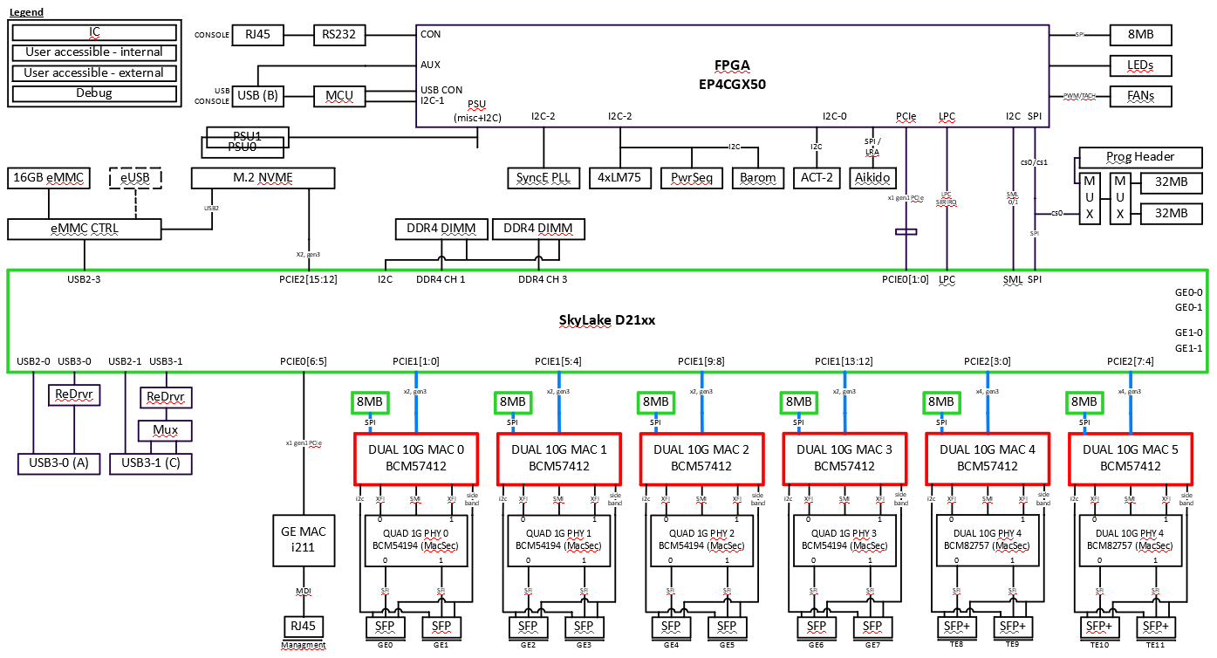

Figure 14 BCM57412 Test Path Block Diagram

Note: the most left SFP port (SFP port 0) is 1st SFP port of 1st BCM54194 1G PHY. The rightest SFP+ port (SFP+ port 1) is 2nd SFP+ port of 2nd BCM82757 10G PHY.

SFP | Port 0 | Port 1 | Port 2 | Port 3 | Port 4 | Port 5 | Port 6 | Port 7
eth number | eth4 | eth5 | eth6 | eth7 | eth8 | eth9 | eth10 | eth11

SFP+ | Port 0 | Port 1 | Port 2 | Port 3
eth number | eth0 | eth1 | eth2 | eth3

BCM57412 MAC Register Test
This test performs write, read and verify on 10G BCM57412 MAC register through PCIe interface.
Failure Analysis:
If any failure occurred in this register test, verify the the trace of PCIe interface between CPU and 10G controller.

BCM57412 SFP I2C Test
This test performs a read from SFP register through I2C interface from BCM57412 MAC to SFP.
Failure Analysis:
If any failure occurred in this register test, verify the the trace of I2C interface between BCM57412 and SFP.

BCM57412 Internal Loopback Test
This test performs write, read and verify on 10G BCM57412 MAC register through PCIe interface.
Failure Analysis:
If any failure occurred in this register test, verify the the trace of PCIe interface between CPU and 10G controller.
If any failure occurs in this test, try the Debugging Steps to narrow down the issue on every BCM57412 base.
1. Check register test is ok.
2. If step 1 is OK, check the packet status, received or not? Received the unexpected packet?
3. If step 2 is OK, consult with CPU vendor and PHY vendor.

1G BCM54194 PHY Test
This is test for connect through SGMII/QSGMII interface to BCM57412 MAC, SFI to SFP by run the Register and Loopback test. There are total four BCM54194 1G PHY are involed in this test.

GE PHY BCM54194 Subtest Menu
a: alter diag flags
b: basic utilities
c: do all diags in this menu
d: do group of diags in this menu
e: GE PHY BCM54194 Utility
f: GE PHY BCM54194 Register Test
g: GE PHY BCM54194 Internal Loopback Test
h: GE PHY BCM54194 SFP External Loopback Test

FLAGS: Continuous OFF Stop on error OFF Ext. loopback ON Min test time OFF
ge-Int loopback OFF
enter GE PHY BCM54194 Subtest Menu item >

Test Path Block Diagram
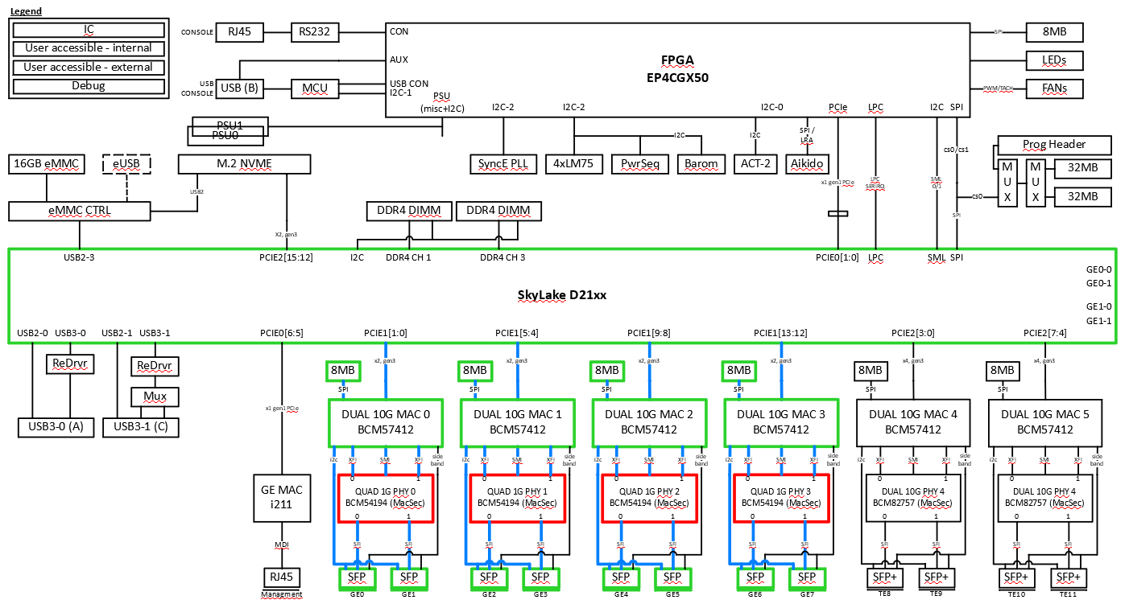
Figure 15 BCM54194 Test Path Block Diagram

1G BCM54194 PHY Register Test
This test performs write, read and verify on 1G PHY register through CPU PCIe to BCM57412 and MDC/MDIO through BCM57412 to BCM54194 interface.
Failure Analysis:
If any failure occurred in this register test, verify the the trace of PCIe interface between CPU and 10G MAC controller and MDC/MDIO between BCM57412 and BCM54194.

1G BCM54194 PHY Internal Loopback Test
This test will generate a testing packet by CPU and go through BCM54712 MAC to PHY, PHY internal loopback to MAC. Finally, the packet back to CPU. Here the topology is:
CPU ⬄ BCM54712 MAC ⬄ BCM54194

The PHY external loopback test will be run if the diagnostics flag Ext. loopback is on, ge-Int loopback is off and insert external SFP loopabck plugs to all SFP ports.
The PHY internal loopback test will be run if the diagnostics flag Ext. loopback is off or the ge-Int loopback is on, do not insert any external SFP loopback plug on all SFP ports.
ge-Int loopback flag is used to control GE PHY internal loopack test, BCM54194 internal loopback test requires no external plug connected.
Ext. loopback | ge-Int loopback | Loopback Test
OFF | n/a | Internal
ON | OFF | External
ON | ON | Internal

Failure Analysis:
If any failure occurred in this loopback test, the problem could be at the BCM57412 PCIe connection to CPU or MDC/MDIO connection to BCM57412. To further isolate the problem, run BCM57412 internal loopback test, and BCM54194 PHY register test.

1G PHY SFP External Loopback Test
It expects SFP with optical loopback cable installed on each port and the diagnostics external loopback flag is on
Failure Analysis:
If any failure occurred in this loopback test, the problem could be at the SFP optical cable, the SFP device, or 10G MAC. To further isolate the problem, the first step should be trying another SFP module, or run the 10G MAC internal loopback.

10G BCM82757 PHY Test
This is test for connect through XFI interface to BCM57412 MAC, SFI to SFP+ by run the Register and Loopback test. There are total two BCM82757 10G PHY are involed in this test.

Fugazi BCM82757 10G PHY Subtest Menu
a: alter diag flags
b: basic utilities

c: do all diags in this menu
d: do group of diags in this menu

e: BCM82757 Register Test
f: BCM82757 Line Side PRBS Test
g: BCM82757 Internal Loopback Test
h: BCM82757 External loopback Test
i: BCM82757 cl37 External loopback Test
j: BCM82757 Utility

FLAGS: Continuous OFF Stop on error OFF Ext. loopback ON Min test time OFF
ge-Int loopback OFF
enter Fugazi BCM82757 10G PHY Subtest Menu item >

Test Path Block Diagram

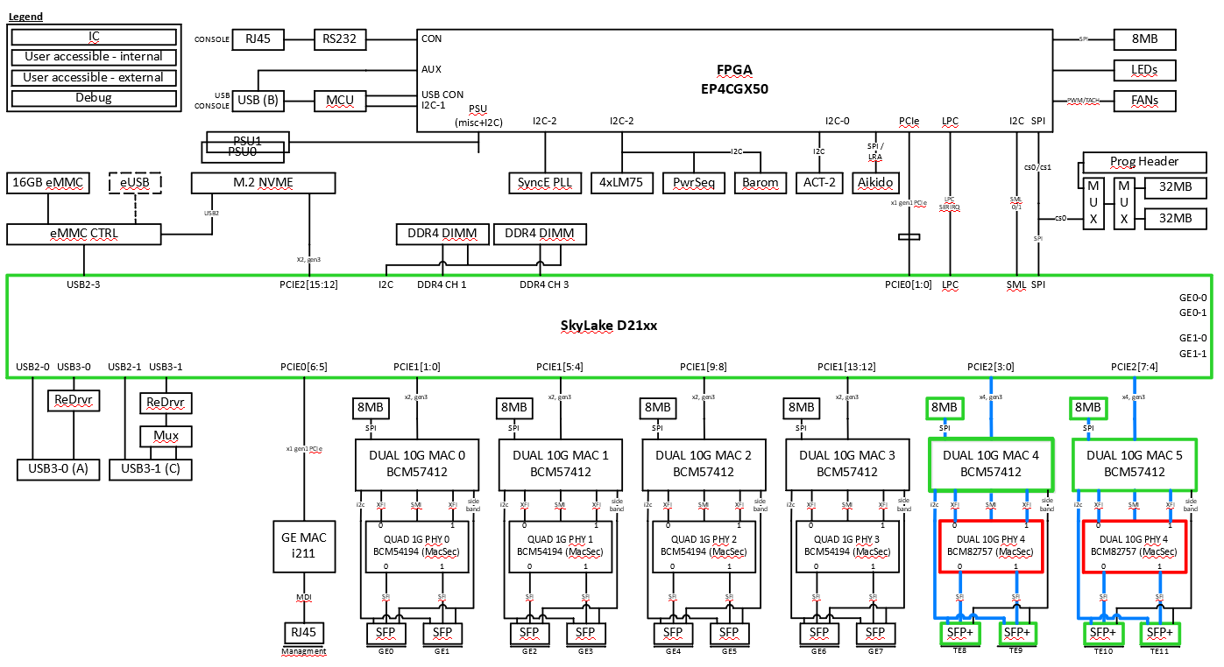
Figure 16 BCM82757 Test Path Block Diagram

10G BCM82757 PHY Firmware Download
10G PHY firmware is bundled into diagnostic image, need to execute firmware download before doing any 10G PHY test.
Failure Analysis:
If any failure occurred in firmware download, the problem could be at the register accessing, verify the the trace of PCIE interface between CPU and BCM54712 or MDC/MDIO interface from BCM54712 MAC to 10G PHY.

10G BCM82757 PHY Register Test
This test performs write, read and verify on 10G PHY register through MDC/MDIO interface.
Failure Analysis:
If any failure occurred in this register test, verify the the trace of MDC/MDIO interface between BCM54712 MAC and BCM82757 PHY.

10G PHY Internal Loopback Test
This test will generate a testing packet by CPU and go through BCM54712 MAC to PHY, PHY internal loopback to MAC. Finally, the packet back to CPU. Here the topology is:
CPU ⬄ BCM54712 MAC ⬄ BCM82757 PHY
Failure Analysis:
If any failure occurred in this loopback test, the problem could be at the PHY, or MAC to PHY SMI interface.
If any failure occurs in this test, try the Debugging Steps to narrow down the issue.
- Check register test is ok.
- If step 1 is ok, check if BCM57412 internal loopback test is ok.
- If step 2 is OK, check the packet status, received or not? Received the unexpected packet?
- If step 3 is OK, consult with CPU vendor and PHY vendor.

10G PHY SFP+ Ext Loopback Test
It expects SFP+ with optical SFP+ loopback module installed on each SFP port and the diagnostics external loopback flag is on
Failure Analysis:
If any failure occurred in this loopback test, the problem could be at the SFP+ optical interface, the SFP+ device, or 10G PHY. To further isolate the problem, the first step should be trying another SFP+ module, and run the 10G PHY internal loopback.

Rommon Flash Test
One sector in SPI flash unused by ROMMON is tested with read/write pattern and restored upon test completion. A utility will be provided with the following options: (1) Sector read, (2) Sector erase, (3) Sector write. There are two SPI flash, are tested by Primary/Secondary Bootflash test.

Here is the menu about Rommon flash:

Boot flash test Subtest Menu
a: alter diag flags
b: basic utilities
c: do all diags in this menu
d: do group of diags in this menu
e: Primary Bootflash Test
f: Secondary Bootflash Test

FLAGS: Continuous OFF Stop on error OFF Ext. loopback ON Min test time OFF
ge-Int loopback OFF
enter Boot flash test Subtest Menu item >

Test Path Block Diagram

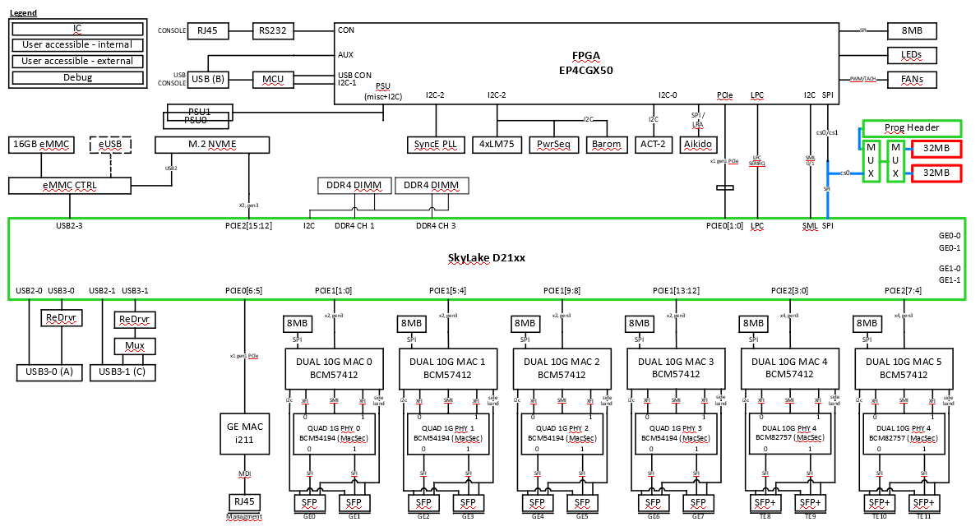
Figure 17 Rommon Flash Test Path Block Diagram

Failure Analysis:
Failure occurs during the Sector Read test is almost guaranteed to be due to bad sectors in the SPI flash and not the data path which is from CPU to the SPI flash. Otherwise, the system will not even boot up. If failure occurred during the Sector Erase and Sector Write test, check the signals on the write path between Host SOC and the SPI flash. If they are correct, then the SPI flash may be blocked or the sectors under test are bad.
If any failure occurs in this test, try the Debugging Steps to narrow down the issue.
1.Check if boot up is OK
2. Check the interfaces between Host SoC and flash is OK.
3. Replace one flash and redo the test

SyncE PLL Test
Diagnostics program performs simple write/read/verify to an unused register from the device IDT8A335004 via I2C interfaces from FPGA. Failure is detected if data in the write and read do not match.

SyncE PLL Subtest Menu
a: alter diag flags
b: basic utilities
c: do all diags in this menu
d: do group of diags in this menu
e: SyncE PLL Register Test
f: SyncE PLL Interrupt Test
g: SyncE Recovered Clock Test
h: SyncE PLL Utility

FLAGS: Continuous OFF Stop on error OFF Ext. loopback ON Min test time OFF
ge-Int loopback OFF
enter SyncE PLL Subtest Menu item >

Failure Analysis:
- If any failure occurred in SyncE PLL Register Test, the problem could be at I2C interface to FPGA, the IDT8A35004 device. Using SyncE PLL Register read utility to read product id at register offset 0xC032, value should be 0x04.
- If any failure occurred in SyncE PLL Interrupt Test, the problem could be at interrupt signal to FPGA, the IDT8A35004 device.
- If any failure occurred in SyncE Revovered Clock Interrupt Test, the problem could be at clocks from BCM82757 10G PHY and BCM54194 1G PHY to IDT8A35004 device , the IDT8A35004 device. .

Test Path Block Diagram

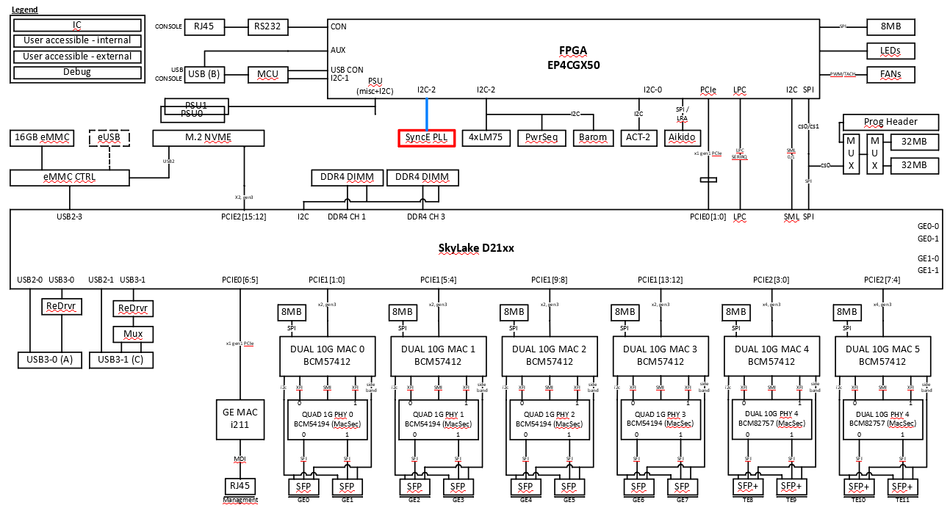
Figure 18 SyncE PLL Test Path Block Diagram

SyncE Pll Recovered Clock Test
Synchronous network clocks are created by the 8A35004 SETS device. The IDT8A35004 received clock inputs from the 1G/10G PHYs and will output clocks to both 1G/10G PHYs and through a clock buffer to the 10G MACs. The way to verify recovered clock output to SyncE device: (1) enable and disable recovered clock output from 1G/10G Phys and (2) verify SyncE device locked status from
- REC_CLK1 to IDT8A35004 on every 1G PHYs.
- CLK_REVCLK0/1 on every 10G PHYs.

Note: This test requires external SFP loopback MUST been plug-in on all the SFP/SFP+ ports.

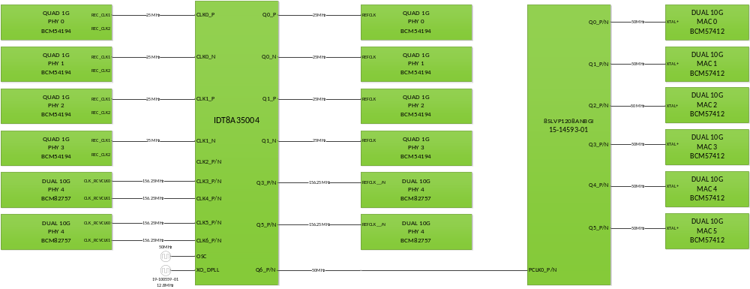

Input | Source Device | Frequency | Type
CLK0 p | BCM54194 Quad 1G PHY0 “REC_CLK1” | 25MHz | CMOS
CLK0 n | BCM54194 Quad 1G PHY1 “REC_CLK1” | 25MHz | CMOS
CLK1 p | BCM54194 Quad 1G PHY2 “REC_CLK1” | 25MHz | CMOS
CLK1 n | BCM54194 Quad 1G PHY3 “REC_CLK1” | 25MHz | CMOS
CLK2 p | unused
CLK2 n | unused
CLK3 p/n | BCM82757 DUAL 10G PHY 4 “CLK_RCVCLK0” | 156.25MHz | CML, AC-coupled, 50Ω internal
CLK4 p/n | BCM82757 DUAL 10G PHY 4 “CLK_RCVCLK1” | 156.25MHz | CML, AC-coupled, 50Ω internal
CLK5 p/n | BCM82757 DUAL 10G PHY 5 “CLK_RCVCLK0” | 156.25MHz | CML, AC-coupled, 50Ω internal
CLK6 p/n | BCM82757 DUAL 10G PHY 5 “CLK_RCVCLK1” | 156.25MHz | CML, AC-coupled, 50Ω internal

Failure Analysis:

If any failure occurred in SyncE Revovered Clock Interrupt Test, the problem could be at clocks from BCM82757 10G PHY and BCM54194 1G PHY to IDT8A35004 device, the IDT8A35004 device, the SFP/SFP+ device, external SFP loopback module, or incorrect SyncE firmware. Using “Show SyncE FW version” utility to check firmware version.

LASI Test

LASI test covers the PHY Network Link change interrupt signal which is connected to BCM57412 MAC LASI pin. BCM57412 MAC firmware is involved to handle when MAC received LASI interrupt from PHY.

- BCM82757 10G PHY: Interrupt is generated when link change from link up to down only. It is level trigger interrupt. Interrupt signal is per PHY port.
- BCM54194 1G PHY: Interrupt is generated when link change either from up to down or down to up. It is edge trigger interrupt. Interrupt signal is per PHY port. But hardware tie PHY’s port 0 and port 1 interrupt together which make only one interrupt signal to BCM57412 MAC LASI pin.

Fugazi LASI Subtest Menu
a: alter diag flags
b: basic utilities
c: do all diags in this menu
d: do group of diags in this menu
e: BCM82757 10G PHY LASI test
f: BCM54194 1G PHY LASI test
g: LASI Utility

FLAGS: Continuous OFF Stop on error OFF Ext. loopback ON Min test time OFF
ge-Int loopback OFF
enter Fugazi LASI Subtest Menu item >

Note:
(1). This test requires external SFP loopback MUST been plug-in on all the SFP/SFP+ ports.
(2). BRCM57412 firmware version must be great or equal to 216.1.245.3. Refer to section 17.4.1, step 4 for how to check BCM57412 firmware version.

BCM57412 MAC firmware is polling PHY’s link status at 250ms interval to report to MAC kernel driver by sending an ASYN event along with PHY link status after it received LASI interrupt while Diag is also configurting PHY to test LASI interrupt. MDIO bus to access from MAC to PHY is shared by both. MDIO bus attribution implementation is need for Diag to access PHY through MAC via MDIO bus to PHY.

Testing LASI operation:
- 10G: good LASI signal case
  - Diag takes the bus, PHY is initialized, LASI is enabled, link is up.
  - Diag enable PHY’s Shallow Line-side loopback (label 1) to bring Network side link down, LASI interrupt is generated.
  - FW doesn't have the bus, and sees the LASI (pending interrupt).
  - Diag releases the bus to FW, and FW generates Async, it takes 0 ~ max 300 ms
  - Diag get ASYN event counter from MAC bnxt_en driver via IOCTL. If counter is 1 (one link down interrupt), test passed.
- 10G: Bad LASI signal case
  - Diag takes the bus, PHY is initialized, LASI is enabled, link is up.
  - Diag enable PHY’s Shallow Line-side loopback (label 1) to bring Network side link down, no LASI interrupt is generated due to bad LASI signal.
  - FW doesn't have the bus and doesn't see the LASI.
  - Host releases the bus to FW, no Async for 300ms or more... (no Async since LASI is enabled, no LASI because broken).
  - Diag get ASYN event counter from MAC bnxt_en driver via IOCTL. The counter is 0, test failed.
- 1G: good LASI signal case
  - Diag takes the bus, PHY is initialized, LASI is enabled, link is up.
  - Diag configure PHY port “power down” to bring Newtwork side link down, LASI interrupt is generated.
  - FW doesn't have the bus, and sees the LASI (pending interrupt),
  - Diag releases the bus to FW, and FW generates Async, it takes 0 ~ 300 ms
  - Diag get ASYN event counter from MAC bnxt_en driver via IOCTL. If counter is 1 (one link down interrupt), test passed.
- 1G: Bad LASI signal case
  - Diag takes the bus, PHY is initialized, LASI is enabled, link is up.
  - Diag configure PHY port “power down” to bring Network side link down, no LASI interrupt is generated due to bad LASI signal.
  - FW doesn't have the bus and doesn't see the LASI.
  - Diag releases the bus to FW, no Async for 300ms or more... (no Async since LASI is enabled, no LASI because broken)
  - Diag get ASYN event counter from MAC bnxt_en driver via IOCTL. The counter is 0, test failed.
Failure Analysis:

If any failure occurred in this test, the problem could be interrupt signal connection from BCM82757 10G PHY, BCM54194 1G PHY to BCM57412 MAC, the SFP/SFP+ device. And check if external SFP loopback module.
To further isolate the problem, the first step should make sure all the SFPs ports have good SFPs and its external loopbacks. And have right BCM57412 firmware version.

Test Path Block Diagram

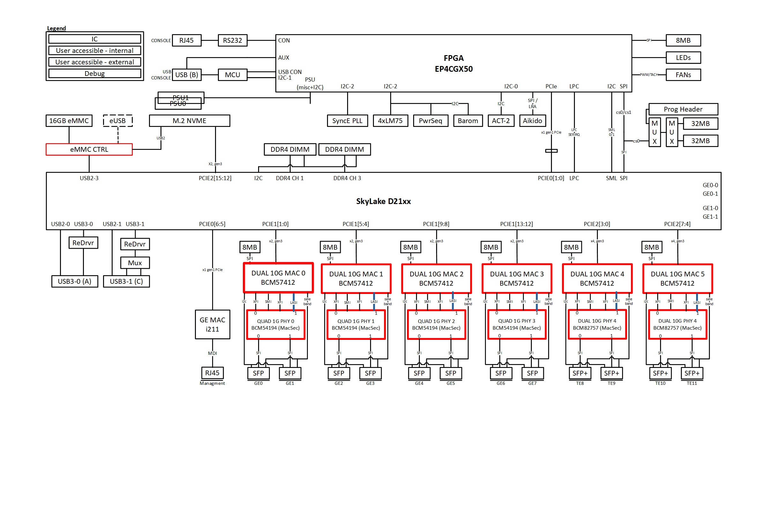
Figure 17 LASI Test Path Block Diagram

Side-Band Test
The “side-band” is consisted of four signals on SFP/SFP+:
- Tx_Disable is an input to the SFP from BCM57412 MAC signaling to the module to disable the transceiver.
- SFP_Abs is an output from the SFP to BCM57412 MAC and BCM82757 10G PHY/BCM54194 1G PHY indicating SFP connection.
- Tx_Fault is an output from the SFP to BCM57412 MAC and BCM82757 10G PHY/BCM54194 1G PHY indicating an error condition in the laser.
- Rx_Lost is an output from the SFP to BCM57412 MAC and BCM82757 10G PHY/BCM54194 1G PHY indicating loss of signals in the receiver.

Test methold:
- Config ‘tx_disable’ to enable (high, tx disable) from BCM54172 MAC firmware.
- Check SFP_abs/’tx_fault/rx_los by read from PHYs.
- Config ‘tx_disable’ to disable (low, tx enable) from BCM54172 MAC firmware.
- Check SFP_abs/’tx_fault/rx_los by read from PHYs.

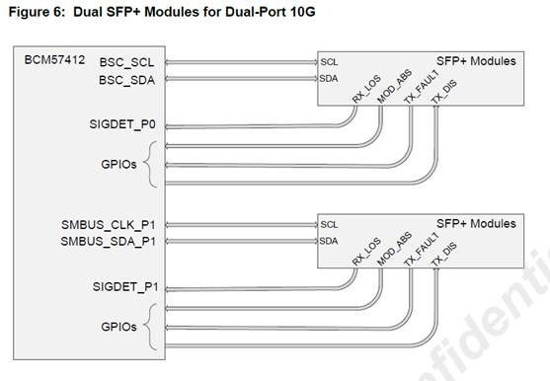
Fugazi Side Band Subtest Menu
a: alter diag flags
b: basic utilities
c: do all diags in this menu
d: do group of diags in this menu
e: BCM82757 Side Band Test
f: BCM54194 Side Band Test
g: Side Band Utility

FLAGS: Continuous OFF Stop on error OFF Ext. loopback ON Min test time OFF
ge-Int loopback OFF
enter Fugazi Side Band Subtest Menu item >

Failure Analysis:
If any failure occurred in this test, the problem could be at the SFP/SFP+ side-band signals, the SFP/SFP+ device. Not all the SFP support “side-band” signal fuction. Diag requires manfacture to use Cisco’s SFP-GE-S/SFP-10G-S. To further isolate the problem, the first step should be trying another SFP/SFP+ module.

Test Path Block Diagram

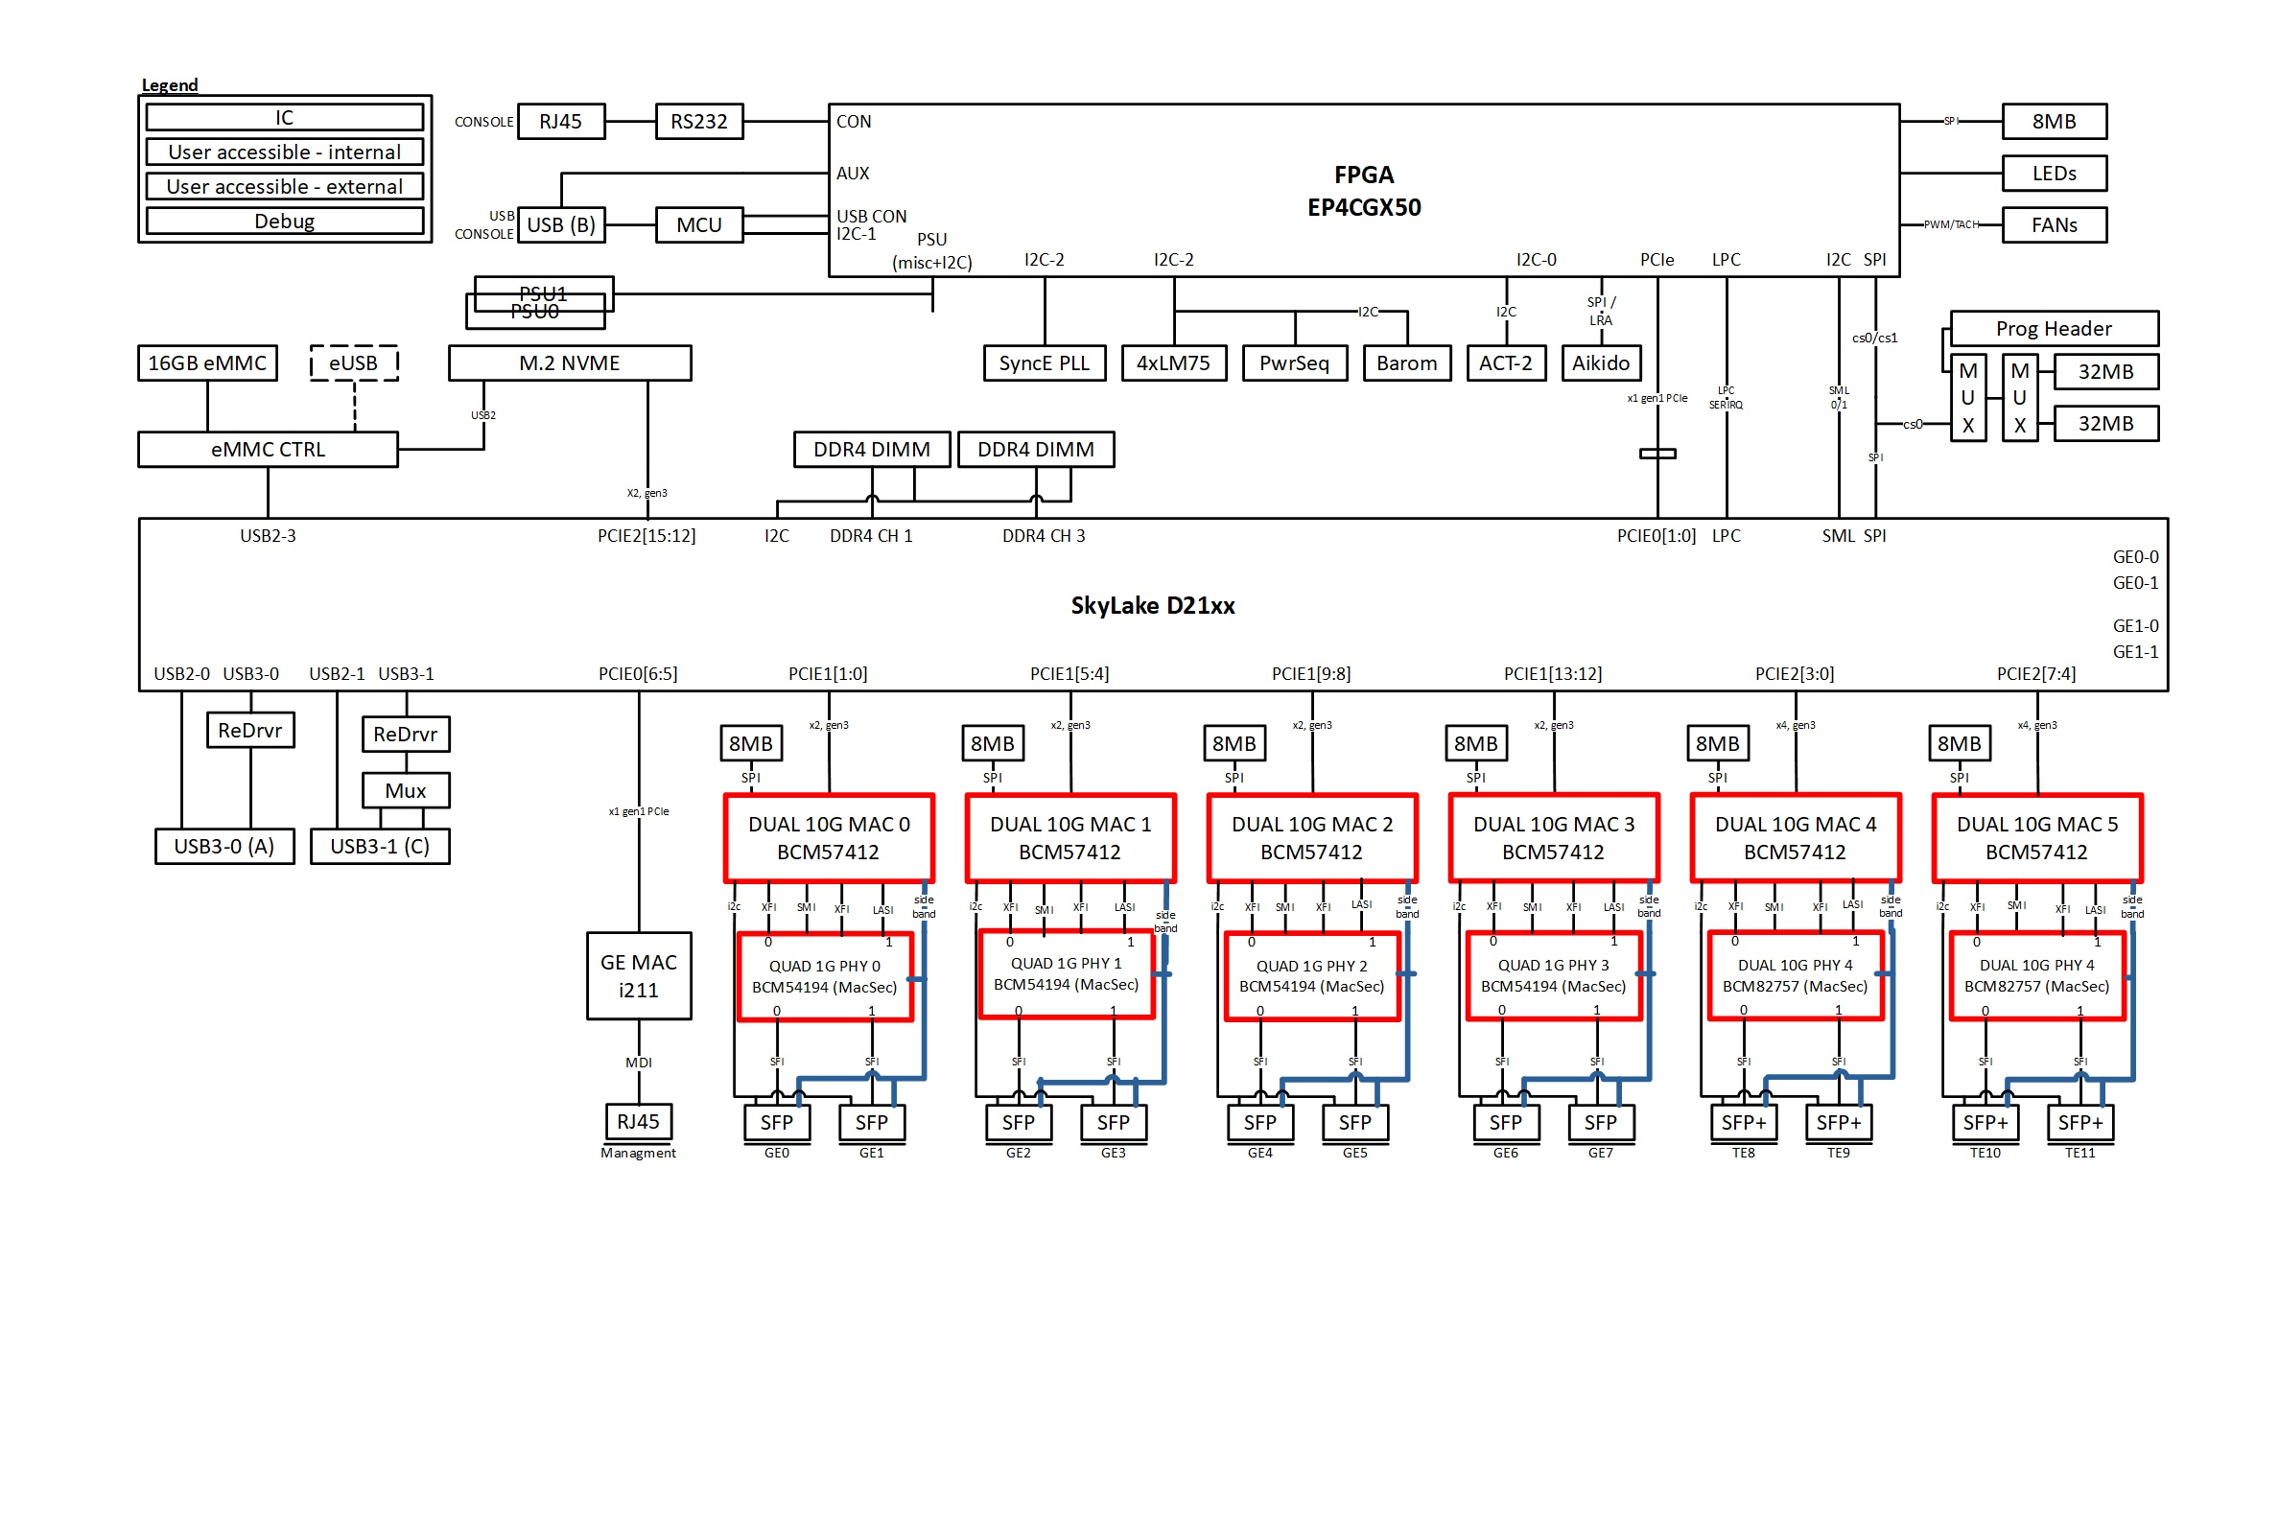

Figure 18 Side-band Test Path Block Diagram

Utilities
The following utilities are intended to ease bring up and debugging efforts.

Diagnostic Utilities Menu
a: PCIE read utility
b: System Information
c: Memory debug utilities
d: FPGA utilities
e: I2C utility
f: Margin utilities
g: Cookie utility
h: USB/Compact Flash utility
i: RTC utilities
j: FAN utilities
k: Mother LED utility
l: Reset system by watchdog
m: Escape to Shell (debugging only)
n: Execute a Shell command (debugging only)

enter Diagnostic Utilities Menu item >

PCIE read Utility
This utility provide read PCIe configuration space at user’s input for [bus number][device number][function number][register offset].

System Information
This utility displays the related information of system, such as CPU, memory, Diags. app. version, temperature and so on. Users can use this utility to get further details of system.

Memory Utility
This utility allows the user to perform various operations on the memory such as fill, read, write and compare. It also provides more extensive memory tests that are not available during the main DDR4 test. The utility performs the requested operation on any accessible memory address and does not protect any part of the memory so it is up to the user to make sure he/she does not alter critical memory and bring down the whole system. These tests perform 8/16/32 bit operations of the requested memory.

Memory Utility Menu
a: alter memory
b: compare memory block
c: display memory
d: move memory block
e: fill memory
f: find memory
g: memory read or write loop
h: memory debug loop
i: address loop

enter Memory Utility Menu item >

FPGA Utility
The FPGA utility allows user to perform various functions that supported by the FPGA. These functions include upgrade the FPGA image, program Aikido FPGA SPI ROM image, and Akido firmware.
Section 17.1 has procedure on how to upgrade FPGA image. Section 17.10 for program Aikido FPGA and firmware.

FPGA utility Menu
a: Platfrom FPGA Program SPI PROM image without header
b: Platform FPGA Program SPI PROM image with header
c: Aikido Program FPGA SPI PROM image
d: Erase/Program Image Upgrade Header
e: Set FPGA update flag
f: Set FPGA revision and date
g: Display FPGA MULTI BOOT registers
h: Display a sector
i: Test NIOS SPI
j: Show Board type/FPGA Version
k: Erase Config header Sector
l: Program Boot Upgrade Flags
m: Reset internal devices
n: Reset external devices
o: rd/wr test
p: FPGA intr test
q: serial IRQ intr test
r: Toggle to CPLD/FPGA (default FPGA)
s: FPGA read
t: FPGA fill
u: FPGA alter
v: Modify Aikido SPI Directory Table
w: AIKIDO SPI read
x: AIKIDO SPI write
y: AIKIDO reset and unreset
z: toggle flag : aikido_mailbox_flag
1a: toggle flag: aikido_act2_flag

enter FPGA utility Menu item >

I2C Utility
The I2C utility gives the user options to read and write to various I2C devices available on the platform such as DDR4 DIMMs, Quack, real time clock (RTC), SYS CLK, PCIe CLK, EEPROM SPD.

I2C Utility Menu
a: alter diag flags
b: basic utilities
c: do all diags in this menu
d: do group of diags in this menu
e: Display Memory Info
f: Show Barometer Info
g: Display Barometer Registers
h: Temperature Sensor
i: Power Sequencer
j: PSU MUX Utility
k: PSU1
l: PSU2
m: USB Console
n: FPGA I2C scan addr.
o: I2C read (no offset)
p: I2C write (no offset)
q: I2C read
r: I2C write
s: Toggle i2c debug flag
t: Reset I2C controller
FLAGS: Continuous OFF Stop on error OFF Ext. loopback ON Min test time OFF
ge-Int loopback OFF
enter I2C Utility Menu item >

Margin Utility
This utility allows EDVT team to read or set different environment variables such as voltage and clock frequency during their hardware validation test.
Section 18.1/18.2 has procedure on how to margin voltage, and frequency.

Margin Utility Menu
a: alter diag flags
b: basic utilities
c: do all diags in this menu
d: do group of diags in this menu
e: Voltage margin utility
f: Frequency margin utility

enter Margin Utility Menu item >

Voltage Margin Utility Menu
a: alter diag flags
b: basic utilities
c: do all diags in this menu
d: do group of diags in this menu
e: Margin Value Init
f: Set 3.3V/3.0V to Normal
g: Set 3.3V/3.0V Margin High
h: Set 3.3V/3.0V Margin Low
i: Show Current Voltage

enter Voltage Margin Utility Menu item >

Frequency Margin Utility Menu
a: alter diag flags
b: basic utilities
c: do all diags in this menu
d: do group of diags in this menu
e: Synce PLL Frequency Margin
f: Show current Synce PLL Frequency

enter Frequency Margin Utility Menu item >

Cookie Utility
This utility allows the user to display or alter any cookie available on motherboard as well as on IO modules.

Cookie utility Menu
a: alter MB CPU cookie
b: program I211/1G/10G port MAC
c: Check MAC programming result
d: program I211 MAC (option)
e: program BCM57412 MAC (option)

enter Cookie utility Menu item >

USB Utility
This utility allows the user to display USB and USB hubs info via Linux API.

USB Main Menu
a: alter diag flags
b: basic utilities
c: do all diags in this menu
d: do group of diags in this menu
e: Show USB info
FLAGS: Continuous OFF Stop on error OFF Ext. loopback ON Min test time OFF
ge-Int loopback OFF
enter USB Main Menu item >

USB-Console Test
USB console test is simple device detection, where usb console cable is installed between the usb port and the console port. As soon as the cable is installed, if usb-console device functions properly, the kernel will begin to probe and communicate with the device to gather information. The device information is then printed in the main serial console port before the serial console is disabled. In case nothing is displayed in the serial console, you can disconnect the usb console cable and then type ‘tail –n7 /var/log/sys.log’. You should be able to see messages similar to the following:
[ 803.116958] usb 1-1.1: new full speed USB device using ehci_hcd and address 10 [ 803.295294] usb 1-1.1: New USB device found, idVendor=05a6,
idProduct=0009
[ 803.377423] usb 1-1.1: New USB device strings: Mfr=1, Product=2,
SerialNumber=0
[ 803.464768] usb 1-1.1: Product: Cisco USB Console [ 803.520945] usb 1-1.1: Manufacturer: Cisco [ 1613.691915] usb 1-1.1: USB disconnect, address 10 [ 1615.148447] usb 1-1.1: new full speed USB devi

Since Rommon doesn’t disable usb console by default, so as soon as usb console is connected to a usb port, serial console is lost. When the usb-console cable is installed, the main serial console is disabled. The control is returned to the main serial console when the usb-console cable is removed.

There are two ways to test usb console, the script in kernel and our diag utility.
It’s better to use utility in our diag, because we also check the FPGA present bit of usb console detected.

Test Path Block Diagram

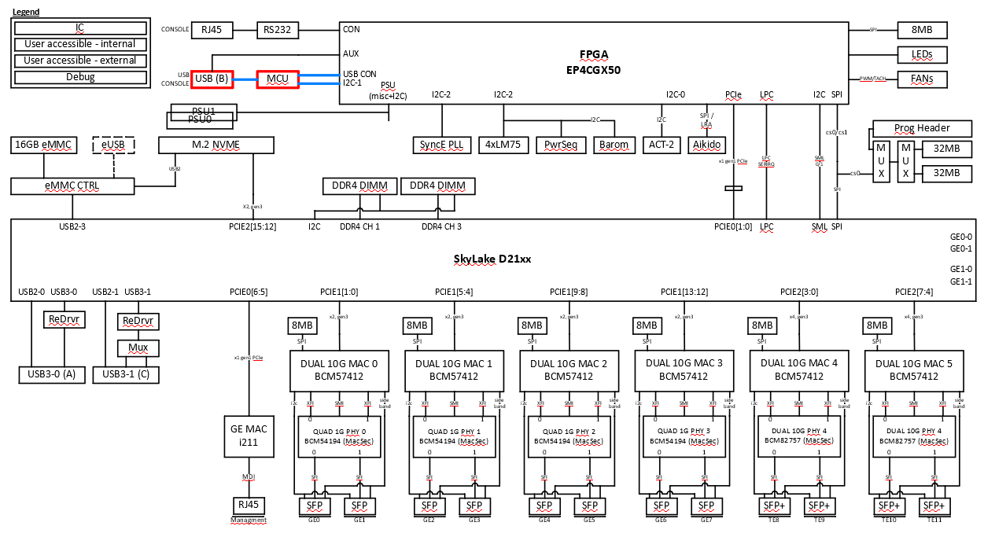
Figure 19 USB Consol Test Path Block Diagram

Test from Diag:
USB Console test is not in the default Diag test. Manuafacture need to follow steps to manyally run USB Console test if needed.
- Power up Fugazi platform, boot up Fugazi linux kernel and run Diag image.
- When Diag menu is up test USB Console by Diag utility:

DiagAPP menu:
b: basic utilities
-> e: I2C utility
-> m: USB Console
-> j: USB Console Detect Test
enter USB Console I2C Utility Menu item > j

Please connect the usb console port to the usb port! And press any key to contiue.
[Note]: manually connect usb-console cable now, one end to USB console port, another end to USB port before press any key,.
USB Console Detected!
Please unplug the usb console, and press any key to contiue.
[Note]: manually remove usb-console cable now before press any key,.
Removed.
Please check the time stamp manually!!!
Aug 5 17:29:33 Diag kernel: [ 730.357463] usb 1-1: Product: Cisco USB Console
Aug 5 17:29:33 Diag kernel: [ 730.357461] usb 1-1: New USB device found, idVendor=05a6, idProduct=0009

enter USB Console I2C Utility Menu item >

- If you see above Detected message from Diag kernel, test passed.

Test from script (put in kernel):
fugazi-diag# ../diag_utils/utils/scripts/usb_console_check
Check USB console port connection event:
Current time:
Tue Oct 22 19:14:52 UTC 2019
Oct 22 19:14:15 Diag kernel: [ 2651.543989] usb 1-1: New USB device found, idVendor=05a6, idProduct=0009
Oct 22 19:10:31 Diag kernel: [ 2426.933984] usb 1-1: Product: Cisco USB Console
Please check the USB console detection and time stamp are what you expected !!
fugazi-diag#
fugazi-diag#
fugazi-diag#
fugazi-diag# usb_console_check
Check USB console port connection event:
Current time:
Tue Oct 22 19:15:29 UTC 2019
Oct 22 19:15:22 Diag kernel: [ 2718.891114] usb 1-1: New USB device found, idVendor=05a6, idProduct=0009
Oct 22 19:15:22 Diag kernel: [ 2718.891116] usb 1-1: Product: Cisco USB Console
Please check the USB console detection and time stamp are what you expected !!
fugazi-diag#

RTC Utility
This utility allows the user to display and program RTC.

RTC Main Menu
a: alter diag flags
b: basic utilities
c: do all diags in this menu
d: do group of diags in this menu
e: RTC get time
f: RTC set time

FLAGS: Continuous OFF Stop on error OFF Ext. loopback ON Min test time OFF
ge-Int loopback OFF
enter RTC Main Menu item >

FAN Utility
This utility allows user to change the FAN settings for debug purpose.

FAN Control Unit Utility Menu
a: alter diag flags
b: basic utilities
c: do all diags in this menu
d: do group of diags in this menu
e: Show fan status
f: Fan enable utility
g: Fan disable utility
h: Fan PWM control
i: Show single fan RPS
j: Change fan speed
k: Display smartfan info
FLAGS: Continuous OFF Stop on error OFF Ext. loopback ON Min test time OFF
ge-Int loopback OFF

Example of display SmartFan information:

enter FAN Control Unit Utility Menu item > k

Smartfan 1 : Valid
cisco cpn : 33-100267-01
cisco rev : A0
cisco sn : SUN24160143
mfg name : SUNON
mfg pn : PF38281BX-Q38U-SA9
mfg assy location : CN
mfg datecode : WE1743
mfg sn :

Smartfan 2 : Valid
cisco cpn : 33-100267-01
cisco rev : A0
cisco sn : SUN2416013D
mfg name : SUNON
mfg pn : PF38281BX-Q38U-SA9
mfg assy location : CN
mfg datecode : WE1746
mfg sn :

Smartfan 3 : Valid
cisco cpn : 33-100267-01
cisco rev : A0
cisco sn : SUN241600UB
mfg name : SUNON
mfg pn : PF38281BX-Q38U-SA9
mfg assy location : CN
mfg datecode : WE1744
mfg sn :

Smartfan 4 : Valid
cisco cpn : 33-100267-01
cisco rev : A0
cisco sn : SUN24160131
mfg name : SUNON
mfg pn : PF38281BX-Q38U-SA9
mfg assy location : CN
mfg datecode : WE1743
mfg sn :

enter FAN Control Unit Utility Menu item >

Test Path Block Diagram

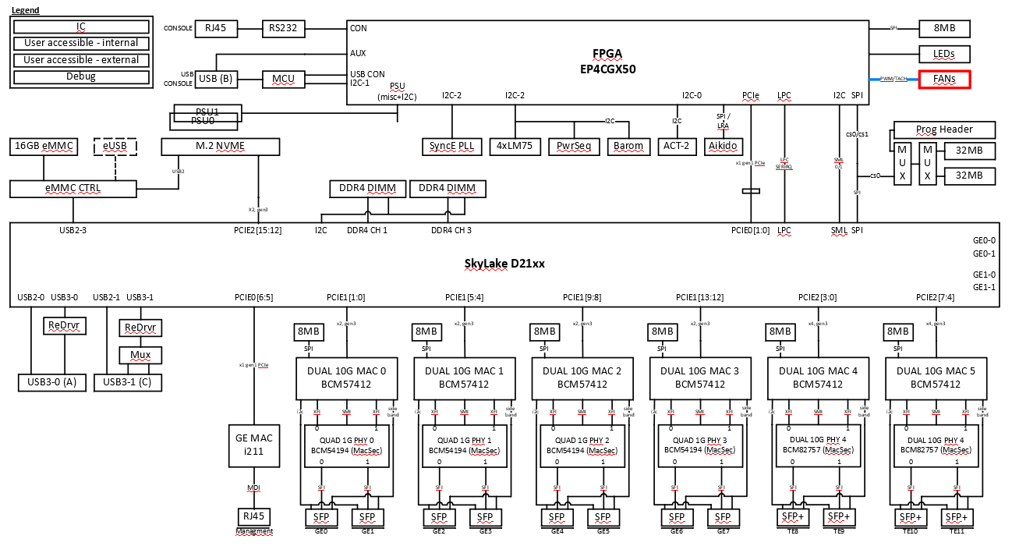
Figure 20 FAN Test Path Block Diagram

Motherboard LED Utility
This utility allows user to control MGMT, GE, SFP, and SFP+ to turn on or off the corresponding LEDs. Using this utility, the manufacturing script can choose to test any group of the LEDs that fit their needs.

LED utility Menu

a: Change RJ-45 eth LED Blink Time
b: Force all LED util
c: Power supply unit1 LED util
d: RJ-45 eth Port0 LED util
e: Blink RJ-45 eth Port0 LED util
f: SFP0 LED util
g: SFP1 LED util
h: SFP2 LED util
i: SFP3 LED util
j: SFP4 LED util
k: SFP5 LED util
l: SFP6 LED util
m: SFP7 LED util
n: SFP0+ LED util
o: SFP1+ LED util
p: SFP2+ LED util
q: SFP3+ LED util
r: System Status LED util
s: Alarm LED util

enter LED utility Menu item >

Test Path Block Diagram

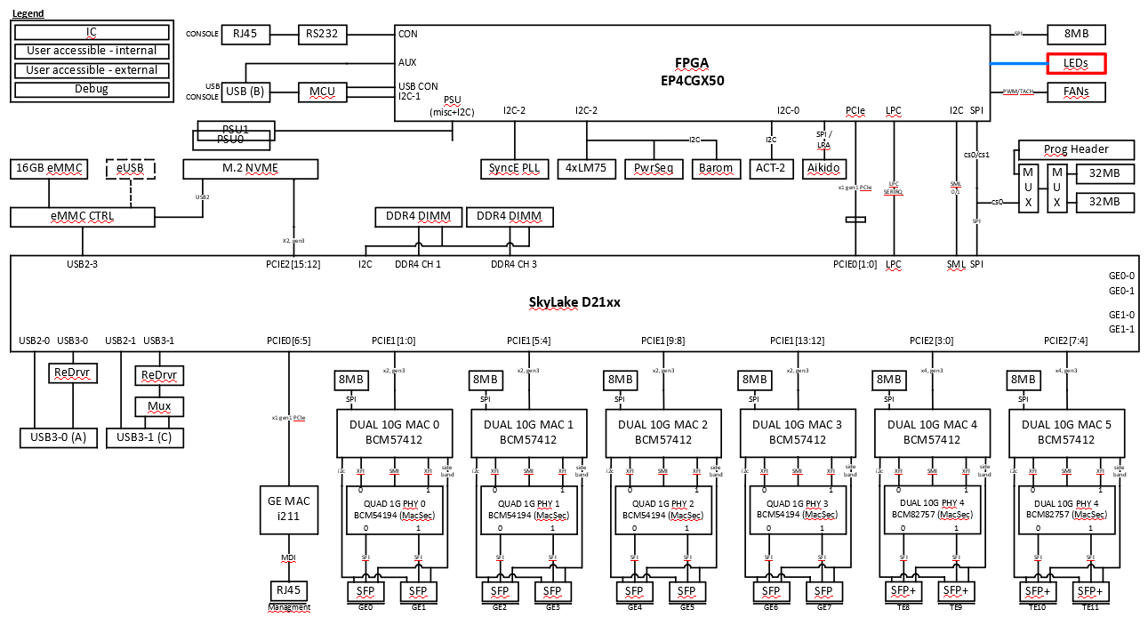
Figure 21 LED Test Path Block Diagram

SyncE PLL Utility
This utility is used to help debug, and display SyncE PLL device IDT8A35004 status. It also provides program SyncE firmware and clock configuration to its EEPROM.

SyncE PLL Utility Menu
a: alter diag flags
b: basic utilities
c: do all diags in this menu
d: do group of diags in this menu
e: Set Debug flag
f: Register read
g: Register write
h: Register dump
i: Status dump
j: Input clock check
k: Show SyncE FW version
l: SW reset
m: EEPROM read
n: EEPROM write
o: Read EEPROM file
p: EEPROM program
q: Set PHY recovered clock output
r: Clear all sticky status

enter SyncE PLL Utility Menu item >

BCM57412 Firmware Upgrade
This utility uses Broadcom CDiag tool by executing script load.sh to operate firmware and mac programming. And provide loopback utility to have option Host looback which will loopback data from host (CPU) back to host. Section 17.4/17.5 has procedure on how to program firmware and configuration data.

BCM57412 MAC Utility

10G MAC BCM57412 Utility Menu
a: alter diag flags
b: basic utilities
c: do all diags in this menu
d: do group of diags in this menu
e: 10G MAC BCM57412 Firmware Download
f: 10G MAC BCM57412 Config Program
g: 10G MAC speed Config
h: Display ports capability
i: BCM57412 Signal Port Internal Loopback Test
j: Dump SFP Module EEPROM
k: BCM57412 lcdiag utility
l: BCM57412 sideband read
m: BCM57412 sideband tx_dis
n: BCM57412 MDIO BUS release
o: BCM57412 MDIO BUS acquire

FLAGS: Continuous OFF Stop on error OFF Ext. loopback ON Min test time OFF
ge-Int loopback OFF
enter 10G MAC BCM57412 Utility Menu item >

BCM54194 Phy Utility
This following utility is used to help debug BCM54194 1G PHY, including configure or clear PHY Host or Line loopback, and PHY’s register read/write, etc.

GE PHY BCM54194 Utility Menu
a: alter diag flags
b: basic utilities
c: do all diags in this menu
d: do group of diags in this menu
e: Show BCM54194 PHY registers
f: Read PHY BCM54194 IEEE Register
g: Write PHY BCM54194 IEEE Register
h: Read PHY BCM54194 RDB Register
i: Write PHY BCM54194 RDB Register
j: Read PHY BCM54194 MDIO45 Register
k: Write PHY BCM54194 MDIO45 Register
l: Reset and Init All BCM54194 PHY
m: Config Loopback Mode
n: PHY BCM54194 reset
o: Check link status
p: PRBS Config/Check
q: Show/Enable Packet counter
r: Interrupt utility
s: Interrupt test
t: BCM57412 sideband tx_dis

FLAGS: Continuous OFF Stop on error OFF Ext. loopback ON Min test time OFF
ge-Int loopback OFF
enter GE PHY BCM54194 Utility Menu item >

Check link status:
enter GE PHY BCM54194 Utility Menu item > o

- Link Status -
Network - downstream port (Check the Fiber link)
System - upstream port(Check the SGMII Link)
------------------------------------------------------
ETH 4 : SFP2 - Network : UP (RDB reg addr:0x21 = 7e5b) // System - UP (reg addr:0x1 = 1cd)
ETH 5 : SFP3 - Network : UP (RDB reg addr:0x21 = 7e5b) // System - UP (reg addr:0x1 = 1cd)
ETH 6 : SFP4 - Network : UP (RDB reg addr:0x21 = 7e5b) // System - UP (reg addr:0x1 = 1cd)
ETH 7 : SFP5 - Network : UP (RDB reg addr:0x21 = 7e5b) // System - UP (reg addr:0x1 = 1cd)
ETH 8 : SFP6 - Network : UP (RDB reg addr:0x21 = 7e5b) // System - UP (reg addr:0x1 = 1cd)
ETH 9 : SFP7 - Network : UP (RDB reg addr:0x21 = 7e5b) // System - UP (reg addr:0x1 = 1cd)
ETH 10 : SFP8 - Network : UP (RDB reg addr:0x21 = 7e5b) // System - UP (reg addr:0x1 = 1cd)
ETH 11 : SFP9 - Network : UP (RDB reg addr:0x21 = 7e5b) // System - UP (reg addr:0x1 = 1cd)
enter GE PHY BCM54194 Utility Menu item >

Show/Enable Packet counter
1)Enable TX or RX packet counter (you can eanble one only)
enter GE PHY BCM54194 Utility Menu item > q
Enter Action(Enable RX packet counter:0, Enable TX packet counter:1, Show packet counter:2) [0]: 0

RX packet Counter Enable at ETH 4
RX packet Counter Enable at ETH 5
RX packet Counter Enable at ETH 6
RX packet Counter Enable at ETH 7
RX packet Counter Enable at ETH 8
RX packet Counter Enable at ETH 9
RX packet Counter Enable at ETH 10
RX packet Counter Enable at ETH 11

2)Do Loopback test

3)Show packet counter
enter GE PHY BCM54194 Utility Menu item > q
Enter Action(Enable RX packet counter:0, Enable TX packet counter:1, Show packet counter:2) [0]: 2

ETH 4 :
------------------------------------------------------
Network - downstream port
RDB reg 0x1 = 2001
RDB reg 0x4 = 0
RDB reg 0x30 = fa2 => packet count
RDB reg 0x2F = 7067
System - upstream port
RDB reg 0x1 = 2000
RDB reg 0x4 = 0
RDB reg 0x30 = 0
RDB reg 0x2F = 7067
ETH 5 :
------------------------------------------------------
Network - downstream port
RDB reg 0x1 = 2001
RDB reg 0x4 = 0
RDB reg 0x30 = fa2 => packet count
RDB reg 0x2F = 7067
System - upstream port
RDB reg 0x1 = 0
RDB reg 0x4 = 0
RDB reg 0x30 = 0
RDB reg 0x2F = 7067
…
…

BCM82757 Phy Utility
This following utility is used to upgrade PHY’s firmware, and help debug BCM82757 10G PHY, Also provide configure or clear PHY Host or Line loopback, Pseudo-Random Bit Stream patterns (PRBS7/ PRBS9/ PRBS15/ PRBS23/ PRBS31) generate or check from PHY at Network side, Eye monitor per serdes lane at Host and Network side for ODVT test.

BCM57412 Utility Menu
a: alter diag flags
b: basic utilities
c: do all diags in this menu
d: do group of diags in this menu
e: BCM82757 Register Read
f: BCM82757 Register Write
g: BCM82757 Register Read (MDIO)
h: BCM82757 Register Write (MDIO)
i: BCM82757 Status dump
j: BCM82757 Regs dump
k: BCM82757 MAC Diagnostic Dump
l: BCM82757 link status
m: BCM82757 Firmware Download
n: BCM82757 Display Eye Scan
o: BCM82757 Config Loopback
p: BCM82757 Config PRBS
q: BCM82757 Config Firmware Lane
r: BCM82757 Config Clause 73
s: BCM82757 Config Clause 37
t: BCM82757 Config Macsec Bypass
u: BCM82757 Show Firmware Version
v: Reset BCM82757 PHY
w: BCM82757 Interrupt utility
x: BCM82757 initialization
y: BCM82757 Analog utility
z: BCM82757 Force Line Side LRM
1a: BCM82757 Signal port External loopback test

FLAGS: Continuous OFF Stop on error OFF Ext. loopback ON Min test time OFF
ge-Int loopback OFF
enter BCM57412 Utility Menu item >

LASI Utility
This following utility is used to help debug “LASI” signals from BCM82757 10G PHY, BCM54794 1G PHY to BCM57412 MAC.

LASI Utility Menu
a: alter diag flags
b: basic utilities
c: do all diags in this menu
d: do group of diags in this menu
e: BCM82757 Register Read
f: BCM82757 Register Write
g: BCM82757 link status
h: BCM82757 Interrupt utility
i: BCM82757 initialization
j: Reset and Init All BCM54194 PHY
k: BCM82757 Interrupt LASI utility
l: BCM54194 Interrupt LASI utility

FLAGS: Continuous OFF Stop on error OFF Ext. loopback ON Min test time OFF
ge-Int loopback OFF
enter LASI Utility Menu item >

Side-Band Utility
This following utility is used to help debug “Side-Band” signals from SFP/SFP+.

Side Band Utility Menu
a: alter diag flags
b: basic utilities
c: do all diags in this menu
d: do group of diags in this menu
e: BCM82757 Register Read
f: BCM82757 Register Write
g: BCM82757 Side_band register dump
h: BCM57412 sideband tx_dis
i: BCM82757 initialization

FLAGS: Continuous OFF Stop on error OFF Ext. loopback ON Min test time OFF
ge-Int loopback OFF
enter Side Band Utility Menu item >

ACT2 Utility
This utility interface for manufacture to program Aikido, ACT2 cookie, and Akido SUDI/WDC.

ACT2 utility Menu
a: alter diag flags
b: basic utilities
c: do all diags in this menu
d: do group of diags in this menu
e: Switch simple mode
f: Get serial number
g: Display session id
h: Manufacturing login
i: Install identity
j: Verify identity
l: Install WDC
m: Close manufacturing login
n: Display CSKMP
o: Display SCC Version
p: ACT2 <--> Diags comminucation test
q: Check for identity
r: Enumerate object
s: burn in test
t: Reset MB Quack chip
u: toggle act2 debug flag
v: Display TAM MFG Error
w: Clear TAM MFG Error
x: Get TAM Chip Info
y: Select S/N for SUDI/WDC
z: Generate ECSKMP
1b: Display WDC
1d: Dump AIKIDO chip info
1e: Toggle AIKIDO AIK Flag
1f: Dump AIKIDO FPGA version
1g: Dump AIKIDO ESPI register

FLAGS: Continuous OFF Stop on error OFF Ext. loopback ON Min test time OFF
ge-Int loopback OFF
enter ACT2 utility Menu item >

    - Reset system by watchdog
This utility is used for using watchdog to reset the system after 1 minute. It will active while user selects this item.

System Level Tests

The diagnostics does not support system level tests.

End User Interface
The End User Interface for Diaglinux will be the same Standard Diagnostic Interface currently used on ISR-G2 and legacy platforms. The following is an example of what the Main Diagnostic Menu looks like:
Main Diagnostic Menu
a: alter diag flags
b: basic utilities
c: do all diags in this menu
d: do group of diags in this menu
e: ACT-2 utilities and programming
f: Motherboard tests
FLAGS: Continuous OFF Stop on error OFF Ext. loopback ON Min test time OFF
ge-Int loopback OFF
enter Main Diagnostic Menu item >The following is the motherboard tests submenu display, entered by typing “ff” from the main menu prompt:

Motherboard Subtest Menu
a: alter diag flags
b: basic utilities
c: do all diags in this menu
d: do group of diags in this menu
e: CPU core test
f: Main Memory test with cache on and ECC checking
g: USB Type A test (need USB3.0 drive)
h: USB Type C test (need USB3.0 drive)
i: eMMC test
j: M.2 slot NVMe/USB test
k: PCIe lane scan test
l: I2C scan test
m: FPGA test
n: I211 Test
o: Boot flash test
p: SyncE PLL test
q: BCM57412 test
r: BCM82757 test
s: BCM54194 test

FLAGS: Continuous OFF Stop on error OFF Ext. loopback ON Min test time OFF
ge-Int loopback OFF
enter Motherboard Subtest Menu item >

The following is an example of the Diagnostic Utilities Menu, entered by choosing option “b” from main menu prompt:

Diagnostic Utilities Menu
a: PCIE read utility
b: System Information
c: Memory debug utilities
d: FPGA utilities
e: I2C utility
f: Margin utilities
g: Cookie utility
h: USB/Compact Flash utility
i: RTC utilities
j: FAN utilities
k: Mother LED utility
l: Reset system by watchdog
m: Escape to Shell (debugging only)
n: Execute a Shell command (debugging only)

enter Diagnostic Utilities Menu item >

Configuration and Restrictions
All external loopback tests require the appropriate external loopback plugs to operate correctly. Furthermore, all LED tests and OIR test will need user intervention to determine if it is passed or failed.
After the kernel prompt appears, user needs to configure Ethernet port 0 interface, if user needs to access files or directory across remote server or needs to download files from tftp server. User can configure the management port with this command:
source envip ip_address/32_bit_mask:tftp_server_ip:gateway_ip tftp_directory
for example:
source envip 14.6.48.5/16:223.255.254.254:14.6.0.1 mcharon

this will configure management port interface 0 with an ip of 14.6.48.5, and netmask of 255.255.0.0. The routing table is configured such that packets with destination of 223.255.254.254 will be routed through 14.6.0.1 gateway.

Regression Testing and Release
The diagnostics will undergo complete regression testing in the Diagnostics and EDVT lab under various environmental conditions such as high/low temperatures, voltages and frequencies to assure that the tests run successfully on virtually all possible customer configurations. This also assures that there is no interference between tests in the same image. After the regression testing and debugging, Diagnostics group will publish the release notes that include pointers to the released image(s) at the group’s website: http://wwwin-rtgaccess.cisco.com/home/diags/releases.html.

Requirements Traceability Considerations

References
- Fugazi Hardware Functional Specifications (EDCS-15612474, < Fugazi Hardware Functional Specifications >
- Fugazi_system_fs (EDCS-15396836), < Fugazi System Functional Specification >

Glossary
The following list describes acronyms and definitions for terms used throughout this document:
- PCI: Peripheral Component Interconnect, a bus standard developed by Intel Corporation. Usually implemented as a 32-bit bus, it can run at clock speeds of 33 or 66 MHz. At 32 bits and 33 MHz, it yields a throughput rate of 133 MBps.
- FPGA: Field programmable gate array, an application-specific integrated circuit that may be re-configured by special software while on customer premises.
- EEPROM: Electronically erasable programmable read-only memory, an integrated circuit that provides a place for executable code that may be changed using software instead of replacing the part.
- Term: <definition in plain text>

Appendix A – Fugazi Diagnostics Images
The following two images are tightly couple with HW and system add-ons and will continue to grow with the product. They are downloaded via network TFTP into the system for execution.
1. fugazi_bzImage.SSA.bin – Linux kernel of the Intel CPU. This image is code signed and booted from ROMMON.
2. fugazilnx – Diagnostics which runs on the Intel Linux.

Fugazi platform diag requires Intel linx kernel, fugazi_bzImage.SSA.bin, to be loaded first before launch Fugazi diagnostics fugazilnx. The data plane diagnostics is invoked from the fugazilnx diagnostics menu.

Checking out the codes
- To obtain the linux kernel source for building fugazi_bzImage.SSA.bin, check out the code from ASR1K git server using command by, for example:
cd to your Fugazi workspace:

git clone ssh://sjc-ads-4750/auto/srtg-diag-os/diags/vendor-diags-rep/git/ASR1K/fugazi/fugazi-x86lnx.git

It will clone the Fugazi linux kernel tree into “fugazi-x86lnx” directory.

- To obtain the Fugazi Diagnostics application source for building fugazilnx, check out the code from ASR1K CVS repository using command by, for example:
cd to your Fugazi workspace:

cvs -d /auto/diag/ngd-linux-rep/cvs co -r ASR1K-main-branch ng_diag

Building the Fugazi Diagnostics Images
- For application:

cd ng_diag/common/src/fugazi/
./make

This will build Fugazi Diagnostics image fugazilnx.

- For kernel:

cd fugazi-x86lnx/
python bkernel_with_sign.py release

It will build Linux kernel image, fugazi_bzImage.SSA.bin , for Fugazi platform with Intel CPU.

Loading Fugazi Diagnostics Images

Loading Fugazi Image from TFTP

- Loading Fugazi linux kernel image

- Copy Linux kernel image, fugazi_bzImage.SSA.bin, to your TFTP server.

- Power the Fugazi platform, you will need a network connection to front panel Ethernet MGMT port, and a serial connection to front panel console port. Set console port baud rate 9600 for ROMMON.

- Fugazi linux kernel is booted up from ROMMON promt. From ROMMON promt, setup rommon variable according to user’s tftp server setup.
Example:
For kernel:
rommon 1 > set
IP_ADDRESS=14.7.15.6
DEFAULT_GATEWAY=14.7.0.1
IP_SUBNET_MASK=255.255.0.0
TFTP_SERVER=223.255.254.253
MAC_ADDR=12:23:34:43:23:21
TFTP_MACADDR=D4:8C:B5:83:C9:5C
TFTP_FILE=/auto/tftp-sjc-users2/pdoong/fugazi/release/fugazi_bzImage.SSA.bin

- Boot up Fugazi linux kernel from ROMMON promt by
rommon 2 > boot tftp:

- Loading Fugazi diagnostic image

After Fugazi linux kernel is booted up from above steps, and kernel is running:

- Copy Fugazi Diagnostics image fugazilnx, to your TFTP server.

- Configure the system management port in linux and specify your tftp server address.

# source envip system-ip-addr/16:tftp-server-ip:gateway-ip tftpboot/your_tftp_dir

The above command sets up environment variables $TFTPDIR=your_tftp_dir and
$TFTP_SERVER=tftp-server-ip which can be use in the command described next.

Example:
fugazi-diag# source envip 14.7.15.6/16:223.255.254.253:14.7.0.1 /auto/tftp-sjc-users2/pdoong/fugazi/release/
fugazi-diag# tftp -g -r $TFTPDIR/fugazilnx –l /fugazi-diag/fugazilnx $TFTP_SERVER
fugazi-diag# cd /fugazi-diag
fugazi-diag# chmod 777 fugazilnx

Loading Fugazi Image from USB

- Copy /auto/tftp-sjc-users2/pdoong/fugazi/fugazi_bzImage.SSA.bin to USB 3.0 Stick.
- Copy /auto/tftp-sjc-users2/pdoong/fugazi/ fugazilnx to USB 3.0 Stick.

- Under rommon promt, boot Fugazi linux kernel from USB
rommon 1 > boot usb0: fugazi_bzImage.SSA.bin

- When Fugazi linux kernel is up, mount USB to /mnt directory
fugazi-diag# mount /dev/sda1 /mnt
fugazi-diag# ls -l /mnt

- Copy Fugazi diag image to fugazi-diag directory.
fugazi-diag# cd /fugazi-diag
fugazi-diag# cp /mnt/fugazilnx ./
fugazi-diag# chmod 777 fugazilnx

Running Fugazi Diagnostics Image

Fugazi Diagnostistics Help command
Under Fugazi linux kernel promt, cd to fugazi-diag directory, and type Fugazi diagnostics application image fugazilnx with -?
fugazi-diag# ./fugazilnx -?
Usage: ./fugazilnx [-f dash_fpga_file] [-s fpga_size]
[-q]
[-c]
-f filename: load FPGA
-q launch diag without initialzing peripheral intf
-c Display FPGA board type and cookie PID without launching Diag application
-s size: specify FPGA size. if not specified, use default

Lunch Fugazi Diagnostistics
Under Fugazi linux kernel promt, cd to fugazi-diag directory to run Fugazi diagnostics application image fugazilnx.
Example:
fugazi-diag# cd /fugazi-diag
fugazi-diag# ./fugazilnx

And, Fugazi diagnostics main menu will come up like this:

…
Diagnostic for TEST, Version 0.0.0(1)
Compiled by iachang on Mon 04-Mar-19 17:51
Miura chip-ID LSB:2757 for PHY:0
Miura chip ID MSB and REV:0x80a0
Chip found!!! Initializing PHY....
No static configurations available for the requested PHY
FW download Started
25% Downloaded
50% Downloaded
75% Downloaded
MST Dload Done:1
Slave Dload Done:3f
FW version:0xd005
Core Ver:0

Main Diagnostic Menu
a: alter diag flags
b: basic utilities
c: do all diags in this menu
d: do group of diags in this menu
e: ACT-2 utilities and programming
f: Motherboard tests
FLAGS: Continuous OFF Stop on error OFF Ext. loopback ON Min test time OFF
ge-Int loopback OFF
enter Main Diagnostic Menu item >

- Run Fugazi Diagnostistics
- To run all the motherboard tests from the top menu, enter "f".
- To invoke the motherboard submenu to select subtests to run, enter "ff", will come up with the following submenu.

Motherboard Subtest Menu
a: alter diag flags
b: basic utilities
c: do all diags in this menu
d: do group of diags in this menu
e: CPU core test
f: Main Memory test with cache on and ECC checking
g: USB Type A test (need USB3.0 drive)
h: USB Type C test (need USB3.0 drive)
i: eMMC test
j: M.2 slot NVMe/USB test
k: PCIe lane scan test
l: I2C scan test
m: FPGA test
n: I211 Test
o: Boot flash test
p: SyncE PLL test
q: BCM57412 test
r: BCM82757 test
s: BCM54194 test

FLAGS: Continuous OFF Stop on error OFF Ext. loopback ON Min test time OFF
ge-Int loopback OFF
enter Motherboard Subtest Menu item >

Lunch Fugazi Diagnostistic without PCIe Scan Test
To avoid some defected Fugazi boards with the PCIe is not functioning correctly which will cause Fuaga diagnostistic menu not come up when lunch Fugazi diagnostics. In order for Fuaga diagnostistic menu still up from these defected boards to debug by using diagnostistic utilities, you could lunch Fuaga diagnostistic with ‘-q’ option which will skip PCIe scan test, and main menu will be up:
fugazi-diag# ./fugazilnx -q

Vendor Libraries
Fugazi uses Intel Skylake-D CPU. The vendor documents are all stored in diag group’s project document directory:
/srtg-diag/docs/projects/Fugazi/datasheet/Broadcom/.
Intel SDK is discussed in the diag x86 Linux kernel section in the following section.

The /Fugazi-diag directory in the root file system
As shown in the previous sections, the fugazi-diag diagnostics image is loaded into the /Fugazi-diag directory in the system root file system. The diag application fugazilnx must be executed in this directory in order to work properly.

Apendix B, discussion of diag x86 linux kernel

Besides the kernel initialization script, applications, scripts, and drivers can be packaged as part of the root file system. Some interesting binaries and scripts that are bundled with the root file systems are listed below:

Applications:

- opentftpd - This is tftp server needed for modules to download firmware.
- dhcpd - This is dhcp daemon needed by modules.
- tcpdump - This proram can be used to debug management and gige poarts.
- udevd /udevtrigger - Udev rules are used to create alias names for usb devices.
- ethtool - For displaying and modifying some parameters of network interface controllers and their device drivers.
- lspci/setpci - Pci utilities to print detailed information about all PCI buses and devices and access to the PCI configuration space.
- picocom - Light-weight version of minicom.
- dmidecode – For dumping a system’s DMI table contents This table contains a description of the systmes’s hardware components such as DIMM info.
- dropbear - Provide ‘ssh’ support, although we could have just used telnet daemon instead.
- reboot_w_fpga. A program that reboots system by writing to FPGA. This is most likely warm boot preferred way to reboot system.
- mce-inject – Inject machine checks into x86 kernel for testing, can use to verify mcelog.
- mcelog – Capture errors reported by the hardware to the kernel, can use mce-inject to verify mcelog functionality.
- lsscsi/genpat/blktst – These tools can be used to perform read/write testing on storage devices.
- SkylakeDPTU/SkylakeDPTUMon – Skylake CPU Power Thermal Utility (under /diag_utils/fugazi/bin/).

Scripts:
- format_flash. Support compact flash formatting used mostly by manufacturing team.
- envip/setip. Quick way of configuring IP and routing table
- switch_console.sh – Quick way to do console switch
- check_board_type.sh – Read FPGA registers to check the system type
- program_i211 – Program I211 firmware and mac address
- eeupdate_mac_program – Program I211 mac address
- tftp_download – Quick way to download files from server to the system

Drivers (loadable modules):
- i2c-i801.ko/i2c-dev.ko. support native i2c devices. These devices are connected to intel i2c conrollers, and not fpga i2c controllers.usb-storage.ko. supports USB.
- cpld.ko. support CPLD.
- addr_vtop.ko. walks kernel table, converting virtual address to physical.
- diag_timer.ko. provides access to kernel timing api.
- ich9_spi.ko. support read/write access to SPI flash device.
- uio_pci_generic.ko, support UIO.
- uio_fpga_dash.ko. support DASH FPGA
- dash_uart.ko. support UART subsystem in DASH FPGA. This is required by nanocom/picocom.
- iqvlinux – Ethernet debug driver for linux (Intel)
- ixgbe – supports 10GB ethernet
- igb – support GB ethernet

Diagnostics Kernel and Fugazi application discussions:

- After kernel boots up, the configuration script launches tftp and dhcp daemons. These services are required so that the host platform can serve firmware files to NG modules. Currently we require the actual firmware to exist in the firmware directory of the target platform, which means the host platform must pre-download the firmware to this firmware directory before a module can be taken out of reset and start to request the firmware. We could have enabled ip forwarding on the host side, so that download request from a module would get forwarded to the remote server that is hosting the module firmware. The disadvantage of ip forwarding is that each time a module needs to download the firmware, it has to retrieve the file all the way from the remote server, whereas in our approach, the file is downloaded from the remote server only once, and is stored in a local firmware directory where it is made available for current and subsequent download to the module. Download from a local directory is faster than from a remote directory. Also, by breaking download process into two stages; first, from the remote server to the local directory, and then from the local directory to the module, it’s easier to isolate download issues.

- Fugazi uses ‘dropbear’ to support ssh sessions. There’s also telnet support.

- Fugazi diags contains scripts that can format compact flash into multiple partitions per IOS specifications. The script is called ‘format_flash’.

- udev rules maps usb slot 0 to device node /dev/usbdrv0x, and usb slot1 to device node /dev/usbdrv1x, where x is the partition number. Normally, a formatted device will have one partition or more, in which case, at the very minimal, we should see /dev/usbdrv01 and /dev/usbdrv11 for usb slot0 and usb slot1, respectively, when both slots are populated. Similarly, compact flash is mapped to /dev/cfx, where x is the partition number.
- If fugazilnx is invoked with a command line argument of ‘1’, BCM will not be initialized, some boot up messages will be skipped, and diagmon prompt will come up quickly.
- After a module completes a test, host code turns off and resets the module. To leave power on, use “SHIFT p” flag. “Stop on Error” flag also prevents module from being turned off when error occurs.

Apendix E, BCM57412 CDiag Tool

Location of BCM57412 software kit

\\171.70.120.141\local\srtg-diag\docs\projects\ASR1K\Fugazi\datasheet\Broadcom\bcm57412\Broadcom_Software_Kit\CiscoCD_v216.1.5.2\

Build CDiag tool for Fugazi project

1. Fugazi is using Linux kernel 4.14 so enter below directory and do “make”:
\broadcom_57412\BCMCD_v212.0.4.2\CDiag\Linux\CMB_A\lcdiag-212.0.110.0-x86_64.k406
(Note: The build server that I used is “sjc-ads-4418”)
2. Pick up below three items after “make” finish:
2.1 <lcdiag> – this is CDiag tool application
2. 2 <cdrv.ko> – this driver is for application lcdiag
2.3 <load.sh> – scipt to launch tool CDiag
3. To execute some of the CDiag tool’s features it also needs:
3.1 <diagfw> – create directory diagfw
(Note: this directory must exist in the same level of “lcdiag” and “load.sh”)
3.2 <cmb_a.bin> – put this bin file into directory diagfw
(Note: this bin file can be found in the “BCMCD_v212.0.4.2\CDiag\Linux\CMB_A\lcdiag-212.0.110.0-x86_64.k406\diagfw”)

Launch CDiag tool for Fugazi

1. cd /fugazi-diag
2. Type “ls” you’ll see:
cdrv.ko diagfw/ lcdiag* load.sh*
3. Type “ls diagfw” you’ll see
cmb_a.bin
4. ./load.sh
5. Below are the logs after launching CDiag tool successfully:
Running in engineering mode...
lcdiag -- Broadcom Cumulus diagnostics tool, version 212.0.110.0
Copyright (c) 2007-2017 Broadcom Limited, all rights reserved.

C : Brd:Rv Bus PCI Spd Base IRQ MAC FamVer Config.
1 : 57412:B1 00:01:00:00 PCIE-8 8.0 0x00C0 38 00AFF7C53C87 212.0.116.0 auto
0x00C6
2 : 57412:B1 00:01:00:01 PCIE-8 8.0 0x00C9 39 00AFF7C53C88 212.0.116.0 auto
0x00CB
1:> dev 2 (Note : this command is switch to port 2)
2:> dev 1 (Note : this command is switch to port 1)
1:> exit (Note : exit CDiag)

Build bnxtmt tool for Fugazi project

1. cd to your Diag kernel directory to make Diag kernel first.
example:
cd /ws/pdoong-sjc/Fugazi-branch2/Fugazi-20190730/fugazi-x86lnx/
python bkernel_with_sign.py

2. cd to your CDdiag directory which contains the BCM57412 bnxtmt Software package from Broadcom
example:
cd /auto/asr1kdiag-sjc/pdoong/Broadcom/bcm57412/CiscoCD_v216.1.1.1/bnxtmt/Linux/CMB_A/bnxtmt-216.1.15.0-x86_64.k406

3. untar bnxtmt-214.2.94.2-x86_64.k406.tar which will create a directory "bnxtmt-214.2.94.2-x86_64.k406/"

4. Copy the "bnxtmt-216.1.15.0-x86_64.k406/" and its files into your Fugazi linux workspace directory:

example:
/ws/pdoong-sjc/Fugazi-branch2/Fugazi-20190730/fugazi-x86lnx/klm/bnxtmt/CMB_A/bnxtmt-216.1.15.0-x86_64.k406/

5. make bnxtmt by:
cd /ws/pdoong-sjc/Fugazi-branch2/Fugazi-20190730/fugazi-x86lnx/klm/bnxtmt/CMB_A/bnxtmt-216.1.15.0-x86_64.k406/
make KERNEL_DIR=/ws/pdoong-sjc/Fugazi-branch2/Fugazi-20190730/fugazi-x86lnx/linux-4.14.86/ KSRC=/ws/pdoong-sjc/Fugazi-branch2/Fugazi-20190730/fugazi-x86lnx/linux-4.14.86/

6. After make, copy 'bnxtmt', 'bnxtmtdrv.ko, 'load.sh' file from:
(note: rename 'load.sh' to ''load_fw.sh' before copy to)

/ws/pdoong-sjc/Fugazi-branch2/Fugazi-20190730/fugazi-x86lnx/klm/bnxtmt/CMB_A/bnxtmt-216.1.15.0-x86_64.k406/

to your Fugazi linux workspace directory (check out from git):

example:
/ws/pdoong-sjc/Fugazi-ASR1K-2/Fugazi-20190730/fugazi-x86lnx/rootfs/fugazi-diag/

7. make under bnxtmt-216.1.15.0-x86_64.k406 to see compiler ok
cd /ws/pdoong-sjc/Fugazi-branch2/Fugazi-20190730/fugazi-x86lnx/klm/bnxtmt/CMB_A/bnxtmt-216.1.15.0-x86_64.k406/
make clean
make

8. build Fugazi linux.

Lunch bnxtmt tool for Fugazi project

      - cd /fugazi-diag from fugazi kernel promt.
      - Type below command under fugazi-diag:
./load_fw.sh
      - Below are the logs after launching bnxtmt tool successfully:
fugazi-diag# ./load_fw.sh
Running in engineering mode...
bnxtmt -- Broadcom Manufacturing tool, version 216.1.54.0
Copyright (c) 2018 Broadcom Limited, All rights reserved.

**********************************************
*** WARNING: Device(s) are used by OS driver.
*** WARNING: Some commands are disabled
**********************************************
C : Brd:Rv Bus PCI Spd Base IRQ MAC FamVer Config.
1 : 57412:B1 00:17:00:00 PCIE-4 8.0 0x422F 40 FC589A00CE88 216.1.152.0 auto
0x4233
2 : 57412:B1 00:17:00:01 PCIE-4 8.0 0x4235 49 FC589A00CE89 216.1.152.0 auto
0x4237
3 : 57412:B1 00:18:00:00 PCIE-4 8.0 0x4239 62 FC589A00CE8A 216.1.152.0 auto
0x423B
4 : 57412:B1 00:18:00:01 PCIE-4 8.0 0x423D 71 FC589A00CE8B 216.1.152.0 auto
0x4240
5 : 57412:B1 00:65:00:00 PCIE-2 8.0 0x4242 80 FC589A00CE80 216.1.126.0 auto
0x4246
6 : 57412:B1 00:65:00:01 PCIE-2 8.0 0x4248 89 FC589A00CE81 216.1.126.0 auto
0x424A
7 : 57412:B1 00:66:00:00 PCIE-2 8.0 0x424C 98 FC589A00CE82 216.1.126.0 auto
0x424E
8 : 57412:B1 00:66:00:01 PCIE-2 8.0 0x4250 107 FC589A00CE83 216.1.126.0 auto
0x4252
9 : 57412:B1 00:67:00:00 PCIE-2 8.0 0x4254 116 FC589A00CE84 216.1.126.0 auto
0x4256
10 : 57412:B1 00:67:00:01 PCIE-2 8.0 0x4258 125 FC589A00CE85 216.1.126.0 auto
0x425A
11 : 57412:B1 00:68:00:00 PCIE-2 8.0 0x425C 134 FC589A00CE86 216.1.126.0 auto
0x425E
12 : 57412:B1 00:68:00:01 PCIE-2 8.0 0x4260 107 FC589A00CE87 216.1.126.0 auto
0x4262
bnxtmt 1:>

Apendix F, Program Various Firmware

Below table list all the firmware version for Fugazi board revision.

 | rommon | FPGA | Aikido | SyncE | MCU | Bcm57412 MAC
P3 | ce8500_8g4x_dev_dedi_prog_SSA.bin  version: dgreeson-Fugazi-Initial-Commit 2134 | fugazi_fpga_sb_rsbl_v1.1.1.ttf  version: 1.0.0 (0x42810000) | fugazi_rsbl_top_update_URP_REL.spi  fugazi.spidir  EncryptedSPIdata_20190308_V_2_6_0002.bin | fugazi_synce_pll_v4_fw_486_c.bin  version: 4.8.6 | pwrseq_1.h  pwrseq_2.h  (version:1.0.1) | From Diag kernel fugazi_bzImage.SSA.bin.V0.0.6:  Firmware: 216.1.96.0  Cfg files: 2019012-07  Bnxtmt: 216.1.54.0  Bnxt_en: 1.10.0-216.1.48.0
P4 | c8500l_8g4x_dev_dedi_prog_20191125_SSA.bin | fugazi_fpga_sb.ttf | fugazi_rsbl_top_update_URP_REL.spi  fugazi.spidir  EncryptedSPIdata_20191014_V_2_6_0004.bin | fugazi_synce_pll_v4_fw_486_c.bin | pwrseq_1.h  pwrseq_2.h  (version:1.0.1) | From Diag kernel fugazi_bzImage.SSA.bin.V0.0.6:  Firmware: 216.1.96.0  Cfg files: 2019012-07  Bnxtmt: 216.1.54.0  Bnxt_en: 1.10.0-216.1.48.0
P5 | c8500l_8g4x_dev_dedi_prog_20200324_SSA.bin | fugazi_fpga_sb_v1.5.0.ttf | fugazi_rsbl_top_update_URP_REL.spi  fugazi.spidir  EncryptedSPIdata_20191101_V_2_6_0005.bin | fugazi_synce_pll_v8_fw_487_e.bin | pwrseq_1.h  pwrseq_2.h  (version:1.0.2) | From Diag kernel fugazi_bzImage.SSA.bin.V0.0.8:  Firmware: 216.1.102.8  Cfg files: 2020-04-28  Bnxtmt: 216.1.54.0  Bnxt_en: 1.10.0-216.1.48.0
PVT | c8000aes-universalk9.pvt.SSA.bin  c8500l_8s4x_dev_rommon_20200821_SSA.pkg  (Version 20200821) | fugazi_fpga_sb_v2.0.0.ttf  (Version 2.0) | fugazi_rsbl_top_update_URP_REL.spi  fugazi.spidir  EncryptedSPIdata_20191101_V_2_6_0005.bin  CE9501_AESGCM_Fugazi_DEV_REL_mfg_key_file_042620.bin.encrypted | fugazi_synce_pll_v8_fw_487_e.bin  (version: 4.8.7, RevE) | pwrseq_1.h  pwrseq_2.h  (version:1.03) | From Diag kernel fugazi_bzImage.SSA.bin.V1.0.0:  Firmware: 216.1.245.3  Cfg files: 2020-09-03  Bnxtmt: 216.1.245.1  Bnxt_en: 1.10.0-216.1.112.0

Upgrade FPGA (EP4CGX5050) Image
Upgrade the Fugazi FPGA image through Fugazi Diag utility by following procedures:
- Copy Fugazi FPGA image file from USB:
  - Copy Fugazi FPGA image file (ex. FPGA image file name is fugazi_fpga_sb_v0.E.0.ttf) to USB 3.0 memory stick.

  - When Fugazi linux kernel is up, mount USB to /mnt directory
fugazi-diag# mount /dev/sda1 /mnt
fugazi-diag# cd mnt

  - Copy Fugazi diag image to fugazi-diag directory under Fugazi linux.
fugazi-diag# cd /fugazi-diag
fugazi-diag# cp /mnt/fugazi_fpga_sb_rsbl_v1.1.1.ttf ./

- Copy Fugazi FPGA image file from TFTP:
    - Copy fugazi_fpga_sb_rsbl_v1.1.1.ttf to your TFTP server.

    - After Fugazi kernel is up, copy SyncE configuration binary file from your TFTP server to fugazi-diag directory under Fugazi linux.
For example:
fugazi-diag# source envip 14.7.15.6/16:223.255.254.253:14.7.0.1 /auto/tftp-sjc-users2/pdoong/

fugazi-diag# tftp -g -r $TFTPDIR/fugazi_fpga_sb_rsbl_v1.1.1.ttf –l /fugazi-diag / $TFTP_SERVER

- Diag converts FPGA ttf file format to hex data in C arrary by run Diag image with -f [fpga image file name]
For example:
fugazi-diag# cd /fugazi-diag
fugazi-diag# ./fugazilnx -f fugazi_fpga_sb_rsbl_v1.1.1.ttf
Dash file name is fugazi_fpga_sb_rsbl_v1.1.1.ttf
3998112 values to be programmed.
File read successfully. 3998112 values found.
…

- Program FPGA hex data to FPGA by Diag utility:
DiagAPP menu:
b: basic utilities
-> d: FPGA utilities
-> b: Platform FPGA Program SPI PROM image with header
enter FPGA utility Menu item > b
Golden(1) or Upgrade(2) image? (0 to exit) [0x2]: 2
upgrade image header will be programmed with
board revision = 0; major = 0; minor = 0; debug = 0;
hour = 0; date = 0; month = 0; year = 0;
update flag = 0xa0
This process will ERASE sectors and Re-Program FPGA.
Do you really want to do it ?
(Press 'y/Y' to continue or any other key to Quit) y
Erasing multiboot image header at sectors 127
erasing sector 127PCI lane scan test
Erasing SPI PROM from sectors 64 to 125.
erasing sector 125FPGA programming test
Programming SPI PROM [0x00400000 to 0x007d01a0]
.............................................................
Verifying ...
.............................................................
image header start_addr 0x7f0000; end_addr 0x7f003f; prog size 0x40
(always update)

Programming 64 bytes of SPI PROM Header to 0x7f0000
…
SPI PROM header Program/Verify OK.

****Please power cycle for the new FPGA to take effect.******

- Power cycle for new FPGA to take effect.
- After power cycle, and rommon is up, check FPGA version if it is correct by
rommon 1 > showmon -v
System Bootstrap, Version Private [dgreeson-Fugazi-Initial-Commit 2134], DEVELOPMENT SOFTWARE
Copyright (c) 1994-2019 by cisco Systems, Inc.
Compiled at Mon Jul 22 09:22:48 2019 by dgreeson
!!! DEBUG CPLD Version Installed. For INTERNAL USE ONLY !!!
Current image running: Boot ROM0
Last reset cause: PowerOn
C8500L-8G4X platform with 16777216 Kbytes of main memory
Product Identifier : C8500L-8G4X
Serial Number - PCA : JAE23290GSK
Serial Number - Chassis : JAE23290GSK
Version Identifier : V00
CPLD Version : 16 (MM/DD/YY): 08/08/19 (1.0)
CPLD Ext Version : 0x42810000 (1.0.0) !!DEBUG!!
CPLD Active : read-only image
Board Version : 2
CPLD-ENV Version : 0203
Hardware Anchor : F01194R22.00d32da632019-05-31
Certificate : 2A29E05DC23038B5
Microloader : MA1011D06.2408022019
Hardware Core : R6.0.8L-f7c14b1-20190805
rommon 2 >

Program BCM57412 MAC and I211 MAC Address
If Fugazi platform’s BCM57412 and i211 MAC address have not programmed, use below steps from Diag utility to program it, and it is only needing to do once per Fugazi platform.

Note: If need to upgrade BCM574 MAC firmware and config files also, please do below steps in sequency:
(1). follow the instruction from section 17.4 (upgrade BCM57412 firmware).
(2). follow the instruction from section 17.5 (upgrade BCM57412 config files).
(3). power cycle after done.
(4). program “BCM57412 and i211 MAC address”.
(5). power cycle.

- Power up Fugazi platform, boot up Fugazi linux kernel and run Diag image.
- When Diag menu is up, get the base MAC address from Aikido cokkie by Diag utility:
DiagAPP menu:
b: basic utilities
-> g: Cookie utility
-> a: alter MB CPU cookie

(0-Discrete-ACT2, 1-Aikido-ACT2): [0]: 1

Select AIKIDO MAIL Box

INDEX
1 EEPROM format version : 4
2 Compatibility byte : ff
3 Controller Type : 0x076e
4 Hardware Revision : 1.0
5 Hardware Date Code : 1243463937
6 PCB Revision : 01
7 New Deviation Number : 0
8 Fab Version : 1
9 PCB Serial Number :
10 RMA History : 00
11 Product Num/Id (PID) : POWERB
12 Hardware Revision : 76.76
13 Version Identifier (VID): V00
14 Digital Signature List : 40 c1 cb c6
15 PCB Revision :
16 Chassis MAC Address : 00ff.42ce.f000
17 MAC Address block size : 128

OPTION
1. CHANGE cookie data field.
2. ADD a new cookie data field.
3. REMOVE a cookie data field.
4. MOVE a cookie data field before another data field.
5. DISPLAY raw cookie content.
6. LOAD default.
7. SAVE then EXIT.
8. EXIT only.
Select an option > 8

- Program BCM57412 and i211 MAC address from above MAC bass address by Diag utility:

DiagAPP menu:
b: basic utilities
-> g: Cookie utility
-> b: program I211/1G/10G port MAC

size is 128
eth0: 0x00:0xff:0x42:0xce:0xf0:0x00
source /diag_utils/fugazi/scripts/function.sh;fugazi_update_all_mac_address 00ff42cef000 128

Programming I211 NIC:1 MAC address 00FF42CEF00C

modprobe iqvlinux
lsmod | grep iqvlinux
iqvlinux 28672 0
ls -l /dev/nal
crw-r--r-- 1 root root 242, 0 Feb 5 16:46 /dev/nal

Using: Intel (R) PRO Network Connections SDK v2.30.2
EEUPDATE v5.30.02.11
Copyright (C) 1995 - 2017 Intel Corporation
Intel (R) Confidential and not for general distribution.

NIC Bus Dev Fun Vendor-Device Branding string
=== === === === ============= =================================================
1 3 00 00 8086-1539 Intel(R) I211 Gigabit Network Connection

Only /INVM* and /MAC commands are valid for this adapter.

1: Updating Mac Address to 00FF42CEF00C...Done.
Exit eeupdate_mac_program script

…

Programming BCM57412:1-2 MAC address 00FF42CEF008 00FF42CEF009

Running in engineering mode...
stty: 'standard input': Inappropriate ioctl for device
lcdiag -- Broadcom Cumulus diagnostics tool, version 214.0.171.0
Copyright (c) 2007-2017 Broadcom Limited, all rights reserved.

C : Brd:Rv Bus PCI Spd Base IRQ MAC FamVer Config.
1 : 57412:B1 00:17:00:00 PCIE-4 8.0 0x03AC 40 00A742CEF008 214.2.94.3 auto
0x03AE
2 : 57412:B1 00:17:00:01 PCIE-4 8.0 0x03B0 41 00A742CEF009 214.2.94.3 auto
0x03B2
3 : 57412:B1 00:18:00:00 PCIE-4 8.0 0x03B5 42 00A742CEF00A 214.2.94.3 auto
0x03B7
4 : 57412:B1 00:18:00:01 PCIE-4 8.0 0x03C7 43 00A742CEF00B 214.2.94.3 auto
0x03C9
5 : 57412:B1 00:65:00:00 PCIE-2 8.0 0x03CB 44 00A742CEF000 214.2.94.3 auto
0x03CD
6 : 57412:B1 00:65:00:01 PCIE-2 8.0 0x03CF 45 00A742CEF001 214.2.94.3 auto
0x03D1
7 : 57412:B1 00:66:00:00 PCIE-2 8.0 0x03D7 46 00A742CEF002 214.2.94.3 auto
0x03DB
8 : 57412:B1 00:66:00:01 PCIE-2 8.0 0x03E2 47 00A742CEF003 214.2.94.3 auto
0x03E5
9 : 57412:B1 00:67:00:00 PCIE-2 8.0 0x03E7 48 00A742CEF004 214.2.94.3 auto
0x03E9
10 : 57412:B1 00:67:00:01 PCIE-2 8.0 0x03EB 49 00A742CEF005 214.2.94.3 auto
0x03ED
11 : 57412:B1 00:68:00:00 PCIE-2 8.0 0x03F8 50 00A742CEF006 214.2.94.3 auto
0x03FA
12 : 57412:B1 00:68:00:01 PCIE-2 8.0 0x03FC 47 00A742CEF007 214.2.94.3 auto
0x03FE
…
Programming MAC addresses (00:ff:42:ce:f0:07) on device 12 ..
exit

stty: 'standard input': Inappropriate ioctl for device

MAC program successfully! Please power cycle the system

- The system needs to be reboot for the new MAC address to take effect.

Program I211 MAC Address Only
During the manufacture bring up Fugazi board, if something got wrong that can’t boot up Fugazi Diag application which effect you to program BCM57412 MAC and I211 MAC address in previous section, you can use below linux script to program I211 (eth12) MAC address only. After this done, tftp throuth I211 should work.

Program From Diag Kernel

At Fugaxi kernel prompt:
fugazi-diag# source /diag_utils/fugazi/scripts/function.sh
fugazi-diag# fugazi_update_all_mac_address xxxxxxxxxxxx 128

note: xxxxxxxxxxxx is MAC address. example: 78bc1aabff80

Program From Diag Utility

- Power up Fugazi platform, boot up Fugazi linux kernel and run Diag image.
- When Diag menu is up, get the base MAC address from Aikido cokkie by Diag utility:
DiagAPP menu:
b: basic utilities
-> g: Cookie utility
-> a: alter MB CPU cookie

(0-Discrete-ACT2, 1-Aikido-ACT2): [0]: 1

Select AIKIDO MAIL Box

INDEX
1 EEPROM format version : 4
2 Compatibility byte : ff
3 Controller Type : 0x076e
4 Hardware Revision : 1.0
5 Hardware Date Code : 1243463937
6 PCB Revision : 01
7 New Deviation Number : 0
8 Fab Version : 1
9 PCB Serial Number :
10 RMA History : 00
11 Product Num/Id (PID) : POWERB
12 Hardware Revision : 76.76
13 Version Identifier (VID): V00
14 Digital Signature List : 40 c1 cb c6
15 PCB Revision :
16 Chassis MAC Address : 00ff.42ce.f000
17 MAC Address block size : 128

OPTION
1. CHANGE cookie data field.
2. ADD a new cookie data field.
3. REMOVE a cookie data field.
4. MOVE a cookie data field before another data field.
5. DISPLAY raw cookie content.
6. LOAD default.
7. SAVE then EXIT.
8. EXIT only.
Select an option > 8

- Program BCM57412 and i211 MAC address from above MAC bass address by Diag utility:

DiagAPP menu:
b: basic utilities
-> g: Cookie utility
-> d: program I211 MAC (option)

Program BCM57412 MAC Address Only

- Power up Fugazi platform, boot up Fugazi linux kernel and run Diag image.
- When Diag menu is up, get the base MAC address from Aikido cokkie by Diag utility:
DiagAPP menu:
b: basic utilities
-> g: Cookie utility
-> a: alter MB CPU cookie

(0-Discrete-ACT2, 1-Aikido-ACT2): [0]: 1

Select AIKIDO MAIL Box

INDEX
1 EEPROM format version : 4
2 Compatibility byte : ff
3 Controller Type : 0x076e
4 Hardware Revision : 1.0
5 Hardware Date Code : 1243463937
6 PCB Revision : 01
7 New Deviation Number : 0
8 Fab Version : 1
9 PCB Serial Number :
10 RMA History : 00
11 Product Num/Id (PID) : POWERB
12 Hardware Revision : 76.76
13 Version Identifier (VID): V00
14 Digital Signature List : 40 c1 cb c6
15 PCB Revision :
16 Chassis MAC Address : 00ff.42ce.f000
17 MAC Address block size : 128

OPTION
1. CHANGE cookie data field.
2. ADD a new cookie data field.
3. REMOVE a cookie data field.
4. MOVE a cookie data field before another data field.
5. DISPLAY raw cookie content.
6. LOAD default.
7. SAVE then EXIT.
8. EXIT only.
Select an option > 8

- Program BCM57412 and i211 MAC address from above MAC bass address by Diag utility:

DiagAPP menu:
b: basic utilities
-> g: Cookie utility
-> e: program BCM57412 MAC (option)

Program I211 Firmware
If Fugazi platform’s I211 firmware have not programmed, use below steps to program it, and it is only needing to do once per Fugazi platform.

- Power up Fugazi platform, boot up Fugazi linux kernel and run Diag image.
- When Diag menu is up, program I211 MAC address by Diag utility:

DiagAPP menu:
ff: Motherboard tests
-> nn: I211 Test
-> g: I211 Utility
-> e: I211 Firmware Download

enter I211 Utility Menu item > e
This utility uses eeupdate64e tool to upgrade I211 firmware
modprobe iqvlinux
lsmod | grep iqvlinux
iqvlinux 28672 0
ls -l /dev/nal
crw-r--r-- 1 root root 242, 0 Feb 5 16:57 /dev/nal

Programming I211 NIC:1 with /diag_utils/intel-eeupdate-tool/I211_Invm_NoAPM_v0.6_FUGAZI.TXT

Using: Intel (R) PRO Network Connections SDK v2.30.2
EEUPDATE v5.30.02.11
Copyright (C) 1995 - 2017 Intel Corporation
Intel (R) Confidential and not for general distribution.

NIC Bus Dev Fun Vendor-Device Branding string
=== === === === ============= =================================================
1 3 00 00 8086-1539 Intel(R) I211 Gigabit Network Connection

Only /INVM* and /MAC commands are valid for this adapter.

Update INVM content ... Verify autoload configuration ... done.
-------------
PLEASE CHECK: If "EEPROM image (excluding MAC Address) updated successfully" message is shown above, the programming passed, else failed.
-------------
The firmware will take effect after next power cycle.

- Power cycle for I211 firmware takes effect.

Program BCM57412 MAC Firmware
If Fugazi platform’s BCM57412 firmware have not programmed, use below steps to program it, and it is only needing to do once per Fugazi platform.

Note: To upgrade BCM574 MAC config files and firmware, must do below steps in sequency:
(1). follow the instruction from section 17.4 (upgrade BCM57412 firmware).
(2). follow the instruction from section 17.5 (upgrade BCM57412 config files).
(3). power cycle after done.

Program From Diag Utility

- Power up Fugazi platform, boot up Fugazi linux kernel and run Diag image.
- When Diag menu is up, program BCM57412 firmware by Diag utility:

DiagAPP menu:
ff: Motherboard tests
-> qq: BCM57412 test
-> h: BCM57412 Utility
-> e: 10G MAC BCM57412 Firmware Download

enter 10G MAC BCM57412 Utility Menu item > e
This utility uses Broadcom CDiag tool by executing script load.sh
unload kernel driver bnxt_en
/diag_utils/fugazi/scripts/function.sh: line 100: [: BCM957412L412C-216.1.1.3.pkg: integer expression expected

Programming BCM57412:1 with BCM957412L412C-216.1.1.3.pkg and 0

Running in MFG mode...
bnxtmt -- Broadcom Manufacturing tool, version 216.1.54.0
Copyright (c) 2018 Broadcom Limited, All rights reserved.

C : Brd:Rv Bus PCI Spd Base IRQ MAC FamVer Config.
1 : 57412:B1 00:17:00:00 PCIE-4 8.0 0xC20C 40 FC589A00CC08 214.2.215.9 auto
0xC20F
2 : 57412:B1 00:17:00:01 PCIE-4 8.0 0xC211 41 FC589A00CC09 214.2.215.9 auto
0xC215
3 : 57412:B1 00:18:00:00 PCIE-4 8.0 0xC21B 42 FC589A00CC0A 214.2.215.9 auto
0xC21D
4 : 57412:B1 00:18:00:01 PCIE-4 8.0 0xC21F 43 FC589A00CC0B 214.2.215.9 auto
0xC221
5 : 57412:B1 00:65:00:00 PCIE-2 8.0 0xC224 44 FC589A00CC00 214.2.215.9 auto
0xC226
6 : 57412:B1 00:65:00:01 PCIE-2 8.0 0xC235 45 FC589A00CC01 214.2.215.9 auto
0xC237
7 : 57412:B1 00:66:00:00 PCIE-2 8.0 0xC239 46 FC589A00CC02 214.2.215.9 auto
0xC23B
8 : 57412:B1 00:66:00:01 PCIE-2 8.0 0xC23D 47 FC589A00CC03 214.2.215.9 auto
0xC23F
9 : 57412:B1 00:67:00:00 PCIE-2 8.0 0xC241 48 FC589A00CC04 214.2.215.9 auto
0xC243
10 : 57412:B1 00:67:00:01 PCIE-2 8.0 0xC245 49 FC589A00CC05 214.2.215.9 auto
0xC247
11 : 57412:B1 00:68:00:00 PCIE-2 8.0 0xC249 50 FC589A00CC06 214.2.215.9 auto
0xC24B
12 : 57412:B1 00:68:00:01 PCIE-2 8.0 0xC24F 47 FC589A00CC07 214.2.215.9 auto
0xC251
GRCP unlockednocfg
......

Reseting ChiMP, core, etc...
GRCP already unlocked
ChiMP FW is up and running
GRCP unlocked
GRCP already unlocked
-------------
PLEASE CHECK: If "ChiMP FW is up and running" message is shown above, the programming passed, else failed.
-------------
The firmware will take effect after next power cycle.

enter 10G MAC BCM57412 Utility Menu item >

- The system needs to be reboot for the new firmware to take effect.

- Check new BCM57412 firmware version from fugazi kernel promt by following CLI

In below example, firmware version is 216.1.96.0.
Repeat below CLI for eth0, eth1, …, eth11.

fugazi-diag# ethtool -i eth0
driver: bnxt_en
version: 1.10.1-216.1.48.0
firmware-version: 216.1.91.0/pkg 216.1.96.0
bus-info: 0000:17:00.0
supports-statistics: yes
supports-test: yes
supports-eeprom-access: yes
supports-register-dump: yes
supports-priv-flags: no

…
fugazi-diag# ethtool -i eth11
driver: bnxt_en
version: 1.10.1-216.1.48.0
firmware-version: 216.1.91.0/pkg 216.1.96.0
bus-info: 0000:68:00.1
supports-statistics: yes
supports-test: yes
supports-eeprom-access: yes
supports-register-dump: yes
supports-priv-flags: no
fugazi-diag#

Program From Diag kernel

- Power up Fugazi platform, boot up Fugazi linux kernel.
- At kernel promt, program BCM57412 MAC firmware by:

fugazi-diag# source /diag_utils/fugazi/scripts/function.sh
fugazi-diag# fugazi_upgrade_bcm57412 all
fugazi-diag# poweroff

Program BCM57412 MAC Configure data
If Fugazi platform’s BCM57412 configuration data have not programmed, use below steps to program it, and it is only needing to do once per Fugazi platform.

Note: To upgrade BCM574 MAC config files and firmware, must do below steps in sequency:
(1). follow the instruction from section 17.4 (upgrade BCM57412 firmware).
(2). follow the instruction from section 17.5 (upgrade BCM57412 config files).
(3). power cycle after done.

Program From Diag Utility

- Power up Fugazi platform, boot up Fugazi linux kernel and run Diag image.
- When Diag menu is up, program BCM57412 firmware by Diag utility:

DiagAPP menu:
ff: Motherboard tests
-> qq: BCM57412 test
-> h: BCM57412 Utility
-> f: 10G MAC BCM57412 Config Download

enter 10G MAC BCM57412 Utility Menu item > f
This utility uses Broadcom CDiag tool by executing script load_fw.sh
unload kernel driver bnxt_en

Programming BCM57412:1 with 0 and fugazi__u2_tg45__bcm57412__2019-12-07.cfg

Running in MFG mode...
bnxtmt -- Broadcom Manufacturing tool, version 216.1.54.0
Copyright (c) 2018 Broadcom Limited, All rights reserved.

C : Brd:Rv Bus PCI Spd Base IRQ MAC FamVer Config.
1 : 57412:B1 00:17:00:00 PCIE-4 8.0 0x8217 40 FC589A00CC08 214.2.215.9 auto
0x8223
2 : 57412:B1 00:17:00:01 PCIE-4 8.0 0x8225 41 FC589A00CC09 214.2.215.9 auto
0x822C
3 : 57412:B1 00:18:00:00 PCIE-4 8.0 0x8232 42 FC589A00CC0A 214.2.215.9 auto
0x8235
4 : 57412:B1 00:18:00:01 PCIE-4 8.0 0x8237 43 FC589A00CC0B 214.2.215.9 auto
0x8239
5 : 57412:B1 00:65:00:00 PCIE-2 8.0 0x823D 44 FC589A00CC00 214.2.215.9 auto
0x823F
6 : 57412:B1 00:65:00:01 PCIE-2 8.0 0x8241 45 FC589A00CC01 214.2.215.9 auto
0x8243
7 : 57412:B1 00:66:00:00 PCIE-2 8.0 0x8245 46 FC589A00CC02 214.2.215.9 auto
0x8249
8 : 57412:B1 00:66:00:01 PCIE-2 8.0 0x824B 47 FC589A00CC03 214.2.215.9 auto
0x824E
9 : 57412:B1 00:67:00:00 PCIE-2 8.0 0x8250 48 FC589A00CC04 214.2.215.9 auto
0x8252
10 : 57412:B1 00:67:00:01 PCIE-2 8.0 0x8255 49 FC589A00CC05 214.2.215.9 auto
0x8257
11 : 57412:B1 00:68:00:00 PCIE-2 8.0 0x825A 50 FC589A00CC06 214.2.215.9 auto
0x825C
12 : 57412:B1 00:68:00:01 PCIE-2 8.0 0x825E 47 FC589A00CC07 214.2.215.9 auto
0x8261
/diag_utils/fugazi/scripts/function.sh: line 137: [: fugazi__u2_tg45__bcm57412__2019-12-07.cfg: integer expression expected
The config file will take effect after next power cycle.
…

Programming BCM57412:11 with 0 and fugazi__u2_tg0123__bcm57412__2019-12-07.cfg

Running in MFG mode...
bnxtmt -- Broadcom Manufacturing tool, version 216.1.54.0
Copyright (c) 2018 Broadcom Limited, All rights reserved.

C : Brd:Rv Bus PCI Spd Base IRQ MAC FamVer Config.
1 : 57412:B1 00:17:00:00 PCIE-4 8.0 0x8223 40 FC589A00CC08 214.2.215.9 auto
0x8225
2 : 57412:B1 00:17:00:01 PCIE-4 8.0 0x8232 41 FC589A00CC09 214.2.215.9 auto
0x8235
3 : 57412:B1 00:18:00:00 PCIE-4 8.0 0x8237 42 FC589A00CC0A 214.2.215.9 auto
0x8239
4 : 57412:B1 00:18:00:01 PCIE-4 8.0 0x823B 43 FC589A00CC0B 214.2.215.9 auto
0x823D
5 : 57412:B1 00:65:00:00 PCIE-2 8.0 0x823F 44 FC589A00CC00 214.2.215.9 auto
0x8241
6 : 57412:B1 00:65:00:01 PCIE-2 8.0 0x8243 45 FC589A00CC01 214.2.215.9 auto
0x8245
7 : 57412:B1 00:66:00:00 PCIE-2 8.0 0x8249 46 FC589A00CC02 214.2.215.9 auto
0x824B
8 : 57412:B1 00:66:00:01 PCIE-2 8.0 0x824E 47 FC589A00CC03 214.2.215.9 auto
0x8250
9 : 57412:B1 00:67:00:00 PCIE-2 8.0 0x8252 48 FC589A00CC04 214.2.215.9 auto
0x8255
10 : 57412:B1 00:67:00:01 PCIE-2 8.0 0x8257 49 FC589A00CC05 214.2.215.9 auto
0x825A
11 : 57412:B1 00:68:00:00 PCIE-2 8.0 0x825C 50 FC589A00CC06 214.2.215.9 auto
0x825E
12 : 57412:B1 00:68:00:01 PCIE-2 8.0 0x8261 47 FC589A00CC07 214.2.215.9 auto
0x8263
The config file will take effect after next power cycle.

enter 10G MAC BCM57412 Utility Menu item >

- The system needs to be reboot for the new configure data to take effect.

Program From Diag kernel

- Power up Fugazi platform, boot up Fugazi linux kernel.
- At kernel promt, program BCM57412 MAC config data by:

fugazi-diag# source /diag_utils/fugazi/scripts/function.sh
fugazi-diag# fugazi_upgrade_cfg_bcm57412 all
fugazi-diag# fugazi_bcm57412_cfg_phyadd
fugazi-diag# poweroff

BCM82757 PHY firmware
BCM57412 firmware is downloaded during the PHY initialization. It is automatically download when run Fugazi Diag image.

fugazi-diag# ./fugazilnx
…
Diagnostic for TEST, Version 0.0.2(4)
Compiled by iachang on Fri 12-Apr-19 15:03
I 0 diag_bcm_lib.c:175:fugazi_bcm57412_init() Found first BCM57412 at 0000:17:00.0: vendor = 14e4 (14e4)
I 0 diag_bnxt.c:52:fugazi_bnxt_init() DBG : bnxt->ifname eth0
I 0 diag_bnxt.c:52:fugazi_bnxt_init() DBG : bnxt->ifname eth2
I 0 diag_bnxt.c:52:fugazi_bnxt_init() DBG : bnxt->ifname eth4
I 0 diag_bnxt.c:52:fugazi_bnxt_init() DBG : bnxt->ifname eth6
I 0 diag_bnxt.c:52:fugazi_bnxt_init() DBG : bnxt->ifname eth8
I 0 diag_bnxt.c:52:fugazi_bnxt_init() DBG : bnxt->ifname eth10
Miura chip-ID LSB:2757 for PHY:0
Miura chip ID MSB and REV:0x80a0
Chip found!!! Initializing PHY....
No static configurations available for the requested PHY
FW download Started
25% Downloaded
50% Downloaded
75% Downloaded
MST Dload Done:1
Slave Dload Done:3f
FW version:0xd005
Core Ver:0
I 9930 diag_miura.c:151:fugazi_miura_fw_download() bcm_plp_init_fw_bcast API for bcmpmFirmwareBroadcastNone option Success for PHY-ID[0], LANE_MAP [0xf] with return code [0]
Miura chip-ID LSB:2757 for PHY:1
Miura chip ID MSB and REV:0x80a0
Chip found!!! Initializing PHY....
FW download Started
25% Downloaded
50% Downloaded
75% Downloaded
MST Dload Done:1
Slave Dload Done:3f
FW version:0xd005
Core Ver:0
I 19890 diag_miura.c:151:fugazi_miura_fw_download() bcm_plp_init_fw_bcast API for bcmpmFirmwareBroadcastNone option Success for PHY-ID[1], LANE_MAP [0xf] with return code [0]

Upgrade SyncE firmware
Synchronous network clocks are created by the 8A35004 SETS device. Its firmware and configuration can be obtained from external EEPROM. Fugazi uses Microchip, AT24CM01 for this purpose. Diag provide utility to upgrade firmware and configure data to the EEPROM through FPGA’s I2C bus.

- Copy SyncE configuration binary file from USB:
    - Copy configuration binary file (for example, bin file called fugazi_synce_pll_v4_fw_486_c.bin) to USB 3.0 memory stick.

    - When Fugazi linux kernel is up, mount USB to /mnt directory
fugazi-diag# mount /dev/sda1 /mnt
fugazi-diag# cd mnt

    - Copy configuration binary file, fugazi_synce_pll_v4_fw_486_c.bin to fugazi-diag directory under Fugazi linux.
fugazi-diag# cp /mnt/ fugazi_synce_pll_v4_fw_486_c.bin /fugazi-diag

- Copy SyncE configuration binary file from TFTP:
    - Copy fugazi_synce_pll_v4_fw_486_c.bin to your TFTP server.

    - After Fugazi kernel is up, copy SyncE configuration binary file from your TFTP server to fugazi-diag directory under Fugazi linux.
For example:
fugazi-diag# source envip 14.7.15.6/16:223.255.254.253:14.7.0.1 /auto/tftp-sjc-users2/pdoong/

fugazi-diag# tftp -g -r $TFTPDIR/ fugazi_synce_pll_v4_fw_486_c.bin –l /fugazi-diag / $TFTP_SERVER

- Program SyncE firmware/configuration binary file to AT24CM01 EEPROM by Diag utility:
DiagAPP menu:
ff: Motherboard tests
-> pp: SyncE PLL tes
-> g: SyncE PLL Utility
-> p: EEPROM program

enter SyncE PLL Utility Menu item > p
Op mask (program/verify, 1/2)) [0x3]: 3

Are you sure you want to program? (y/n) [n]: y
Please enter EEPROM data file name [ex:idt8a3_eeprom_data.bin], and make sure it have been copied to fugazi-diag directory
(Enter q to quit): fugazi_synce_pll_v4_fw_486_c.bin

Going to open and read eeprom data from fugazi_synce_pll_v4_fw_486_c.bin

Read eeprom data from idt8a3_eeprom_data.bin successful

Dump EEPROM data? (y/n) [n]: n
Programming (~20 seconds) ................................................................................................................................
Programming EEPROM passed

Verifying (~15 seconds)
Read data from EEPROM ................................................................................................................................
Compare EEPROM data with EEPROM file

Verifying EEPROM passed

enter SyncE PLL Utility Menu item >

- Power cycle new SyncE firmware/configuration takes effect.

- Check new SyncE firmware version by Diag utility:
DiagAPP menu:
ff: Motherboard tests
-> qq: SyncE PLL tes
-> g: SyncE PLL Utility
-> k: Show SyncE FW version

enter SyncE PLL Utility Menu item > k

SyncE Product ID: 0x5004
SyncE HW revision ID: 2 (RevB)
SyncE PLL firmware version: 4.7.0 (product release)
SyncE PLL configuration version: 0

enter SyncE PLL Utility Menu item >

Upgrade MCU firmware
Theres is an MCU power sequencer in the design to handle the power up and power down sequence, also monitor all power rails’ voltage. Power sequencer has an I2C bus connected to FPGA, Diag can upgrade the MCU image through this I2C bus.
- Copy MCU image files from USB:
    - Copy two MCU image file, pwrseq_1.h and pwrseq_2.h to USB 3.0 memory stick.

    - When Fugazi linux kernel is up, mount USB to /mnt directory
fugazi-diag# mount /dev/sda1 /mnt
fugazi-diag# cd mnt

    - Copy these two MCU image files to firmware directory under Fugazi linux.
fugazi-diag# cd /firmware
fugazi-diag# cp /mnt/pwrseq_1.h /firmware/pwrseq_1.h
fugazi-diag# cp /mnt/pwrseq_2.h /firmware/pwrseq_2.h

- Copy MCU image files from TFTP:
    - Copy two MCU image file, pwrseq_1.h and pwrseq_2.h to your TFTP server.

    - After Fugazi kernel is up, copy these two MCU image files from your TFTP server to firmware directory under Fugazi linux.
For example:
fugazi-diag# source envip 14.7.15.6/16:223.255.254.253:14.7.0.1 /auto/tftp-sjc-users2/pdoong/

fugazi-diag# tftp -g -r $TFTPDIR/pwrseq_1.h –l /firmware/pwrseq_1.h $TFTP_SERVER
fugazi-diag# tftp -g -r $TFTPDIR/pwrseq_2.h –l /firmware/pwrseq_2.h $TFTP_SERVER

- Program MCU image to MCU by Diag utility:
DiagAPP menu:
b: basic utilities
-> e: I2C utility
-> i: Power Sequencer
-> e: Update Power Sequencer FW
enter Power Sequencer Utility Menu item > e
Usage : Please copy the MCU image into 'firmware' directory
'q' - Not to upgrade and quit only
'c' - Continue to upgrade
Do you want to quit or continue to upgrade : c
Enter MCU firmware file name : pwrseq_2.h

You're using firmware image pwrseq_2.h
Start to upgrade MCU firmware

Successfully sent 0x1 rows data to device, totally rows data should be sent is 0x109
Bootload operation done, reset system...

Initializing Hardware ...
Fugazi platform

- It will automatically reset the system for the new MCU image take effect.

- Check new MCU image version by Diag utility:
DiagAPP menu:
b: basic utilities
-> e: I2C utility
-> i: Power Sequencer
-> f: Show Power Sequencer FW version
enter Power Sequencer Utility Menu item > f
Power Sequencer FW version is 1.01.

How to Format eMMC
Diag requires eMMC must been partition to SLC mode in order for Diag to test eMMC. If eMMC device has not done so on the the Fugazi platform that going to run Fugazi Diag test, please run below script to format the eMMC, and it is only needing to do once per Fugazi platform.

- Power up Fugazi platform, boot up Fugazi linux kernel image from rommon.
- From kernel promt, check if eMMC device is exist by
fugazi-diag# ls -l /dev/emmc0
lrwxrwxrwx 1 root root 3 Mar 20 12:25 /dev/emmc0 -> sdc

- If eMMC exist, from kernel promt, run script to program firmware for all the BCM57412 and i211 network manage port.
fugazi-diag# source /diag_utils/fugazi/scripts/function.sh
fugazi-diag# fugazi_emmc_setup

example:
fugazi-diag# source /diag_utils/fugazi/scripts/function.sh
fugazi-diag# fugazi_emmc_setup

Upgrading EMMC device sdb firmware ...

Diagnostic sgtool for sd_health, Version 1.1.0
Compiled by ptong on Fri 09-Sep-16 14:47
SCSI Inquiry:
Vendor Id CISCO eMMC HS-SD/MMC
Product Id eMMC HS-SD/MMC
Revision 2.11

Toshiba chip detected.

+++ Dumping health report summary +++
Vendor proprietary health report:
EXT_CSD[301:207] all '0', pass
Device life time estimation type B: 0x01
Device life time estimation type A: 0x00
Pre EOL information: 0x01

+++ Dumping block erase summary +++
MLC (or enhanced mode) Max/Ave Erase Counts = 2 / 1
pSLC Max/Ave Erase Counts = 0 / 0

+++ Dumping bad block summary +++
Initial bad/Runtime bad block count = 71 / 0
MLC (or enhanced mode) remaining blocks in bank0/ bank1= 51 / 51
pSLC remaining blocks in bank0/ bank1= 0 / 0

sdb has corrected firmware revision.

Partitioning EMMC device sdb ...

[ 407.382547] EXT4-fs (sdb1): mounting ext2 file system using the ext4 subsystem
[ 407.401413] EXT4-fs (sdb1): mounted filesystem without journal. Opts: (null)
sdb1 already has a partition with filesystem
/dev/sdb1: UUID="2622249d-6faf-490a-aa08-a32430644df9" TYPE="ext2"

- The system need to be POWER CYCLEED (not SW reboot) for the new firmware and sd_partition to take effect.

Program Aikido FPGA
Program Fugazi Aikido FPGA SPI PROM image through Fugazi Diag utility on SPI bus from Fugazi FPGA to Aikido device by following procedures.
Be cautious that make sure both Aikido FPGA SPI PROM image and Aikido firmware are matched to support security boot. Otherwise, after programed Aikido FPGA image and firmware, Fugazi can not boot up after power cycle.

- Copy Aikido FPGA and firmware files from USB:
    - Copy Akido FPGA file (for example, file called fugazi_akd_top_update_URP_REL.spi) to USB 3.0 memory stick.
    - Copy Akido firmware file (for example, file called EncryptedSPIdata_20190308_V_2_6_0002.bin) to USB 3.0 memory stick.
    - Copy Akido SPI Directory file (for example, file called fugazi_v0.spidir) to USB 3.0 memory stick.

    - When Fugazi linux kernel is up, mount USB to /mnt directory
fugazi-diag# mount /dev/sda1 /mnt
fugazi-diag# cd mnt

    - Copy above files from USB to fugazi-diag directory under Fugazi linux.
fugazi-diag# cp /mnt/fugazi_akd_top_update_URP_REL.spi /fugazi-diag
fugazi-diag# cp /mnt/EncryptedSPIdata_20190308_V_2_6_0002.bin /fugazi-diag
fugazi-diag# cp /mnt/fugazi_v0.spidir /fugazi-diag

- Copy Aikido FPGA and firmware files from TFTP:
    - Copy fugazi_akd_top_update_URP_REL.spi, EncryptedSPIdata_20190308_V_2_6_0002.bin , fugazi_v0.spidir to your TFTP server.

    - After Fugazi kernel is up, copy Aikido FPGA and firmware files from your TFTP server to fugazi-diag directory under Fugazi linux.
  - For example:
  - fugazi-diag# source envip 14.7.15.6/16:223.255.254.253:14.7.0.1 /auto/tftp-sjc-users2/pdoong/

  - fugazi-diag# tftp -g -r $TFTPDIR/fugazi_akd_top_update_URP_REL.spi –l /fugazi-diag / $TFTP_SERVER

- Power up Fugazi platform, boot up Fugazi linux kernel and run Diag image.
- When Diag menu is up, program BCM57412 firmware by Diag utility:

DiagAPP menu:
b: basic utilities
-> d: FPGA utilities
-> c: Aikido Program FPGA SPI PROM image

enter FPGA utility Menu item > c
=============================================================
= Please prepare FPGA FW / Aikido FW / SPI Table =
= in TFTP server at the same location with TSN Diag image =
=============================================================
Please enter FPGA file name [ex:Top_TSN_update_REL_170717_SB.spi]
(Enter q to quit): fugazi_akd_top_update_URP_REL.spi

Found 'fugazi_akd_top_update_URP_REL.spi'

cp fugazi_akd_top_update_URP_REL.spi fpga_bitstream.bin
Please enter Aikido FW file name [ex:EncryptedSPIdata_release_20170713_v2_2_000C.bin]
(Enter q to quit): EncryptedSPIdata_20190308_V_2_6_0002.bin

Found 'EncryptedSPIdata_20190308_V_2_6_0002.bin'

cp EncryptedSPIdata_20190308_V_2_6_0002.bin fw_bitstream.bin
Please enter SPI Directory file name [ex:Top_TSN_170717_SB.spidir]
(Enter q to quit): fugazi_v0.spidir

Found 'fugazi_v0.spidir'

cp fugazi_v0.spidir spidir_bitstream.bin

Select Aikido Interface:
(2-Device Bus): [2]:

Select AIKIDO Device Bus (Mailbox)
FW Ver equal or large than 0x23
flash type - 0x1 ;flash offset - 0x36d000
FW Ver : 24 00 09
Chip Type : 80
Chip Vendor: 80
Chip FW Ver: 80
Post Result: 00
Chip Mode : SIMPLE
TAM Library Version: 3.4.2

Open FPGA File Size = 412496 Bytes!
Open AIKIDO File Size = 63128 Bytes!
Open SPI Table File Size = 12 Bytes!

AIkido Firmware = 0x80
MFG ID = c2 17 c2
DEV ID = c2 20 18

============== SPI Directory Table =================
addr 0 1 2 3 4 5 6 7 8 9 a b c d e f
00 10 30 00 01 00 00 d0 36 00 00 00 ff ff ff ff

Golden Start Address = 0x301000
Golden Version = 0x0001
Update Start Address = 0x36d000
Update Version = 0x0000

Upgrade AIKIDO FPGA:

Write data size 1024 start from 0x0,
Write data size 1024 start from 0x400,
Write data size 1024 start from 0x800,
Write data size 1024 start from 0xc00,
…
Write data size 848 start from 0x64800, Done!

Upgrade AIKIDO FW:

Write data size 1024 start from 0x0,
Write data size 1024 start from 0x400,
Write data size 1024 start from 0x800,
…
Write data size 664 start from 0xf400, Done!

Start to Authenticate Image...
Done!

Update FPGA SPI DIR table...
Done!
============== SPI Directory Table =================
addr 0 1 2 3 4 5 6 7 8 9 a b c d e f
00 10 30 00 01 00 00 d0 36 00 00 00
Golden Start Address = 0x301000
Golden Version = 0x0001
Update Start Address = 0x36d000
Update Version = 0x0000

======= Please power cycle for the new FPGA to take effect.=======

- Power cycle new Aikido FPGA takes effect.

- Check Aikido FPGA and firmware version by Diag utility:

DiagAPP menu:
e: ACT-2 utilities and programming

enter Main Diagnostic Menu item > e
Main MenuSmart cookie test
Enter (m)otherboard (Q)UIT >m

(0-Discrete-ACT2, 1-Aikido-ACT2): [0]: 1
Select AIKIDO MAIL Box
MOTHER_BOARD I2C Reset
MOTHER_BOARD I2C Un-reset Detecting ACT2 chip...

Control Type : [0x10e0]
ProdName/Id : [CE8500-8G4X]
PCB Serial Num : [JAD23140VFF]
Chassis Serial Num : [JAD23140VFF]

TAM Chip Setup In Simple Mode, device_type = 0
Chip Type : 80
Chip Vendor: 80
Post Result: 00
Chip Mode : SIMPLE
Firmware Version: 80
TAM Library Version: 3.4.2

Above bring you into ACT2 utility menu:

ACT2 utility Menu:
-> 1d: Dump AIKIDO chip info
-> 1f: Dump AIKIDO FPGA version
enter ACT2 utility Menu item > 1d
chip_info.fw_version (hex)= 24 00 09
version v2.4.0009

enter ACT2 utility Menu item > 1f
0x1

ROMMON Upgrade Using IOS

You will need two images in order to upgrade ROMMON by IOS.
      - Download IOS image for Fugazi (C8500L-8S4X) platform from Cisco's software website https://software.cisco.com/download/home
      - Acquire rommon package file, for rommon version you want to program, from IOS/rommon team.

The example here are using:
  - IOS image: c8000aes-universalk9.pvt.SSA.bin
  - Rommon package: c8500l_8s4x_dev_rommon_20200821_SSA.pkg

Copy ROM upgrade package to USB or bootflash

Copy these two files to usb stick or Fugazi bootflash.

Upgrading with ROM package in USB or bootflash
CLI:
Steps | Bootup IOS from USB | Bootup ISO from bootflash
1 | rommon 1 > boot usb0:c8000aes-universalk9.pvt.SSA.bin | rommon 1 > boot bootflash:c8000aes-universalk9.pvt.SSA.bin
2 | Hit <return> when you see “Press RETURN to get started!”
3 | Router> enable
4 | Router# upgrade rom-monitor filename usb0: c8500l_8s4x_dev_rommon_20200821_SSA.pkg r0 | Router# upgrade rom-monitor filename bootflash: c8500l_8s4x_dev_rommon_20200821_SSA.pkg r0
5 | Router# reload  DO NOT POWER CYCLE
6 | Repeat step 1 to 5
7 | Repeat #1 and boot back into IOS one last time

Note: Need to do the upgrade twice, hence step #6, so both rom0 and rom1 get upgrade.

Tips:
- Set DEVICE_MANAGED_MODE=autonomous to the ROMMON variables first. Then the platform will boot to an IOS prompt instead of asking for username and password.
- If been ask following questions from IOS:
Would you like to enter basic management setup? [yes/no]: no
Would you like to enter the initial configuration dialog? [yes/no]: no
Would you like to terminate autoinstall? [yes]:yes
- When you get to an IOS prompt at the Enable level, use ‘copy run start’ to create a basic configuration. On the next boot, you will not see those questions.

Upgrade Fugazi P4 board log:
rommon 1 > showmon -v
System Bootstrap, Version 20200814, DEVELOPMENT SOFTWARE
Copyright (c) 1994-2020 by cisco Systems, Inc.
!!! DEBUG CPLD Version Installed. For INTERNAL USE ONLY !!!
Current image running: Boot ROM0
Last reset cause: PowerCycleRequest
C8500L-8G4X platform with 66060288 Kbytes of main memory

Product Identifier : C8500L-8G4X
Serial Number - PCA : JAE23510GTT
Serial Number - Chassis : JAE23510GTT
Version Identifier : V01
CPLD Version : 20 (MM/DD/YY): 01/15/20 (1.4)
CPLD Ext Version : 0x43810400 (1.4.0) !!DEBUG!!
CPLD Active : upgrade image
Board Version : 3
CPLD-ENV Version : 0207
Hardware Anchor : F01194R21.01d12c1d22019-12-05
Certificate : 2A29E05DC23038B5
Microloader : MA1011D06.2508072019
Hardware Core : R6.3.6-ad09815-20191209

rommon 12 > set
PS1=rommon ! >
IP_SUBNET_MASK=255.255.0.0
TFTP_RETRY_COUNT=36
TFTP_TIMEOUT=7200
DEVICE_MANAGED_MODE=autonomous
MCP_STARTUP_TRACEFLAGS=00000000:00000000
TFTP_MACADDR=00:db:ad:ba:d0:05
RET_2_RTS=
IP_ADDRESS=14.6.40.8
DEFAULT_GATEWAY=14.6.0.1
CRYPTO_BI_THPUT=1000000
RET_2_RCALTS=
TFTP_FILE=/auto/tftp-sjc-users3/iachang/fugazi_bzImage.SSA.bin.V1.0.0
BSI=0
RANDOM_NUM=156158226
rommon 14 > boot usb0:c8000aes-universalk9.pvt.SSA.bin
Located c8000aes-universalk9.pvt.SSA.bin
#####################################################################################
…
Package header rev 3 structure detected
IsoSize = 786739200
Performing Integrity Check ...
Performing Signature Verification ...
RSA Signed DEVELOPMENT Image Signature Verification Successful.
Image validated

Universally administered MAC addresses are not allowed, 00:db:ad:ba:d0:05
Sep 18 20:47:05.493: %BOOT-5-OPMODE_LOG: R0/0: binos: System booted in AUTONOMOUS mode
…
Press RETURN to get started! Hit [ENTER]
Router>enable
Router#copy run start
Destination filename [startup-config]? startup-config
Building configuration...
[OK]
Router# upgrade rom-monitor filename bootflash: c8500l_8s4x_dev_rommon_20200821_SSA.pkg r0
…
Router#$-monitor filename usb0:c8500l_8s4x_dev_rommon_20200821_SSA.pkg r0
Verifying the code signature of the ROMMON package...
Chassis model C8500L-8G4X has a single rom-monitor.

Upgrade rom-monitor

Target copying rom-monitor image file
…
ROMMON Variable data passed verification check (1).
Switching back to ROM 0
ROMMON upgrade complete.
To make the new ROMMON permanent, you must restart the RP.
Router#reload
Proceed with reload? [confirm] y
…
Initializing Hardware ...
…
Rom image verified correctly

System Bootstrap, Version 20200814, DEVELOPMENT SOFTWARE
Copyright (c) 1994-2020 by cisco Systems, Inc.

!!! DEBUG CPLD Version Installed. For INTERNAL USE ONLY !!!
Current image running: Boot ROM0
…
Rommon upgrade requested
Flash upgrade reset 1 in progress

........

Initializing Hardware ...
…
Current image running: *Upgrade in progress* Boot ROM1
…
Current image running: Boot ROM0

Last reset cause: LocalSoft
C8500L-8G4X platform with 66060288 Kbytes of main memory

Rommon upgrade requested
Flash upgrade reset 2 in progress

........

Initializing Hardware ...
…
System integrity status: 0x610
Rom image verified correctly

System Bootstrap, Version 20200821, DEVELOPMENT SOFTWARE
Copyright (c) 1994-2020 by cisco Systems, Inc.

!!! DEBUG CPLD Version Installed. For INTERNAL USE ONLY !!!

Current image running: *Upgrade in progress* Boot ROM1

Last reset cause: BootRomUpgrade
C8500L-8G4X platform with 66060288 Kbytes of main memory
rommon 2 > showmon -v

System Bootstrap, Version 20200821, DEVELOPMENT SOFTWARE
Copyright (c) 1994-2020 by cisco Systems, Inc.

rommon 3 > boot usb0:c8000aes-universalk9.pvt.SSA.bin
…
Press RETURN to get started! Hit [ENTER]
…
Router>enable
Router# upgrade rom-monitor filename bootflash: c8500l_8s4x_dev_rommon_20200821_SSA.pkg r0
…
Verifying the code signature of the ROMMON package...
Chassis model C8500L-8G4X has a single rom-monitor.

Upgrade rom-monitor

Target copying rom-monitor image file
…
ROMMON Variable data passed verification check (1).
Switching back to ROM 1
ROMMON upgrade complete.
To make the new ROMMON permanent, you must restart the RP.
Router#
Router#reload
…
Do you wish to proceed with reload anyway[confirm] y

…
Initializing Hardware ...
…
System integrity status: 0x610
Rom image verified correctly

System Bootstrap, Version 20200821, DEVELOPMENT SOFTWARE
Copyright (c) 1994-2020 by cisco Systems, Inc.

!!! DEBUG CPLD Version Installed. For INTERNAL USE ONLY !!!

Current image running: *Upgrade in progress* Boot ROM0
Last reset cause: BootRomUpgrade
C8500L-8G4X platform with 66060288 Kbytes of main memory
…
rommon 1 >
rommon 2 > showmon -v

System Bootstrap, Version 20200821, DEVELOPMENT SOFTWARE
Copyright (c) 1994-2020 by cisco Systems, Inc.
…

Apendix G, Margin Voltage and Clock Frequency

How to Margin Voltage

Margin Voltage From Diag Utility

Diag provide the voltage margin utility that allows EDVT team to set voltage normal, high, or low voltage during their hardware validation test.

- Power up Fugazi platform, boot up Fugazi linux kernel and run Diag image.
- When Diag menu is up,
- Configure voltage margin initialization value by Diag utility:
DiagAPP menu:
b: basic utilities
-> f: Margin utilities
-> e: Voltage margin utility
-> e: Margin Value Init

enter Margin Utility Menu item > e
Process Completed.
enter Margin Utility Menu item >

- Set voltage margin Normal/High/Low by Diag utility:
DiagAPP menu:
b: basic utilities
-> f: Margin utilities
-> e: Voltage margin utility
-> f: Set 3.3V/3.0V to Normal
-> g: Set 3.3V/3.0V Margin High
-> h: Set 3.3V/3.0V Margin Low

- Get current voltage level by Diag utility:
DiagAPP menu:
b: basic utilities
-> f: Margin utilities
-> e: Voltage margin utility
-> i: Show Current Voltage

enter Voltage Margin Utility Menu item > i

--- Margin None ---

Margin Voltage From Rommon Promt

- Power up Fugazi platform, at rommon promt.
- Set voltage margin Normal/High/Low from rommon:
rommon 1 > setvoltmargin
usage: setvoltmargin [<both> | <3.3V> <1.8V/1.5V>]
0: norm, 1: -3%, 3: +3%

- Reset system for new voltage margin takes effect from rommon promt:
rommon 2 > i

Resetting .......

- Get current voltage level from rommon promt:
rommon 1 > getvoltmargin
3.3V not margined
1.8V/1.5V not margined

How to Margin Frequency
Diag provide the clock frequency margin utility that allows EDVT team to margin 1PPM to 200PPM of frequency to high, low, or normal during their hardware validation test.
This frequency clock output is source of BCM54194 1G PHY and BCM82757 10G PHY. It requires reset both 1G and 10G PHY after frequency margin, which requires user to load BCM82757 10G PHY firmware after frequency margin operation even just configure to normal frequency. With this limitans, User needs to go back to kernel prompt and run Fugazi Diagnostics image again, it will load BCM82757 10G PHY firmware during Fugazi Diag booting up, refer to section 14.4.

PPM: Parts Per Million, or out of a million.
100PPM = 0.001% of normal frequency high or low.

- Power up Fugazi platform, boot up Fugazi linux kernel and run Diag image.
- When Diag menu is up,
- Margin frequency by Diag utility:
DiagAPP menu:
b: basic utilities
-> f: Margin utilities
-> f: Frequency margin utility
-> e: Synce PLL Frequency Margin

For 100ppm frequency High:

enter Margin Utility Menu item > e
frequency margin in ppm (0: normal; 1 ~ 200) [100]: 100
frequency margin high or low (1: high; 0: low) [1]:
DPLL 0: PLL Frequency margin 100ppm High at 500.049988MHz done.
DPLL 1: PLL Frequency margin 100ppm High at 500.049988MHz done.
DPLL 2: PLL Frequency margin 100ppm High at 625.062500MHz done.
DPLL 3: PLL Frequency margin 100ppm High at 500.049988MHz done.
Reset all 10G PHYs...
Unreset all 10G PHYs...

For 100ppm frequency Low:

enter Margin Utility Menu item > e
frequency margin in ppm (0: normal; 1 ~ 200) [100]: 100
frequency margin high or low (1: high; 0: low) [1]: 0
DPLL 0: PLL Frequency margin 100ppm Low at 499.950012MHz done.
DPLL 1: PLL Frequency margin 100ppm Low at 499.950012MHz done.
DPLL 2: PLL Frequency margin 100ppm Low at 624.937500MHz done.
DPLL 3: PLL Frequency margin 100ppm Low at 499.950012MHz done.
Reset all 10G PHYs...
Unreset all 10G PHYs...

For 100ppm frequency Normal:

enter Margin Utility Menu item > e
frequency margin in ppm (0: normal; 1 ~ 200) [100]: 0
frequency margin high or low (1: high; 0: low) [1]:
DPLL 0: PLL Frequency margin 0ppm Normal at 500.000000MHz done.
DPLL 1: PLL Frequency margin 0ppm Normal at 500.000000MHz done.
DPLL 2: PLL Frequency margin 0ppm Normal at 625.000000MHz done.
DPLL 3: PLL Frequency margin 0ppm Normal at 500.000000MHz done.
Reset all 10G PHYs...
Unreset all 10G PHYs...

- Get current margin frequency by Diag utility:
DiagAPP menu:
b: basic utilities
-> f: Margin utilities
-> f: Frequency margin utility
-> f: Show current Synce PLL Frequency

enter Frequency Margin Utility Menu item > f
DPLL 0: PLL current Frequency 500.000000MHz - Normal
DPLL 1: PLL current Frequency 500.000000MHz - Normal
DPLL 2: PLL current Frequency 625.000000MHz - Normal
DPLL 3: PLL current Frequency 500.000000MHz – Normal

Checkout/Build/Load/Run Personnel
Person(s) who verify the checkout/Build/Load/Run process
Software Module(eg. platform or module FW) | Primary (normally the author) | Secondary / Verified by
Fugazi_bzImage.SSA.bin | Ian Chang /Ping Doong | Sofian (Steja)/Lun Liu (illiu)
fugazilnx | Ian Chang /Ping Doong | Sofian (Steja)/Lun Liu (illiu)
Table 4 Reviewers list

Attachments

Review Action Items

Reviewer: Ping, Ian
Comments | Resolution | Status
Does it support NIM and NGIO? | No, removed this part. | Close
Change temperature sensor from MAX1617 to LM75. | Modified it. | Close
Does I211phy with 4 ports? | Removed. | Close
Please add test path block diagram of Rommon flash test. | Added it. | Close
Need to update the log of FPGA firmware upgrade | Will update the full log after we finish this part.  Done. In section 17.1 | Close
Which one show current in I2C utility? | Not support | close
Delete Frequency margin utility. | Removed. | Close
Add PHY utility for PRBS, EYE, SERDE Semphasis | Added. | Close
Should we use later one - BCMCD_v214.0.3.1.zip? | We have o use latest one, CiscoCD_v214.2.1.1 | Close
Add deep linside loopback test to phy | Added. | Close
Can we control LEDs in LED utility? | Not sure.  Aug19-2020: yes, has verified. | Close
Removed data plane | Done | Close
Update Fugazi Platform Overview table | Wait for HFS. | Close
Remove NGIO word. | Done | Close
Component Level Tests and Data Path Tests  n: IO FPGA register test -> n: IO FPGA test  CPU Internal/Cache/Core Numbers Test  Check the test method and refer to TSN | Done | Close
Aux Loopback Test Do we need test AUX? | Yes, add in uart utility. | Close
USB Type A Test -> 7.1.1.5.2 USB Type A slot and type B slot Test | Done. | Close
USB-Console Test -> move to base utility. | Done | Close
eMMC Test  Failure Analysis: add run M2. USB test to verify eMMC CTRL | Done. | Close
SSD Test -> M.2 NVME ???(ask HW)  Failure Analysis: plug-in other path M.2 module to verify . | Done | Close
Rommon Flash Test  Failure Analysis: ask viper how to test. | Will update after check it works.  Aug20-2020: this test is in default test “Boot flash test”, section 7.1.1.14.. | Close
Aikido FPGA Test  Failure Analysis: think how to failure analysis.  Ask HW which reigster can be tested. | Aug20-2020: this test is in default test “Aikido FPGA register test”, section 7.1.1.3.3. | Close
Add pcie lan scan test | Added. | Close
Utilities : add utility items screen shot | Added | Close
Cookie Utility  b: program host CPU 1G/10G MAC ->  program BCM54194 MAC  program BCM82757 MAC | Done | Close
UART Utility : Do we need it ? | Yes, added utility menu. | Close
BCM54194 Phy Utility -> remove test item, keep utility in the item | Done | Close
BCM82757 Phy Utility -> remove test item, keep utility in the item | Done | Close
Reset system by watchdog  Ask HW the 1 minute watchdog time. | It is the same FPGA as Curie. | Close
update the Diag APP / Kernel build process. | Done | Close
Apendix B, discussion of diag x86 linux kernel  Applications: we can remove this item and refero to Curie DFS | Yes, already updated. | Close
Removed 1RU / Curie / Broadwell / NGIO  diaram -> diagram | Done | Close
Ping Doong review comments base on Fugazi_Diags_func_Spec_20190227
Section 7.2.5 Margin Utility is different than fugazi diag menu | done | close
Section 7.1.1.7, need blue line for I2C to PSU1/PSU2 | Added | Close
Section 7.1.1.4/5, remove blue line for “side band” to SFP | Done | Close
Add SyncE PLL test/utility | Done | close
Check Appendix B/E, section 17 if contents are correct. | Done | Close
Add Appendix F, Program Virious firmware to add how to program firmware to virious devices on the platform, like, FPGA, MAC, PHY, etc. | Done | close
7.1. 1.1 CPU Internal/Cache/Core Numbers Test → Ian need to check the RED statement | Done | close
7.2.6 Margin Utility → Lenlen check RED statement | Removed the statement. | close
Need to add the script for test USB Console test | Done | close
The following is comments from PRRQ review
All the comments from PRRQ reviewer  https://wwwin-prrqng.cisco.com/prrqui/#/review-details/description?bugId=EDCS-16577059-2&type=doc&queueName=asr1k-diag-sustaining | done | close

End of Document

