**Review of Existing mHealth Apps for Self-Management of Inflammatory Bowel Disease using the Mobile Application Rating Scale**

**Linda Y. Chen, MS1,2, Afroza Sultana, BS1, Yi Hang Ian Yen, BA1, Meghan Reading Turchioe, PhD, MPH, RN1, Ruth M. Masterson, Ph.D., MSc, RN1; 1Weill Cornell Medicine, New York, NY, 2Memorial Sloan Kettering Cancer Center, New York, NY**

**Abstract**

**Introduction**

Inflammatory bowel disease (IBD) is a chronic condition that targets the gastrointestinal tract and affects over 3 million adults in the United States [1]. Both self- and clinical management are vital in the maintenance and prevention of disease exacerbation. The rising prevalence of IBD diagnosed in young adults has paralleled the rapid growth of mobile devices. Many mobile Health (mHealth) applications have been developed to support disease management, which aims to facilitate adherence to treatment plans, thus making it easier to achieve disease remission and improve quality of life [2].

**Objective**

This study aims to review commercially available mHealth apps to evaluate their quality and functionalities using validated instruments and to identify the best mHealth application for IBD monitoring and management.

**Methods**

A comprehensive search from 3 App Stores (Google Play, Apple, Amazon) for IBD management apps was conducted. The search terms used were symptom-specific (e.g. Diarrhea), site-specific (e.g. Bowel), and disease-specific (e.g. Crohn’s Disease, Ulcerative Colitis, Irritable Bowel Syndrome, Inflammatory Bowel Disease). The final list of apps is rated using Mobile Application Rating Scale (MARS), criteria IQVIA Institute for Healthcare Informatics, and self-management recommendations from the Crohn’s & Colitis Foundation of America [3]. Inter-rater reliability was used to confirm concordance among the reviewers. The remaining apps were rated by 2 reviewers independently.

**Results**

A total of 3,003 apps were screened and 14 apps were downloaded for review. The majority of the apps excluded were due to not being specific to IBD management, general health, or containing only one function related to IBD management. The highest rating for MARS is 4.2/5 and for IQVIA functional score is 9/11. None of the apps have met all 8 self-management recommendations, however, 3 apps contain 7 of the suggested features. The highest-rated app is Oshi: IBD Tracker, which held the highest ratings from MARS, a functional score of 10, and contained most of the recommended features. The inter-rater reliability was high (two-way mixed CA-ICC = 0.94, 95% CI: 0.68-0.99).

**Conclusion**

There are limited numbers of commercially available mHealth apps that have a high MARS score, IMS functional score, and contains all recommended features suggested by the Crohn’s and Colitis Foundation. Those with IBD should consider using Oshi: IBD Tracker for health monitoring and management. In addition, app developers should strive to improve their design based on self-management guidelines from the Crohn’s and Colitis Foundation and to increase the number of higher-order functionalities, including collecting, intervening and evaluating data.

**Introduction**

Inflammatory bowel disease (IBD), which includes Crohn’s disease (CD) or ulcerative colitis (UC), affects 3.1 million adults in the United States (U.S.) [1]. IBD is a chronic condition that targets the gastrointestinal (GI) tract. It is caused by an overreaction of the immune system that can create continuous damage to the digestive tract in the absence of an effective maintenance and treatment plan [4,5]. Some of the symptoms of IBD may include diarrhea, abdominal pain, rectal bleeding, urgent bowel movements, fever, loss of appetite, weight loss, fatigue, night sweats, and loss of normal menstrual cycle [6]. Individuals with active IBD who are on treatment will require both self- and clinical management [7] to achieve remission. Individuals affected by IBD may enter a state of remission and developing a way to keep symptoms in check can prevent reoccurrence. The consequence of poor monitoring and management of this chronic disease may lead to complications such as strictures, fistulas, abscesses, perforation, and colorectal cancer [8]. The need for proper monitoring and management of chronic disease combined with the rapid growth of technology has propelled many developers to focus their design on mobile health (mHealth) applications (apps).

The current technological landscape can provide an opportunity for patients to take a more active role in the monitoring and management of their health by using mHealth. mHealth apps are programs developed for devices such as smartphones, tablets, or computers for healthcare purposes. Based on the data published by Pew Research Center in 2019, 96% of adults between the ages of 18 to 29 and 92% of adults between the ages of 30 to 49 own a smartphone [9]. Additionally, the global population that has access to the internet is substantial, 5.1 billion in 2018 and predicted to increase by another 5.8 billion by 2025 [8,10]. In the U.S. alone, it was reported that 35% of adults in 2013 have used the internet to research medical conditions [8,11], and this percentage may have increased due to technological advancements and improved accessibility of the internet. According to the Crohn’s & Colitis Foundation of America, those with CD and UC are frequently diagnosed between the ages of 15 and 35. Adults within this age population are avid users of mobile technology as their daily drivers and predicted to be more open to the use of mobile apps for IBD management [2,12,13].

The incorporation of mHealth with the current practice guidelines for IBD may improve patient health outcomes [8,14–16]. Symptoms of IBD are very individualized hence IBD care and management are unique to each person [17]. The suggested guideline for determining IBD disease status is based on documentation of disease activity and such documentation can help determine the efficacy of therapy [15,16]. The Crohn’s & Colitis Foundation of America has recommended 8 self-management functions for IBD which include medication tracking, monitoring of bowel movements, document food intake, tracking of mood and symptoms, provide a support network, doctor’s appointment reminder, and offer educational information[3,18]. mHealth technology is promising in that it serves as a tool to empower patients to become more proactive in learning and tracking the progress of their health. Additionally, mHealth provides potential benefits for caretakers of patients with IBD. These benefits include education of disease management, remote monitoring, early interventions based on tracked data, and improve medication adherence due to alerts/reminders [19]. Some of the common features currently presented in commercially available IBD mHealth apps include logging in symptoms, bowel habits, medications, and mood, access to disease activity questionnaires, and information on IBD management [8]. The purpose of mHealth is to encourage self- or home management by increasing adherence to a treatment plan to achieve disease remission and to provide improvement to the quality of life [17,20].

In the U.S. the two biggest platforms for mobile app downloads are Google Play App Store and Apple’s iTunes App Store [19]. Additionally, the Amazon App Store is very popular - it has 101 million subscribers to Prime members in the Amazon ecosystem. There are so many IBD related apps for download from the three App Stores that it may become overwhelming for patients and their providers to know the most effective mHealth app for monitoring and management of their health. Therefore, it is important to evaluate these mHealth apps to discover apps with the most potential benefits for IBD.

To date, there was a study by a Canadian group from the University of Saskatchewan that did a smartphone app review for IBD disease management, but many of the apps reviewed are more relevant to those residing in Canada [21]. There is still a need to identify these apps for the U.S. population. Other research publications have been done to review commercially available mHealth apps [8,12,19,22]. However, their focus is on how mHealth fits into a clinical framework, patient-provider interactions, and explores limitations and challenges [12,14,19]. There are also electronic health (eHealth) technology-related studies that had been published examining the effectiveness of eHealth in healthcare delivery for IBD management [13,17,20,23]. Much of the studies involving mHealth apps for IBD management did not include the evaluation of apps using a systematic scale to assess efficacy in monitoring and management of the disease [24]. Therefore, we want to bridge this knowledge gap to thoroughly review commercially available mHealth apps to analyze their functionalities using a systematic scale [25] and to identify the best tool for IBD monitoring and management.

The study will follow the established methodology designed for the review and analysis of existing mobile phone apps for Heart Failure Symptom monitoring and management [25] but will be modified for IBD. The objective is to (1) explore all the commercially available IBD-related apps for disease monitoring and management from the three app stores, Google, Apple, and Amazon, (2) review their functionalities and (3) assess the apps based on the Mobile Application Rating Scale (MARS) [26], functionality scores based on IQVIA (formerly IMS Health) Institute for Healthcare Informatics [27], and compliance with guidelines recommended from the Crohn’s & Colitis Foundation of America [3,18].

**Methods**

In February 2020, our research team conducted a comprehensive search of IBD management apps from 3 of the most popular mobile app stores in the U.S: Google Play App Store, Apple’s iTunes App Store, and Amazon App Store. Each of these 3 app stores was searched using the search terms of “Diarrhea”, “Bowel”, “Crohn’s Disease”, “Ulcerative Colitis”, “Irritable Bowel Syndrome”, and “Inflammatory Bowel Disease”.

**Search Strategy**

Figure 1 is the PRISM diagram illustrating the app screening process. In our initial screening phase, apps were assessed by their titles, product description, and screenshots to identify relevance and inclusion. Apps that were (1) games and entertainment, (2) general health and fitness, (3) cancer-related, (4) educational or informational, (5) diet and nutrition, (6) medication-related, (7) needed specific login from the healthcare system, (8) not specific to IBD, (9) not in English, or (10) currently not available on the app stores were excluded for further assessments. Following that, the second round of search that entailed a more in-depth look into the app functionalities was carried out to eliminate (1) general health management apps, (2) paid apps, (3) singular functional apps (apps with only one management function), and (4) duplicates (same apps returned from multiple search terms). Final rounds of the app screening were completed and apps that were duplicates, with a consumer rating of less than 3, and not available in the U.S.A were excluded.

**App Evaluation Survey**

The remaining apps were downloaded for evaluation using the MARS, IQVIA Institute for Healthcare Informatics, and guidelines from the Crohn’s & Colitis Foundation. A Google Docs survey was developed to include the full (1) MARS scale, (2) IQVIA Institute for Healthcare Informatics functionality scoring system, and 8 questions related to specific self-care behaviors for IBD disease management as recommended by the Crohn’s & Colitis Foundation of America. The reason for employing and combining multiple functionality scoring systems for our review was due to the different types of information each of them provides on app functionality. The MARS functionality score is designed to assess apps’ performance, ease of use, navigation and gestural design of the app [25,26], whereas the IQVIA Institute for Healthcare Informatics functionality score places a stronger emphasis on assessing the scope of app functions [25,27]. By factoring in all three tools, it will allow the study to give a more in-depth evaluation of each IBD management app. Two reviewers independently evaluated the final list of apps that were downloaded from the survey. Data extracted from the survey was to be reviewed. The data were exported from the survey file for further analysis.

**Figure 1.** App screening process.

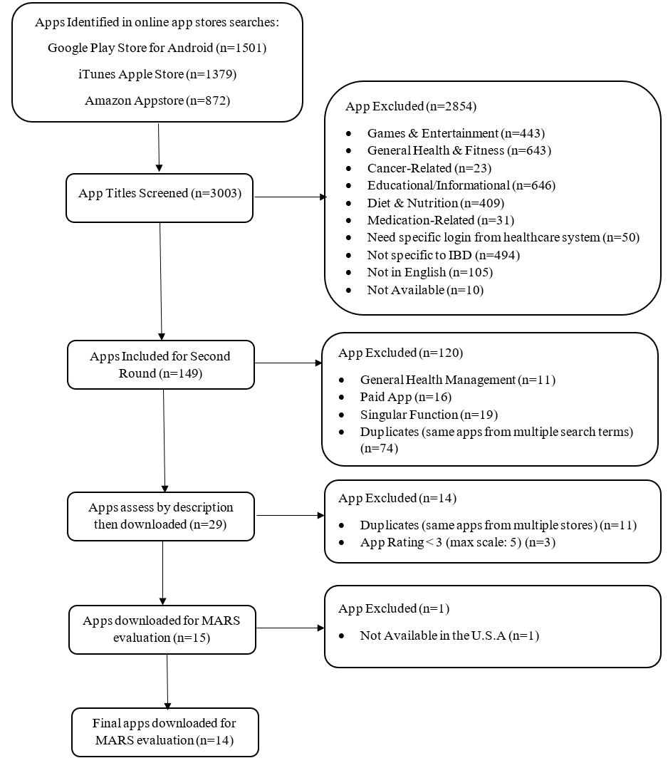

**Mobile Application Rating Scale**

The MARS scale, scored using a 5-point Likert scale (1-inadequate, 2-poor, 3-acceptable, 4-good, and 5-excellent), was used to rate the app quality. It consists of 3 main sections– classification, quality, and satisfaction– as well as modifiable app-specific sections that can be adapted to include or exclude specific functionalities based on app nature [25,26]. The classification section provides descriptive and information about the apps [25,26]. The quality section included both objective and subjective scales. The objective scale includes engagement, functionality, aesthetics, and information quality [25]. The subjective scale examines app quality, worth recommending, stimulates repeat use, and overall satisfaction [26]. The final evaluation of the MARS will be assessed by the mean score based on both the objective and subjective scales in addition to the overall mean scores for each quality scale.

**IQVIA Institute for Healthcare Informatics Functionality Score**

In addition to the MARS, the IQVIA Institute for Healthcare Informatics functionality scoring system [27] uses 7 independent functionality criteria (Inform, Instruct, Record, Display, Guide, Remind/Alert, and Communicate), and 4 functional subcategories to determine the app’s capabilities to provide relevant information to the users. [25,27]. Each reviewer assessed the apps on whether they have any of the 11 functionalities and a score of 0 to 11 will be generated. The functionalities are illustrated in Figure 2. This tool provides an assessment of app functionalities, offering another perspective to the evaluation.

**Crohn’s & Colitis Foundation of America**

Finally, each of the apps was evaluated for their inclusion of 7 specific IBD-specific self-care behaviors recommended by the Crohn’s & Colitis Foundation [3,18]. These behaviors included (1) tracking food intake (food diary), (2) daily monitoring of bowel habits, (3) emotion/ mood and (4) pain level, (5) following a restricted diet, (6) attending doctor’s appointment, and (7) taking prescribed medications on schedule. These guidelines are established for clinical practice with the intent of suggesting preferable approaches to IBD diseases. Apps evaluation will also take into consideration whether it was compliant with the recommended guidelines.

**Data Analysis**

Four reviewers studied the use of the MARS scoring methodology [26]. Four apps were chosen to be independently reviewed and the interrater reliability was calculated to confirm concordance among the reviewers. The two-way mixed interclass correlation coefficients (ICCs) analysis was performed using the statistical software, STATA (StataCorp LLC, College Station, TX). The following assumptions will be made for analysis: (1) variance of raters is negligible, (2) the mean rater error is zero [25], (3) effect of the individual rater and average of the raters are drawn from a large population [25,28].

**Results**

**Descriptive Characteristics**

A total of 3003 apps were screened and 14 apps were downloaded for review based on the strategy specified in the PRISM diagram (Figure 1). Most of the apps excluded from the initial 3003 apps are due to no relevance to IBD management (n=937), general health (n=643), or containing only one function related to IBD management, such as only for food tracking (n=409) or just containing educational information (n=646).

Table 2 contains descriptive information of the apps reviewed in this study. The apps included in the review are all Free but 28% (n=4) of the apps have an upgraded version costing between ($2.99 – $18.49). The apps downloaded are the most updated version as of February 2020, with 71% (n=10) of the apps updated within a year. Also, 71% (n=10) is available in both Apple and Google platforms and 86% (n=12) have a privacy policy regarding stored data. The average consumer star rating is 3.9 (±0.56) with a range from 0 to 5, with the higher value being the top-rated. There are 4 apps with over 50,000 installs: 1. Cara Care: IBS, IBD, GI Health, 2. mySymptoms Food Diary & Symptom Tracker (Lite), 3. GI Monitor, 4. Oshi: IBD Tracker.

|  |  |  |  |  |  |  |  |
| --- | --- | --- | --- | --- | --- | --- | --- |
| **Table 2:** Description of included apps | | | | | | | |
| Name | Star Ratingc | Installsa,c | Version | Cost | Platform | Privacy Policy | IQVIA scoreb |
| **Oshi: IBD Tracker** | 4.3 | 50,000+ | 1.9.0/1.9.0.2103 | Free | Apple/Google | Yes | 10 |
| **GI Monitor** | 3.2 | 100,000+ | 5.1.8/5.1.8 | Free | Google/Amazon | Yes | 8 |
| **Gut Health Storylines** | 4.5 | 500+ | 7.16/5.4.4 | Free | Apple/Google | Yes | 7 |
| **Cara Care: IBS, IBD, GI Health** | 4.5 | 400,000+ | 5.2.0/4597 | Free | Apple/Google | Yes | 7 |
| **My IBD Care** | 4.3 | 1,000+ | 2.401/2.33.6 | Free | Apple/Google | Yes | 7 |
| **myIBD+** | 3.55 | 1,000+ | 2.1/1.0 | Free | Apple/Google | No | 7 |
| **IBD Disk USA** | N/R | 10+ | 1 | Free | Google | Yes | 7 |
| **My IBD Manager from AGA** | 3.4 | 100+ | 1.5.1/2.0.0 | Free | Apple/Google | Yes | 6 |
| **CDHF App** | 3.7 | N/R | 1.1.0 | Free | Apple | Yes | 6 |
| **Gi BodyGuard from the CDHF** | 3.25 | 1,000+ | 3.0/1.3 | Free | Apple/Google | No | 6 |
| **mySymptoms Food Diary & Symptom Tracker (Lite)** | 4.4 | 400,000+ | 5.210-f | Free | Apple/Google | Yes | 5 |
| **myColitis** | 3.65 | 5,000+ | 2.0.4/2.0.3 | Free | Apple/Google | Yes | 5 |
| **IBD Fighter** | N/R | 500+ | 1.2.3/1.0 | Free | Apple/Google | Yes | 5 |
| **Bowelle - The IBS tracker** | 4.8 | N/R | 1.16.9 | Free | Apple | Yes | 4 |

aData on number of installs were only available in Google Pay

bThe functionality score refers to the IMS Functionality Score which ranges from 0-11.

cAbbreviations: N/R: not recorded

**MARS App Quality Scores**

Table 3 illustrates the scores from the review outlined by MARS. The apps were rated based on the following categories: Engagement, Function, Aesthetics, Information, Satisfaction, Behavior Change. Item 19 from MARS, regarding evidence-based information, was not used as part of the scoring because the majority of the apps have not been trialed/tested. The inter-rater reliability calculated based on MARS scoring was high (two-way mixed CA-ICC = 0.937, 95% CI: 0.684-0.995), indicating consensus between the reviewers. The MARS scale ranges from 0 being the lowest to 5 being the highest score. The highest median score was from information (4.4) and the lowest was from satisfaction (2.25).

The overall score from MARS ranges from 3.2 to 4.2 with a median score of 3.75 and 64% (n=9) of the apps have an overall score between 3 – 3.9 and 36% (n=5) have scores between 4 – 4.2. The maximum overall score is 4.2 and 4 apps achieved this rating: 1. Oshi: IBD Tracker, 2. Gut Health Storylines, 3. myColitis, 4. My IBD Care. The app Oshi: IBD Tracker attained the highest rating for both satisfaction (4.1) and behavior change (4.3).

|  |  |  |  |  |  |  |  |
| --- | --- | --- | --- | --- | --- | --- | --- |
| **Table 3.** Mobile Application Rating Scale scores | | | | | | | |
| Name | Engage | Function | Aesthetics | Information | Satisfaction | Behavior Change | Overall* |
| **Oshi: IBD Tracker** | 4.2 | 4.6 | 4.2 | 4.0 | 4.1 | 4.3 | 4.2 |
| **Gut Health Storylines** | 4.1 | 4.4 | 4.7 | 3.5 | 2.9 | 3.4 | 4.2 |
| **myColitis** | 3.9 | 5.0 | 4.5 | 3.5 | 3.8 | 3.9 | 4.2 |
| **My IBD Care** | 3.9 | 4.6 | 4.3 | 4.0 | 3.1 | 3.6 | 4.2 |
| **Cara Care: IBS, IBD, GI Health** | 3.9 | 5.0 | 3.7 | 3.8 | 3.1 | 3.4 | 4.1 |
| **myIBD+** | 3.2 | 4.8 | 4.0 | 3.4 | 2.4 | 3.3 | 3.8 |
| **IBD Disk USA** | 2.2 | 4.3 | 4.2 | 4.4 | 1.5 | 1.8 | 3.8 |
| **mySymptoms Food Diary & Symptom Tracker (Lite)** | 3.1 | 4.5 | 4.0 | 3.2 | 3.5 | 3.9 | 3.7 |
| **IBD Fighter** | 2.9 | 3.6 | 4.7 | 2.5 | 1.5 | 2.3 | 3.4 |
| **CDHF App** | 3.9 | 3.8 | 2.7 | 3.3 | 1.6 | 3.1 | 3.4 |
| **Bowelle - The IBS tracker** | 2.1 | 4.1 | 3.8 | 3.1 | 2.0 | 2.3 | 3.3 |
| **Gi BodyGuard from the CDHF** | 2.6 | 4.1 | 3.3 | 2.8 | 2.1 | 2.6 | 3.2 |
| **My IBD Manager from AGA** | 3.0 | 3.8 | 2.5 | 3.4 | 1.6 | 2.6 | 3.2 |
| **GI Monitor** | 2.7 | 3.4 | 3.5 | 3.1 | 1.9 | 3.1 | 3.2 |

*Overall score is based on the mean value from Engage, Function, Aesthetics, and Information category

**Functionality**

The median functionalities based on IQVIA Institute for Healthcare Informatics was a 6.5 (4 – 10) out of a total of 11, with one app achieving the highest number of functionalities of 10: Oshi: IBD Tracker. All apps provide both display and record functions, and very few apps provided the function to collect (n=5), evaluate (n=4), and intervene (n=1). There are 11 apps with the function to inform and provide reminders/alerts, 9 to instruct, 9 to communicate, 6 to guide, and 6 to share (Figure 2).

**Figure 2**. The functionality of included apps based on IQVIA Institute for Healthcare Informatics functionality scores

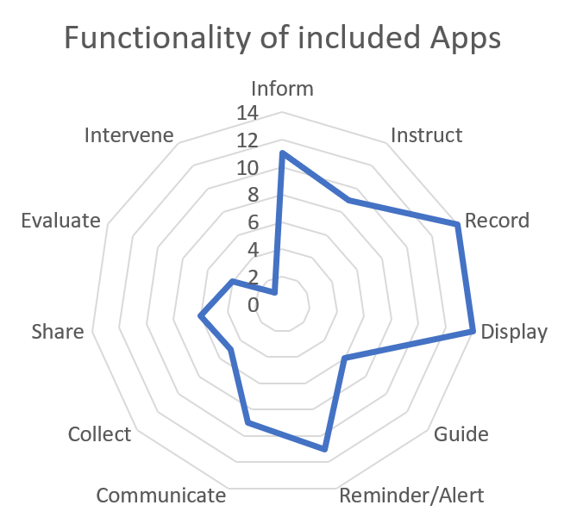

All the apps have the function to display and record data. The information the apps can record, and display includes symptoms, moods/stress, vitals, bowel movements, nutritional intake, appointment calendars, and activity level. Most of the apps provide information about health status in graphical format (pie, line, and bar graphs). Much of the reminders/alerts function is related to medication adherence. The function to communicate from the apps includes: (1) email to your support team, (2) communicate with experts, (3) direct text messaging (Whatsapp and Text). The 6 apps that can share health information all involved the export of pdf reports to the user’s registered email which allows the document to be shared with others.

The app with the highest functionality score is Oshi: IBD Tracker with the ability to inform, instruct, record, display, guide, reminders/alerts, communicate, shared, evaluate, and intervene. Oshi: IBD Tracker is available in both Google Play Store and Apple’s iTunes App Store. The app allows users to input daily symptoms (Figure 3a) and display the information in a line graph format (Figure 3b). Furthermore, it provides information to patients based on user-entered data, such as sending information to users when high stress was indicated (Figure 4a). Also, based on the symptoms entered, it can automatically generate a partial Harvey-Bradshaw Index (HBI) score to help users determine the severity of their IBD. Additionally, it can connect to the Apple HealthKit (Figure 4b) and sync with other Health/Fitness Trackers (Figure 4c), such as Fitbit and Garmin. The Android version of the app only has the Health/Fitness Tracker option under ‘Connected Devices’. Through the app, patients can ask experts questions about their health concerns and these questions, with the patient’s identity anonymized, are shared among the IBD community (Figure 4d). Oshi Health aims to have additional functionalities such as provider communication, EMR integration, and Flare predictors to be included in future upgrades.

**Figure 3**. Oshi: IBD Tracker features: (a) information input and (b) output of user-entered data

(a)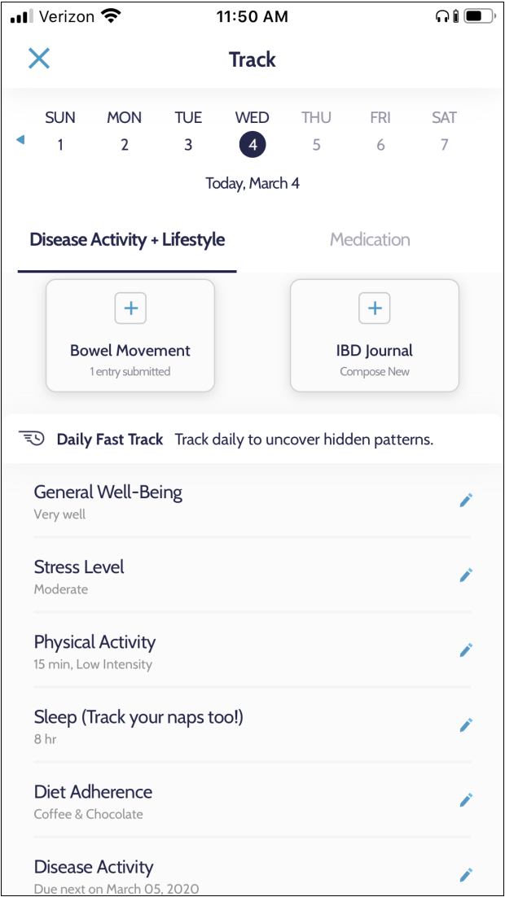 (b) 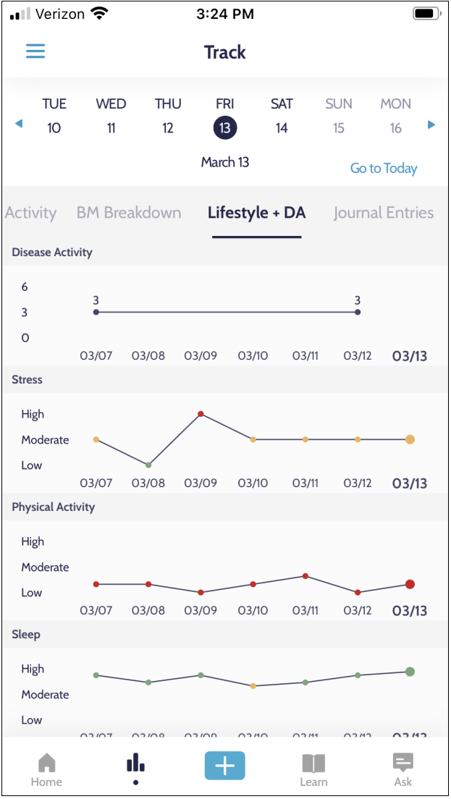

**Figure 4.** Oshi: IBD Tracker features: (a) intervene, (b,c) connection with other technologies, and (d) ask the expert

(a)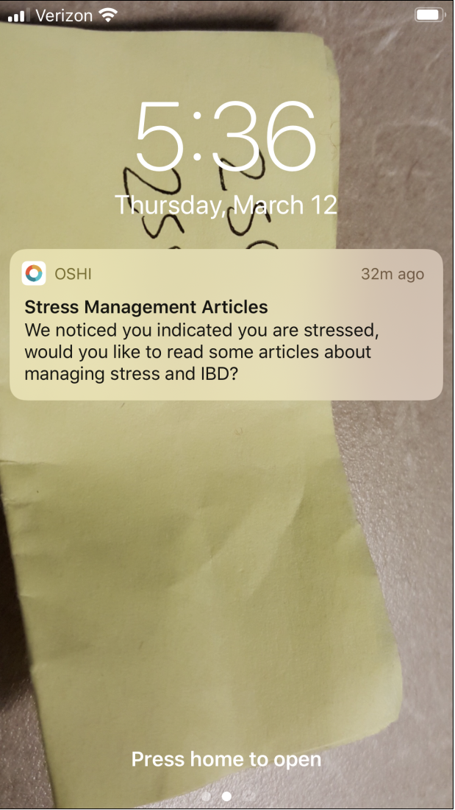 (b) 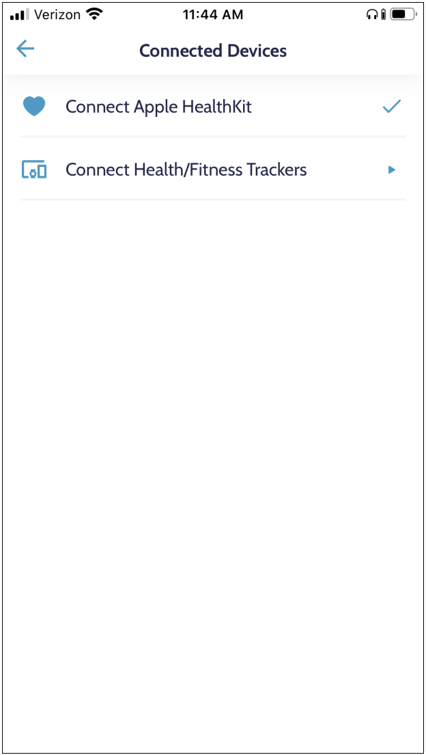 (c)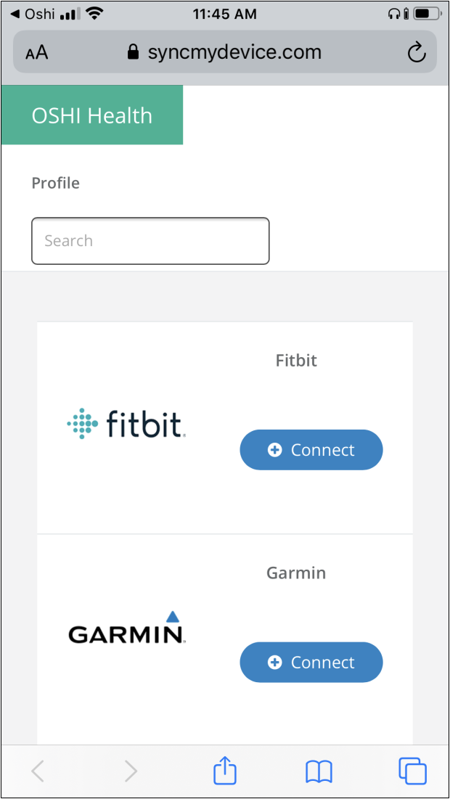 (d)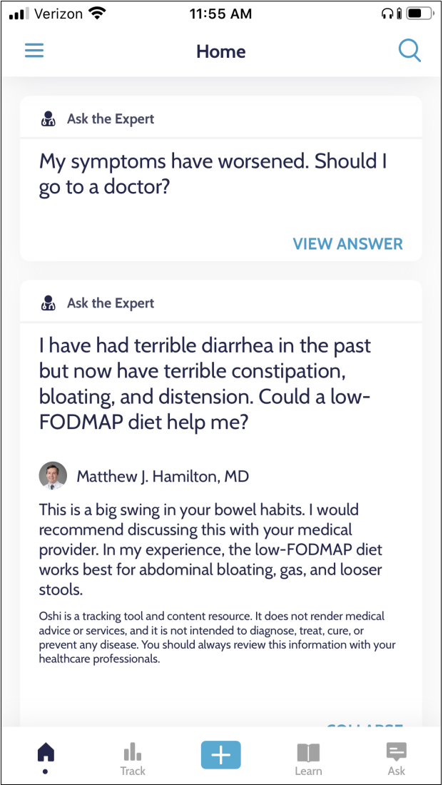

**Crohn’s & Colitis Foundation of America Guidelines**

Table 4 indicates the self-management guidelines from the Crohn’s & Colitis Foundation for individuals diagnosed with IBD. These guidelines include adherence to medication, keeping doctor’s appointments, nutritional/diet tracking, managing symptoms (include bowel movement), coping with stress/emotion via support network, and education/information (3–5,29). There are 3 apps contain most of the recommended guidelines: (1) Oshi: IBD Tracker, (2) Gut Health Storylines, and (3) GI Monitor. Only 14% of the apps (n=2) that was review contains the ability to remind the patient of their doctor’s appointment. All the apps can track bowel movements, but few apps can alert/remind the patient of doctor’s appointments (n=2) and to provide network support (n=3). A majority of the apps can track mood/stress (n=13), monitor symptoms (n=13), track diet/nutrition (n=11), and give alerts/reminders for medication (n=11). About 50% of the apps review provide education/information (n=8) about IBD for the patient.

|  |  |  |  |  |  |  |  |  |  |
| --- | --- | --- | --- | --- | --- | --- | --- | --- | --- |
| **Table 4.** Crohn’s & Colitis Foundation of America – recommendations for IBD self-management | | | | | | | | | |
| Name | Medication Adherence | Bowel Movements | Diet & Nutrition | Mood/ Stress Tracking | Monitoring Symptoms | Support Network | MD Appointment Reminders | Educational/ Informational | Total Score |
| Oshi: IBD Tracker |  |  |  |  |  |  |  |  | 7 |
| Gut Health Storylines |  |  |  |  |  |  |  |  | 7 |
| GI Monitor |  |  |  |  |  |  |  |  | 7 |
| My IBD Care |  |  |  |  |  |  |  |  | 6 |
| My IBD Manager from AGA |  |  |  |  |  |  |  |  | 6 |
| myColitis |  |  |  |  |  |  |  |  | 6 |
| myIBD+ |  |  |  |  |  |  |  |  | 6 |
| Cara Care: IBS, IBD, GI Health |  |  |  |  |  |  |  |  | 5 |
| CDHF App |  |  |  |  |  |  |  |  | 5 |
| mySymptoms Food Diary & Symptom Tracker (Lite) |  |  |  |  |  |  |  |  | 5 |
| Bowelle – The IBS tracker |  |  |  |  |  |  |  |  | 4 |
| Gi BodyGuard from the CDHF |  |  |  |  |  |  |  |  | 4 |
| IBD Fighter |  |  |  |  |  |  |  |  | 4 |
| IBD Disk USA |  |  |  |  |  |  |  |  | 3 |

**Overall App Quality**

Oshi: IBD Tracker app is the best IBD self-management app based on evaluation from the MARS (4.2/5), IQVIA Institute for Healthcare Informatics functionality score (10/11), and the recommended features from the Crohn’s and Colitis Foundation (7/8). The feature with the highest MARS rating from the app is function (4.6), followed by its ability to change patient behavior (4.3). The app contains most of the criteria from the IQVIA Institute for Healthcare Informatics, only missing the function to store input data directly to the user’s mobile phone, hence it can only function when the internet is available. This app also covers most of the recommended features from the Crohn’s & Colitis Foundation but lacking the ability to send reminders for doctor’s appointments. This app is relatively new, launched in 2018, and its developers are still actively improving and upgrading.

**Discussion**

The fact that many people suffering from symptoms of IBD are young, and that more than 92% of adults own a smartphone, have opened a path for mobile health application as an effective means for improving health outcomes and quality of life. The treatment for IBD involves both self and clinical management. It is highly recommended that adherence to the guidelines and inclusion of functionality from IQVIA may help with improving the quality of life for individuals with IBD. There have been few studies that completed an in-depth review of the mHealth apps available for IBD management [2,12,21,30]. Due to the ever-evolving technological advancements, many of the previous highly-rated apps have become obsolete. The purpose of this review was to review commercially available mHealth apps to evaluate their quality and functionalities using validated instruments and to identify the best mHealth application for IBD monitoring and management We found all apps have both the record and display functionality but few apps have the functionality to collect, intervene, and evaluate. Additionally, from the apps that were review, the majority lacks the ability to set alerts/reminders for doctor’s appointments and does not contain a social network for support.

**Function: MD Appointment Reminders**

MD appointment reminders/alerts are an important function to include in IBD related health apps, as IBD management does not only occur inside the office nor only in the home. For a holistic approach and to achieve maximum benefits for any chronic disease management, it is important for the two sectors of a patient's lives to be in sync. Disease management occurs in the provider's office, is carried out at home and must be connected back to the provider for optimal success. According to the Chronic Care Model (CCM) [31], for effective care of chronic disease, care for patients must include the following: (1) health systems, (2) community resources, (3) self-management support, (4) delivery system design, (5) clinical decision support, and (6) clinical information system. The use of mHealth apps can contribute to the CCM. One of the components of the CCM is delivery system design which focuses on teamwork, as between provider and patients, to ensure compliance with planned visits and to sustained follow-up. Thus, it would be essential to both providers and patients if the mHealth apps could include doctor’s appointment reminders and a direct line of connection to the provider so that care is continuous and thorough. Overall, we found two mHealth apps, Gut Health Storyline and My IBD Care, that have the function to alert/remind users of their upcoming doctor’s appointment. Though Oshi: IBD Tracker is the highest rated app in both MARS and IQVIA functionality scores, it currently lacks this feature. Currently, only apps affiliated with the medical institution have this capability. There is also an indication that ideal eHealth intervention for IBD improved communications between patients and providers [2]. To take full advantage of mHealth, it is very important to ground care back to the provider's office.

**Function: Evaluation & Intervene**

To accrue the maximum benefit of mhealth apps to those with IBD, data collected from the apps should incorporate the function to evaluate and intervene, which is lacking in the majority of the apps that we reviewed. The goal of mHealth is to empower patients to make more informed decisions based on the information collected about their condition. The report they obtained from the apps must provide an evaluation of subjectively input data, in addition to objective, quantifiable physiological, and behavioral data. Furthermore, the reports must be in a form comprehensible to the patient because not all patients can understand the graphs display in the apps [32]. Additionally, the ability to notify the patient that intervention is recommended, such as consultation with your physician, is significant in preventing the worsening of the disease. The benefits of providing both evaluation and intervention functionality enable longitudinal data to be used to react to any deviations to the patient’s health as well as forecast possible critical or relevant gastrointestinal situations. Both retrospective and prospective information have the potential to optimize and personalize treatment or therapy concepts by identifying critical points for intervention [33]. Concerning that, developers, clinicians, and patients have a joint responsibility to think of new data-driven therapy concepts based on aggregated data through mHealth to ensure high quality and efficient patient-centered treatment for IBD diseases.

**Strengths and Limitations**

The strength of this study focuses on the use of the proven methodology for systematic review based on previously published work [25]. The methodology has been adapted towards mHealth apps for IBD management and the guidelines used are from the Crohn’s & Colitis Foundation of America. This foundation has provided useful information to help IBD patients for more than 50 years. Additionally, previous studies on mHealth apps for IBD management did not use the rigorous evaluation technique as this study. The study conducted by the Canadian group in 2018 only used the MARS to evaluate their IBD apps whereby this research utilized MARS, IQVIA functionality score, and IBD management guidelines for a more well-rounded assessment of the apps.

Although the methodology is considering a strength to this study, it also has limitations. To strengthen the results of this study, a long-term evaluation of the application is necessary. All the analysis of this review was based on initial use and impression of the apps. The short-term review of the apps might lead to features that could be missed or lack of understanding of certain feature’s capabilities.

Lastly, the apps reviewed in this study are limited to what is available to the U.S population and also based on the devices from Apple iOS and Google, which are the most popular digital platforms in the U.S.A. Since IBD is a worldwide problem, over 6.8 million cases globally [34], there could be apps developed in other countries that may be more advance and effective. However, in this study, apps from other countries were not reviewed due to regional availability issues.

**Future directions and outlook**

Useage of health applications may have initial steady use, however consistent usage of mobile apps overtime needs to be further promoted and encouraged to optimize the benefits of built-in functions, appointment reminders/alerts, evaluation, and intervention. In a study conducted by Peng et al, barriers in health application adoption: Low awareness of health apps, lack of app literacy, lack of need for health apps, and cost contribute to low adaptation to using mHealth [35]. The study also found that barriers to continued use as lack of time and effort, and lack of motivation may contribute to the lack of sustainable app usage. Motivators to use mHealth apps were found to be social competition, intangible rewards, hedonic factors (game effect), and internal motivation [35]. Similar to what is explained in the health belief model (HBM), continuous use of mhealth applications has to come from patients' desires to improve their well-being. While the tools provided may be initially useful, users may get tired of the consistent manual entering of symptoms. As perceived barriers tend to be the strongest factor for health behavior and health behavior change, current mHealth app must be created based on the HBM framework to promote consistent use. Therefore, to help improve app usage sustainability, developers should work with patients to learn factors that contribute to long term use.

The recommended guideline from the Crohn’s & Colitis Foundation can benefit from stronger evidence that supports its benefits in IBD self-management. The effectiveness of self-management for IBD still needed verification on their ability to improve health outcomes. Study trials indicate that self-management interventions may produce benefits such as the reduction in disease activity, and improvement to adherence and psychological health but the results were not conclusive due to inconsistency in results from other trials [36]. Hence, an adequately power randomized trial is required to assess the efficacy of self-management and to identify the required specifications for IBD care [36]. To quantify how useful mHealth is in IBD management, more research, both systematic and clinical trials, is needed in the future. The recommended guidelines used to evaluate the mHealth app in this study may be changed in accordance with future research evidence.

Moreover, it is highly recommended that the top app was chosen from this review, Oshi: IBD Tracker should be further evaluated in a clinical trial. This developer of this app is continuously striving to improve its functionality. Therefore, by incorporating the app in a clinical trial, it will give more feedback to further improve and enhance the app to provide better patient care.

**Conclusion:**

There are limited numbers of commercially available mHealth apps that have a high MARS score, IMS functional score, and contains all recommended features suggested by the Crohn’s and Colitis Foundation. Those with IBD should consider using Oshi: IBD Tracker for health monitoring and management. Nevertheless, app developers should strive to improve their design based on self-management guidelines from the Crohn’s and Colitis Foundation and to increase the number of higher-order functionalities, including collecting, intervening and evaluating data. Furthermore, we need to involve patients during the development phase of the app to gain better insights into factors that contribute to keeping users engaged and motivated. By resolving the inadequacies as specified from this review, IBD mHealth app will be a valuable instrument for both providers and patients to successfully treat and maintain the disease.

**References**

1. Dahlhamer JM, Zammitti EP, Ward BW, Wheaton AG, Croft JB. Prevalence of Inflammatory Bowel Disease Among Adults Aged ≥18 Years - United States, 2015. MMWR Morb Mortal Wkly Rep. 2016 Oct 28;65(42):1166–9.

2. Con D, De Cruz P. Mobile Phone Apps for Inflammatory Bowel Disease Self-Management: A Systematic Assessment of Content and Tools. JMIR Mhealth Uhealth. 2016 Feb 1;4(1):e13.

3. Benefits of self-management interventions for young patients with IBD have been identified, but further research is needed | Crohn’s & Colitis Foundation [Internet]. [cited 2020 Jan 27]. Available from: https://www.crohnscolitisfoundation.org/blog/benefits-self-management-interventions-young-patients-ibd-have-been-identified-further

4. Causes of Ulcerative Colitis – Understand the Possible Factors [Internet]. [cited 2020 Jan 18]. Available from: https://www.crohnsandcolitis.com/ulcerative-colitis/causes?cid=ppc_ppd_ggl_uc_da_what_is_the_cause_of_ulcerative_colitis_Exact_64Z1867746&gclid=Cj0KCQiA9orxBRD0ARIsAK9JDxRMGLO7Lfr1eL3Qf0bFCMkYVldX2SKL0KAqGQKe2d_38Kh0g2LnkeMaAi4iEALw_wcB

5. Causes of Crohn’s Disease – Understand the Possible Factors [Internet]. [cited 2020 Jan 18]. Available from: https://www.crohnsandcolitis.com/crohns/causes?cid=ppc_ppd_ggl_cd_da_cause_of_crohn%27s_disease_Exact_64Z1867745&gclid=Cj0KCQiA9orxBRD0ARIsAK9JDxSyZ4eY_pczoEO9T2U7uFyMvJlLCnnarciFnygTqQMS4o35Q3383dYaAvgTEALw_wcB

6. The Facts about Inflammatory Bowel Disease | Crohn’s & Colitis Foundation [Internet]. [cited 2020 Jan 18]; Available from: https://site.crohnscolitisfoundation.org/assets/pdfs/ibdfactbook.pd

7. Bossuyt P, Pouillon L, Bonnaud G, Danese S, Peyrin-Biroulet L. E-health in inflammatory bowel diseases: More challenges than opportunities? Dig Liver Dis. 2017 Dec;49(12):1320–6.

8. Yin AL, Hachuel D, Pollak JP, Scherl EJ, Estrin D. Digital health apps in the clinical care of inflammatory bowel disease: scoping review. J Med Internet Res. 2019 Aug 19;21(8):e14630.

9. Demographics of Mobile Device Ownership and Adoption in the United States | Pew Research Center [Internet]. [cited 2020 Jan 11]. Available from: https://www.pewresearch.org/internet/fact-sheet/mobile/

10. The Mobile Economy. GSMA [Internet]. 2019 [cited 2020 Jan 10]; Available from: https://www.gsmaintelligence.com/research/?file=b9a6e6202ee1d5f787cfebb95d3639c5&download

11. Health Online 2013 | Pew Research Center [Internet]. [cited 2020 Jan 18]. Available from: https://www.pewresearch.org/internet/2013/01/15/health-online-2013/

12. Walsh A, Travis S. What’s app? Electronic health technology in inflammatory bowel disease. Intest Res. 2018 Jul 27;16(3):366–73.

13. Con D, Jackson B, Gray K, De Cruz P. eHealth for inflammatory bowel disease self-management - the patient perspective. Scand J Gastroenterol. 2017 Sep;52(9):973–80.

14. Matsuoka K, Kobayashi T, Ueno F, Matsui T, Hirai F, Inoue N, et al. Evidence-based clinical practice guidelines for inflammatory bowel disease. J Gastroenterol. 2018 Mar;53(3):305–53.

15. Rubin DT, Ananthakrishnan AN, Siegel CA, Sauer BG, Long MD. ACG clinical guideline: ulcerative colitis in adults. Am J Gastroenterol. 2019;114(3):384–413.

16. Lichtenstein GR, Loftus EV, Isaacs KL, Regueiro MD, Gerson LB, Sands BE. ACG clinical guideline: management of crohn’s disease in adults. Am J Gastroenterol. 2018 Mar 27;113(4):481–517.

17. Ankersen DV, Carlsen K, Marker D, Munkholm P, Burisch J. Using eHealth strategies in delivering dietary and other therapies in patients with irritable bowel syndrome and inflammatory bowel disease. J Gastroenterol Hepatol. 2017 Mar;32 Suppl 1:27–31.

18. Hanson G, Sareigo J. Living with Crohn’s Disease. Crohn’s & Colitis Foundation [Internet]. 2018 Oct [cited 2020 Feb 23]; Available from: http://www.crohnscolitisfoundation.org/sites/default/files/legacy/assets/pdfs/living-with-crohns-disease.pdf

19. Kelso M, Feagins LA. Can smartphones help deliver smarter care for patients with inflammatory bowel disease? Inflamm Bowel Dis. 2018 Jun 8;24(7):1453–9.

20. Jackson BD, Gray K, Knowles SR, De Cruz P. Ehealth technologies in inflammatory bowel disease: A systematic review. J Crohns Colitis. 2016 Sep;10(9):1103–21.

21. Liu EY, Crawford J, Worobetz L, Bhasin S. A148 SMARTPHONE APPS FOR IBD DISEASE MANAGEMENT: A QUANTITATIVE EVALUATION. J Can Assoc Gastroenterol. 2018 Mar 1;1(suppl_1):254–5.

22. Sewitch MJ, Fallone CA, Ghali P, Lee GE. What Patients Want in a Smartphone App That Supports Colonoscopy Preparation: Qualitative Study to Inform a User-Centered Smartphone App. JMIR Mhealth Uhealth. 2019 Jul 2;7(7):e12242.

23. Carlsen K, Hald M, Dubinsky MC, Keefer L, Wewer V. A Personalized eHealth Transition Concept for Adolescents With Inflammatory Bowel Disease: Design of Intervention. JMIR Pediatr Parent. 2019 Apr 24;2(1):e12258.

24. Masterson Creber RM, Grossman LV, Ryan B, Qian M, Polubriaginof FCG, Restaino S, et al. Engaging hospitalized patients with personalized health information: a randomized trial of an inpatient portal. J Am Med Inform Assoc. 2019 Feb 1;26(2):115–23.

25. Masterson Creber RM, Maurer MS, Reading M, Hiraldo G, Hickey KT, Iribarren S. Review and Analysis of Existing Mobile Phone Apps to Support Heart Failure Symptom Monitoring and Self-Care Management Using the Mobile Application Rating Scale (MARS). JMIR Mhealth Uhealth. 2016 Jun 14;4(2):e74.

26. Stoyanov SR, Hides L, Kavanagh DJ, Zelenko O, Tjondronegoro D, Mani M. Mobile app rating scale: a new tool for assessing the quality of health mobile apps. JMIR Mhealth Uhealth. 2015 Mar 11;3(1):e27.

27. Patient Apps for Improved Healthcare: From Novelty to Mainstream. IMS Institute for Healthcare Informatics. 2013

28. McGraw KO, Wong SP. Forming inferences about some intraclass correlation coefficients. Psychol Methods. 1996;1(1):30–46.

29. IBD Symptom Tracker. |Crohn’s & Colitis Foundation [Internet]. [cited 2020 Feb 23]; Available from: https://www.crohnscolitisfoundation.org/sites/default/files/legacy/assets/pdfs/ibd-symptom-tracker.pd

30. Pedersen N. EHealth: self-management in inflammatory bowel disease and in irritable bowel syndrome using novel constant-care web applications. EHealth by constant-care in IBD and IBS. Dan Med J. 2015 Dec;62(12):B5168.

31. Barr VJ, Robinson S, Marin-Link B, Underhill L, Dotts A, Ravensdale D, et al. The expanded Chronic Care Model: an integration of concepts and strategies from population health promotion and the Chronic Care Model. Hosp Q. 2003;7(1):73–82.

32. Ancker JS, Senathirajah Y, Kukafka R, Starren JB. Design features of graphs in health risk communication: a systematic review. J Am Med Inform Assoc. 2006 Dec;13(6):608–18.

33. Meister S, Deiters W, Becker S. Digital health and digital biomarkers – enabling value chains on health data. Current Directions in Biomedical Engineering. 2016 Jan 1;2(1).

34. GBD 2017 Inflammatory Bowel Disease Collaborators. The global, regional, and national burden of inflammatory bowel disease in 195 countries and territories, 1990-2017: a systematic analysis for the Global Burden of Disease Study 2017. Lancet Gastroenterol Hepatol. 2020 Jan;5(1):17–30.

35. Peng W, Kanthawala S, Yuan S, Hussain SA. A qualitative study of user perceptions of mobile health apps. BMC Public Health. 2016 Nov 14;16(1):1158.

36. Tran L, Mulligan K. A Systematic Review of Self-Management Interventions for Children and Adolescents With Inflammatory Bowel Disease. Inflamm Bowel Dis. 2019 Mar 14;25(4):685–98.