The problem: Item valuing in the video game Dark and Darker. It’s currently a time-consuming task to value items since the market is always changing. I want to use AI to predict the value of an item based off its info. Items are also used as currency, and the items used for currency can change. For example, a rare axe could be worth 3 common swords. The idea is to use the trade post, where people showcase their items with prices to train a machine learning model. The data could easily include ~80,000 trade messages. The data is structured but messy.
The input: Item info (name, type, effects, rarity)
The output is one of: Relative value score/Price range/Price in multiple currencies

These are some items; some have effects some do not. Some effects are more desirable and increase the price of an item.
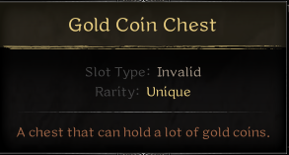
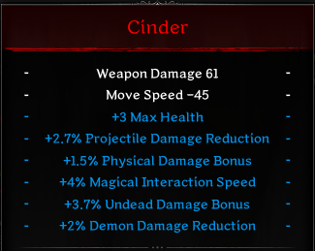
In the example above, +3 Max Health and +1.5% Physical Damage Bonus increase the items value, while +4% Magical Interaction Speed and the others are near useless.

The trade post has many styles of messages for different purposes. Handling noise is an area of my concern. Below is an example of some common messages.
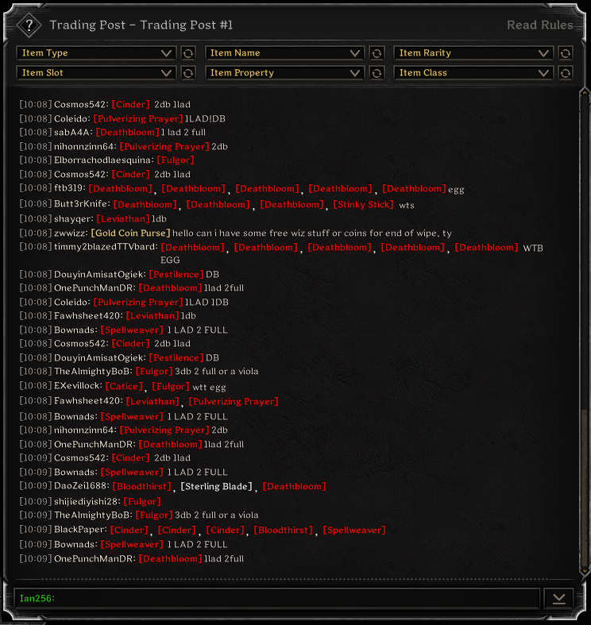

This is what the data looks like for a trade message, not all the info is needed.
{
"result": 1,
"chats": [
{
"index": "82824401",
"chatType": 1,
"time": "1769134743670",
"chatData": {
"accountId": "3168203",
"characterId": "16245919",
"nickname": {
"originalNickName": "SoftHandSlayer",
"streamingModeNickName": "Barbarian#11115145",
"karmaRating": -2,
"rankId": "LeaderboardRankData:Id_LeaderboardRank_Voyager_II",
"fame": 477,
"nameplateSkinId": "NameplateSkinData:Id_NameplateSkin_RuinsExplorer",
"rankIconType": 1,
"adventureRankId": "LeaderboardRankData:Id_LeaderboardRank_Voyager_II",
"arenaRankId": "LeaderboardRankData:Id_LeaderboardRank_Cadet"
},
"chatDataPieceArray": [
{
"chatStr": "[Catice]",
"chatDataPieceItem": {
"uid": "538209800249418756",
"iid": "CrystalSword_8001",
"pp": [
{
"pid": "Effect_PhysicalWeaponDamage",
"pv": 13
},
{
"pid": "Effect_MagicalWeaponDamage",
"pv": 21
},
{
"pid": "Effect_MoveSpeed",
"pv": -25
}
],
"sp": [
{
"pid": "Effect_Strength",
"pv": 2
},
{
"pid": "Effect_ActionSpeed",
"pv": 24
},
{
"pid": "Effect_ProjectileReductionMod",
"pv": 26
},
{
"pid": "Effect_UndeadDamageMod",
"pv": 22
},
{
"pid": "Effect_Agility",
"pv": 2
},
{
"pid": "Effect_MemoryCapacityAdd",
"pv": 3
}
],
"se": []
}
},
{
"chatStr": "4db",
"chatDataPieceItem": {
"uid": "0",
"iid": "",
"pp": [],
"sp": [],
"se": []
}
}
],
"partyId": ""
}
}
],
"banDurationMin": 0,
"chatIdx": "0"
}

