Table of Contents

Overview 2

File History future 2

Summary 3

Configuration 5

Backup 17

Restore 21

Appendix A 26

Appendix B 28

Appendix C 31

Appendix D 34

Glossary 35

Document last updated: Sunday, 14 July 2024

# Overview

[*File History*](https://learn.microsoft.com/en-us/windows/compatibility/new-file-history-feature) is a feature in Microsoft Windows operating system version 10 that automatically creates backups of files that are present in folders. This ensures that even if the original files are lost, damaged or deleted, you can still restore them with ease. Moreover, you can also access different versions of your files from a specific point in time as per your requirement. *File History* automatically backs up files that are in folders. If the originals are lost, damaged, or deleted, you can restore all of them. You can also find different versions of your files from a specific point in time.

The utility automatically (or manually) backs up copies of your files at regular intervals to an external storage (USB) device. There is the provision to select which folders are backed up and which are ignored.

*File History* is integrated into the Microsoft Windows operating system, so there are no additional licence or cost implications.

The *File History Service* in Windows 10 is the engine that runs behind the scenes to make the File History utility function. Here's a breakdown of its role:

* **Enables Backups:** This service is responsible for automatically backing up your important files and folders at regular intervals (usually hourly) as long as the configured drive is connected.
* **Maintains File Versions:** It keeps track of different versions of your files, allowing you to restore older versions in case you accidentally overwrite or delete something.
* **Manages Storage:** The File History Service manages the storage space allocated for backups. It can delete older versions of files to free up space as needed.
* **Runs Continuously:** This service typically runs in the background, quietly performing backups without requiring any manual intervention.

In simpler terms, the File History Service is the backbone of the File History utility. It ensures your designated files are automatically backed up and readily available for restoration if needed.

## File History future

Prompt.

I'm led to believe that Microsoft is planning to remove (or discontinue) the Microsoft Windows 10 "File History" utility. Do you know anything about this please or know when this will happen?

Response.

I haven't found any official news from Microsoft regarding the complete removal of File History in Windows 10. It's still a built-in backup option.

There have been talks about Microsoft prioritizing OneDrive and pushing it as a cloud storage solution for backups. However, File History remains a valuable tool for users who prefer local backups or a combination of both cloud and local storage.

Here are some things to consider:

* While File History might not be the main focus for future updates, it's still functional in Windows 10.

* It's a good idea to stay updated on Microsoft announcements to see if their backup strategy changes in the future. You can follow their official Windows Blog for news: [https://blogs.windows.com/](https://blogs.windows.com/)

If local backups are important to you, File History is a good option for now. But it's also wise to keep an eye out for any future updates from Microsoft regarding their backup solutions.

Gemini. ( 19 April 2024 ). Information from a conversation with Google Gemini. Google AI. https://gemini.google.com/?hl=en

## Summary

1. **Purpose and Functionality**:

- **File History** keeps backup versions of your local files automatically.

- You can back up to a storage device such as a local external USB hard disk.

- It's recommended to invest in a large enough external drive to store ample data.

2. **Setting Up File History**:

- In **Windows 10**:

- Click **Start**, then go to **Settings > Update & Security > Backup**.

- Toggle on **"Automatically backup files"** and click on **"More options."**

- Customize what gets backed up: Add or exclude specific folders.

- Click **"Backup Now"** to initiate the backup process.

3. **Customization**:

- You can exclude specific folders from the backup by selecting them and clicking **"Remove."**

- To add a folder, click **"Add a folder"** and select the desired directory.

- Adjust backup intervals (minutes, hourly, daily, or weekly) as needed.

4. **Background Process**:

- **File History** works silently in the background.

- If you disconnect and later reconnect the external drive, it will continue backing up new versions of your files.

5. **Managing Space**:

- If you keep older file versions, your external drive may eventually run out of space.

- **File History** allows you to move backups to a larger external drive:

- Connect both the current and new drives.

- Launch the classic **Control Panel** (via **System and Security > File History**).

- Select the new drive and choose the existing backup to move.

- Click **OK** to transfer the backup.

Remember, **File History** ensures your files are backed up automatically, providing peace of mind for data protection!

# Configuration

These are the steps to implement *File History* on a Microsoft Windows version 10 computer*.* This is a one-off task because once setup, there shouldn’t be any need to do this again.

Before starting the configuration process though, as mentioned by Google Gemini, the Microsoft Windows "File History" utility requires the use of a service[1] by the name of *File History Service* which should be running in order to take "File History" backups.

The *Services Control Manager* panel, also known as Services, is a tool in the Windows 10 operating system that lets you manage background processes called services. It shows you a list of services with their names, descriptions, current status (running, stopped, paused), and startup type (automatic, manual). You can start, stop, pause, or change the startup type of individual services.

In short, it's like a mission control for background programs on your Windows 10 system.

Carry out the following steps to see whether this service is running, and start it if necessary.[2]

Step 1

Start the *Services Control Manager panel* by typing **services** in the Windows search box.

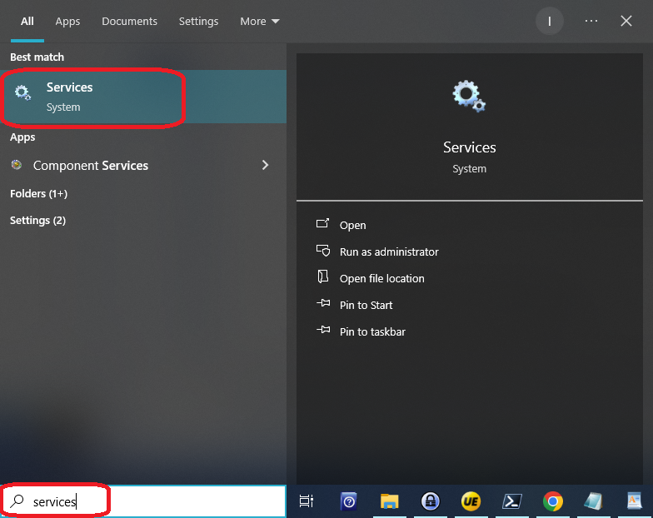

Step 2

Scroll down to **File History Service** and check column **Status**. If this column shows a status of **Running**, then all is well and there is nothing further to do at this stage. Exit this GUI screen and go to step 5.

In this example, the service isn’t running so we’re going to start it.

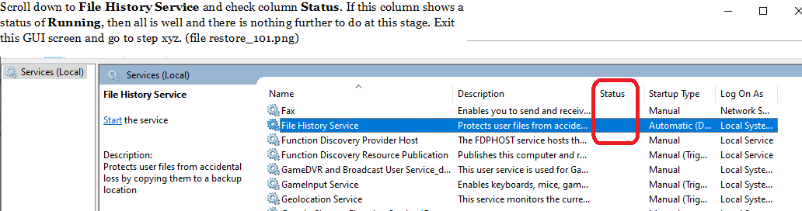

Step 3

Ensure service **File History Service** is highlighted and click **Start** which is towards the left-hand side of the panel.

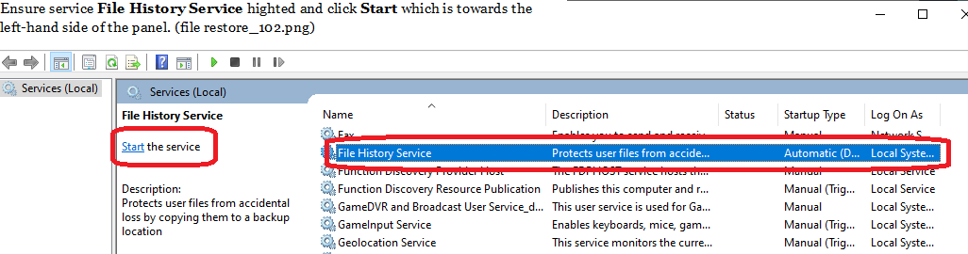

Step 4

Column **Status** should now have a status of **Running** as shown. Exit this GUI screen.

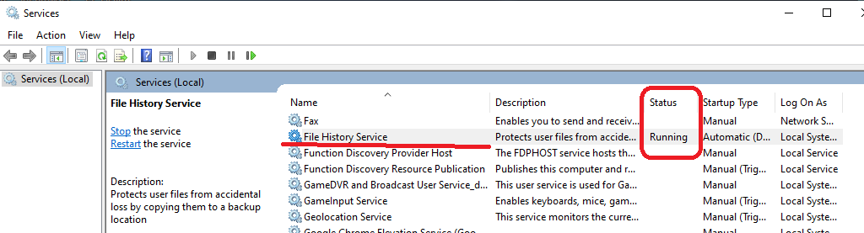

Step 5

Click **Start**



Step 6

Click **Settings** (which is the cog icon)

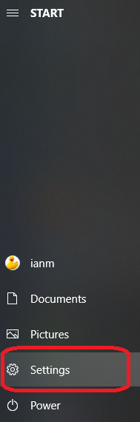

Step 7

Click **Update & Security** (which may be at the bottom so scroll down until you find it).

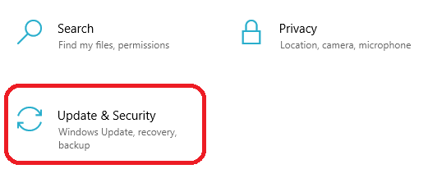

Step 8

Click **Files Backup** (which is one of the menu options on the left-hand side).

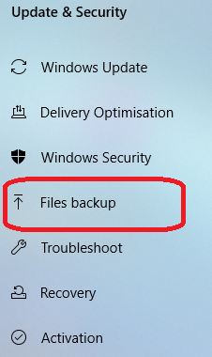

Step 9

Click **Add a drive**. This enables you to select your USB drive as a backup drive and should have been inserted prior to this step.

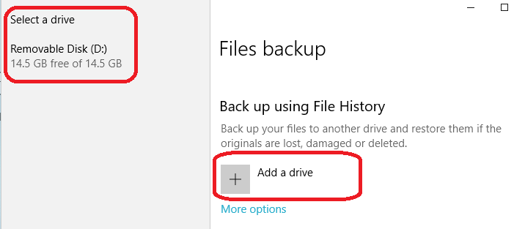

Now click on the '*Removable Disk*' which appears on the left-hand side at the top. Typically, there will only be one drive listed here. In the example shown, I’m using external drive ‘D’ but this may be different on other laptops and computers. It doesn’t really matter what the drive letter is as long as it’s an external drive.

The slider button below the words '*Automatically back up my files*' will now be colored blue.

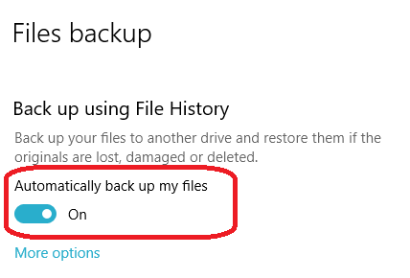

Step 10.

Click on the words **More options**.

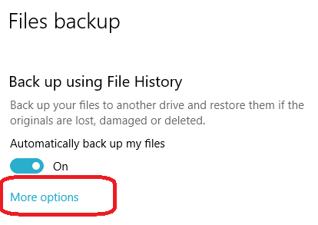

Step 11

When you initially go in to this screen without any prior setting up, you will see a list of folders such as these:

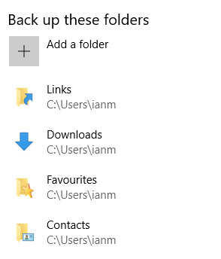

For this backup requirement, we don't need all of these folders, so we can remove them. Because our file of interest is in the '*Backup*' folder, do not remove this one.

To remove the folders from this list, click on the folder you want to remove, then click **Remove**. Please note, we're only removing folders from the backup list NOT the file system. Folders on the file system remain untouched.

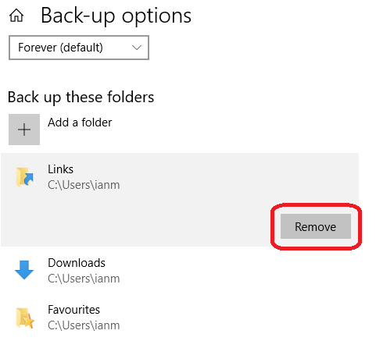

Removing folders from this list can be quite slow. As far as I'm aware, there is no bulk delete facility.

When the unwanted folders have been removed, we should have a list like this:

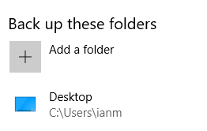

**Assumptions:**

Our file of interest is in the *Desktop* folder so this is the reason we’re backing up this particular folder. If the file of interest is in another folder, then backup that folder and rather than the *Desktop* folder.

Step 12

Click on the dropdown box under the words **Back up my files** to set the required frequency of the backup.

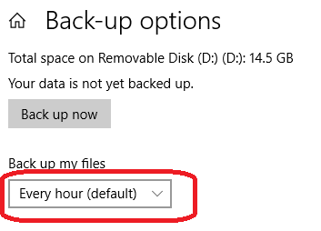

Unless there is any other requirement, set this to 'daily'.

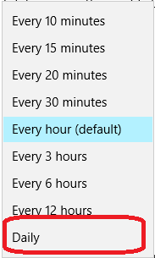

Step 13

Click on the dropdown box under the words **Keep my backups** to set the required retention period of the backup.

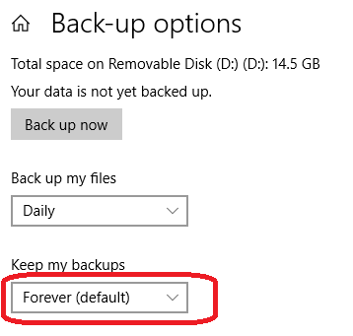

Unless there is any other requirement, set this to '*Until space is needed*'.

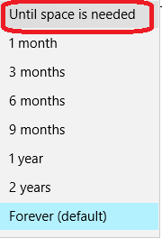

The "until space is needed" option refers to how long backups are retained. Let me explain:

* When you choose “until space is needed”, File History will keep saving versions of your files indefinitely until the available storage space is exhausted.
* As your storage fills up, File History will automatically delete older versions to make room for new backups.
* Essentially, it ensures that your backups continue until the storage space is required for other data.

Remember that *File History* is a valuable tool for safeguarding your files, but it’s essential to monitor storage usage to prevent unexpected interruptions.

Step 14

With the Back-up options configured, we should now see the following:

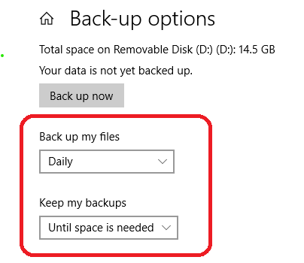

On looking at the backup drive as selected in step 5, you will see a folder called *D:\FileHistory*. This is where the backups live.

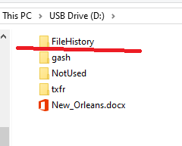

The configuration is now complete.

# Backup

These are the steps to back up a file (or files) once the configuration has been completed.

Step 1

Click **Start**



Step 2

Click **Settings**

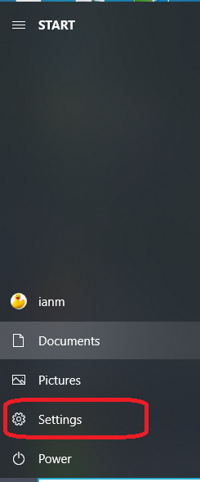

Step 3

Click **Update & Security**. This may be towards the bottom so you may have to scroll down to find it.

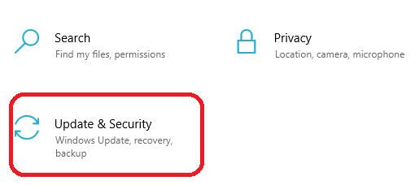

Step 4

Click **Files Backup**. This can be found on the left-hand side.

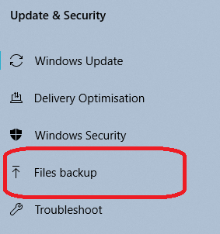

Step 5

Click on the words **More options**.

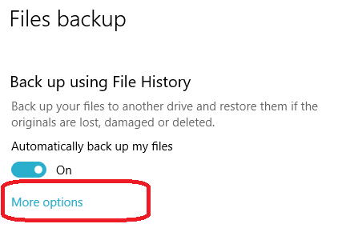

Step 6

Click on the button **Back up now**.

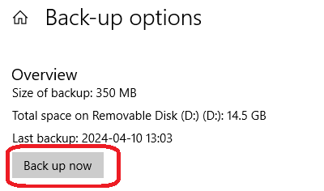

The **Last backup** timestamp shown should reflect the date and time to within a few minutes of the current date and time. Thus, confirming a backup has recently taken place. The file will only be backed up if it has been modified recently.

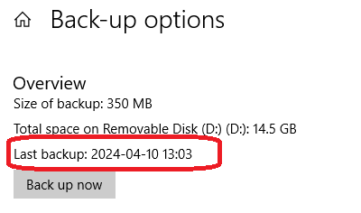

# Restore

Restoring a file from *File History* backups.

Step 1

Right-click on the file (shortcut or physical file) that you want to restore from a backup.

Step 2

Left-click on the option **Restore previous versions**.

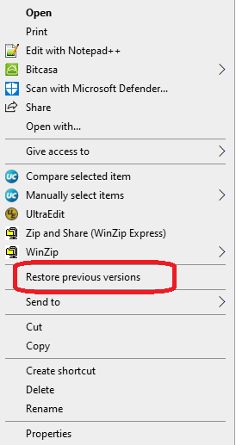

You will be presented with a dialog box listing the available file versions to restore.

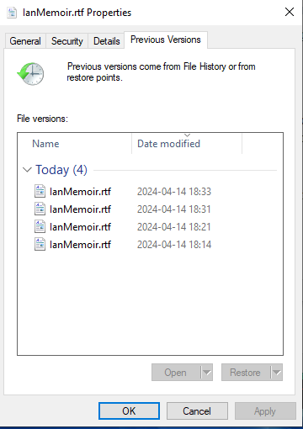

Step 3

Left-click on the particular version you wish to restore.

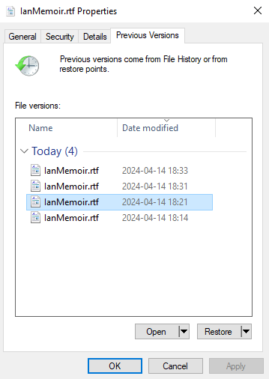

Step 4

Click **Restore**.

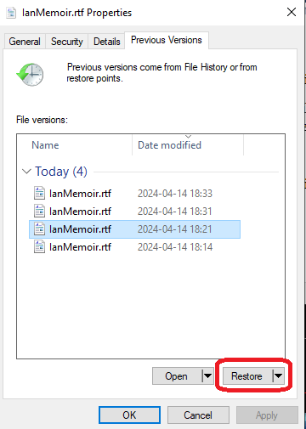

Step 5

Click the words **Replace the file in the destination**.

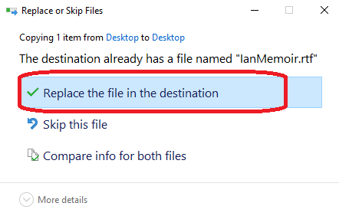

When the restore finishes, which only takes a few moments, Microsoft Windows File Explorer opens in the directory where the file was restored to.

# Appendix A

Using [Microsoft PowerShell](https://learn.microsoft.com/en-us/powershell/).

Microsoft PowerShell can be used in some aspects of this work for any troubleshooting or diagnostics that may be required. How useful this will be remains to be seen.

Microsoft Windows service *File History Service*

# Check the status of service ‘File History Service’

Get-Service -DisplayName "File History Service";

# Stop File History Service

# May need elevated privileges for this command.

Stop-Service -DisplayName "File History Service";

# Start File History Service

# May need elevated privileges for this command.

Start-Service -DisplayName "File History Service";

See what files we have backed up on a USB drive

& {

Set-StrictMode -Version Latest;

$ErrorActionPreference = "Stop";

$m = 'memoir';

$dletter = Get-Volume | Where-Object {$_.DriveType -eq 'Removable'} |

Select-Object -ExpandProperty DriveLetter;

$path = ('{0}:\FileHistory' -f $dletter );

Write-Host ('Looking at path [{0}]' -f $path);

Get-ChildItem -File -Path $path -Recurse | Where-Object {$_.Name -match $m}

}

# Appendix B

Troubleshooting

General troubleshooting steps.

Let's troubleshoot an issue with Windows 10 File History. Here are some steps you can take to investigate and potentially resolve the problem:

1. **Check File History Settings**:

- Open any folder by double-clicking its name.

- Click the **Home** tab on the Ribbon atop your folder, then click the **History** button.

- The File History program will appear, showing previous versions of files. Ensure that the settings are configured correctly¹.

2. **Verify Backup Frequency**:

- Go to **Control Panel > All Control Panel Items > File History**.

- Note the last run date. If it's outdated, follow these steps:

- Turn off File History.

- Turn it back on.

- Check if the last run date updates correctly.

3. **Check Event Logs**:

- Open the **Event Viewer** (you can search for it in the Start menu).

- Look for any errors related to File History.

4. **Manually Clean Up Old Backups**:

- Sometimes old backups are not automatically removed.

- Open File History and choose **Advanced Settings**.

- Click **Clean Up Versions** and use the drop-down to remove older files.

- Hit the **"Clean up"** button³.

5. **Recreate File History Backup**:

- If the above steps don't resolve the issue, consider deleting the existing File History backup and re-creating it.

- You can do this by:

- Deleting the current backup.

- Re-creating your user account on your new system.

- Then set up File History again².

6. **Enable Previous Versions**:

- To enable Previous Versions (similar to File History), connect an external drive to your computer.

- Open **Settings > Update & Security > Backup**.

- Click the **"Add a drive"** button and select the drive to use as the backup drive⁴.

Remember to back up any critical files manually before making changes to ensure their safety. If you encounter any specific error messages during these steps, feel free to share them, and we can troubleshoot further.

Source: Conversation with Bing, 10/04/2024

(1) File History - Multiple Previous Versions; Where are they kept. <https://answers.microsoft.com/en-us/windows/forum/all/file-history-multiple-previous-versions-where-are/d674ac58-6e1d-4a25-b4c5-06ca15b0fe0e>.

(2) Win10 - File history - Old backups are not being auto removed when .... <https://answers.microsoft.com/en-us/windows/forum/all/win10-file-history-old-backups-are-not-being-auto/92e96cae-0bb7-4420-86b3-710b3c63e2b8>.

(3) Get File History to recognize previous backup - Microsoft Community. <https://answers.microsoft.com/en-us/windows/forum/all/get-file-history-to-recognize-previous-backup/c9f4c39f-64b0-49ad-aba3-51516a6463df>.

(4) How to enable Previous Versions to recover files on Windows 10. <https://pureinfotech.com/enable-previous-versions-recover-files-windows-10/>.

# Appendix C

Troubleshooting – Event Log specific

The Microsoft Windows Event Viewer logs may have information relating to any problems.

The "FileHistory-Engine" and "File History backup log" in the Event Viewer are indeed used to log events related to the File History feature in Windows 10. These logs can contain a variety of entries, not just errors or problems.

While it's true that these logs will contain entries when there are errors or problems with File History, they should also log other events such as successful backup operations. This allows you to see a history of File History's operations, which can be useful for troubleshooting or verifying that backups are being performed as expected¹.

If you're not seeing any entries in these logs, there could be a few reasons for this. One possibility is that the logging feature is not enabled. You can check this by looking at the properties of the logs in the Event Viewer. Another possibility is that File History hasn't had any events to log since the last time the logs were cleared¹.

Remember, these logs are a technical tool intended for troubleshooting and should be used with care. If you're having issues with File History, it's usually best to use the built-in troubleshooting tools in Windows or to seek help from a professional¹.

Using the event viewer, do you know where the event log is for me to look for "file history" errors or problems please?

Certainly! To investigate "File History" errors or problems using the Event Viewer, follow these steps:

1. **Open Event Viewer**:

- Press the **Windows key** and type **"Event Viewer"**.

- Click on the **Event Viewer** app that appears in the search results.

2. **Navigate to the File History backup log**:

- In the left pane of Event Viewer, navigate to:

Applications and Services Logs

--> Microsoft

--> Windows

--> FileHistory-Engine

- Click on **FileHistory-Engine** to view "File History related log". It's quite possible there aare no entries in the log file.

3. **Search for the entries**:

- Scroll through the list of events in the right pane.

- Double-click on the events to view details.

4. **Copy the Event Details**:

- Click the **Copy** button at the bottom of the event details.

- Include the copied log in your reply so that we can further assist you.

Remember to check both the **Application** and **System** logs in Event Viewer for any additional information related to File History errors.

Source: Conversation with Bing, 10/04/2024

(1) what does event ID 204 mean when file history backup is being used .... <https://answers.microsoft.com/en-us/windows/forum/all/what-does-event-id-204-mean-when-file-history/6d96313d-022a-41ef-86c5-9fd8a42acaf9>.

(2)what does event ID 204 mean when file history backup is being used .... <https://bing.com/search?q=event+viewer+file+history+errors>.

(3)undefined. <https://answers.microsoft.com/en-us/windows/forum/all/file-history-multiple-previous-versions-where-are/d674ac58-6e1d-4a25-b4c5-06ca15b0fe0e>.

(4) undefined. <https://answers.microsoft.com/en-us/windows/forum/all/win10-file-history-old-backups-are-not-being-auto/92e96cae-0bb7-4420-86b3-710b3c63e2b8>.

(5) undefined. <https://answers.microsoft.com/en-us/windows/forum/all/get-file-history-to-recognize-previous-backup/c9f4c39f-64b0-49ad-aba3-51516a6463df>.

(6) undefined. <https://pureinfotech.com/enable-previous-versions-recover-files-windows-10/>.

(7) How to Troubleshoot Windows Problems Using Event Viewer Logs - MUO. <https://www.makeuseof.com/how-troubleshoot-windows-event-viewer-logs/>.

(8) File History Event View error - Microsoft Community. <https://answers.microsoft.com/en-us/windows/forum/all/file-history-event-view-error/eb1a3906-b447-4d0f-bb93-0a9e2b775b95>.

How to View Windows 10 Crash Logs and Error Logs. <https://www.partitionwizard.com/partitionmagic/windows-10-crash-log.html>.

(10) undefined. <http://schemas.microsoft.com/win/2004/08/events/event>.

(11) en.wikipedia.org. <https://en.wikipedia.org/wiki/Event_Viewer>.

# Appendix D

Event Viewer – Event ID’s of possible interest

Yes, there are several other Event IDs related to File History in the Event Viewer that you should be aware of for fault finding and troubleshooting purposes. Here are some common ones:

1. **Event ID 200**: This event indicates that the File History service has started.

2. **Event ID 201**: This event indicates that the File History service has stopped.

3. **Event ID 203**: This event indicates that a backup operation has completed successfully.

4. **Event ID 205**: This event indicates that a backup operation has failed. It often includes details about the reason for the failure.

5. **Event ID 202**: This event indicates that the File History service has encountered an error.

6. **Event ID 206**: This event indicates that a backup was skipped. It might occur if there were no changes detected in the files since the last backup.

7. **Event ID 207**: This event indicates that a backup was cancelled. It might occur if the backup process was manually stopped by the user or due to other reasons.

8. **Event ID 208**: This event indicates that File History has detected a file system error that prevented it from running.

These events can provide valuable insights into the status and behaviour of the File History feature on your system, helping you identify and resolve any issues that may arise during backup operations.

# Glossary

Here is a glossary of technical terms related to the Microsoft Windows 10 “File History” utility, compiled from the provided sources.

**File History**: This is a built-in feature in Microsoft Windows 10 that provides a local backup solution. It automatically creates and saves copies of files to an external storage device, such as a USB hard drive.

**File History Service**: This is a background service that powers the File History utility. It manages the backup process, including scheduling, version control, and storage management.

**Services Control Manager Panel**: This Windows 10 tool, also referred to as "Services," displays and manages background processes called "services." Users can start, stop, pause, or modify the startup type (automatic or manual) of these services.

**External Storage (USB) Device**: File History primarily utilizes an external storage device, commonly a USB hard drive, to store file backups.

**Backup Drive**: This refers to the designated external storage device, like a USB hard drive, selected within File History's settings to store backup copies of files.

**Backup Frequency**: Users can customize the frequency at which File History creates backups, choosing from options like every hour, daily, or at specific intervals.

**Backup Retention**: File History allows users to define how long backups are kept. Options typically include defined periods (e.g., one month, one year) or until storage space is needed.

**Restore Previous Versions**: This function, available by right-clicking a file, allows the restoration of older versions of files from File History backups.

**Event Viewer**: This built-in Windows tool records system events, including those related to File History. By analysing these logs, users can diagnose and troubleshoot problems with the utility.

**Event ID**: Within the Event Viewer, each logged event is tagged with a unique Event ID. These IDs help identify the nature of the event, aiding in troubleshooting. Specific Event IDs are associated with File History operations, such as successful backups, failed backups, or service errors.

**Microsoft PowerShell**: This task automation and configuration management framework from Microsoft can be used to manage and troubleshoot File History.

The sources predominantly focus on practical aspects of using and managing File History. They don't deeply explain the technical intricacies of how the service interacts with the file system or handles data storage.

For a deeper technical understanding of these aspects, you might want to explore resources beyond the provided document.

1. Windows Services (also known as Services, services.msc, service control manager, part of Microsoft Management Console, and services snap-in) is an app in Windows that allows you to manage the settings of other apps and processes that run in the background. It is most commonly used to troubleshoot problems.
2. Microsoft PowerShell can be used to look at the status of this service.