# KeePass with Putty sessions and ssh

This blog (document) is about launching SSH sessions through putty but from within KeePass, mostly using Windows although other Operating Systems may also work. Putty essentially organises and launches SSH sessions between computers; KeePass is a Password Safe storage system. By manipulating the form of the URLs in KeePass we can simply right click an Entry and select open URL to launch a putty session.

# Launching from the URL

KeePass makes manipulating the URL very easy as it has a built in versatile mechanism to launching (what it calls) it’s URLs – it can be tweaked to launch any program on your computer. The URL can be used to execute applications such as PuTTY. For example, typing in

cmd://C:\temp\putty.exe

would not launch any specific SSH link, only the PuTTY application itself. To launch something more specific we can add parameters, i.e.

cmd://putty.exe -ssh -l {USERNAME} myvm.example.com

# Using Putty’s sessions

That works fine but I’d actually like to use the session management included in Putty. Up until now we haven’t specified a session to putty, this means it uses the “Default Settings” session. But I have specific sessions for each computer I connect to (different settings for each session).

Now we need to store the Putty Session name somewhere in the KeePass Entry. We have a few options. We can change the URL for any ad-hoc URL:

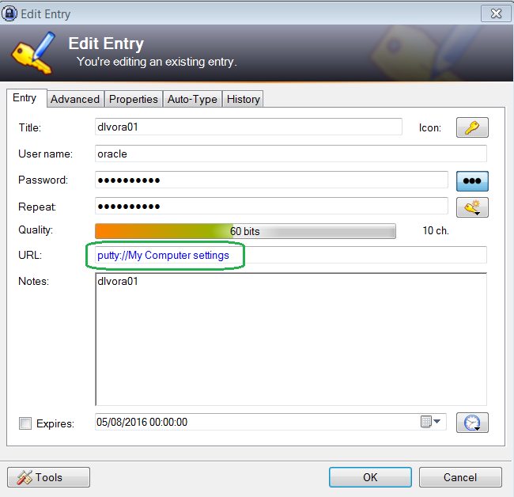

and use the URL Override Scheme to supply the parameters we really need.

cmd://putty.exe -load {URL:RMVSCM} -ssh -l {USERNAME}

or the other alternative is to use the “String Fields” in the *Advance* tab of each entry. Click *Add* button and give it a name e.g. “PUTTYSESSION”, then a value “My Computer settings”. Now all the URL needs is the protocol (it’ll ignore everything else when the URL is launched); the URL Override Scheme becomes:

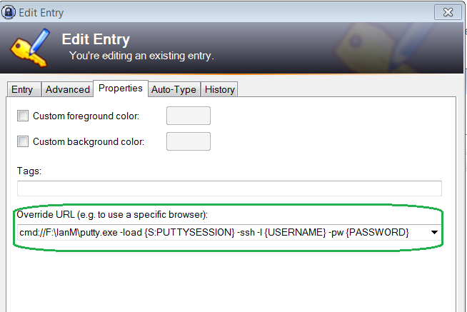

The ‘S’ parameter defines the server session to load (and connect to). A string field by the name of PUTTYSESSION contains the name of the server to connect to which is how KeyPass knows which server we’re talking about.

The Override URL is effectively:

cmd://F:\IanM\putty.exe -load {S:PUTTYSESSION} -ssh -l {USERNAME} -pw {PASSWORD}

For confirmation, parameter USERNAME is preceded by a lowercase ‘el’.

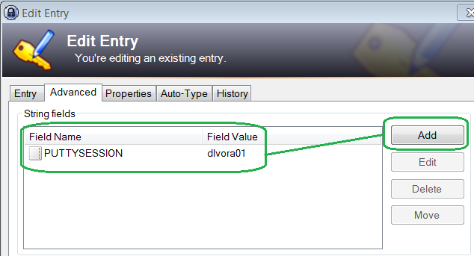

In other words, the *URL Override Scheme* overrides the URL that is set on the *Entry* tab and it’s this that holds the information used to connect to the server in question with the required username and password.

Keywords: keypass putty unix session login username password

Source: <http://blog.akademy.co.uk/2014/01/keepass-with-putty-sessions-in-ssh/>

Tuesday, 09 August 2016