|  |  |
| --- | --- |
| **Test Case:** *NavegationUol*  **Expected Result:** *Result OK*  **Status:** *Failed* | **Date :** *24/08/2020*  **Hour:** *17:31* |

**1. OBJECTIVE**

This document aims to provide proof of the tests run for application validation.

2. EVIDENCE OF TEST STEPS

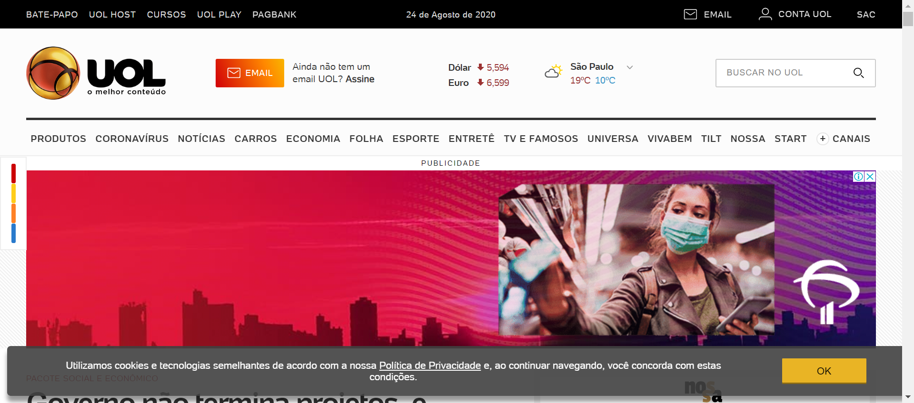

|  |  |
| --- | --- |
| Action: Navigate | Action time: 00:00:24 |
| Resultado expect: The page was successfully loaded | Resultado obtained: The page was successfully loaded |

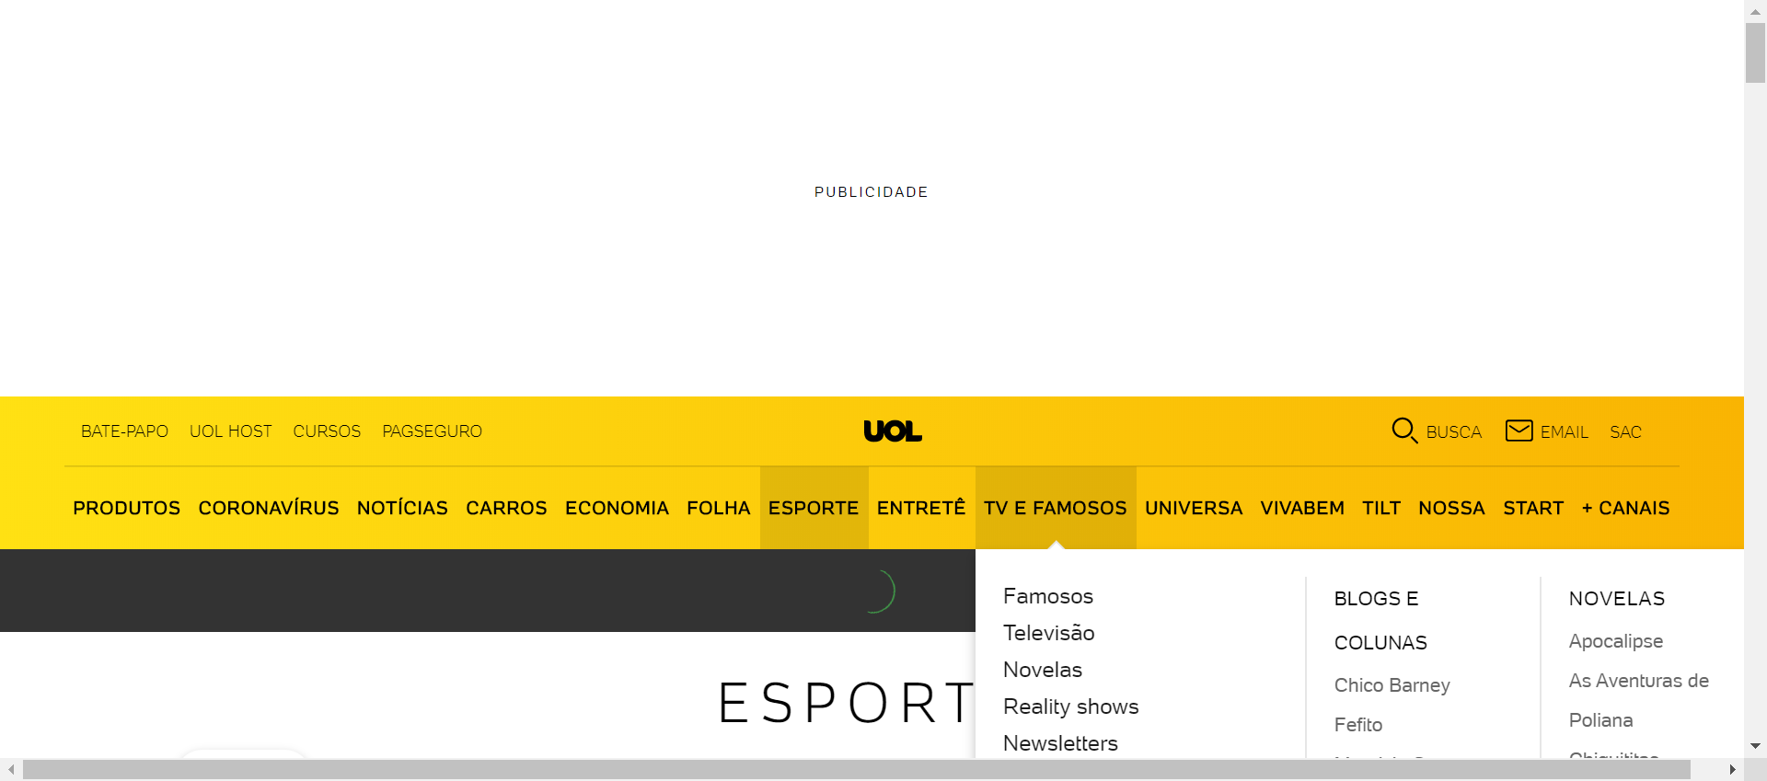

|  |  |
| --- | --- |
| Action: Click | Action time: 00:00:01 |
| Resultado expect: The object was successfully clicked | Resultado obtained: The object was successfully clicked |