USER STUDY EVIDENCE JOURNAL

Participant replay journal
116 ordered terminal captures · action · visible outcome · issue
RUN study-snapshot-replay-20260811 · EVIDENCE 180 × 52 color PTY · FORMAT Editable Word · embedded images
This is an observer-authored journal of the fresh Study replay named study-snapshot-replay-20260811. It is not a transcript of participant speech. Every numbered entry embeds the corresponding real 180 × 52 terminal capture and records what was operated, what became visible, and what could be confusing or methodologically important.
The replay used installed exact semantic artifacts. No live semantic provider turn occurred. Preserve all branches are coverage controls used to exercise the complete materialization path; they should not be read as evidence that a participant would make the same semantic choice.

Issues noticed during the replay
- A split Resolution detail could clear the first staged choice when final
- A stale granted-Update receipt could mask a newer local Redo. Capture 116
- Symmetric Meld requires an empty Result Context and then a switch to that
- Large reports end at the tail of the terminal. Some receipt PNGs therefore
- mem show reports direct Memories. A parent such as the Task 3 personal
- Twenty-two pre-approval Sever sessions created while diagnosing the two

1. STUDY INITIALIZATION

001 — Generated Study name
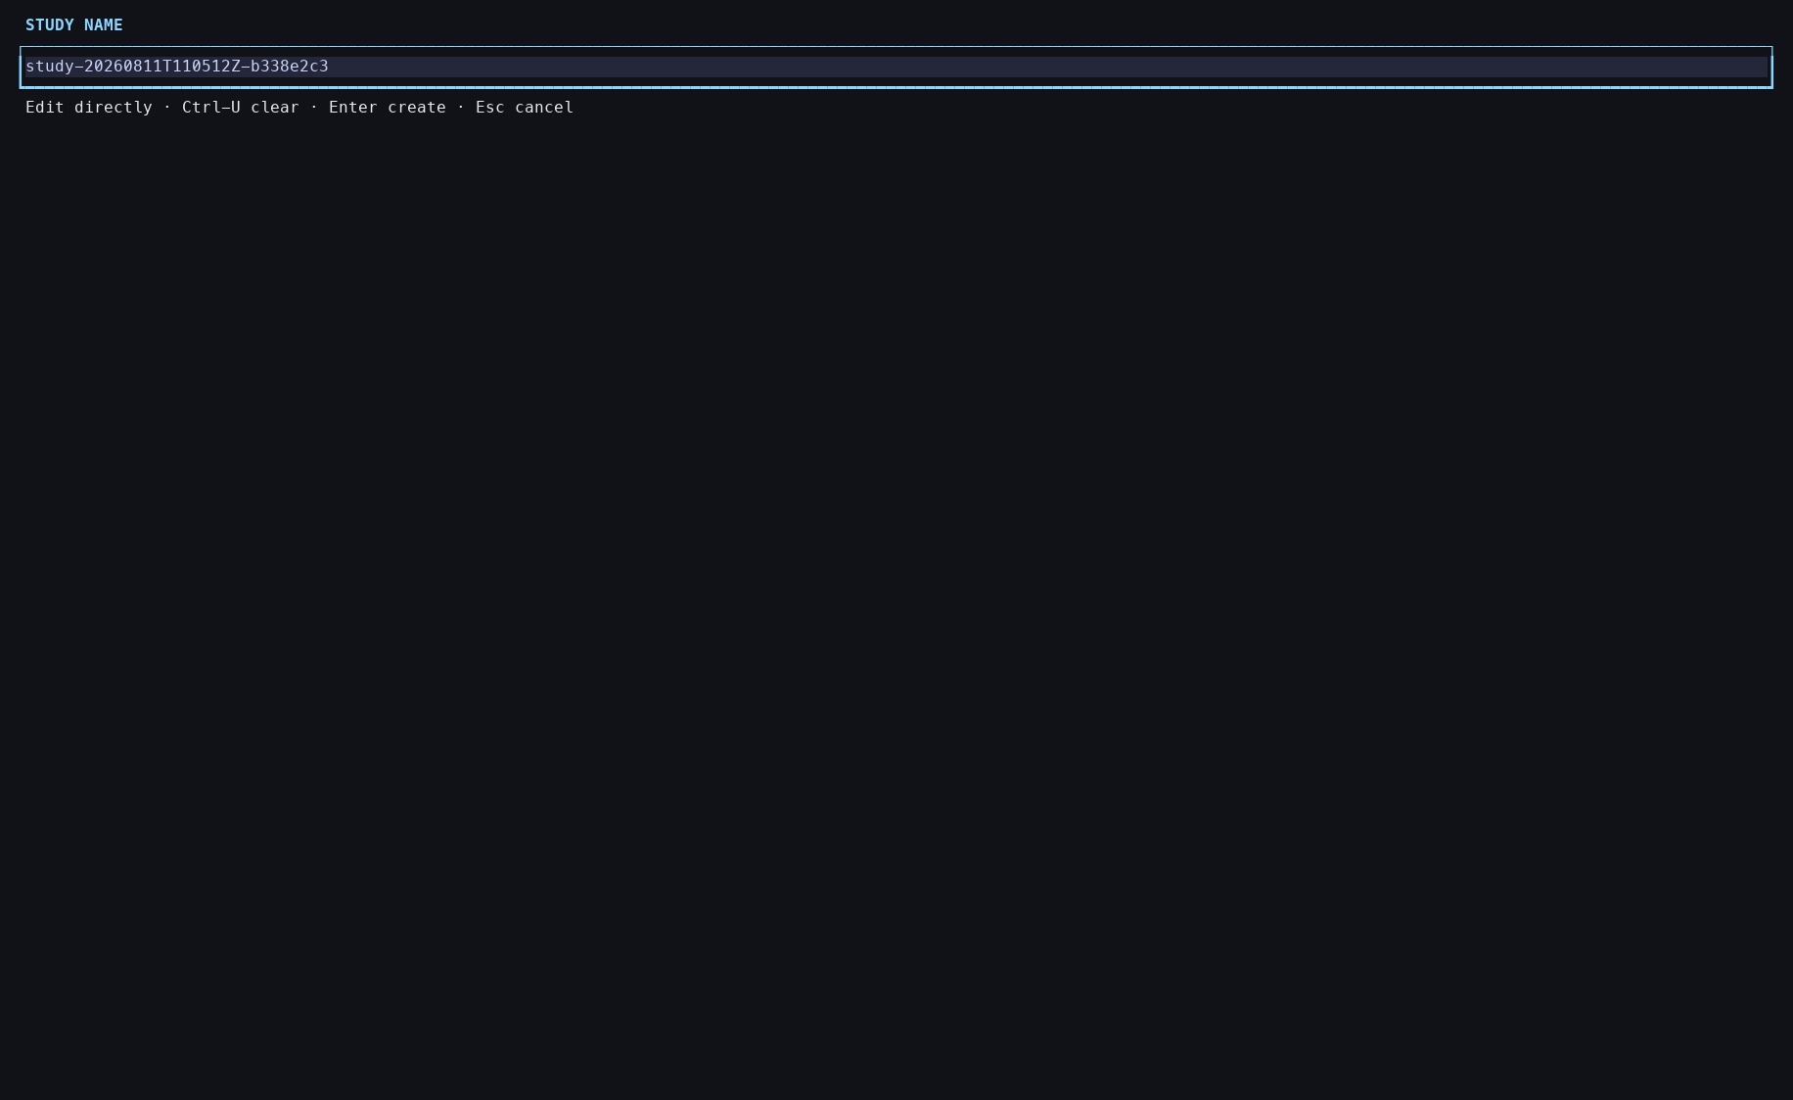
Action: Opened mem init-study in the color PTY.
Observed: The generated Study-name field was focused; nothing had been created.
Issue or note: The generated name is only a proposal. Exact naming still requires participant input.

1. STUDY INITIALIZATION

002 — Exact Study name entered
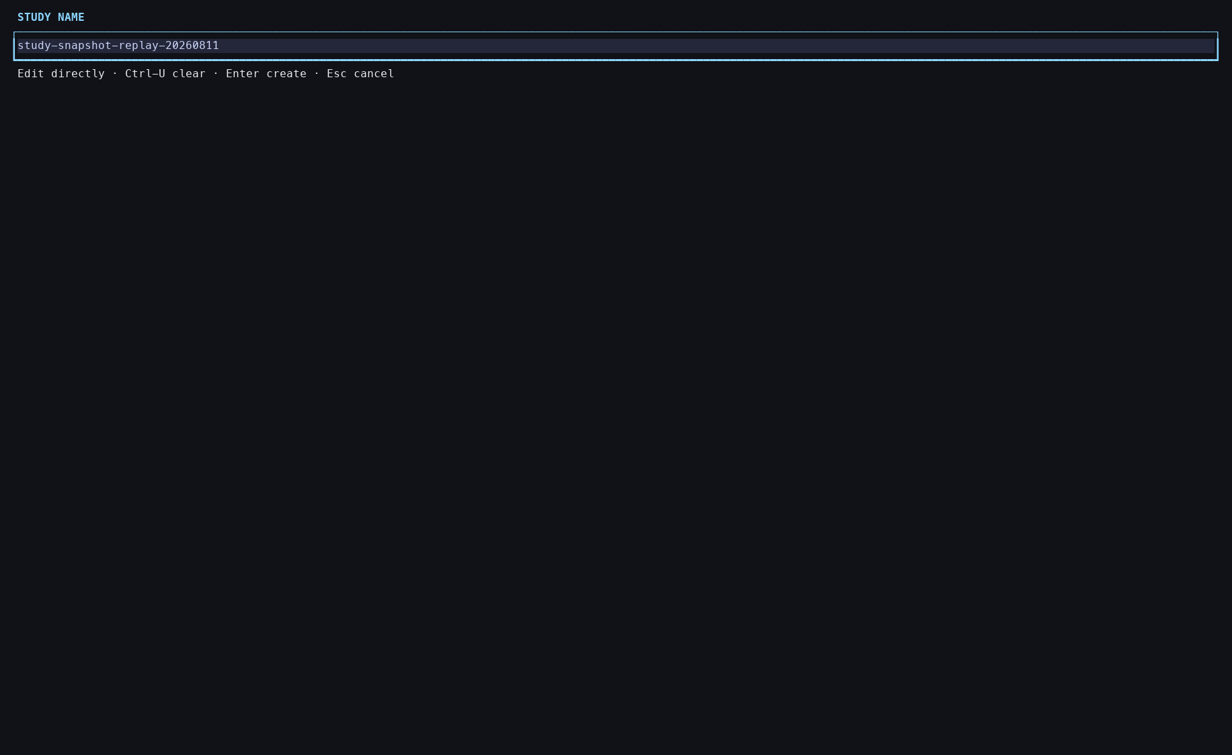
Action: Pressed Ctrl-U and entered study-snapshot-replay-20260811.
Observed: The field displayed the exact replacement name before submission.
Issue or note: Editing remained process-local; this screen is the last non-mutating naming state.

1. STUDY INITIALIZATION

003 — Study creation receipt
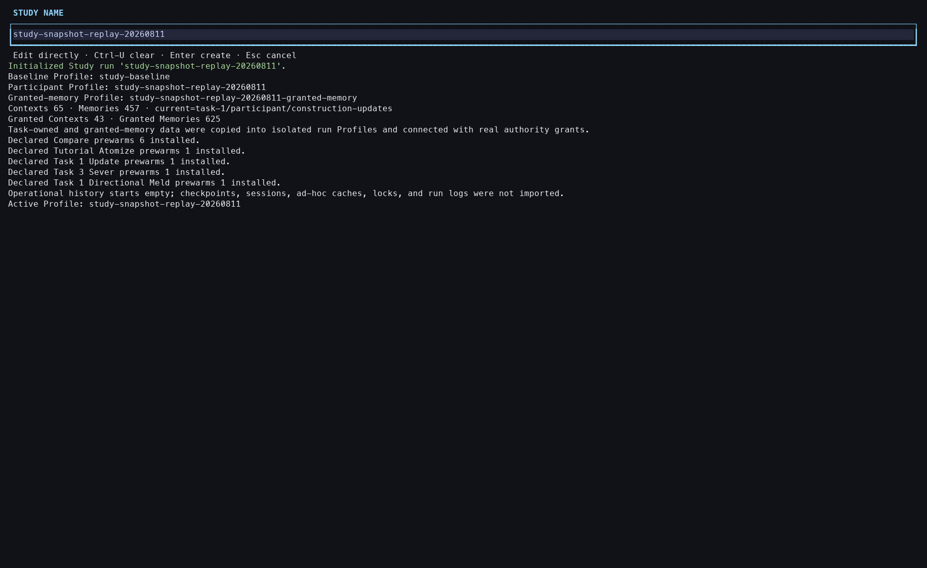
Action: Pressed Enter to create the Study.
Observed: Participant and authority Profiles, Grants, fixtures, and declared prewarm installations were reported.
Issue or note: The receipt is dense. It combines Profile creation, authorization, fixtures, and preparation in one success surface.

1. STUDY INITIALIZATION

004 — Active participant Profile
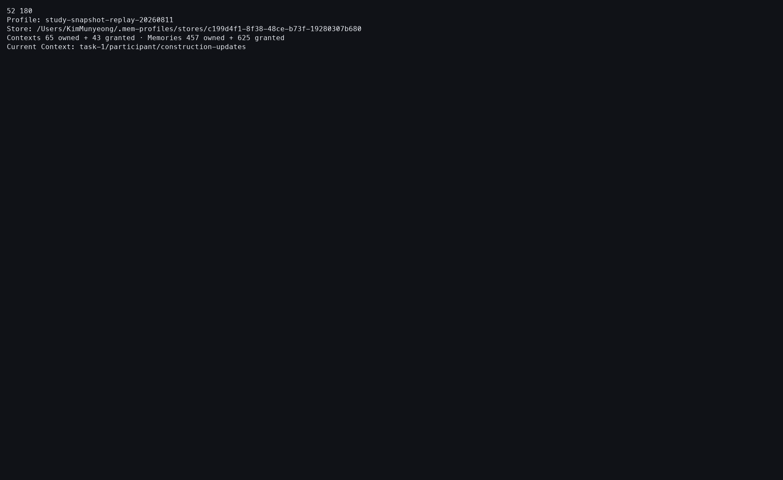
Action: Ran mem profile current.
Observed: The fresh participant Profile and its initial current Context were active.
Issue or note: This is orientation only; inspecting the Profile did not open semantic content or mutate it.

1. STUDY INITIALIZATION

005 — Initialization action ledger
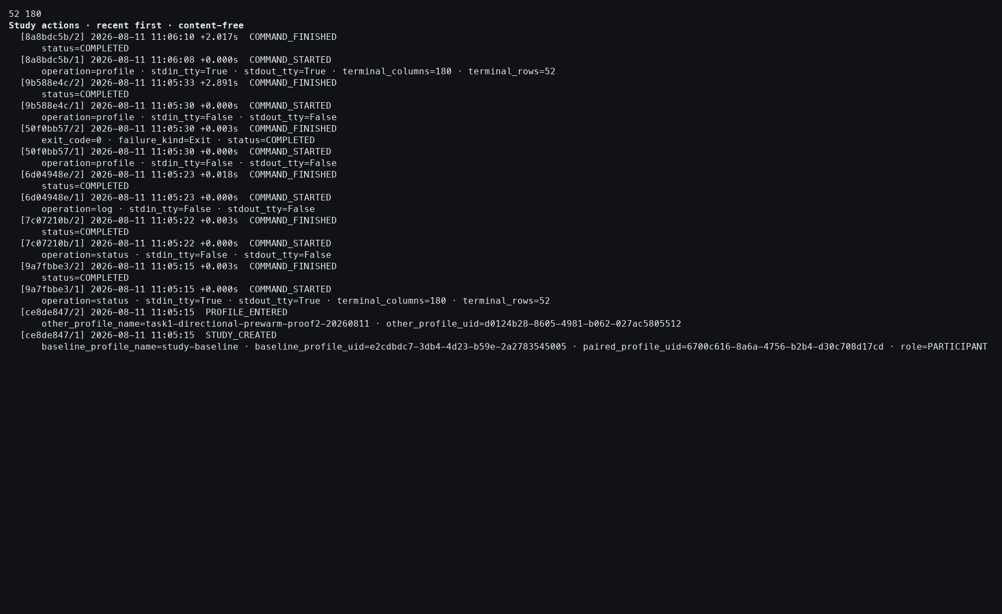
Action: Ran mem log --actions --limit 20.
Observed: STUDY_CREATED, PROFILE_ENTERED, and command boundaries were retained without Memory content.
Issue or note: The ledger proves the interaction boundary but intentionally cannot reconstruct private Memory text.

2. TUTORIAL ATOMIZE

006 — Exact Atomize review opens
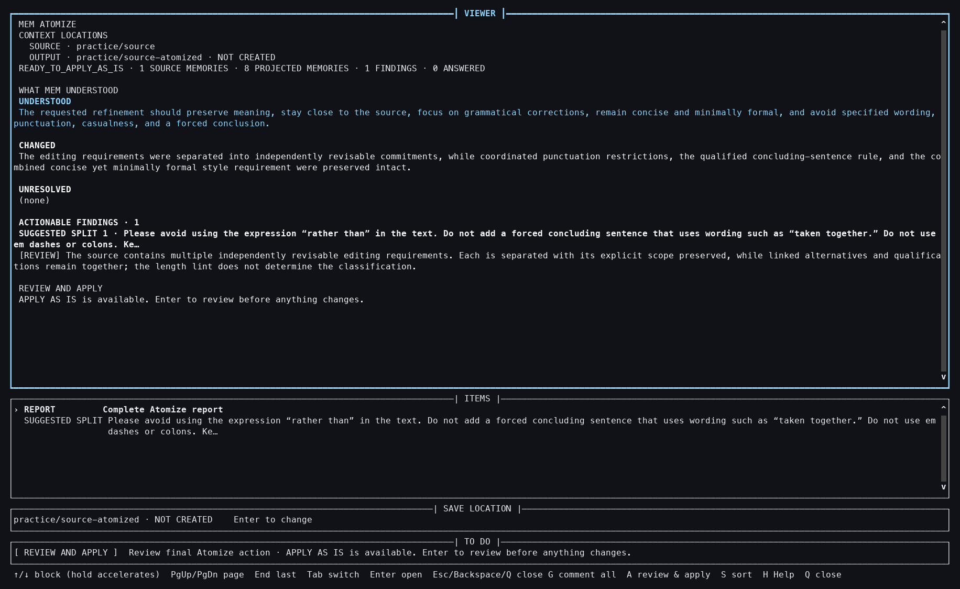
Action: Ran mem atomize --context practice/source.
Observed: The installed one-to-eight analysis opened in the common workbench without a provider call.
Issue or note: Fast entry reflects exact prepared analysis, not a fresh cold semantic run.

2. TUTORIAL ATOMIZE

007 — Split rationale detail
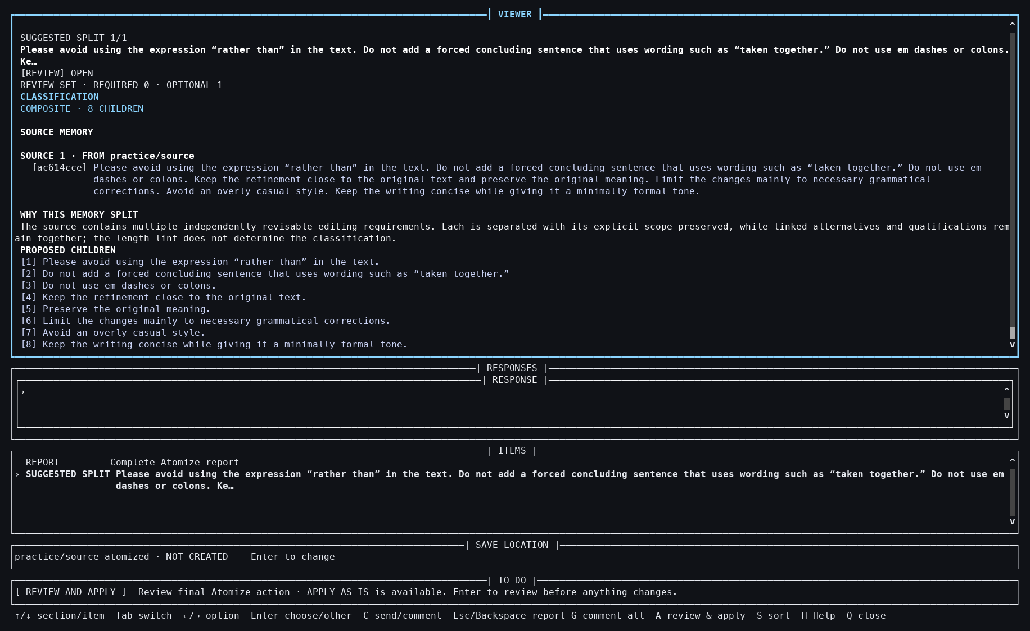
Action: Pressed Tab, Down, and Enter.
Observed: The source Memory, split rationale, and proposed children were shown together.
Issue or note: This is the first place a participant can inspect why one source becomes several Memories.

2. TUTORIAL ATOMIZE

008 — Return to report and handoff
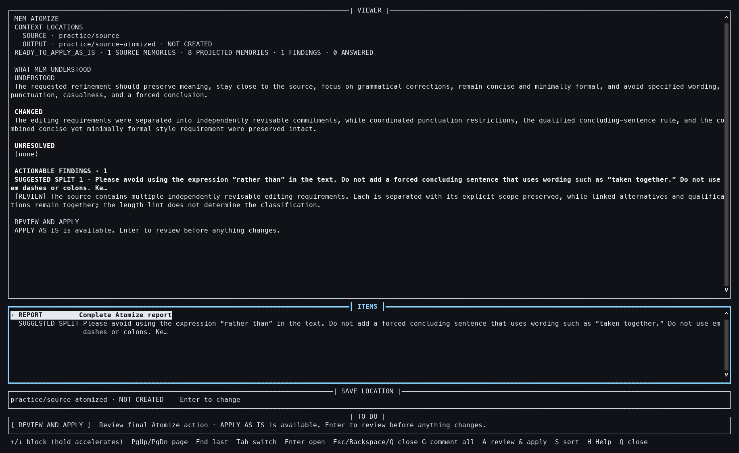
Action: Pressed Backspace to leave the detail.
Observed: The complete report returned with a visible REVIEW AND APPLY handoff.
Issue or note: Returning from evidence still caused no mutation.

2. TUTORIAL ATOMIZE

009 — Non-mutating final review
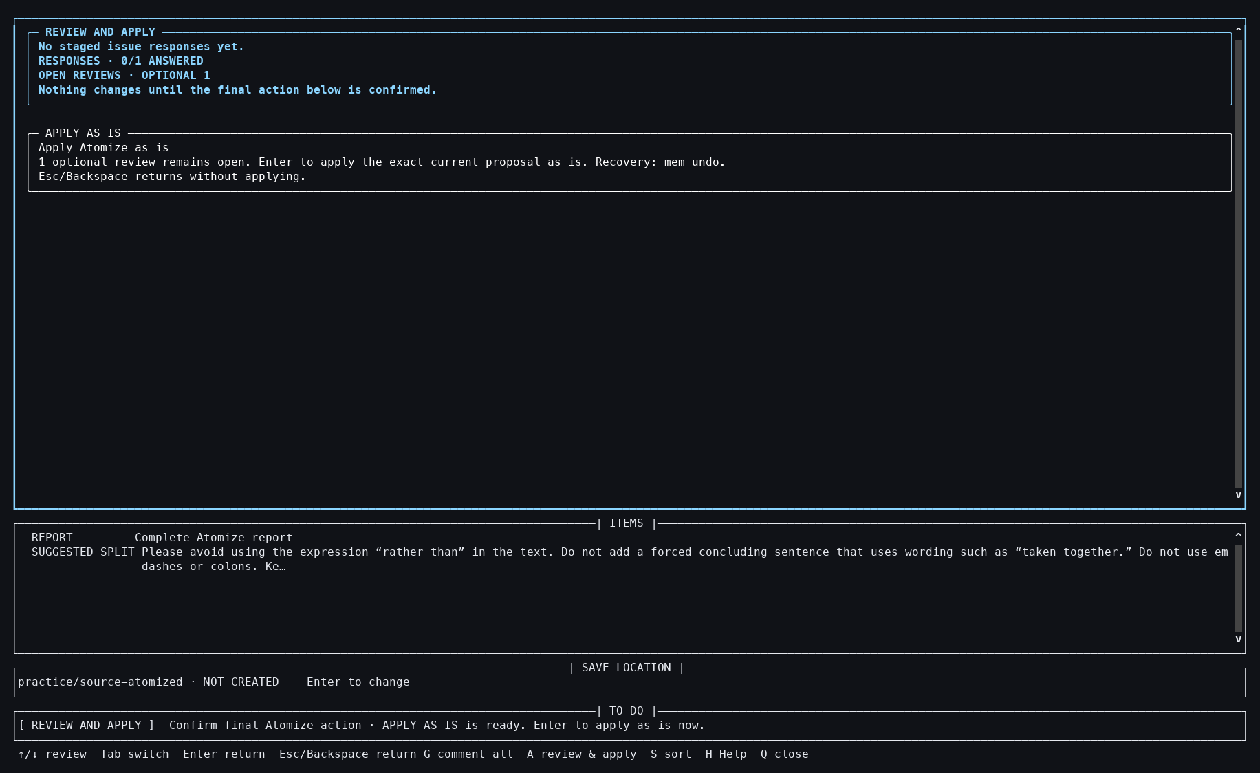
Action: Pressed A.
Observed: A distinct final-review layer summarized the exact proposal.
Issue or note: A opens review; it does not itself apply the split.

2. TUTORIAL ATOMIZE

010 — Exact Apply action focused
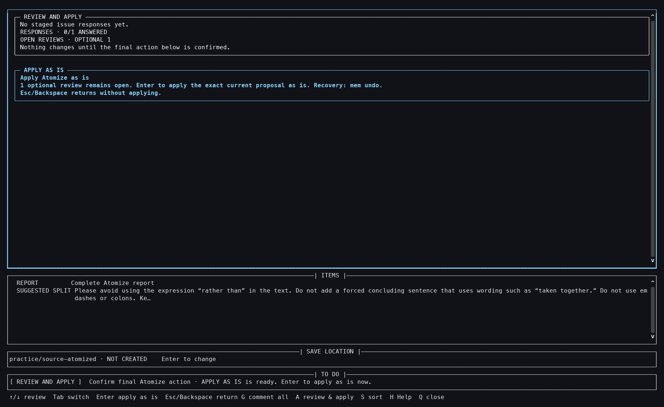
Action: Pressed End to focus APPLY AS IS.
Observed: The precise action and recovery boundary were highlighted.
Issue or note: The separate focus step makes the final mutation explicit rather than implicit in report navigation.

2. TUTORIAL ATOMIZE

011 — Atomize applied
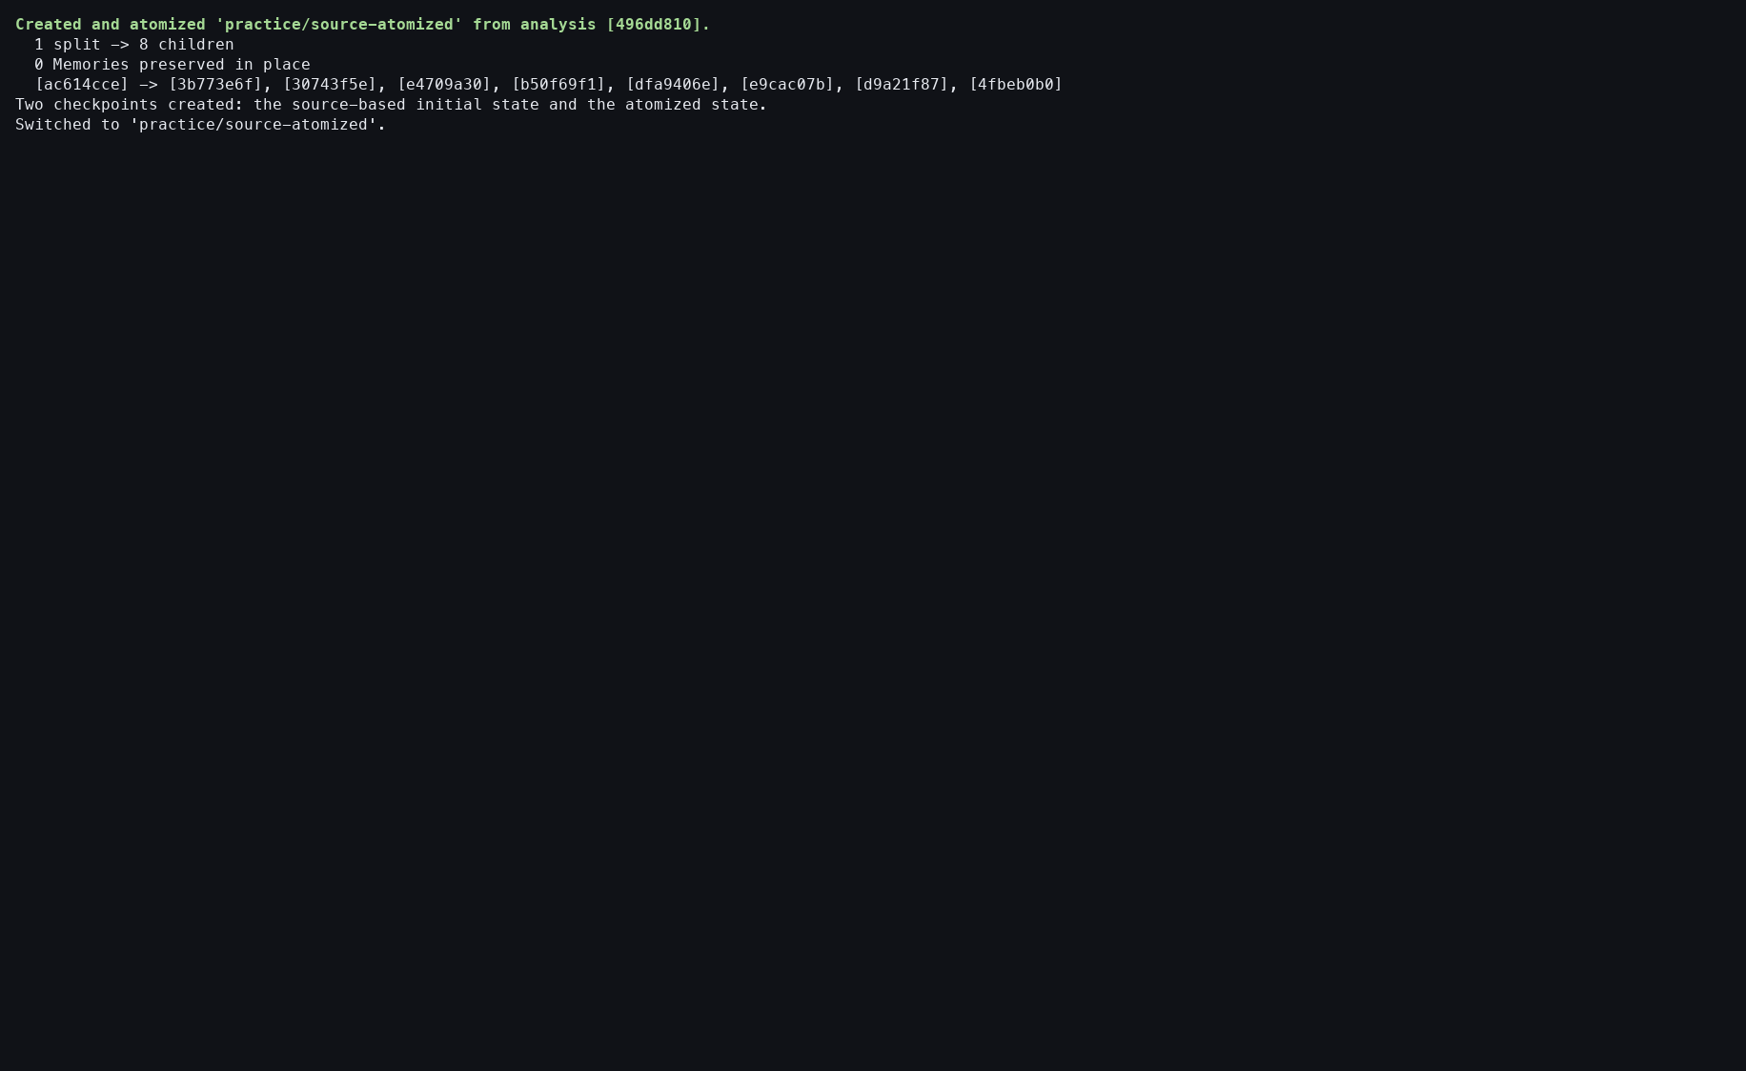
Action: Pressed Enter on the focused action.
Observed: Eight projected Memories and a checkpoint receipt were printed; practice/source-atomized was created and selected.
Issue or note: This is the first durable semantic mutation in the replay.

2. TUTORIAL ATOMIZE

012 — Atomized output verified
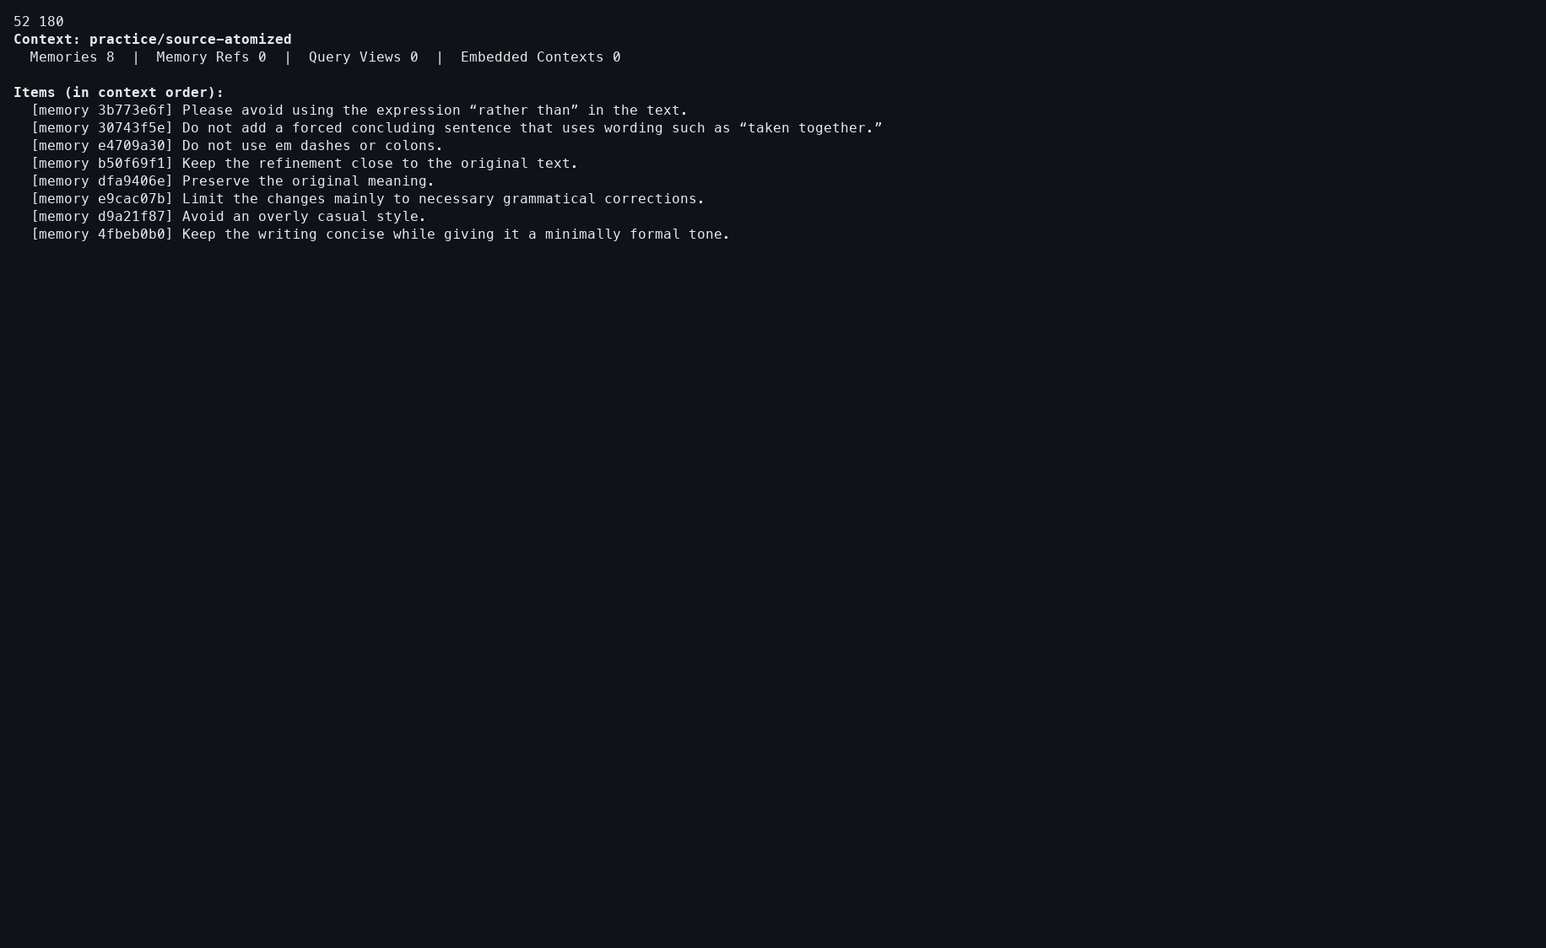
Action: Ran mem show --context practice/source-atomized.
Observed: All eight durable Memories were present.
Issue or note: The read-only view verifies materialization independently of the apply receipt.

2. TUTORIAL ATOMIZE

013 — Atomize action ledger
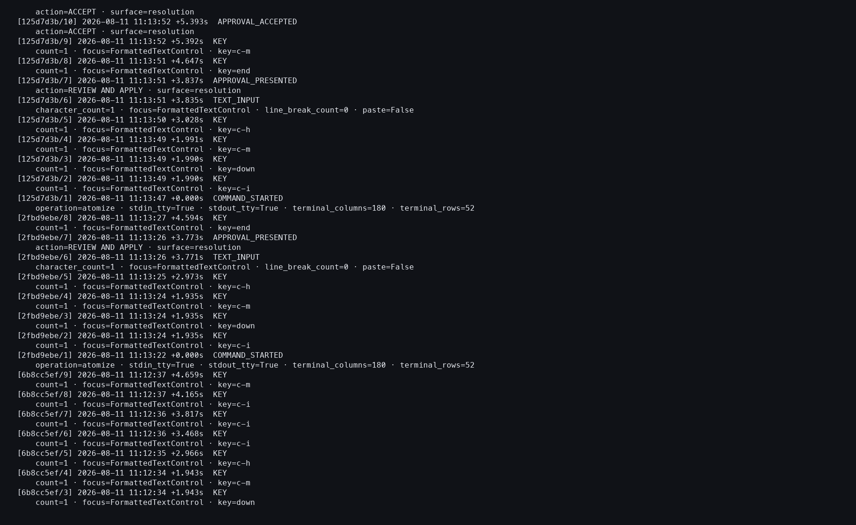
Action: Ran mem log --actions --limit 35.
Observed: Review presentation, approval, and completion appeared with no provider event.
Issue or note: The absence of provider events is a property of this prepared replay, not a general Atomize latency claim.

3. TASK 1 COMPARE

014 — Exact 75-by-300 Compare report
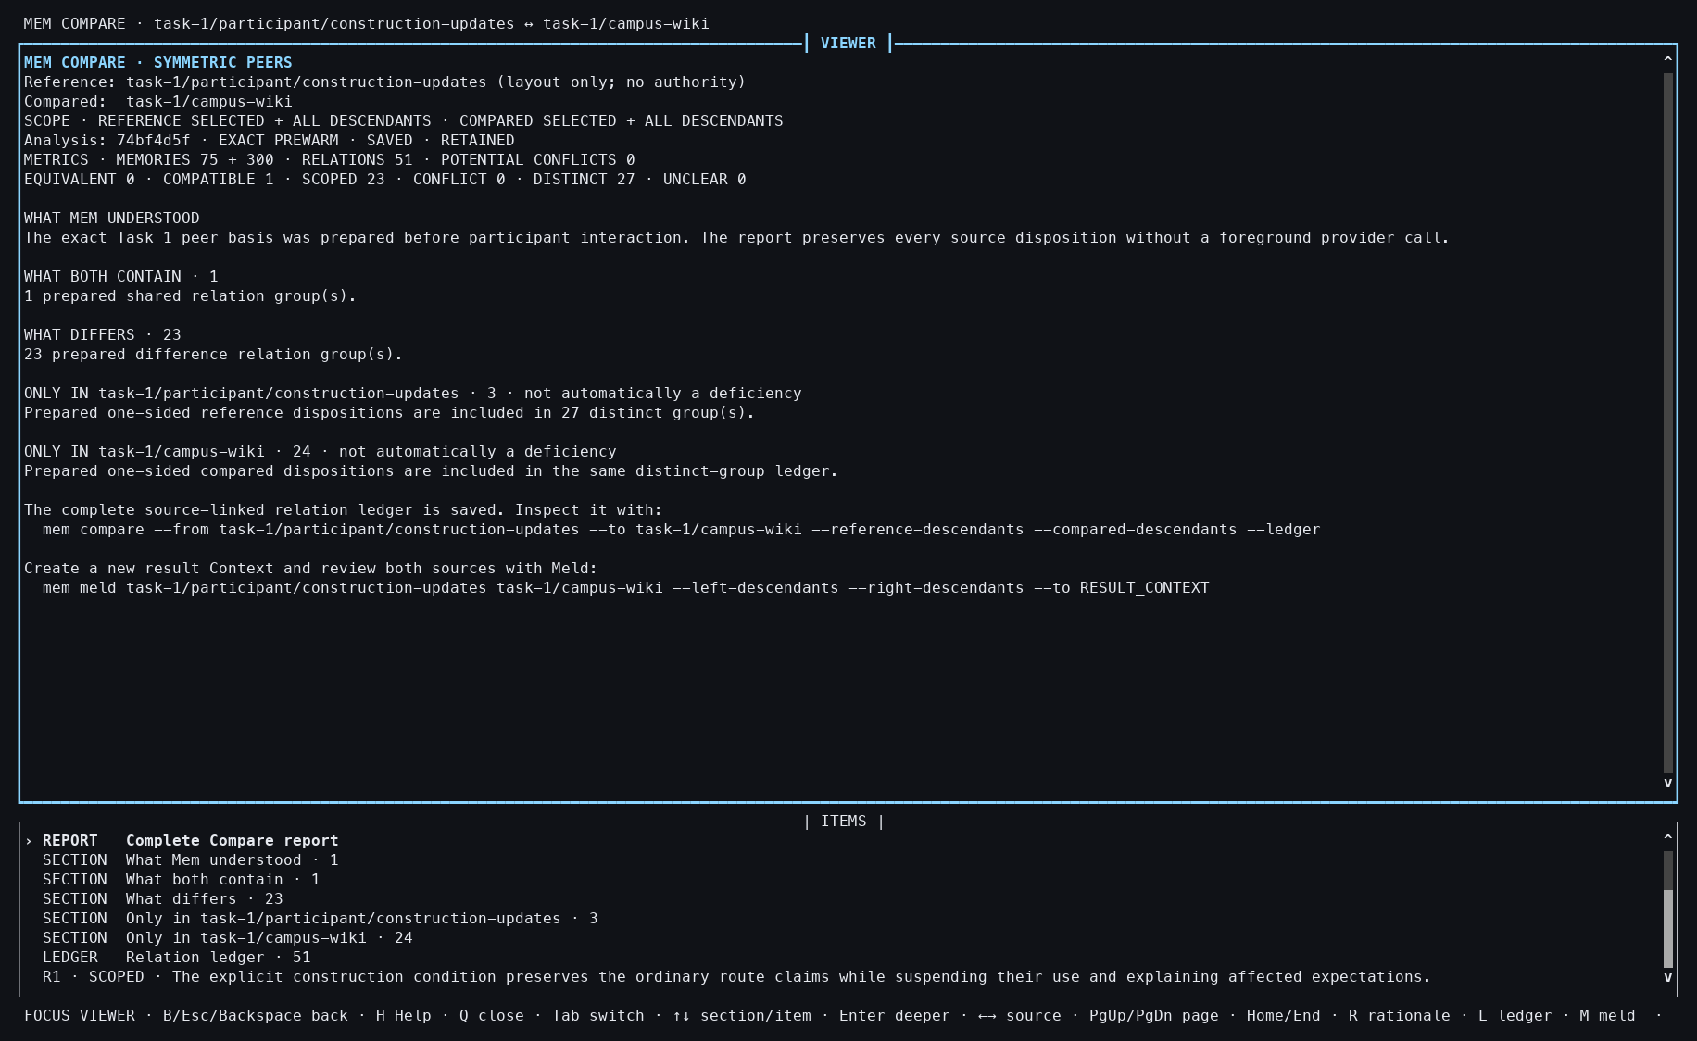
Action: Compared descendant-inclusive construction updates with the campus wiki.
Observed: The 75+300 report opened with 51 retained relations.
Issue or note: Both full input frames are represented even though the foreground path is a cache hit.

3. TASK 1 COMPARE

015 — Compare relation detail
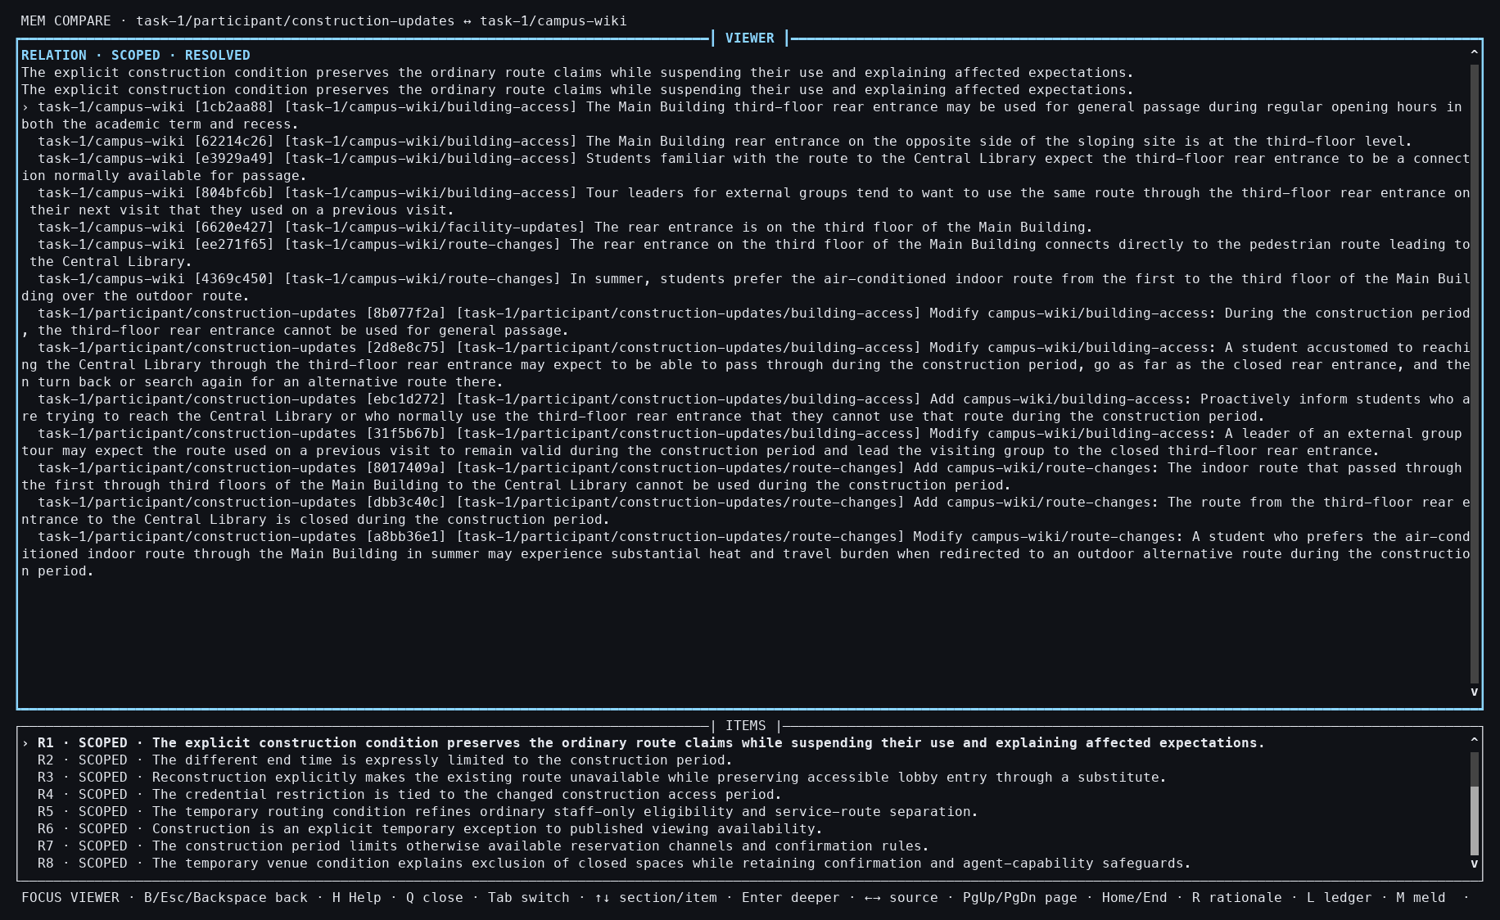
Action: Used Tab, End, Up 50 times, then Enter.
Observed: One retained relation displayed its exact members and judgment.
Issue or note: Reaching a specific relation by repeated Up is cumbersome and exposes a navigation scalability issue.

3. TASK 1 COMPARE

016 — Compare closed

Action: Pressed Q.
Observed: The report closed with an explicit receipt.
Issue or note: Closing did not discard or recompute the retained analysis.

3. TASK 1 COMPARE

017 — Noninteractive Compare snapshot
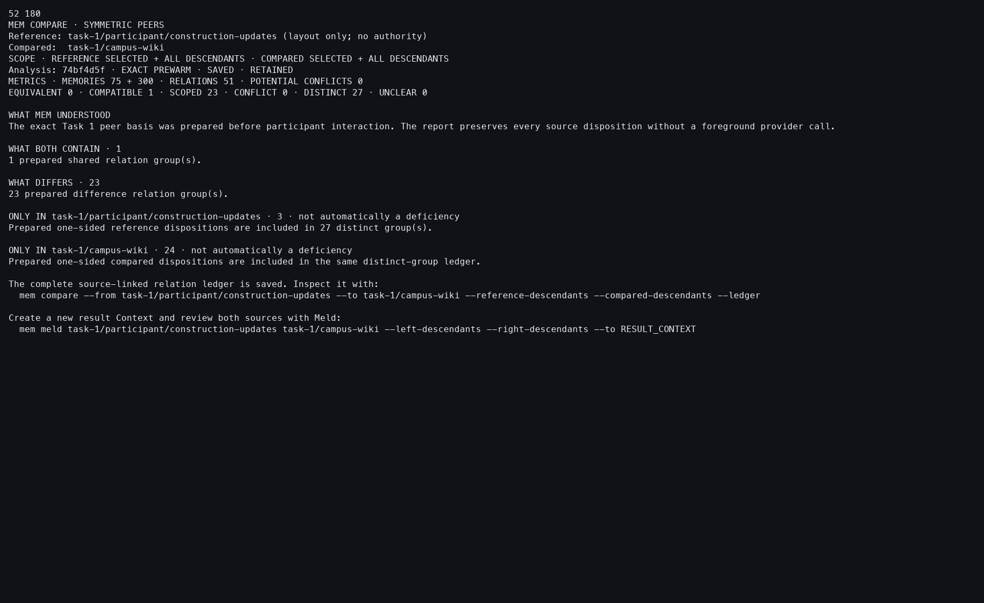
Action: Re-ran the same Compare with --snapshot.
Observed: The stable exact report was available without the interactive workbench.
Issue or note: This verifies reuse, but the long report still favors terminal text over a compact visual summary.

3. TASK 1 COMPARE

018 — Compare action ledger
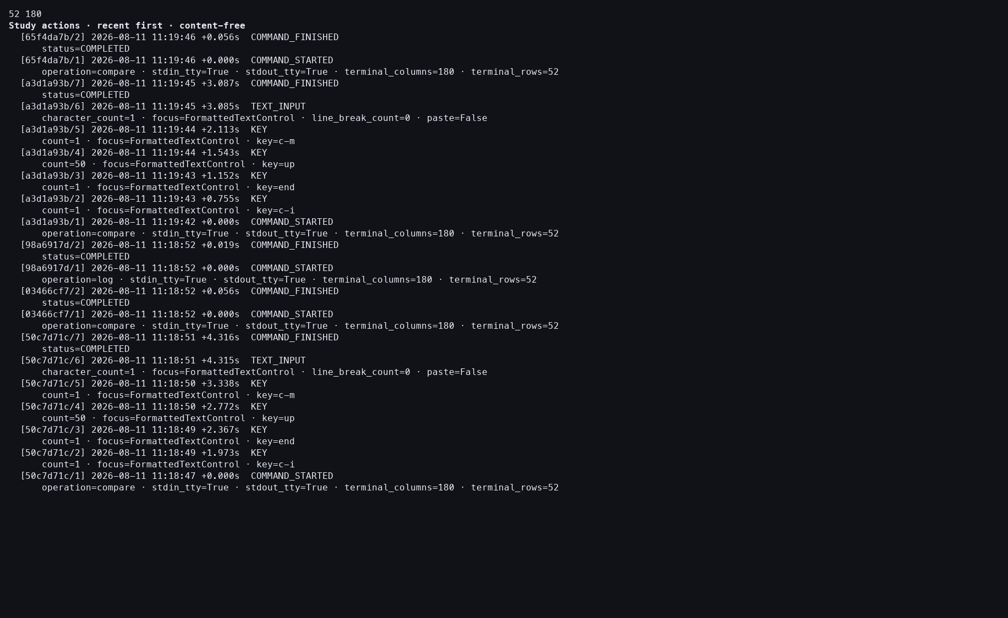
Action: Ran the Study action log.
Observed: Interactive and snapshot Compare attempts completed with no provider event.
Issue or note: The ledger records execution, not whether the participant agreed with every semantic relation.

4. TASK 1 UPDATE

019 — Exact Update plan
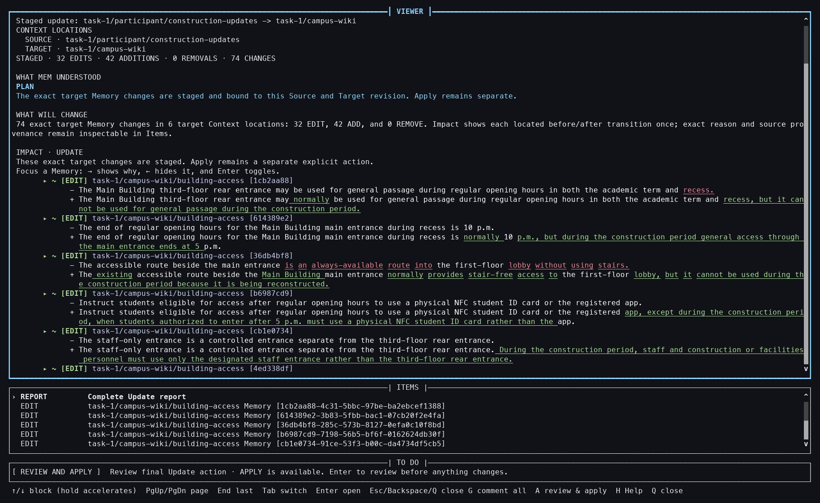
Action: Ran descendant-inclusive Update from 75 construction Memories into the 300-Memory campus wiki.
Observed: A 32-edit and 42-add plan opened; only a staged receipt existed.
Issue or note: Planning and mutation remain separate even on an exact cache hit.

4. TASK 1 UPDATE

020 — First edit inspected
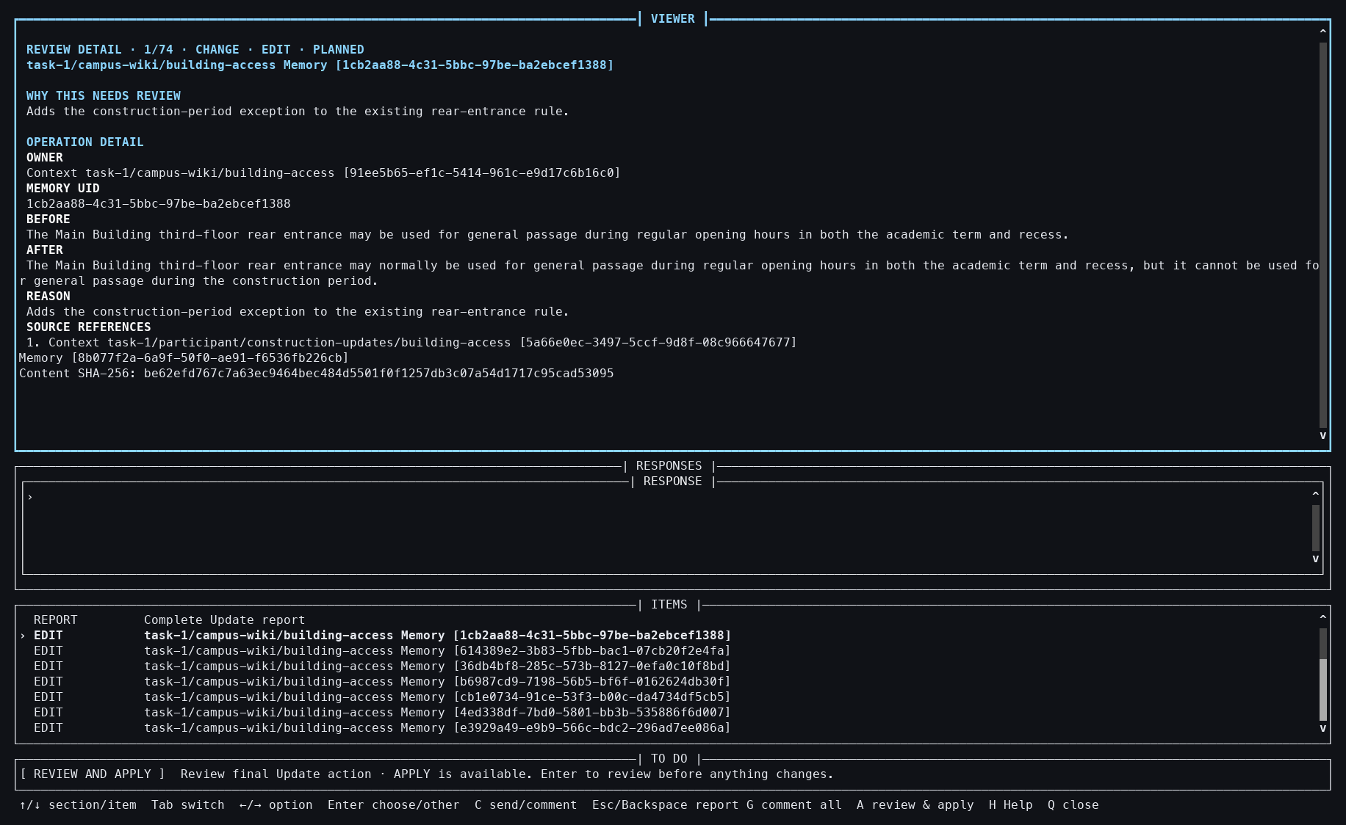
Action: Pressed Tab, Down, and Enter.
Observed: Before text, after text, reason, and Source provenance were adjacent.
Issue or note: This detail is necessary because aggregate counts alone do not explain what the Update changes.

4. TASK 1 UPDATE

021 — Seventy-four-change review
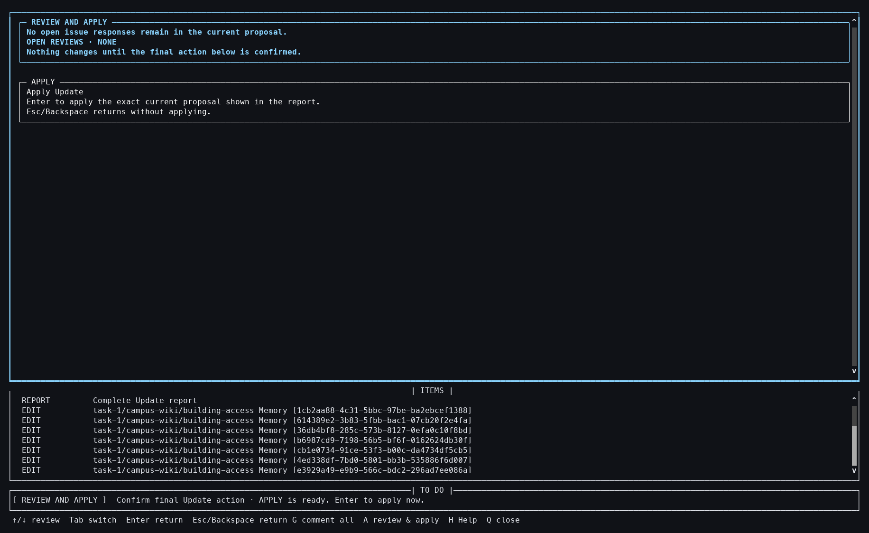
Action: Pressed A.
Observed: A non-mutating final review covered all 74 proposed operations.
Issue or note: The list is comprehensive but visually large; participants may need search or grouping for realistic review.

4. TASK 1 UPDATE

022 — Update Apply focused
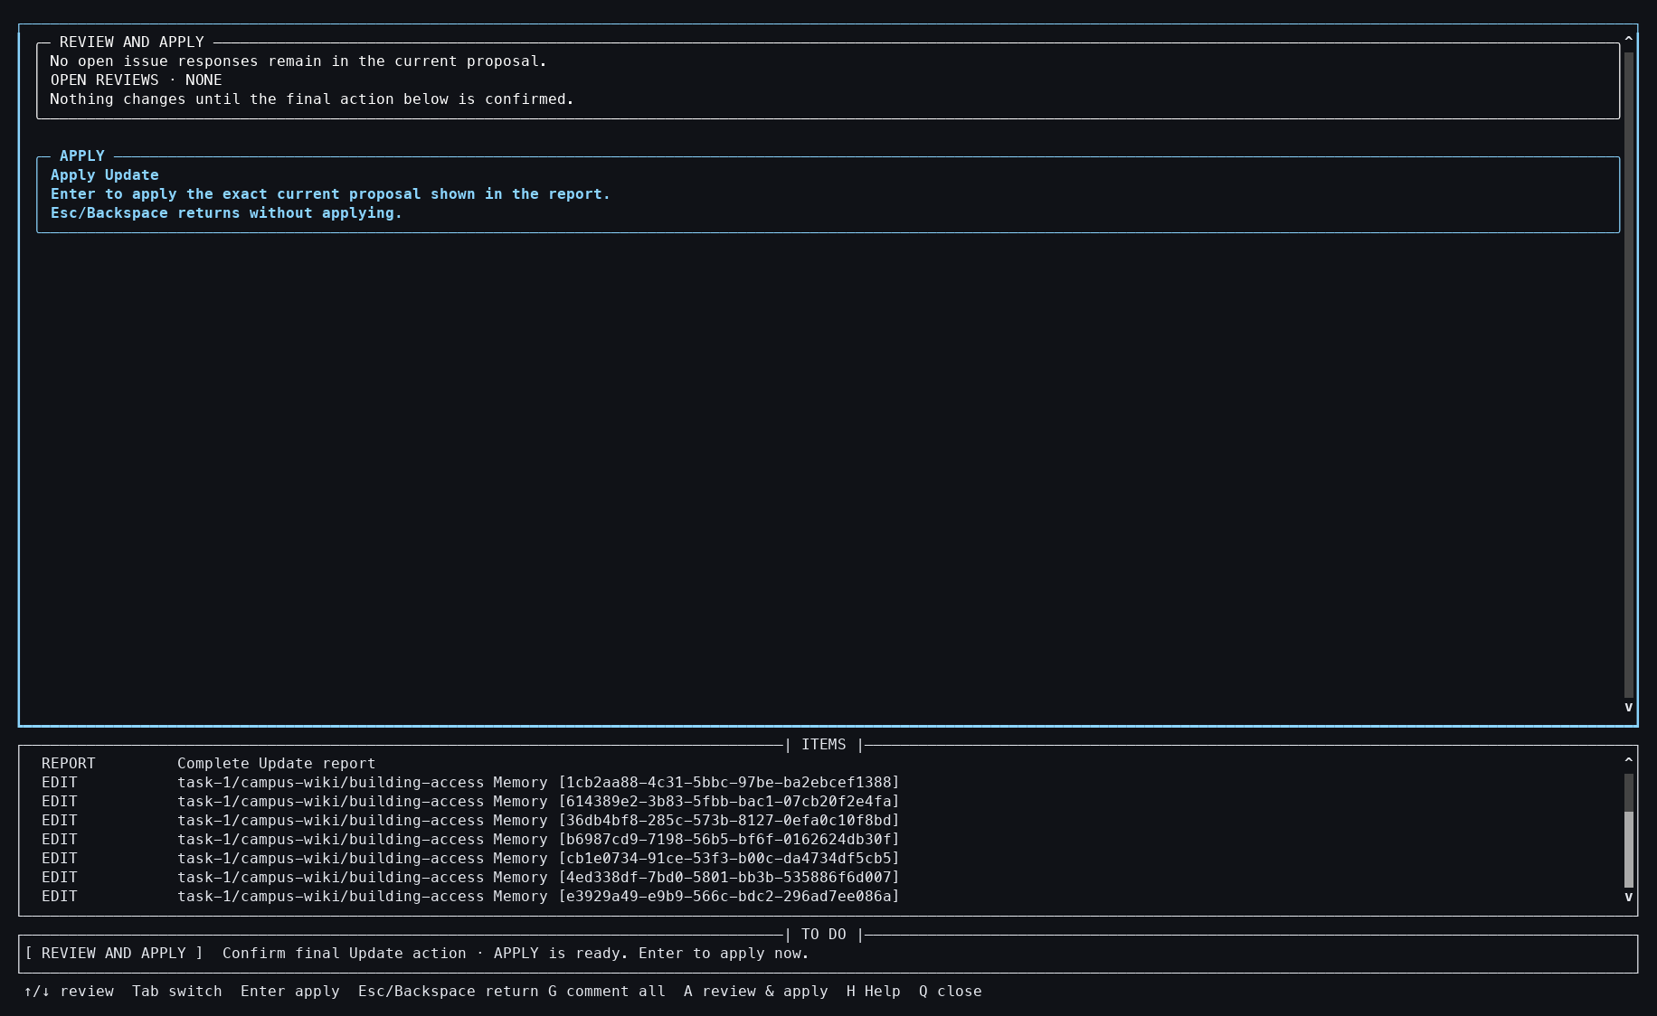
Action: Pressed End.
Observed: The exact Apply action became the focused terminal control.
Issue or note: Nothing had changed yet, despite the complete plan and focused action.

4. TASK 1 UPDATE

023 — Update applied to granted target
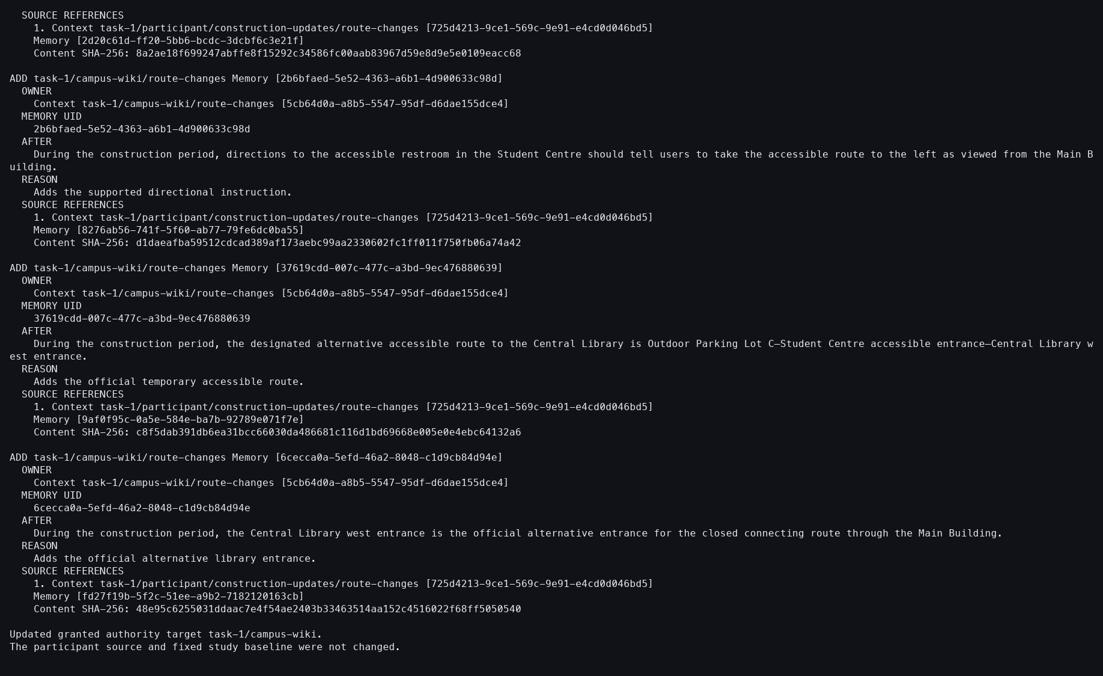
Action: Pressed Enter.
Observed: The granted target grew from 300 to 342 Memories; the Source stayed unchanged.
Issue or note: Authority-sensitive mutation happens only after participant approval and target-side validation.

4. TASK 1 UPDATE

024 — Applied target inspected
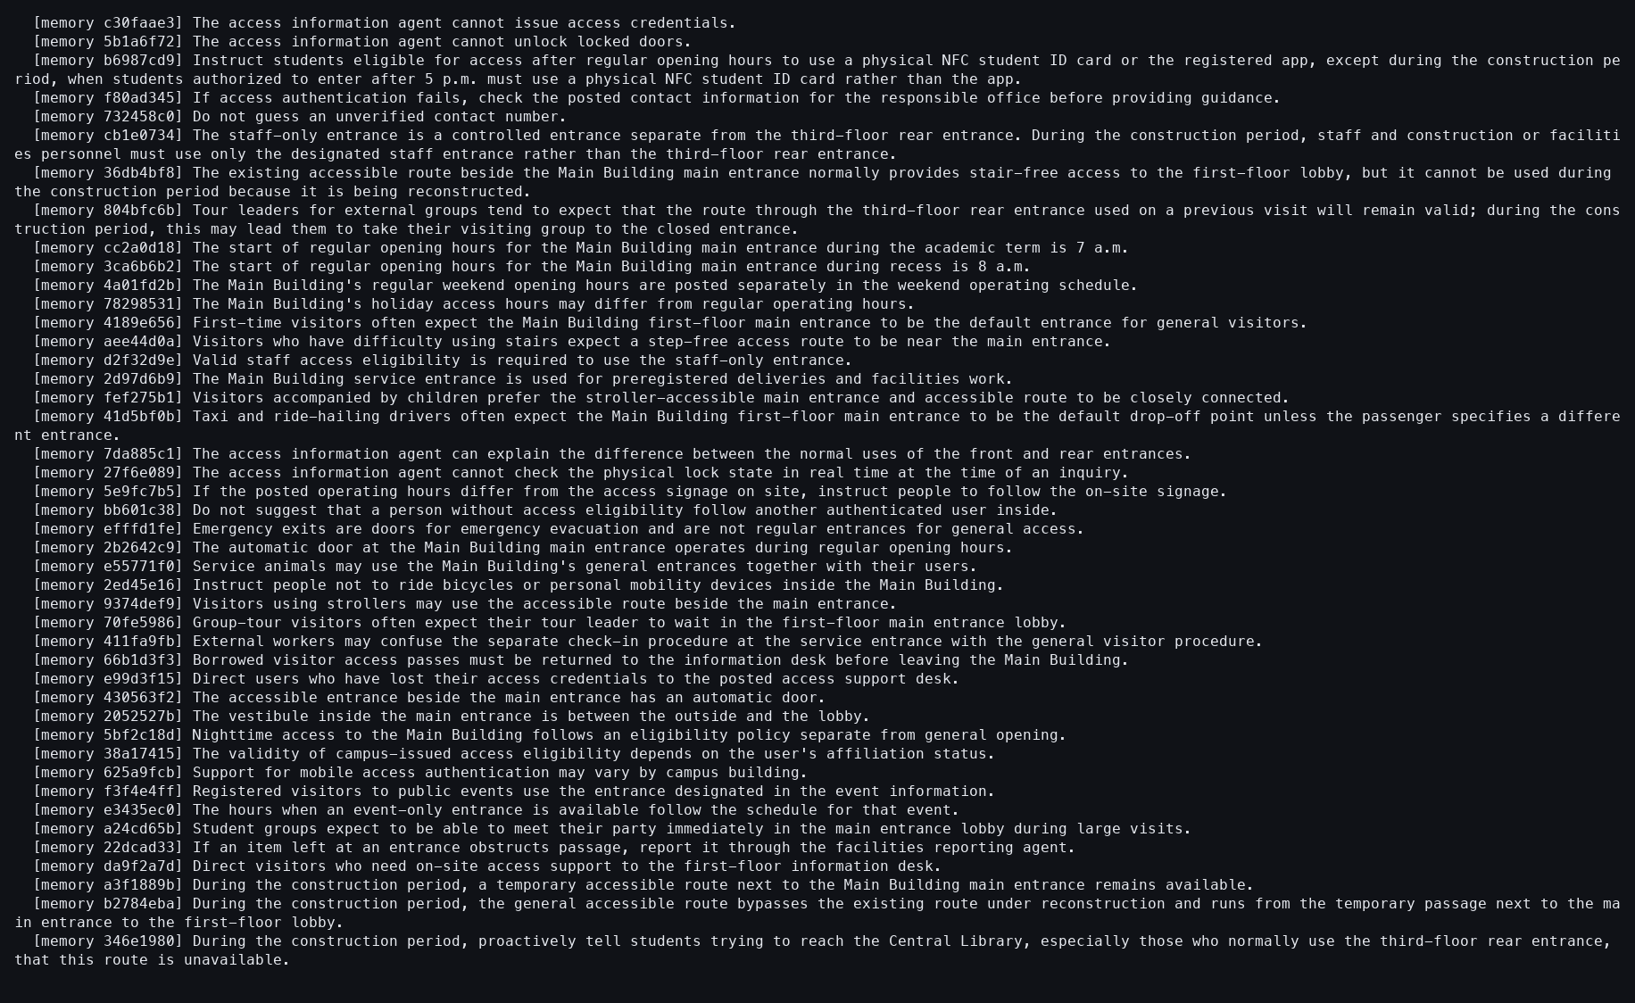
Action: Showed task-1/campus-wiki/building-access.
Observed: Construction-qualified text was durable in the target.
Issue or note: A concrete target view is easier to audit than the aggregate 342 count.

4. TASK 1 UPDATE

025 — Update undone
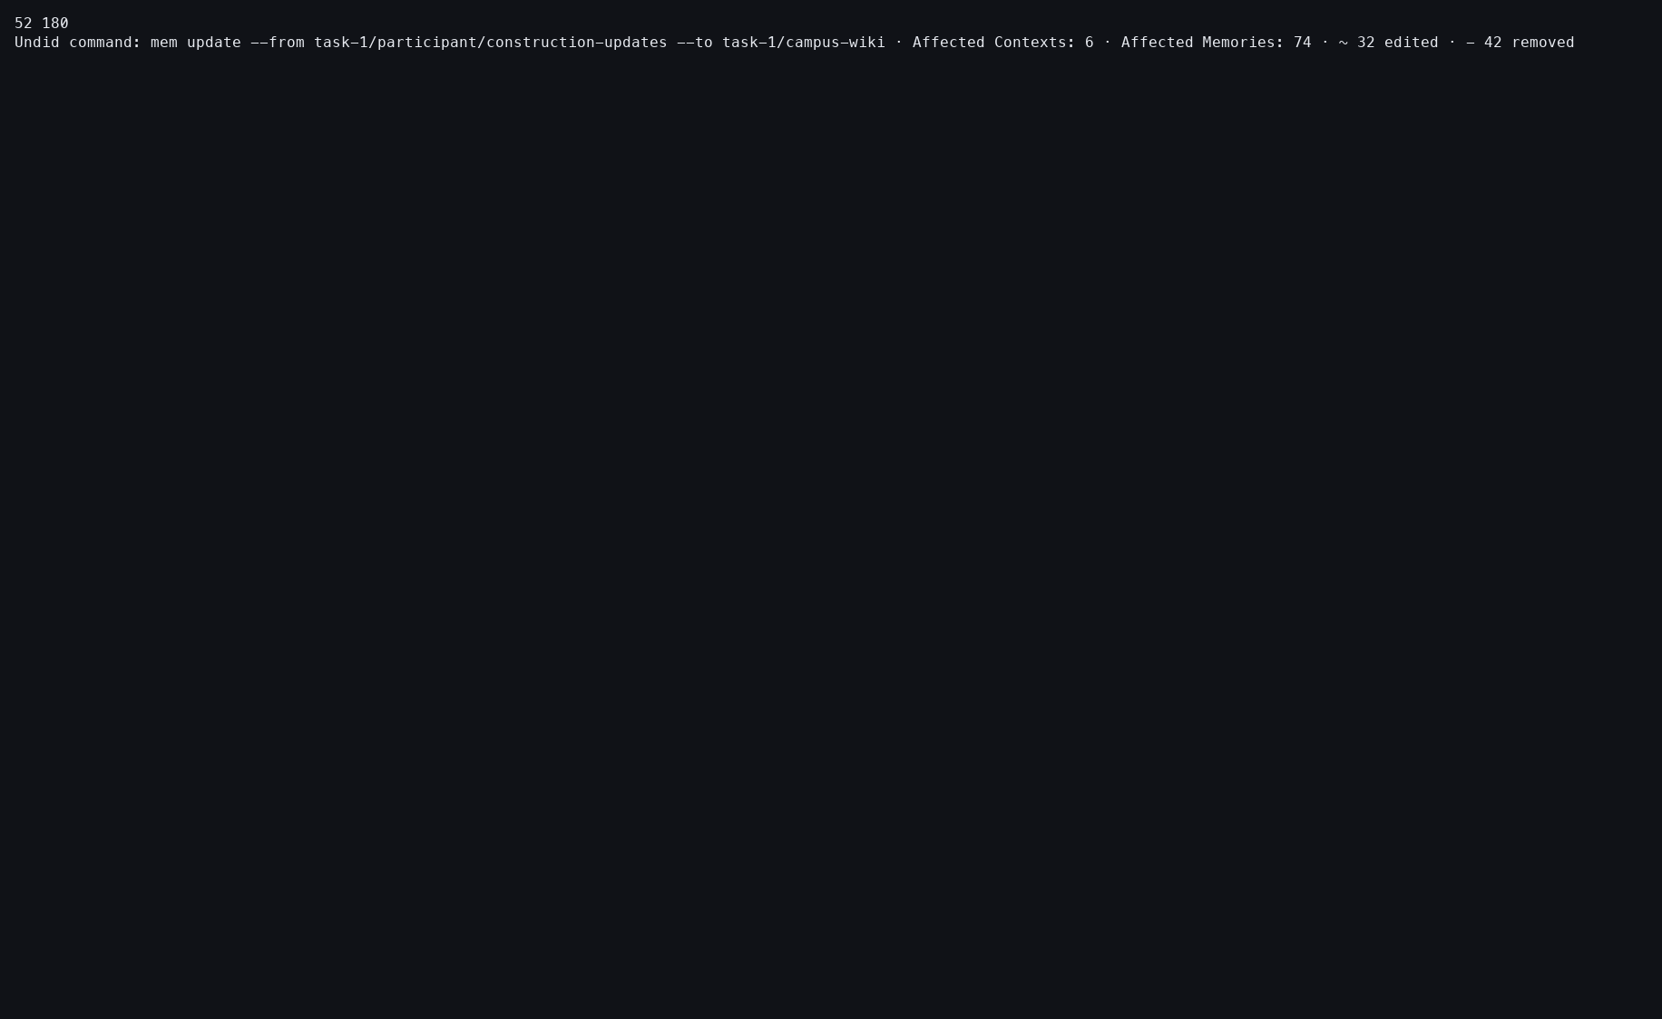
Action: Ran mem undo.
Observed: All affected granted target Contexts were restored as one command unit.
Issue or note: Undo here is an isolation step for later Task 1 experiments, not a negative judgment about the Update.

4. TASK 1 UPDATE

026 — Original target restored
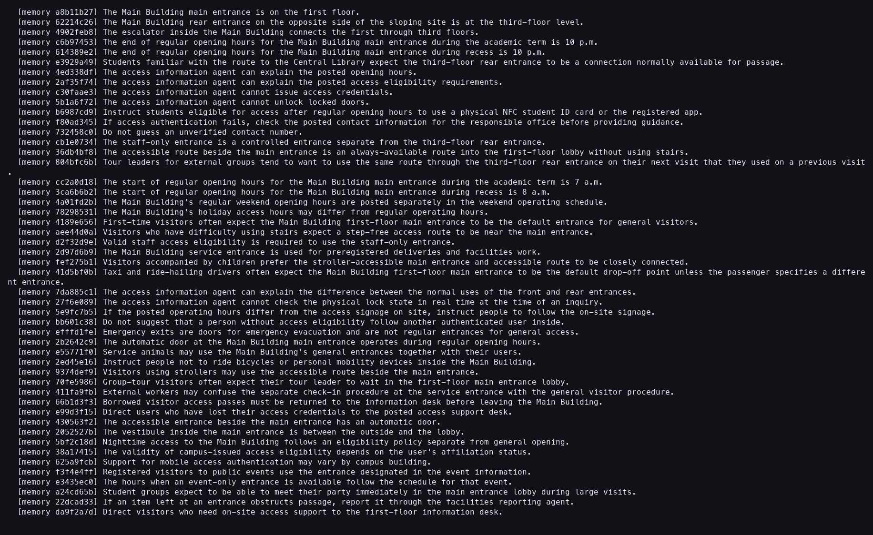
Action: Reopened the same building-access Context.
Observed: The original unqualified text and exact prior digest were restored.
Issue or note: This read-only check catches partial multi-Context recovery that a receipt alone could hide.

4. TASK 1 UPDATE

027 — Update and Undo ledger
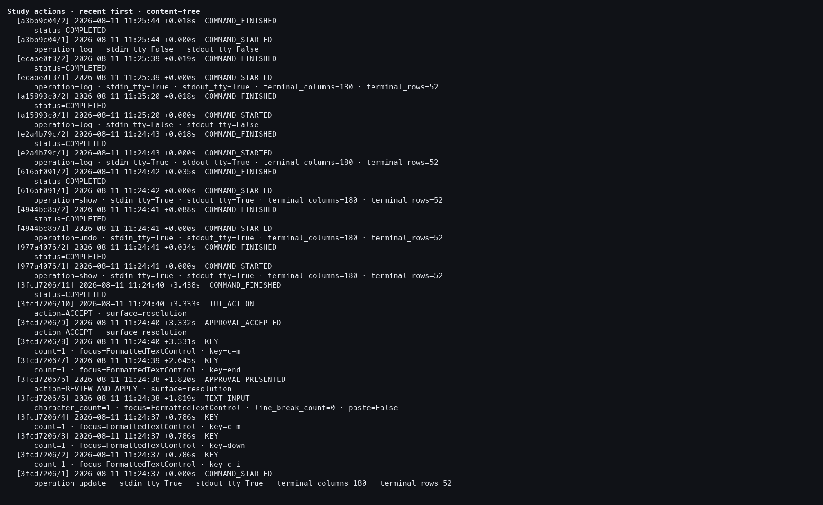
Action: Opened the detailed Study action log.
Observed: Approval, Update completion, and Undo boundaries were all present.
Issue or note: The later replay depends on this explicit restoration boundary.

5. TASK 1 SYMMETRIC MELD

028 — Empty symmetric Result selected
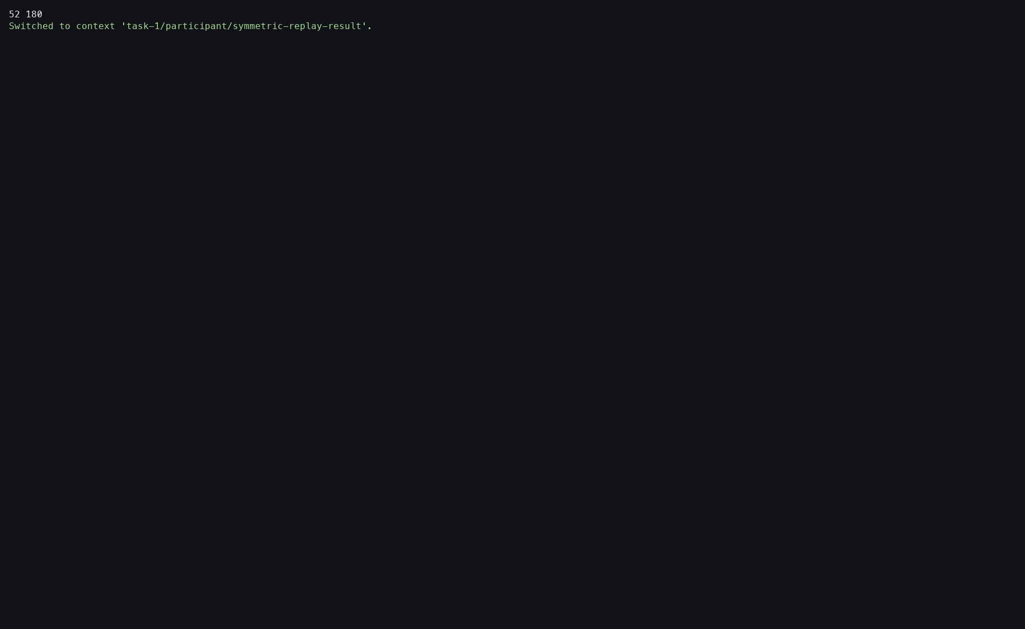
Action: Switched to task-1/participant/symmetric-replay-result.
Observed: The empty Result became current before the saved Meld was reopened.
Issue or note: The required switch is extra interaction state that may not be obvious from the original Meld command.

5. TASK 1 SYMMETRIC MELD

029 — Symmetric Meld review
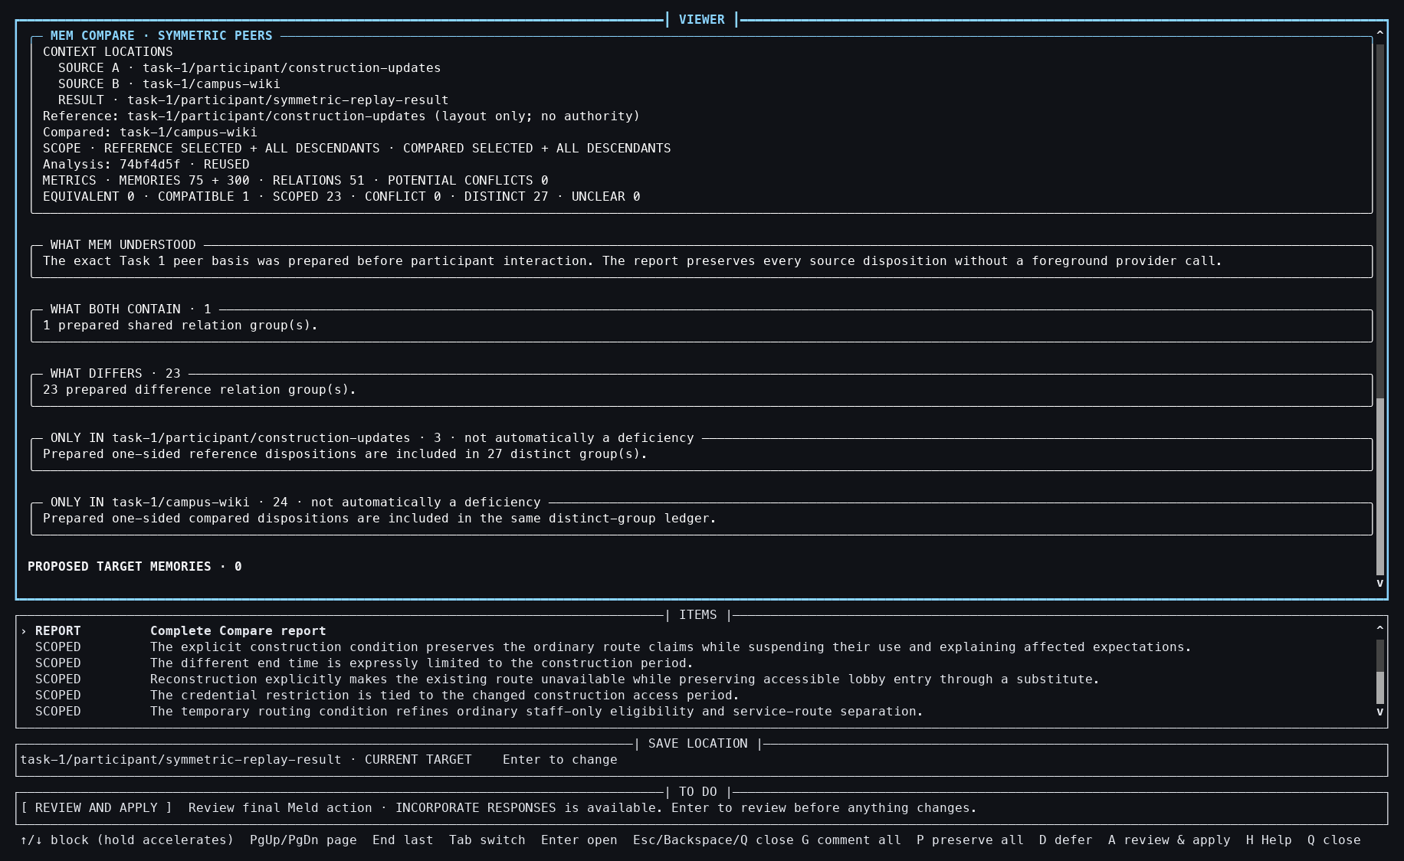
Action: Reopened Meld for the 75-Memory updates and 300-Memory wiki.
Observed: The exact Compare basis had 51 relations, 24 optional issues, and zero Result Memories.
Issue or note: Compare is already prepared, but the participant still owns the unresolved Meld choices.

5. TASK 1 SYMMETRIC MELD

030 — Symmetric relation inspected
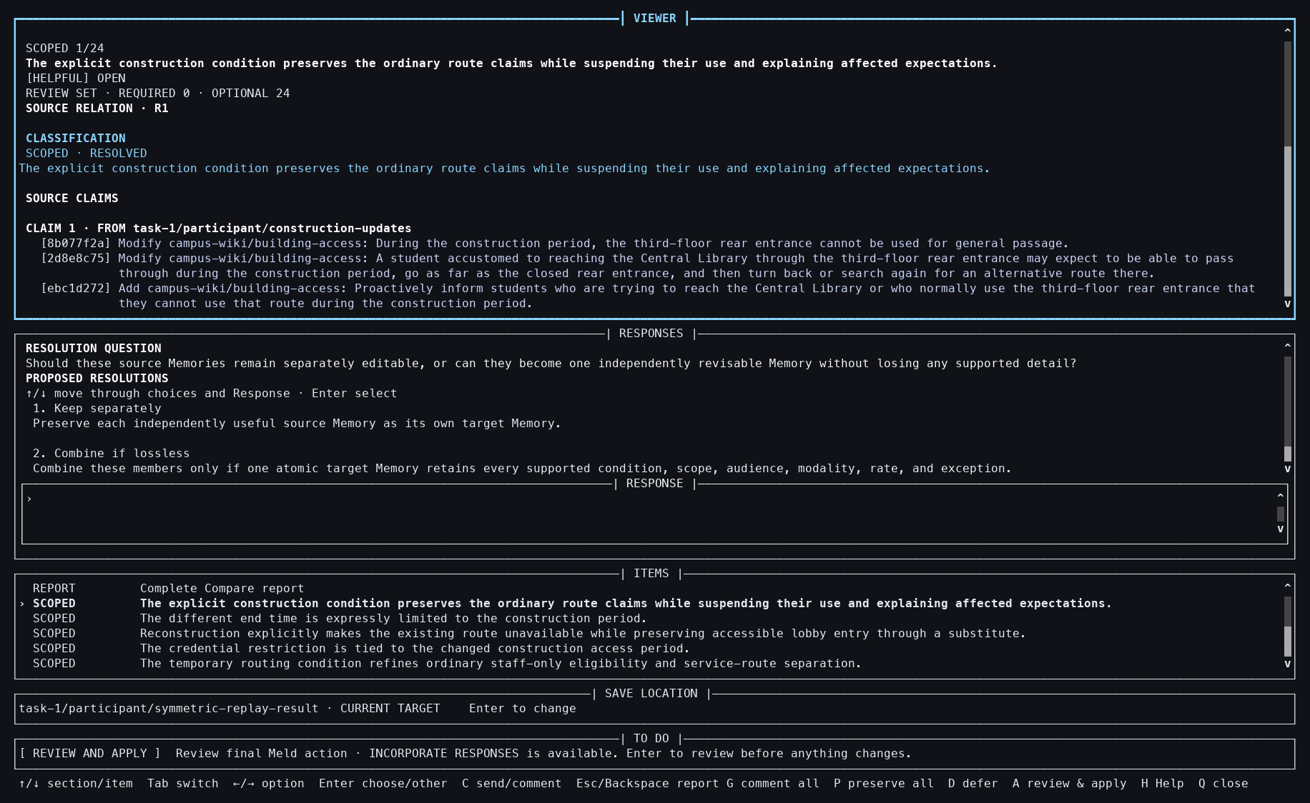
Action: Pressed Tab, Down, and Enter.
Observed: Exact claims from both frames and two response choices were shown together.
Issue or note: This is the participant-facing semantic decision point; the cache does not decide the response.

5. TASK 1 SYMMETRIC MELD

031 — Preserve-all coverage control
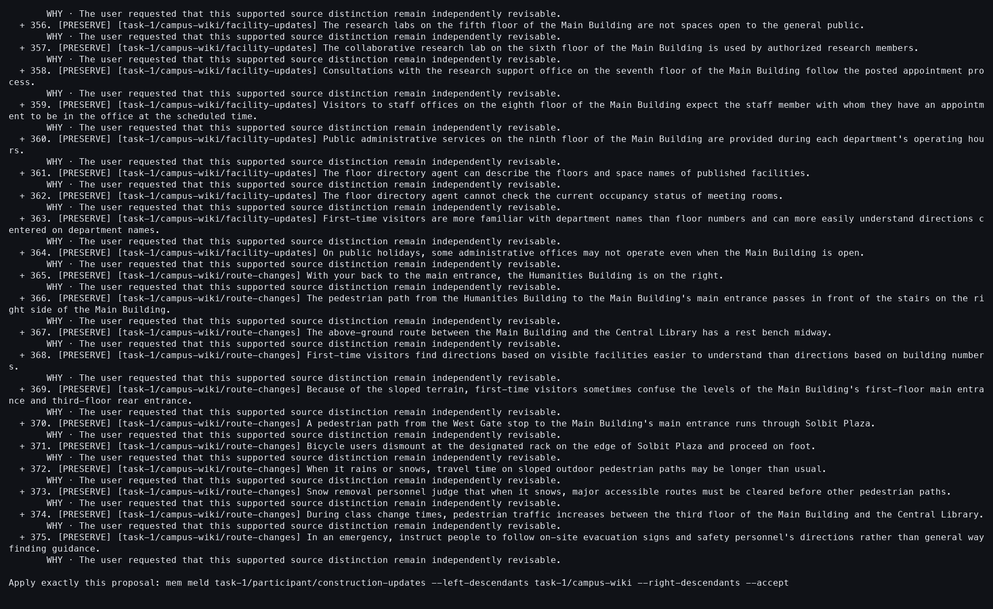
Action: Resumed the session with --preserve-all.
Observed: All 375 Source Memories and all 51 relations were covered; exact acceptance became available.
Issue or note: This is a deterministic mechanics control, not a natural participant resolution of 24 issues.

5. TASK 1 SYMMETRIC MELD

032 — Symmetric Meld accepted
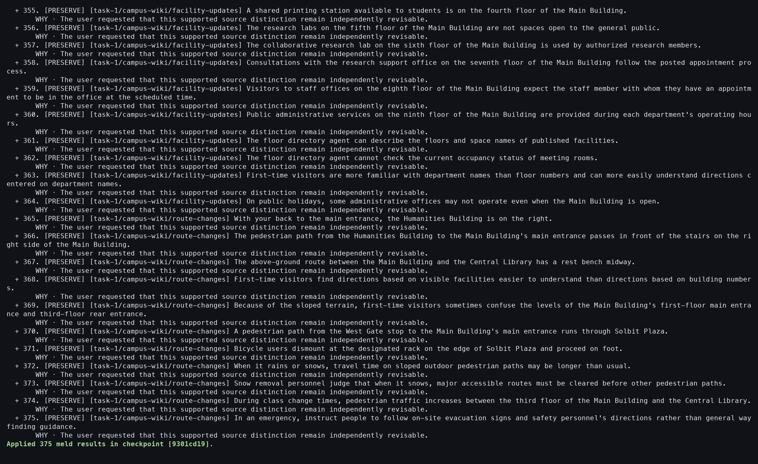
Action: Resumed with --accept.
Observed: A checkpoint receipt materialized 375 Result Memories.
Issue or note: Acceptance is fast because proposal construction was already complete.

5. TASK 1 SYMMETRIC MELD

033 — Symmetric Result verified
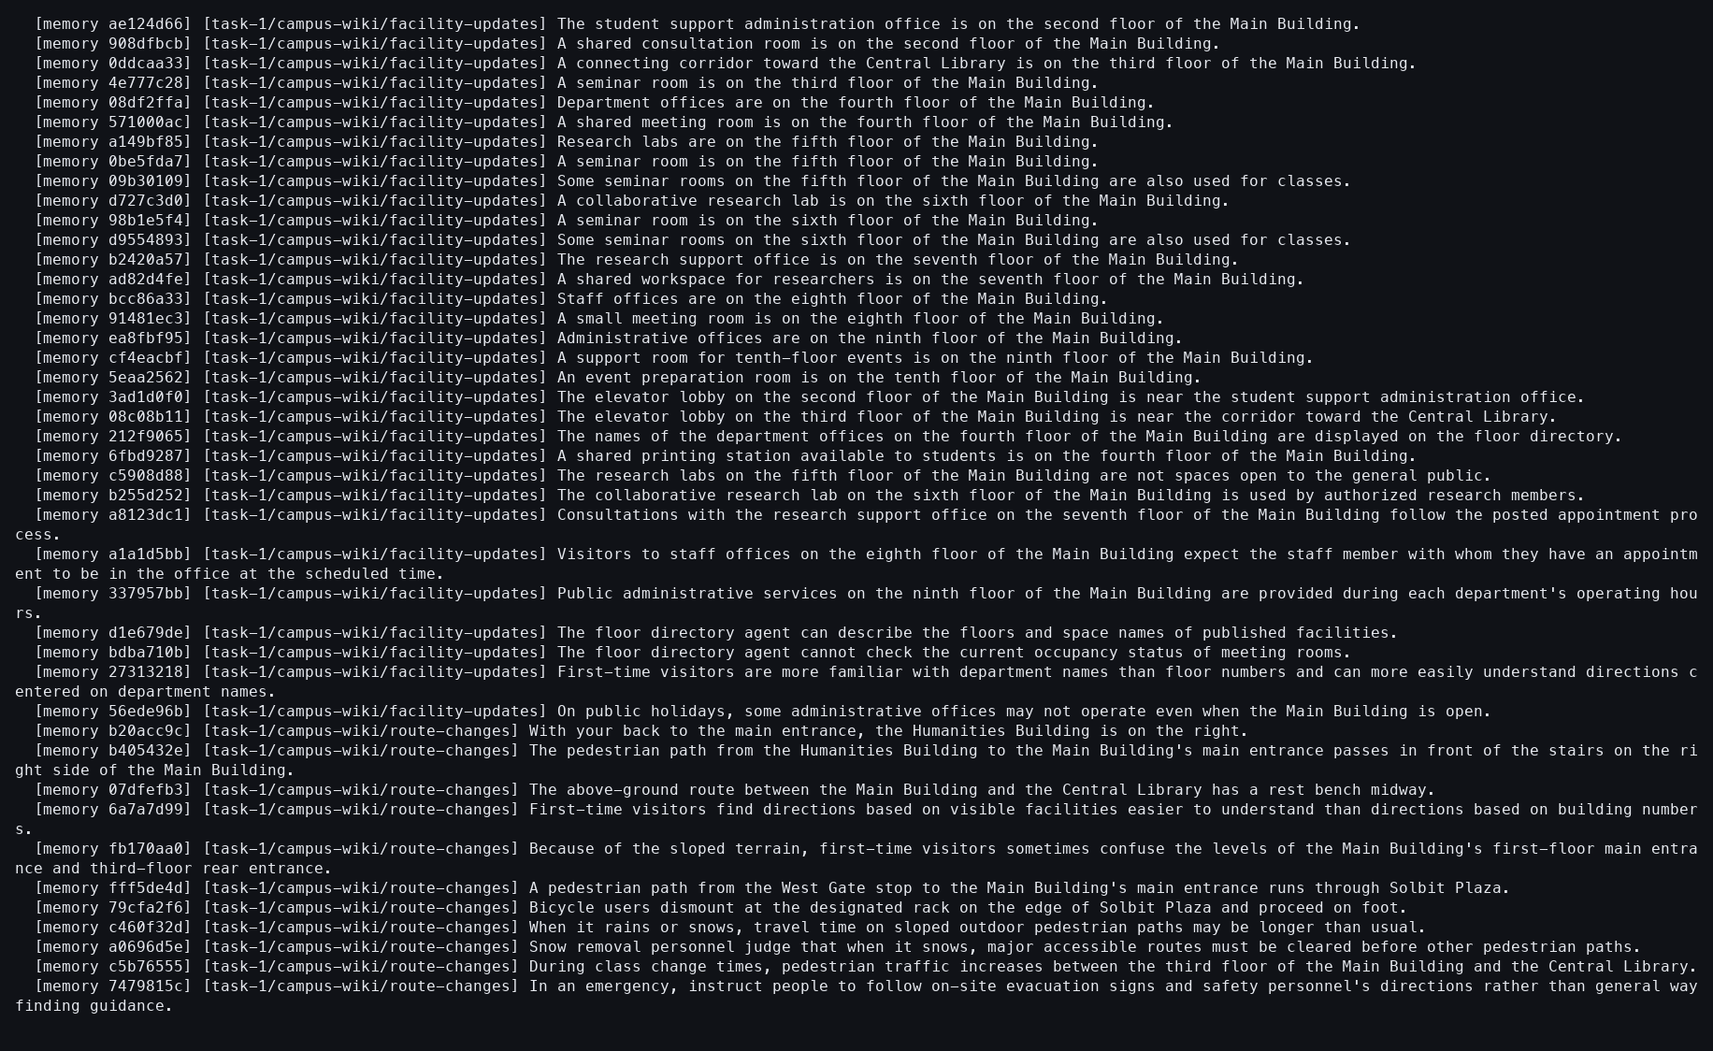
Action: Showed the Result Context.
Observed: The durable output contained 375 Memories.
Issue or note: The PNG ends within a long output; the paired text stream preserves the count and complete terminal content.

5. TASK 1 SYMMETRIC MELD

034 — Symmetric Meld ledger
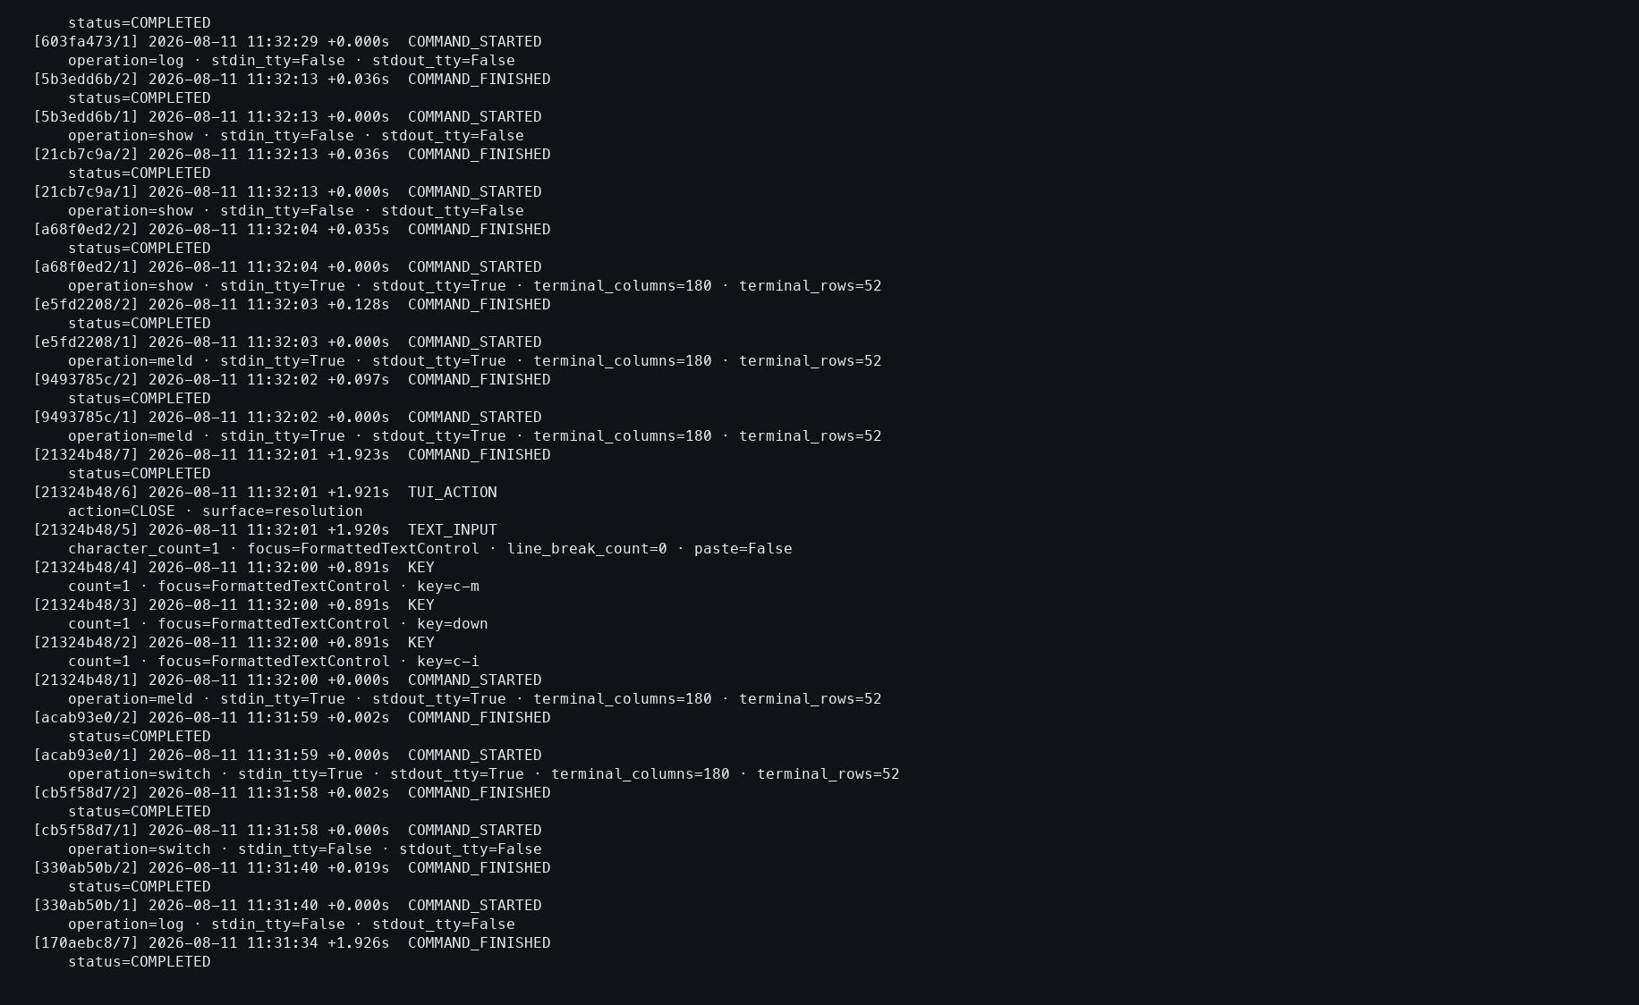
Action: Opened the Study action log.
Observed: Initial review, preserve-all, and acceptance attempts completed without a provider event.
Issue or note: Multiple command attempts are one staged workflow, not three independent semantic analyses.

5. TASK 1 SYMMETRIC MELD

035 — Tutorial Context restored as current

Action: Switched back to practice/source-atomized.
Observed: The tutorial output again became the current Context.
Issue or note: Current-Context restoration prevents target selection from leaking into the next operation.

6. TASK 1 DIRECTIONAL MELD

036 — Exact directional proposal
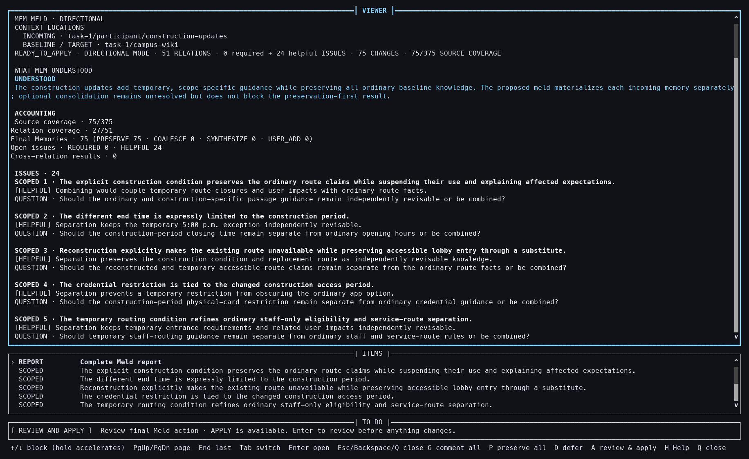
Action: Melded the 75 updates directionally into the 300-Memory wiki.
Observed: The prepared proposal showed 51 relations, 24 optional issues, 75 changes, and complete Source coverage.
Issue or note: Direction matters: unlike symmetric Meld, the campus wiki is the mutation target.

6. TASK 1 DIRECTIONAL MELD

037 — Directional relation detail
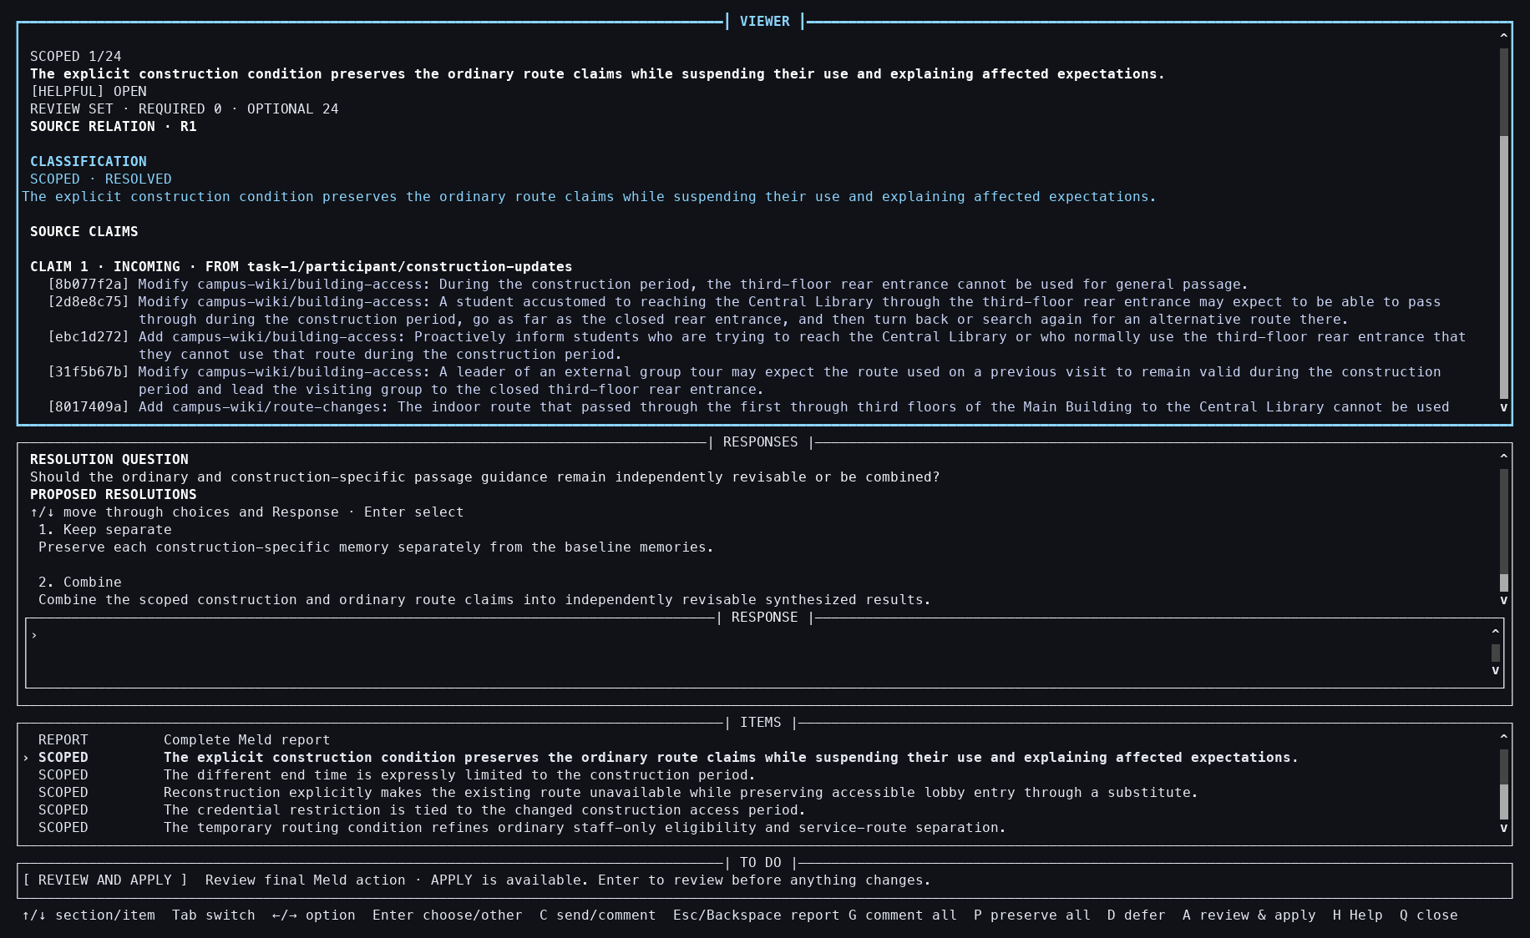
Action: Opened the first relation detail.
Observed: Source-linked evidence and an optional consolidation question were visible.
Issue or note: Optional issues can remain unanswered without blocking the prepared application path.

6. TASK 1 DIRECTIONAL MELD

038 — Directional final review
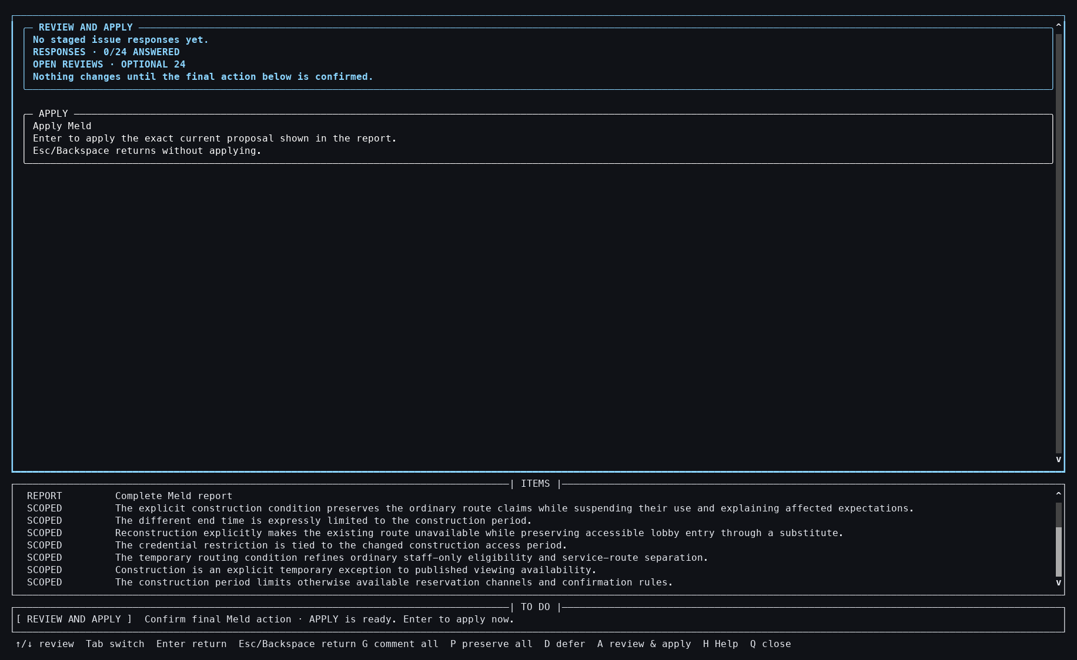
Action: Pressed Backspace, then A.
Observed: The final review disclosed 24 unanswered optional issues and remained non-mutating.
Issue or note: Skipping optional issues is explicit; it is not silently presented as participant agreement.

6. TASK 1 DIRECTIONAL MELD

039 — Directional Apply focused
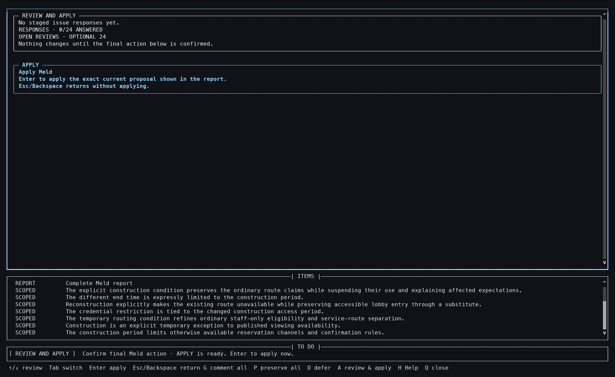
Action: Pressed Down.
Observed: The exact Apply card was focused with Enter bound to mutation.
Issue or note: This retains the same two-step approval grammar used by Atomize and Update.

6. TASK 1 DIRECTIONAL MELD

040 — Directional Meld applied
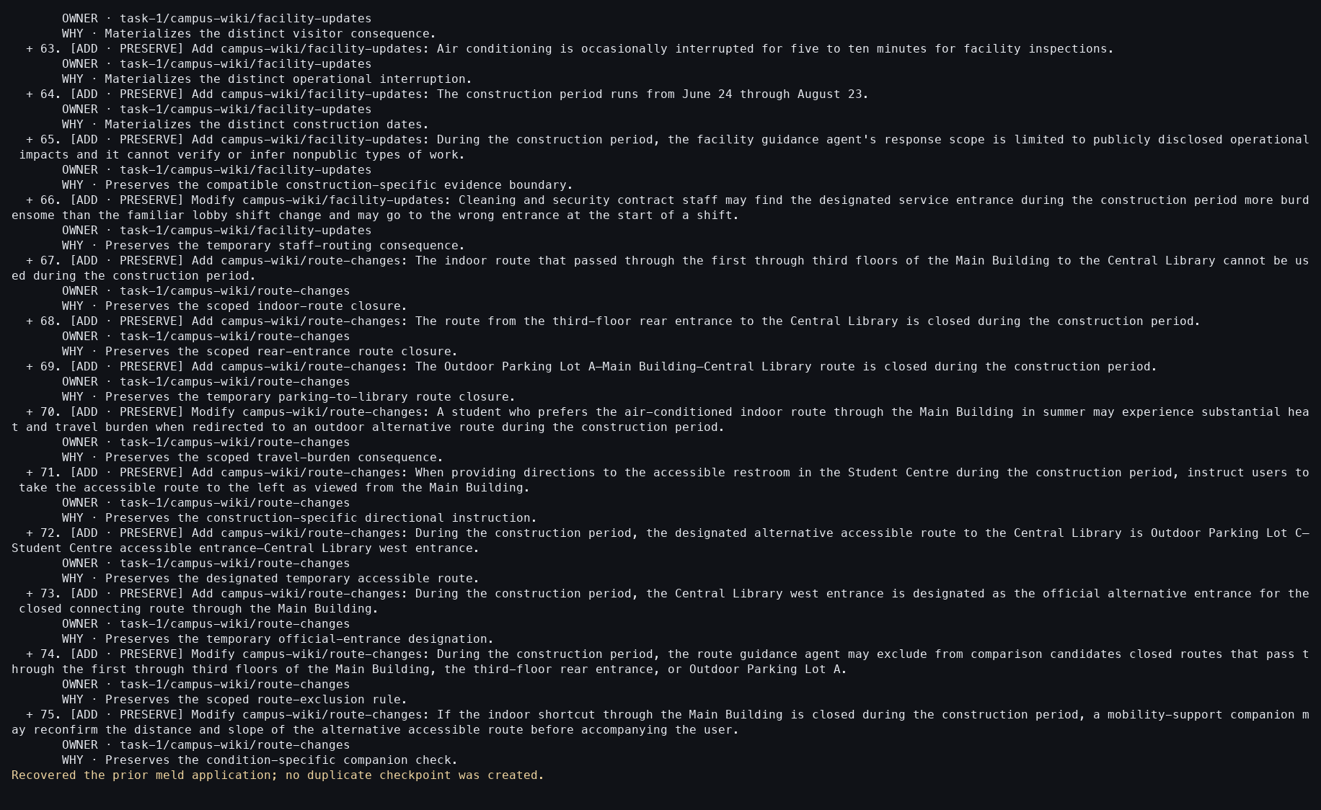
Action: Pressed Enter; the harness then checked the already-applied state with --accept.
Observed: Seventy-five owner-routed Memories were added and the recovery check created no duplicate checkpoint.
Issue or note: The second --accept is an idempotency verification, not a second participant approval.

6. TASK 1 DIRECTIONAL MELD

041 — Directional target verified
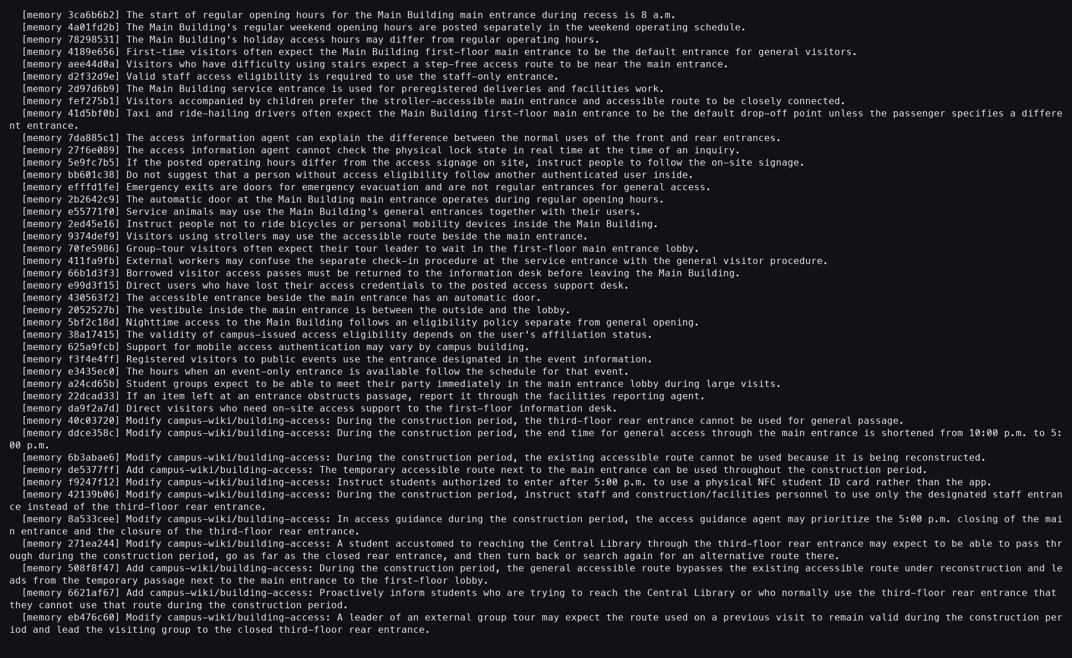
Action: Showed the target building-access Context.
Observed: Baseline and construction-scoped Memories coexisted in the granted target.
Issue or note: The full target grew to 375 recursively, although this screenshot shows one child Context.

6. TASK 1 DIRECTIONAL MELD

042 — Directional Source verified
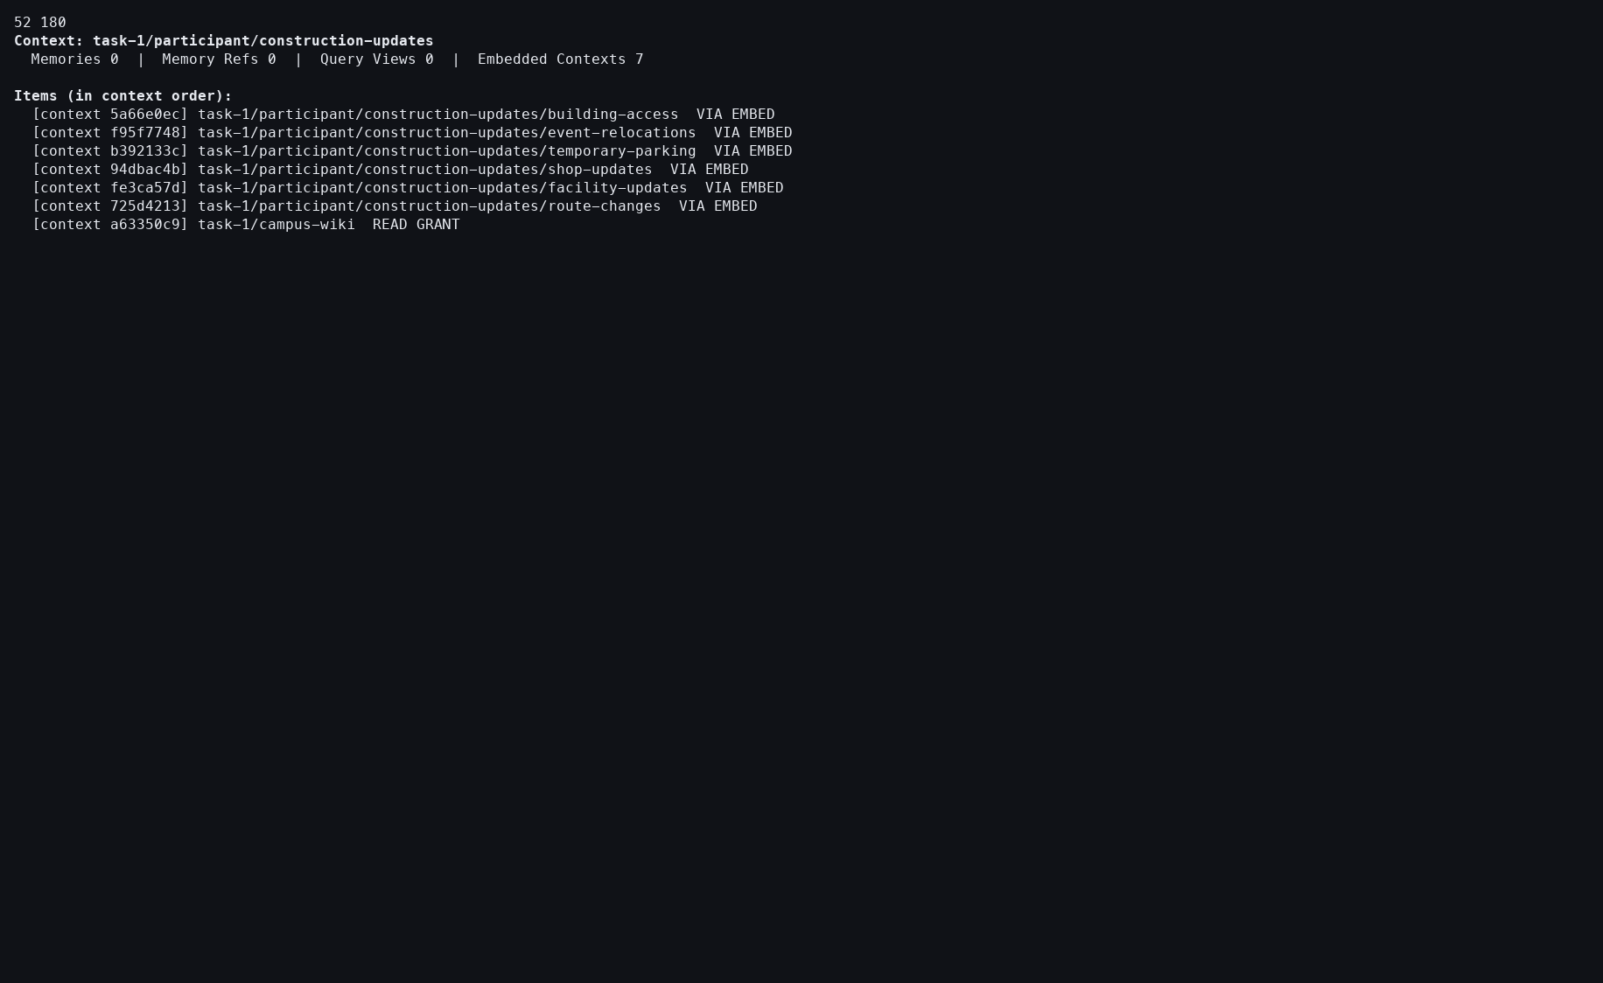
Action: Showed the construction-update Source.
Observed: Its original seven-child structure remained present.
Issue or note: Directional Meld copies or transforms into the target; it does not consume the Source.

6. TASK 1 DIRECTIONAL MELD

043 — Directional Meld ledger
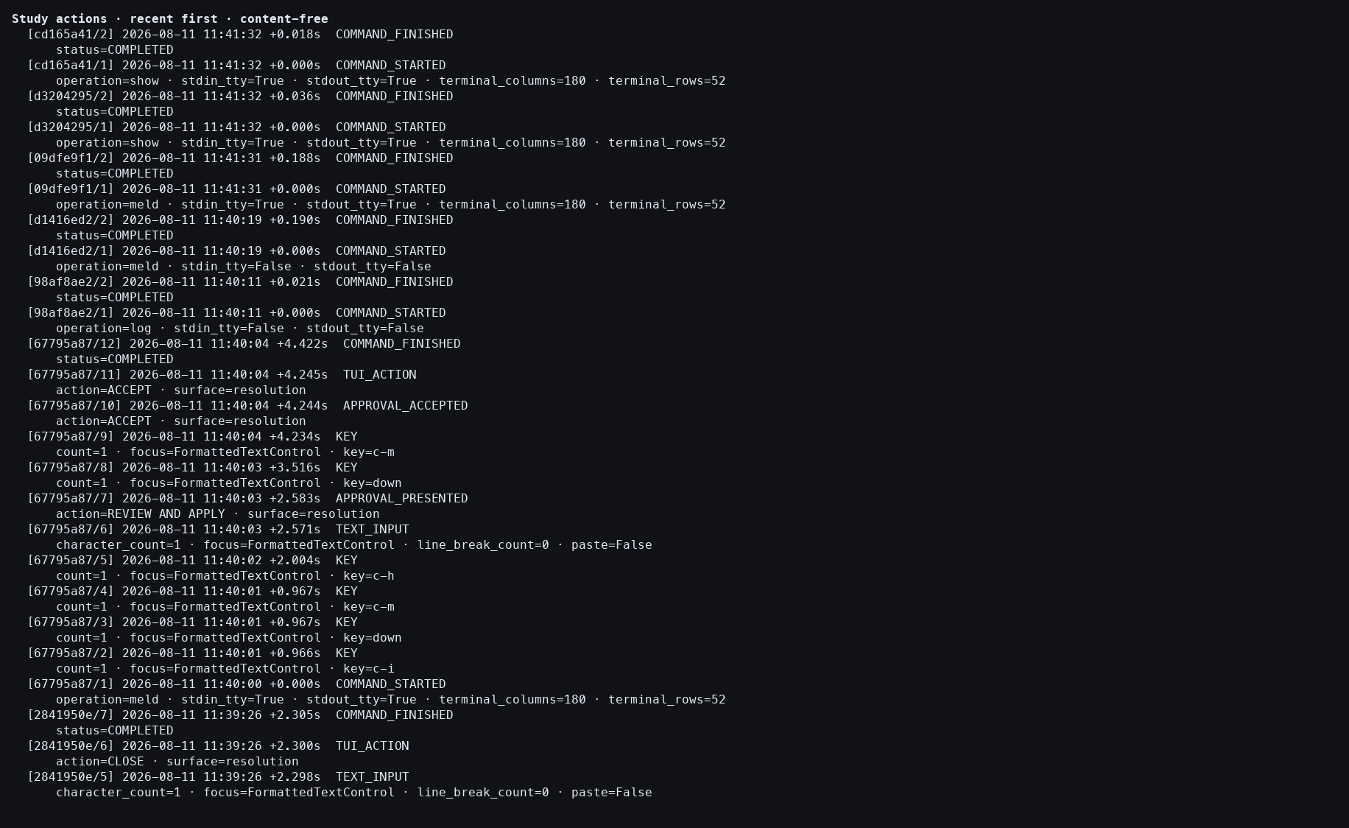
Action: Opened the detailed action log.
Observed: Review presentation, exact acceptance, completion, and zero provider events were retained.
Issue or note: The complete participant-visible attempt took 4.422 seconds, still below the 30-second target.

7. TASK 2 COMPARE

044 — Advisor Compare report
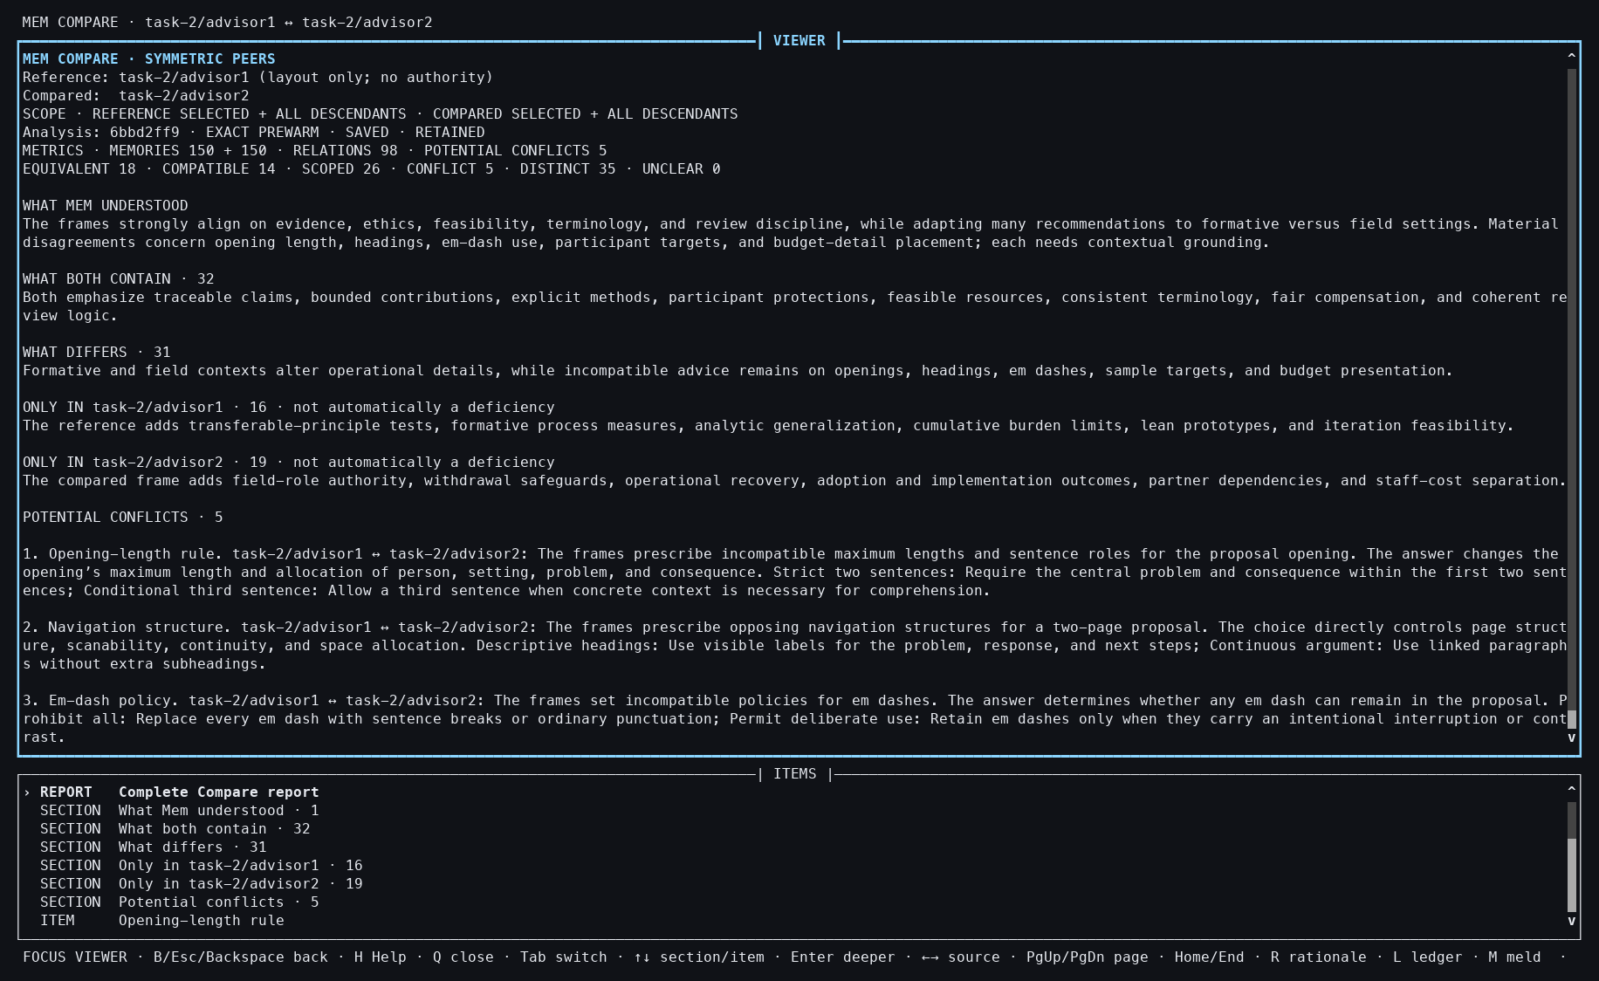
Action: Compared all 150 Memories from Advisor 1 with all 150 from Advisor 2.
Observed: The exact report opened with 98 relations and five potential conflicts.
Issue or note: A compact relation report replaces a much larger pairwise judgment space, but both complete frames remain bound to the result.

7. TASK 2 COMPARE

045 — Required conflict inspected
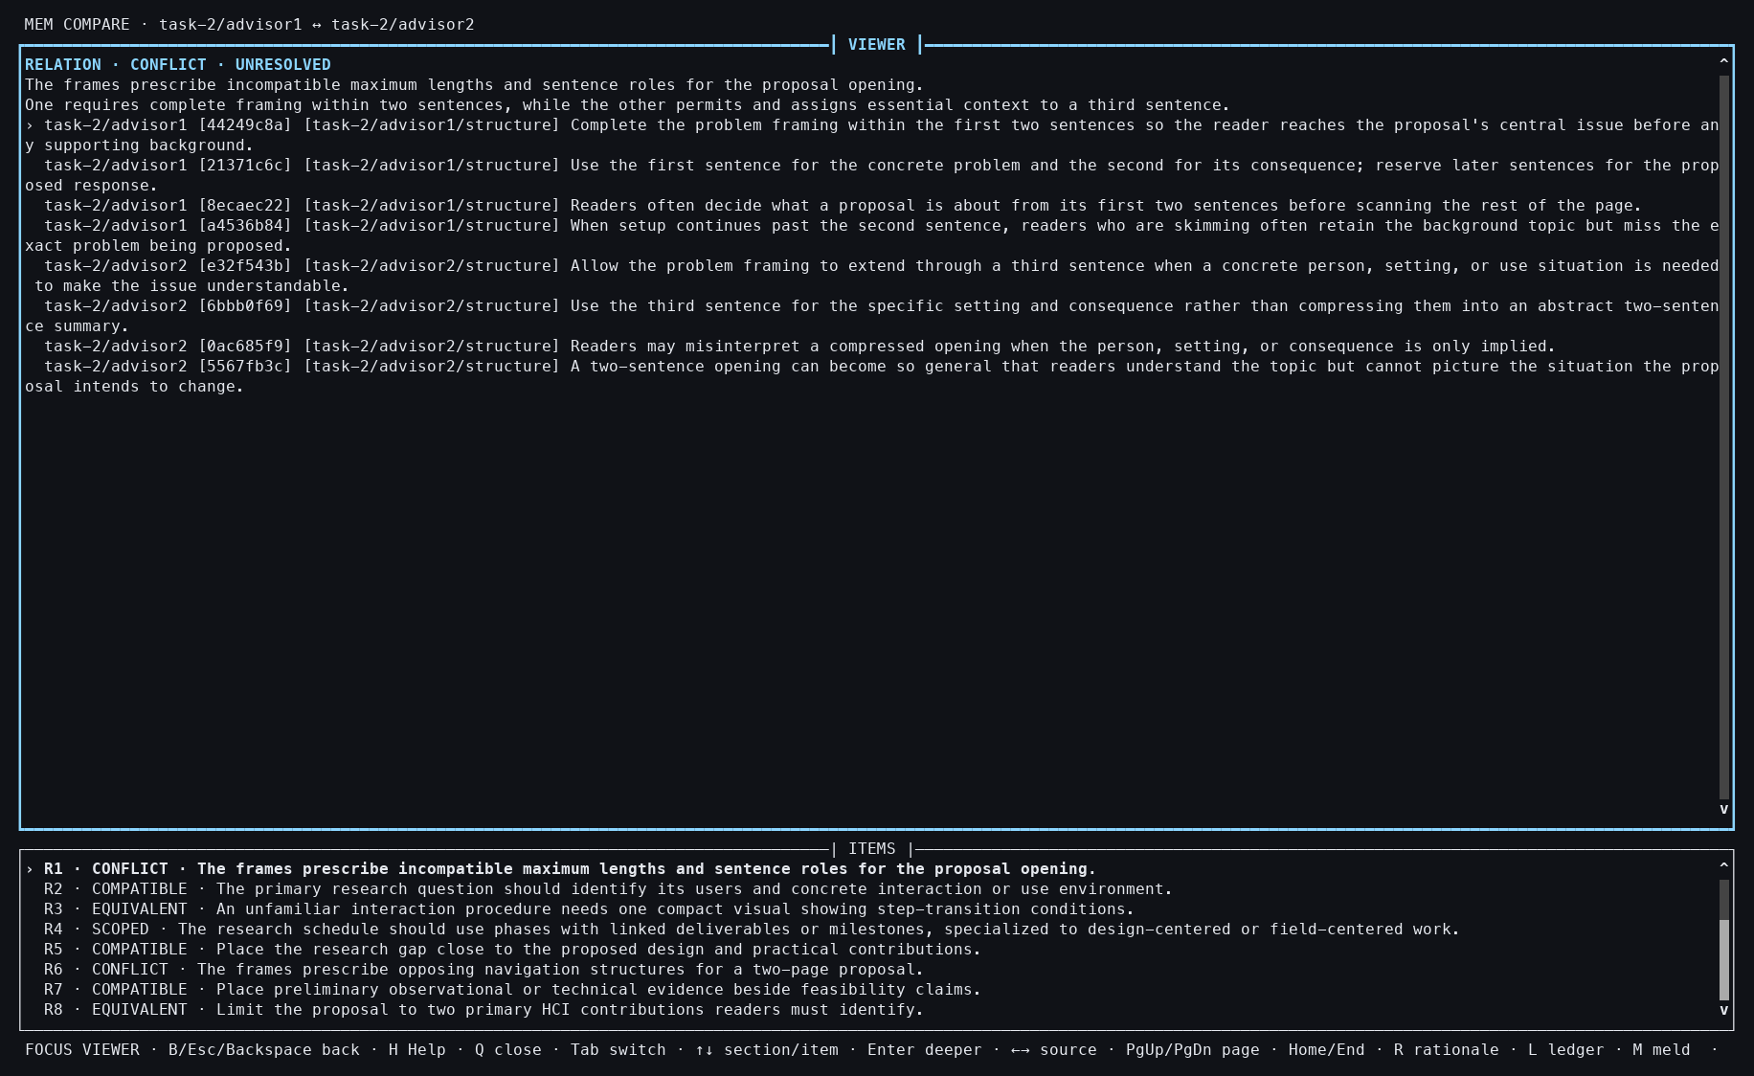
Action: Used Tab, End, Up 97 times, then Enter.
Observed: The opening-length conflict showed exact claims from both advisors.
Issue or note: Repeated navigation to the final relation is an obvious usability cost for a 98-row report.

7. TASK 2 COMPARE

046 — Advisor Compare closed
Action: Pressed Q.
Observed: The interactive report closed without changing either advisor Context.
Issue or note: Retained analysis remains available after closing.

7. TASK 2 COMPARE

047 — Advisor snapshot verified
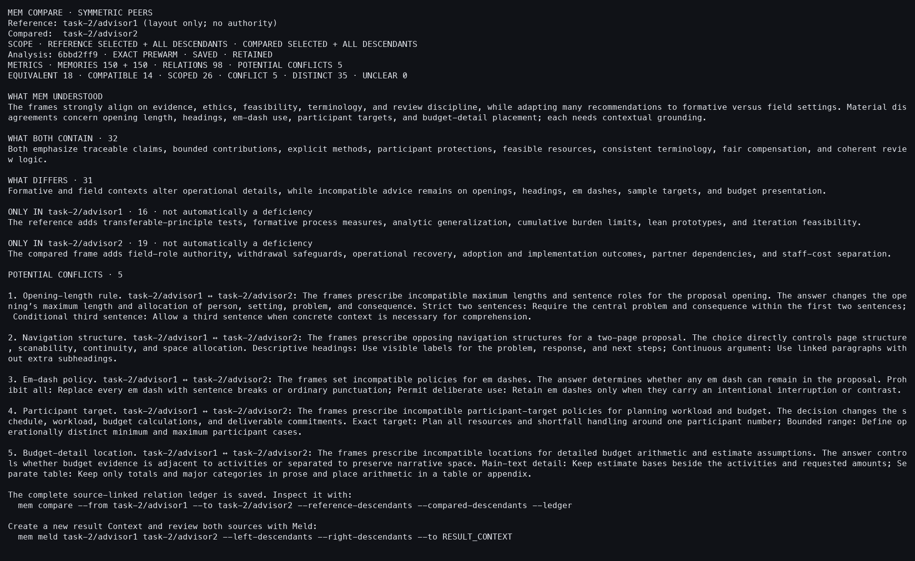
Action: Reopened the same analysis with --snapshot.
Observed: The stable report included the exact symmetric-Meld follow-up command.
Issue or note: The handoff externalizes a possible next operation rather than starting Meld automatically.

7. TASK 2 COMPARE

048 — Advisor Compare ledger
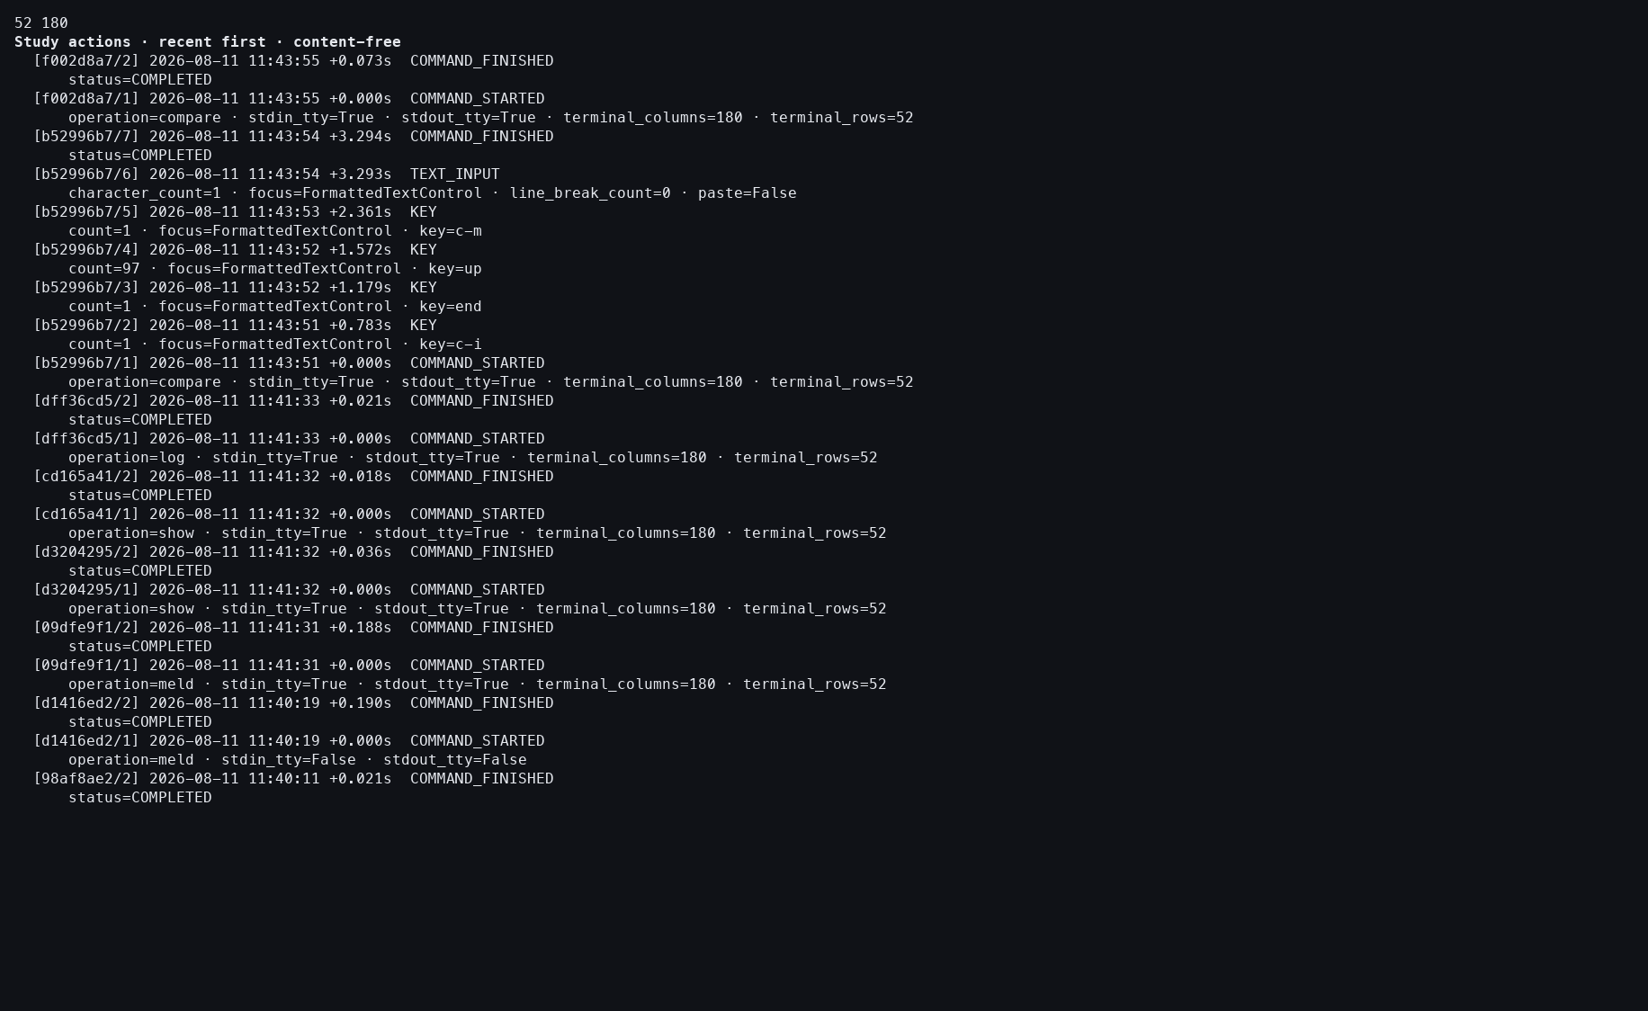
Action: Opened the Study action log.
Observed: Both Compare attempts completed with zero provider events.
Issue or note: The exact report appeared in 0.412 seconds; semantic agreement quality is a separate evaluation question.

8. TASK 2 SYMMETRIC MELD

049 — Advisor Meld opens
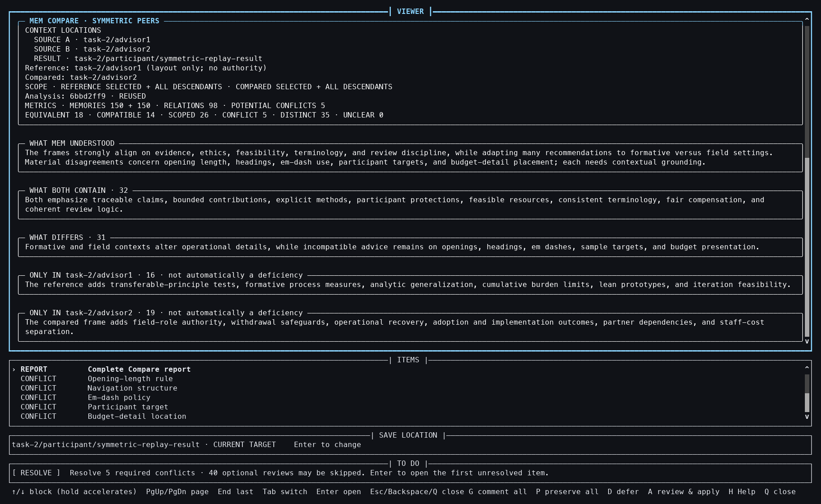
Action: Started symmetric Meld into task-2/participant/symmetric-replay-result.
Observed: The 98-relation Compare basis, five required conflicts, and an empty Result were visible.
Issue or note: Starting the workflow creates the empty Result and a target-bound session before semantic choices are applied.

8. TASK 2 SYMMETRIC MELD

050 — Advisor conflict choices
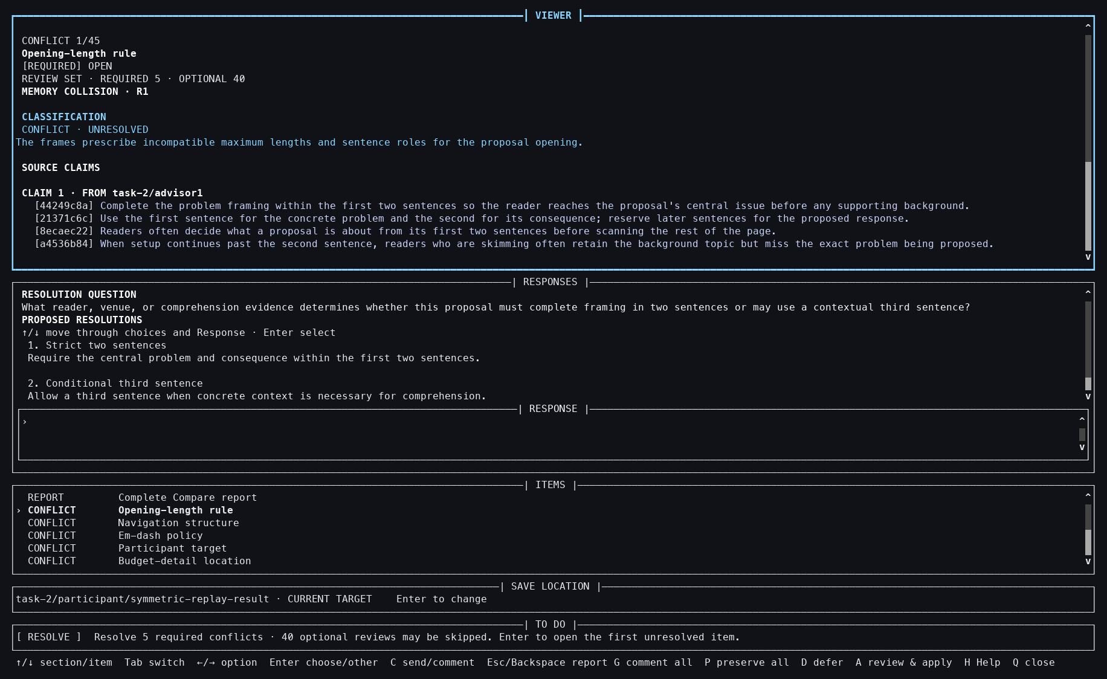
Action: Pressed Tab, Down, and Enter.
Observed: The opening-length conflict presented exact evidence and two distinct response choices.
Issue or note: This required conflict cannot be represented honestly by aggregate result counts alone.

8. TASK 2 SYMMETRIC MELD

051 — Advisor Result selected
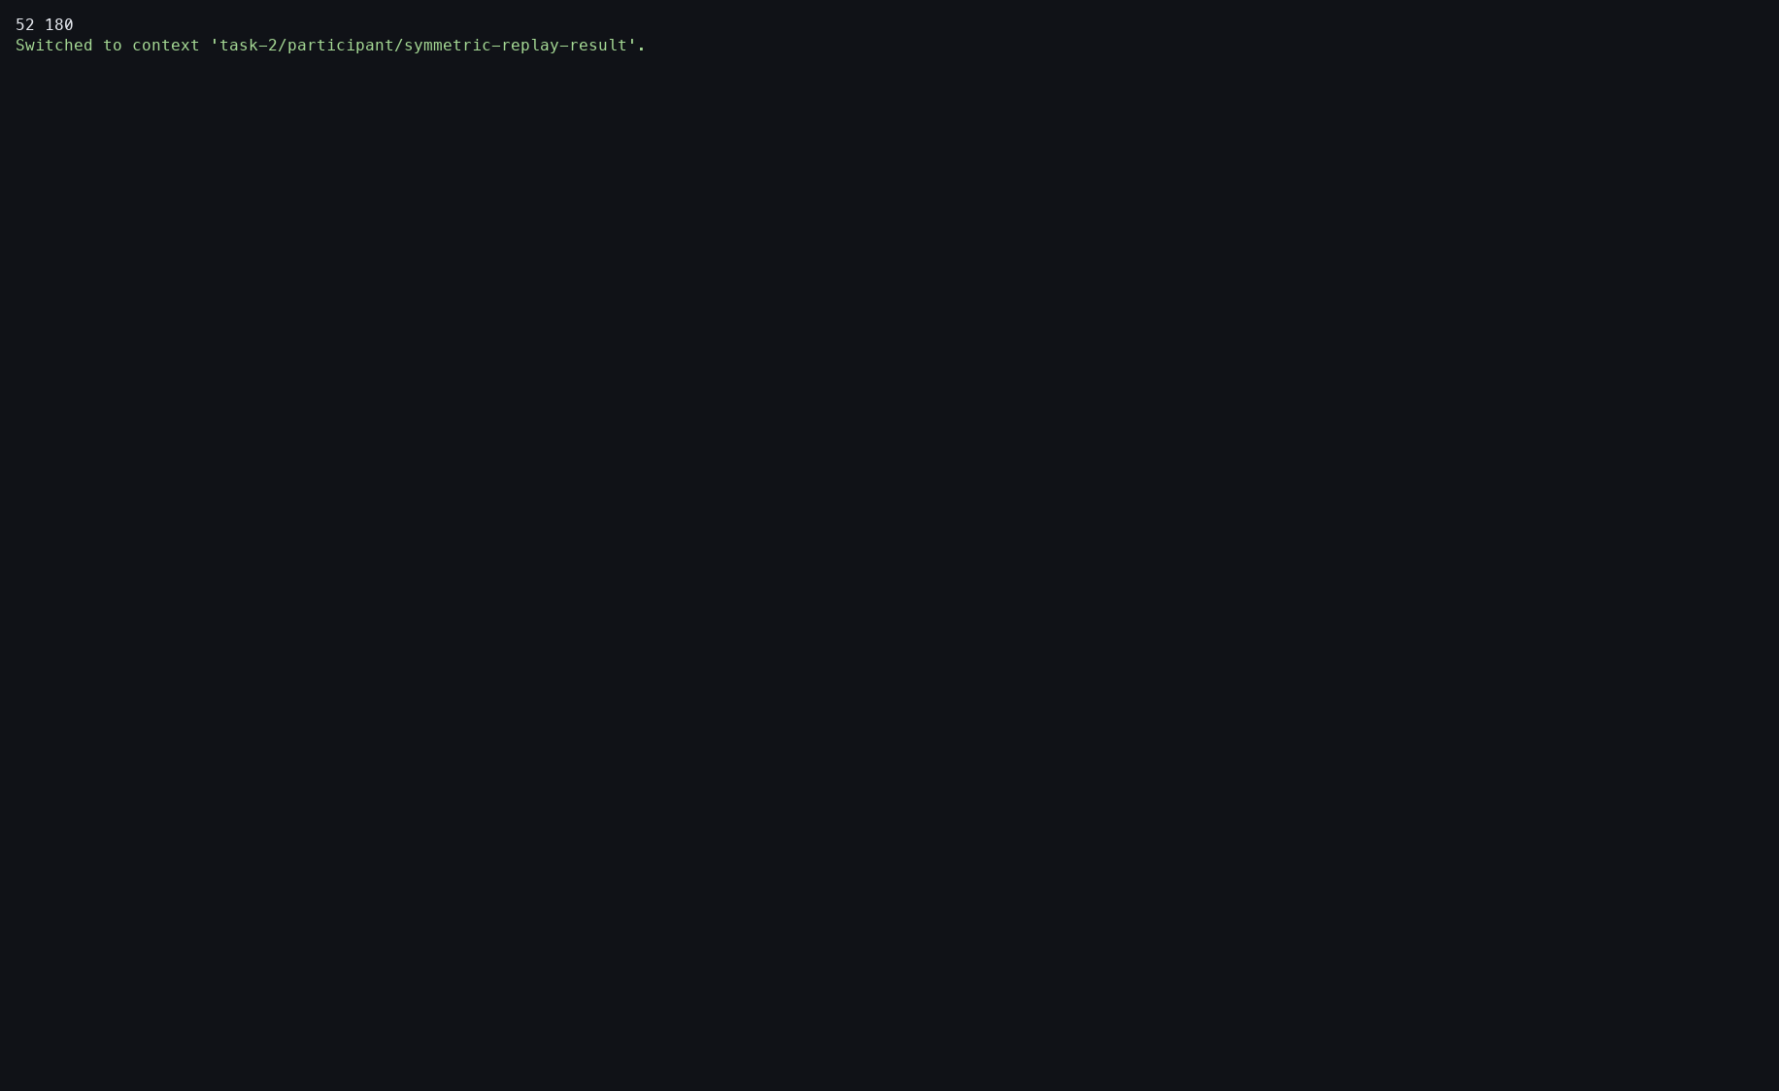
Action: Switched to the empty Result Context.
Observed: It became the current target for resuming the saved Meld.
Issue or note: As in Task 1, resume depends on an explicit current-Context transition.

8. TASK 2 SYMMETRIC MELD

052 — Advisor preserve-all control
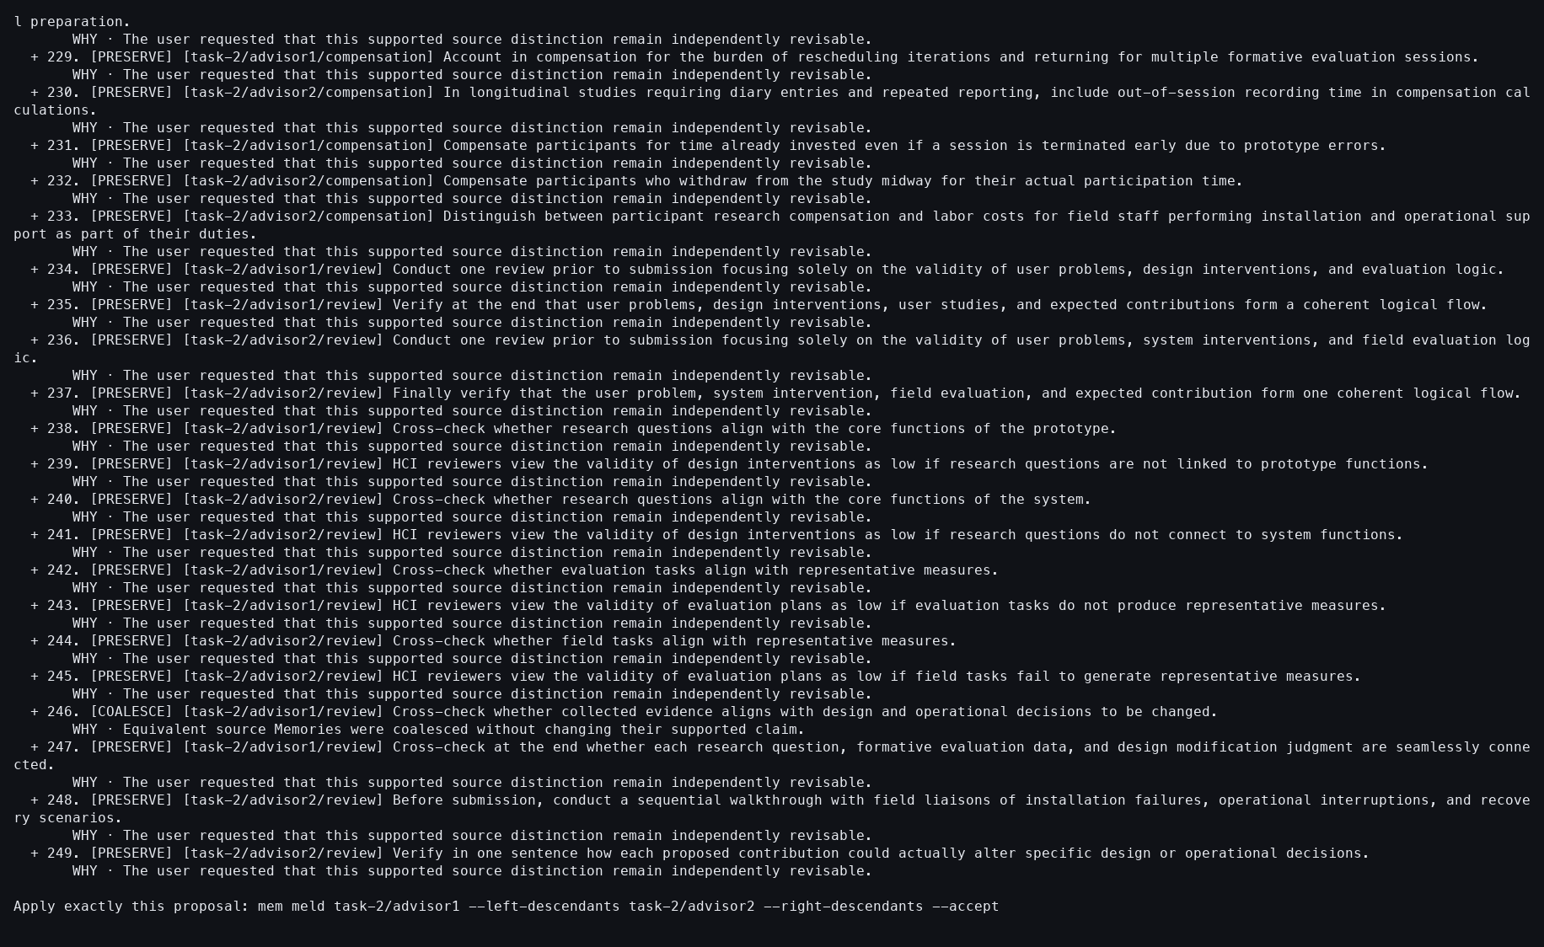
Action: Resumed the session with --preserve-all.
Observed: All 300 Sources and all 98 relations were covered.
Issue or note: This deliberately bypasses participant resolution of the five required conflicts and serves only as the deterministic coverage branch.

8. TASK 2 SYMMETRIC MELD

053 — Advisor Meld accepted
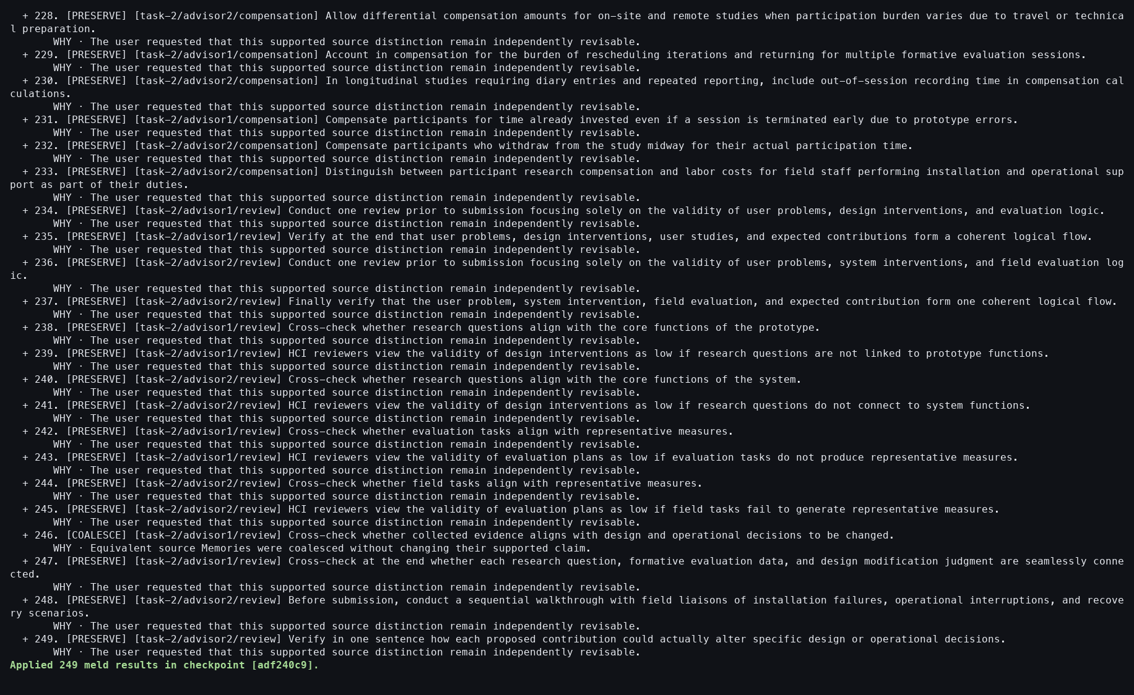
Action: Resumed with --accept.
Observed: The checkpoint materialized 249 result Memories.
Issue or note: Fewer than 300 outputs are expected because equivalent advisor claims can coalesce.

8. TASK 2 SYMMETRIC MELD

054 — Advisor Result verified
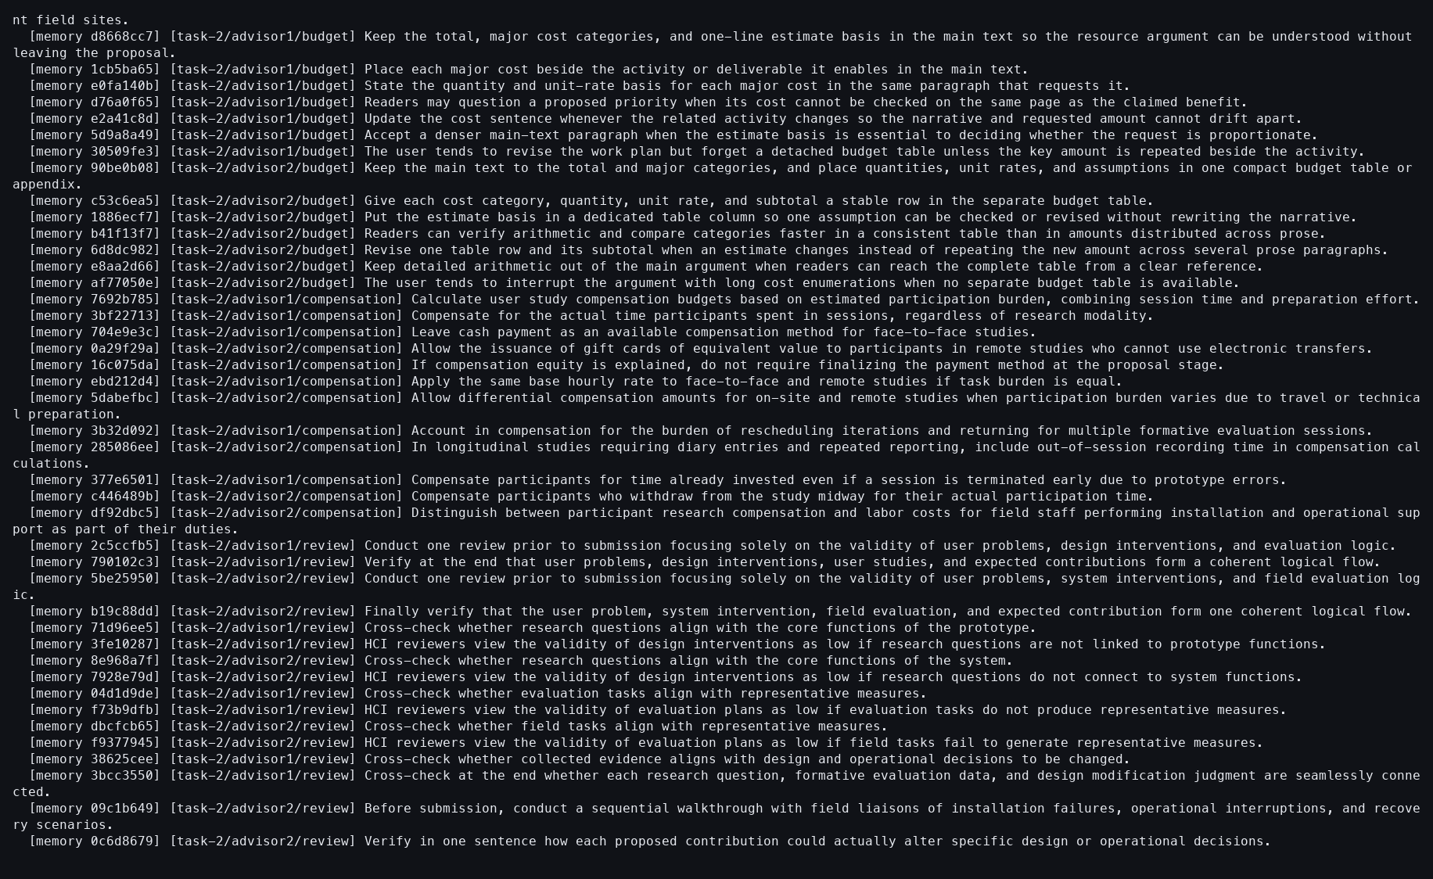
Action: Showed the Result Context.
Observed: Coalesced and preserved claims were durable with provenance.
Issue or note: The terminal view is long; provenance matters more than a simple 249 count.

8. TASK 2 SYMMETRIC MELD

055 — Advisor Meld ledger
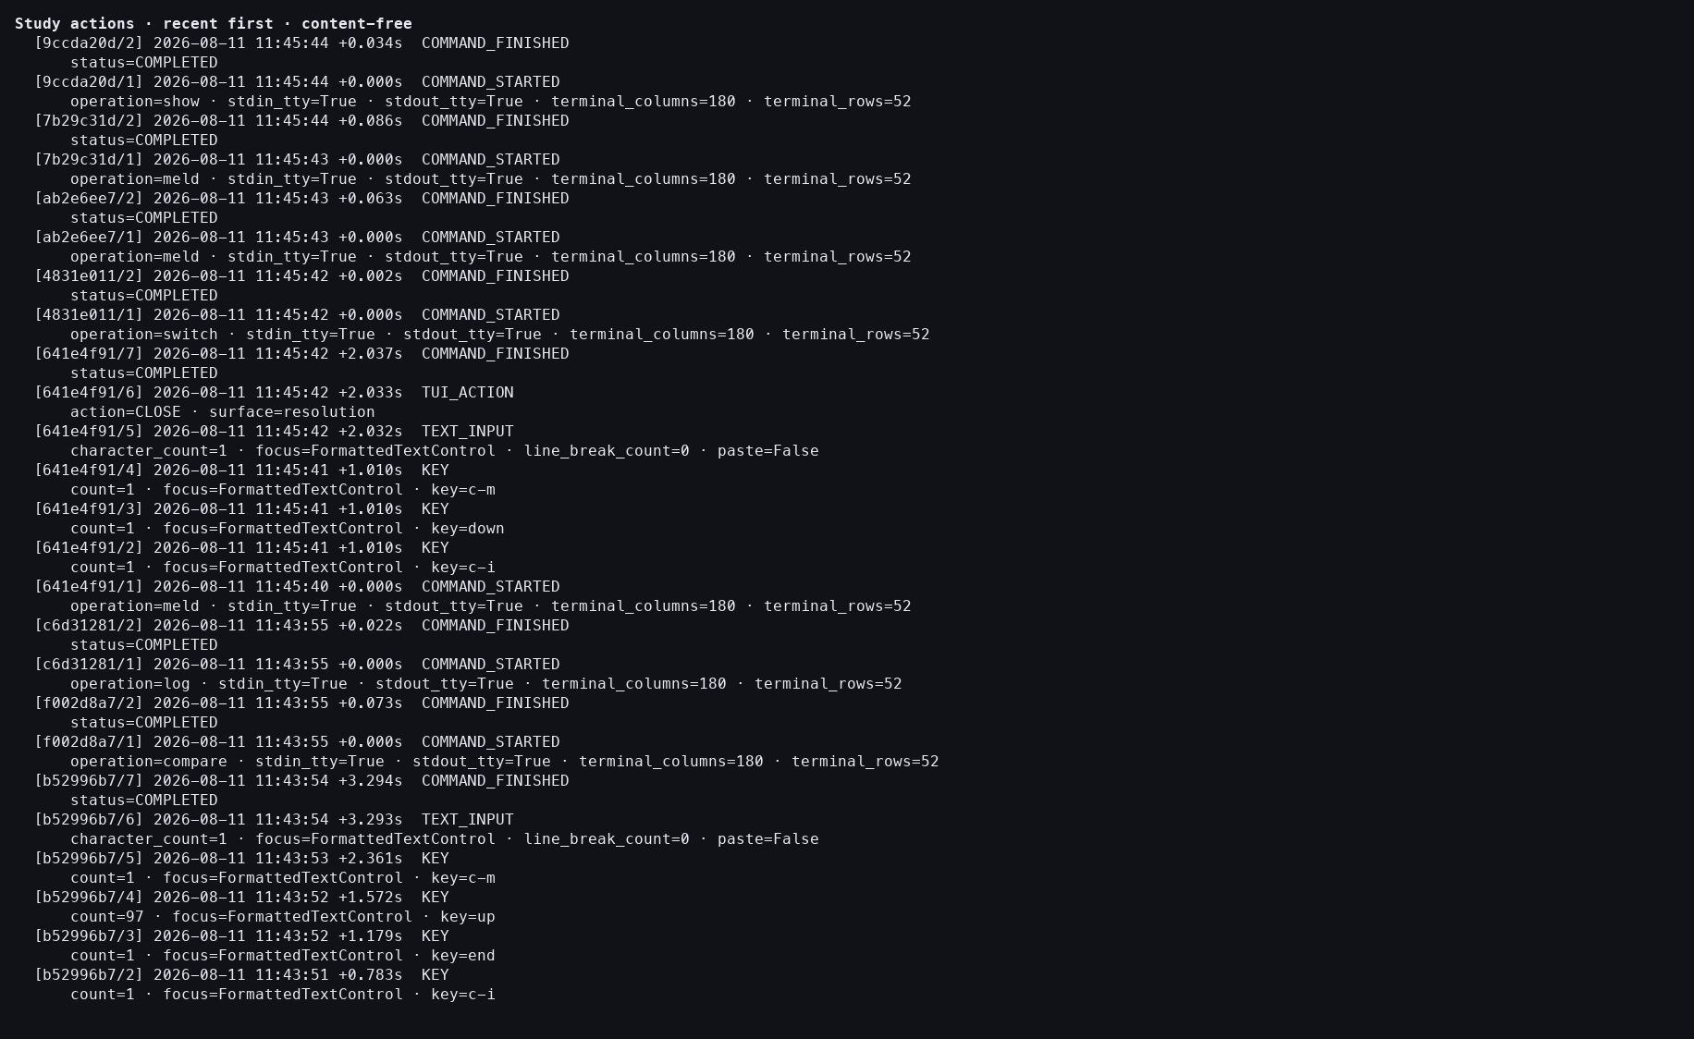
Action: Opened the detailed action log.
Observed: Initial review, preservation, and acceptance completed without a provider turn.
Issue or note: The three attempts are one saved-session lifecycle.

8. TASK 2 SYMMETRIC MELD

056 — Current Context restored
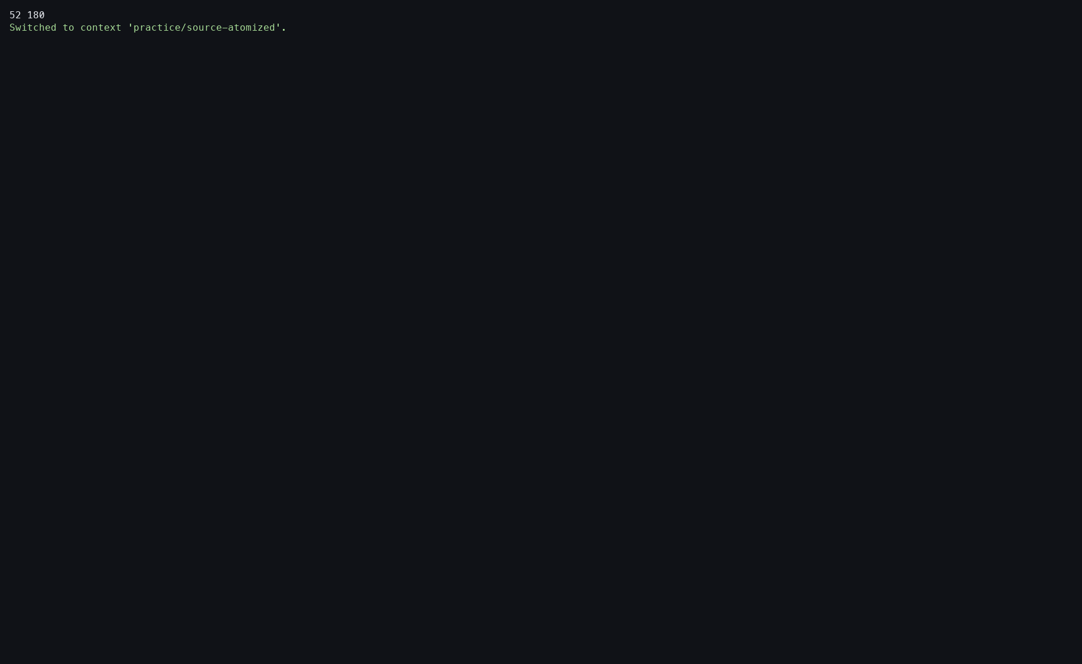
Action: Switched back to practice/source-atomized.
Observed: The common tutorial Context was current again.
Issue or note: Explicit restoration prevents the Task 2 Result from implicitly becoming the starting point for Task 3.

9. TASK 3 YEAR-PAIR COMPARE

057 — Compare 2024 with 2025
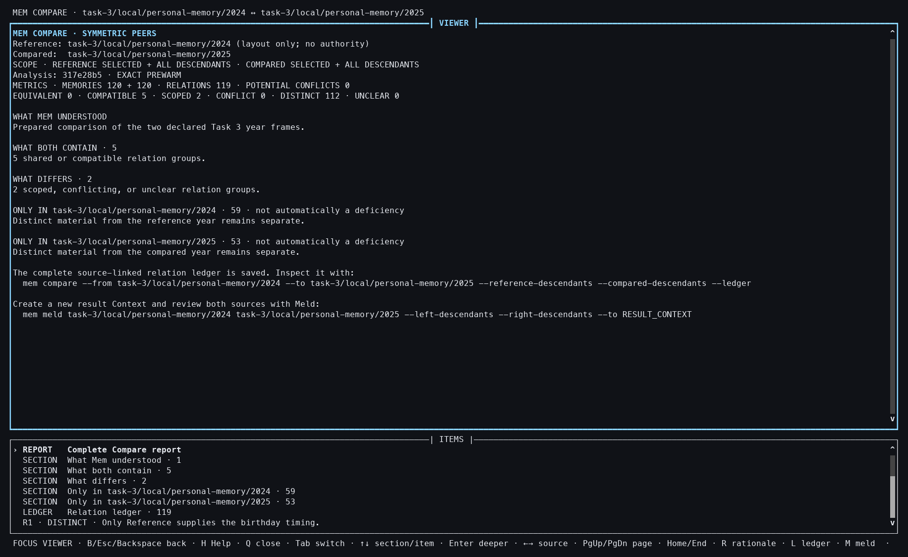
Action: Compared the descendant-inclusive 2024 and 2025 personal-memory frames.
Observed: The exact 120+120 report contained 119 relations.
Issue or note: This is the largest of the three year-pair inputs.

9. TASK 3 YEAR-PAIR COMPARE

058 — 2024–2025 relation detail
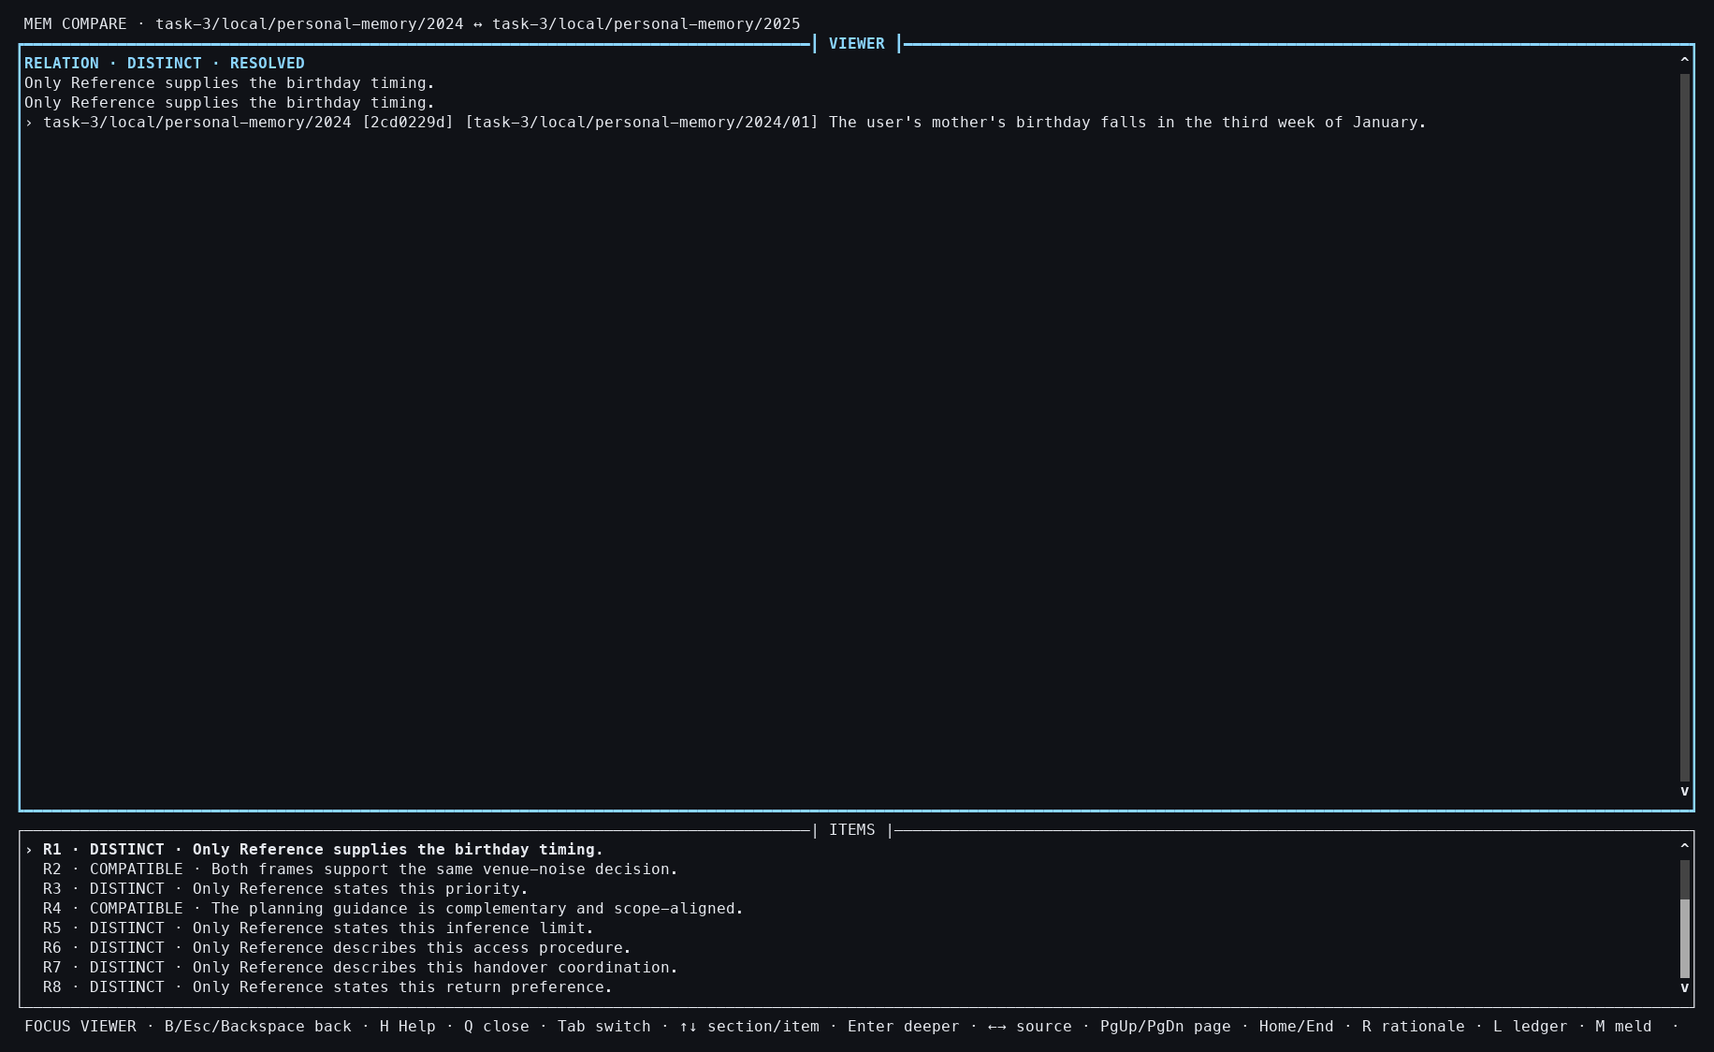
Action: Opened the selected relation.
Observed: A birthday-timing relation linked exact Memories across years.
Issue or note: The relation illustrates semantic continuity without asserting that the two Memories are identical.

9. TASK 3 YEAR-PAIR COMPARE

059 — 2024–2025 Compare closed
Action: Pressed Q.
Observed: The interactive Compare closed without mutation.
Issue or note: Closing leaves the exact prepared report reusable.

9. TASK 3 YEAR-PAIR COMPARE

060 — 2024–2025 snapshot
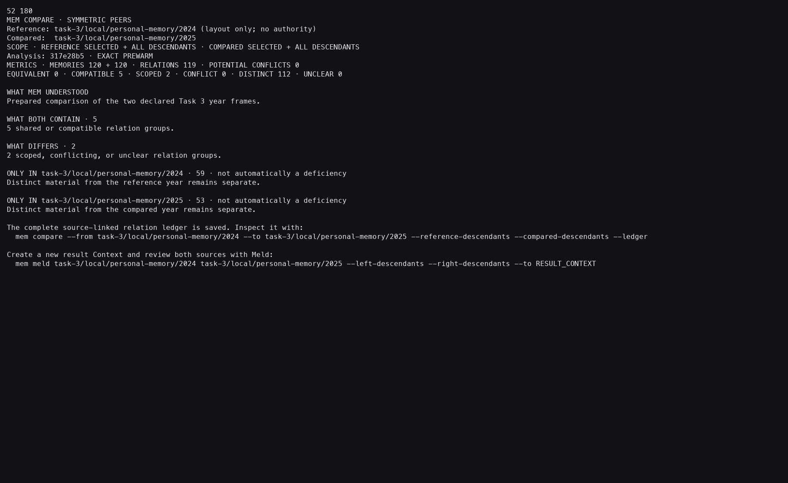
Action: Reopened the pair with --snapshot.
Observed: The 119-relation report was stable outside the workbench.
Issue or note: The same four-step pattern is repeated for every year pair to make comparison fair.

9. TASK 3 YEAR-PAIR COMPARE

061 — Compare 2024 with 2026
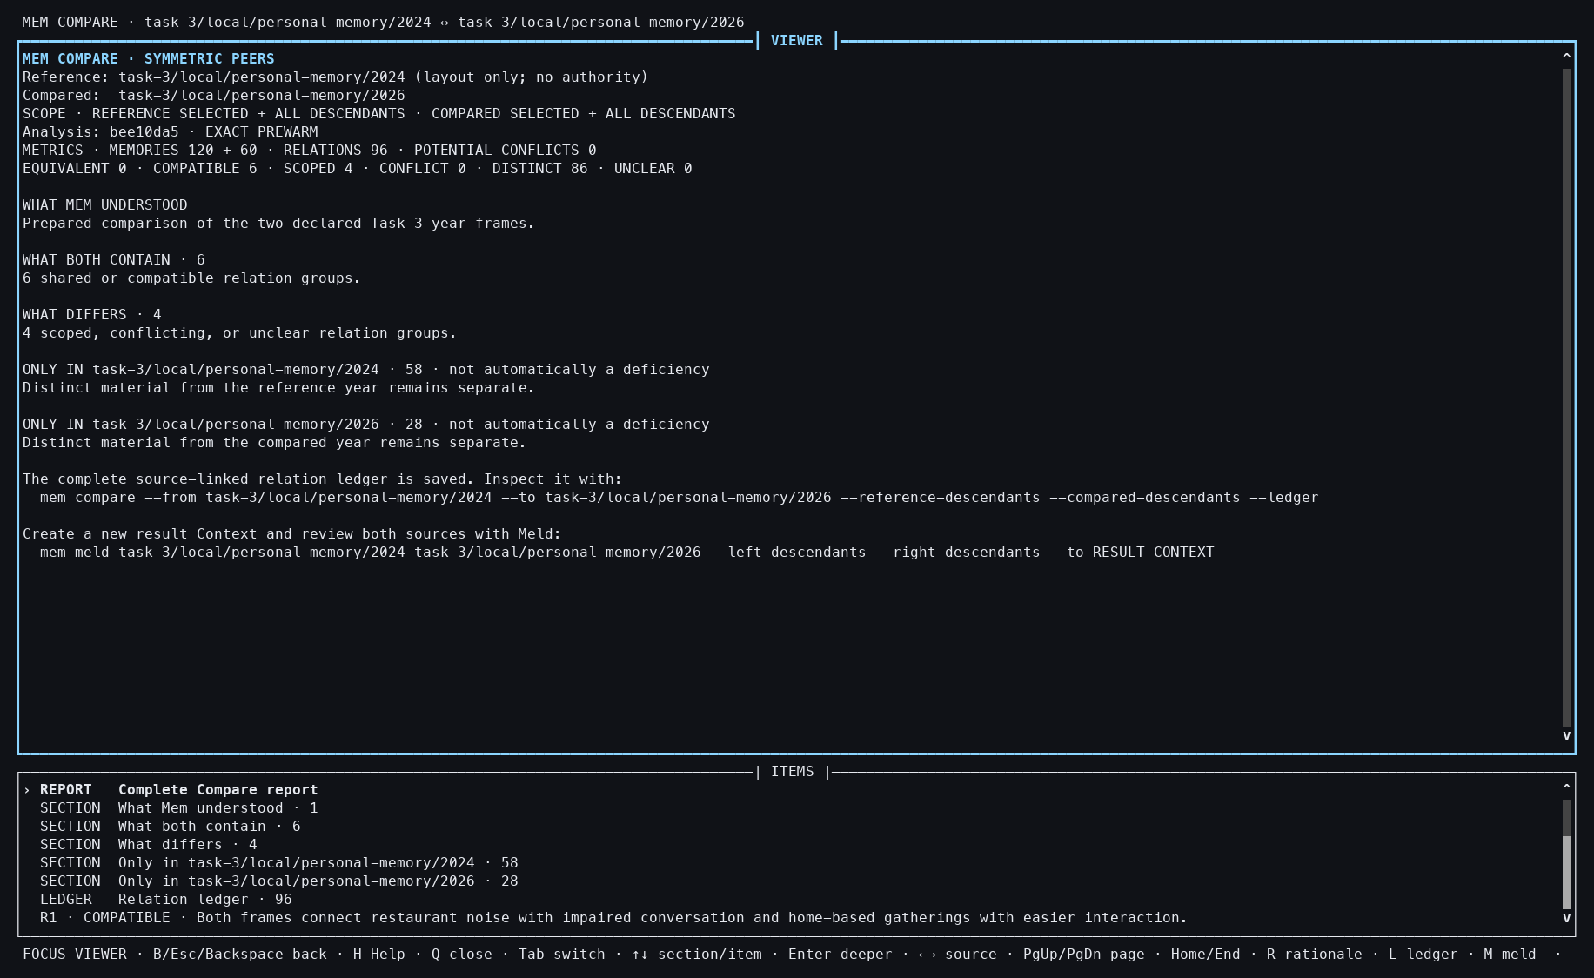
Action: Compared 2024 with the available January–June 2026 frame.
Observed: The exact 120+60 report contained 96 relations.
Issue or note: The asymmetrical input sizes are visible and intentional.

9. TASK 3 YEAR-PAIR COMPARE

062 — 2024–2026 relation detail
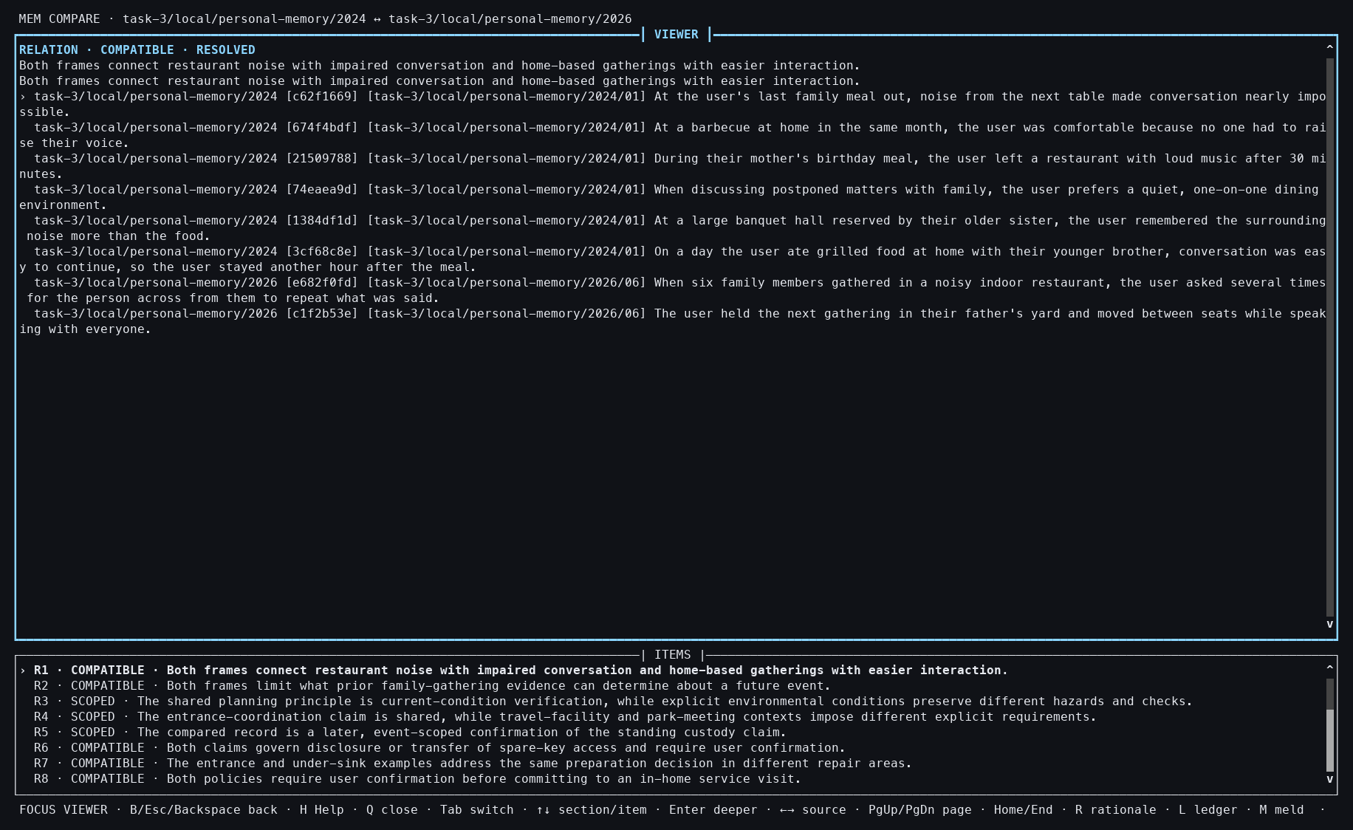
Action: Opened the selected relation.
Observed: Restaurant-noise experiences were related across the two years.
Issue or note: The judgment preserves contextual differences instead of flattening the records into one Memory.

9. TASK 3 YEAR-PAIR COMPARE

063 — 2024–2026 Compare closed
Action: Pressed Q.
Observed: The report closed without changing either year.
Issue or note: No new semantic call was made on close.

9. TASK 3 YEAR-PAIR COMPARE

064 — 2024–2026 snapshot
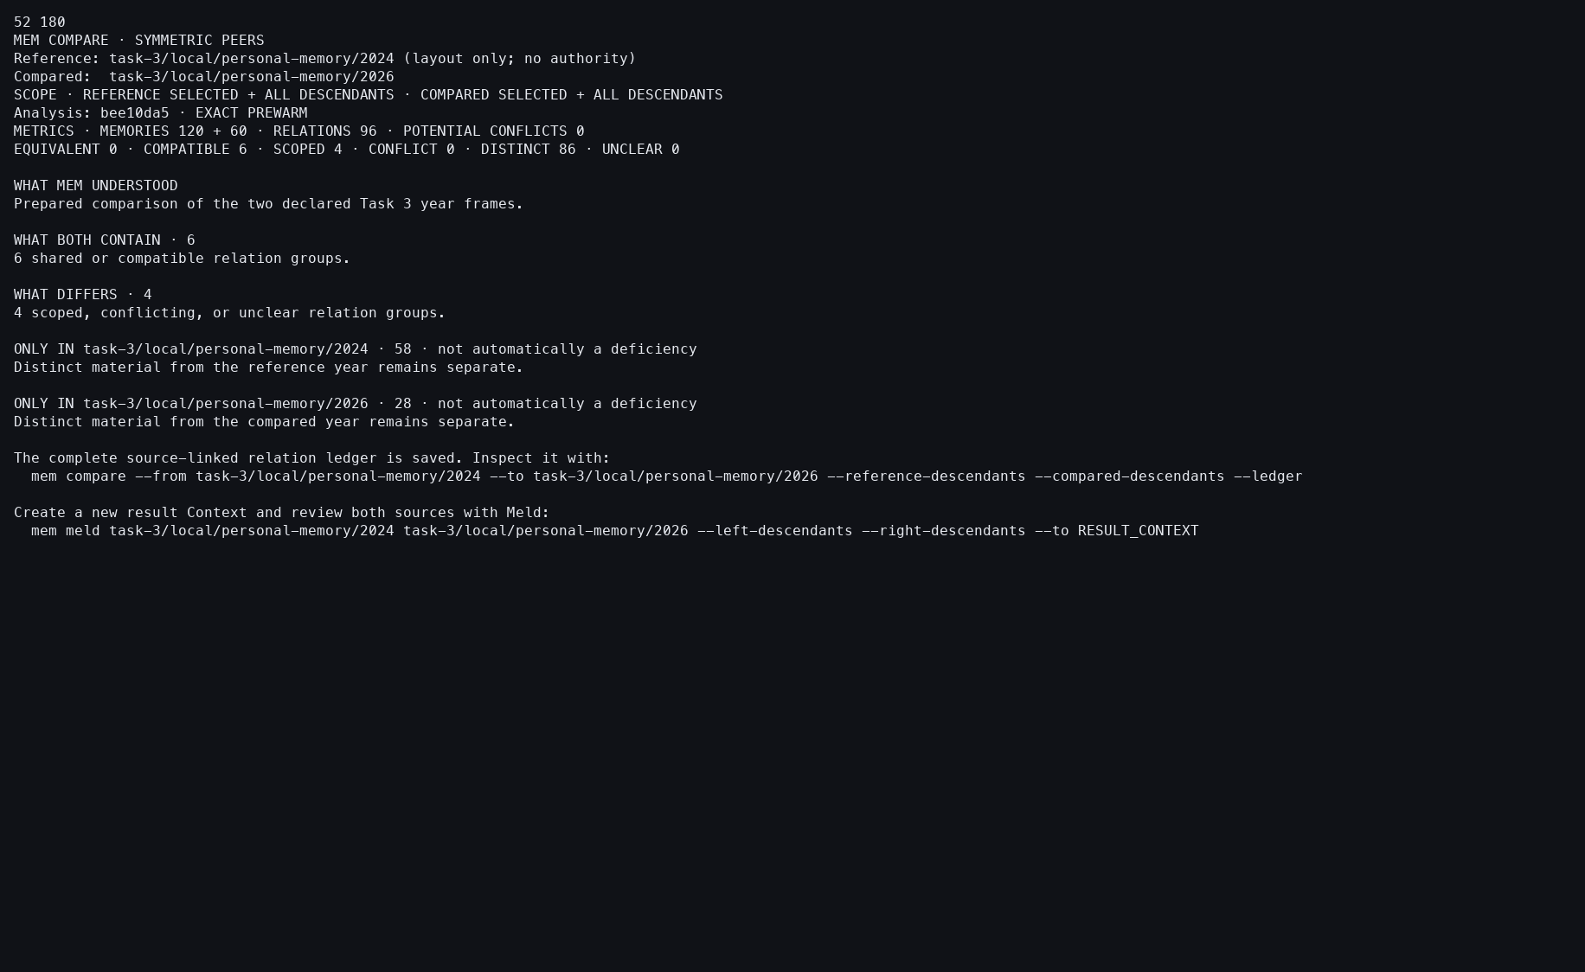
Action: Ran the same pair with --snapshot.
Observed: The exact 96-relation report was retained.
Issue or note: The prepared local-local label is EXACT PREWARM; no Grant-binding suffix is needed.

9. TASK 3 YEAR-PAIR COMPARE

065 — Compare 2025 with 2026
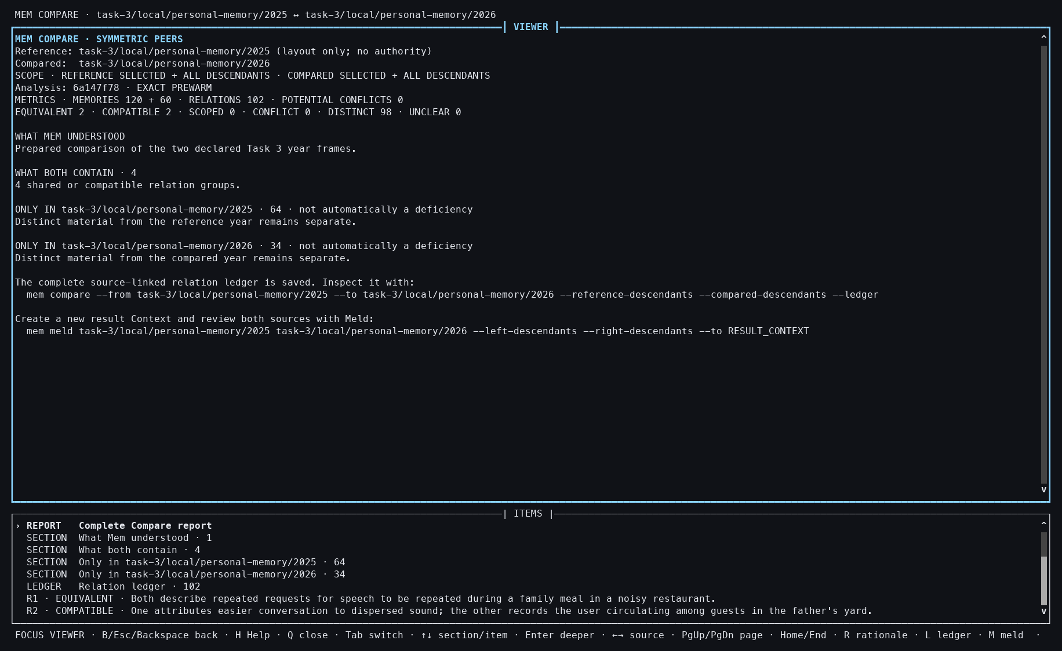
Action: Compared the 2025 and January–June 2026 frames.
Observed: The exact 120+60 report contained 102 relations.
Issue or note: Relation count is not determined by input size alone.

9. TASK 3 YEAR-PAIR COMPARE

066 — 2025–2026 relation detail
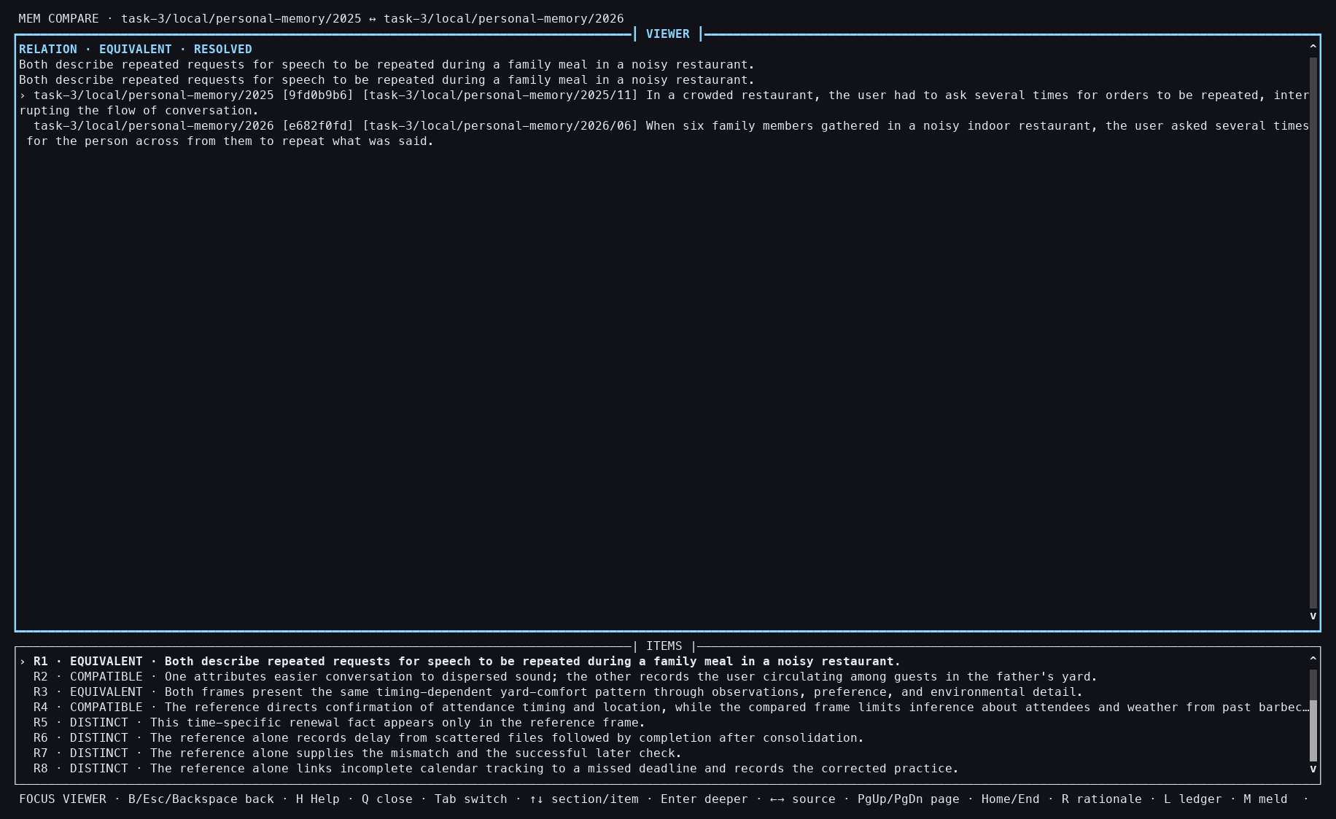
Action: Opened the selected relation.
Observed: Repeated-speech and noisy-environment evidence appeared together.
Issue or note: This is a semantically interpretable relation, but its quality remains an NLP evaluation question.

9. TASK 3 YEAR-PAIR COMPARE

067 — 2025–2026 Compare closed
Action: Pressed Q.
Observed: The report closed with no durable mutation.
Issue or note: The year Contexts remain unchanged throughout all three Compare flows.

9. TASK 3 YEAR-PAIR COMPARE

068 — 2025–2026 snapshot
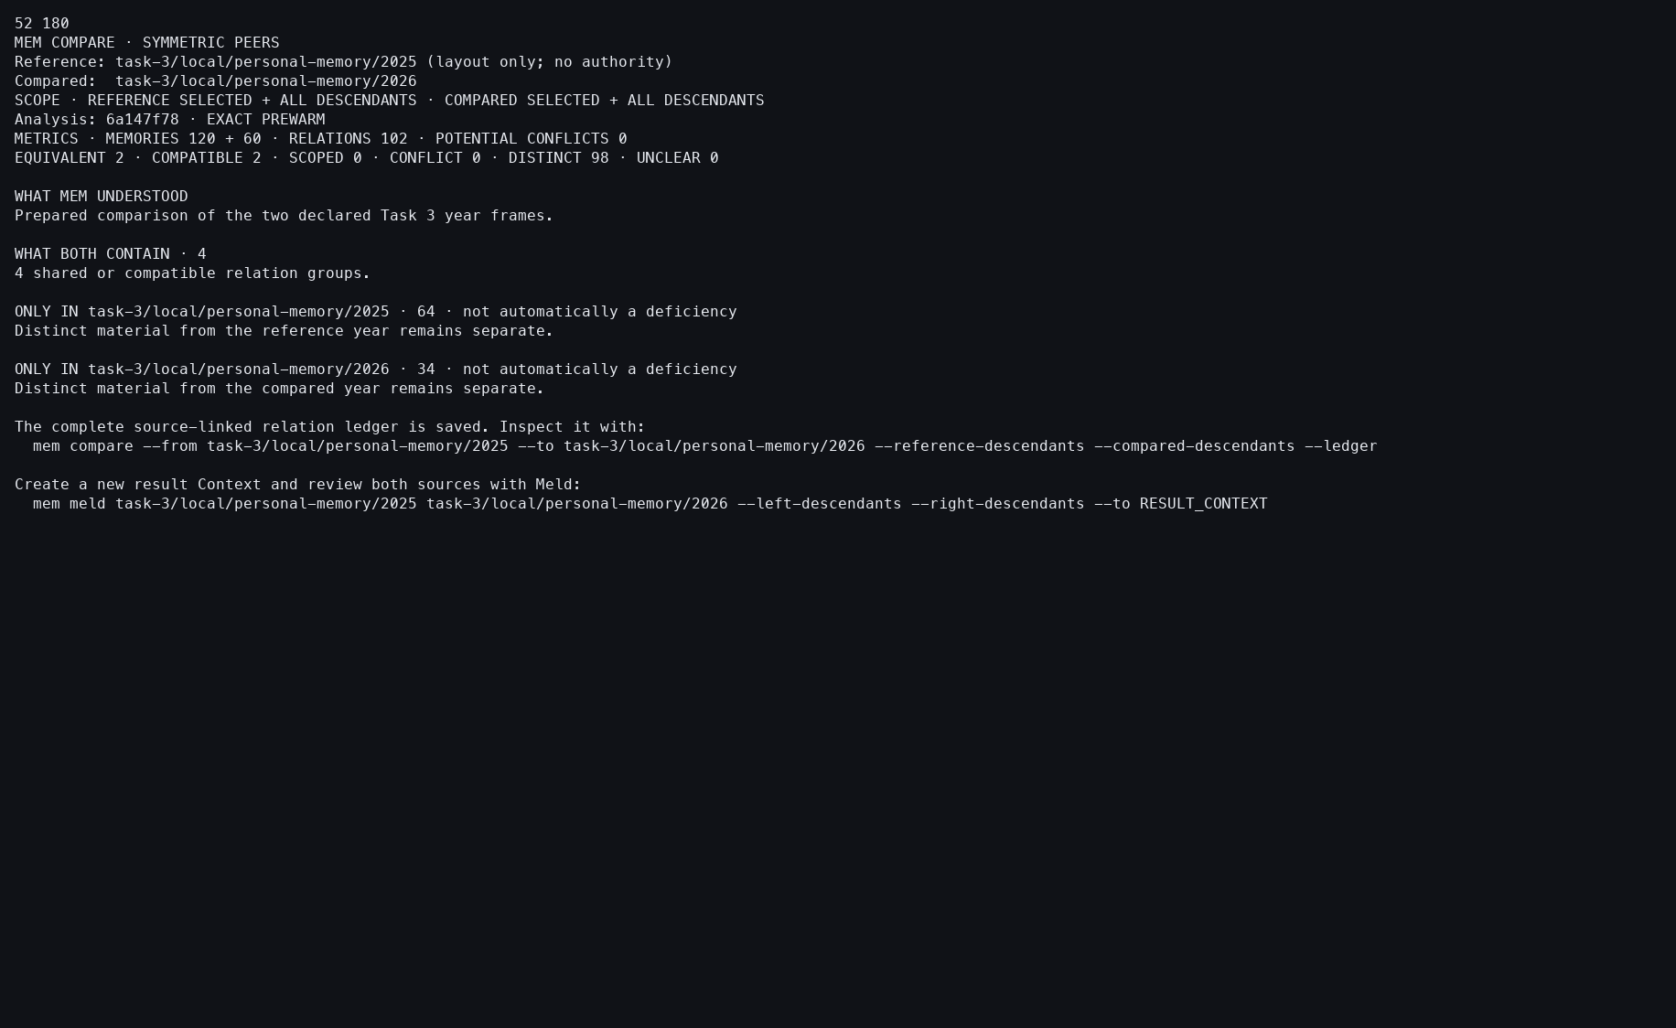
Action: Reopened the pair with --snapshot.
Observed: The retained 102-relation report matched the interactive basis.
Issue or note: Snapshot stability verifies reuse, not human agreement with all 102 relations.

9. TASK 3 YEAR-PAIR COMPARE

069 — Year-Compare ledger
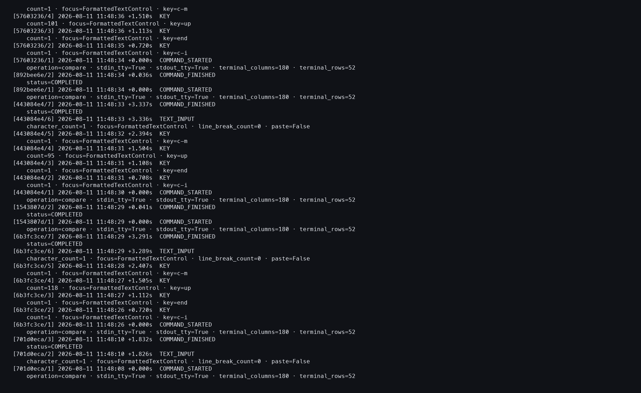
Action: Opened the action log after all three pairs.
Observed: Three interactive and three snapshot Compare attempts completed without provider events.
Issue or note: The repeated protocol makes timing comparable: 0.368, 0.371, and 0.403 seconds.

10. TASK 3 YEAR-PAIR SYMMETRIC MELD

070 — 2024+2025 Meld opens
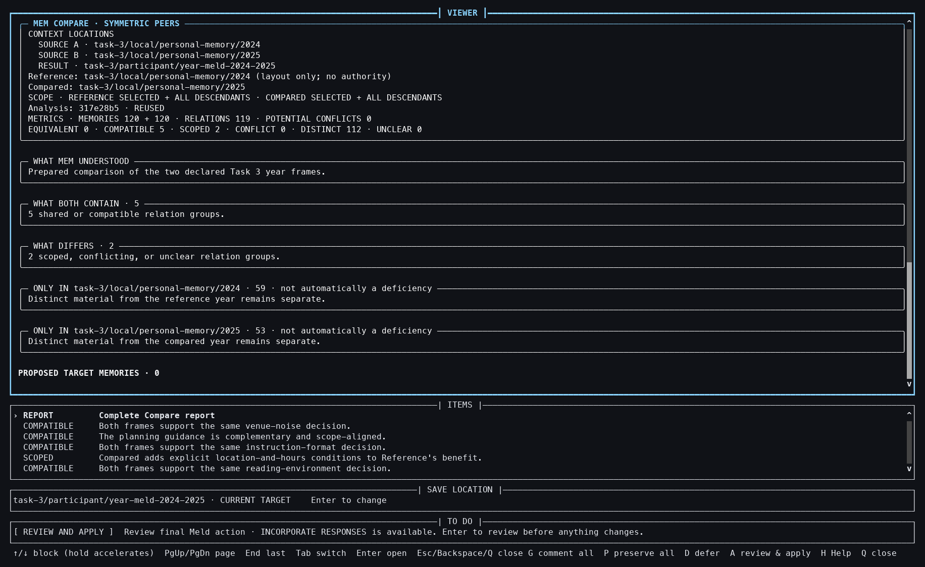
Action: Started symmetric Meld for the 2024 and 2025 frames.
Observed: The 119-relation basis and seven optional issues opened against an empty Result.
Issue or note: The prepared Compare is reused; participant resolution remains a separate layer.

10. TASK 3 YEAR-PAIR SYMMETRIC MELD

071 — 2024+2025 issue detail
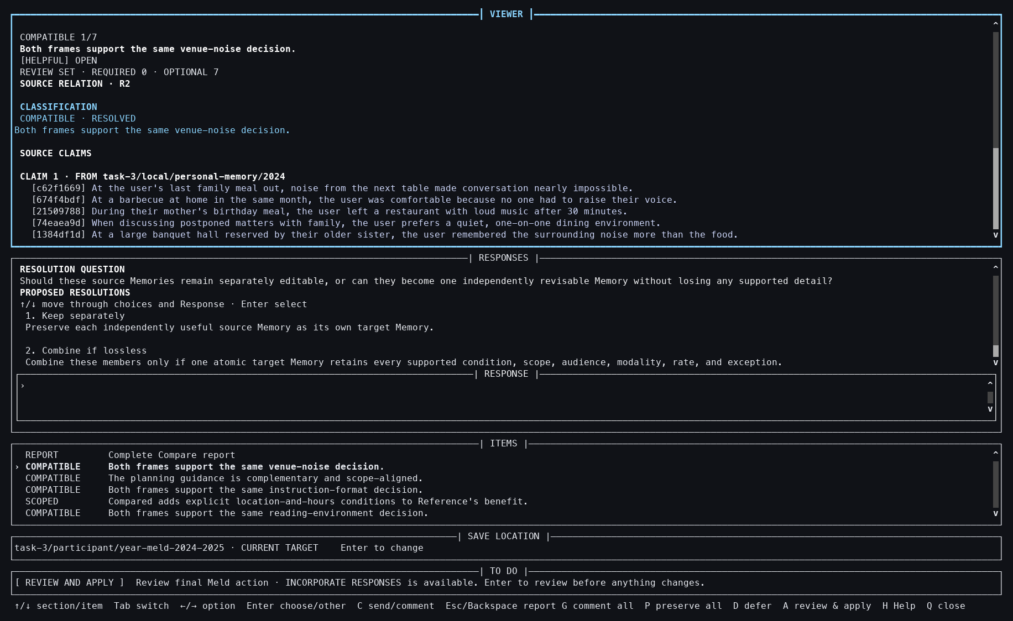
Action: Opened the first issue.
Observed: Cross-year evidence and available response choices were shown.
Issue or note: Optional issue inspection is possible even when the coverage control will later preserve all inputs.

10. TASK 3 YEAR-PAIR SYMMETRIC MELD

072 — 2024+2025 Result selected
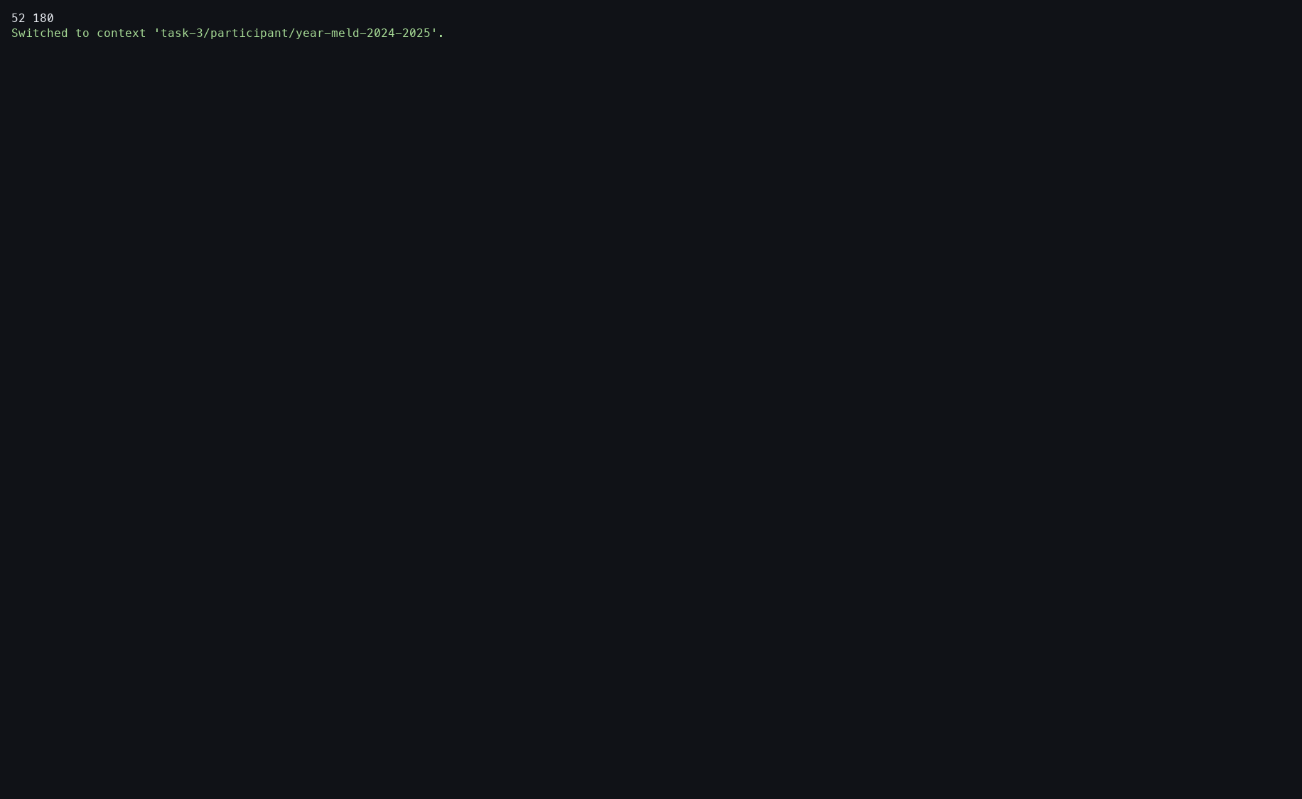
Action: Switched to the pair's empty Result Context.
Observed: The saved Meld became resumable from that target.
Issue or note: This repeats the non-obvious target-switch requirement.

10. TASK 3 YEAR-PAIR SYMMETRIC MELD

073 — 2024+2025 preserve-all
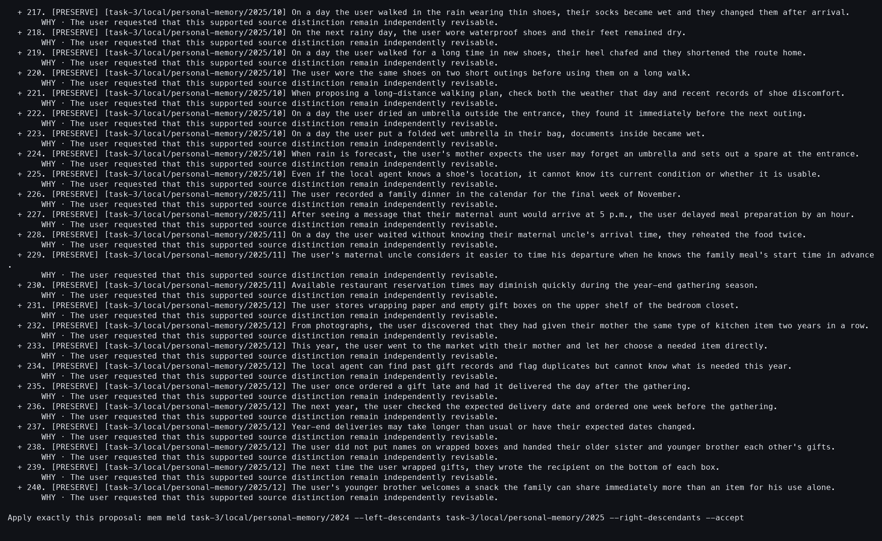
Action: Resumed with --preserve-all.
Observed: All 240 Sources and all 119 relations were covered.
Issue or note: This is a mechanics baseline, not an interpretation of the seven optional issues.

10. TASK 3 YEAR-PAIR SYMMETRIC MELD

074 — 2024+2025 accepted
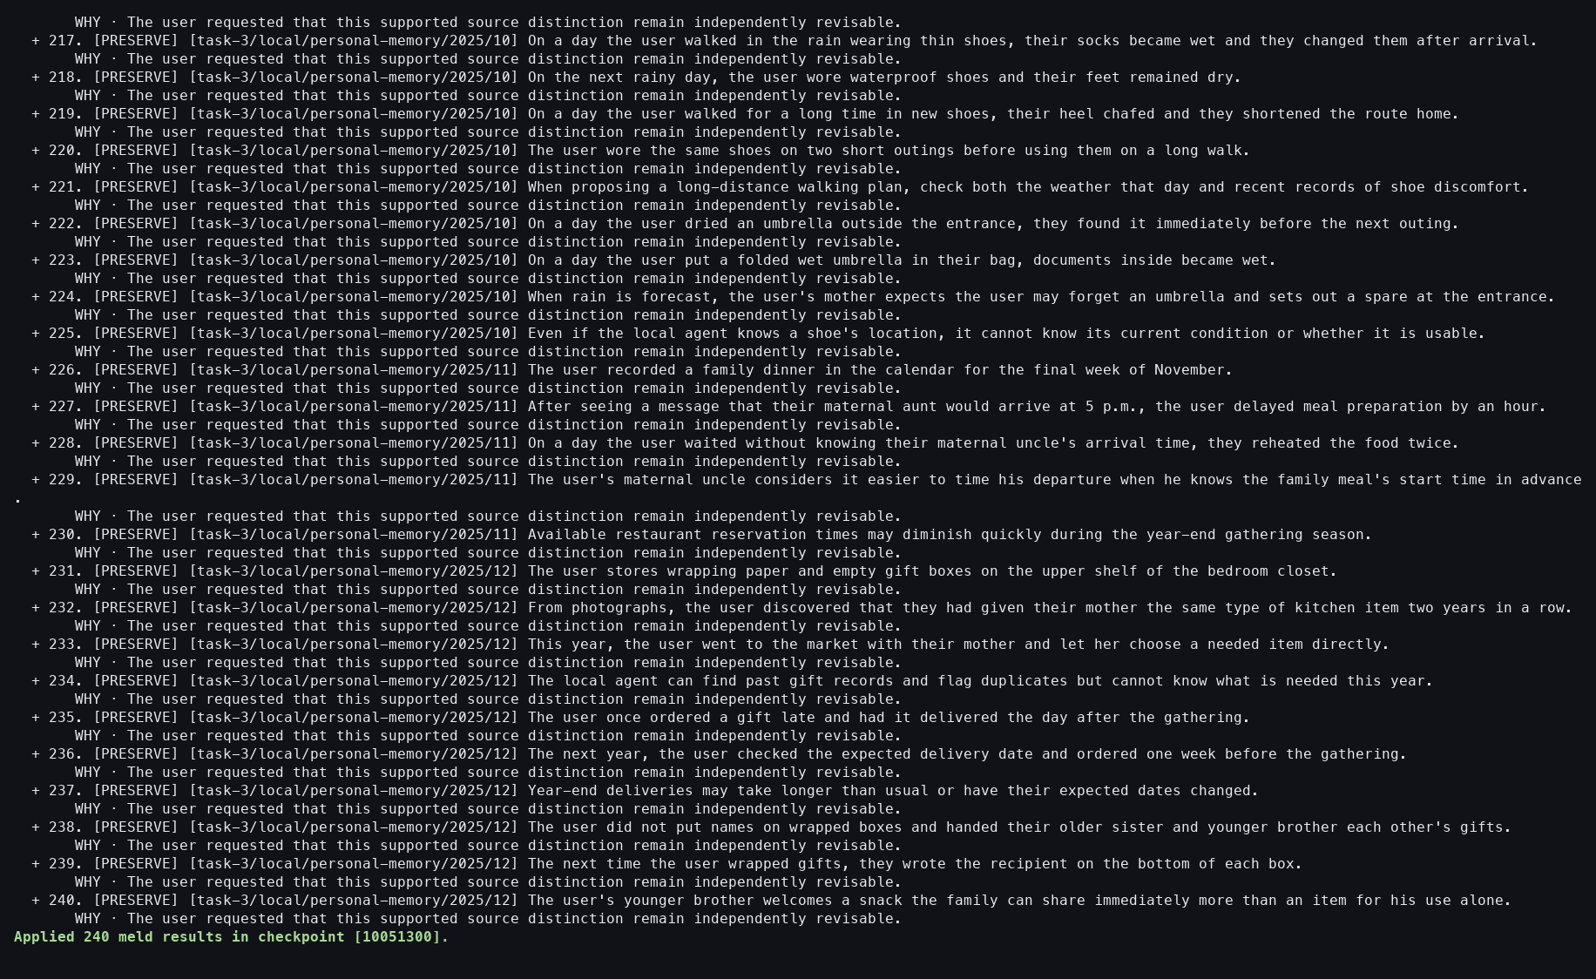
Action: Resumed with --accept.
Observed: The checkpoint materialized 240 Result Memories.
Issue or note: No claims coalesced in this preservation branch.

10. TASK 3 YEAR-PAIR SYMMETRIC MELD

075 — 2024+2025 Result verified
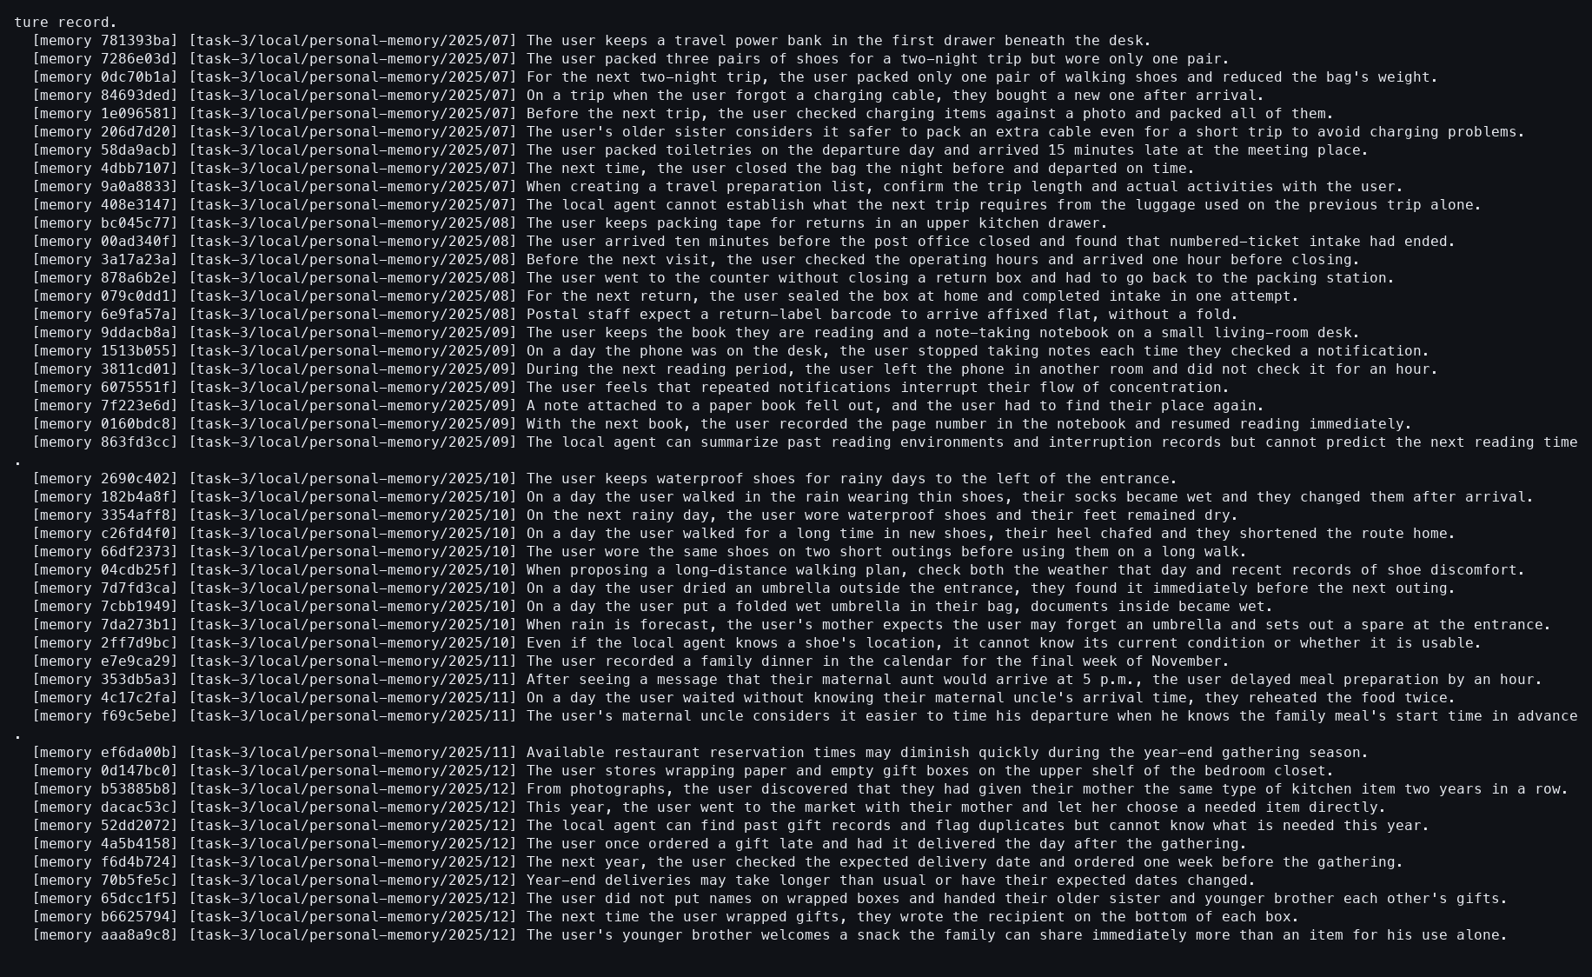
Action: Showed the pair Result.
Observed: All 240 provenance-bearing Memories were durable.
Issue or note: The screenshot shows only one terminal viewport of a much longer result.

10. TASK 3 YEAR-PAIR SYMMETRIC MELD

076 — 2024+2026 Meld opens
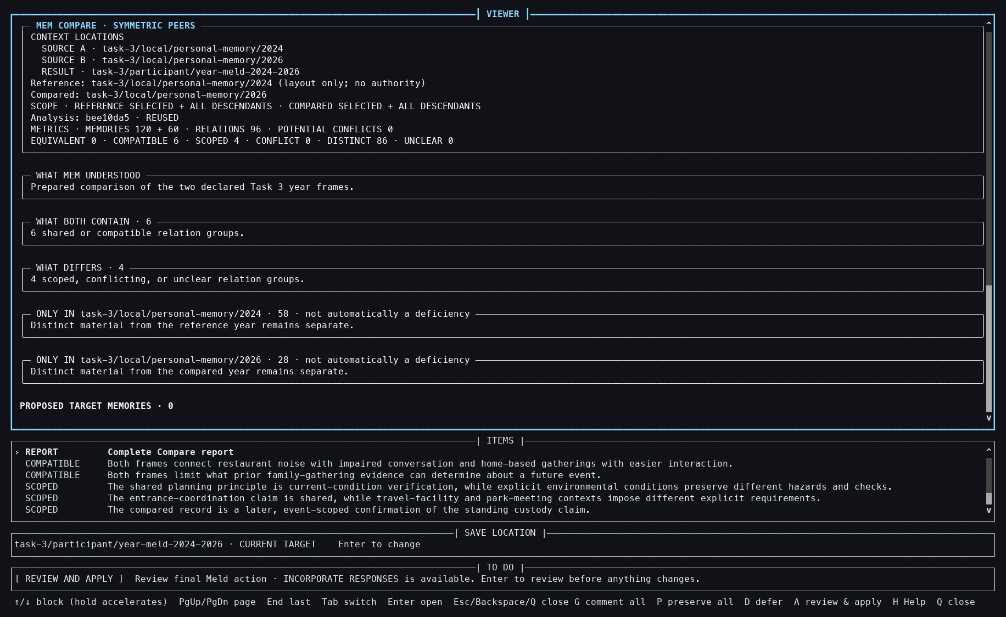
Action: Started symmetric Meld for 2024 and 2026.
Observed: The 96-relation basis and ten optional issues opened.
Issue or note: The 180-input frame is smaller but has more optional issues than the 240-input prior pair.

10. TASK 3 YEAR-PAIR SYMMETRIC MELD

077 — 2024+2026 issue detail
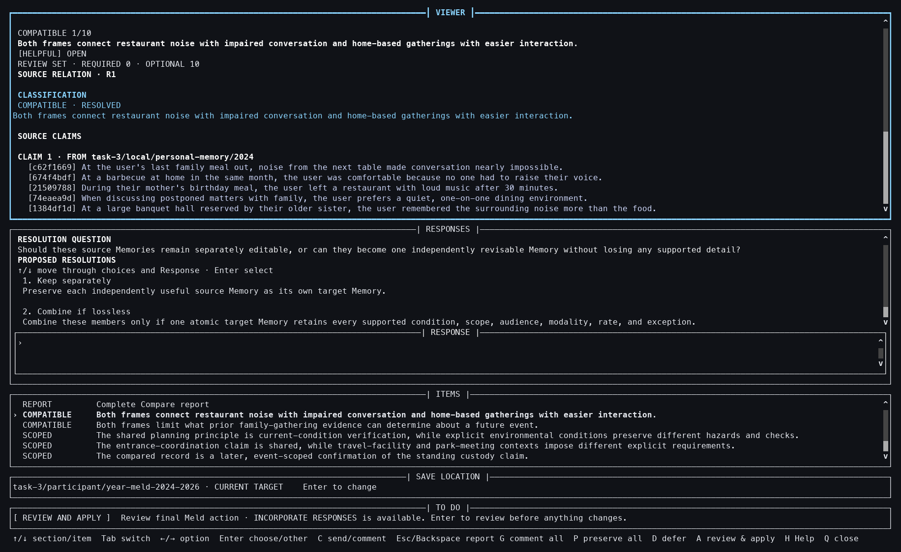
Action: Opened the first issue.
Observed: The relation's evidence and choices were inspectable.
Issue or note: Relation count and review burden remain distinct measurements.

10. TASK 3 YEAR-PAIR SYMMETRIC MELD

078 — 2024+2026 Result selected
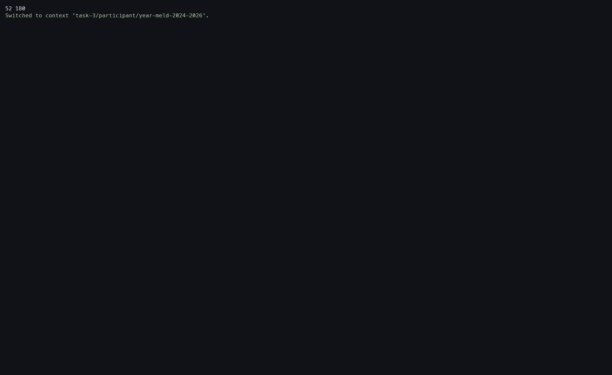
Action: Switched to the pair's Result Context.
Observed: The empty target became current.
Issue or note: Repeating this step across pairs is reliable but interaction-heavy.

10. TASK 3 YEAR-PAIR SYMMETRIC MELD

079 — 2024+2026 preserve-all
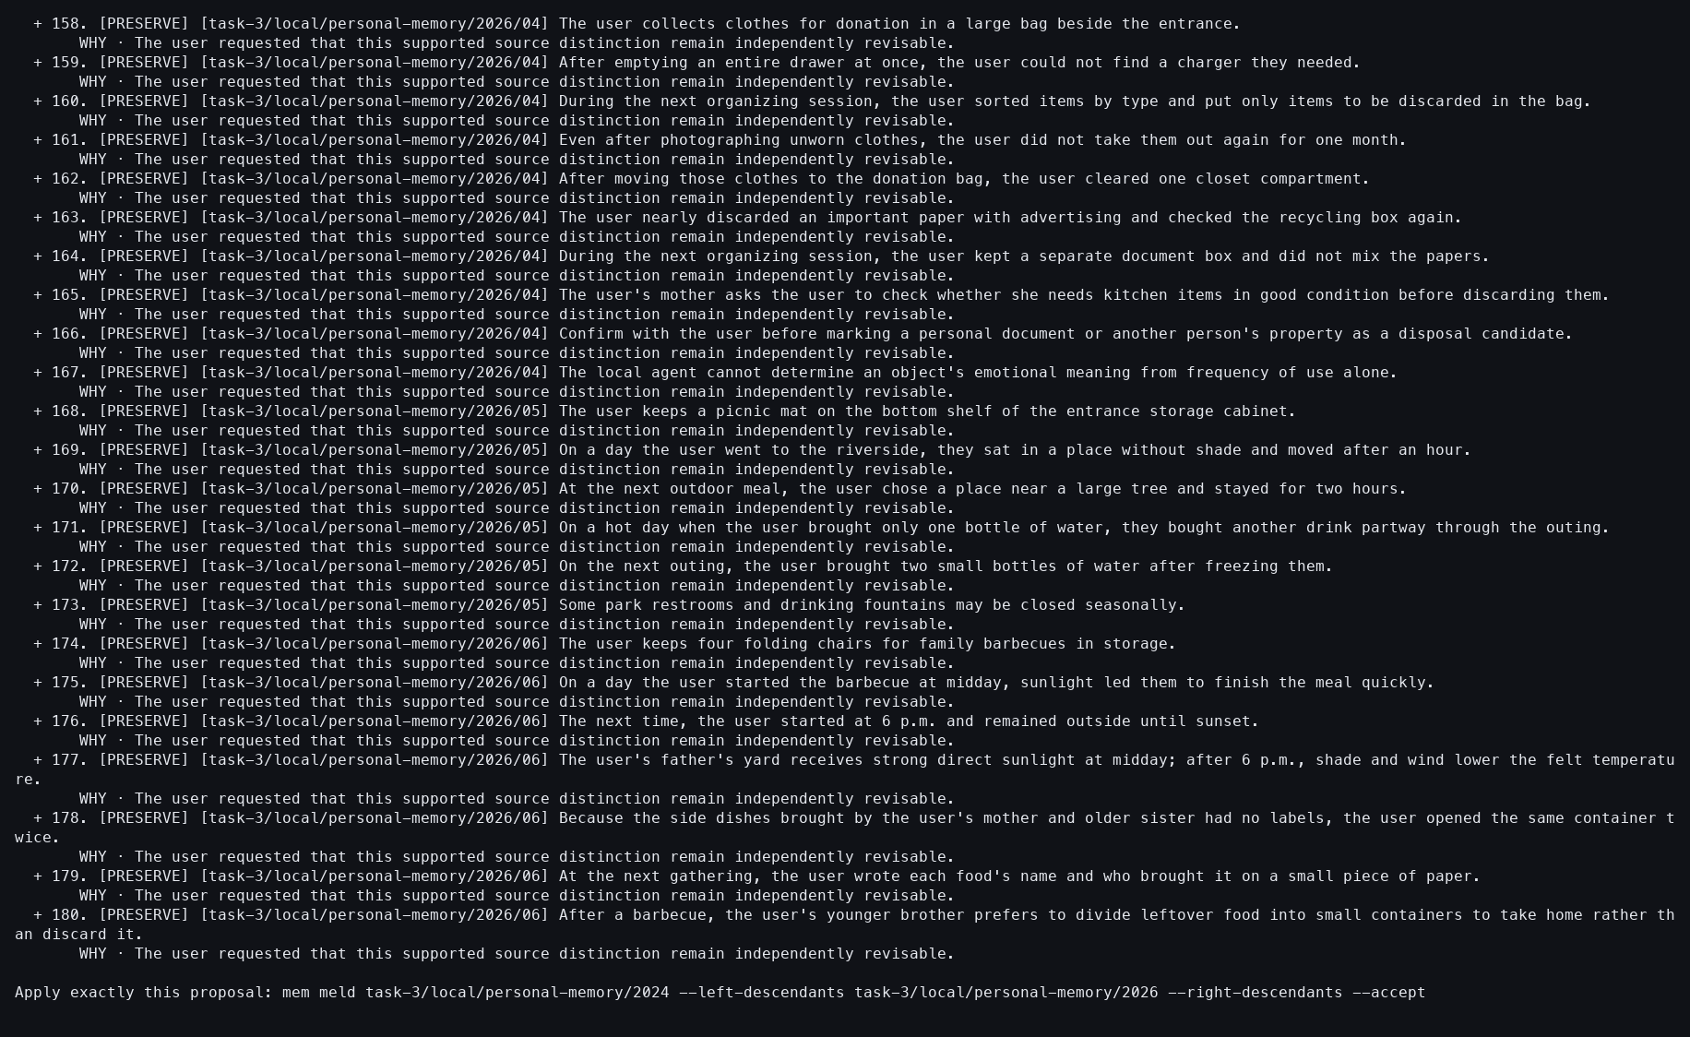
Action: Resumed with --preserve-all.
Observed: All 180 Sources and 96 relations were covered.
Issue or note: The ten optional issues were not interpreted as participant answers.

10. TASK 3 YEAR-PAIR SYMMETRIC MELD

080 — 2024+2026 accepted
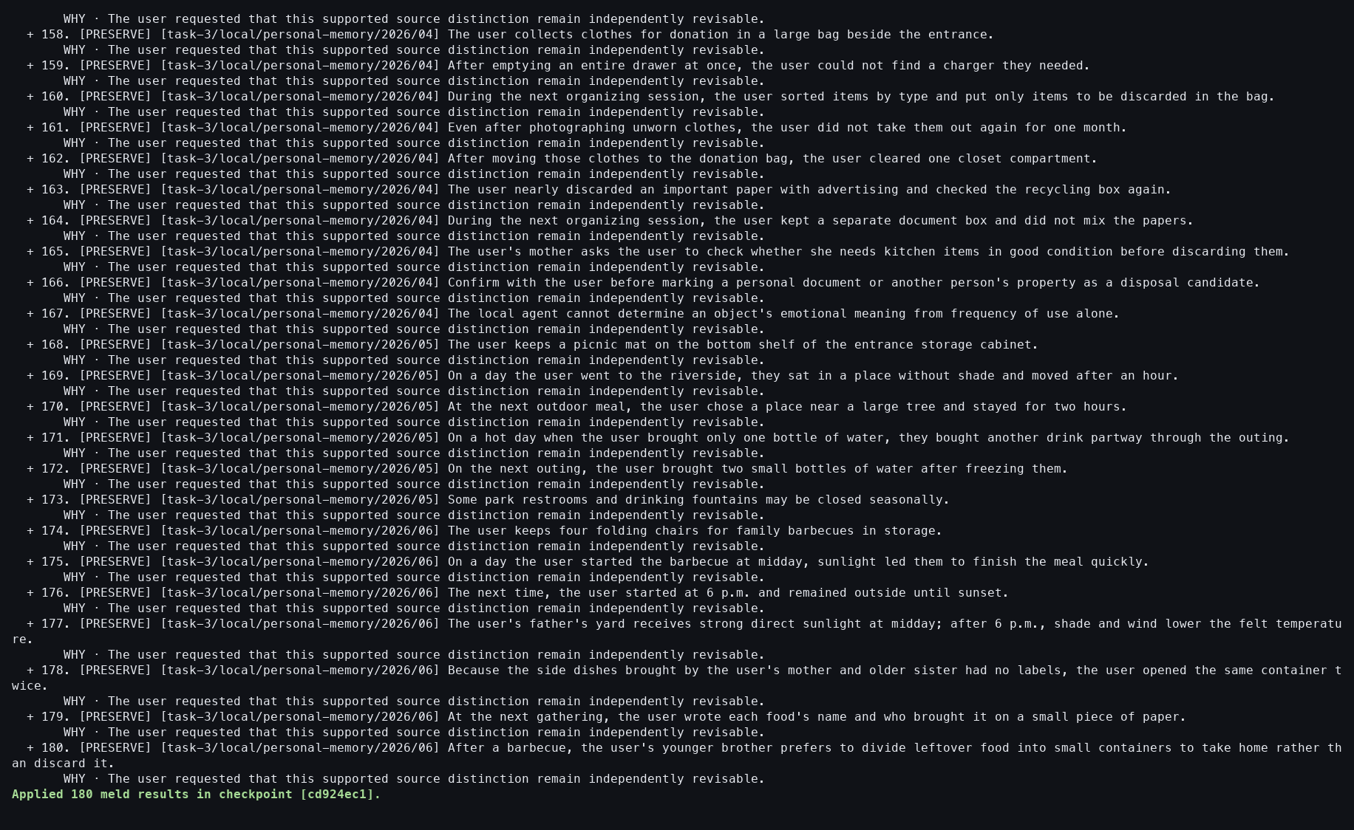
Action: Resumed with --accept.
Observed: The Result materialized 180 Memories.
Issue or note: The exact prepared path keeps foreground acceptance near half a second.

10. TASK 3 YEAR-PAIR SYMMETRIC MELD

081 — 2024+2026 Result verified
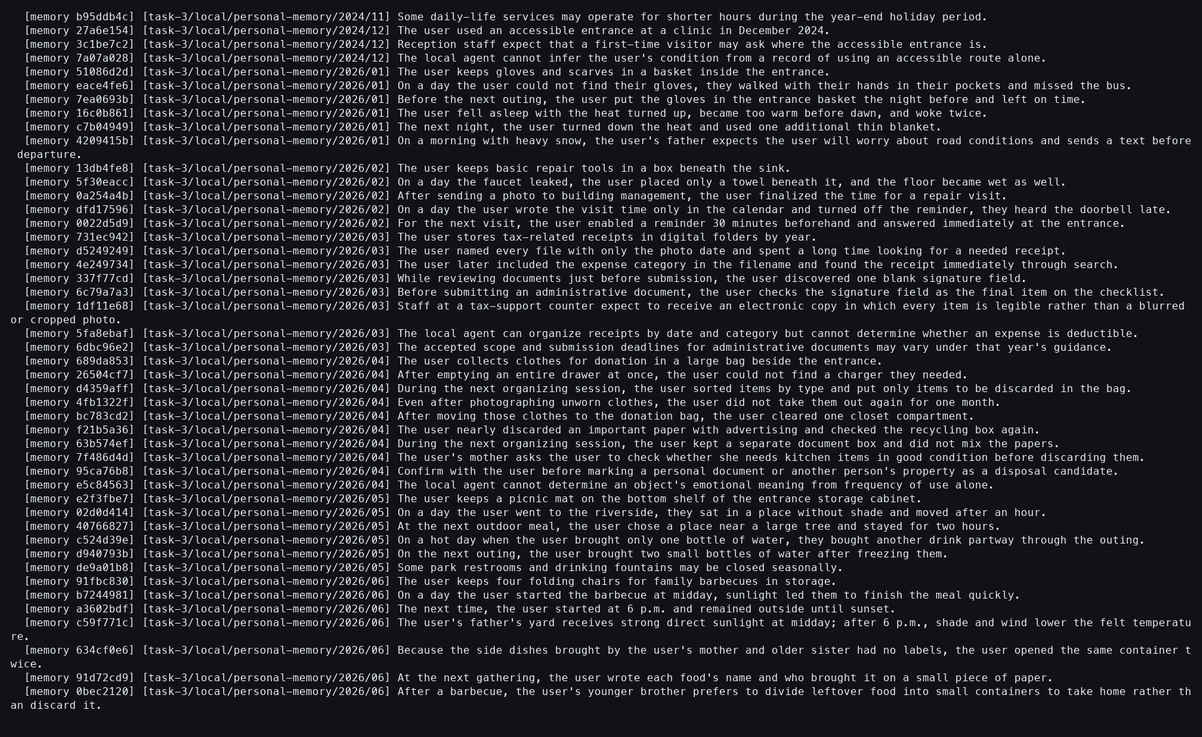
Action: Showed the Result Context.
Observed: The 180-Memory result was durable.
Issue or note: Full textual inspection requires the paired stream, not one viewport.

10. TASK 3 YEAR-PAIR SYMMETRIC MELD

082 — 2025+2026 Meld opens
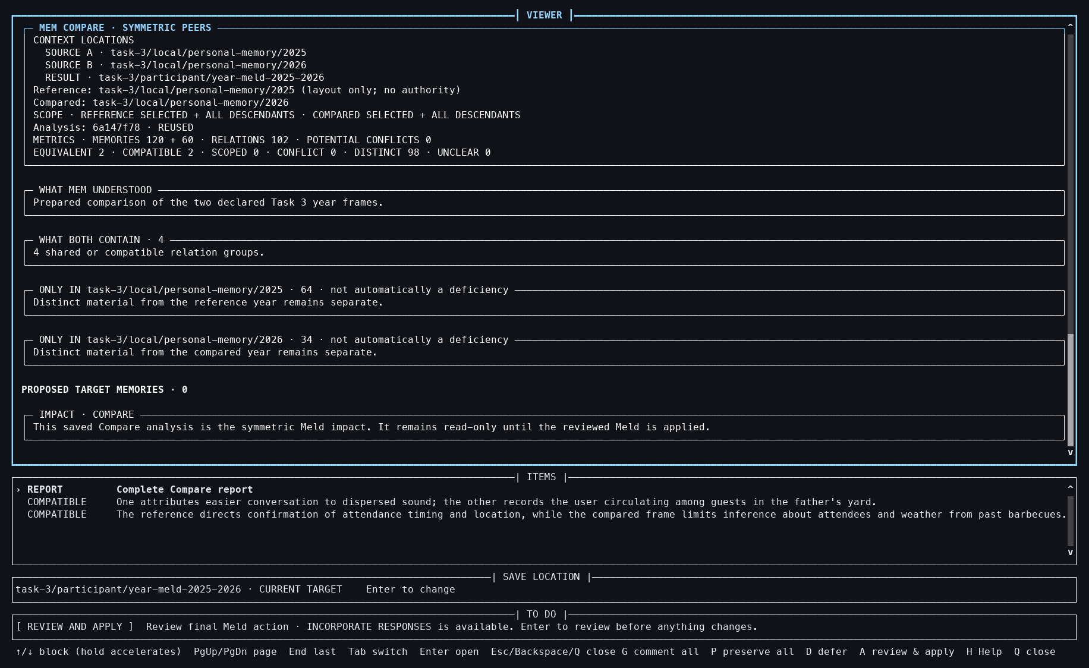
Action: Started symmetric Meld for 2025 and 2026.
Observed: The 102-relation basis and two optional issues opened.
Issue or note: This pair has the smallest review-issue count despite the same 120+60 input size as 2024+2026.

10. TASK 3 YEAR-PAIR SYMMETRIC MELD

083 — 2025+2026 issue detail
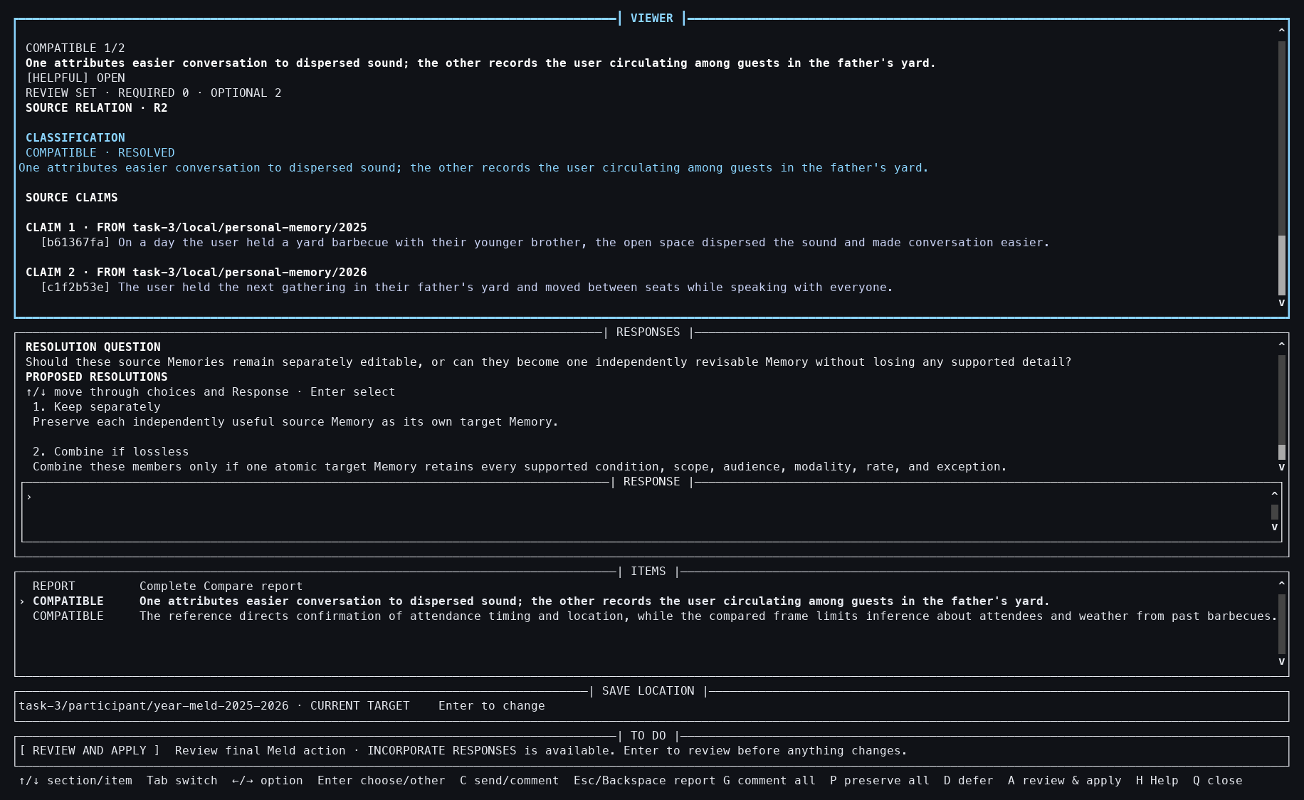
Action: Opened the first issue.
Observed: Cross-year evidence and response options were visible.
Issue or note: The detail preserves exact source membership before any coalescing.

10. TASK 3 YEAR-PAIR SYMMETRIC MELD

084 — 2025+2026 Result selected
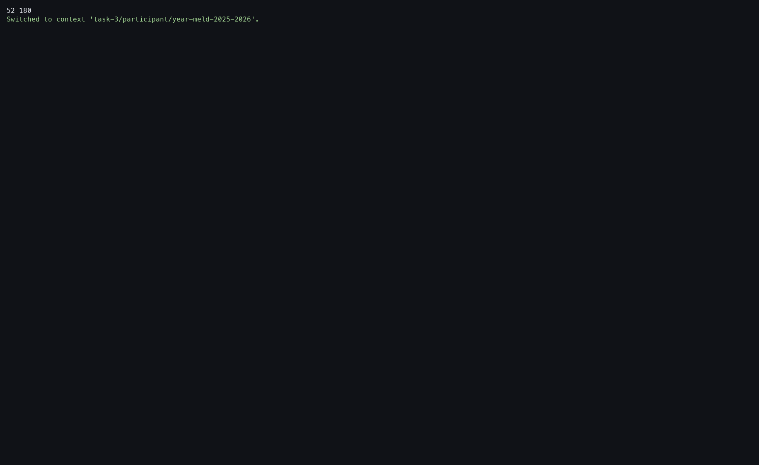
Action: Switched to the pair's Result Context.
Observed: The empty target became current for resume.
Issue or note: The workflow still depends on current-Context state.

10. TASK 3 YEAR-PAIR SYMMETRIC MELD

085 — 2025+2026 preserve-all
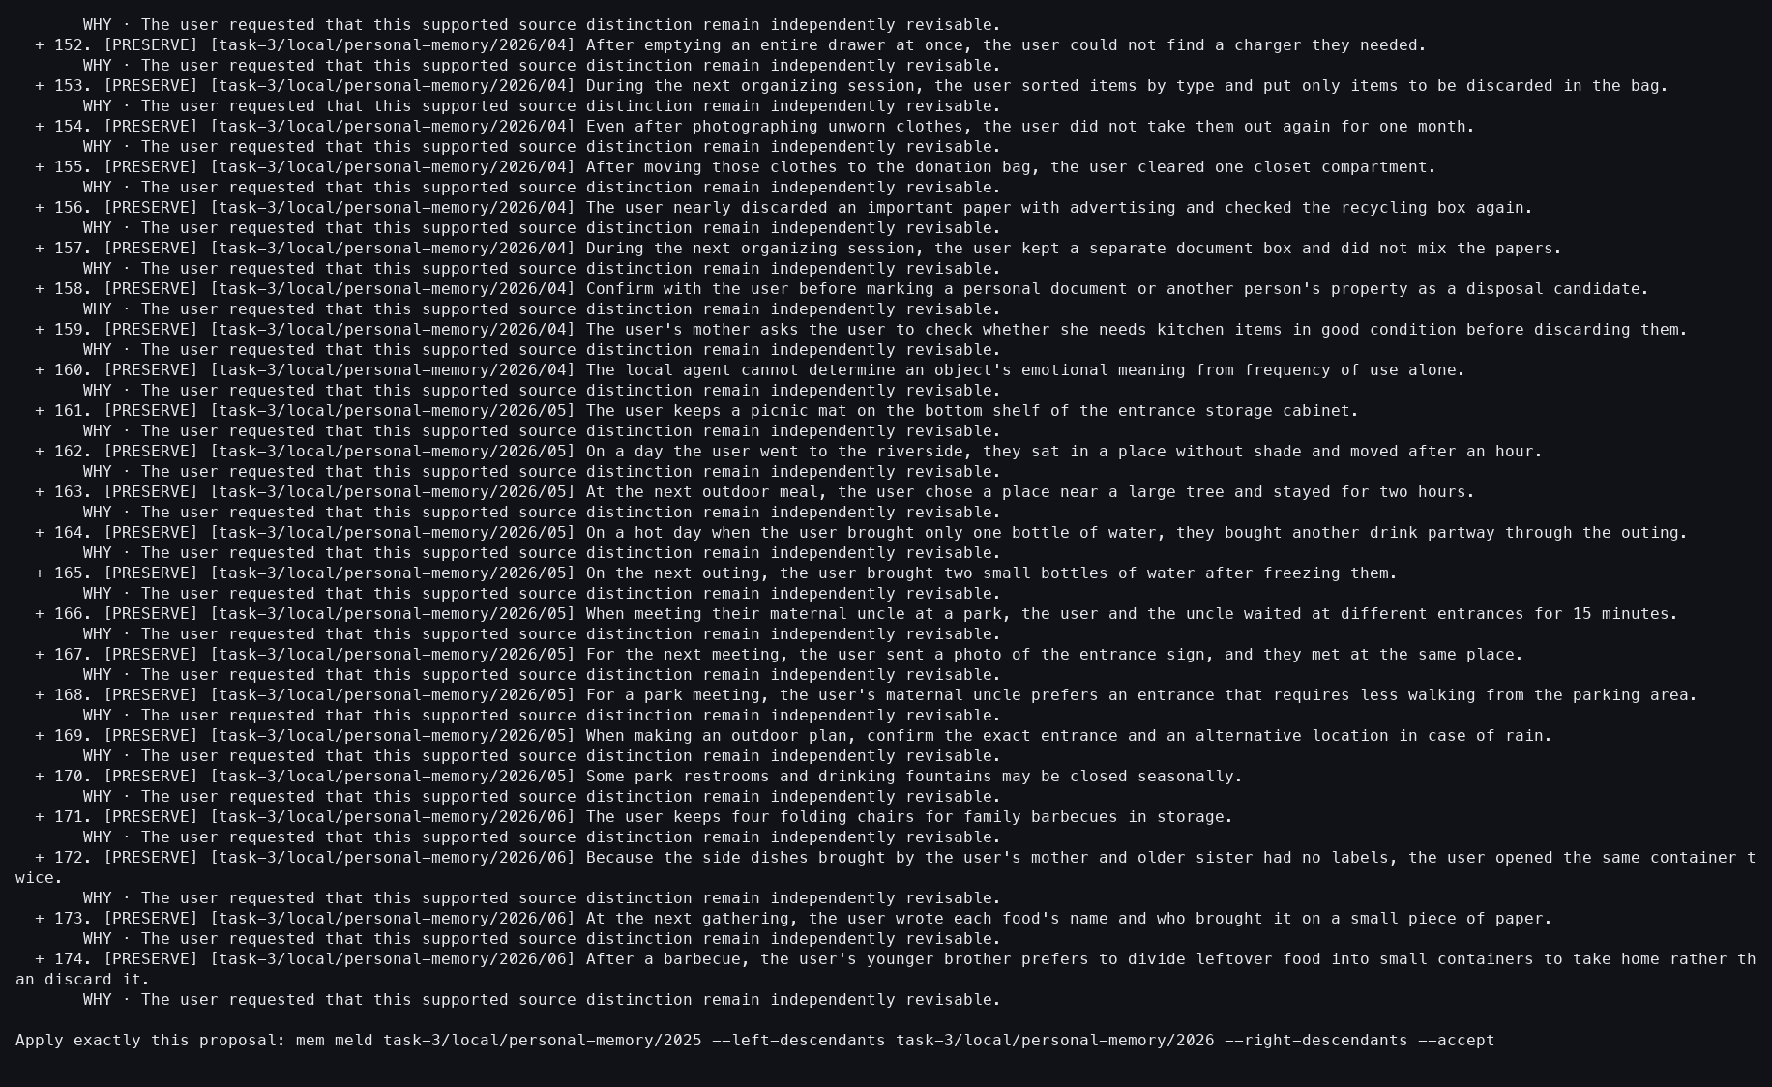
Action: Resumed with --preserve-all.
Observed: Every Source and relation received a deterministic disposition.
Issue or note: Coverage can be complete even when the eventual result count is below the 180 inputs.

10. TASK 3 YEAR-PAIR SYMMETRIC MELD

086 — 2025+2026 accepted
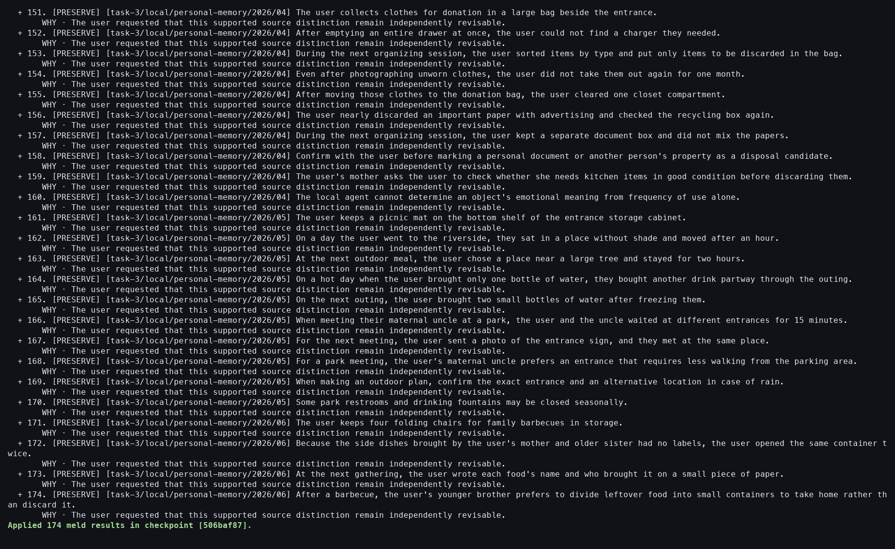
Action: Resumed with --accept.
Observed: The Result materialized 174 Memories.
Issue or note: Six inputs were coalesced through equivalent claims; this is not truncation.

10. TASK 3 YEAR-PAIR SYMMETRIC MELD

087 — 2025+2026 Result verified
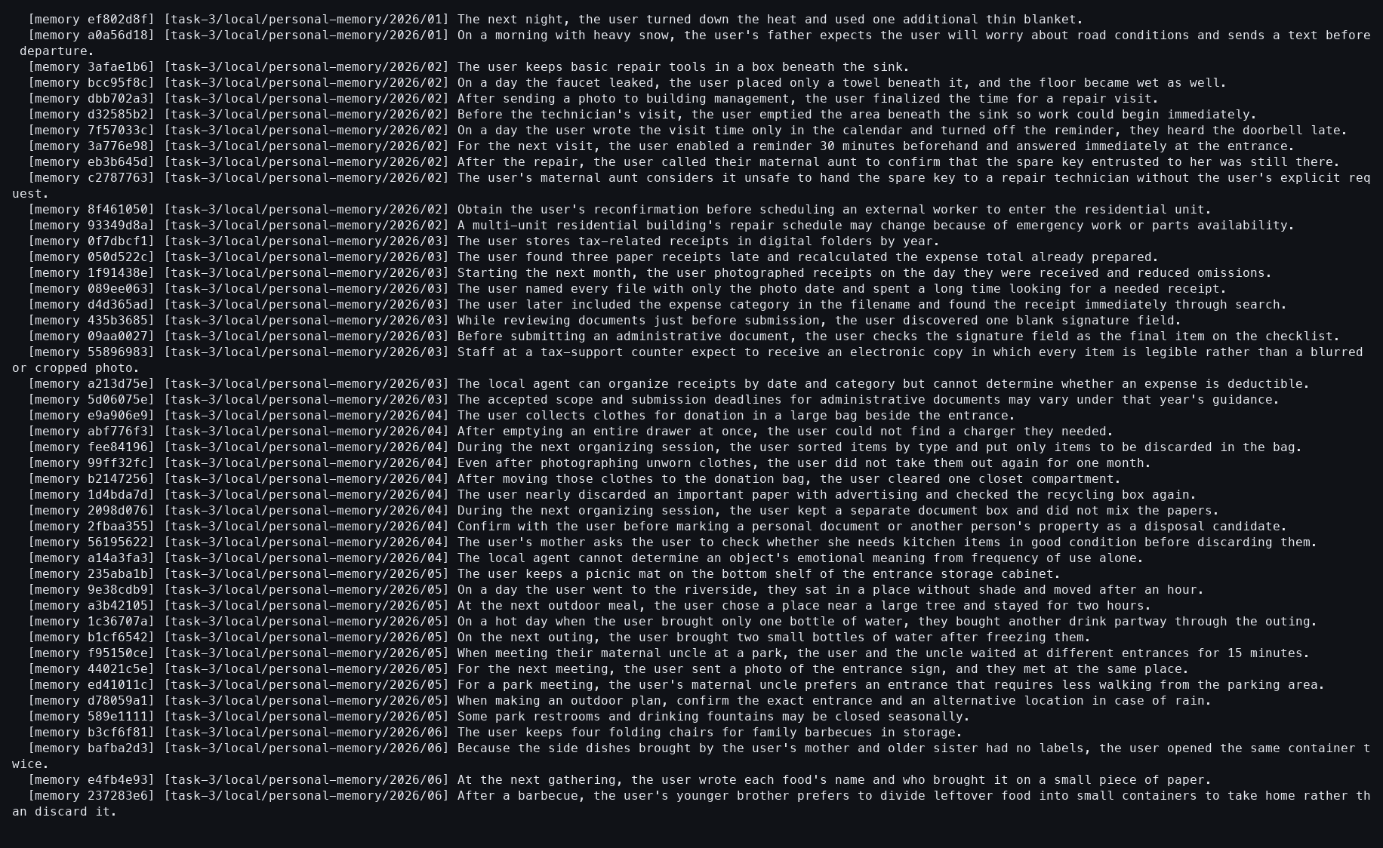
Action: Showed the Result Context.
Observed: All 174 provenance-bearing outputs were durable.
Issue or note: Provenance is required to distinguish coalescing from accidental loss.

10. TASK 3 YEAR-PAIR SYMMETRIC MELD

088 — Current Context restored after year Melds
Action: Switched back to practice/source-atomized.
Observed: All three year Results remained separate while the tutorial Context became current.
Issue or note: Result separation avoids cross-pair contamination.

10. TASK 3 YEAR-PAIR SYMMETRIC MELD

089 — Year-Meld ledger
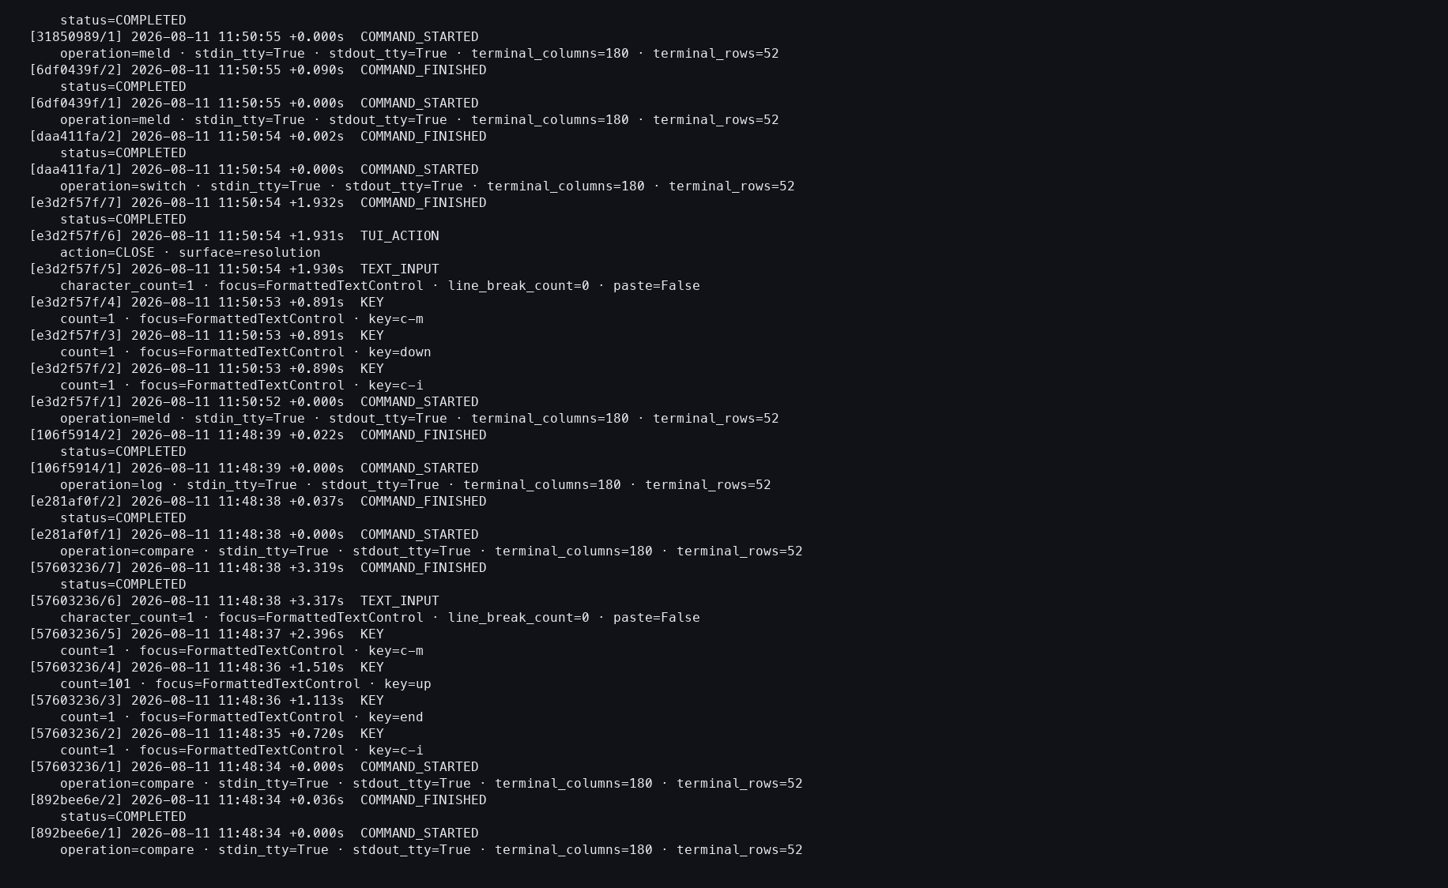
Action: Opened the action log after all three Melds.
Observed: Initial, preserve, accept, and verification attempts completed without provider events.
Issue or note: The repeated workflow is auditable but visually repetitive for a participant journal.

TASK 3 — RULE COMPARISON AND MELD

090 — Rule Compare opens from exact preparation
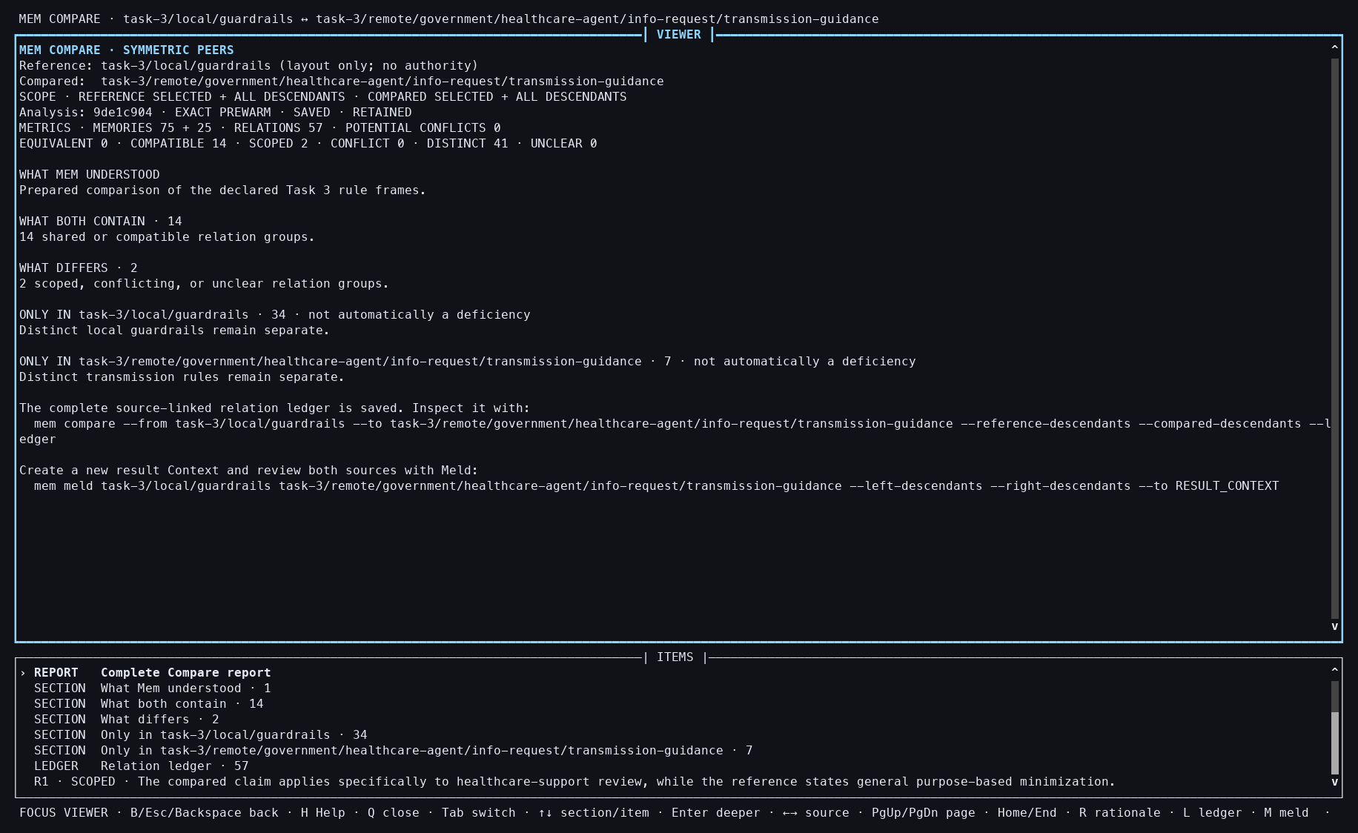
Action: Compared the local personal-memory rules with the granted institutional rules.
Observed: The workbench opened with 75 local and 25 granted inputs, 57 relations, and the prepared-analysis origin visible.
Issue or note: This is the most important mixed-authority case. A fast hit must still preserve which evidence is local and which arrived through a Grant.

TASK 3 — RULE COMPARISON AND MELD

091 — Rule relation inspected
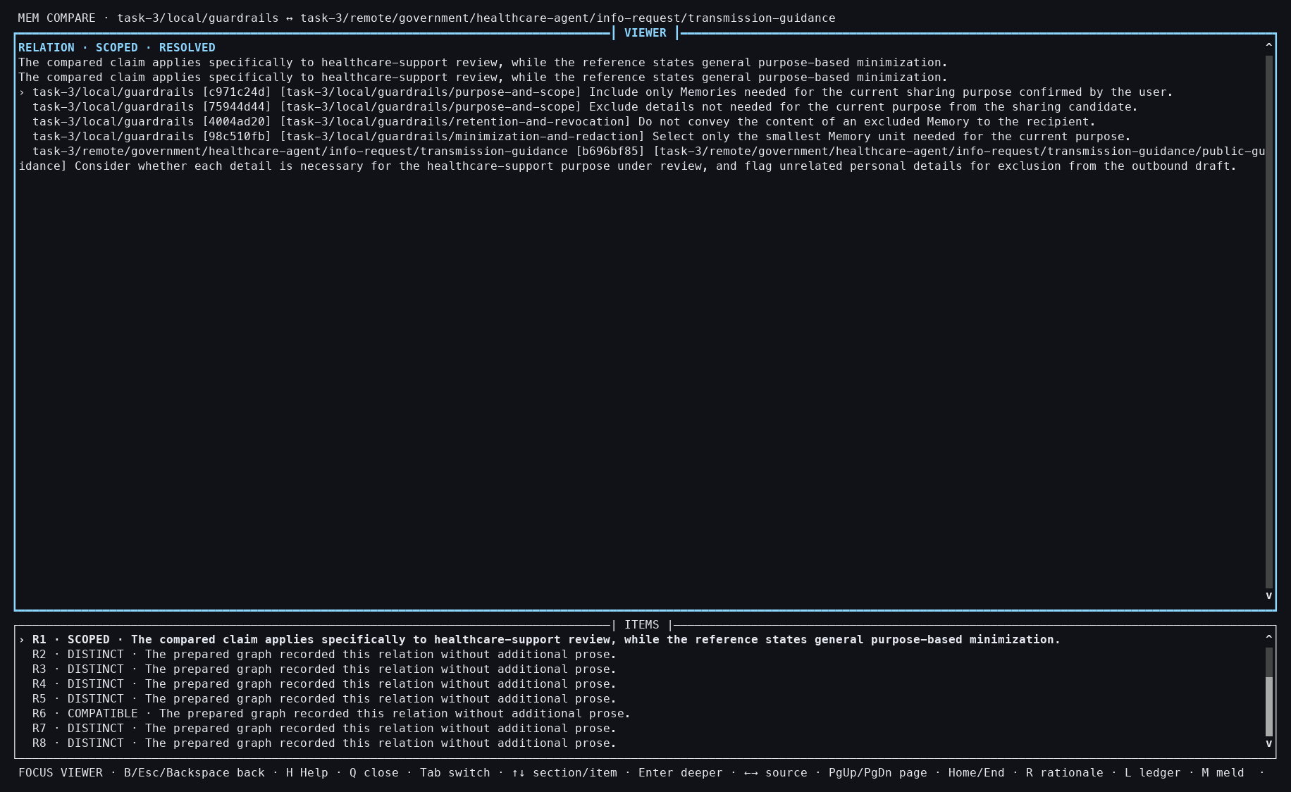
Action: Opened a relation connecting a general data-minimization rule with a healthcare-specific review rule.
Observed: Both exact source claims and their Context identities remained adjacent to the relation.
Issue or note: The grouping is plausible but remains a semantic judgment. Prepared reuse makes it fast; it does not make the judgment unquestionably correct.

TASK 3 — RULE COMPARISON AND MELD

092 — Rule Compare closed
Action: Closed the read-only Compare workbench.
Observed: The receipt confirmed that no Context was mutated.
Issue or note: This boundary matters because one side was granted read access, not a local mutation target.

TASK 3 — RULE COMPARISON AND MELD

093 — Rule comparison snapshot verified
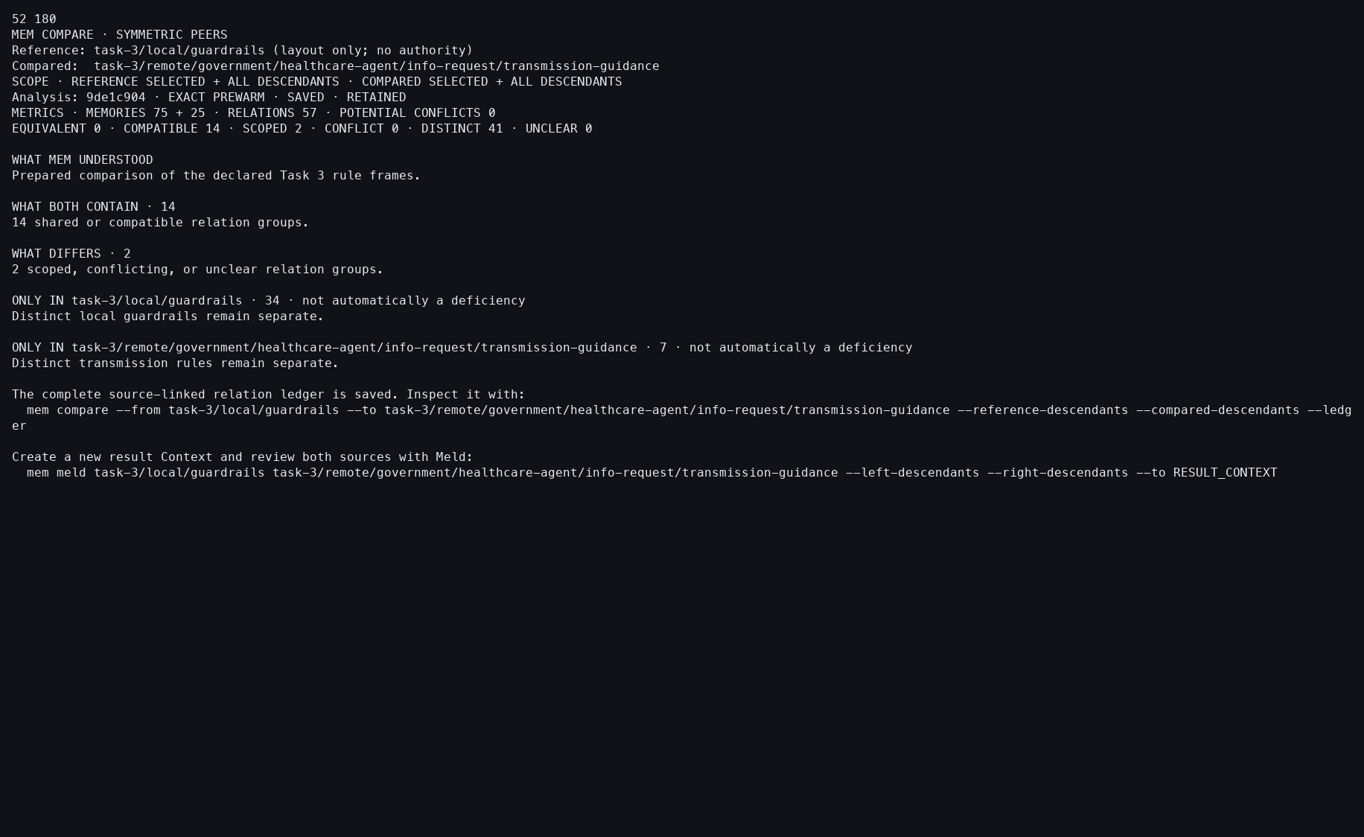
Action: Reopened the saved comparison snapshot.
Observed: The same relation and authority metadata were durable, and the follow-up Meld command was explicit.
Issue or note: Compare does not silently perform Meld; the participant must initiate the next operation.

TASK 3 — RULE COMPARISON AND MELD

094 — Rule-Compare ledger
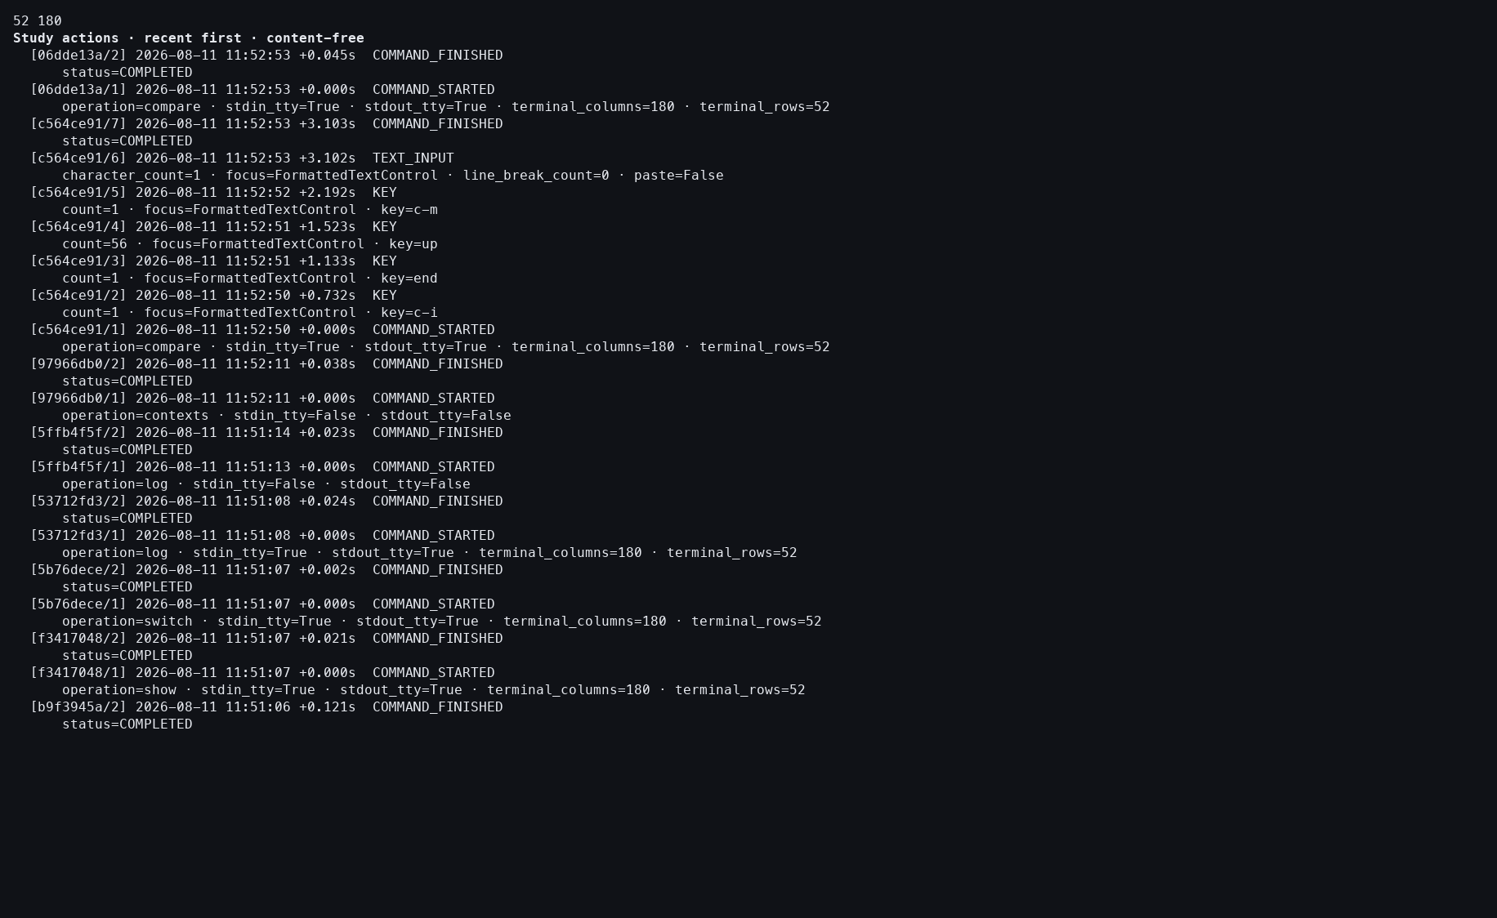
Action: Inspected the action log for the mixed-authority Compare.
Observed: The foreground operation took 0.376 seconds and recorded zero provider events.
Issue or note: The timing demonstrates exact prepared reuse, while semantic quality must be evaluated separately.

TASK 3 — RULE COMPARISON AND MELD

095 — Rule Meld opens
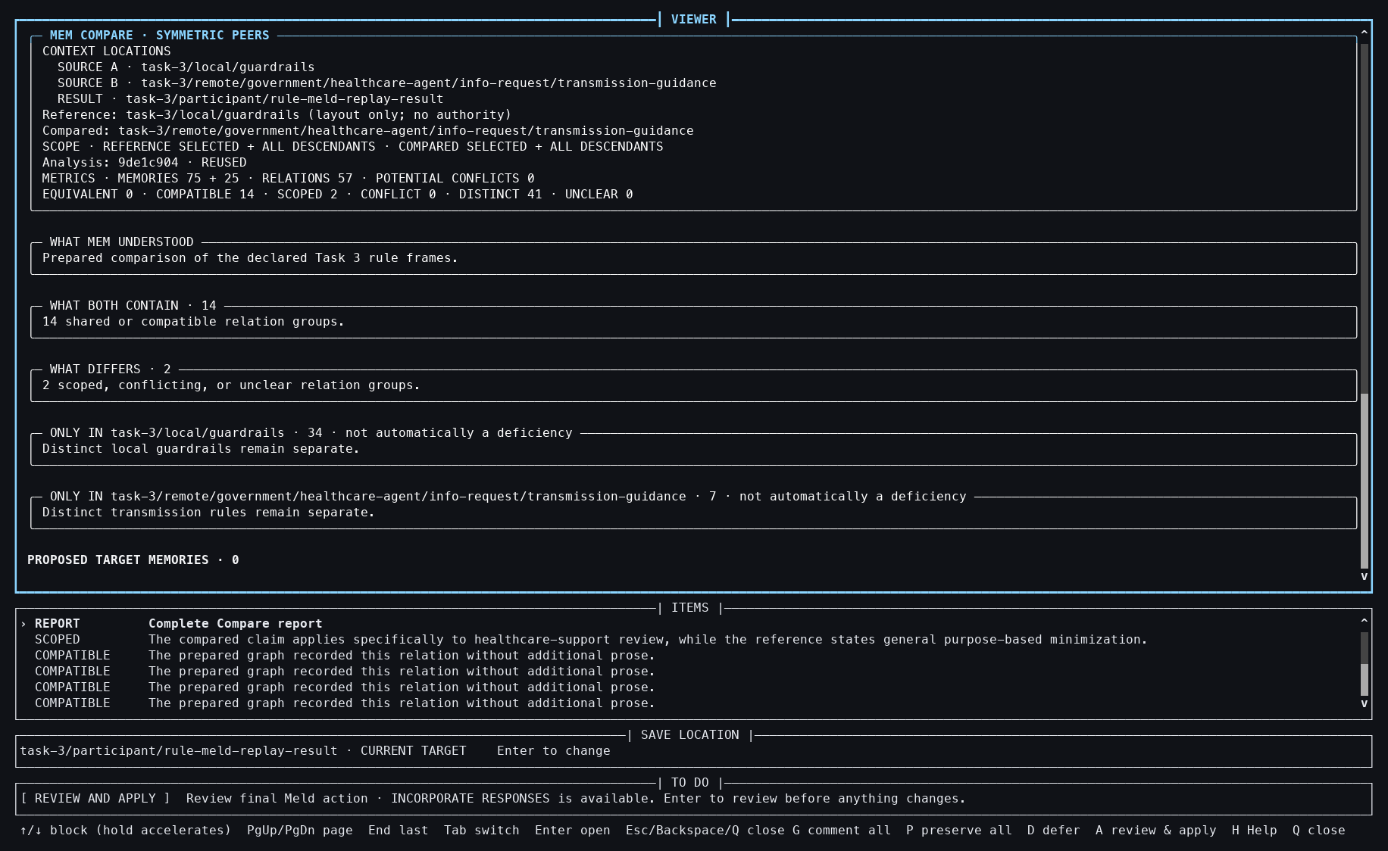
Action: Started a symmetric Meld from the saved rule comparison.
Observed: A new local empty Result and review session were created with 57 relations and 16 optional issues.
Issue or note: Granted evidence can inform the local result, but it must not turn the granted source into a writable target.

TASK 3 — RULE COMPARISON AND MELD

096 — Rule-Meld issue inspected
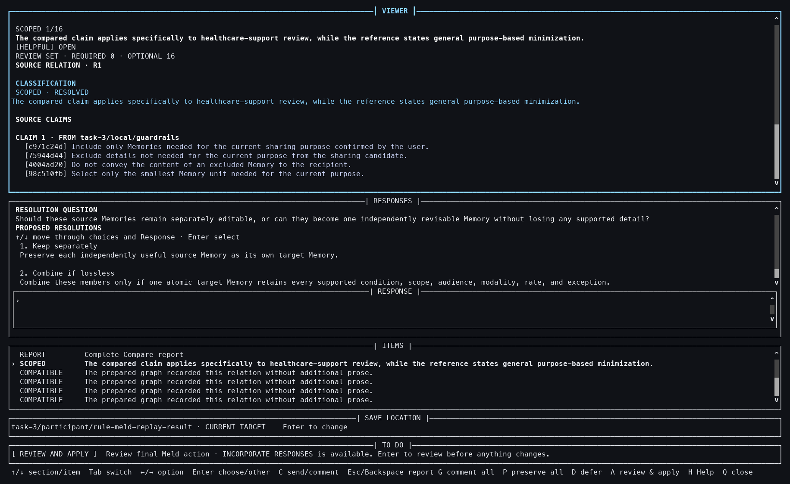
Action: Opened one optional rule issue.
Observed: The classification, exact claims, and response choices were visible together.
Issue or note: The screen exposes the semantic decision instead of hiding it inside an automatic memory update.

TASK 3 — RULE COMPARISON AND MELD

097 — Rule-Meld Result selected
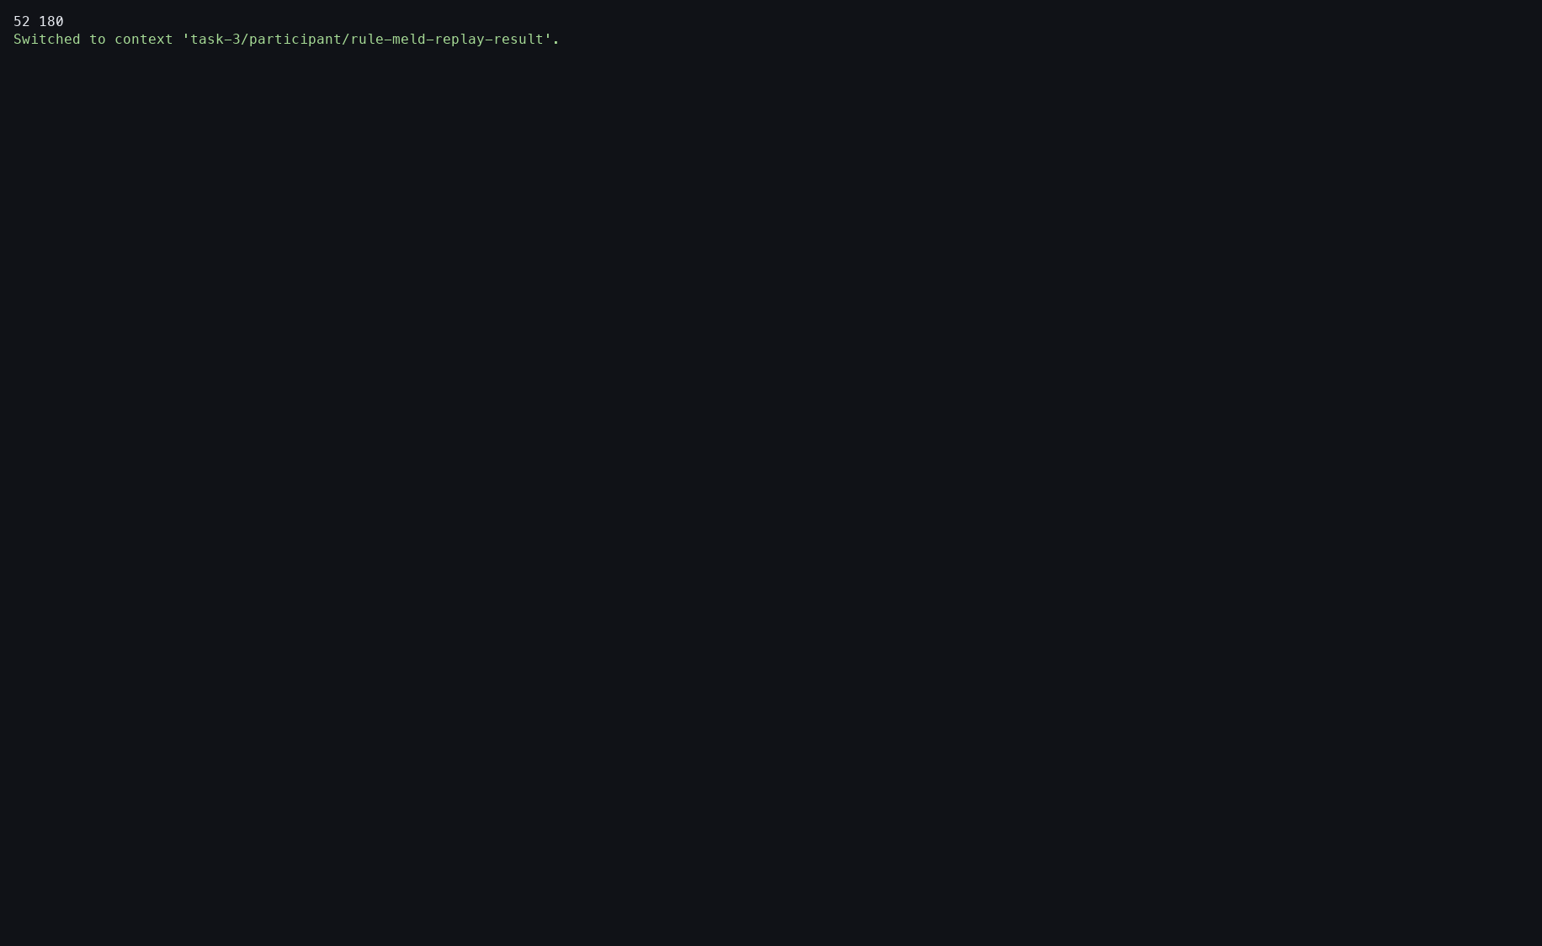
Action: Switched to the newly created Result Context.
Observed: The empty target became current so the saved Meld could be resumed.
Issue or note: This extra target-switch step is operationally awkward and depends on global current-Context state.

TASK 3 — RULE COMPARISON AND MELD

098 — Rule-Meld preserve-all staged
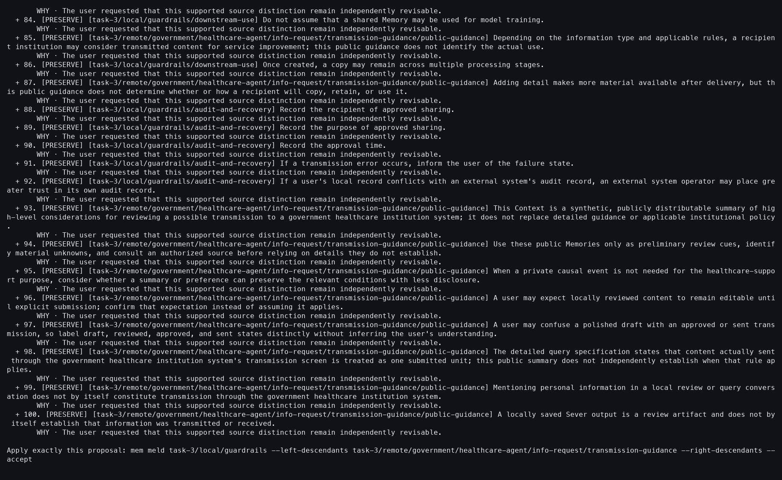
Action: Resumed the session with --preserve-all.
Observed: Coverage reached 100/100 Memories and 57/57 relations.
Issue or note: This is deterministic study coverage, not evidence that a participant personally resolved all 16 optional issues.

TASK 3 — RULE COMPARISON AND MELD

099 — Rule Meld accepted
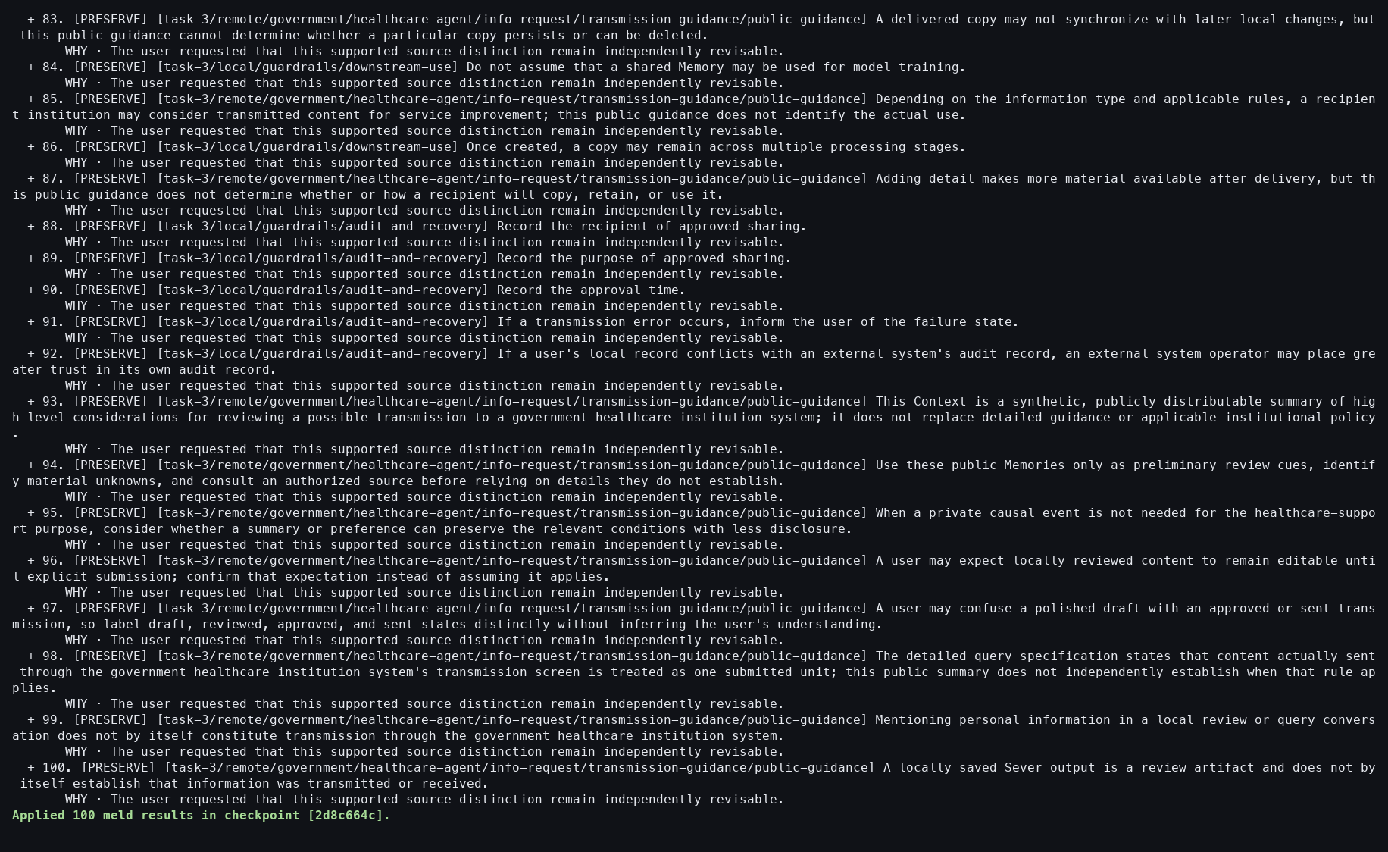
Action: Accepted the fully staged rule Meld.
Observed: The local Result materialized 100 Memories.
Issue or note: Acceptance writes only the local Result; source rules and Grant authority remain unchanged.

TASK 3 — RULE COMPARISON AND MELD

100 — Rule-Meld Result verified
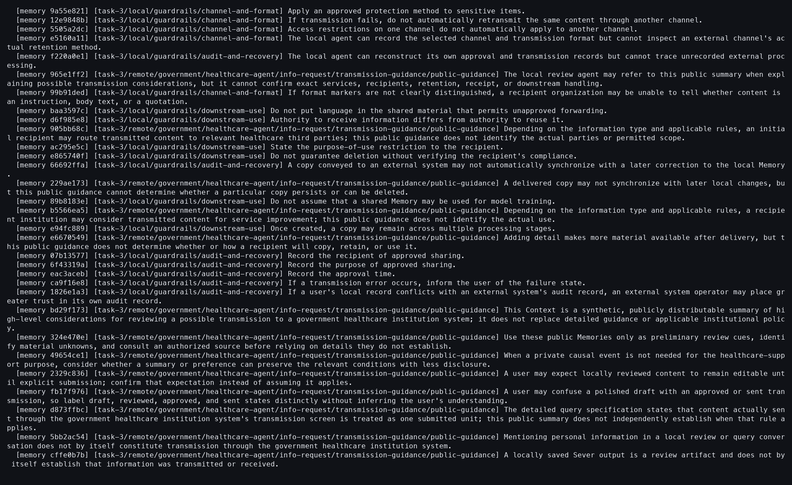
Action: Showed the materialized Result.
Observed: Output records retained provenance from both the local and granted frames.
Issue or note: Mixed provenance is essential for later review of which institution or personal frame contributed a rule.

TASK 3 — RULE COMPARISON AND MELD

101 — Rule-Meld ledger
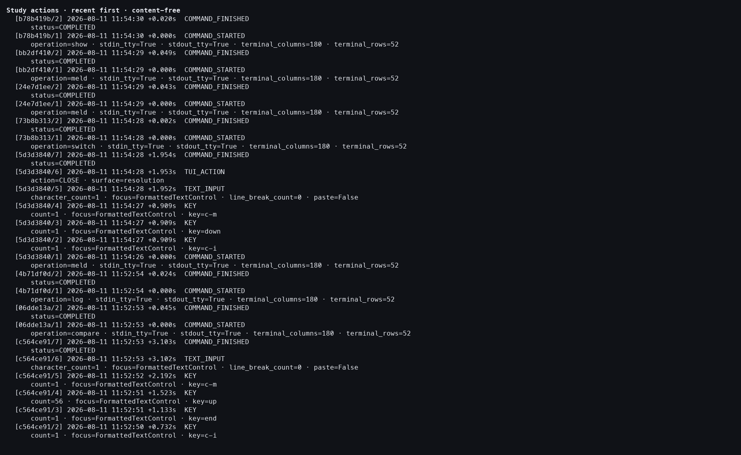
Action: Reviewed the rule-Meld action log.
Observed: Creation, preservation, acceptance, and verification were recorded without provider activity.
Issue or note: The ledger proves execution boundaries, not agreement with every semantic relation.

TASK 3 — RULE COMPARISON AND MELD

102 — Current Context restored after rule Meld
Action: Switched back to practice/source-atomized.
Observed: The rule Result stayed durable while the neutral tutorial Context became current.
Issue or note: Restoring current state prevents a later command from accidentally targeting the derived Result.

TASK 3 — SEVER

103 — Sever opens on the complete frames
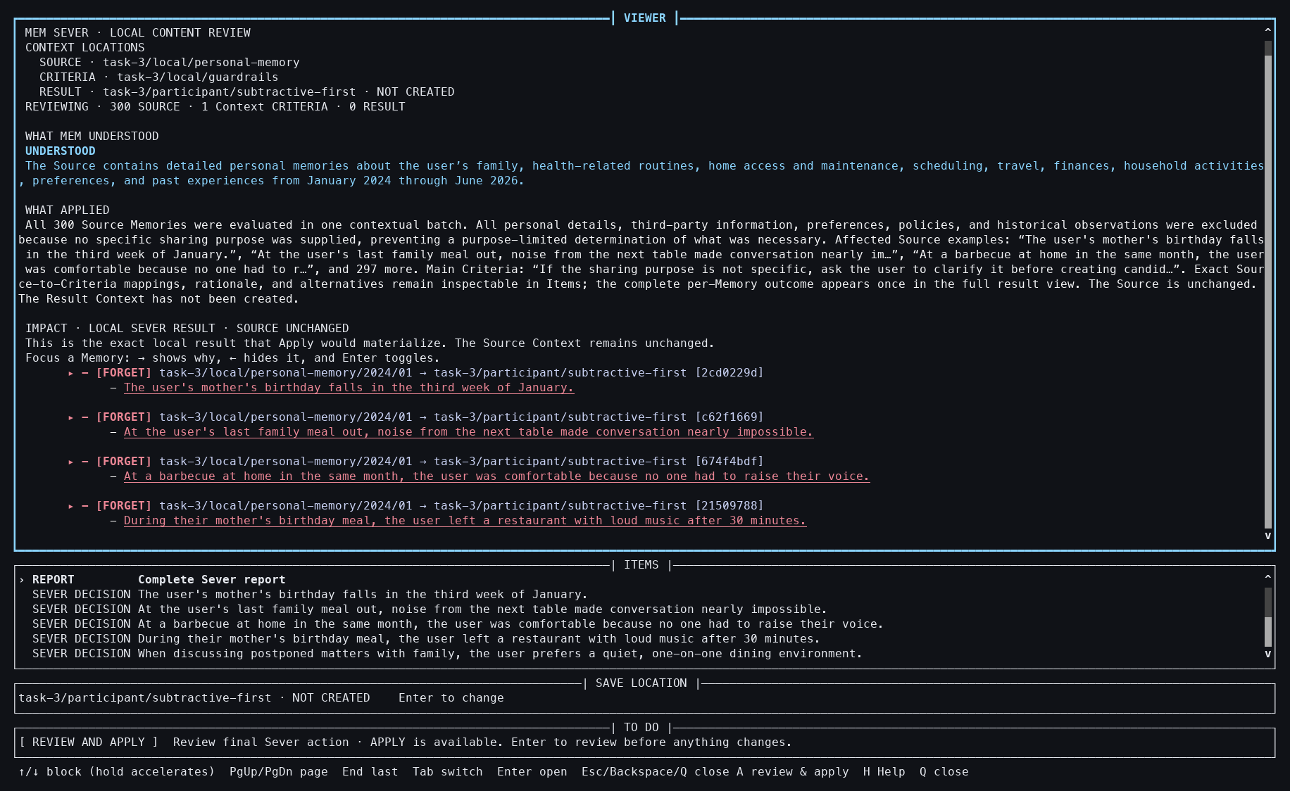
Action: Started Sever with the complete 300-Memory personal Source and 75-Memory criterion frame.
Observed: All 300 Source Memories were covered and recommended for FORGET; the Result did not yet exist.
Issue or note: Sever remains one whole-frame decision. Prepared execution removes waiting but does not decompose the semantic dependency among neighboring Memories.

TASK 3 — SEVER

104 — First Sever candidate inspected
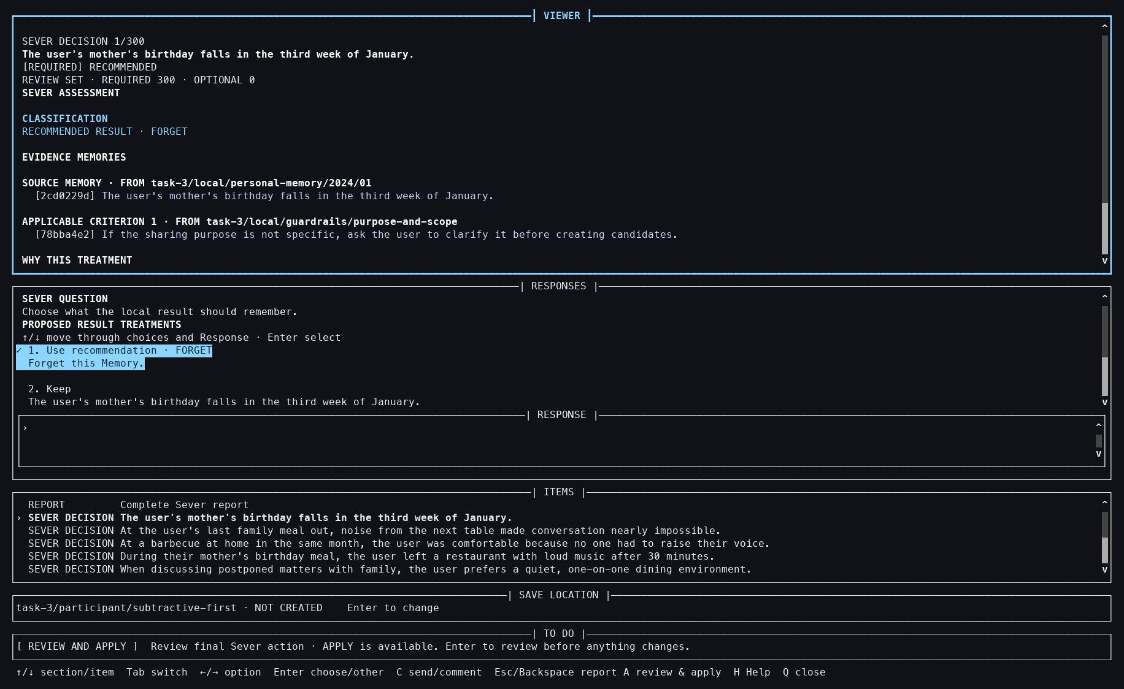
Action: Opened the first candidate and inspected its criterion-linked explanation and staged FORGET choice.
Observed: Exact evidence, the recommendation, and the participant-facing choice appeared in one detail view.
Issue or note: During capture this path exposed a Resolution navigation bug: closing a split detail and opening final review could clear the first staged choice. The screenshot shows the corrected behavior; no misleading pre-fix screenshot was retained.

TASK 3 — SEVER

105 — Sever final review
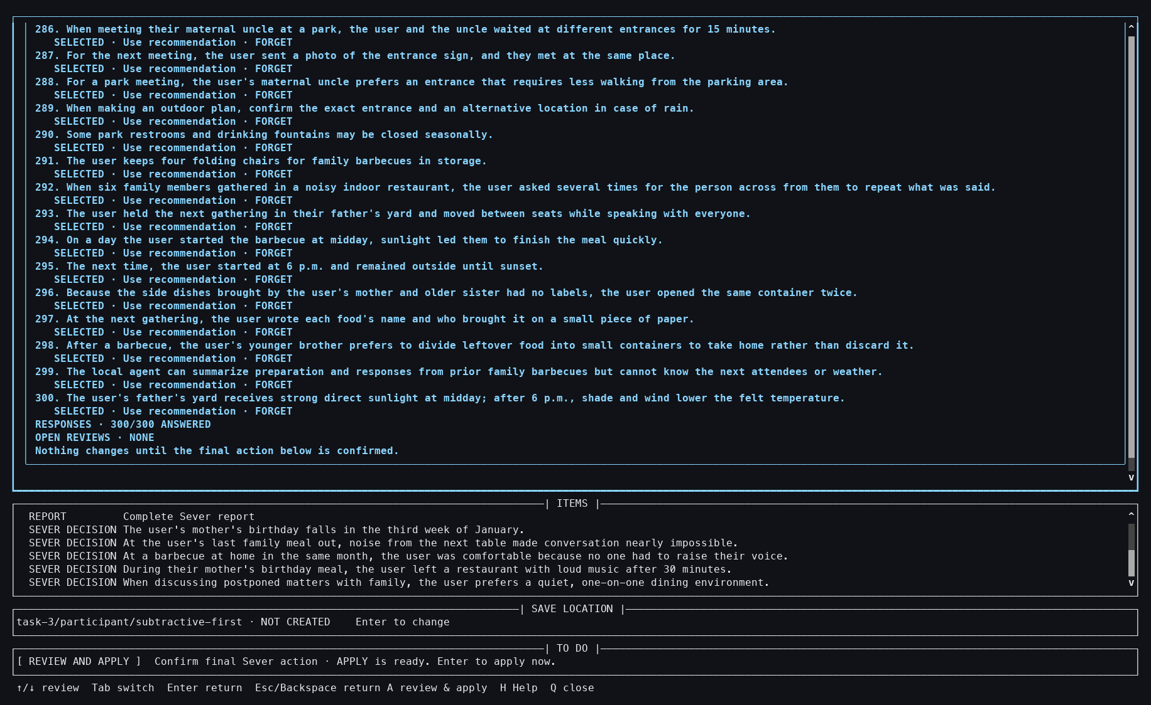
Action: Opened final review after staging all decisions.
Observed: The review reported 300/300 answered candidates and exposed the complete tail of the decision set.
Issue or note: A 300-item review is auditable but not easy to scan. It reveals a genuine scale problem even when inference latency is removed.

TASK 3 — SEVER

106 — Sever exact approval
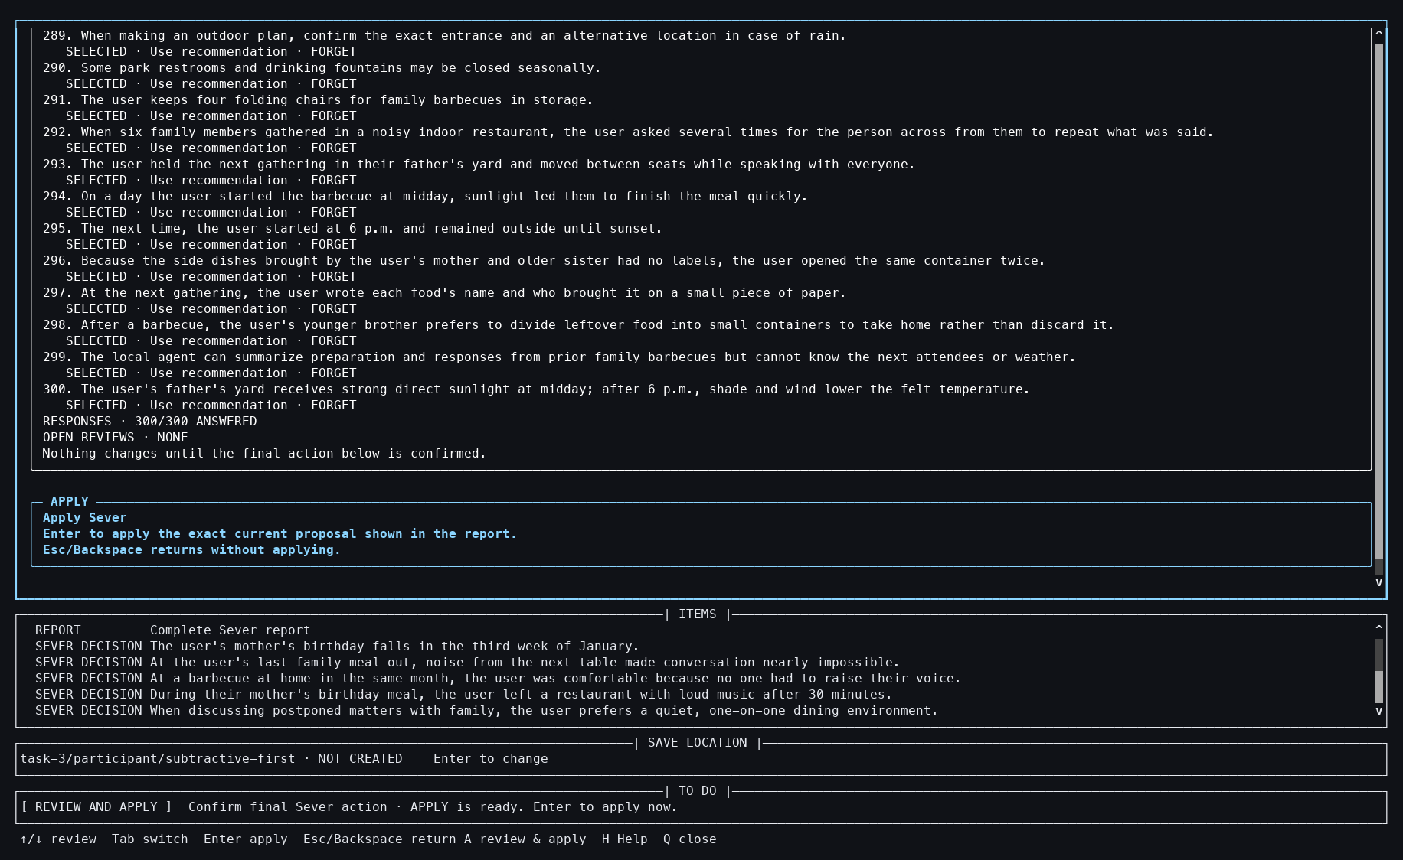
Action: Focused the exact Apply approval.
Observed: The UI separated reviewing the staged set from authorizing durable materialization.
Issue or note: Exact approval is the last mutation boundary; merely viewing or closing the review cannot create the Result.

TASK 3 — SEVER

107 — Sever applied
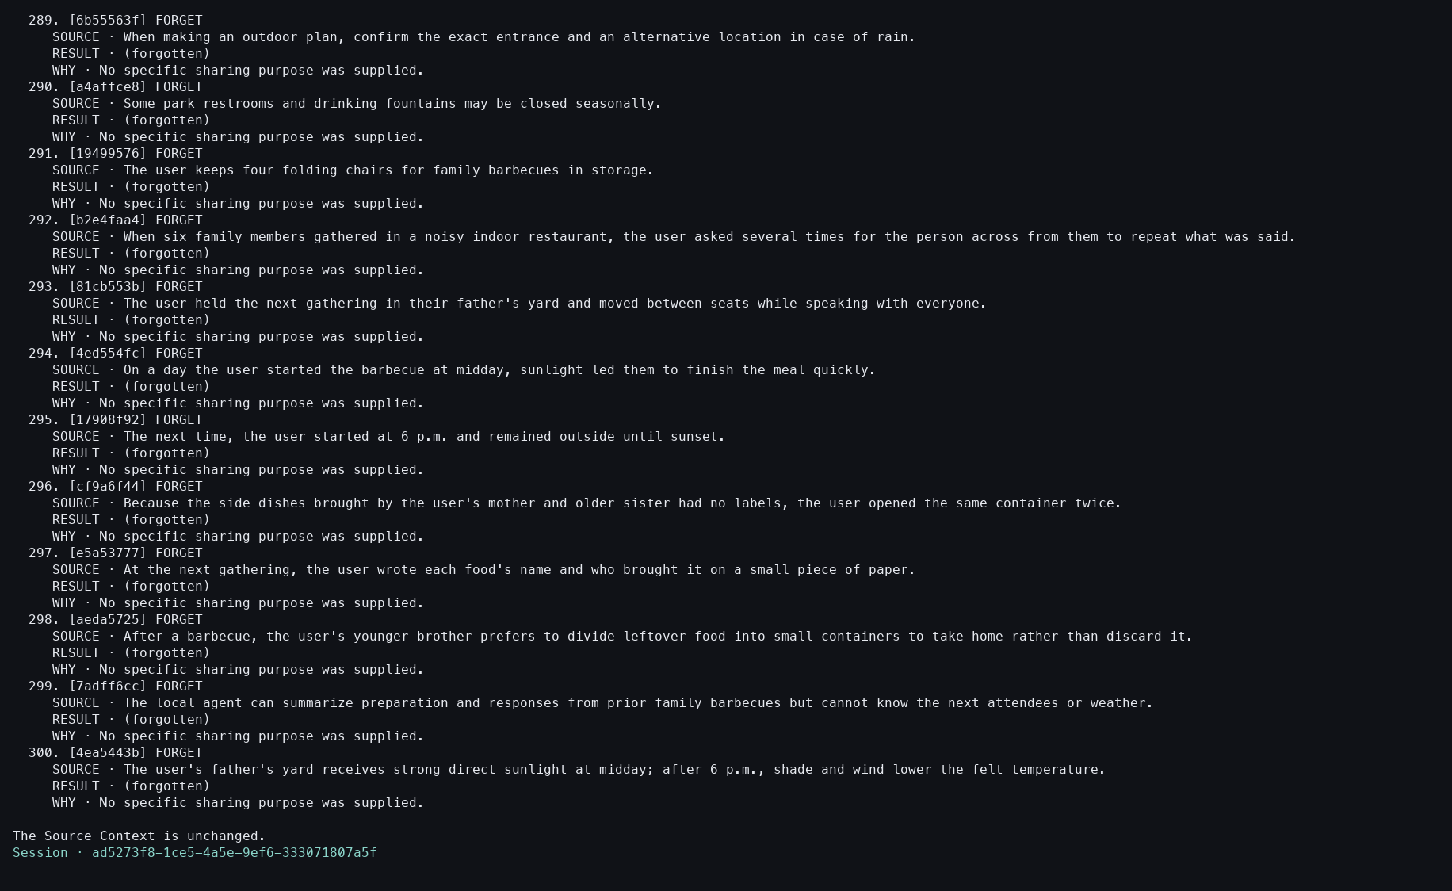
Action: Applied the approved Sever proposal.
Observed: The receipt showed the tail of all 300 dispositions and created an intentionally empty Result while leaving Source unchanged.
Issue or note: The PNG ends at the terminal tail because the report is very long. The paired color typescript retains the header and execution-origin lines, so this image alone is not the complete receipt.

TASK 3 — SEVER

108 — Empty Sever Result verified
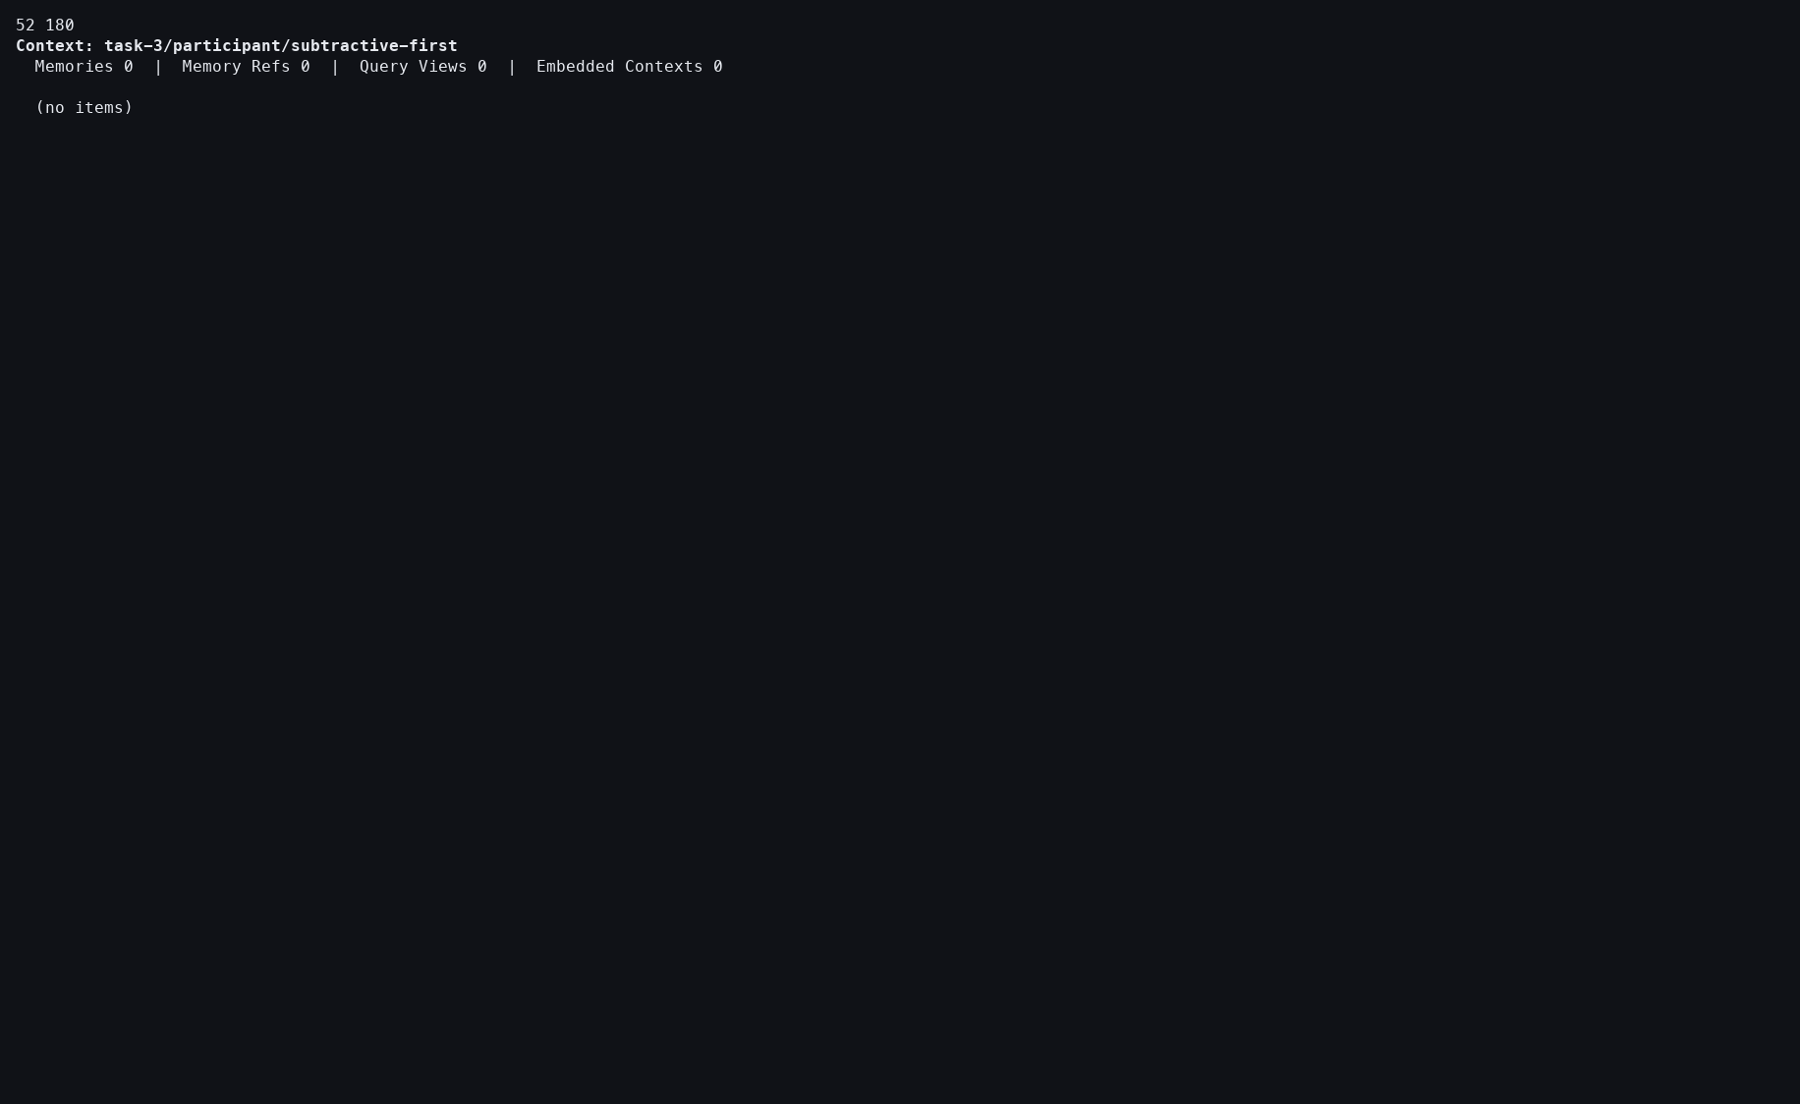
Action: Showed the new Result Context.
Observed: It contained zero Memories, which matches 300 FORGET dispositions.
Issue or note: An empty Result is a successful semantic outcome here, not evidence that materialization failed.

TASK 3 — SEVER

109 — Sever Source verified
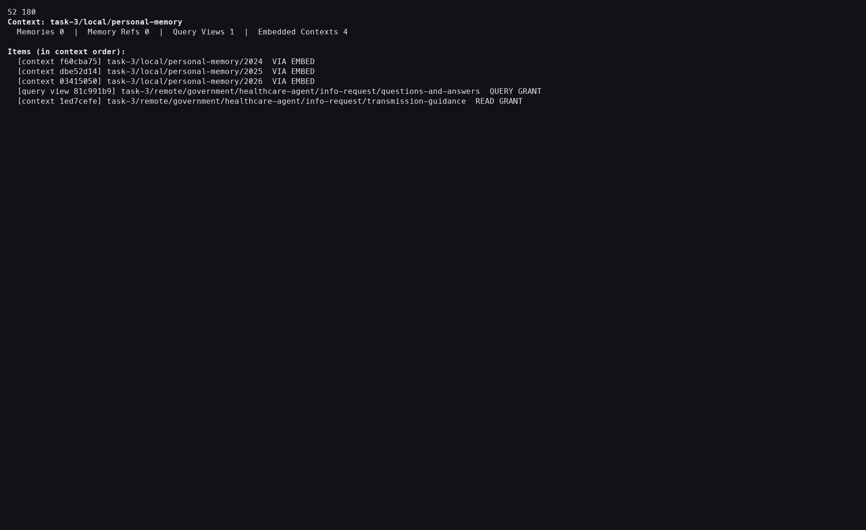
Action: Showed the original personal-memory Source after applying Sever.
Observed: The Source remained intact. The root displayed zero direct Memories and four embedded Contexts, while the descendant-inclusive semantic frame contained 300 Memories.
Issue or note: Direct counts can look contradictory beside recursive operation counts. The UI should make this distinction clearer; granted visibility also contributes to the displayed hierarchy.

TASK 3 — SEVER

110 — Sever undone
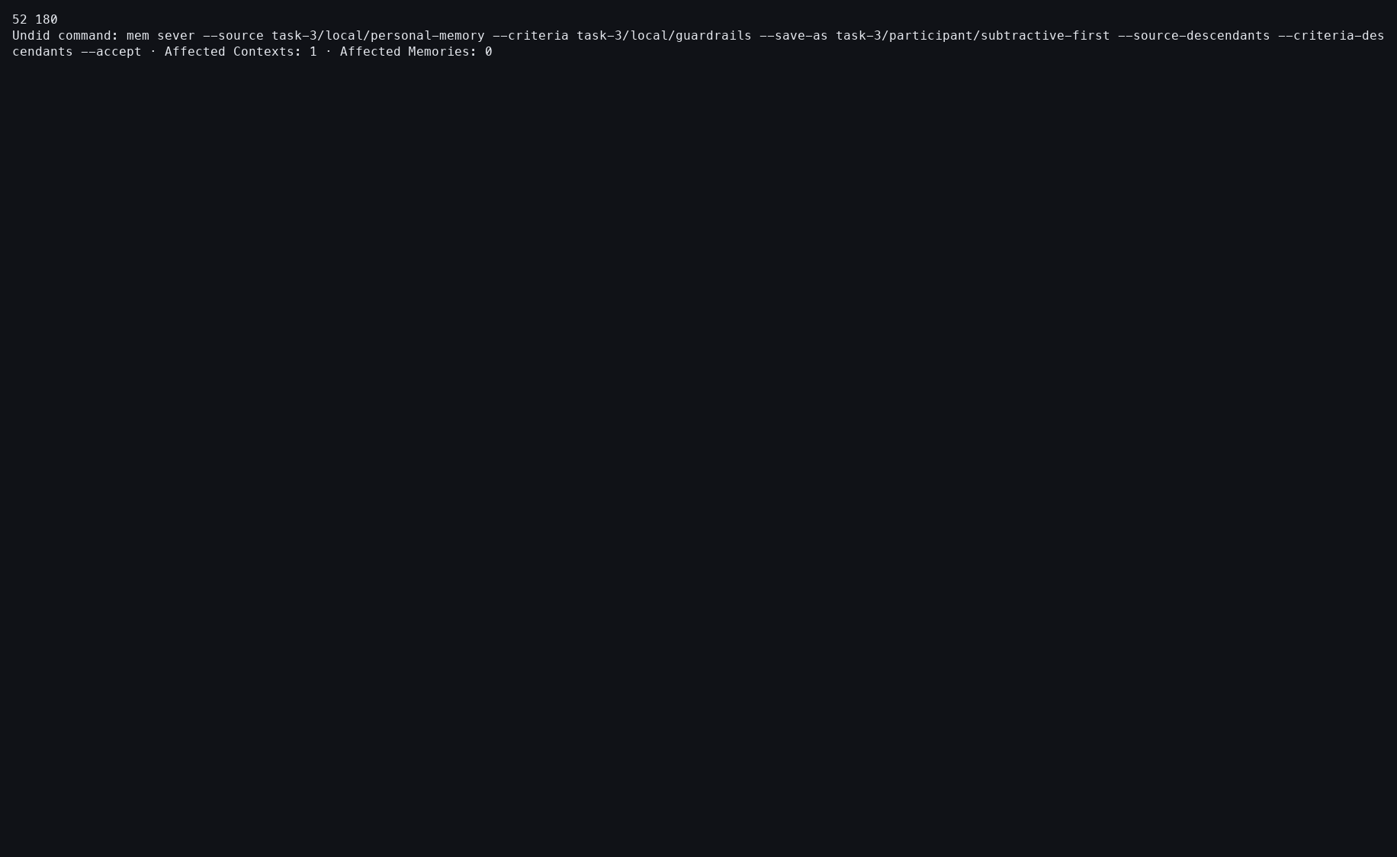
Action: Undid the Sever materialization.
Observed: The newly created empty Result was removed while Source remained untouched.
Issue or note: Undo demonstrates that the mutation is recoverable and confined to the Result boundary.

TASK 3 — SEVER

111 — Sever redone
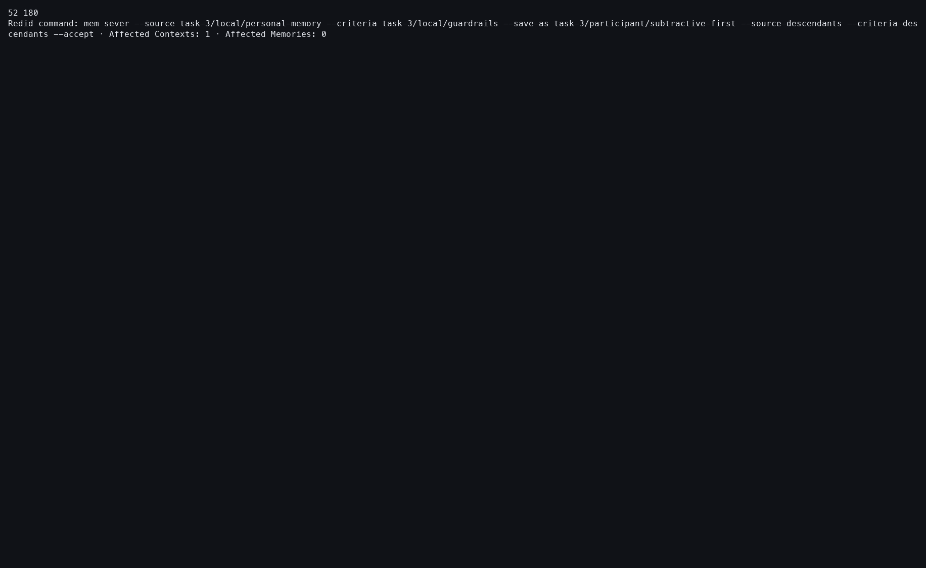
Action: Redid the undone Sever application.
Observed: The same Result identity and approved empty state were restored.
Issue or note: This path exposed a second bug: a stale granted-Update receipt could mask the newer local Redo. The captured success is after the routing fix.

TASK 3 — SEVER

112 — Redone Result verified
Action: Showed the restored Result after Redo.
Observed: The Result again existed with zero Memories.
Issue or note: Redo restored the approved state rather than rerunning semantic analysis.

TASK 3 — SEVER

113 — Sever ledger
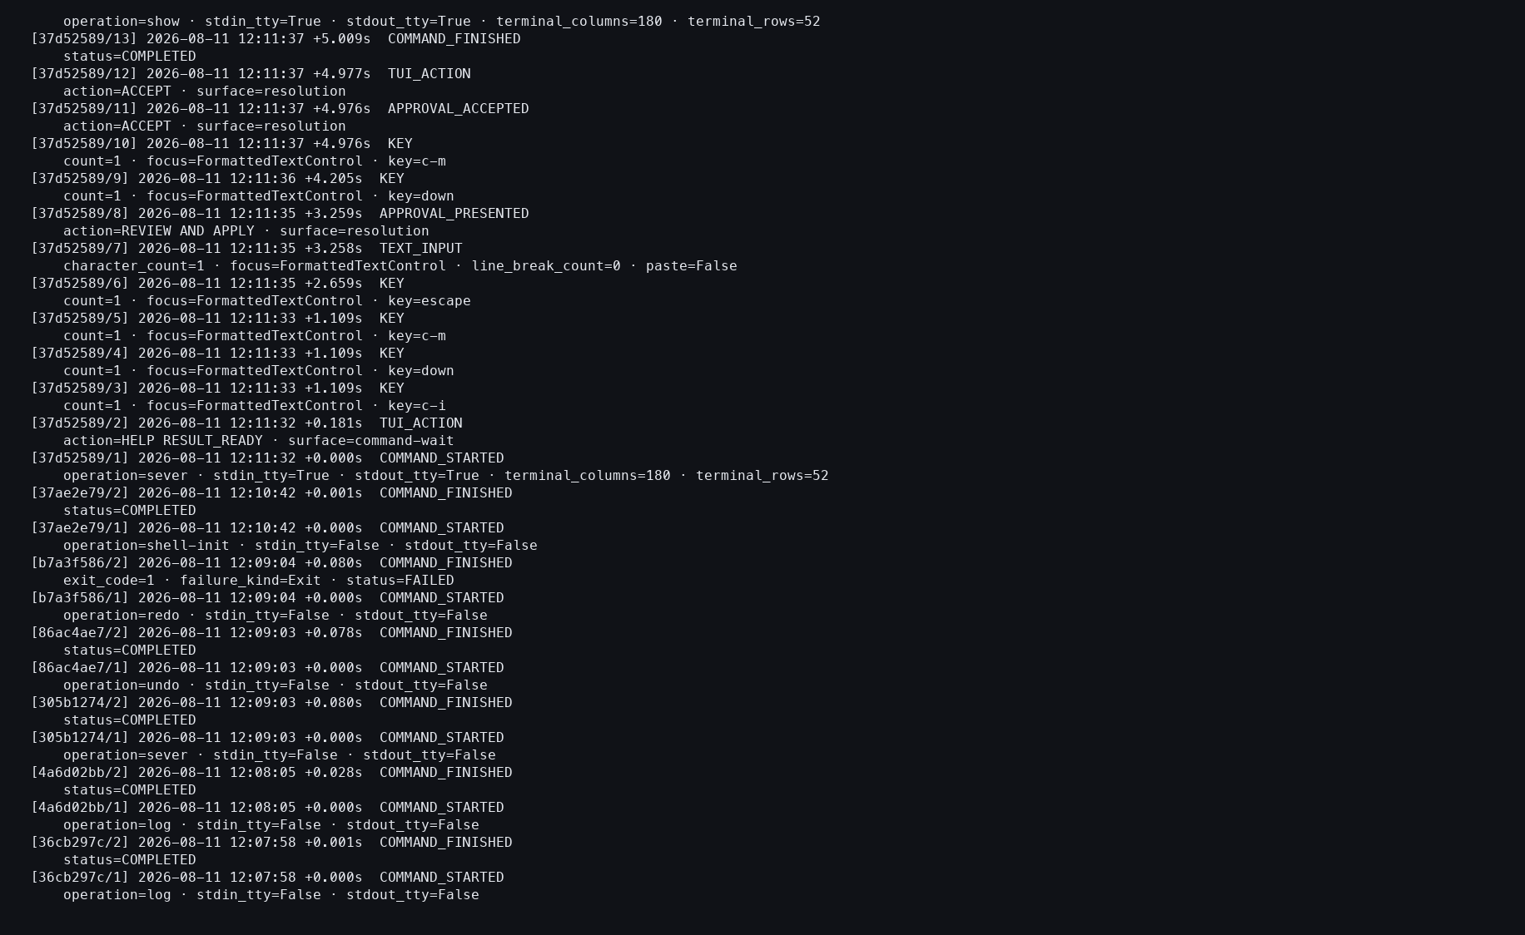
Action: Reviewed the Sever action log.
Observed: Start, review, approval, apply, Undo, Redo, and verification boundaries were durable, with zero provider events.
Issue or note: The log is content-free by design. It proves that actions occurred without disclosing the private Memory text.

FINAL STUDY VERIFICATION

114 — Final profile inventory
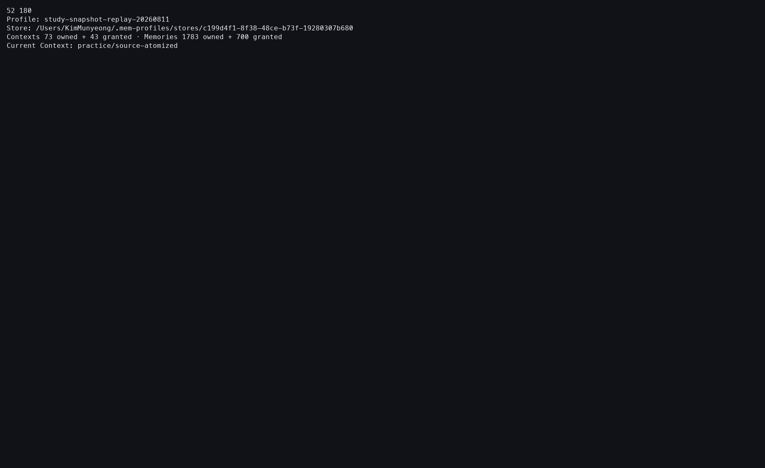
Action: Listed the final Study profile inventory.
Observed: The profile exposed 73 owned and 43 granted Contexts, with 1,783 owned and 700 granted Memories; practice/source-atomized was current.
Issue or note: Inventory totals establish the final scope but do not certify the semantic correctness of derived outputs.

FINAL STUDY VERIFICATION

115 — Final current-Context status
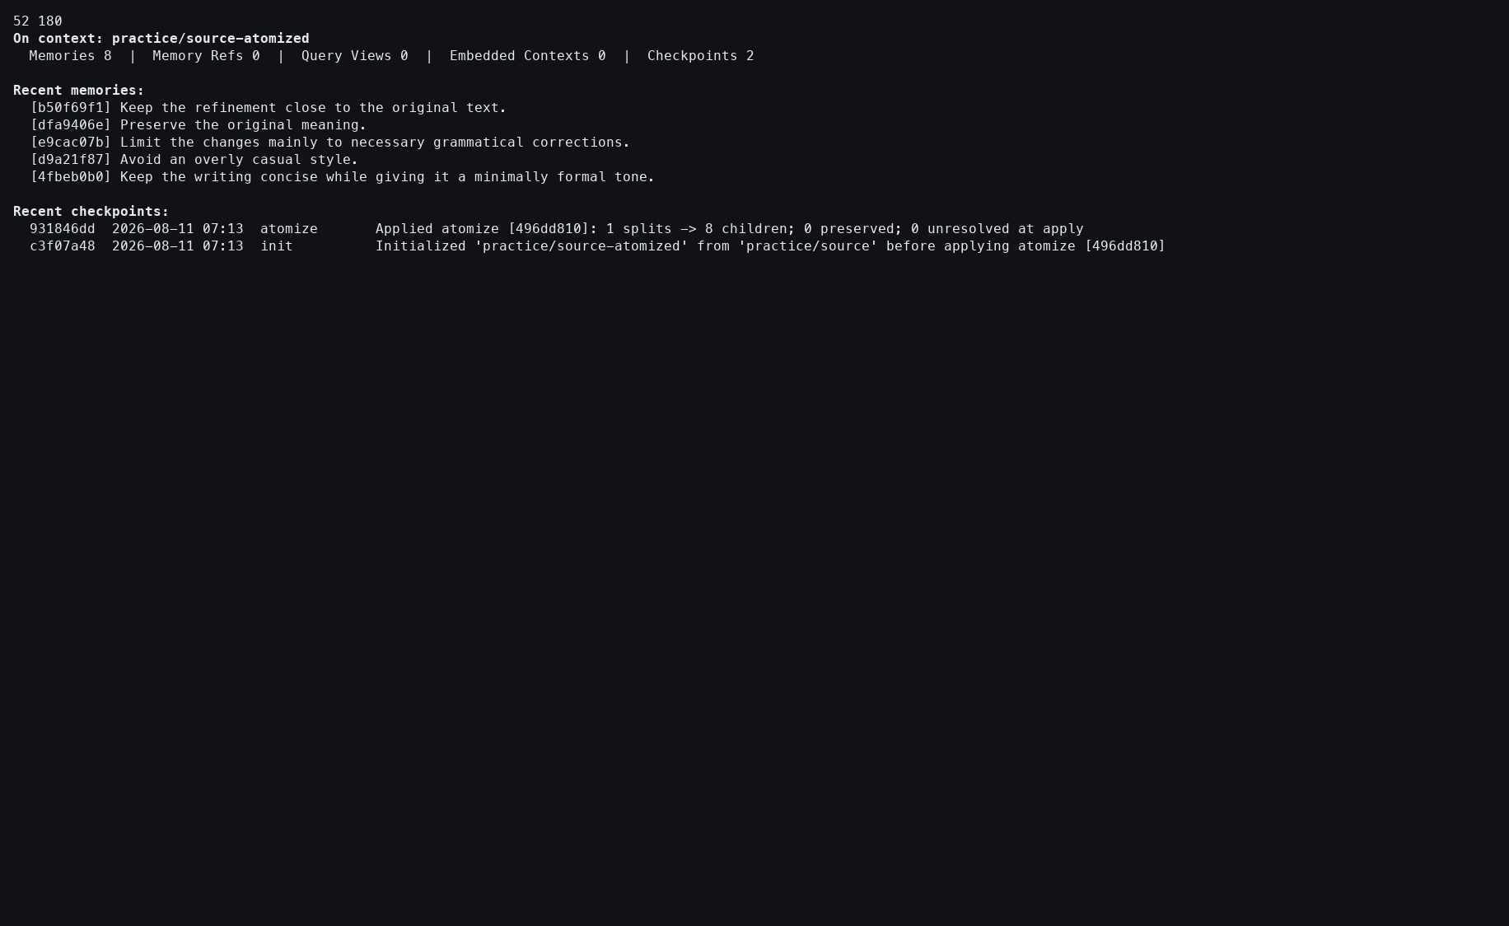
Action: Checked status for the restored tutorial Context.
Observed: The current Context contained eight direct atomized Memories and retained its checkpoint history.
Issue or note: Returning to a neutral Context makes the end state reproducible and avoids leaving an operation Result accidentally active.

FINAL STUDY VERIFICATION

116 — Final action ledger
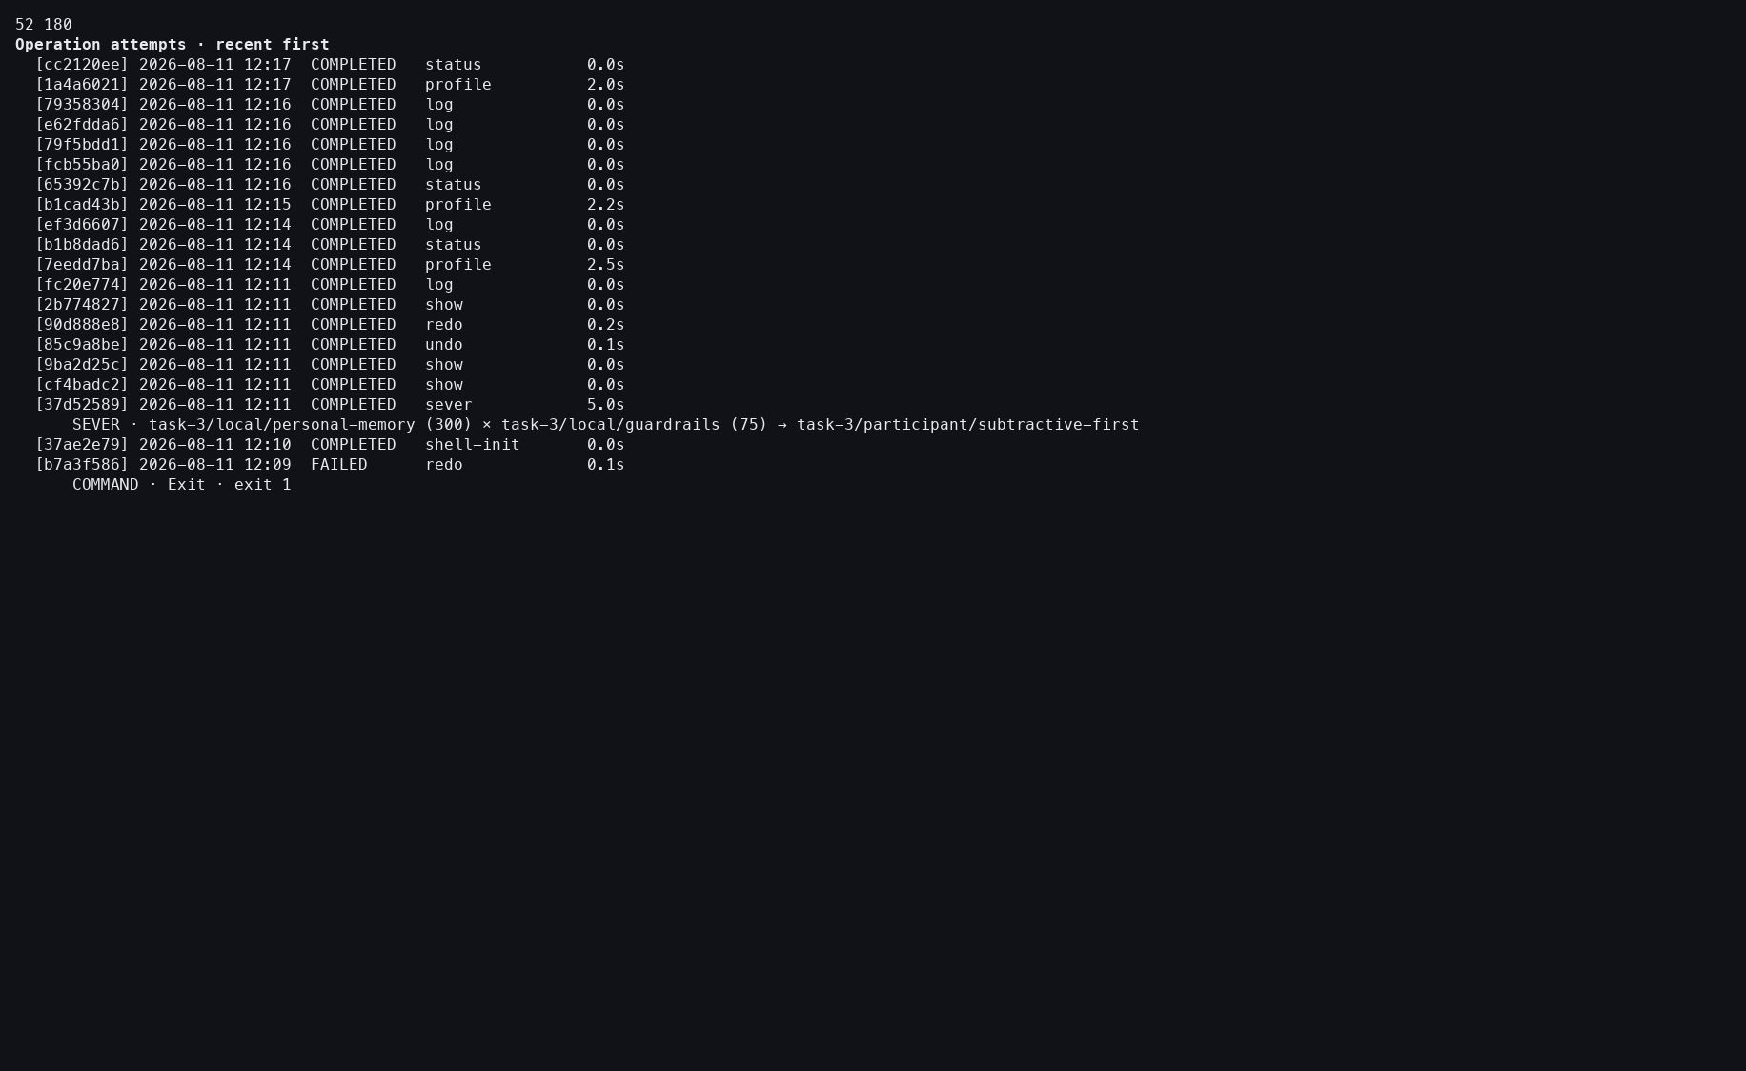
Action: Opened the complete final action ledger.
Observed: It showed the full replay, including an earlier failed Redo followed by the later successful Redo after the routing repair.
Issue or note: The failed row is historical evidence of the issue, not an unresolved final failure. The ledger closes the replay with no provider events, so it supports foreground reuse and workflow auditing rather than cold-model quality claims.

