40% nursing home deaths

<https://www.nytimes.com/interactive/2020/us/coronavirus-nursing-homes.html>

nursing home deaths are 20% of yearly deaths

<https://www.jamda.com/article/S1525-8610(08)00172-2/pdf>

Yearly death total

<https://www.cdc.gov/nchs/products/databriefs/db355.htm#:~:text=In%202018%2C%20a%20total%20of,at%20birth%20increased%200.1%20year.>

[https://www.cdc.gov/coronavirus/2019-ncov/covid-data/pdf/covidview-08-07-2020.pdf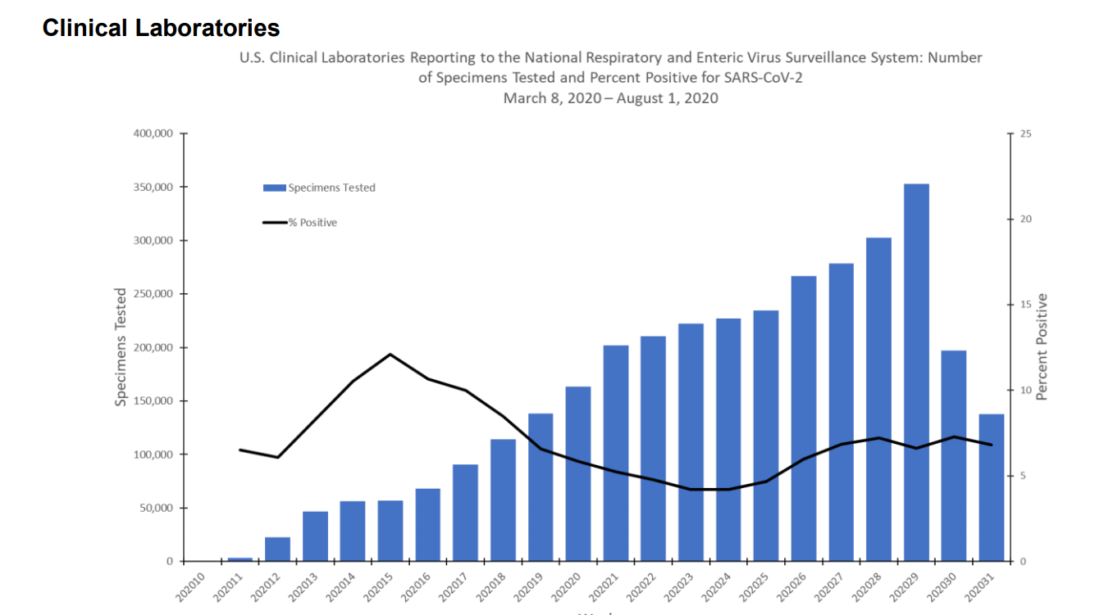](https://www.cdc.gov/coronavirus/2019-ncov/covid-data/pdf/covidview-08-07-2020.pdf#)

fewer heart attacks, strokes

<https://medicalxpress.com/news/2020-05-hospitals-heart-covid-.html>