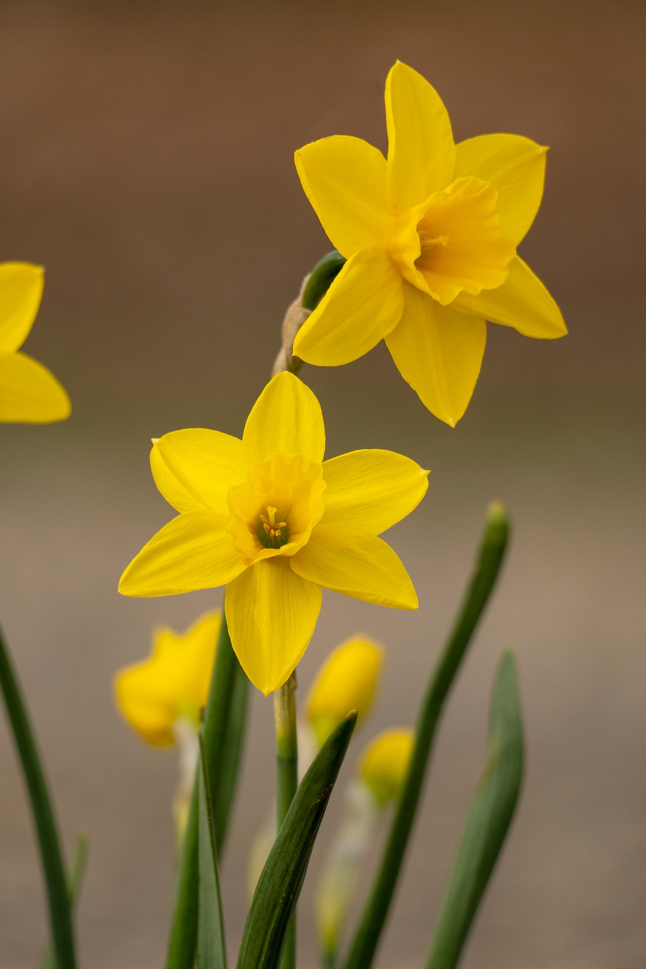

Squeglia Lab:

Organic R Textbook

Ian Cero, PhD MStat

2022