Title Page

# My Plot

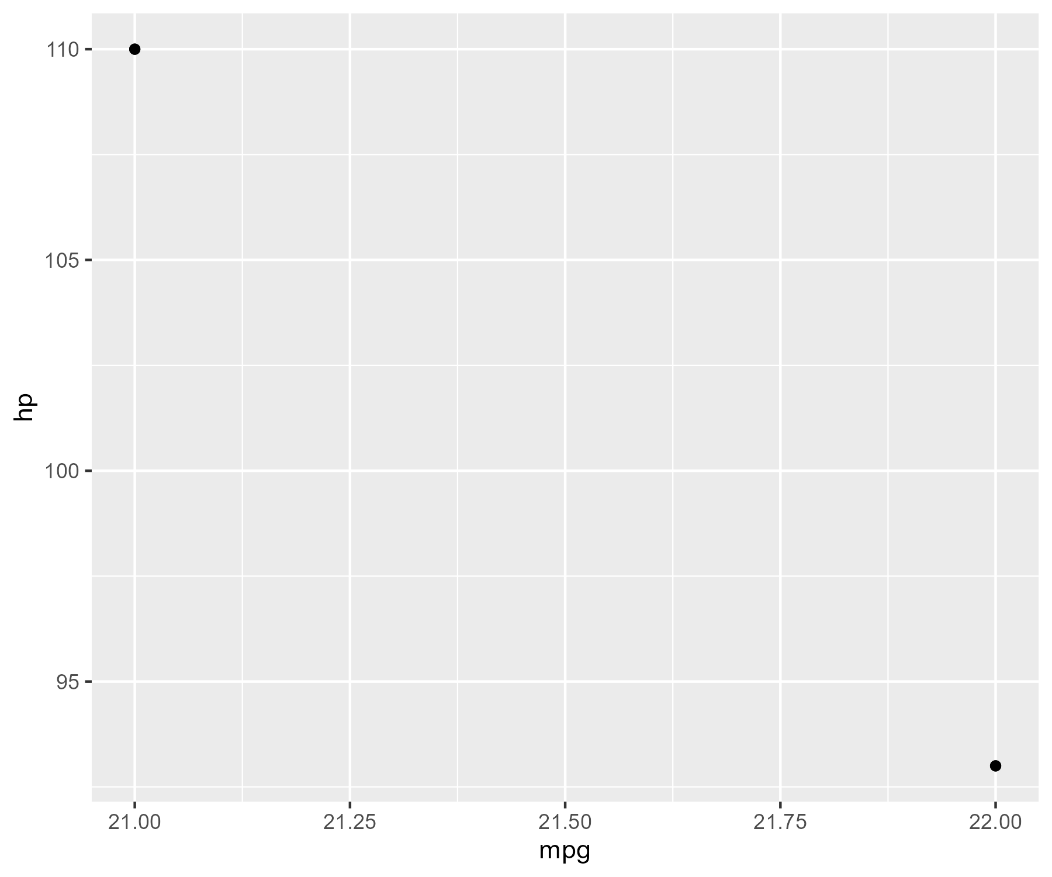

This is a sample plot

# My Plot



This is a sample plot

# My Plot



This is a sample plot

# My Plot



This is a sample plot