**Author: Ian Chen**

In the initial interface, only generate patterns and simple measurements are available.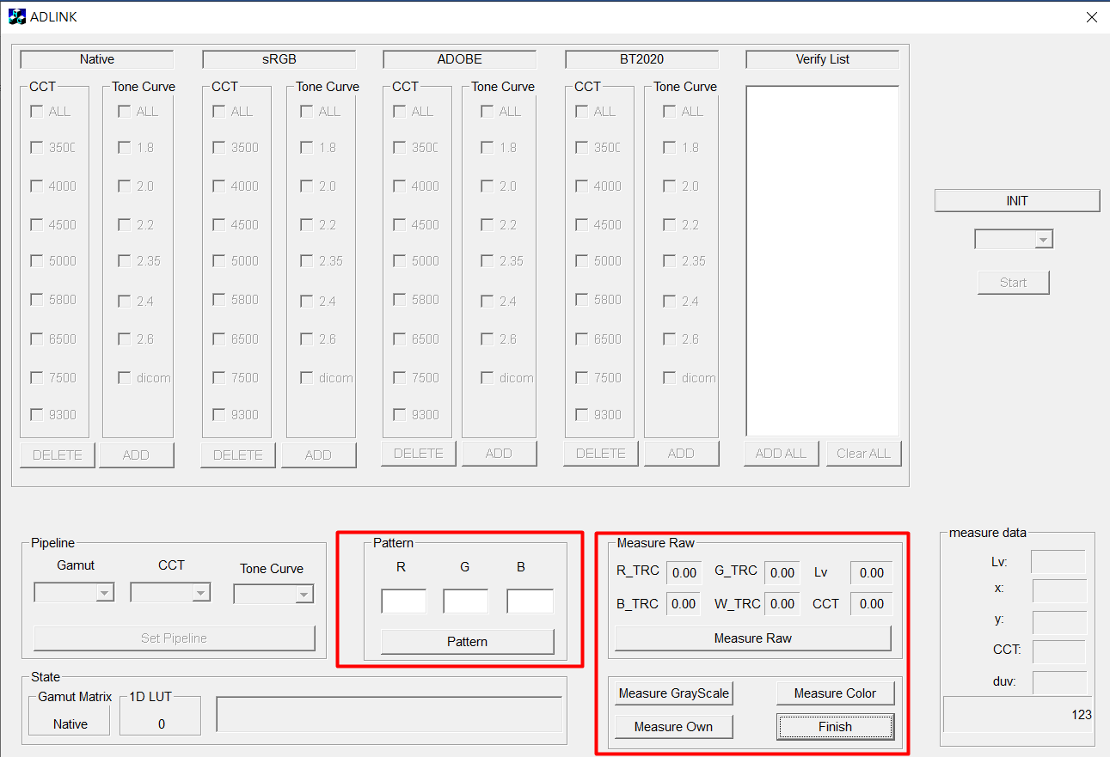

If you need to perform Calibration, Verification, and Set Video Pipeline, you must first click the button 'INIT' to initialize the panel.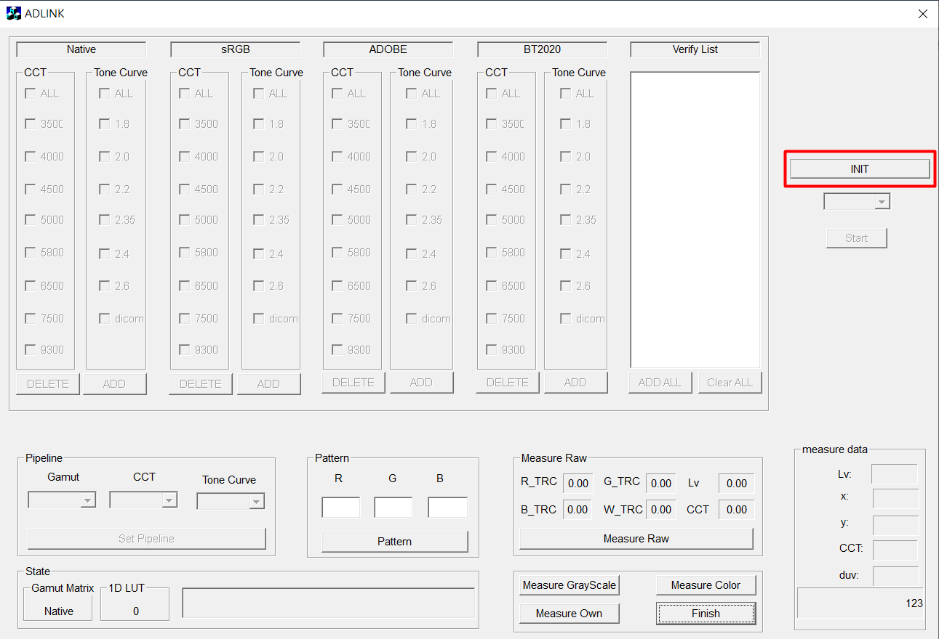

During the process:

* Write some data to MCU/FPGA (Initial Gamut Matrix、1D LUT)
* Measure the basic characteristics of the panel:
  + - 1. Tone curve of R、G、B、W channel
      2. Max luminance
      3. Correlated Color Temperature

It takes about two minutes and five seconds, please be patient.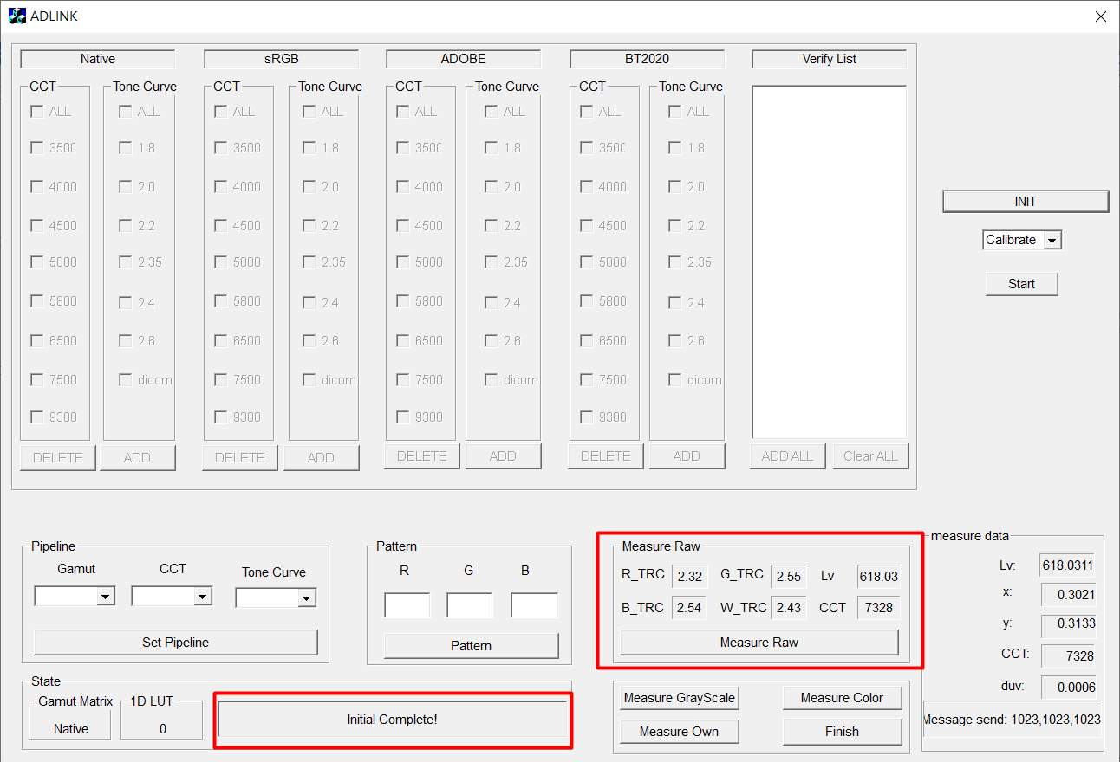

**Now you can use any function!**

**Function 1. Generate Pattern**

Input value of R、G、B, and click button ‘Pattern’.

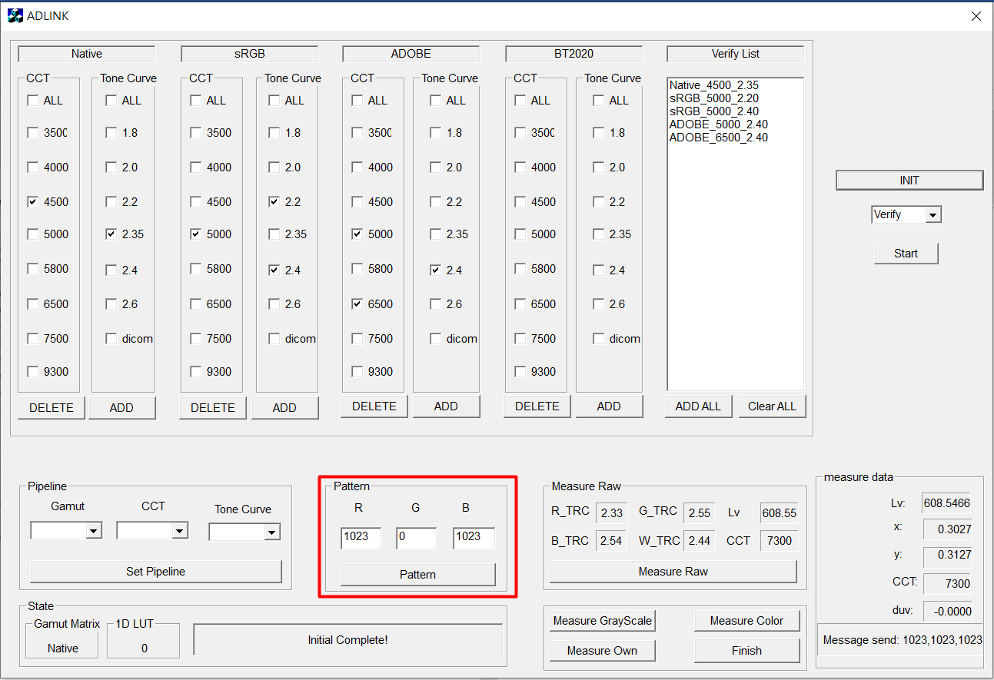

**Function 2. Measure Raw**

Measures the current color characteristics of the panel, if there is a change to the video pipeline this will also be set to 'Raw' instead of the unmodified panel.

Measurement data includes:

1. Tone curve of R、G、B、W channel
2. Max luminance
3. Correlated Color Temperature

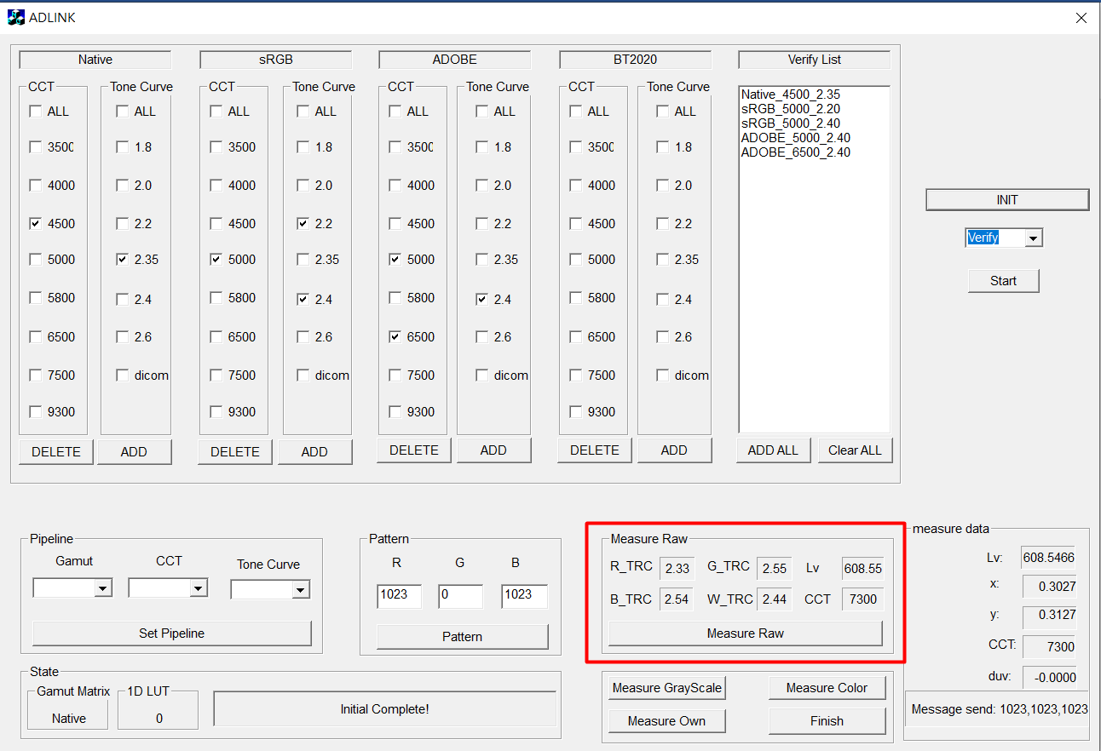

**Function 3. Calibration**

Step 1: Select mode ‘Calibrate’

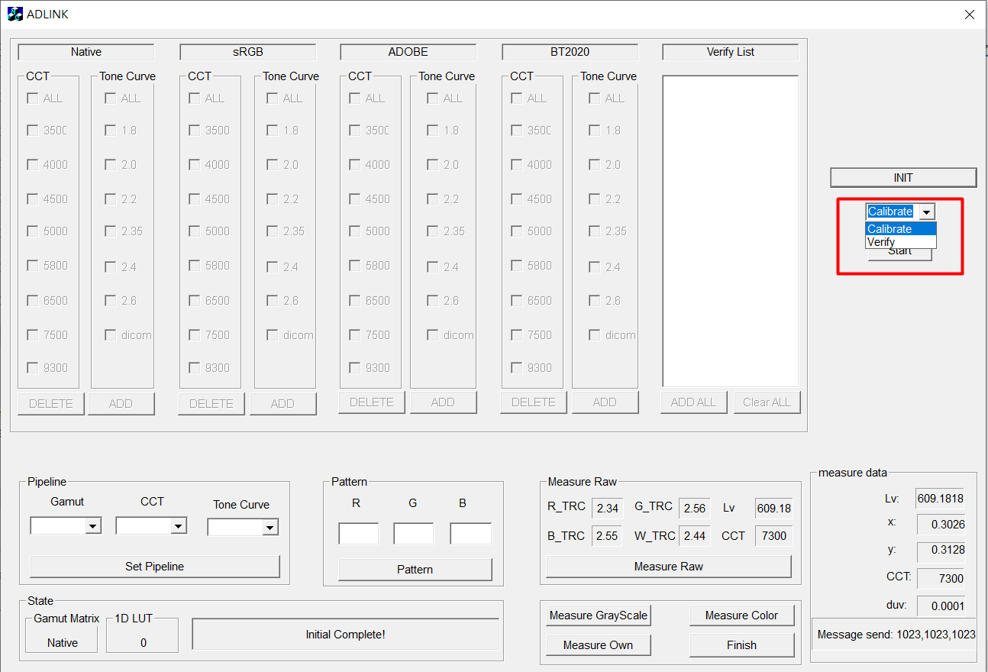

Step2: Click the button ‘Start'

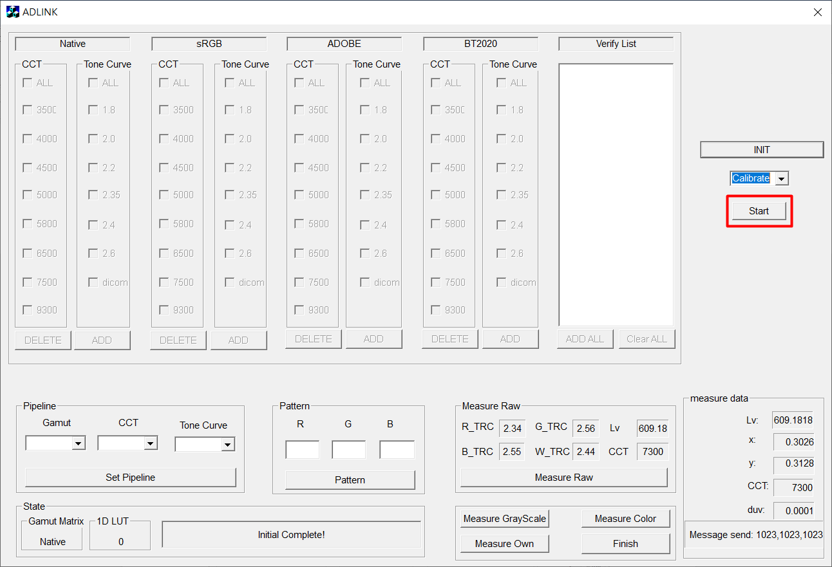

Perform color temperature correction.

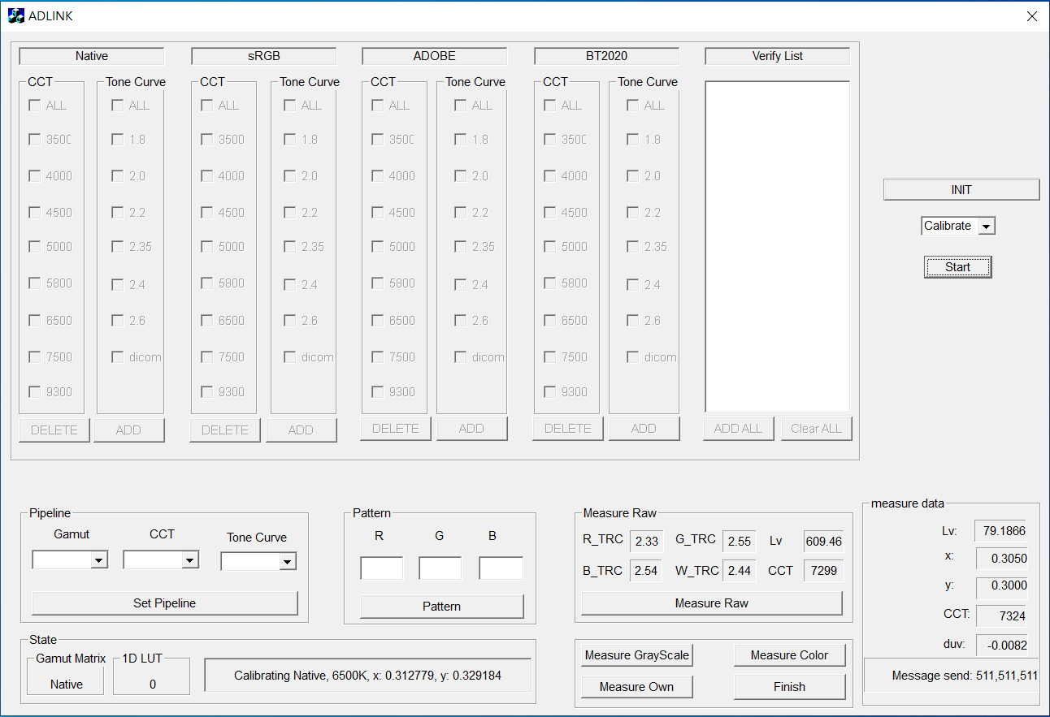

You can get which color gamut combination is currently corrected in the status bar in the lower left corner.

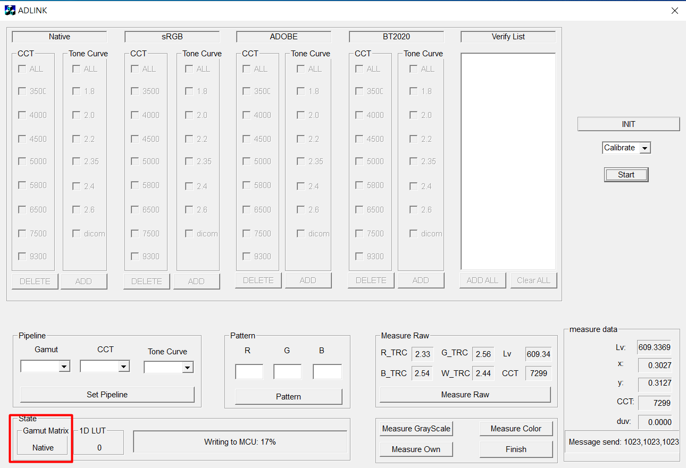

**Function 4. Verification**

Step1: Select mode ‘Verify’, If you select it, the condition options area will become available.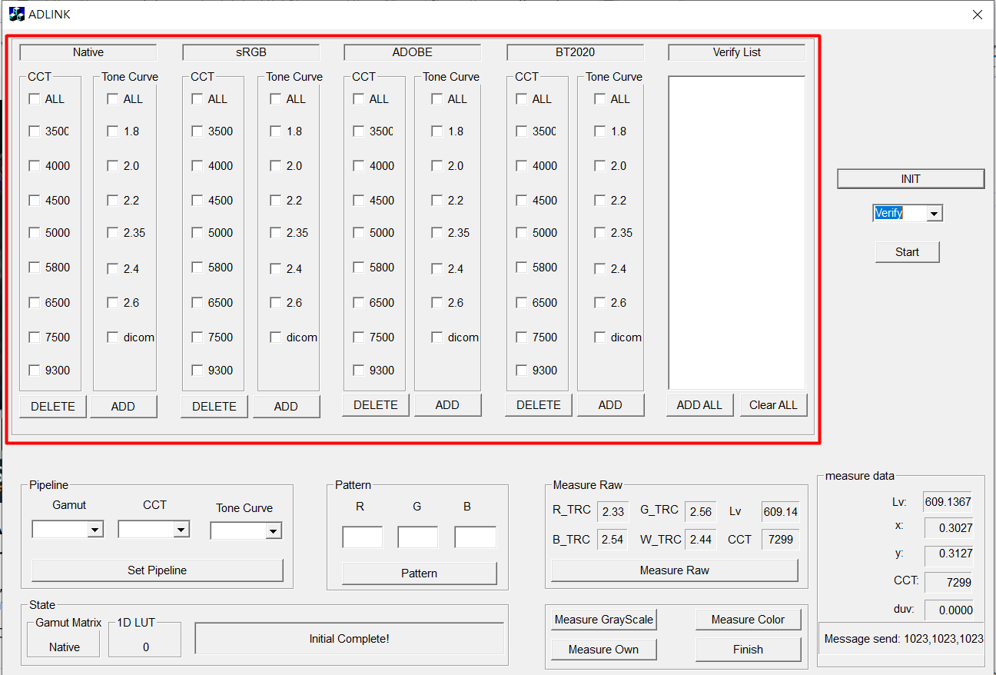

Step2. Select any desired combination of verifications in the condition options area, and click the button ‘ADD’ or button ‘ DELETE’ to update the status of the Verify list

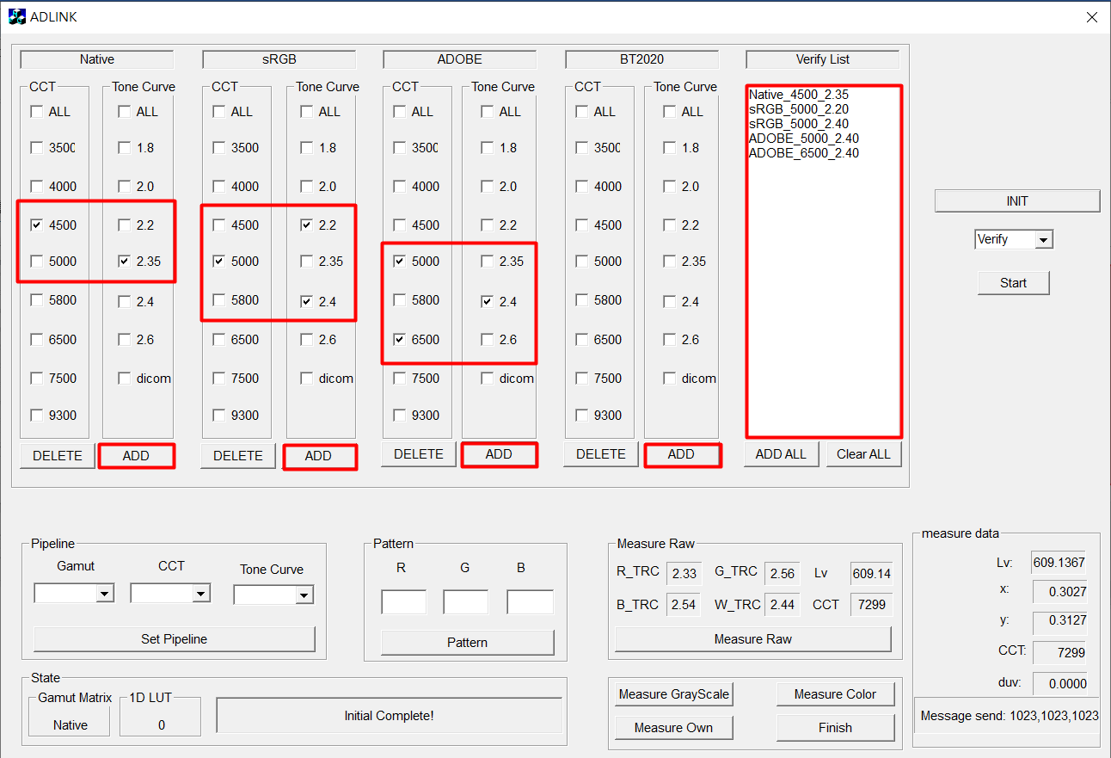

Step3. Click button ‘Start’

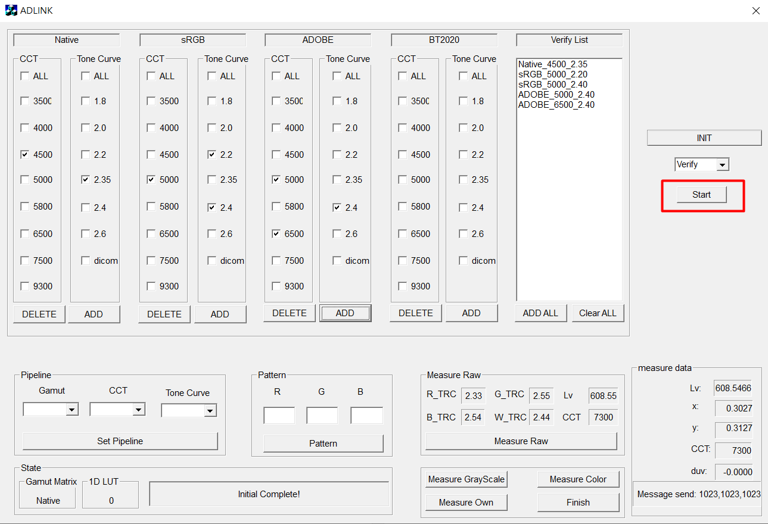

In these places you can get which combination is currently verified.

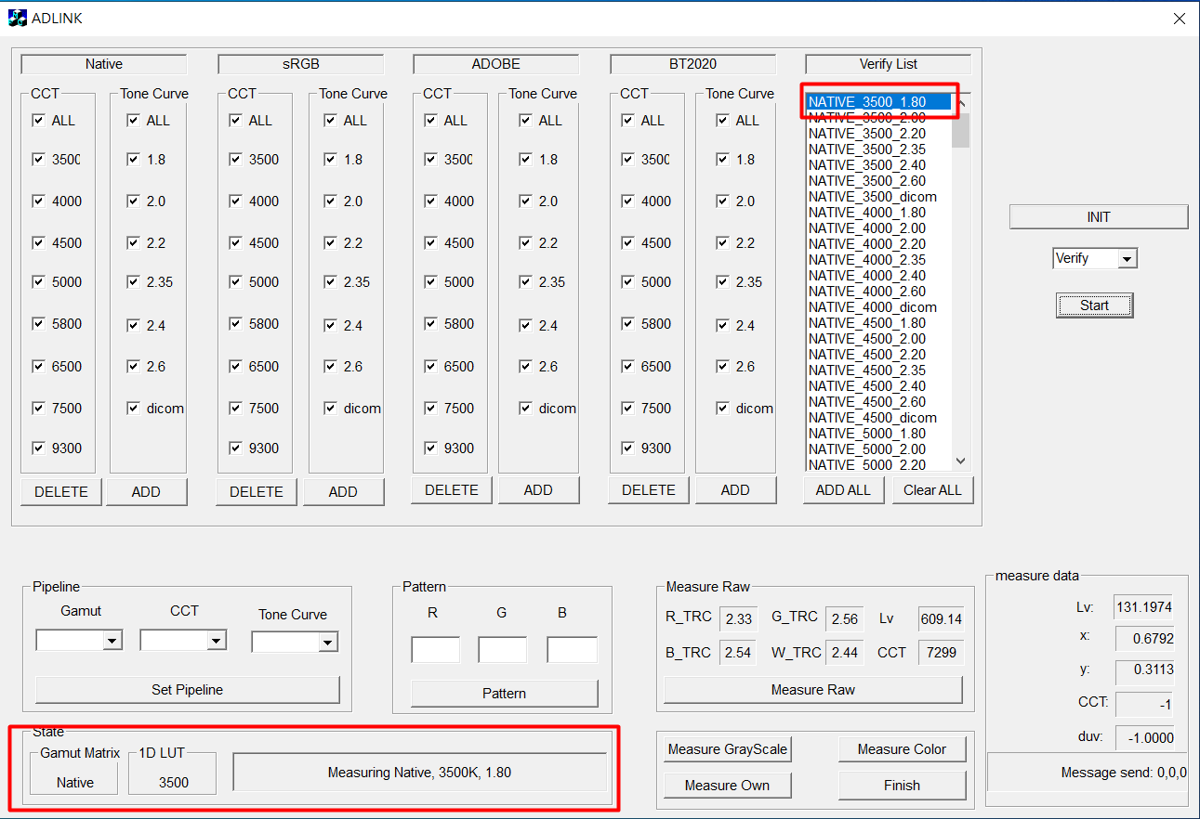

**Function 5. Set Video Pipeline**

Step 1. Select the combination of color gamut, color temperature, and tone curve to be set.

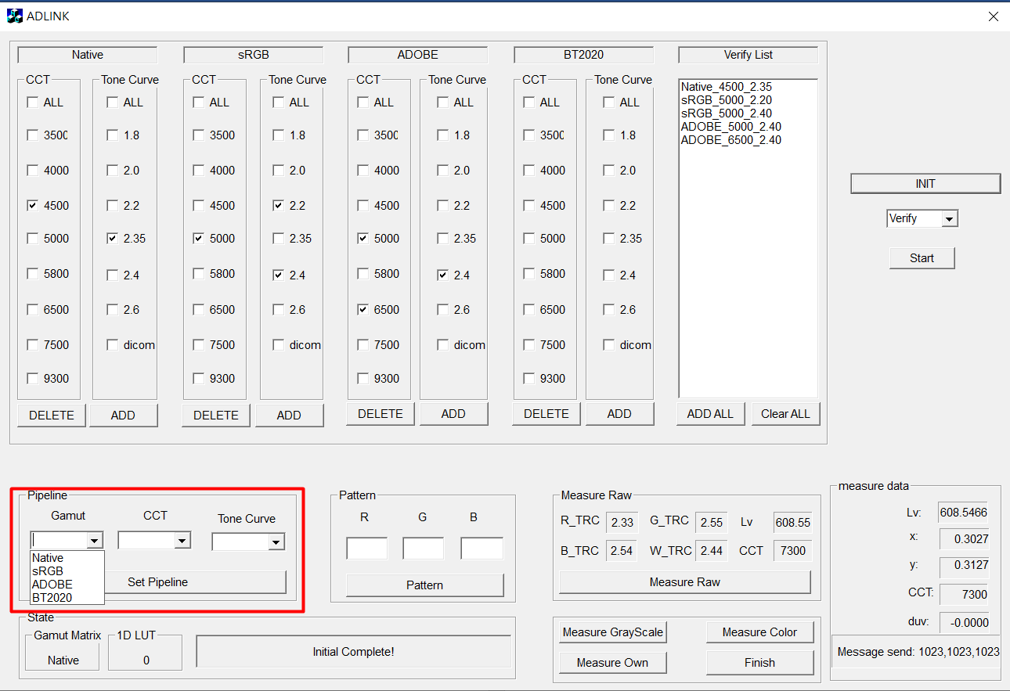

Step2. Click button ‘Set Pipeline’, The panel will be set according to the selected conditions, and will automatically execute ‘Measure Raw’ once.

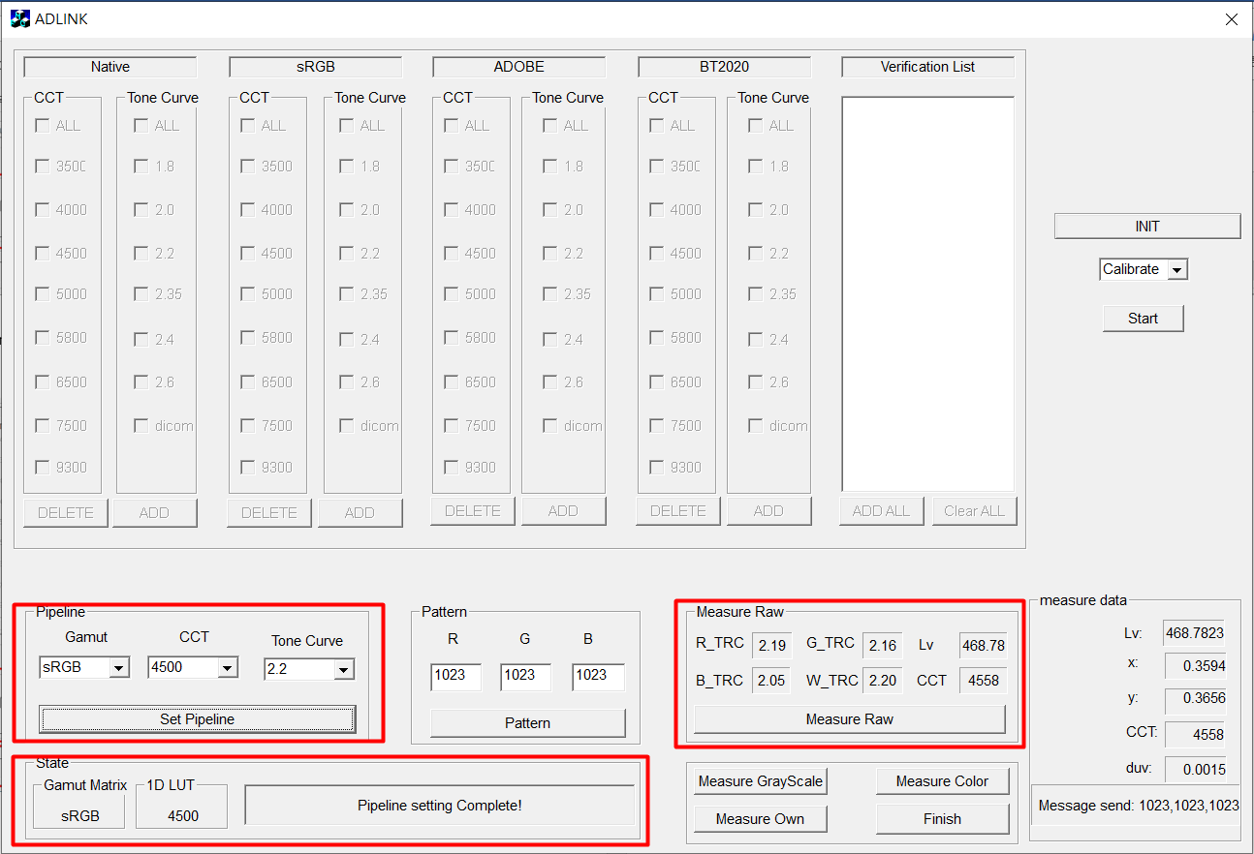

**Function 6. Other Measurement Options**

It can measure the current grayscale、color of the panel or the measurement LUT specified by yourself

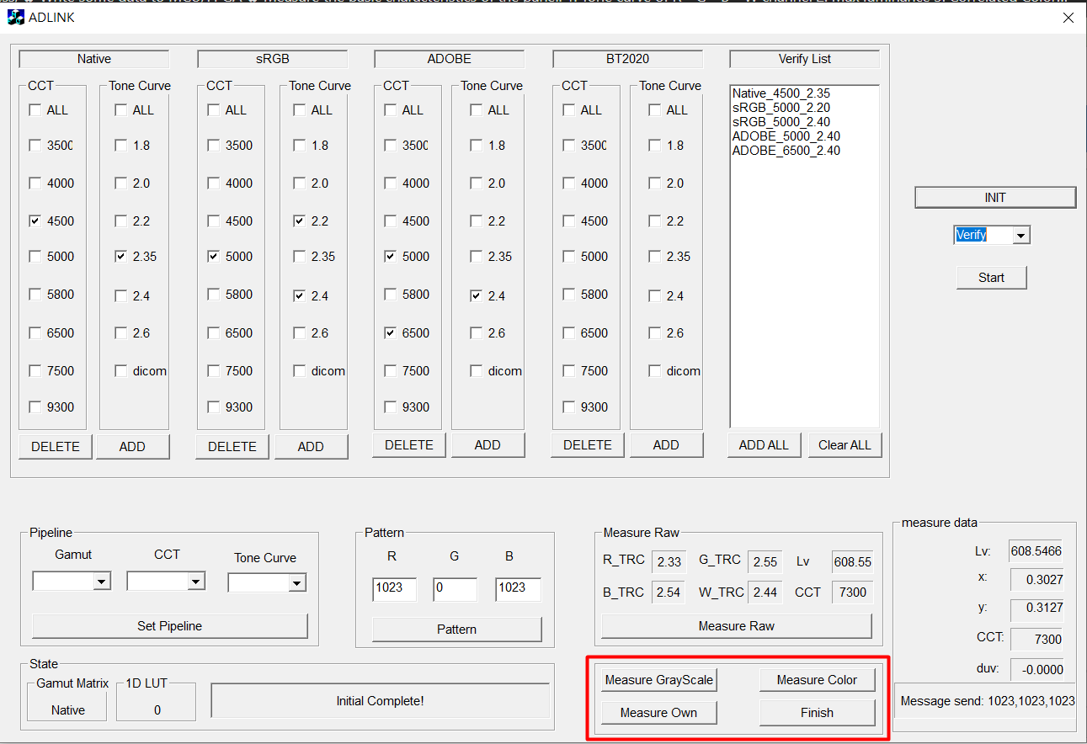

You can customize the LUT to be measured in the directory ‘data’ and name it ‘RGB_Own_LUT.csv’, and the measured results will be recorded in ‘Own.csv’.

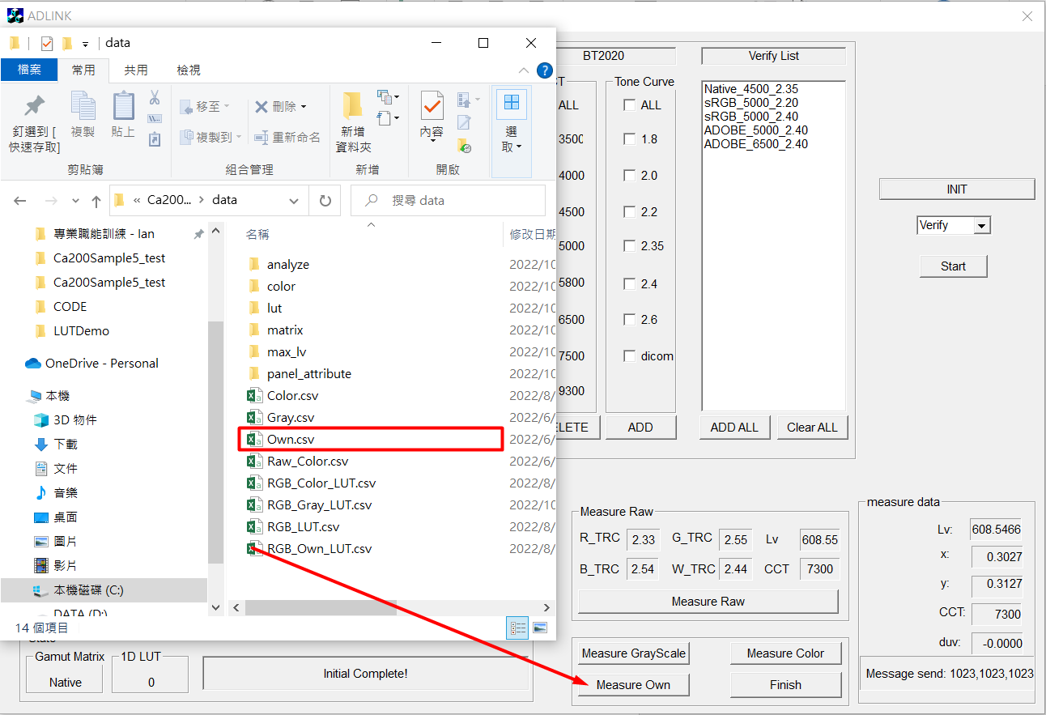

The format of the custom LUT must conform to the following figure: I, R, G, B.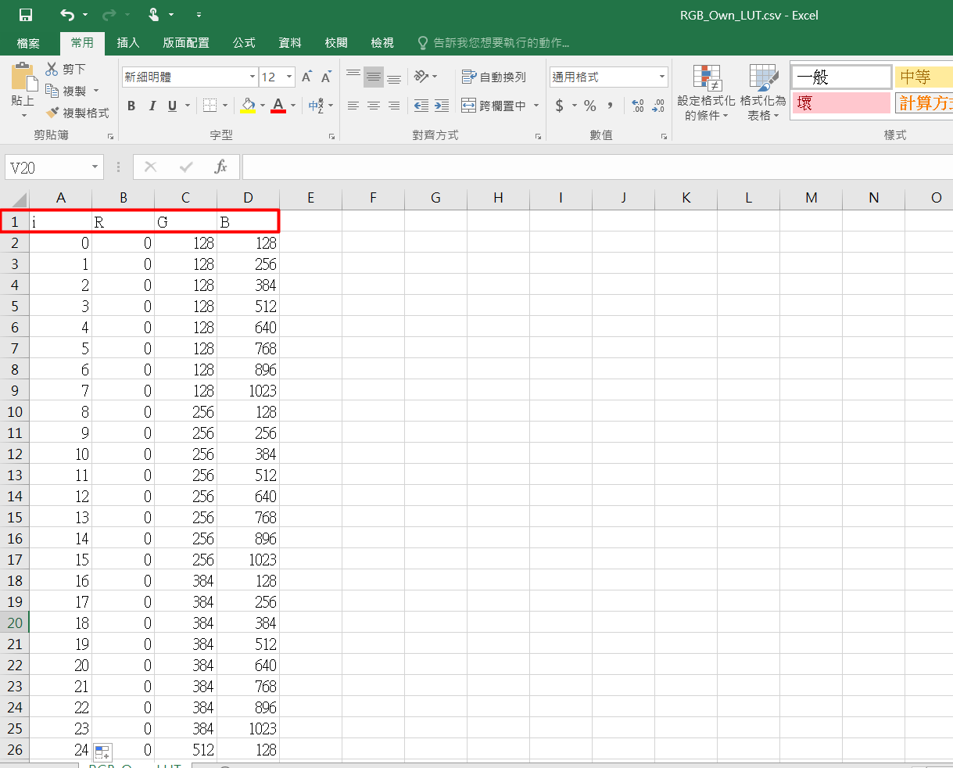

Grayscale and color measurement results will be recorded in

'Gray.CSV' and 'Color.CSV' respectively.

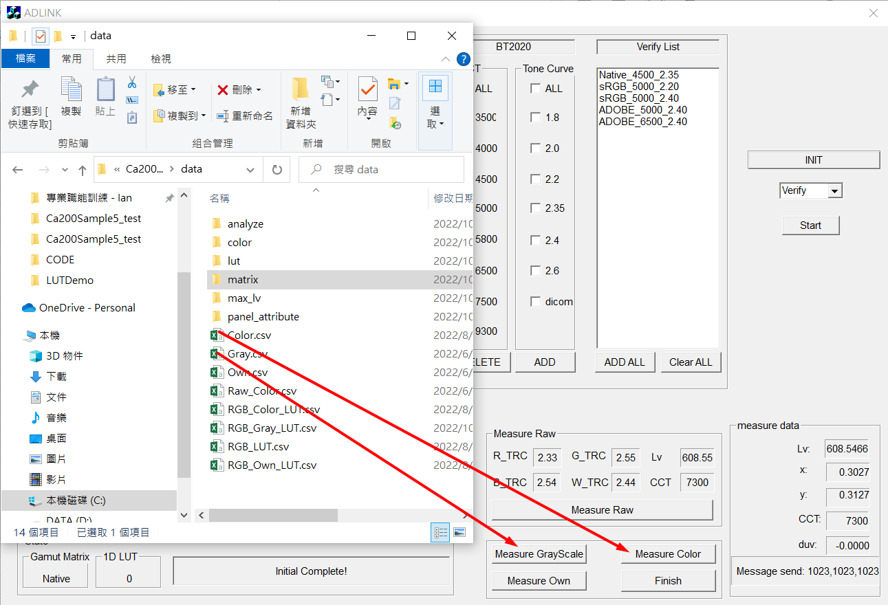

**Function 7. Enable IMAGE Insertion**

If you check "IMAGE", you can use your own image instead of RGB PATTERN.

# You need to connect HDMI first and share the screen synchronously!

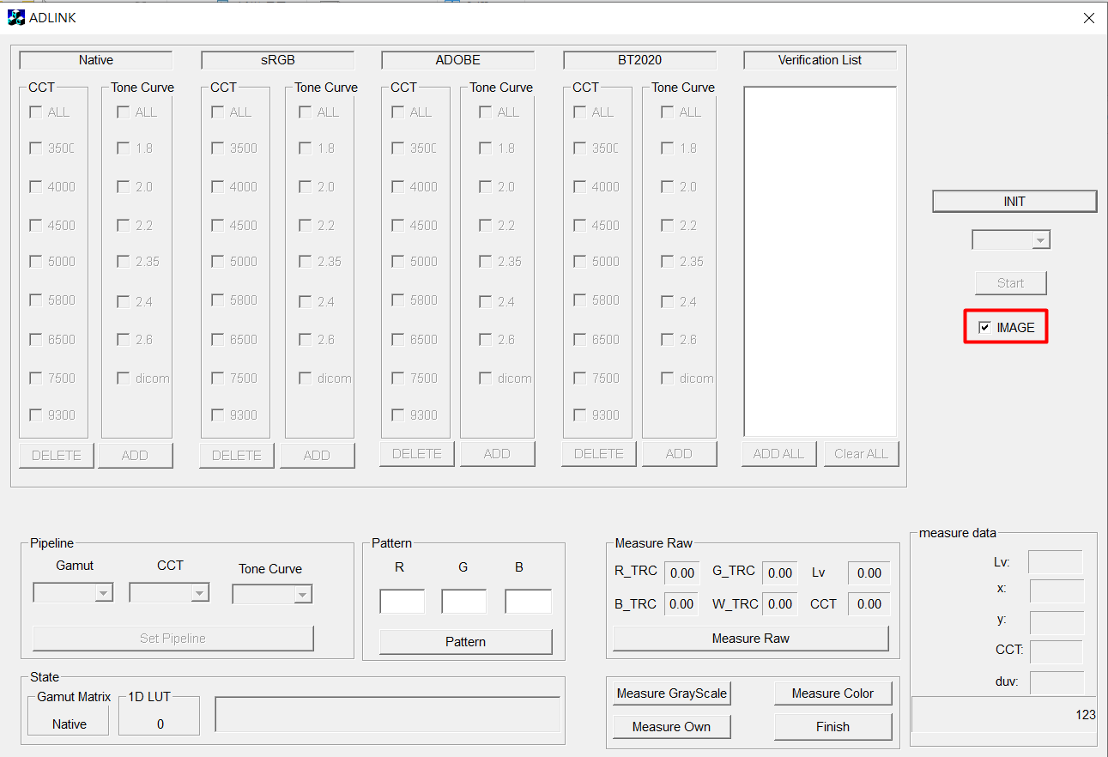

Like this:

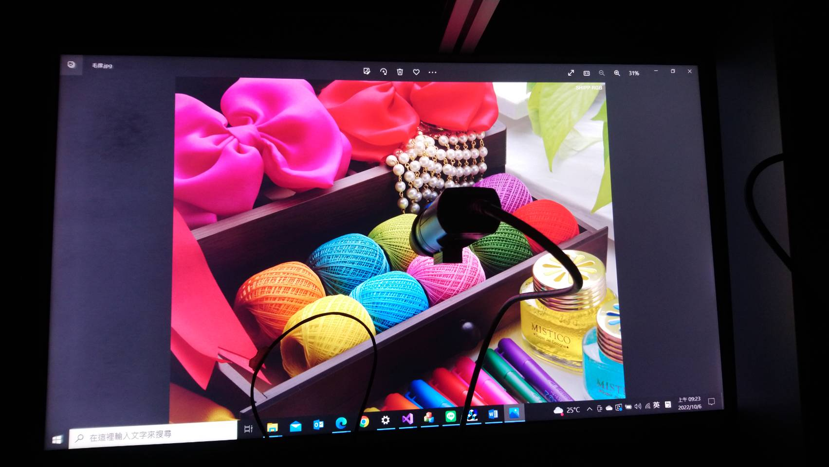

If unchecked, it will switch back to RGB PATTERN mode.

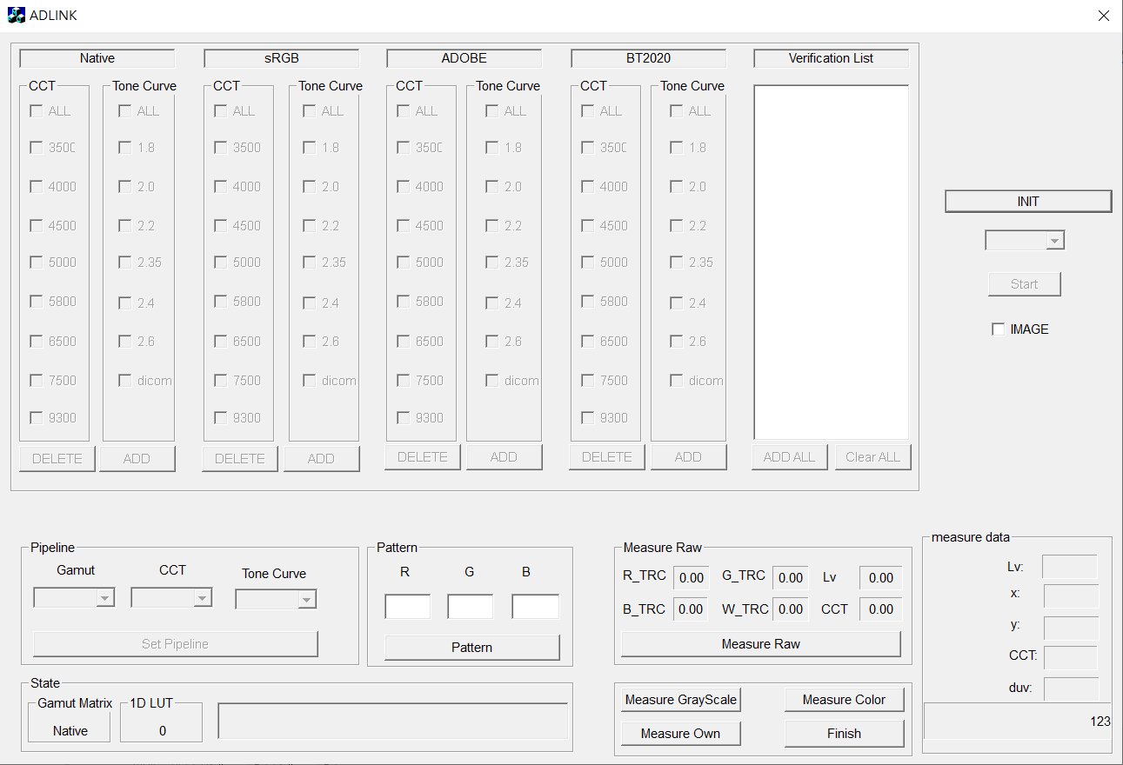

Like this:

