# Monitor Information Monitor Run Time Calibration Date

# AUO X 04/2023

# Measure Condition Color Gamut

# Gamma Curve : 2.2

# Color Gamut: sRGB / Rec. 709

# Measurement Device: Konicaminolta CA-410

**Gamma Curve**

**

Primaries Measurement Table

**Grey-Scale Tracking DICOM (AAPM-TG 270)**

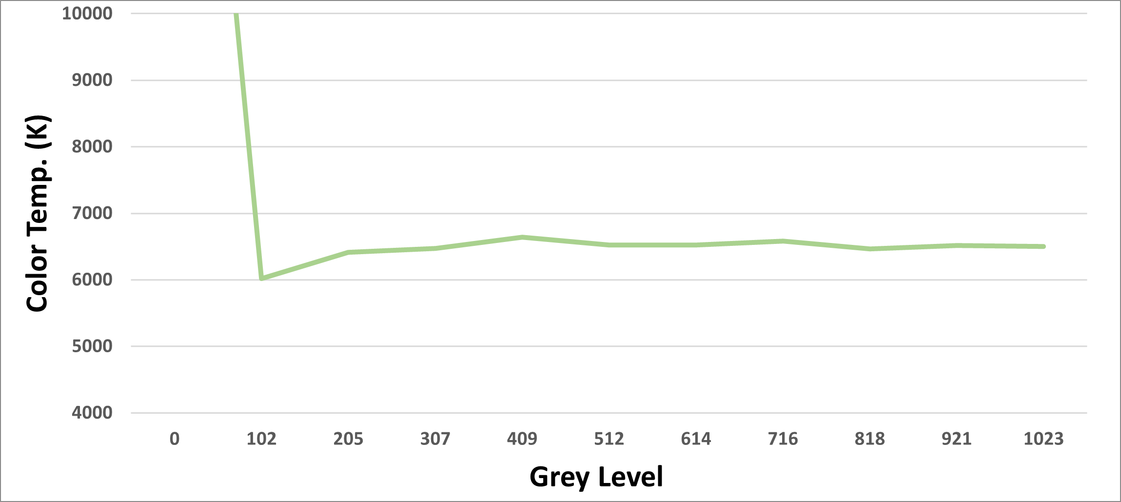 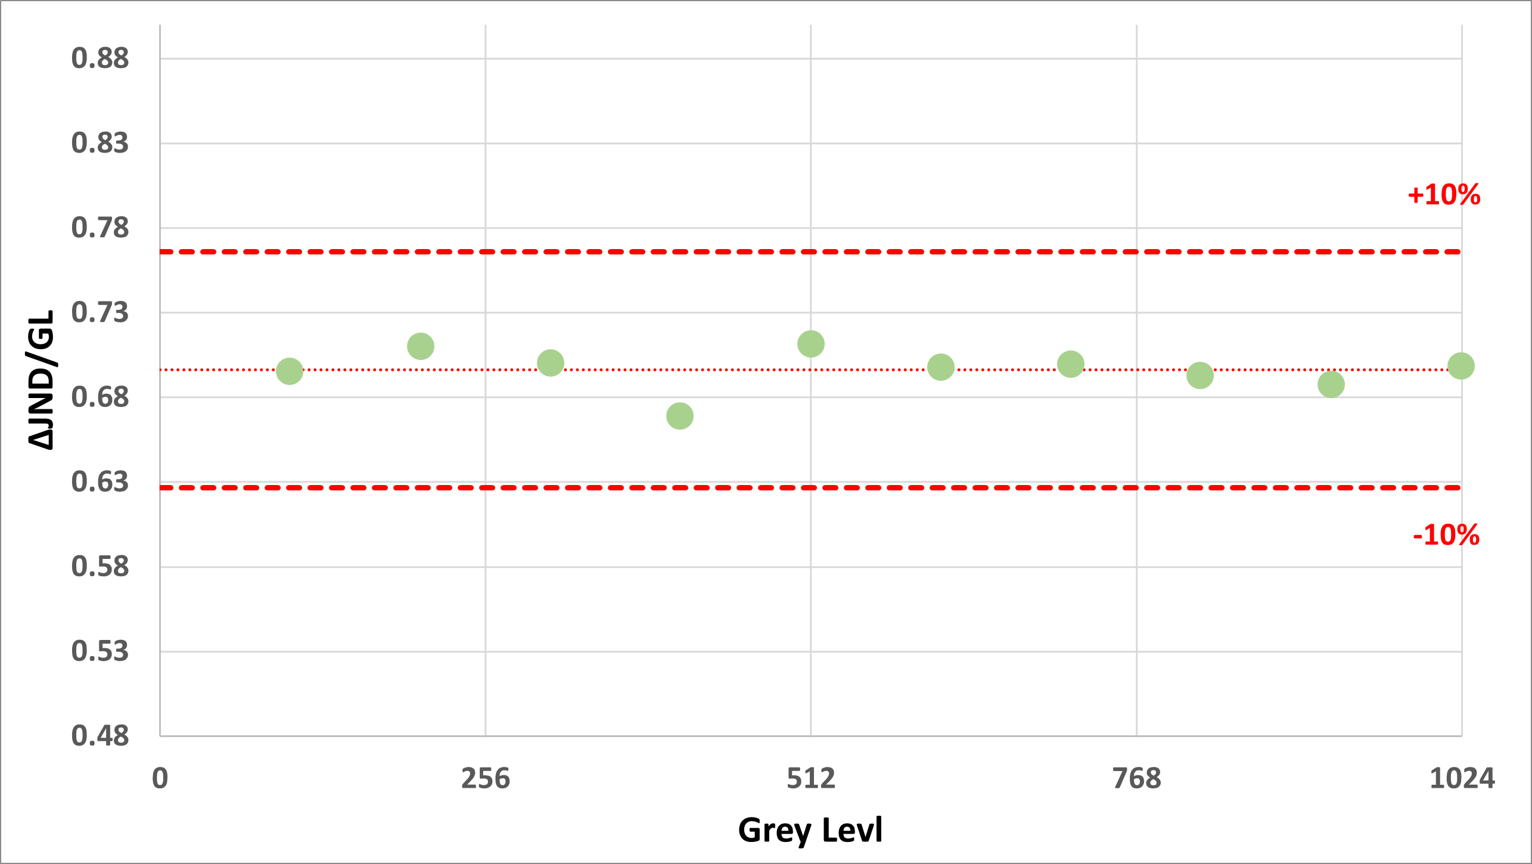

**∆E Measurement Avg. ∆E00 = 0.331**

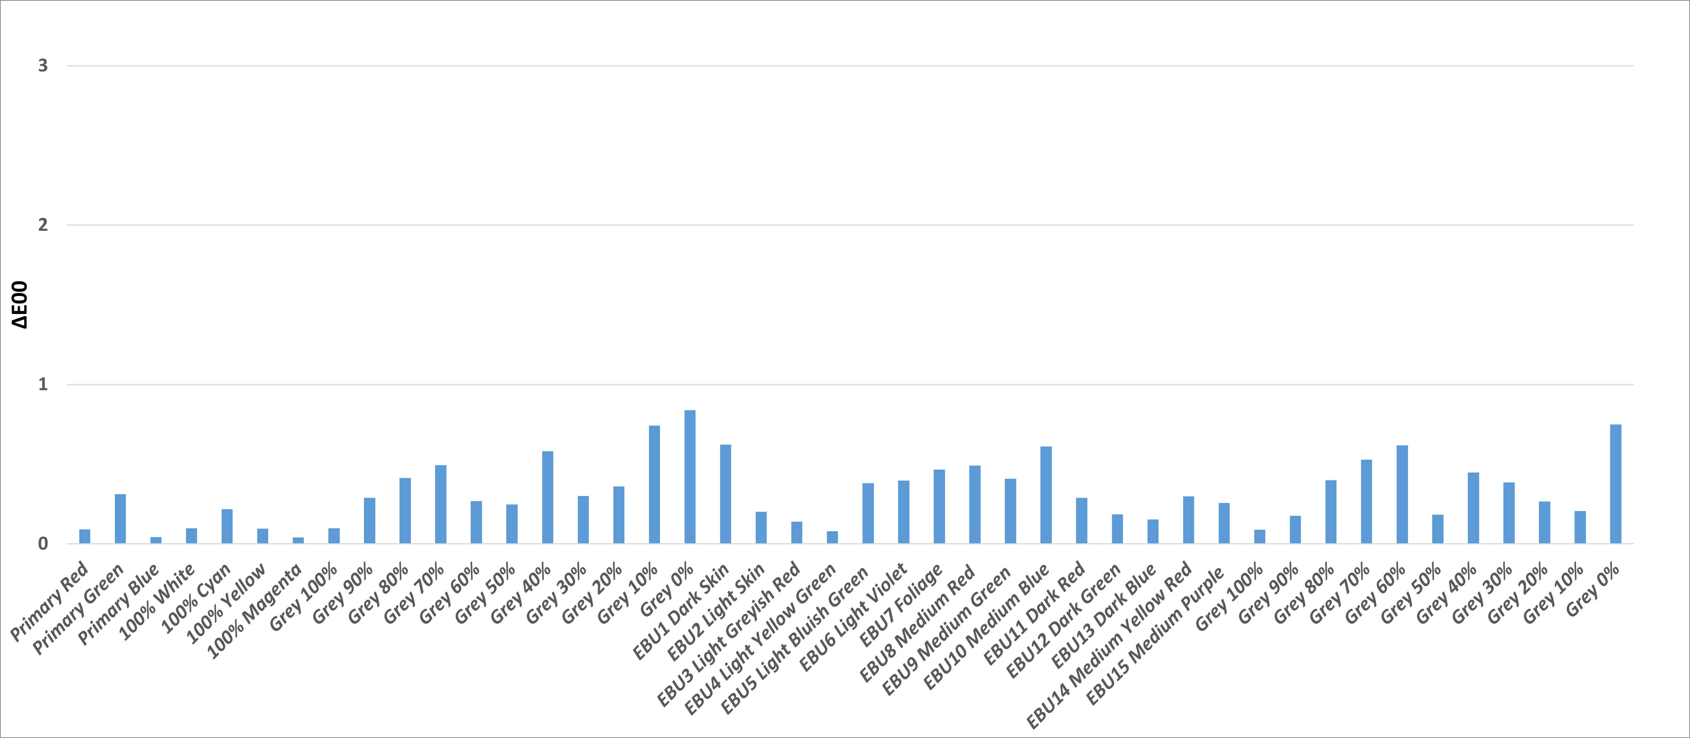

**EBU Color Matching (EBU - TECH 3325)**

* **一張含有 圖表 的圖片

  自動產生的描述**EBU 1 Dark Skin
* EBU 2 Light Skin
* EBU 3 Light Greyish Red
* EBU 4 Light Yellow Green
* EBU 5 Light Bluish Green
* EBU 6 Light Violet
* EBU 7 Foliage
* EBU 8 Medium Red
* EBU 9 Medium Green
* EBU 10 Medium Blue
* EBU 11 Dark Red
* EBU 12 Dark Green
* EBU 13 Dark Blue
* EBU 14 Medium Yellow Red
* EBU 15 Medium Purple

**Results**

|  |  |  |  |  |  |  |
| --- | --- | --- | --- | --- | --- | --- |
| **Color** | **u'** | **v'** |  | **u*v\*** | **E\*** | **E00** |
| Primary Red | 0.4503 | 0.5229 |  | 0.6119 | 0.616 | 0.091 |
| Primary Green | 0.1259 | 0.5628 |  | 1.0556 | 1.0561 | 0.311 |
| Primary Blue | 0.1754 | 0.1576 |  | 0.099 | 0.1118 | 0.043 |
| 100% White | 0.1978 | 0.4685 |  | 0.1051 | 0.1051 | 0.099 |
| 100% Cyan | 0.1382 | 0.4551 |  | 0.6749 | 0.6877 | 0.217 |
| 100% Yellow | 0.2042 | 0.5529 |  | 0.3258 | 0.3262 | 0.096 |
| 100% Magenta | 0.3053 | 0.3296 |  | 0.1268 | 0.1324 | 0.04 |
| Grey 100% | 0.1978 | 0.4685 |  | 0.4547 | 0.8004 | 0.099 |
| Grey 90% | 0.1979 | 0.4682 |  | 0.3868 | 0.6523 | 0.288 |
| Grey 80% | 0.1982 | 0.4687 |  | 0.3108 | 0.4387 | 0.413 |
| Grey 70% | 0.1973 | 0.4679 |  | 0.2907 | 0.2924 | 0.494 |
| Grey 60% | 0.1976 | 0.4685 |  | 0.8555 | 0.856 | 0.269 |
| Grey 50% | 0.1979 | 0.4681 |  | 0.2345 | 0.2588 | 0.248 |
| Grey 40% | 0.1971 | 0.4671 |  | 0.2087 | 0.2629 | 0.581 |
| Grey 30% | 0.1977 | 0.4691 |  | 0.7532 | 0.7593 | 0.301 |
| Grey 20% | 0.1983 | 0.4696 |  | 0.5291 | 0.5549 | 0.36 |
| Grey 10% | 0.2025 | 0.4718 |  | 0.3176 | 0.3435 | 0.744 |
| Grey 0% | 0.1727 | 0.4216 |  | 0.1138 | 0.1139 | 0.84 |
| EBU 1 Dark Skin | 0.2505 | 0.5002 |  | 1.5328 | 1.5678 | 0.623 |
| EBU 2 Light Skin | 0.2371 | 0.4931 |  | 0.4614 | 0.4634 | 0.201 |
| EBU 3 Light Greyish Red | 0.2371 | 0.4854 |  | 0.3626 | 0.3703 | 0.139 |
| EBU 4 Light Yellow Green | 0.1804 | 0.5455 |  | 0.1936 | 0.2022 | 0.081 |
| EBU 5 Light Bluish Green | 0.1638 | 0.4564 |  | 1.0426 | 1.0431 | 0.381 |
| EBU 6 Light Violet | 0.2096 | 0.4167 |  | 1.0464 | 1.0464 | 0.398 |
| EBU 7 Foliage | 0.1828 | 0.5208 |  | 0.7978 | 0.8266 | 0.465 |
| EBU 8 Medium Red | 0.3244 | 0.496 |  | 0.9269 | 0.9377 | 0.492 |
| EBU 9 Medium Green | 0.1515 | 0.5334 |  | 1.1369 | 1.1404 | 0.409 |
| EBU 10 Medium Blue | 0.1775 | 0.3701 |  | 1.1045 | 1.1075 | 0.612 |
| EBU 11 Dark Red | 0.3058 | 0.4906 |  | 0.5933 | 0.6039 | 0.289 |
| EBU 12 Dark Green | 0.146 | 0.5327 |  | 0.4353 | 0.4388 | 0.185 |
| EBU 13 Dark Blue | 0.1833 | 0.343 |  | 0.1918 | 0.2159 | 0.154 |
| EBU 14 Medium Yellow Red | 0.2728 | 0.5271 |  | 0.65 | 0.654 | 0.299 |
| EBU 15 Medium Purple | 0.2338 | 0.4025 |  | 0.8227 | 0.8228 | 0.257 |
| DICOM Grey 100% | 0.1978 | 0.4685 |  | 0.4543 | 0.4543 | 0.089 |
| DICOM Grey 90% | 0.198 | 0.4684 |  | 0.112 | 0.1121 | 0.176 |
| DICOM Grey 80% | 0.1973 | 0.4682 |  | 0.1199 | 0.1818 | 0.399 |
| DICOM Grey 70% | 0.1971 | 0.4677 |  | 0.3111 | 0.3644 | 0.528 |
| DICOM Grey 60% | 0.1968 | 0.4675 |  | 0.4019 | 0.4207 | 0.617 |
| DICOM Grey 50% | 0.1975 | 0.4683 |  | 0.157 | 0.1733 | 0.184 |
| DICOM Grey 40% | 0.1977 | 0.4697 |  | 0.7987 | 0.805 | 0.449 |
| DICOM Grey 30% | 0.199 | 0.4692 |  | 0.746 | 0.7643 | 0.386 |
| DICOM Grey 20% | 0.1982 | 0.4675 |  | 0.4586 | 0.474 | 0.266 |
| DICOM Grey 10% | 0.2 | 0.4698 |  | 0.1793 | 0.188 | 0.207 |
| DICOM Grey 0% | 0.1725 | 0.4218 |  | 0.1051 | 0.1052 | 0.749 |

**Raw Measurement Data**

|  |  |  |  |  |  |  |
| --- | --- | --- | --- | --- | --- | --- |
| **Color** | R | G | B | X | Y | Z |
| Primary Red | 1023 | 0 | 0 | 295.2 | 152.4 | 14 |
| Primary Green | 0 | 1023 | 0 | 259.2 | 515 | 84 |
| Primary Blue | 0 | 0 | 1023 | 129.4 | 51.7 | 681.9 |
| 100% White | 1023 | 1023 | 1023 | 683.2 | 719.2 | 781.5 |
| 100% Cyan | 0 | 1023 | 1023 | 388.3 | 568.4 | 775.3 |
| 100% Yellow | 1023 | 1023 | 0 | 554.2 | 667 | 99.5 |
| 100% Magenta | 1023 | 0 | 1023 | 425.9 | 204.4 | 696.5 |
| Grey 100% | 1023 | 1023 | 1023 | 683.2 | 719.2 | 781.5 |
| Grey 90% | 921 | 921 | 921 | 544.8 | 572.9 | 624.9 |
| Grey 80% | 818 | 818 | 818 | 416.3 | 437.4 | 474.1 |
| Grey 70% | 716 | 716 | 716 | 310.2 | 327 | 358.3 |
| Grey 60% | 614 | 614 | 614 | 220.6 | 232.5 | 252.8 |
| Grey 50% | 512 | 512 | 512 | 148.5 | 156.1 | 170.4 |
| Grey 40% | 409 | 409 | 409 | 91 | 95.8 | 106 |
| Grey 30% | 307 | 307 | 307 | 48.2 | 50.8 | 54.8 |
| Grey 20% | 205 | 205 | 205 | 19.4 | 20.4 | 21.9 |
| Grey 10% | 102 | 102 | 102 | 3.9 | 4.1 | 4.2 |
| Grey 0% | 0 | 0 | 0 | 0.5 | 0.5 | 0.9 |
| EBU1 Dark Skin | 465 | 319 | 257 | 76.4 | 67.8 | 42.2 |
| EBU2 Light Skin | 813 | 613 | 529 | 293.6 | 271.5 | 196.3 |
| EBU3 Light Greyish Red | 733 | 547 | 509 | 234.9 | 213.7 | 174.1 |
| EBU4 Light Yellow Green | 519 | 633 | 212 | 159.5 | 214.4 | 53.9 |
| EBU5 Light Bluish Green | 395 | 629 | 650 | 173.4 | 214.7 | 280 |
| EBU6 Light Violet | 646 | 553 | 776 | 245.4 | 216.8 | 395.1 |
| EBU7 Foliage | 361 | 435 | 261 | 75.3 | 95.4 | 47.4 |
| EBU8 Medium Red | 792 | 345 | 338 | 202.7 | 137.8 | 76.9 |
| EBU9 Medium Green | 413 | 784 | 389 | 200.9 | 314.4 | 129.2 |
| EBU10 Medium Blue | 370 | 446 | 727 | 133.9 | 124.1 | 340.8 |
| EBU11 Dark Red | 462 | 224 | 229 | 66 | 47.1 | 30.5 |
| EBU12 Dark Green | 262 | 554 | 280 | 88.6 | 143.7 | 61.2 |
| EBU13 Dark Blue | 239 | 265 | 498 | 52.3 | 43.5 | 145.6 |
| EBU14 Medium Yellow Red | 976 | 619 | 320 | 364.4 | 312.9 | 94.9 |
| EBU15 Medium Purple | 628 | 416 | 673 | 188 | 143.9 | 290.4 |
| Grey 100% | 1023 | 1023 | 1023 | 683.1 | 719.1 | 781.5 |
| Grey 90% | 921 | 921 | 921 | 425 | 446.9 | 485.9 |
| Grey 80% | 818 | 818 | 818 | 261.6 | 275.9 | 301 |
| Grey 70% | 716 | 716 | 716 | 159.5 | 168.2 | 184.8 |
| Grey 60% | 614 | 614 | 614 | 94.7 | 100 | 110.1 |
| Grey 50% | 512 | 512 | 512 | 54.8 | 57.7 | 62.9 |
| Grey 40% | 409 | 409 | 409 | 29.6 | 31.2 | 33.5 |
| Grey 30% | 307 | 307 | 307 | 15.7 | 16.5 | 17.7 |
| Grey 20% | 205 | 205 | 205 | 7.1 | 7.5 | 8.2 |
| Grey 10% | 102 | 102 | 102 | 2.5 | 2.6 | 2.8 |
| Grey 0% | 0 | 0 | 0 | 0.5 | 0.5 | 0.9 |