Color analyze

**Step 1: Establishing a Test LUT.**

Usually, you can skip the step of generating LUT and directly use the values in LUT.csv, unless you need to modify the RGB values of the pattern.

1.1 Execute “EBU_analyze.py”, and enter "1" when the program starts to generate the LUT.



2.2 Then the corresponding RGB values will be generated and stored in "LUT.csv".

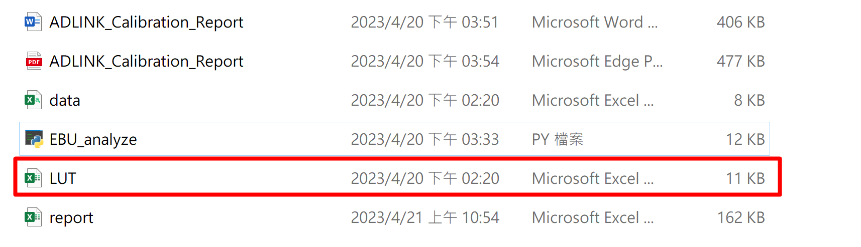

**Step 2: Measure Data.**

Use the RGB values of the test LUT as input to measure the data. It is important to note that there are two parts of gray RGB in the LUT, which are gamma and DICOM modes. The corresponding panel settings must be provided for each mode.

**Step 3: Fill in the test data in the default verification file "data.csv".**

The left side is the original panel data and the right side is the corrected data. If there is no need for comparison, the original data can be ignored.

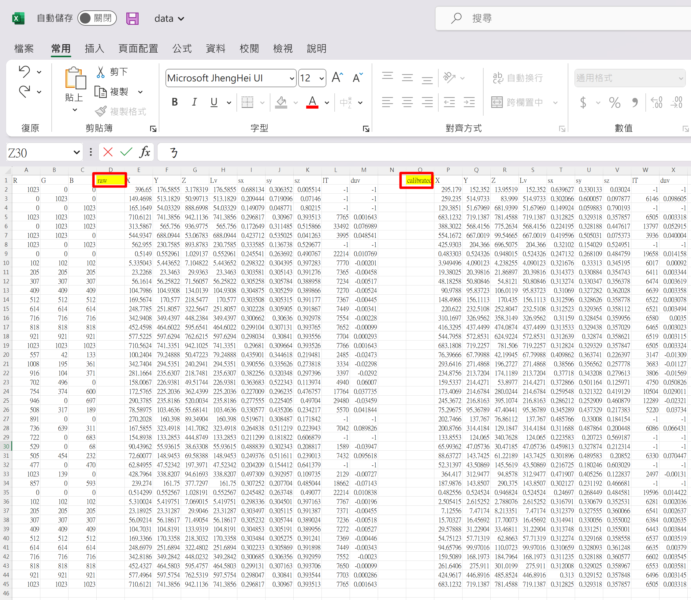

**Step 4. Analyze.**

4.1 Execute “EBU_analyze.py” and enter "2" when the program starts to perform the analysis and generate a report.



4.2 The results will be saved in "report.csv".

There are 5 tabs in the file.

"Data" contains the original data provided by the user.

"Data_Inverse_Sort" and "DICOM_DATA" are intermediate processing data and have no meaning.

"Gamma & EBU Color" and "DICOM" contain graphical analysis data.



**Step 5. Generate formal report.**

Finally, you can refer to the "IB" format to import data and graphical analysis into Word or other editors and save it as a PDF file.

