Where to find All Text-Edit-able places

# 1. As seen from How-to-edit-text-quick.docx, #1 is already covered:

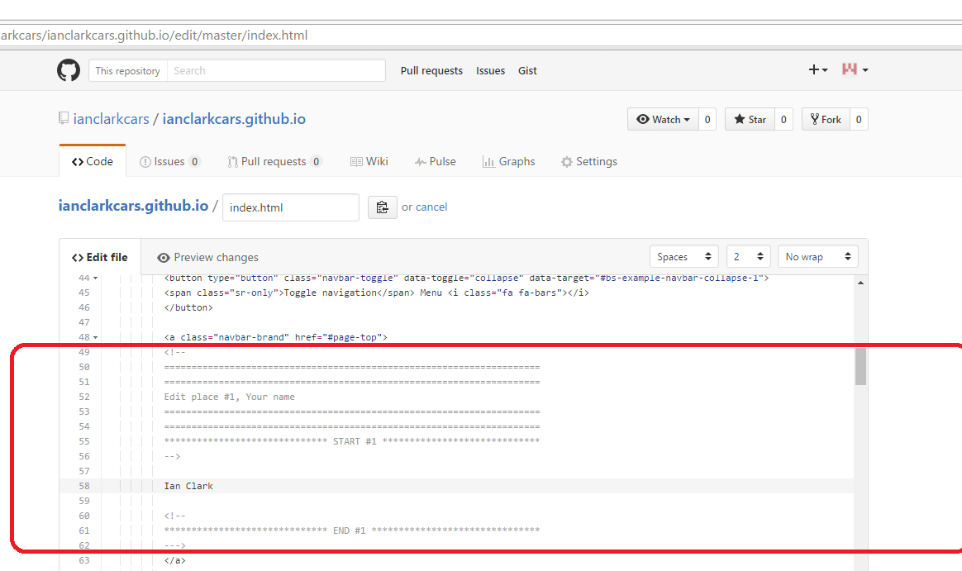

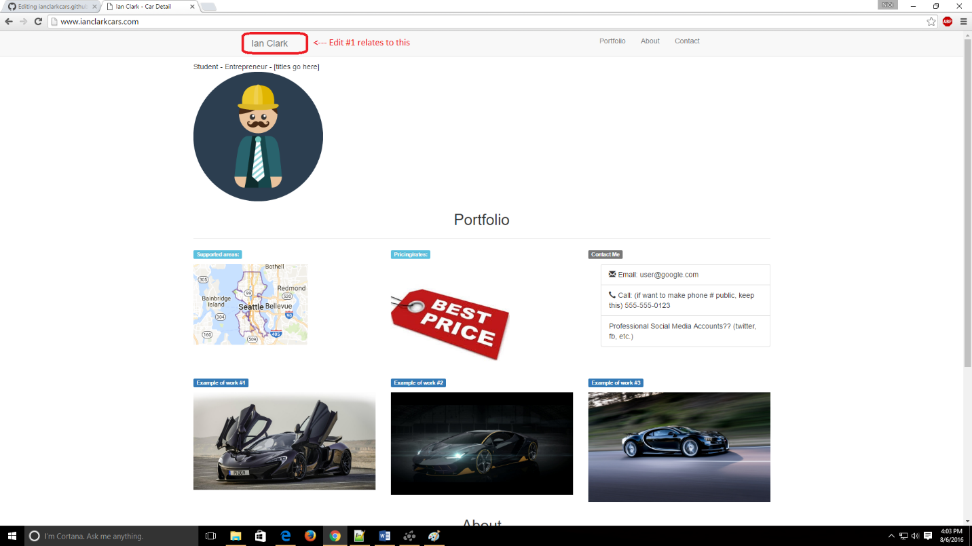

# 2. Name again

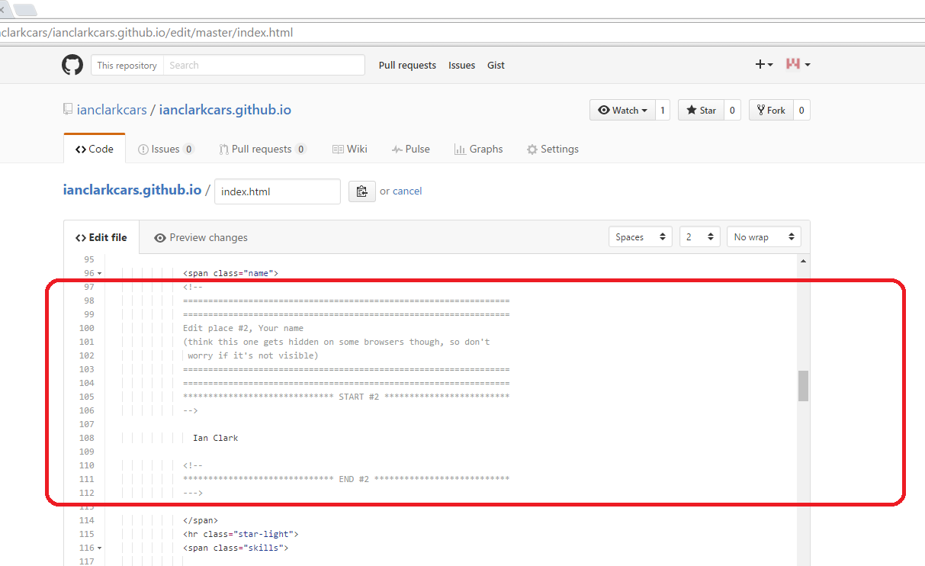

(Where it’s hidden, at least in my web browser)

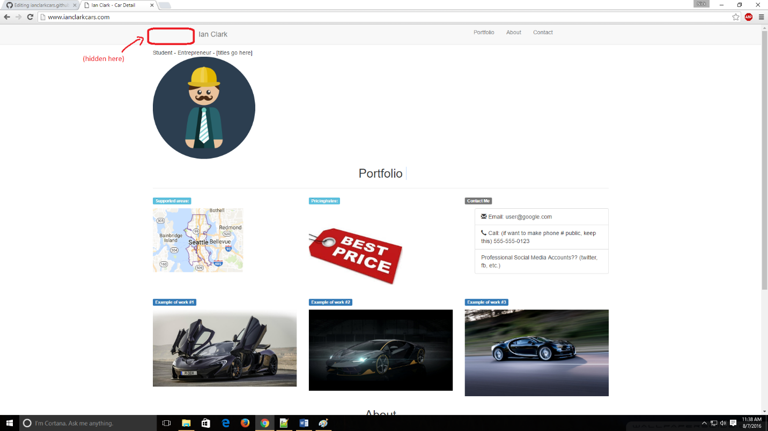

# 3. Titles

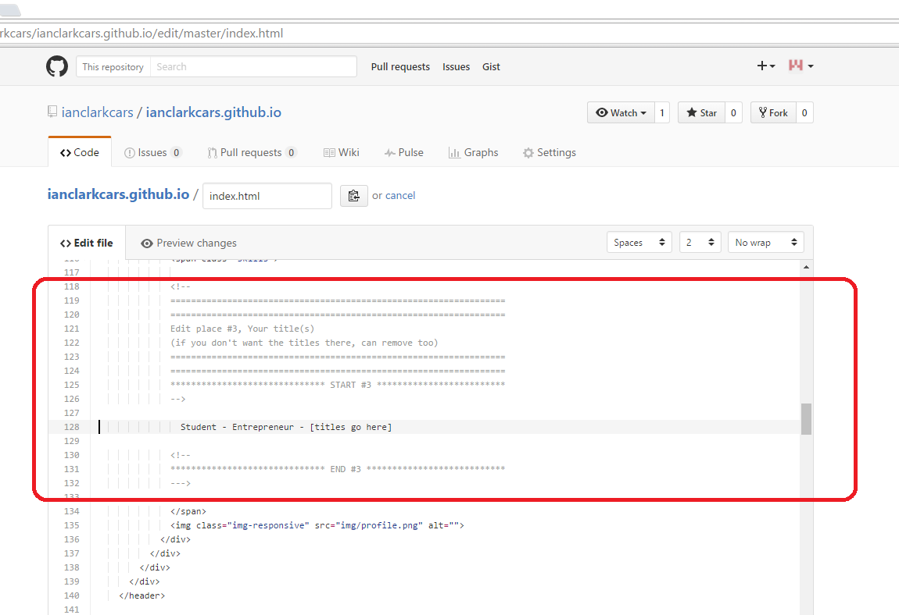

(Can just delete the lines if you don’t want titles on your web page, below is where they appear)

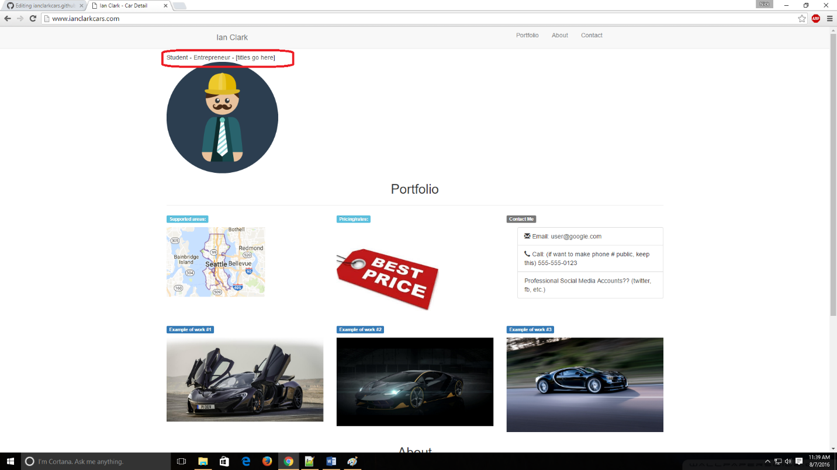

# 4. Box/Tile # 1 (row 1, col 1)

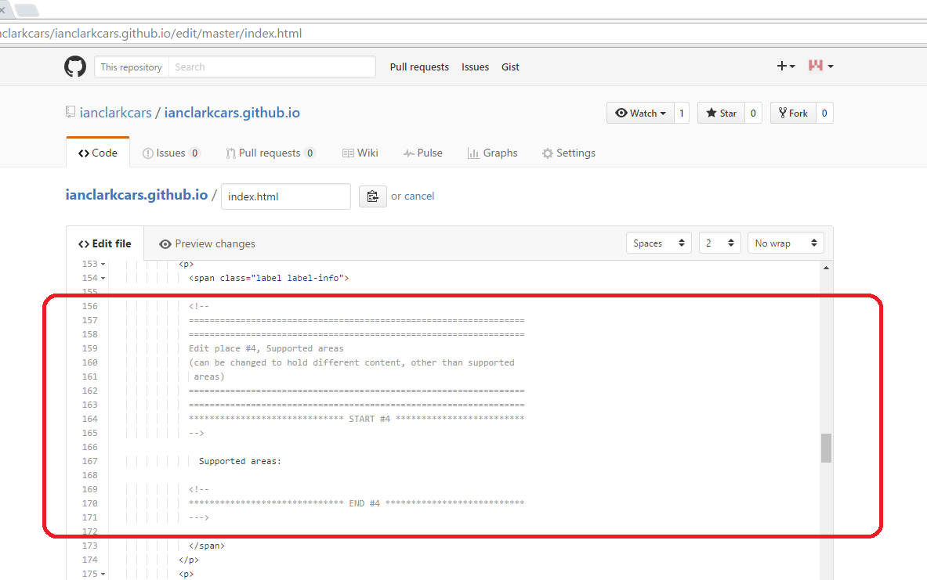

(Relates to this area on website)

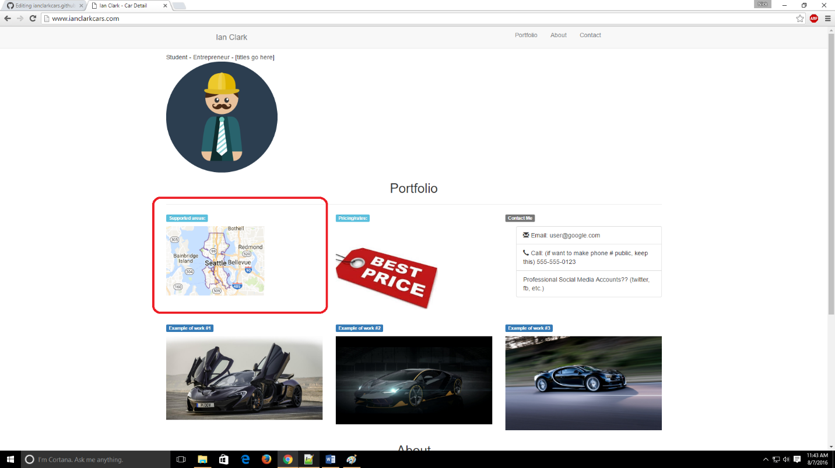

# 5. Box/Tiles # 2 (row 1, col 2)

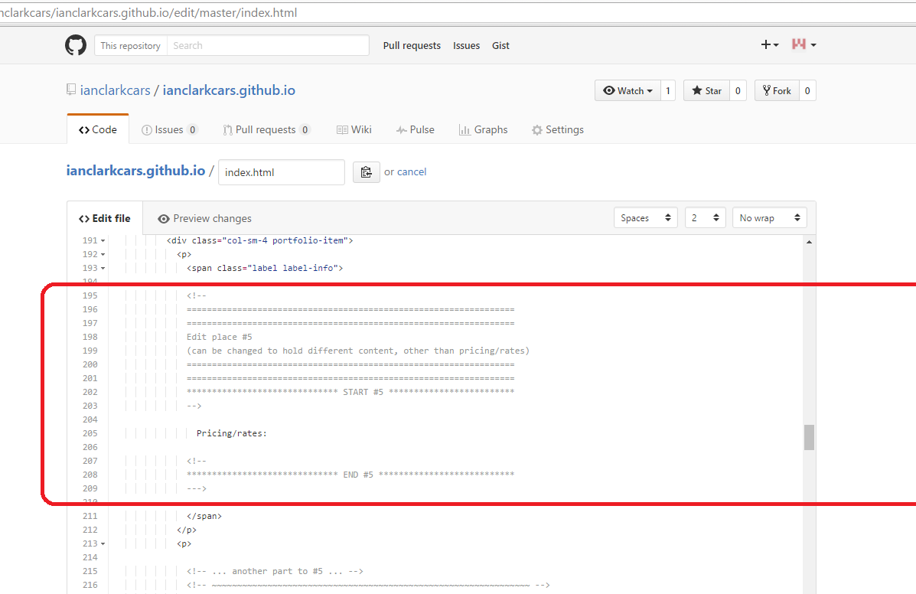

(Relates to this area on website)

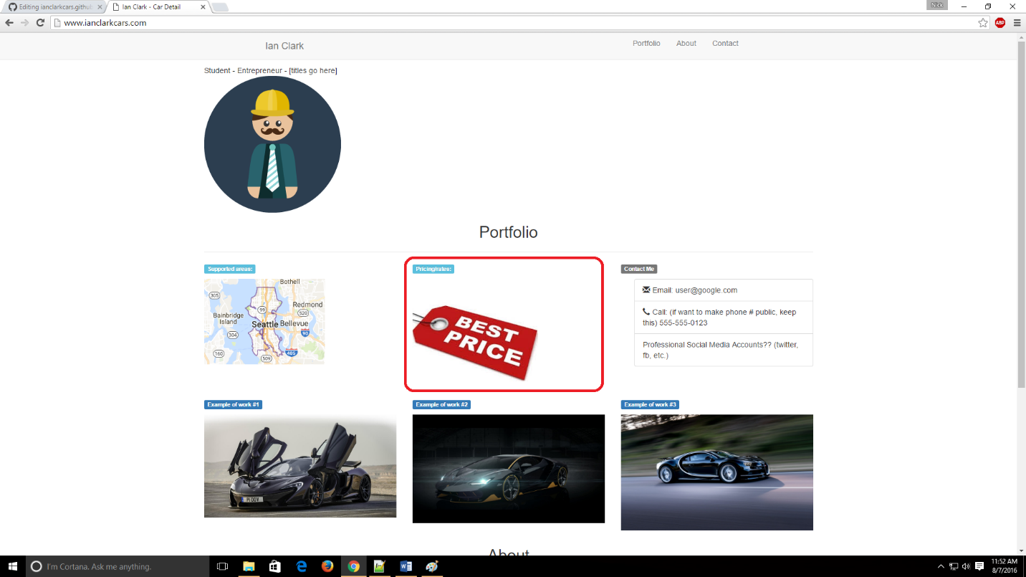

# 6. Box/Tile # 3 (row 1, col 3)

-<insert contact me screen shots>

# 7. Box/Tile #4 (row 2, col 1)

-<insert example of work #1 / McLaren here>

# 8. Box/Tile #5 (row 2, col 2)

-<insert example of work #2 / Lamborghini here>

# 9. Box/Tile #6 (row 2, col 3)

-<insert example of work #3 / Bugatti here>

# 10. About…

11. Contact

12. Location