How to Edit Text (Quick)

# 1. Go to https://github.com/ianclarkcars/

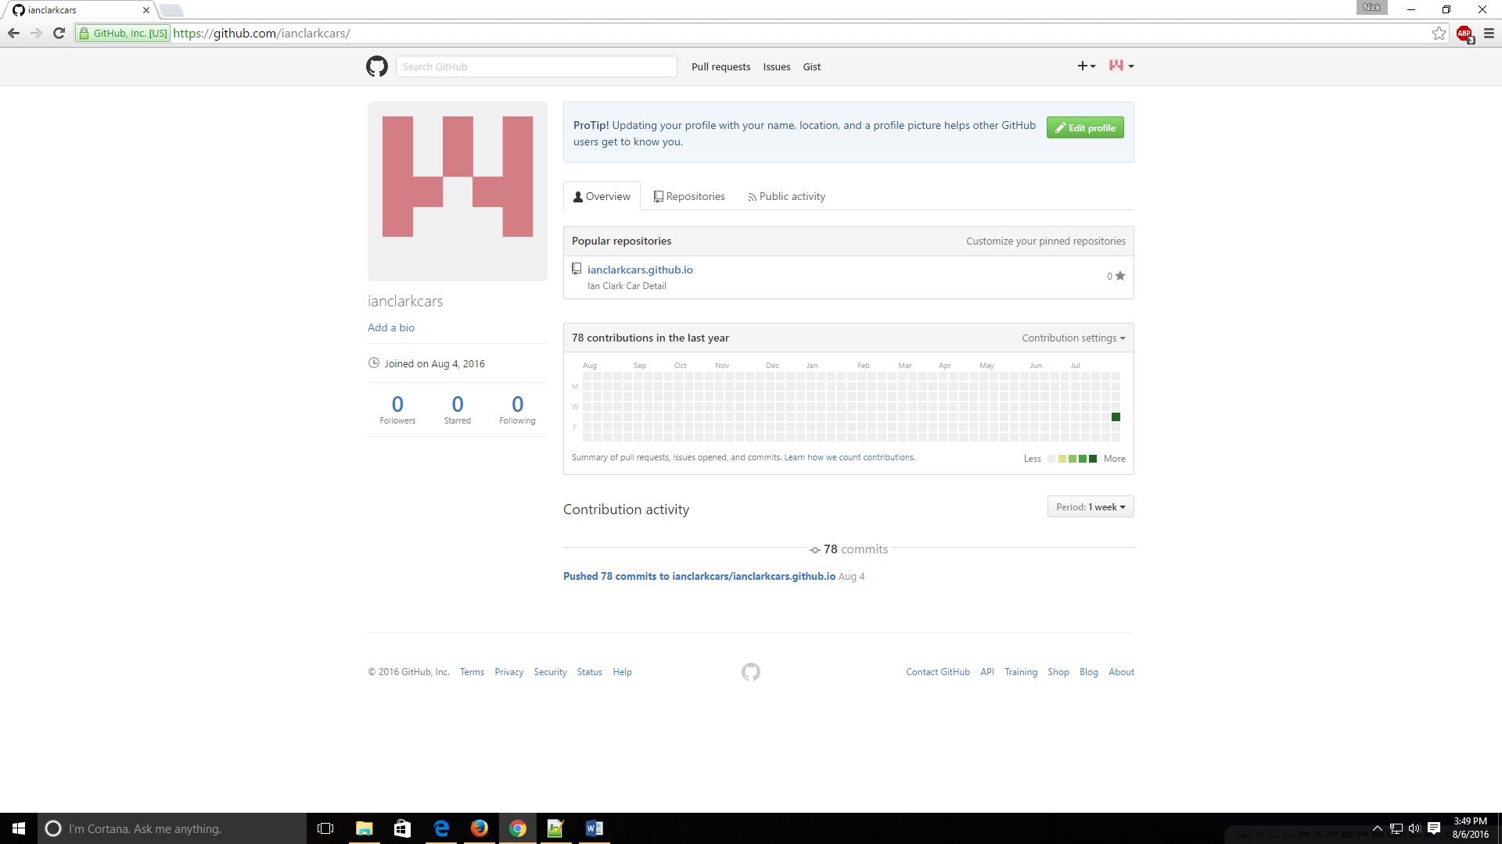

(Should look something like this page)

# 2. Click on your website project (see the red circle)

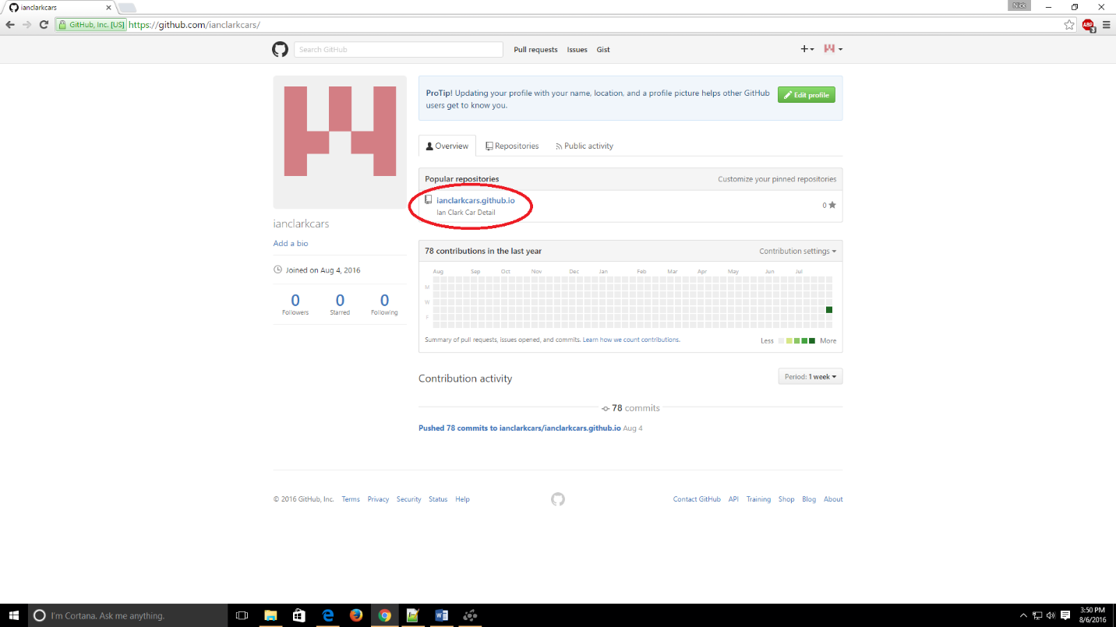

(Could also just skip step 1 and go to this link from now on, https://github.com/ianclarkcars/ianclarkcars.github.io)

# 3. Click on the index.html file (see the red circle)

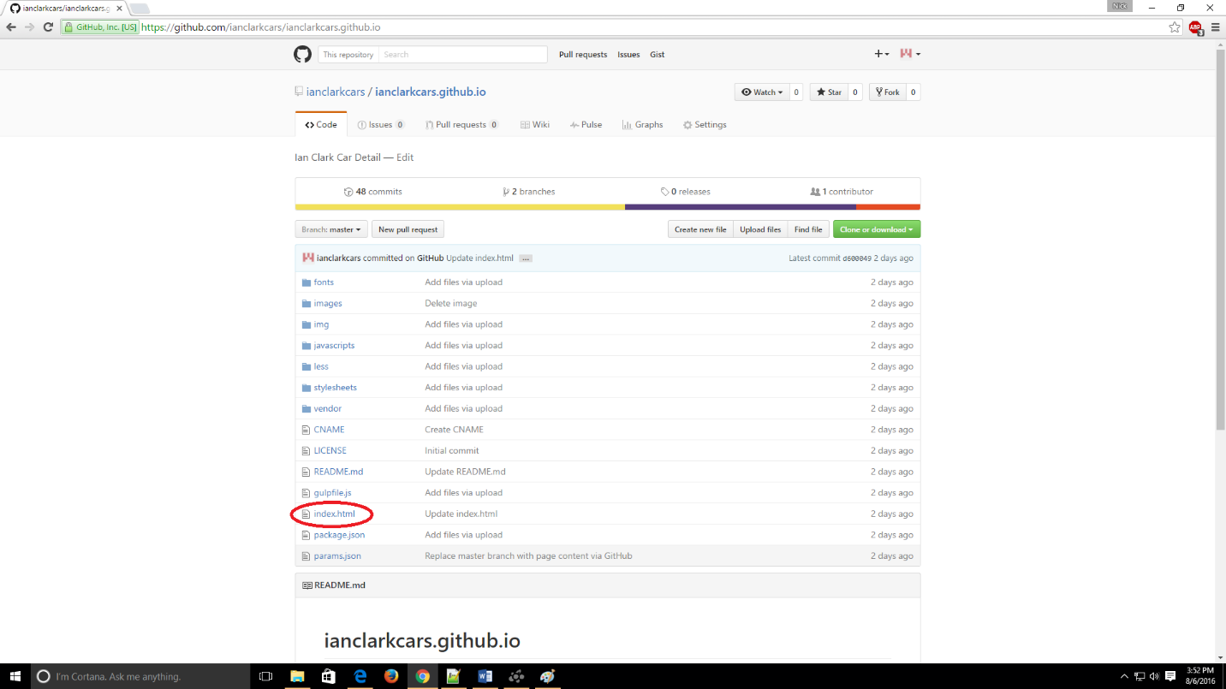

(This file, index.html, is what counts the most because it’s the source of your website’s front page)

# 4. You should be looking at the file on github (see below picture)

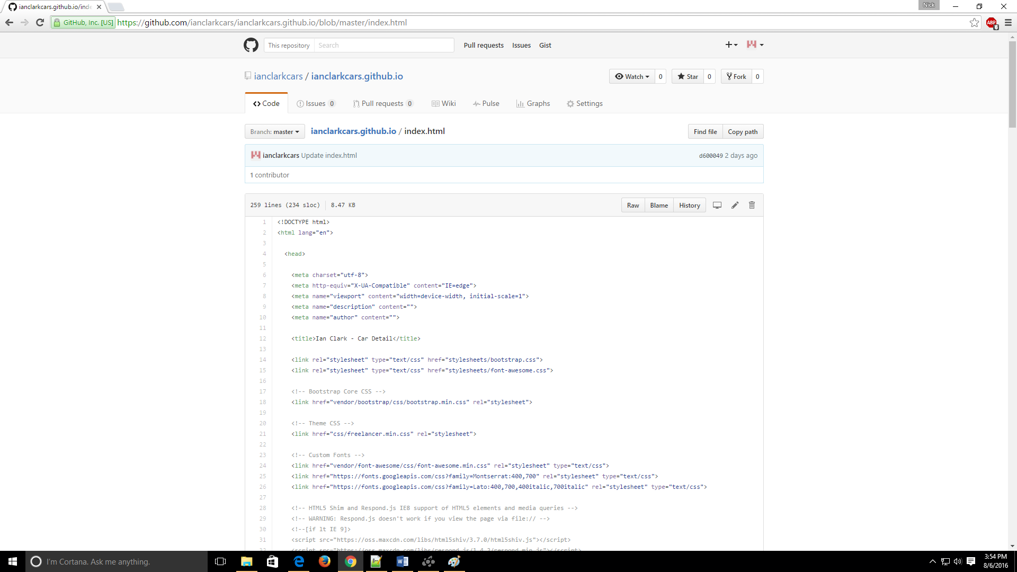

(It should look something like this)

# 5. Hit the edit button (aka the pencil icon in the red circle)

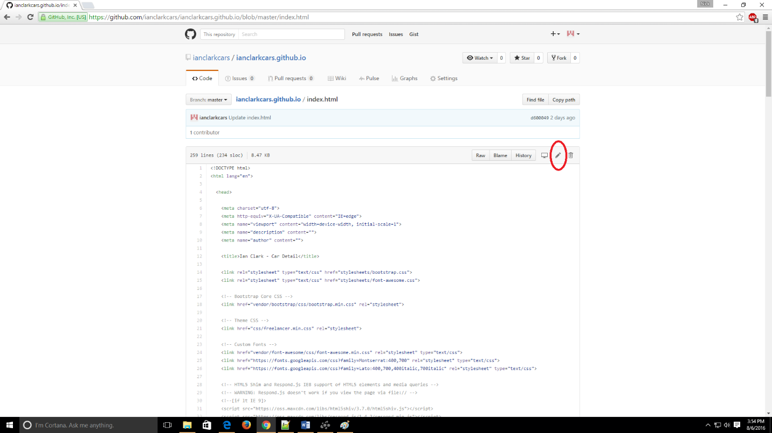

# 6. You should be looking at the same index.html file on github but now in an editor

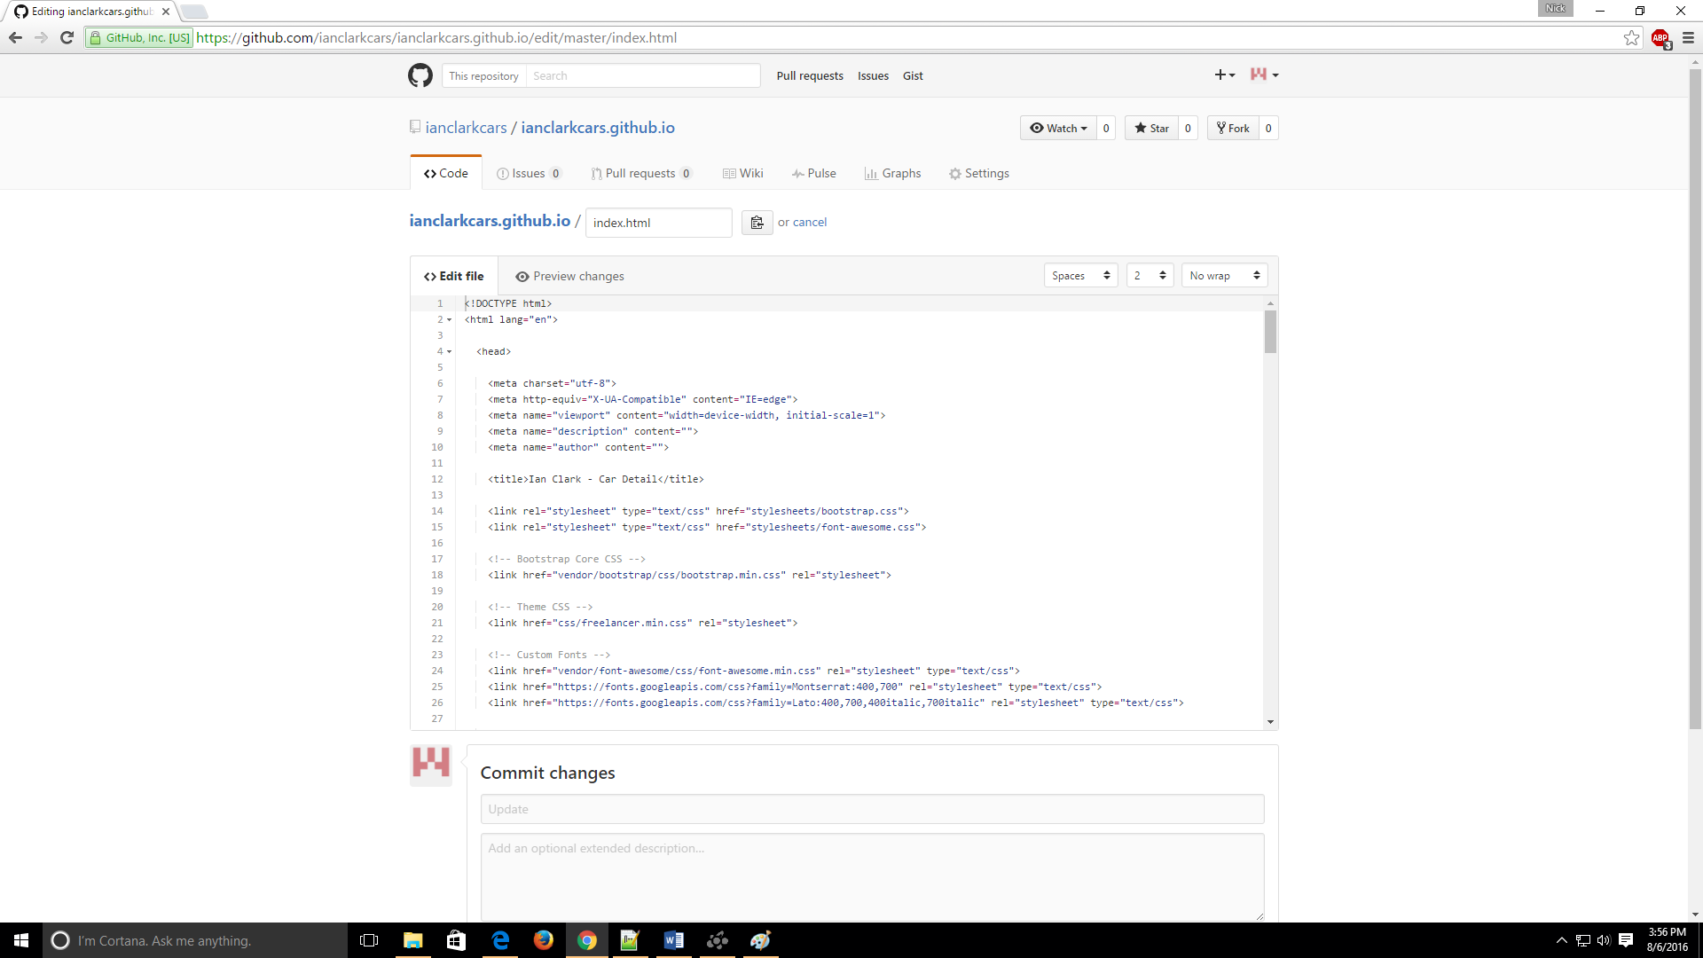

(the editor should look something like this)

# 7. Find the parts of code blocks in the editor that I marked off to help find where you should edit text that in turn edits the text as seen on the main site page of your website

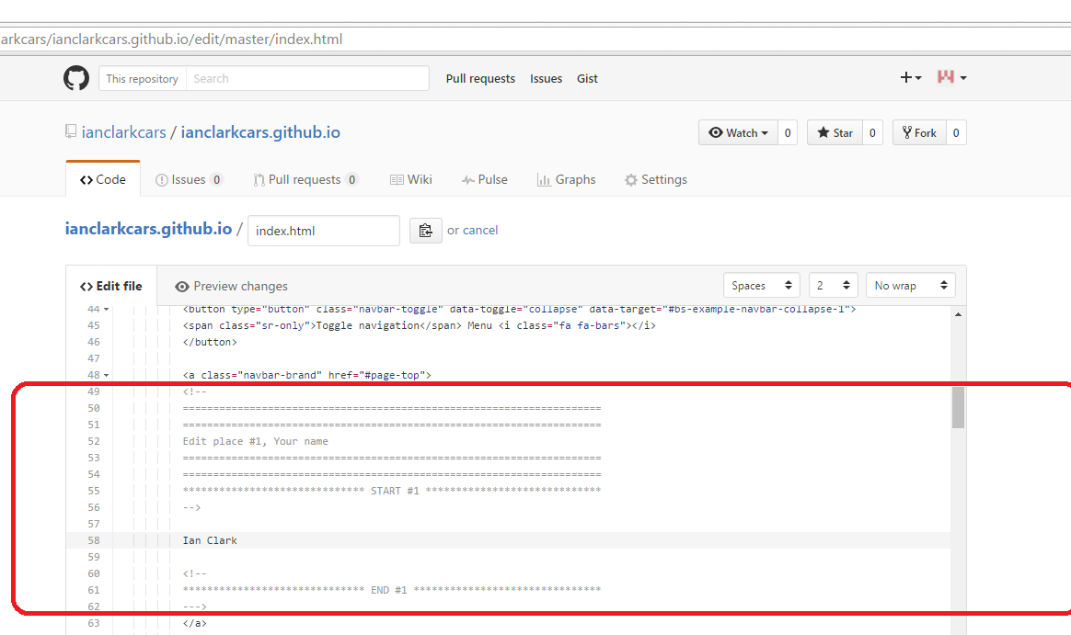

(See this above example of how I marked off where an edit that you might want to make, same idea throughout the entire file)

(See the below example of where that text appears on the main page of your website)

