Upload images (Quick)

# 1. Login to GitHub.com

# 2. Go to:

https://github.com/ianclarkcars/ianclarkcars.github.io/tree/master/images

# 3. Page should look like this:

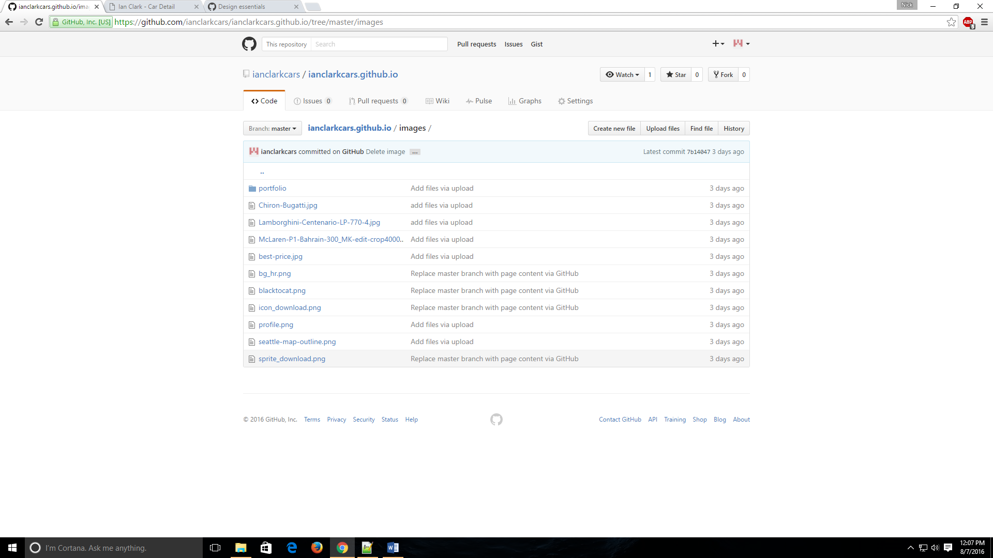

# 4. Hit the ‘upload’ file button

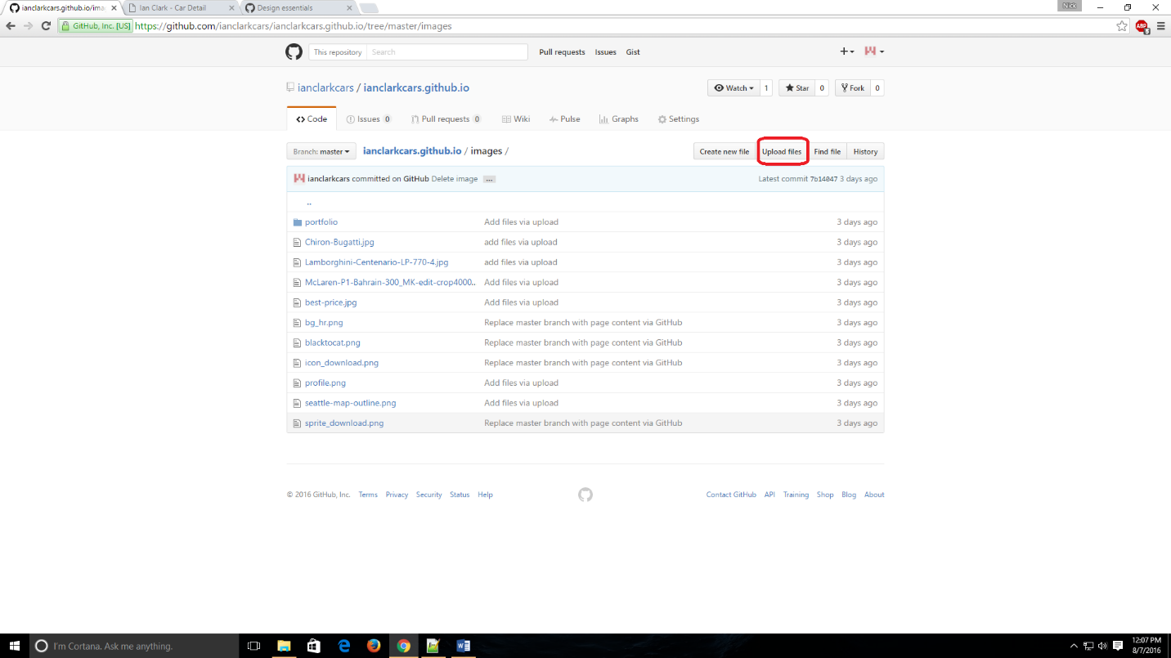

# 5. Choose your files

# 6. (Hit the GREEN BUTTON, COMMIT CHANGES)

# (I forgot to mention that, save == green button that says commit changes)

7. to use these images on website, go to the edit text document

8. edit the index.html file

9. insert images using the follow line:

<img src="images/best-price.jpg" class="img-responsive" alt="">

The portion, “images/best-price.jpg” is an image, and it’s in the folder, “images” that we used in step #1

So if I uploaded a brand new image, for example, football.png, then I’d use:

<img src="images/football.png" class="img-responsive" alt="">