**Communications Report**

**Table of Contents for Comms -**

1. Design Parameters
2. Equipment and Design
3. Communication Link Description
4. GNSS/GPS Selection
5. Progress, Timeline and Future
6. References
7. Appendix

**List of figures –**

Figure 1, pg. 4 - Ubiquiti radio equipment

Figure 2, pg. 5 - Specs for the AM-2G16-90 sector base station used for network

Figure 3, pg. 6 - TX/gain sensitivity vs modulation for the M2 radios

Figure 4, pg. 6 - MCS relations for referencing modulation schemes outlined in specifications

Figure 5, pg. 7 - Radiation pattern for the AM-2G16-90 antenna from specification sheet

Figure 6, pg. 7 - Radiation pattern for the AMO-2G10 antenna from specification sheet

Figure 7, pg. 9 - Received power at the rover

Figure 8, pg. 10 - Smith chart for Ubiquiti omni antenna chain 1

Figure 9, pg. 11 - Smith chart for Ubiquiti omni antenna chain 2

Figure 10, pg. 11 - Smith chart for Ubiquiti omni antenna chains 1 and 2

Figure 11, pg. 12 - Description of normalized Smith chart

Figure 12, pg. 14 - Proposed system Layers

Figure 13, pg. 15 - Sparkfun XA1110 GPS Breakout module

Figure 14, pg. 17 - GANTT chart for communications

**Abstract/Summary/Introduction for Communications -**

Since communications is what is said to make or break a rover in this competition, reliable, manageable, and fast communications is the focus for our first year competing. Building from the ground up and having limited electrical engineers on the team is driving us to find a quality out-of-the-box radio that can handle our needs. The electrical engineering team is proposing a Wi-Fi based communication system. It will utilize the 802.11a 2.4GHz station with equipment that is designed for maximum allowable FCC transmission over the unlicensed bands. This avoids possible accidental disqualification. This will also improve monitoring during autonomous navigation where the largest amount of data needs to be transmitted and many nodes need to be monitored. GNSS (Global Navigation Satellite System) will be a separate module due to accessibility of hardware. Future Lynx Robotics students will be able to build off this system for many URC competitions to come which is a focus on top of being able to make this rover competition ready on our first build.

Though the communications section, the radio hardware selected, system analysis, current hardware characterizations, protocol selection, hardware analysis, GNSS selection and is followed by an overview of the progress through this project and what is to come.

1. **Design Parameters for Comms**

From the 2023 URC guidelines:

“ 3.c.ii. 2.4 GHz frequency band (2.400-2.4835 GHz): Teams shall use center frequencies that correspond to channels 1-11 of the IEEE (Institute of Electrical and Electronics Engineers) 802.11 standard for 2.4 GHz. Teams shall not use frequency bandwidths greater than 22 MHz. The competition schedule will notify teams which channels may be used for each mission, and teams must be able to shift to other channels as required. Teams shall be limited to using no more than three channels in the 2.4 GHz band. 3.c.iii. These restrictions apply to both the command station to rover communications and any local wireless network such as (but not limited to) on-board the rover between subsystems. 3.c.iv. Teams may use spread spectrum or narrowband (fixed channel allocation) within the sub-band limits as they fit… 3.c.vi. Teams are allowed and encouraged to operate in bands outside of 900 MHz and 2.4 GHz and are encouraged to obtain ham radio licenses to allow operation on less used bands. However, in the event of interference outside of 900 MHz and 2.4 GHz, teams will not be granted additional time or special considerations. Outside the 900MHz and 2.4GHz bands, teams are strongly encouraged to investigate spread spectrum, automatic channel switching, frequency hopping, or other interference-tolerant protocols… 2.c.v. The Global Navigation Satellite System (GNSS) standard shall be the WGS 84 datum. Coordinates will be provided in latitude/longitude format (e.g., decimal degrees; degrees decimal minutes; degrees minutes seconds).” [1]

Summarized Comm Design Requirement and Limitations-

We may have a 3m max height for the base station and 1.2m max height for the rover. The autonomous mission is the furthest distance with a maximum of 2km required. Various rock formations are the primary and the only obstacles other than objects we are intended to interact with in the field. For the 2.4GHz band in which we propose to operate withing, we may not have a band larger than 22MHz, use more than 3 channels and must be able to switch channels with ease if instructed to. We must be able to transfer high-definition video and more than one stream of it, which requires a minimum of 2 Mbps each and a reserved band of 6MHz. We must also be able to reliably transmit control data such as multiple motor actuators and sensor readings without any delay all over the same network channel.

1. **Communications Equipment and Design**

Equipment –

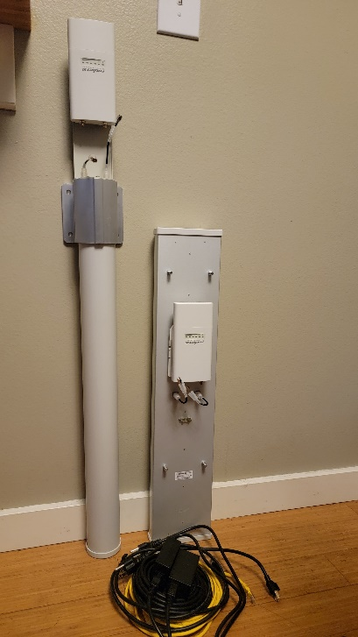

Figure 1: Ubiquiti radio equipment

The proposed antenna for the rover is a 10dBi Ubiquiti 2x2 MIMO omni antenna using the Rocket M2 as the radio. The base station uses the same company’s high powered 17dBi Ubiquiti 2x2 MIMO base station 90-degree sector antenna along with another Rocket M2 radio. The communications equipment will be connected to the rover’s controller, the NVIDIA Jetson TX2, and laptops on the control side. The RF hardware is shielded to reduce external noise at the transceiver. IP (Internet Protocol) cameras may be connected into the LAN ethernet router. Smaller 8dBi antennas may be able to replace the 10dBi antenna currently proposed and are being investigated further to save height, weight, durability, and power. The rover’s antenna comes with a 24V 0.5A DC (Direct Current) PoE (Power over Ethernet) wall plug injector, which is not usable for remote application. This is remedied with a well-regulated passive DC PoE injector of the same ratings with a dedicated ground in which will be able to reproduce the low-noise signal quality intended by the manufacturers OEM PoE injector. For GNSS (Global Navigation Satellite System) communications the Sparkfun XA1110 GPS breakout is ideal and its specifications are further outlined in section IV.

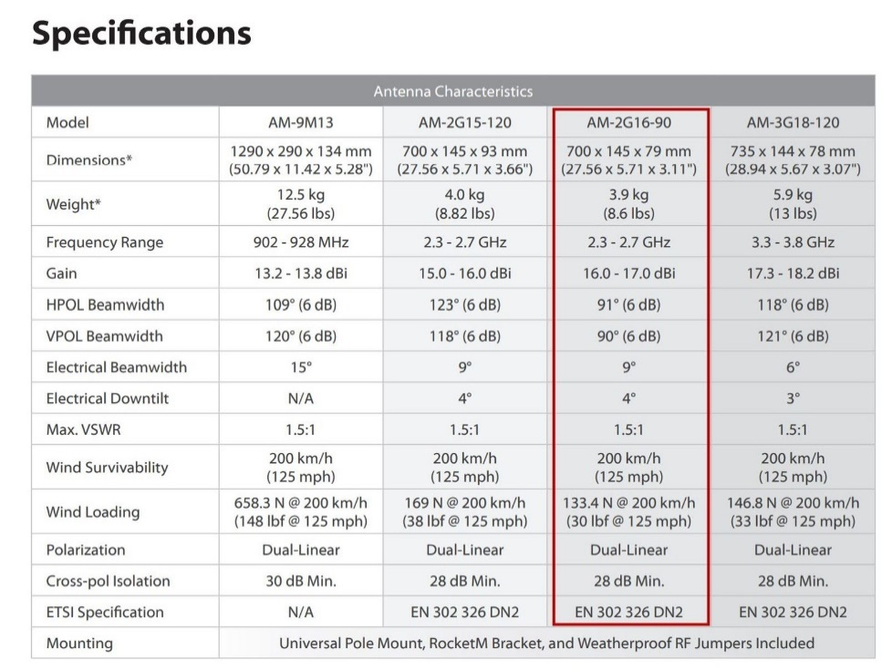

Figure 2: Specifications for the AM-2G16-90 sector base station used for network

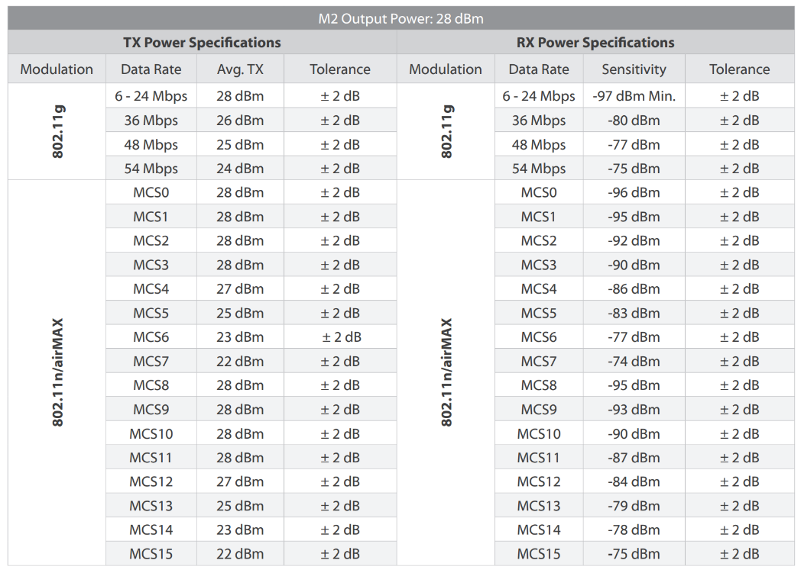

Figure 3: TX/gain sensitivity vs modulation for the M2 radios

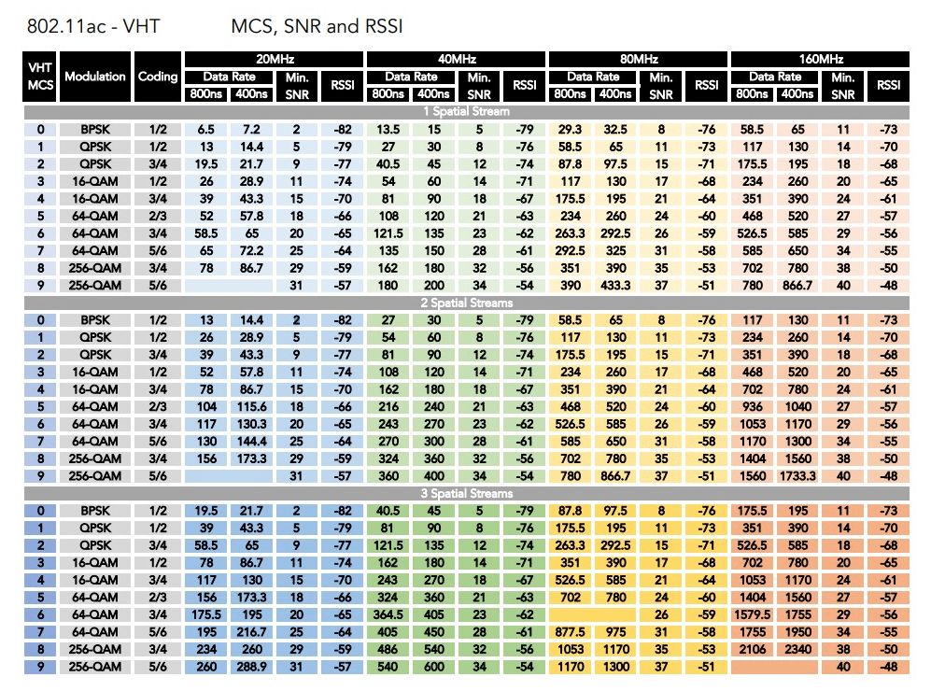

*Figure 4: MCS relations for referencing modulation schemes outlined in specs. [2]*

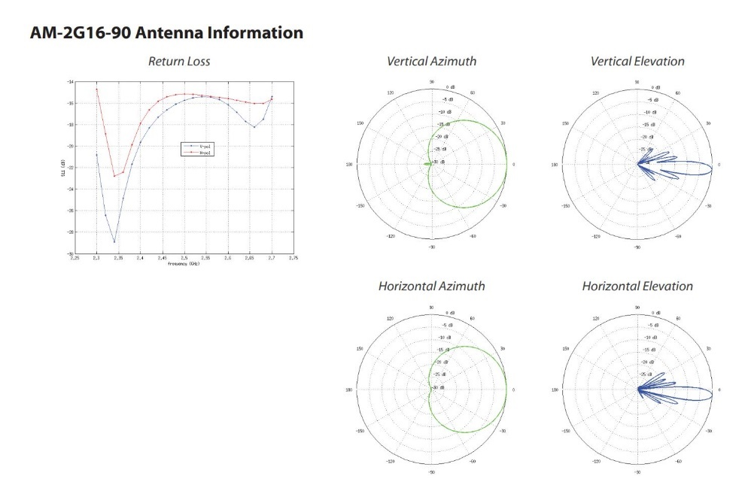

Figure 5: Radiation pattern for the AM-2G16-90 antenna from specification sheet

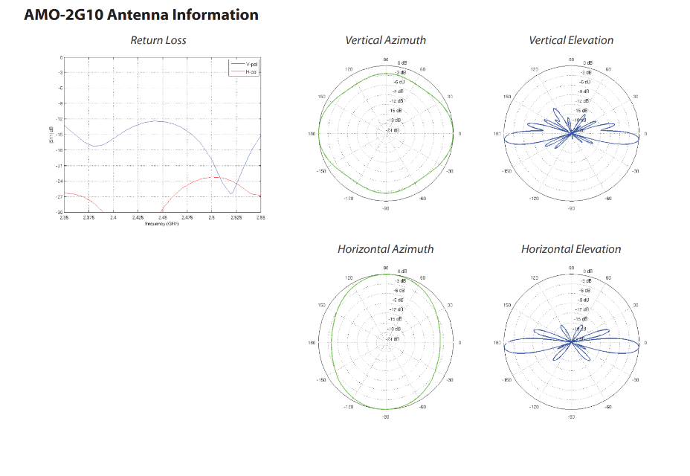

Figure 6: Radiation pattern for the AMO-2G10 antenna from specification sheet

Our network will be in the 802.11n link due to our carrier frequency of 2.4GHz and competition guidelines. We have two spatial streams due to the 2x2 MIMO Ubiquiti radios and antennas. From the MCS table, figure 4, we can see that the data rate halves every time the bandwidth halves. This is essential due to the channel limitations in the URC guidelines. 10 MHz is assigned for video and 5MHz for controls, so all 3 channels will be needed providing values scaled to 0.75 the value seen in the 20 MHz column under ‘Data Rate’. A major advantage to a 10 or 15MHz channel width is a 1.5 to 3dB lower noise floor for better reception. We can also see that the first five modulation schemes are slow but show that it is possible to transmit both video and controls over the network and should retain good sensitivity for long distances. RX power in 802.11n is relative to its modulation scheme, –96dbm to near –86 is ideal, so we will choose one between MCS0 and MCS5. Video data requires a rate of 2-4.2Mbps for good video, this means we could do two video streams (require 6 to 8MHz reserved regardless of number of streams) and operate as low as 10MHz channel width providing a stronger signal for distance as previously explained. 802.11n has a faster structure, but we must choose the correct modulation scheme and bandwidth for the extremes both expected and unexpected to encounter.

Using figure 4, we see that transmit power in this throughput range is 27dBm average but can transmit 28dB for the modulation schemes of interest. Referring to figures 5 and 6 (radiation pattern), there is almost no elevation radiation with only 4 degrees radiated. This means that the base station antenna should be positioned at the mean altitude of the rover’s antenna for maximum signal transmission. This requires surveying the competition grounds and resetting both the antenna height and direction for each competition.

Calculations and Characterizations:

We use the values previously investigated to produce the receive power to distance relationship. Gain at various distances graphed are graphed in figure 7. This is the formula used for calculating distance with loss based off the Contemporary Friis Transmission equation:

To graph with receiving power with respect to distance:

Using the original Contemporary Friis Transmission, we get better results:

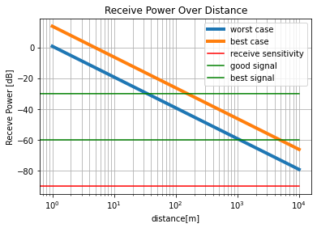

Figure 7: Received power at the rover

In figure 7, the worst-case formula first calculates the effective isotopically radiated power, , then the free space loss, , and finally relates the function to distance. The above graphs show that we should see a good signal of 30dB above the sensitivity level without obstruction though all distances and provides a worst-case at 1km with a best case of 4km. The worst case at our max distance provides around a 25dB signal. Other teams using the same communication equipment configuration have reported 800m (about 2624.67 ft) without line of sight which appears to positively correlate to this analysis.

Due to the previous modulation analysis, we should be able to make a –60dB signal easily sensed with a –90 to –96dB sensitivity providing 30 to 36dB received. Packet loss is known to increase with distance causing delays and crashes with TCP (Transmission Control Protocol) transport. This may be overcome by using TCP protocols for heavy traffic items such as videos in which emulate the UDP (User Datagram Protocol) transport method of dropping the data and not the connection to prevent hang-ups when packets are lost. This would preserve lower data rate controls functionality by not bottlenecking the transmission and by avoiding mixing UPD and TCP connections while retaining the reliability of TCP. Protocol structuring used for gaming has been designed exactly for this purpose and will be investigated further.

Antenna scatter parameters:

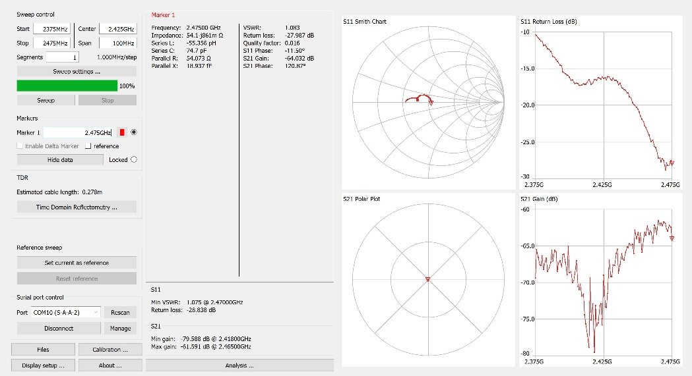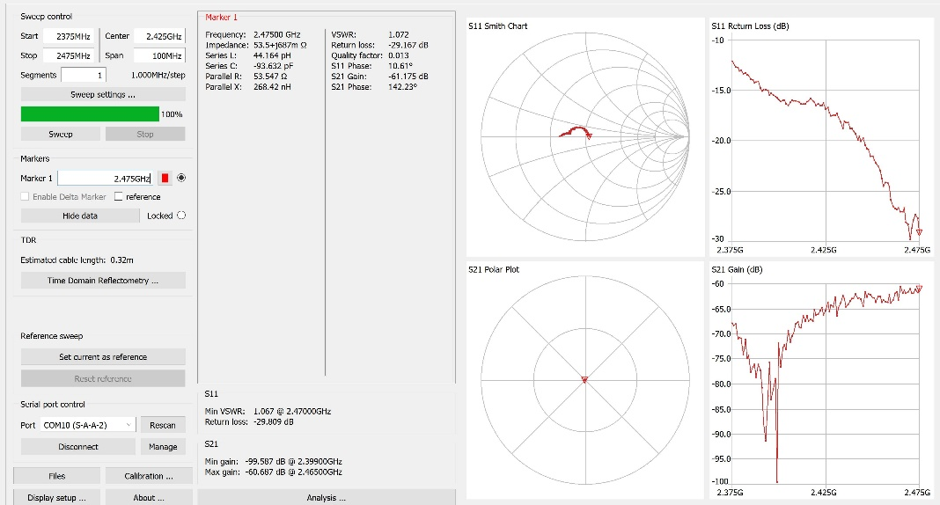

Figure 8: Smith chart for Ubiquiti omni antenna chain 1. With mount (left) and without mount (right)

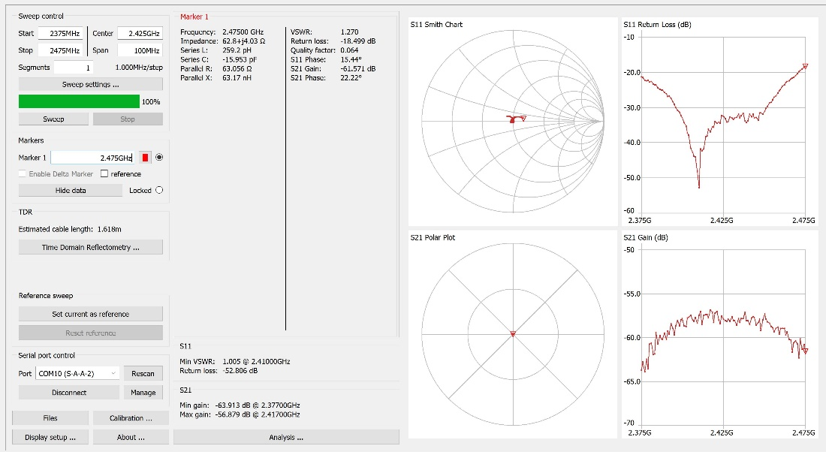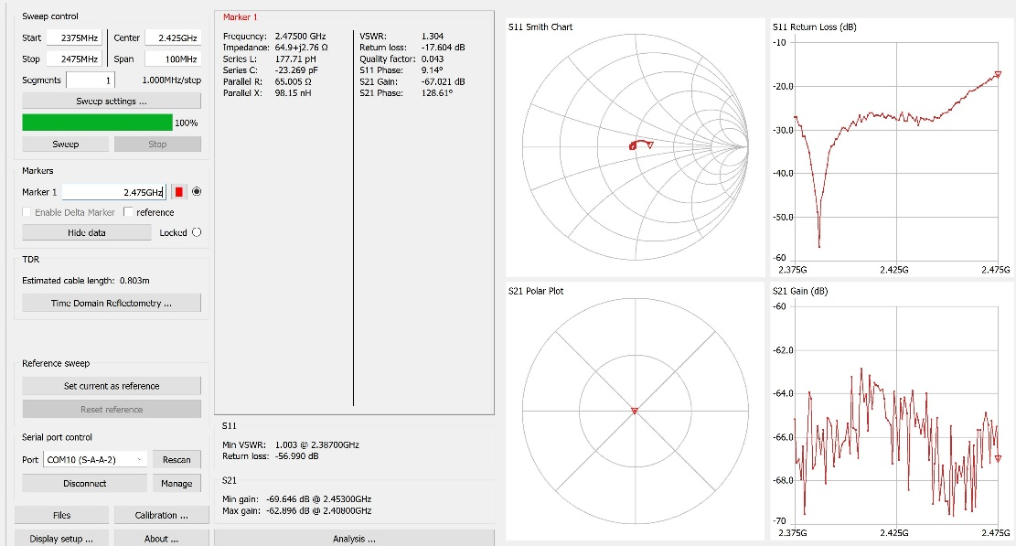

Figure 9: Smith chart for Ubiquiti omni antenna chain 2. With mount (left) and without mount (right)

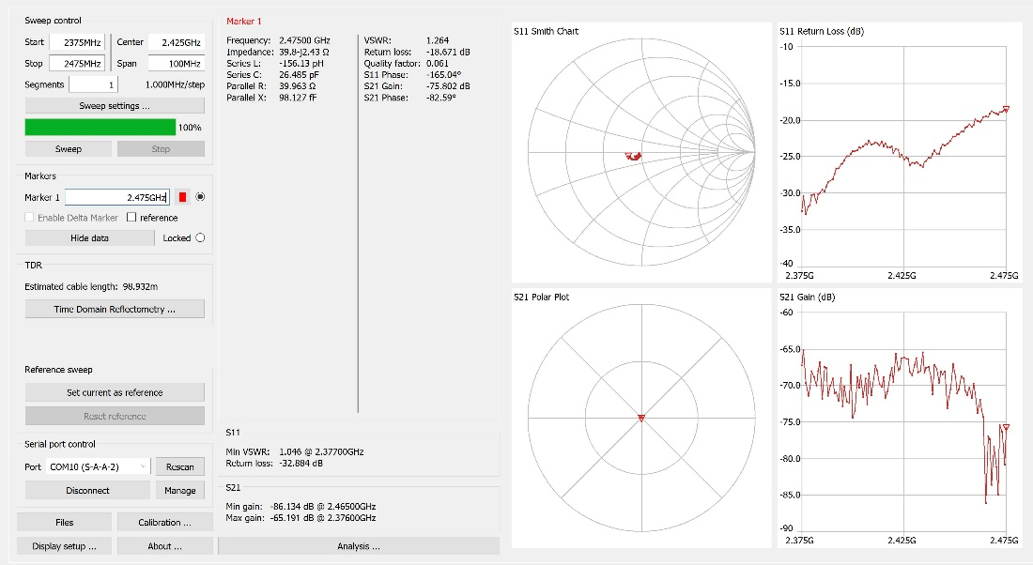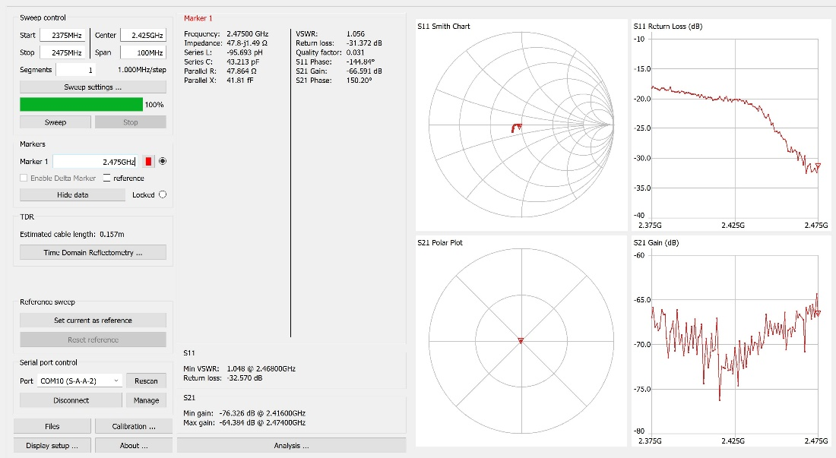

Figure 10: Smith chart for Ubiquiti omni antenna chains 1 (left) and 2 (right)

For reference of a Smith chart’s axis:

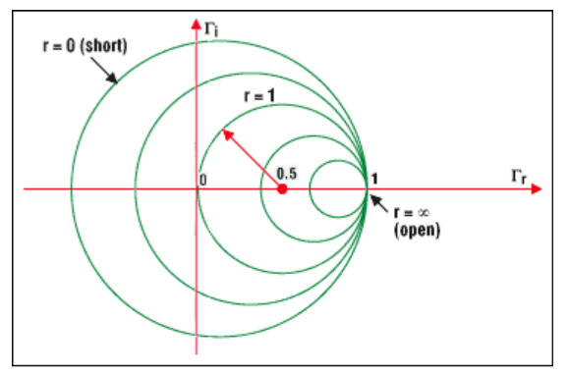

*Figure 11: Description of normalized Smith chart axis relative to complex reflection and load resistance [3]*

We can see that in a noisy uncontrolled environment with radiation such as household power lines, Wi-Fi, etc., we can see a good response from the antennas where they are all centered at 50-ohms and at the minimum reflection axis. It should also be noted that the RP-SMA adaptor had its own characteristics which needed to be accounted for. Due to being unable to find a calibration kit for this connection, the only way it worked was calibrating the open with the adapter on. All other calibrations were done without the adapter and are causing minor discrepancies between the datasheet and the findings.

The omni antenna was tested with and without the factory mount to attempt to reduce weight due to the 50kg limit and the aluminum mount weighed approximately 1.5kg on its own. The comparison is provided in figures 8 and 9. A carbon fiber mount with a folding joint should be far lighter and more versatile. The scatter parameter testing provides that we can operate with a custom mount but need to do real-world testing when we have video and the ability to transmit it over distances. The reason for this is the return loss’ minimum shifted below the usable range where it sat perfectly in the lower 3 channels before. All return losses in the transmission bandwidth test at 2% loss or less given a return loss maximum of about –17dB across the findings.

Benefits -

The Ubiquiti radio system should remove the need for amplifiers, antenna matching, filters, requiring multiple onboard radio units, and can provide real-time video transmission. It removes concerns about FCC regulations if no amplification is used, and the system is used as the manufacturer designed. It should be noted that this makes multiple high-bandwidth video streams easier to achieve and may allow the limited electrical engineering team to focus on quality controls.

1. **Communication Link Description**

The communication link is 802.11n, with TCP transport communicating between IP devices. As previously explained in the design section, we need to mitigate control reliability without latency and multiple high throughput video streams. UDP provides unreliable transport, but due to the protocols structure it will not crash software when packets are lost. It is not suggested to use multiple protocols for a single application therefore, to prevent bottlenecks and control latency, a TCP transport protocol is proposed in which is specifically designed to allow packet loss strictly for the video and establishing a more reliable TCP port connection for controls. A high-level overview of the network layers is provided in figure 12. Only the station to rover connection should be over the WPAN (Wireless Personal Area Network)., all other connections for video and controls are separated using LAN connections, and restricted DNS mask will prevent too loose of an IP block protocol. This will increase connection reliability and prevent loss and latency despite concurrent streams occurring over the WPAN.

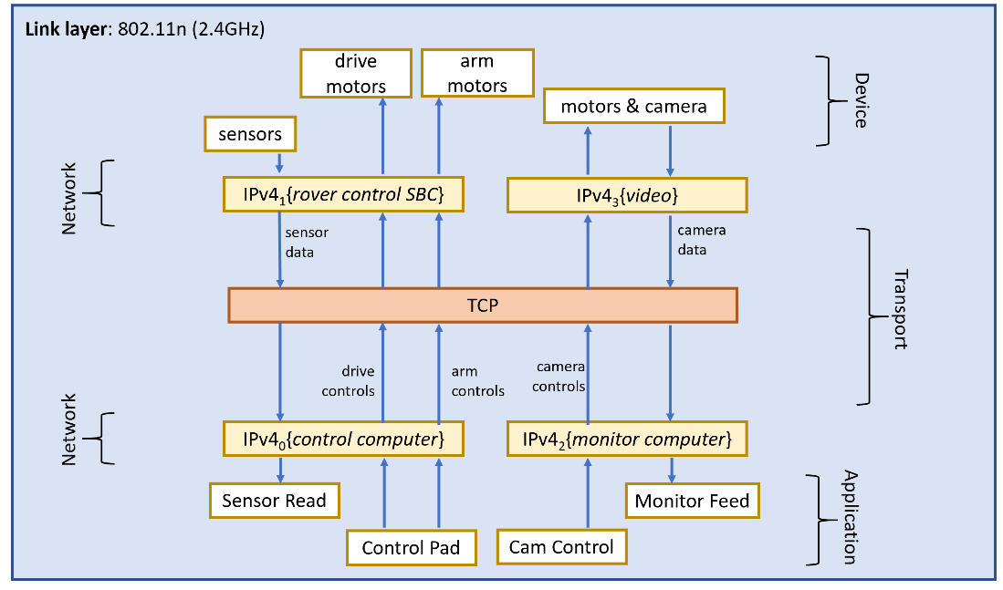

Figure 12: Proposed system Layers

1. **GNSS/GPS Selection**

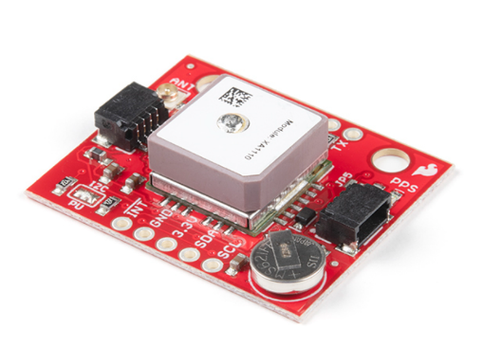

Figure 13: Sparkfun XA1110 GPS Breakout module

GNSS will be managed by an external chip connected via I2C or SPI bus (SPI is faster but only 10Hz is needed). Currently the proposed GNSS unit is the Sparkfun XA1110 GNSS Breakout which is designed for drone use and is intended for equipping evaluation boards with GNSS tracking. It requires only 30mW of power and is very compact as most GNSS units are. The module should require no extra preamplification or antenna but provides a port for using an external U.FL antenna if necessary. The internal transceiver is shielded and should prevent interference with the control communications. Differential GNSS is suggested for accuracy in the autonomous section. Another GNSS module may be needed as a reference point. The satellite data used is the WGS 84 datum. The unit has an update rate of 10Hz, meaning 100ms update rate which is more than enough for the speeds required of the rover to complete the autonomous mission.

1. **Progress, Timeline, and Future for Communications**

There have been a few evolutions of the communications system since the beginning of the term. The original idea was to use an SDR (Software Defined Radio) to create our own communication systems. We were to use a radio module such as Analog Devices Pluto+, LimeSDR or HackRF One. The device is versatile, where the protocol is compiled using a block schematic of either Python of C++ in a software such as GNURadio or Pothos to define the functionality of the radio. Unfortunately, due to the dynamic ranges in which these SDRs operate requires many FCC regulations and certifications to be considered. Furthermore, if we were to operate outside of the unlicensed band, we would need to obtain a HAM radio license. Due to this being our first time and many resources saying that communications, “makes or breaks” many young teams attempting to compete, we decided it would be far wiser to avoid accidentally disqualifying the team due to aliasing in the wrong bands, transmission failure, extensive development times, requiring extensive antenna compatibility design work and unable to knowledgeably adhere to FCC regulations. No engineer on our team has been educated in digital communication systems or regulations required to not cause serious problems.

These problems brought the first evolution in the concept which was to find a 915s prebuilt radio system due to the protection of from interference given the guidelines, provides long distance communication out of line of sight, easily configured networks and the equipment is FCC certified when configured as designed. Ubiquity was used by many other teams, was the only radio system that had reasonable pricing given the electronics shortage currently occurring and had a gateway interface that allowed for configuration like a home router which provides a dynamic system for needs that may change through the project. Unfortunately, the shortage made it where no M9 Rockets were available and no other equipment with the required specifications were less than ten times the cost, all being well above a thousand dollars.

The current evolution was forced to occur and that was the 2.4GHz radio system, which is also from Ubiquiti. Due to the higher attenuation through materials that occurs with 2.4GHz transmissions, even more attention has been placed on increasing distance and finding protocols that are most tolerant of and resilient to interference. As previously explained in the communication layers section, we are now focusing more simple modulation schemes to achieve this, but due to not currently having all the throughput information and equipment for testing we are ready and waiting for distance testing to emulate these conditions and verify the analysis previously made for distance. After distance testing and confirming the best settings, as can be seen in the GANTT chart in figure 14, we will continue distance testing and then prepare for the field as we test, compiling such information as tools needed, common failures, etc. to be ready for anything that may happen. At the end of that phase, we will be compiling reports essential for entry into the competition.

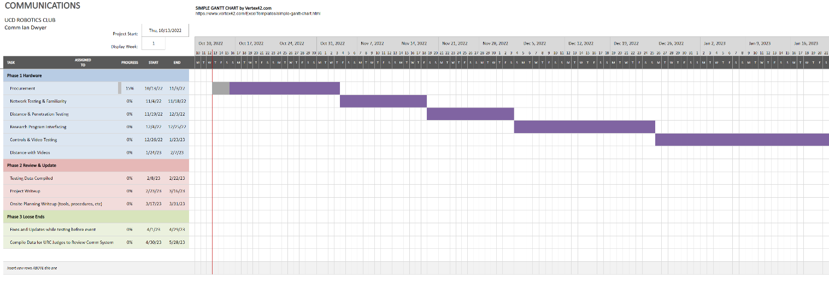*Figure 14: GANTT chart for communications*

1. **References**

[1] Requirements & Guidelines. (2022). Retrieved 13 October 2022, from https://urc.marssociety.org/home/requirements-guidelines

[2] Vouzis, P. (2020). What is the MCS Index?. Retrieved 13 October 2022, from https://netbeez.net/blog/what-is-mcs-index/

[3] Impedance Matching and the Smith Chart Tutorial | Maxim Inte. (2002). Retrieved 13 October 2022, from https://www.maximintegrated.com/en/design/technical-documents/tutorials/7/742.html

1. **APPENDIX**

#Python code for power received graph

import NumPy as np

import matplotlib.pyplot as plt

f = 2.440*10**(9) #middle of 2.4GHz band used

wvlngth= 2.99*10**(8)/f

d = np.linspace(1,10000,10000) #check to 10km

Pt = 27 #both rockets transmit at this power

Pl = 3 #assumes a large 3dB wire loss (half power loss)

Gt = 17 #base station antenna gain

Gr = 10 #rover antenna gain

GS = -60*np.ones(10000) #what is considered a good signal by

RS = -90*np.ones(10000) #receive sensitivity found through forums, no datasheet. Will note findings

BS = -30*np.ones(10000) #best signal after characterizing equipment sensitivity (SAME AS QUANTUM!!)

# formula found from a missing resource for worst-case since it omits the Gr and adds wire loss

Pr_worst = (Pt-Pl+Gt)+(20*np.log10(wvlngth/(4*np.pi*d)))

# Contemporary Friis transmission

Pr_best = (Pt+Gt+Gr)+(20*np.log10(wvlngth/(4*np.pi*d)))

plt.plot(d,Pr_worst, label='worst case', linewidth='4')

plt.plot(d,Pr_best, label='best case', linewidth='4')

plt.plot(RS, label='receive sensitivity',color='red')

plt.plot(GS, label='good signal',color='green')

plt.plot(BS, label='best signal', color='green')

plt.legend()

plt.xscale('log')

plt.grid(True,which='both', ls='-')

plt.xlabel("distance[m]")

plt.ylabel("Receve Power [dB]")

plt.title("Receive Power Over Distance")

#-30 dBm: This is the maximum signal strength. If you have this measurement, you are standing right next to the access point.

#-50 dBm: This is considered an excellent signal strength.

#-60 dBm: This is a good signal strength.

# -67 dBm: This is a reliable signal strength. This is the minimum for any online services that require a reliable connection and Wi-Fi signal strength.

# -70 dBm: This is not a strong signal strength. You may be able to check your email.

# -80 dBm: This is an unreliable signal strength. You may be able to connect to your network, but you will not support most online activity.