**FOOT CARE NURSING MASTER PLAN**

**Company Name: The Gentle Sole**

**Registered on: July 22, 2025**

**Consider Contents to the Website**

**Introduction:**

"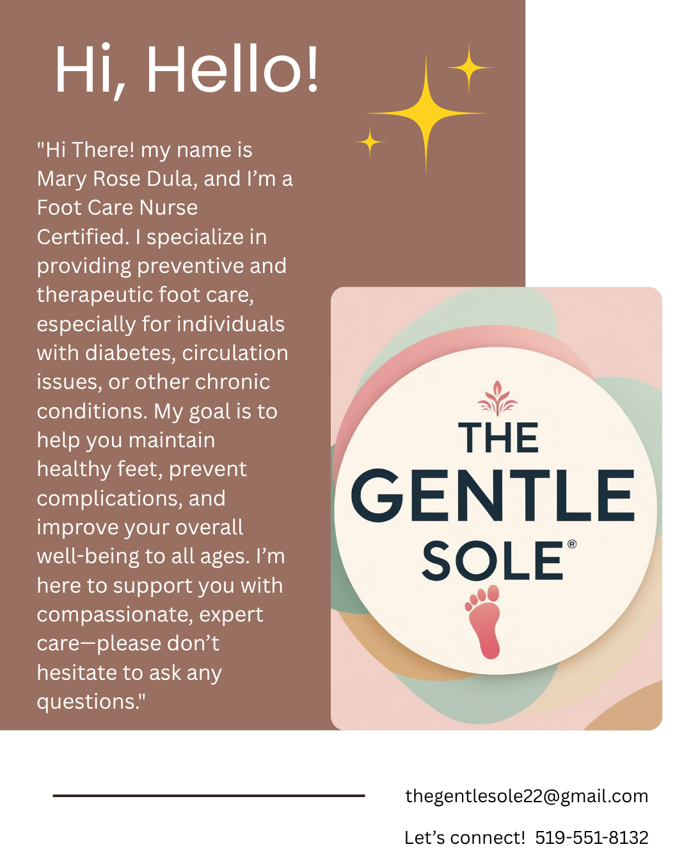



**LOGO (See Above)**

As a dedicated Footcare Nurse, I bring compassion, precision, and a love for holistic care to every client I serve. From preventative care to specialized foot health support, my mission is to keep you confidently and comfortably on your feet.

Certified FootCare Nurse offering services to all ages In-Home, In-Mobile, Nursing Homes, Retirement Homes, Seniors Homes, Hospitals and so on!

Your feet deserve gentle, professional care. At The Gentle Sole Foot care, I am now welcoming new clients for in-home services tailored to your needs.

Services offered:

* Nail Trimming & Filling
* Corn & Callus reduction
* Diabetic foot care
* Moisturizing and gentle massage
* Foot health reduction
* Referrals if needed to podiatrist
* Full Assessment from below the knee to the foot
* Temporary Ingrown Removal

Compassionate care you can trust – because every step matters!

**Pricing:**

* $65 with or without insurance! – initial assessment (1 hour)
* Routine: $55 with or without insurance! – (45 min)
* Extra $5 fee for driving to them. Windsor x Essex x Kingsville x Lasalle x Tecumseh
* In-Home, In-Mobile, Nursing Homes, Retirement Homes, Riverside Seniors apartments, Hospitals and so on!
* Every 4, 6, 8 weeks follow up!
* Follow up clients inactive for 6 months or more
* Gmail Email: [thegentlesole22@gmail.com](mailto:thegentlesole22@gmail.com)
* Instagram: @thegentlesole
* Facebook: The Gentle Sole
* Website: [www.thegentlesole.ca](http://www.thegentlesole.ca) (hopefully this is still available from godaddy)