Summary of Documentation Tasks and Files

Manual
Working copy of MSWord document in cvs slri/seqhound_priv/docs/The_SeqHound_Manual.doc
Formatting template for MSWord document
slri/seqhound_priv/docs/ shound.dot
Converted pdf version in website cvs (Website Repository not the Local Repository) html/seqhound/api_help/docs/The_SeqHound_Manual.pdf
A copy of the pdf is included in the archive seqhound.docs.3.01.tar.gz which is included on the ftp site ftp://ftp.blueprint.org/pub/SeqHound/Documents/ and sourceforge

Editing the Manual
The only person committing changes to cvs for the Manual should be the main documentation person.
Programmers should check out the most recent version of the Manual with “Track changes while editing” enabled. The Manual should be saved in cvs with this option enabled so that they do not need to worry about it.
Tools->Track Changes->Highlight Changes –Track changes while editing - checked
Programmers should edit the Manual and then email it back to the documentor.
Use the accept/reject changes feature in MSWord to accept/review their changes, check that the formatting is ok and then cut and paste relevant sections into the main copy of the Manual.
Tools->Track Changes->Accept or Reject changes
There is a compare documents feature (“diff”) in MsWord if required.
Tools->Track Changes->CompareDocuments

Formatting
The formatting templated makes it easy to change and manage the look of the Manual. To use the template, it should be attached to your copy of the Manual. To attach the template do the following:
Tools->Templates and Add-Ins->Attach
browse to the path of your copy of shound.dot which should have been checked out of cvs (probably slri\seqhound_priv\docs\shound.dot)
Automatically update styles should be checked.

Some of the main formats (styles) used in the Manual are

Headings 1-4 for headings ( these will also appear in the table of contents.)
Normal, Body, b for regular text
Code, x for code examples
literal, fc for text output
user input, fcb for command line prompts/input
user input replaceable, fcb is used in examples to show variables for which a context-specific substitution should be made.
shound_function for SeqHound function names
- ListNumber,ln for numbered lists
ListNumber, lnn for continuation of numbered lists.
technical italics, fix is used for filenames, file extensions, URLs, and email addresses.
Note for notes

If in doubt, the name of the format/style is visible on the Formatting tool bar. You can also use existing text as a template. If the formatting does not look correct it is best to first reset the text to Normal,Body, b and Default Paragraph Font and then try to reapply the formatting. If text has been assigned a style and then changes have been made to the formatting of that text (say bold or italics), the style of the text cannt be changed to another style until the additional formatting has been removed (high-lite the text and then press CNTRL + SPACE).

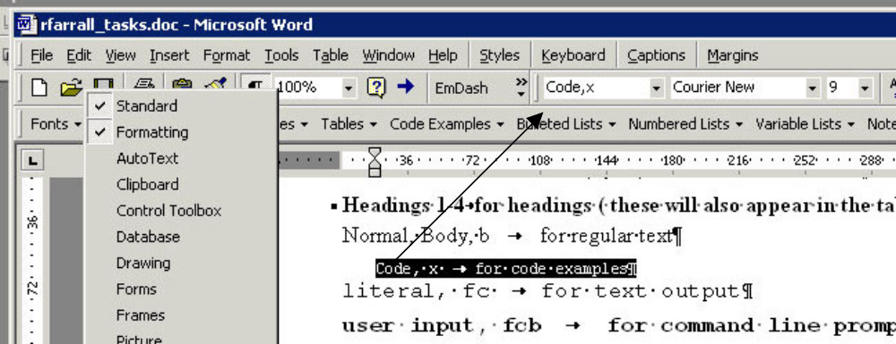

Comments
Use the comments feature in MSWord to manage TODOs or flag areas which need work.
Insert->comment
Exisiting comments in the manual will appear highlighted with yellow and with a reference number. I try to use the format release version, username and comment and bug number if relevant.. The comments need to be stripped before converting to a pdf. See the Converting to pdf section.
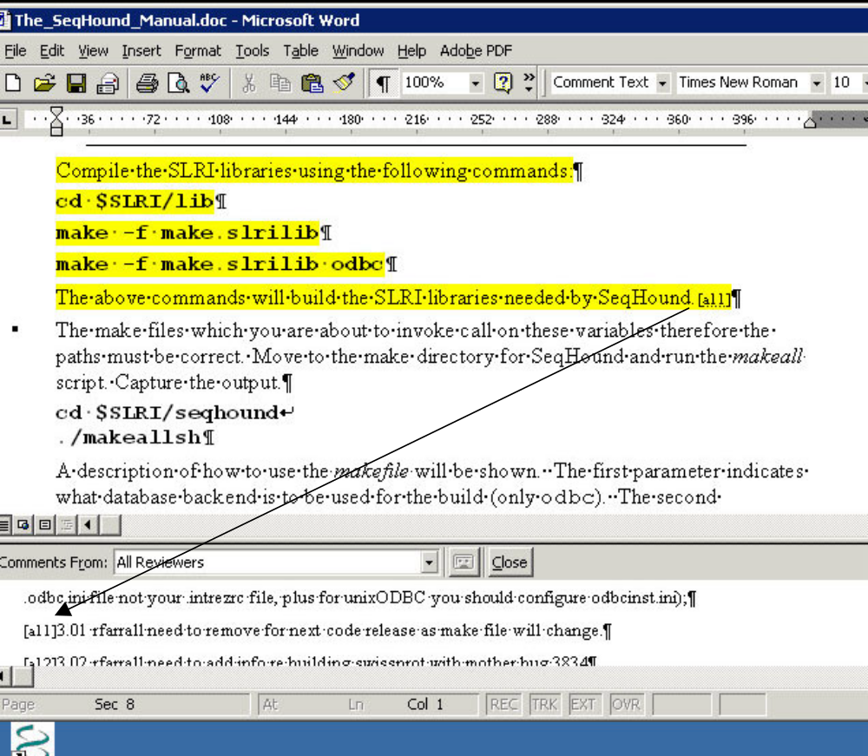

Properties
Use the section of the Manual to keep notes of changes and then use these to create the cvs log comments when checking in the Manual.
File->properties Comments:
Table documentation
When adding many new tables then use the PHPMyAdmin interface output to cut and paste into Manual to avoid typing errors.

Converting to pdf
Convert to pdf using Adobe Acrobat professional available embedded in MS Word. The copy on Citrix has bugs.
- make a local copy of the Manual –it speeds up conversion and allows for temporary changes to the Manual. THIS COPY MUST BE IN THE SAME DIRECTORY AS A seqhound.dot file OR THIS WILL NOT WORK.
- Find and replace comment marks (^a) with blank to remove all the comments in the local copy only. The comments should not be converted.
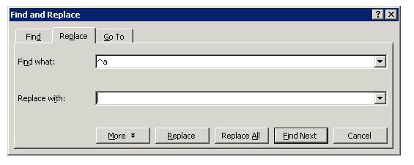
- Make sure the table of contents is up to date. Right click anywhere in the table of contents and select
Update field->Update entire table OR PRESS F9

Make sure that the API description in section 3 has been updated.

- Adobe pdf settings
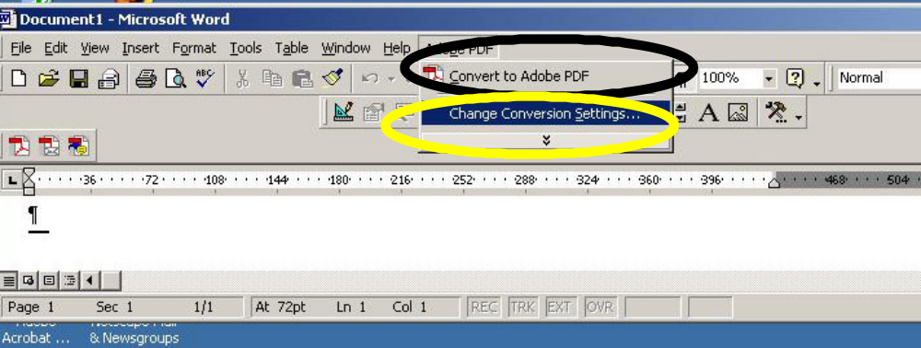
Use Standard Adobe settings. The only change required is to the Bookmarks section: I have included the Settings and Word tabs for reference.
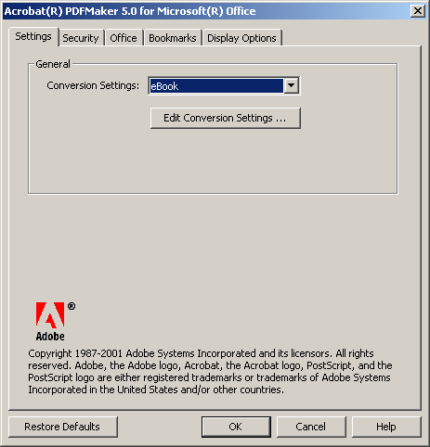

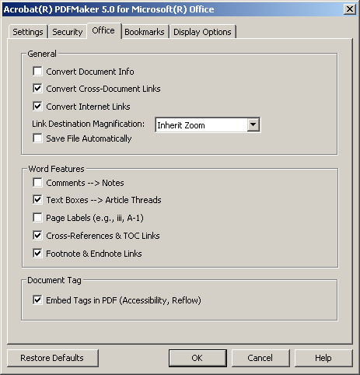
only convert headings 1-4 to bookmarks.
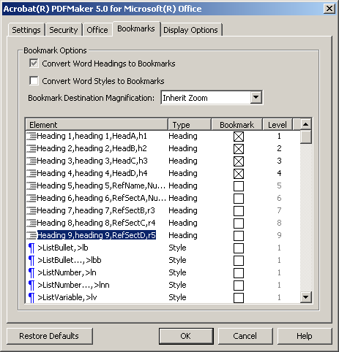

Note that Adobe 5 and 6 cannot convert bookmarked hyperlinks therefore all the links in the Function listing in the Manual point to the main apidetail page.

Conversion to pdf may take greater than 1 hr. 20 min. Move the Word document to a local (e.g. C: disk) to speed up conversion.

The pdf version can be checked into cvs at
website/html/seqhound/api_help/docs

View the pre-release on Ed’s internal blueprint website before copying to production.
http://lisa.blueprint.org/~ehaldors/sandbox/seqhound/

API documentation in the Manual
(see also API documentation)
When API functions are added or removed they need to be updated in the Manual under “An overview of the SeqHound API”. and in the “Description of the SeqHound parsers and data tables by module” under the API section for the appropriate table

Remote instructions
See also READMEs

Table diagrams
Main visio diagram for production is in cvs slri/seqhound_priv/docs/SeqHound_Schema.vsd
slri/seqhound_priv/docs/SeqHound_text.vsd
slri/seqhound_priv/docs/Gene Ontology Module Diagram.vsd
The first figure is auto-generated. We are moving towards a totally hand-edited visio of the SeqHound Schema since this is easier to control and edit (next two visio files).

Converted pdf version in website cvs
html/seqhound/api_help/docs/ SeqHound_Schema_Prod.pdf
The tables in this file are in the MySQL database seqhound on the server skinner.
There are three tabs in the diagram
production – production tables
development – tables underdevelopment but in the database. This is empty but left in case there are new development tables added to seqhound.
ontoglyphs – the ontoglyph tables
The database model is refreshed using the MySQL OCBC 3.51 driver connection to the seqhound MySQL database which enables automatic updates for existing tables. New tables are added to table list but not to diagram.
The following are the menus available in Visio on Citrix.
- Database->Refresh Model
- Select myodbc3-test
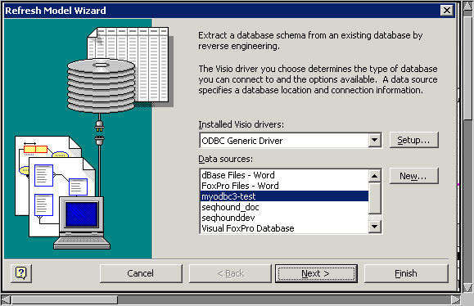
- the password is sh. You will likely receive an error message. Go to step 4.
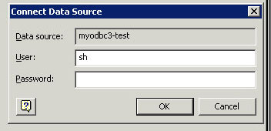

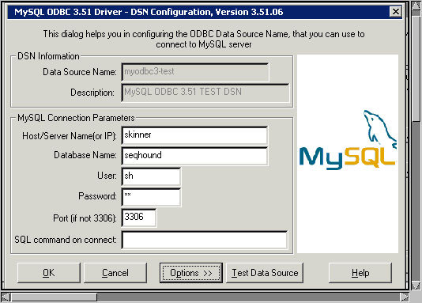

After the model is refreshed then the date needs to be changed at the top of the appropriate page(tables last updated: Oct 06, 2004 16:51)

This file only covers the seqhound database. Tables in different databases such as prebind are in separate files. The diagrams can be merged as pdfs or using PowerPoint.
When converting to pdf only the production tab is converted.
There is no simple way to extract changes between revisions.
prebind
slri/seqhound_priv/docs/SeqHound_Schema_Prebind.vsd
mmatan's diagram
to be created

Converting to pdf
Convert to pdf using Adobe Acrobat professional available on workstation near IT. The prebind pdf diagram can be inserted into the main pdf diagram using Adobe or via Powerpoint then converting Powerpoint to pdf.

READMEs

Remote APIs
java
/slri/seqhound/java/README
perl
slri/seqhound/perl/README.pod
bioperl
slri/seqhound/bioperl/REAME.pod
C
Only in Manual

C++
/slri/seqhound/src_cxx/README needs to be updated
Note: The Manual includes reformatted versions of the READMEs the Manual and the READMEs should be changed at the same time.
C and C++ need to be updated in Manual and README

ftp site
ftp://ftp.blueprint.org/pub/SeqHound/
Various README text files in directories

Release notes
slri/seqhound/release/Release_notes_n.nn.txt
I use a combination of cvs logs (most programmers are good at indicating bug number in cvs log), bugzilla's and programmer input.
I use a a perl script with cvs log functionality to extract cvs logs to an xml output and then use XMLSPY on Citrix to load into a database. This makes it easier for me to sort and filter the logs. The script is cvs2cl.pl and is available from http://www.red-bean.com/cvs2cl/
perl ~/programs/perl/modules/cvs/cvs2cl.pl --xml -b -t -r -l "-d'>yyyy-mm-dd'"
If this is too complicated just use the normal cvs log output.
Release notes are made available on the ftp site and posted to the usergroup and SourceForge.

Function tracker
slri/seqhound_priv/docs/apifunctsstatus.xls
Website version
website/html/seqhound/apifunctsstatus.html
The Excel document is converted to html using OpenOffice as it produces cleaner html than the Micrososft conversion. In OpenOffice
File->Save As->HTML Document...
The resulting html table is pasted into the cvs updated version of website apifunctsstatus.html and checked in
Any functions marked as NEW in a previous release need to be updated to A, R etc. in the next release.
If you have difficulty inserting the new html into the website file then Ed Haldorsen should be able to help you.

API documentation
Java
java/src/org/blueprint/seqhound/SeqHound.java
The API documentation is in javadocs in the source code; therefore, changes to the java API documentation need to be done in the source code. Instructions for generating html documentation are in the java README. Resulting documentation is copied to my directory called javadocs. Ed Haldorsen is informed when updated and he updates the website directly. The website cvs is bypassed because the documents are autogenerated docs. I have requested the same setup. See RT http://rt.blueprint.org/Ticket/Display.html?id=1851
Note The instructions will change for the new interface. Please see Mike Matan for details. Bug 4668
Bioperl
/slri/seqhound/bioperl/SeqHound.pm
API docs embedded in source code in POD format. The user can use standard perl POD tools to convert the documentation to html, text, man pages etc. The api docs do not appear on the website.
Perl, C, C++
Moved from access database to a plain text file
I've included the text file and perl scripts in the email - I didn't have a chance to move to cvs before I left.
website website/html/seqhound/
apifunctslist.html
apifunctsdet.html
Note for perl there is a copy in POD format in slri/seqhound/perl/README_API.pod This should be updated at the same time.
HTTP calls
website website/html/seqhound/
httpcalls.html
seqhound/html/gethttpcalls.pl is a perl script which generates a list of function names and http calls for seqhound from the file seqhoundapi.c. I cut and pasted the generated seqrem?fnct=SeqHoundFunction&arg=value into the API text file
I'm not sure how the new java code will affect the completeness of this list.

wikis
http://wiki.blueprint.org/i
In-house Seqhound Administrator Manual
ERD Table Schema (MySql)
Setting Up SeqHound Java
Setting Up SeqHound Bioperl (now refers to README in bioperl release)

Tutorials
Perl
Working copy in cvs slri/seqhound_priv/docs/seqhound_perl_tutorial.pod
Website website/html/seqhound/perl_tutorial.html
In POD format which can be converted into html, text.etc using standard POD tools pod2text and pod2html. The resulting html is cut and paste into the most recent version of the website file. See the POD section in O’Reilly for writing POD comments or follow existing format.
Taverna
slri/seqhound_priv/docs/ seqhound_taverna_tutorial.doc
and example workflow
seqhound_taverna_tutorial_structure01.xml
The tutorial is on hold due to Java return values

