SeqHound Taverna Tutorial

Introduction
SeqHound is a biological sequence retrieval system inspired by Entrez. The sequence and structure database content is derived from GenBank and is updated on a daily basis. SeqHound also stores annotation links for sequences; these include links to Gene Ontology (GO) descriptions, MedLine abstracts, the NCBI taxon database, associated structures, redundant sequences, sequence neighbours, conserved domains, data base cross-references, Online Mendelian Inheritance in Man (OMIM) identifiers, LocusLink identifiers and complete genomes.
This tutorial explores using Taverna for accessing information in SeqHound. It covers some common SeqHound functions and provides an example workflow. The tutorial assumes a basic understanding of Taverna and familiarity with bioinformatics resources such as NCBI's Entrez.. Documentation of Taverna is available on the Taverna homepage http://taverna.sourceforge.net/. The “Getting started with Taverna” in the Taverna User Manual and Dr Peter Li's Taverna Tutorial are good places to start learning about Taverna.

Accessing SeqHound in Taverna
SeqHound functions are available in Taverna from the services pane under SeqHound@seqhound.blueprint.org.
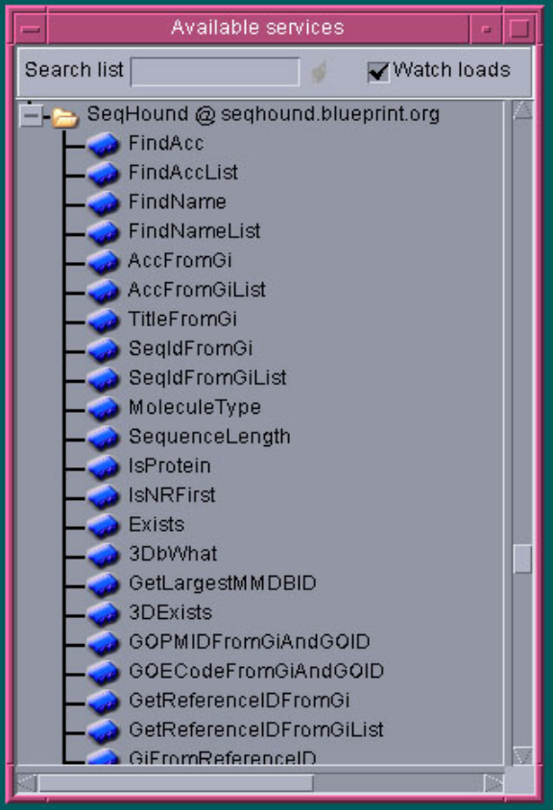

A summary of the purpose of each function is available in Taverna under the function’s metadata tab.
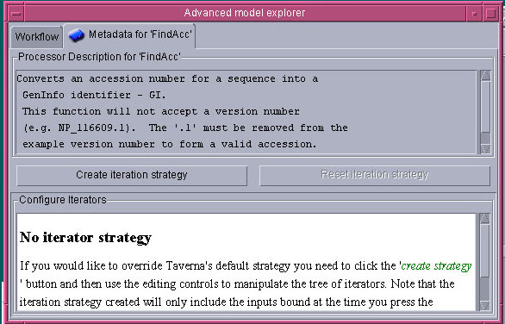

The SeqHound Taverna functions are based on the SeqHound Java API. More detailed documentation of SeqHound and the APIs including Javadocs are available from the SeqHound website http://www.blueprint.org/seqhound/seqhound_documentation.html. The next release of the Java API will contain more detailed API documentation. The ``Using the SeqHound remote API'' section in the SeqHound manual provides a good overview of functions available.

Retrieving GenBank GenInfo (GI) identifiers
The SeqHound API is GenBank GenInfo (GI) centric in that many functions use this identifier as a key to retrieve sequence and sequence annotation data Therefore, identifiers from other databases and GenBank accessions must be converted to GIs before using many of the APIs.
FindAcc():
Converts a GenBank accession for a sequence into a GenInfo identifier
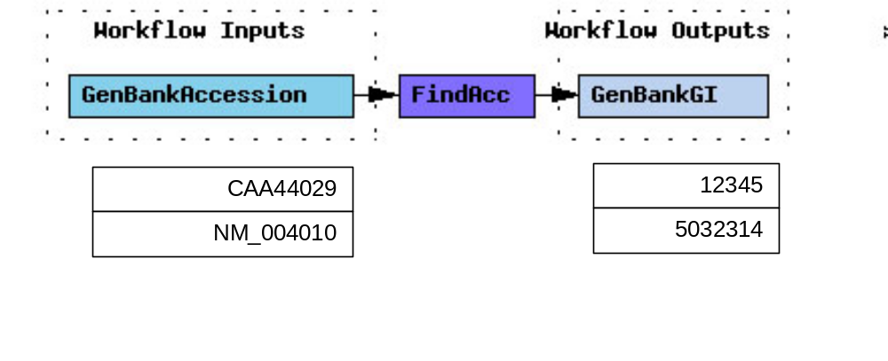
FindName():
Converts a non-GenBank database identifier such as EMBL, FlyBase, Swiss-Prot and PIR into a GI identifier.
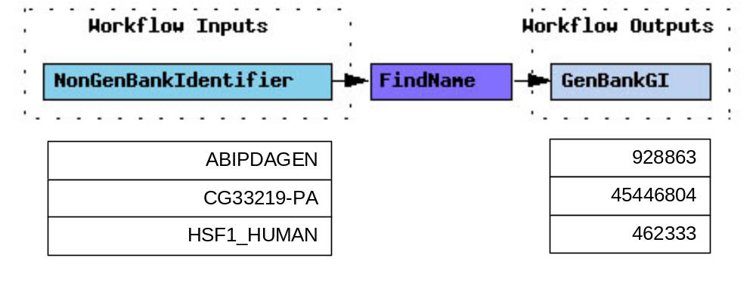
GiFromPDBchain():
Protein data bank (PDB) records may contain multiple sequence identifiers. For example, 100D has 2 GIs and FindName() will only return one of them. To return a specific GI use GiFromPDBchain() which also takes a PDB chain input.
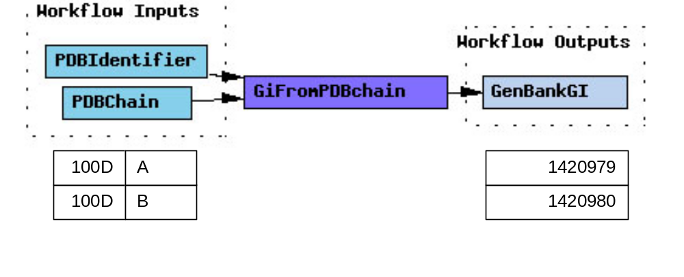

Redundant Protein GIs.
Sequence records in GenBank are redundant. For example, two different sets of authors may submit the same sequence to GenBank and each set of authors will be given different GIs. The identical sequences may have different annotations and some may have an associated structure record while others do not. SeqHound groups sequences that are exactly the same under a single identifier (Redundant Group Identifier). The redundant sequence functions are useful when trying to collect all of the annotation that applies to a biological sequence but may be scattered across several sequence records.
For example, 3DFromGi() does not return any structure records (MMDBIds) for the protein GI: 54695556.
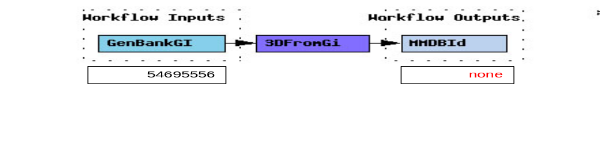
If the RedundantGroup() function is used to retrieve the list of identical protein sequence GIs first then two MMDBIds are returned.
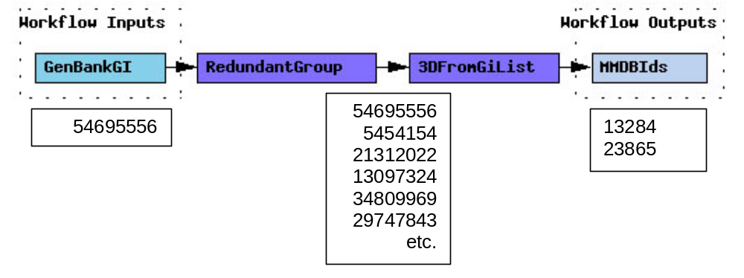
Some functions automatically use redundancy information so that the RedundantGroup() step is not required. For example, 3DNeighboursFromGi() or the redundant version of GOIDFromGi(), GOIDFromRedundantGi(). The API documentation specifies if redundancy information is used.
Note: The redundant group identifiers apply to protein GIs only.

List Functions
Many API functions have two forms: one that takes a single item as input and one that takes a list. For example GOIDFromRedundantGi() and GOIDFromRedundantGiList().
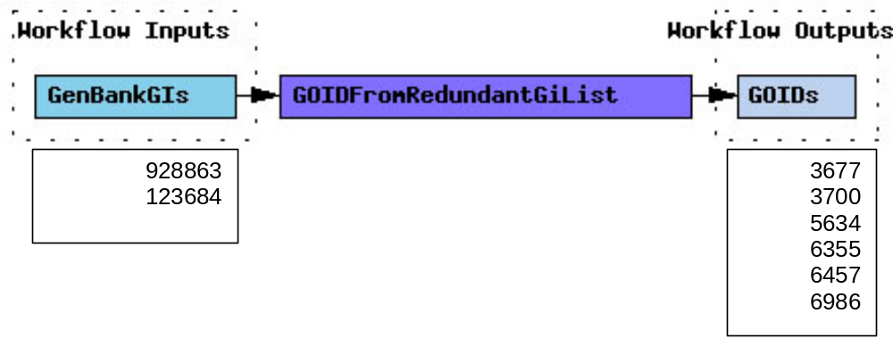
The output for list functions may not be in an order that corresponds with the order of input value since each input value may return no result or may return an unpredictable number of results. In the example, GI 928863 does not return any GOIDs. The list functions return empty lists when no data is returned for any of the input values.
If it is important to match input with output then looping through the single input version of the function instead of using the list function would normally provide the solution in Taverna. Unfortunately, most single input versions of SeqHound functions which return lists of values return null when no data is found. This causes a service error in Taverna which may terminate the function before all input values have been passed. A subworkflow containing the single input function may be used to prevent the function from terminating as shown in the Structure example for 3DNeighboursFromGi(). We are currently looking at providing more meaningful return values when data is not found.

Structure Example
SeqHound structure records are based on NCBI's Molecular Modeling Database (MMDB) which is a compilation of all the PDB 3-D structures of biomolecules from crystallographic and NMR studies. Theoretical structure models are omitted in MMDB. The example takes a comma delimited list of protein accessions and retrieves MMDBIds, PDB text files, sequence neighbours with structure, and protein FASTA sequences for the sequences in the PDB files. The workflow is available from ftp://ftp.blueprint.org/pub/SeqHound/Documents/xxxx.xml
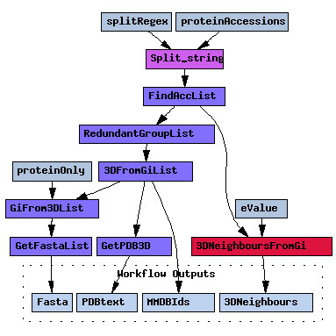
There are additional functions which may be useful when exploring structure such as GetDomainsFromGiWithEvalue() which retrieves domains for a given protein sequence from the Conserved Domain Database (CDD) as assigned by Reverse Position Specific BLAST (RPS BLAST). Please see the API documentation for more functions. VAST structure neighbours are not available in SeqHound.
Note that the PDB files returned from SeqHound are NCBI-MMDB PDB-Format Files derived from ASN.1 and may have some changes from the original PDB file. For example, taxonomic information may be reannotated using NCBI Taxonomy. See the REMARK section in the returned PDB file for complete details.

Useful Links

SeqHound
SeqHound Website help section
http://www.blueprint.org/seqhound/api_help/seqhound_help_guides.html
Usergroup
http://lists.blueprint.org/mailman/listinfo/seqhound.usergroup
The usergroup is intended for general public announcements and public group discussion on SeqHound. This may include suspected bugs, feature requests, or problems and solutions working with SeqHound.

Taverna
Taverna homepage http://taverna.sourceforge.net/

NCBI
Molecular Modeling Database (MMDB)
http://www.ncbi.nlm.nih.gov/Structure/MMDB/mmdb.shtml
Handbook on Macromolecular Structure Databases http://www.ncbi.nlm.nih.gov/books/bv.fcgi?rid=handbook.chapter.94
Conserved Domain Database (CDD)
http://www.ncbi.nlm.nih.gov/Structure/cdd/cdd.shtml

Protein Data Bank
http://www.rcsb.org/pdb/

Bugs
The example inputs in this tutorial will be reviewed periodically as they may become obsolete.
If you think you have found a bug then please submit the details to seqhound@blueprint.org.

