# Coding in the Cloud

This tutorial will show you how to setup Software as a Service (SaaS) called Codenvy so that you can learn to program using the Cloud. Using the cloud will let you program from any computer on almost any browser.

## Step #1

Open a browser such as Chrome or Internet Explorer and type the URL <https://codenvy.com>

Once you see the following screen select the “Try Codenvy” button.

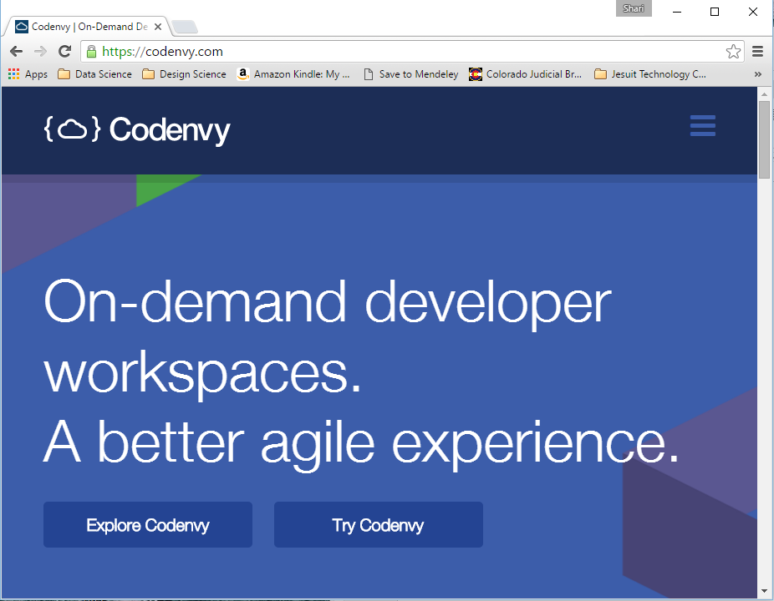

## Step #2

Select “Stat with Saas”

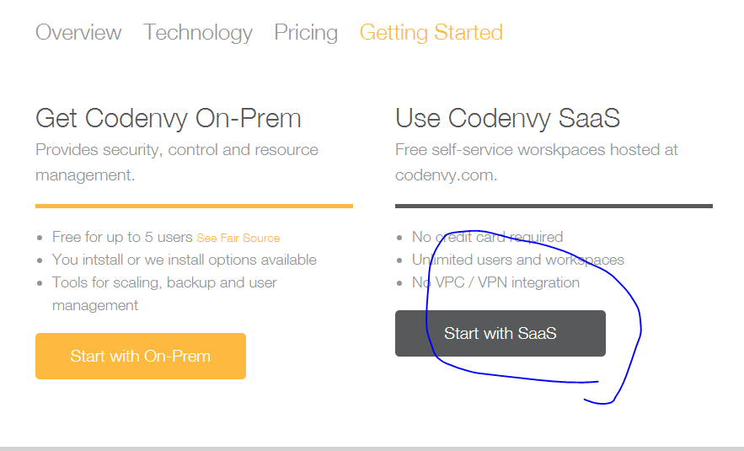

## Step #3

Select “Create Free Account”

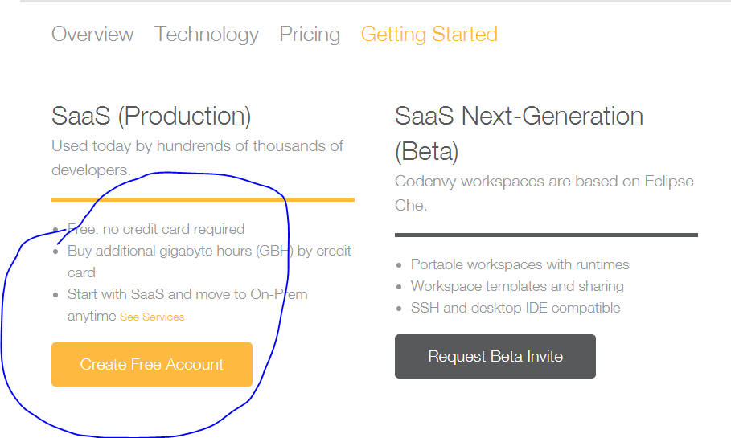

## Step #4

Enter your email address and create a workspace name such as “CoderDoJo”.

Click “Sign Up”

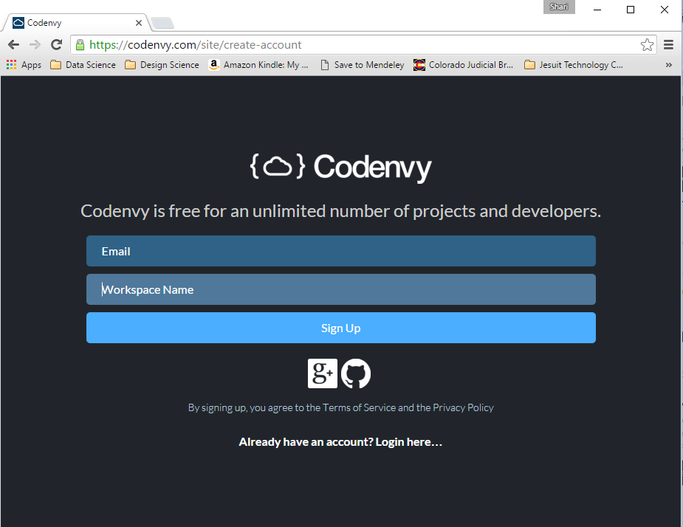

## Step #5

Check your email for a message from Codenvy. Follow the instructions in the email to confirm that you are a real person.

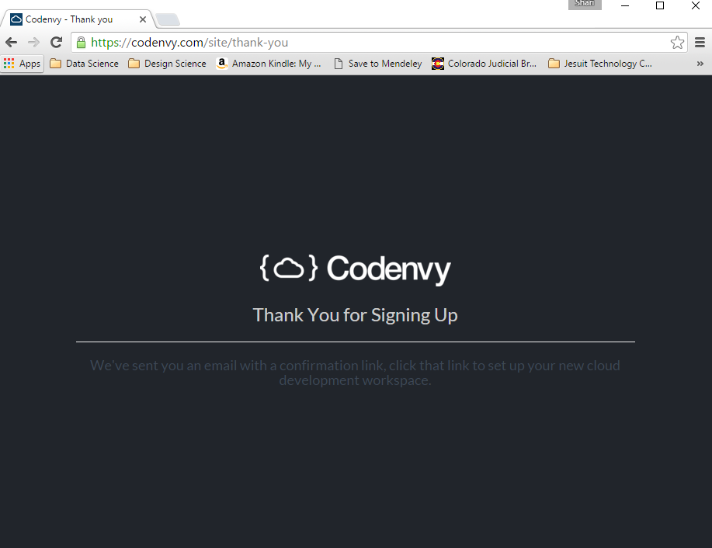

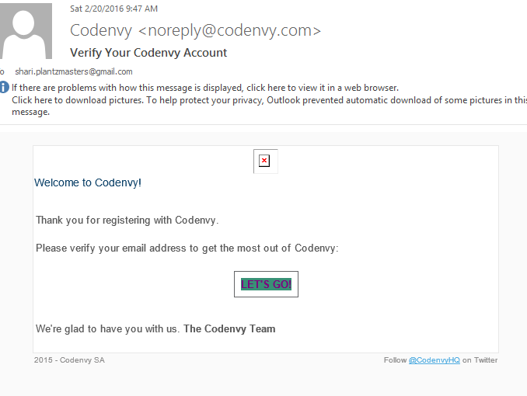

## Step #6

Follow the instructions to complete creating your account. You probably want to just skip entering credit card information for now.

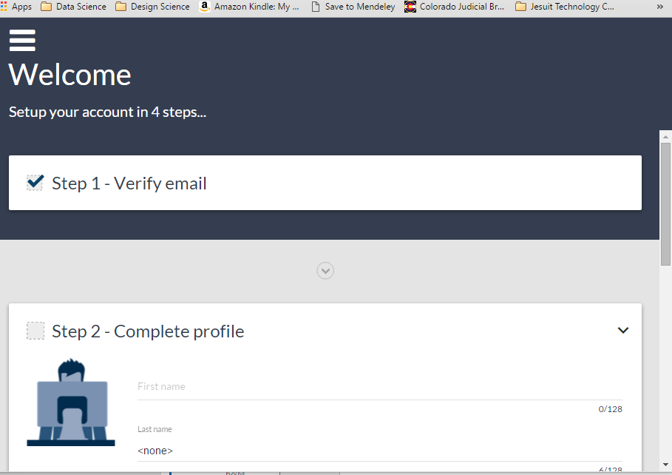

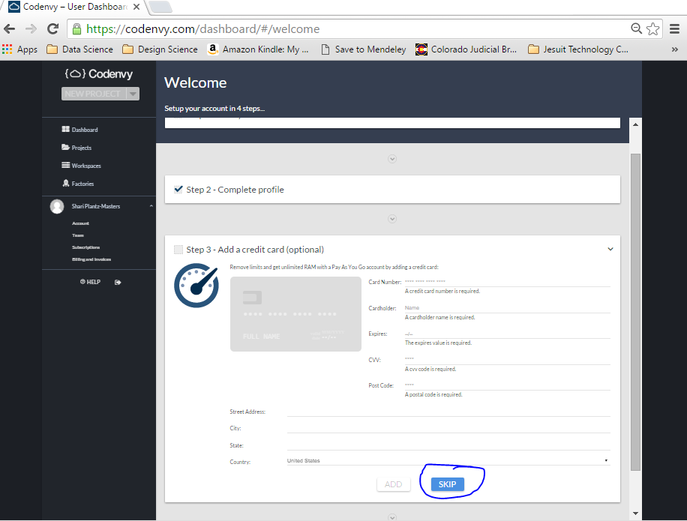

## Step #7

**Almost There!!!**

Let’s create myfirstwebsite. Select the “Create Project” button.

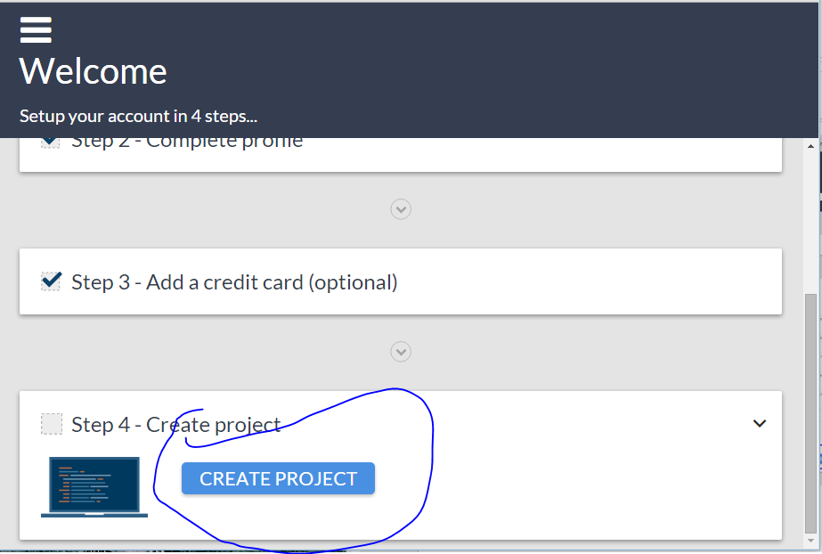

## Step #8

Select “GIT REPOSITORY”

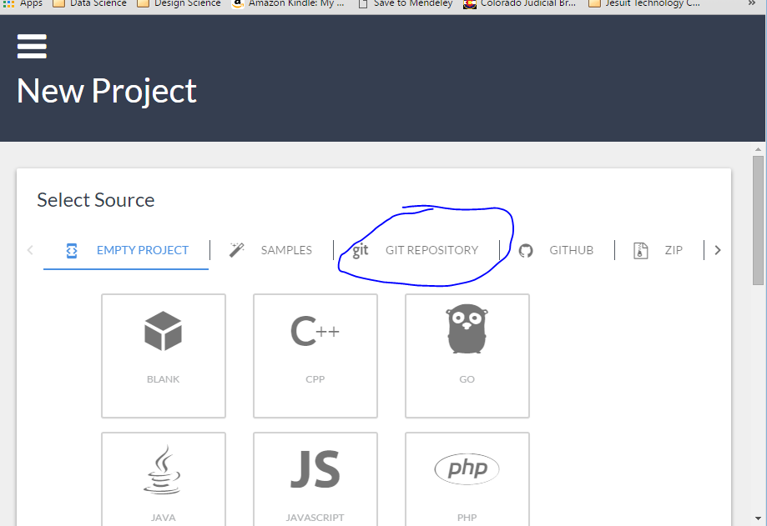

## Step #9

Where the screen says “Git URL:” type or copy and paste

<https://github.com/CoderDojoDenver/MyFirstWebsite>

Most likely you want your project to start out being private so select “PRIVATE”

Select “CREATE PROJECT” for codenvy to set up your workspace and create the project.

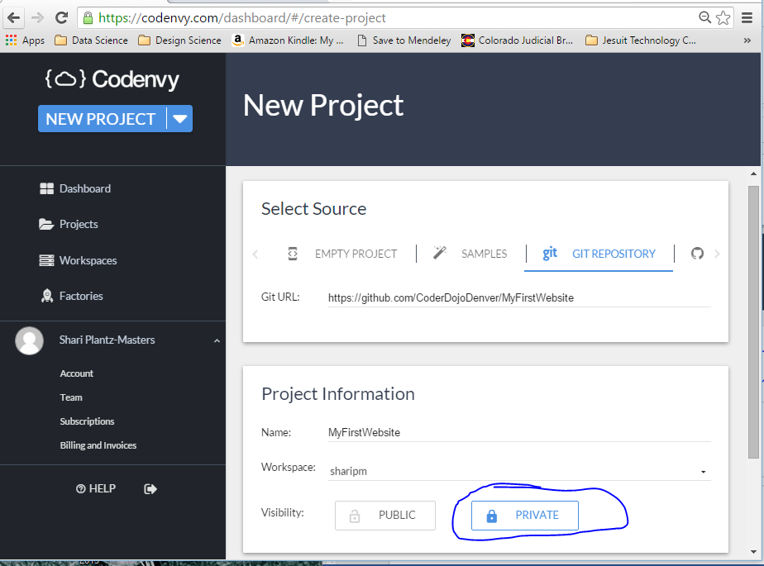

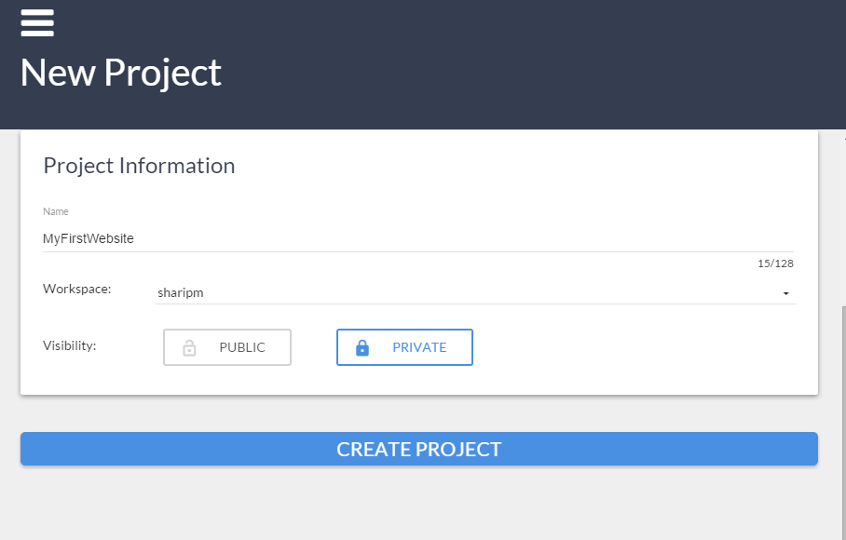

## Step #10

Let’s start working on our project. Select “OPEN IN IDE”

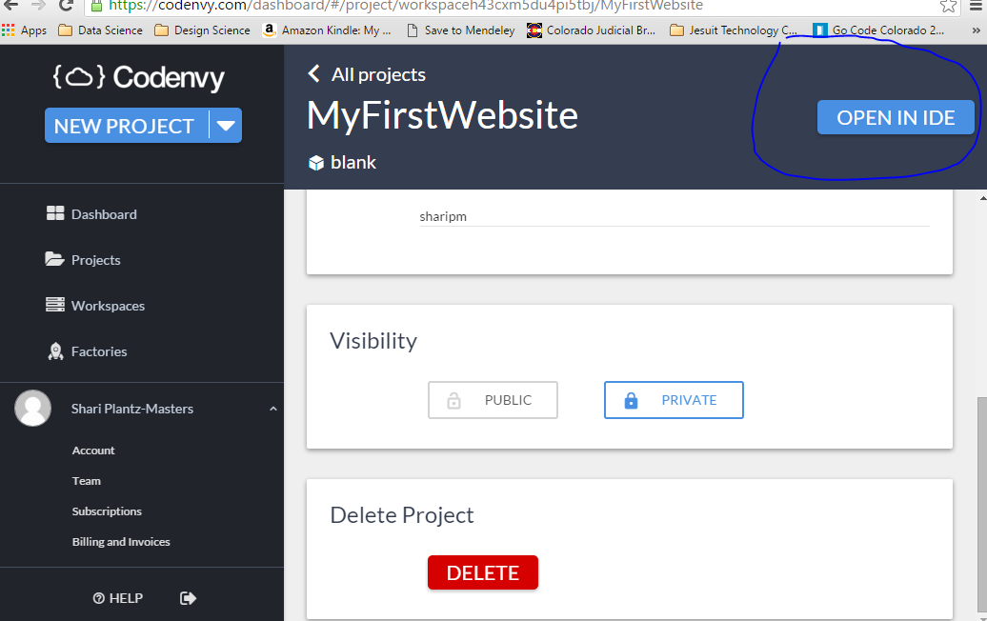

## Step #11

At this point you show see this screen and your project will be loaded into Codenvy.

## Step #12

Let’s run the project

In the top menu click “Run” then select “Run With…”

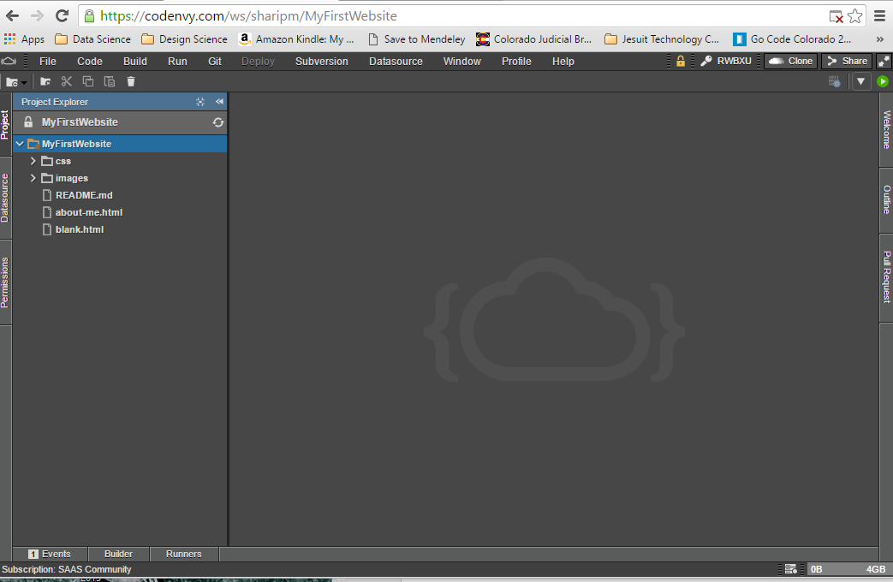

## Step #13

On the left side in the Configs area scroll down and select “Apache 2?

On the right side in the Properties box select “Project Default”

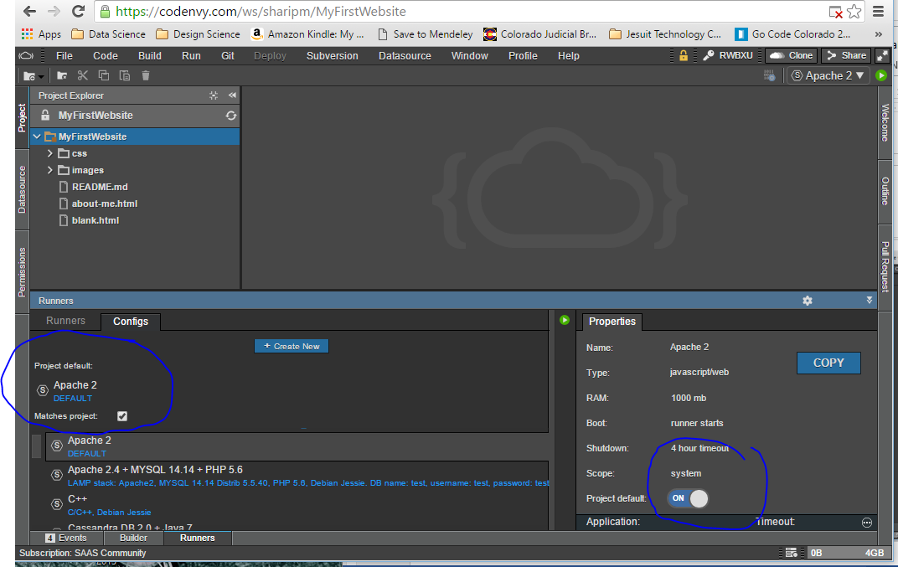

## Step #14

On the top menu select Run again and select “Run” from the drop down

You will see Codenvy start up your web site. When it’s done look at the bottom of the screen for the application url as seen in the screen shot. Select this link and your web site will open up.

