Supplementary material
Ian Driver
Abstract

Independent Researcher, Detroit, MI, USA · Correspondence: driver.ian@gmail.com
Supplement to “Annotating single-cell data on a laptop”. Figures and tables referenced from the main text as Supplementary Figure S1–S5 and Supplementary Table S1–S3.

Supplementary figures
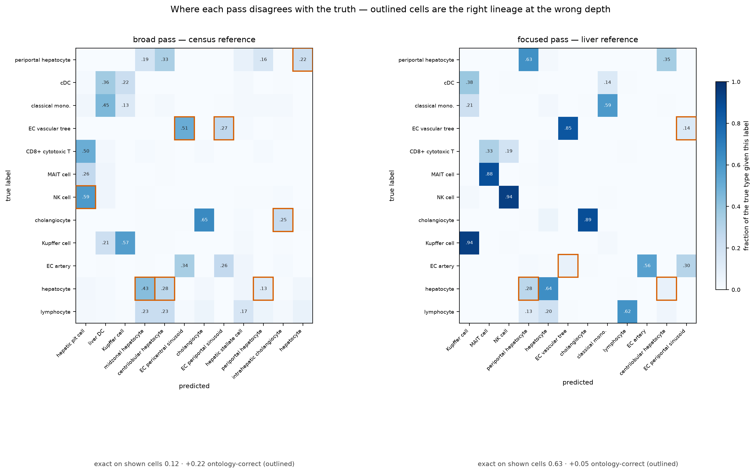
Figure S1. Confusion matrices for the broad and focused passes on the withheld cross-study liver query. Each cell is the fraction of a true type receiving that label; outlined cells are off-diagonal calls that are an ancestor or descendant of the truth in the Cell Ontology, i.e. error under exact match and credit under ontology-aware concordance. The broad pass scores 0.12 exact on the shown cells and recovers +0.22 through the ontology — its mistakes are the right lineage at the wrong depth (hepatocyte → midzonal or centrilobular hepatocyte; NK cell → hepatic pit cell, the Cell Ontology term for a liver NK cell). The focused pass is 0.63 exact, +0.05.
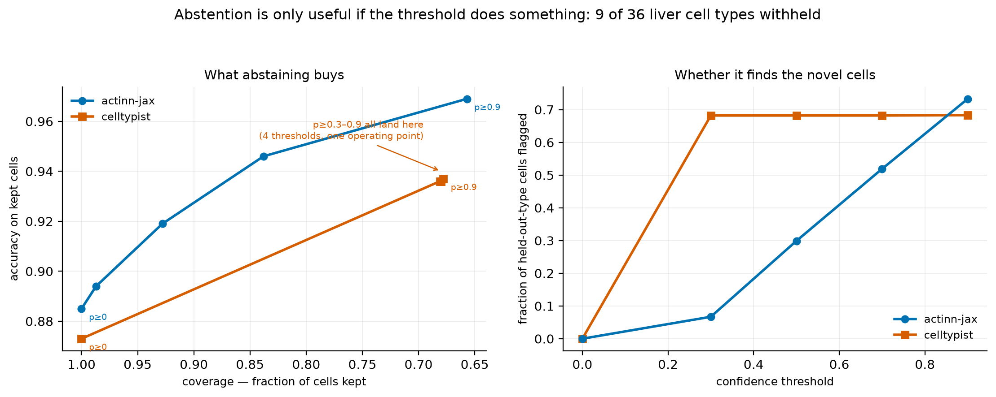
Figure S2. Abstention with 9 of 36 liver cell types withheld from the reference, so 1,350 query cells are genuinely out of distribution. Left: accuracy on kept cells against coverage. Right: the fraction of held-out-type cells flagged as the threshold rises. actinn-jax traces a usable curve on both axes; CellTypist’s probabilities are saturated, so thresholds from 0.3 to 0.9 land on a single operating point and its novel-cell detection is flat from 0.3 onward.
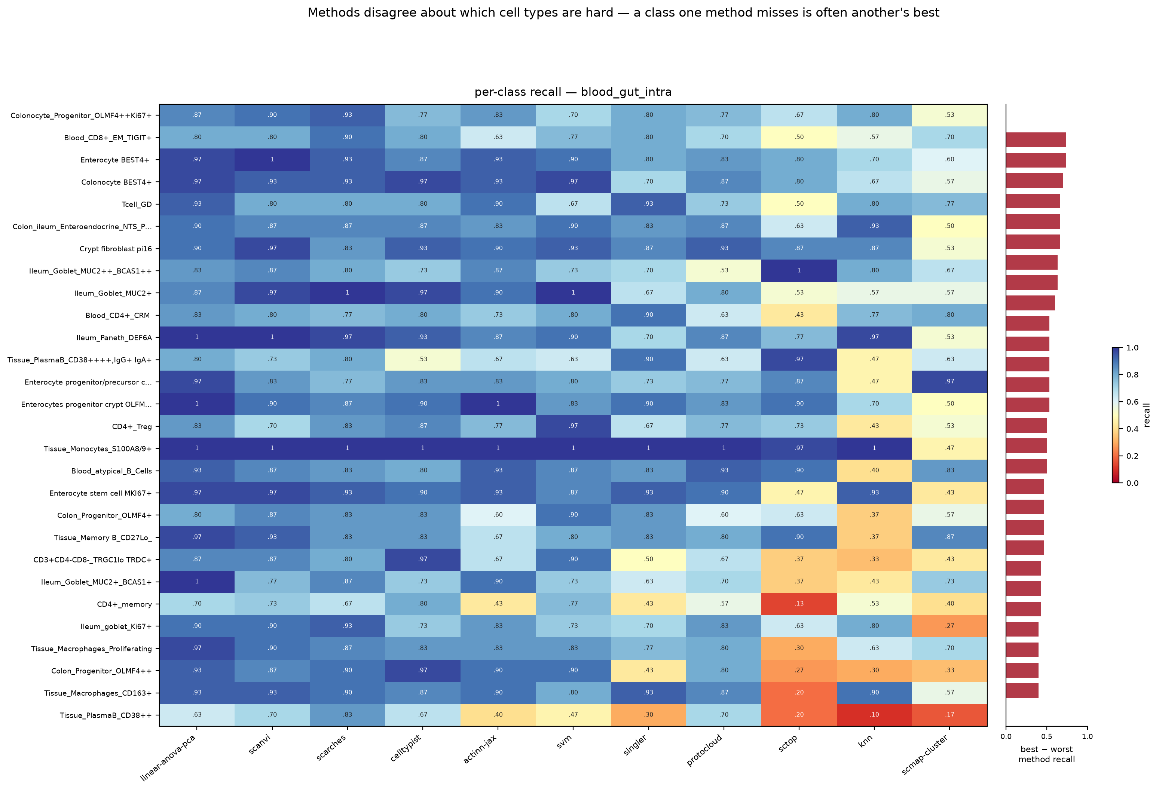
Figure S3. Per-class recall for eleven methods on the 86-type blood+gut split, ordered by how much the methods disagree (best minus worst recall, right-hand strip). The best and worst method differ by a median of 0.30 recall per class and up to 0.73; mean pairwise Spearman between methods’ per-class recall is 0.58. Class size is not the explanation — the test split is capped per label at 14–30 cells for all 86 classes, and the ten smallest classes score slightly higher than the ten largest (0.865 vs 0.827).
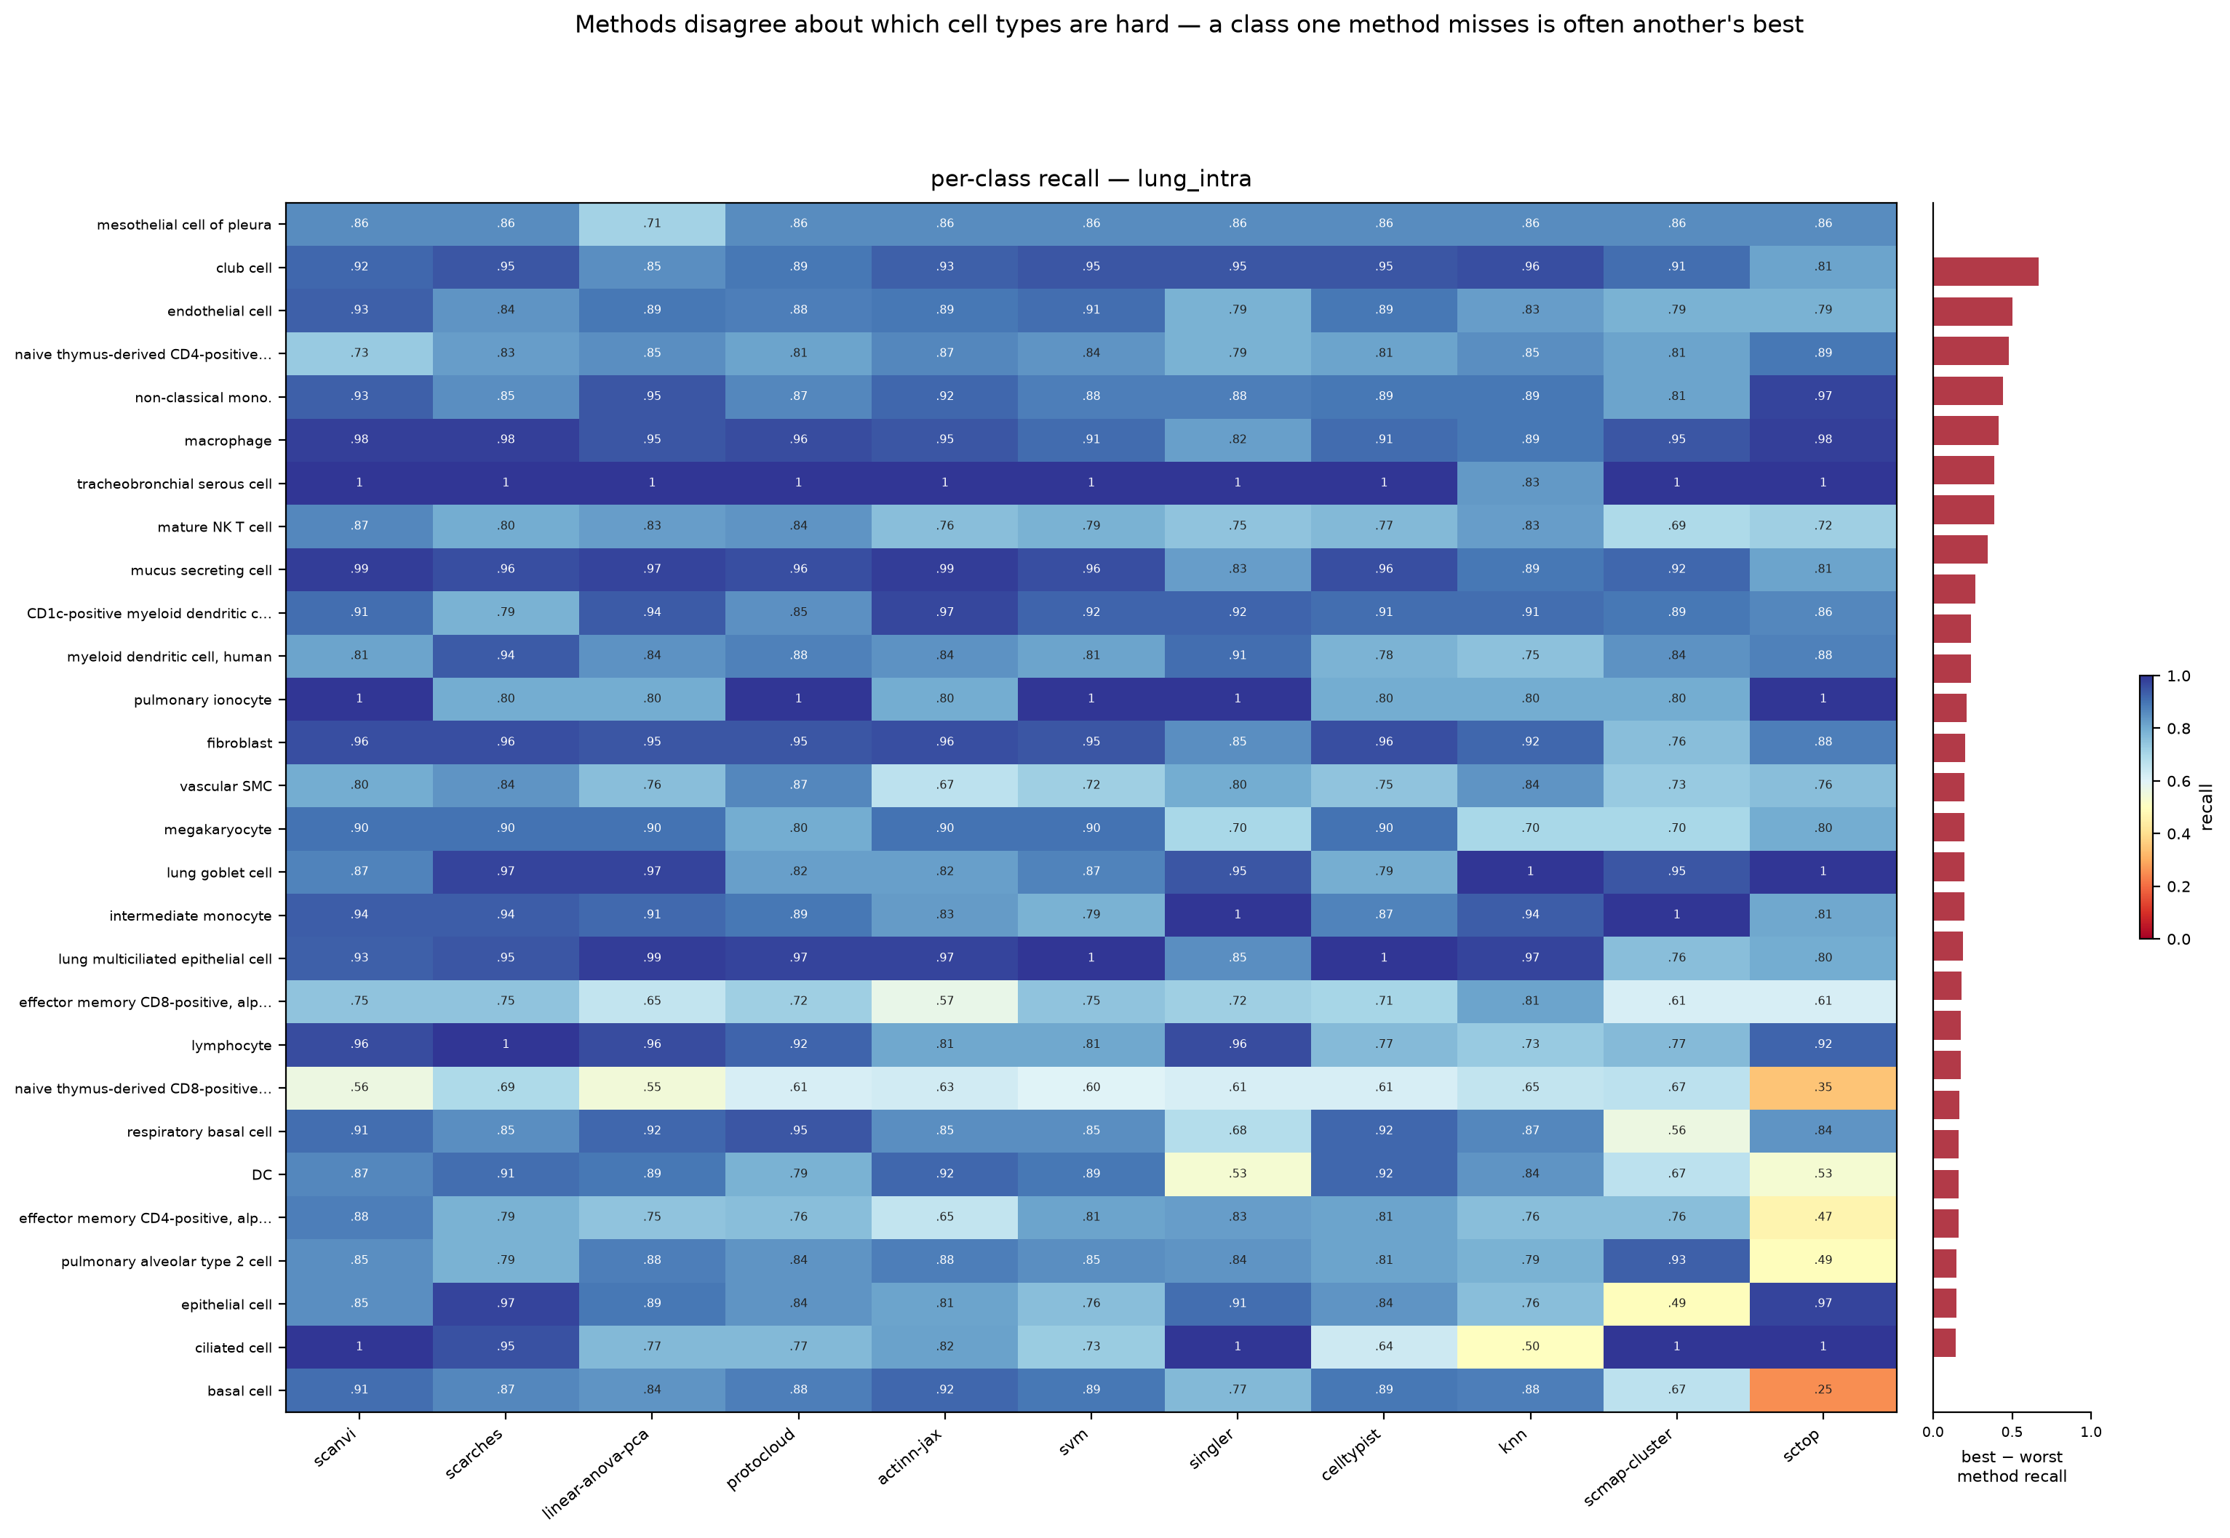
Figure S4. Per-class recall on the 46-type lung split. Mean pairwise Spearman 0.65; median best-minus-worst 0.16.
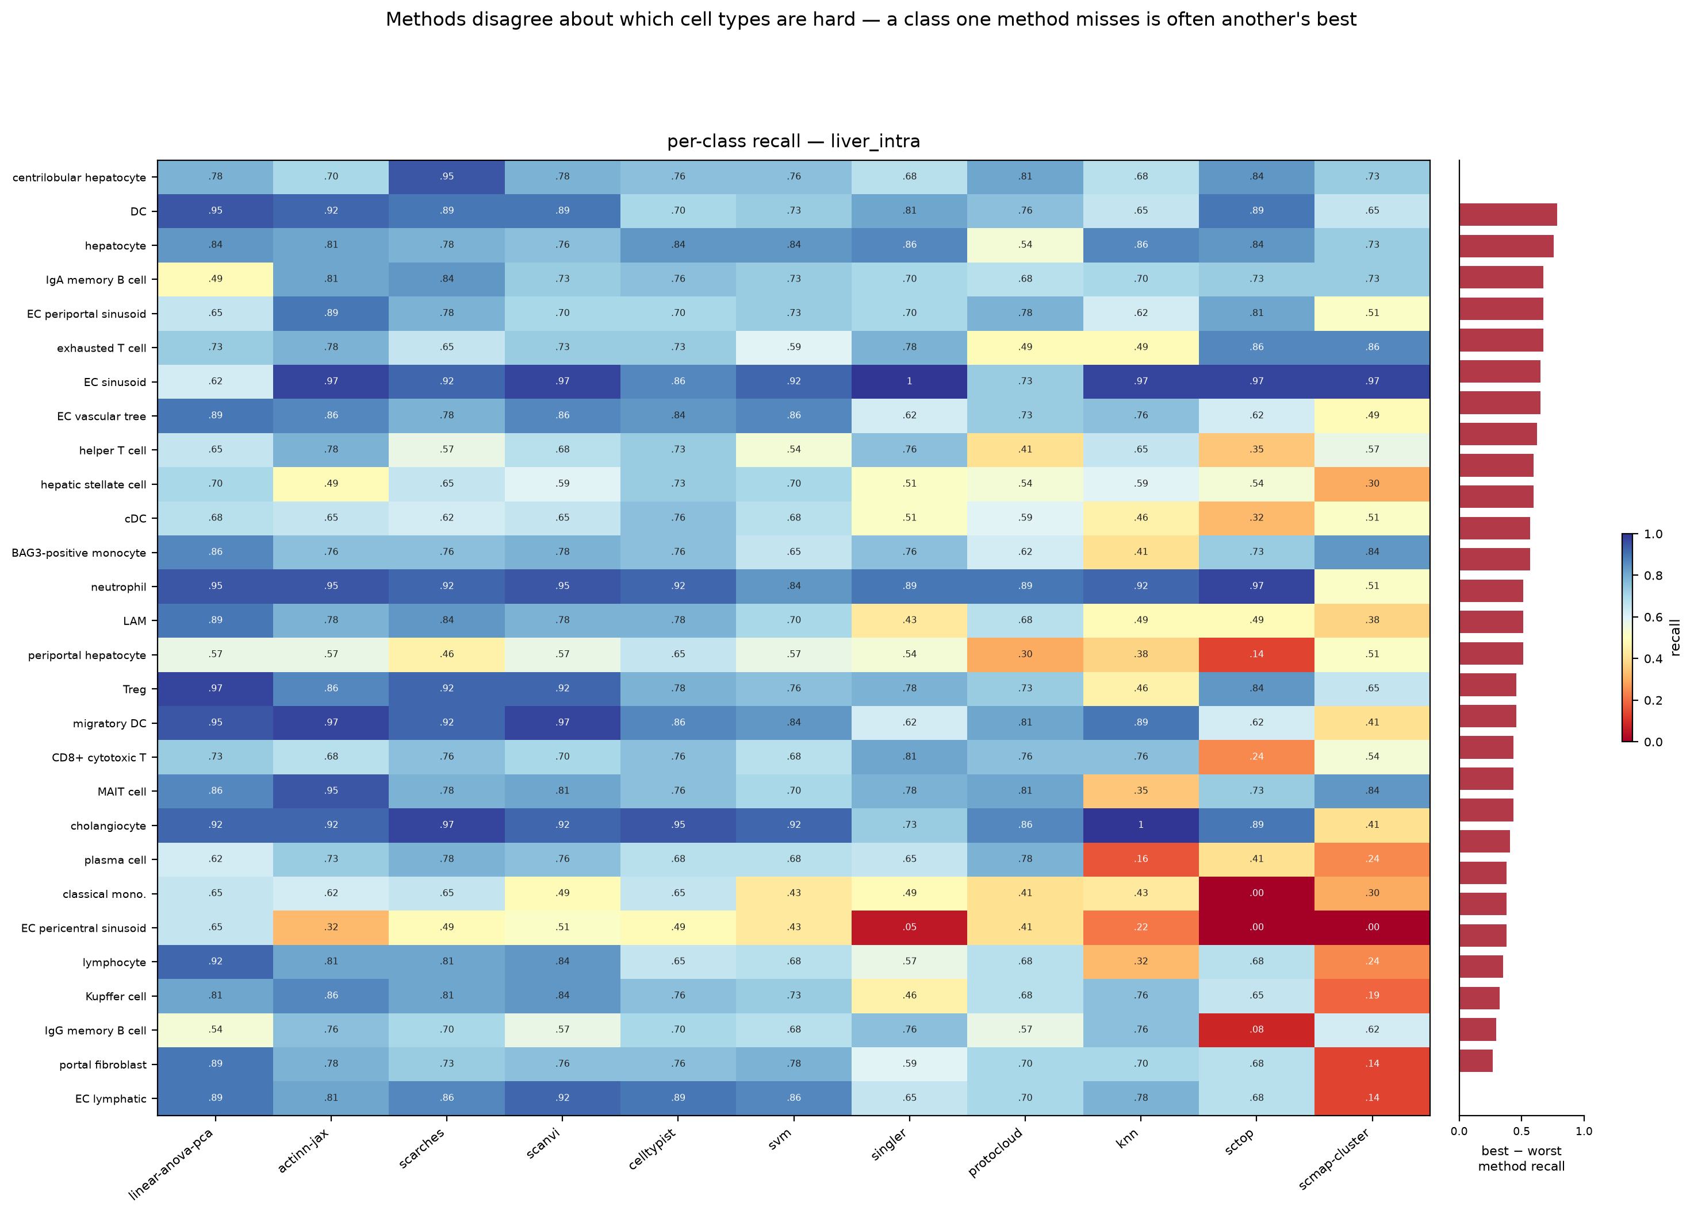
Figure S5. Per-class recall on the 36-type liver split. Mean pairwise Spearman 0.66; median best-minus-worst 0.43 — the widest disagreement of the three splits.

Supplementary tables
method | source | tier | engine | rejection | runtime
actinn-jax | [Ma & Pellegrini 2020] | classical | JAX MLP | confidence threshold | JAX
SVM | [Pedregosa 2011] | classical | linear SVM (SGD) | — | scikit-learn
kNN | [Pedregosa 2011] | classical | k-nearest neighbors | — | scikit-learn
CellTypist | [Domínguez Conde 2022] | linear | L2 logistic regression | prob threshold | scikit-learn
linear-anova-pca | [Pedregosa 2011] † | linear | normalize → ANOVA → PCA(220) → logreg | prob | scikit-learn
scTOP | [Yampolskaya 2023] | parameter-free | rank z-score class-average projection | — | NumPy
SingleR | [Aran 2019] | correlation | Spearman + fine-tuning | — | R
scmap-cluster | [Kiselev 2018] | correlation | centroid cosine | yes (unassigned) | R
scANVI | [Xu 2021] | deep | scVI semi-supervised VAE | prob | scVI
scArches | [Lotfollahi 2022] | deep | scANVI reference surgery | prob | scVI
ProtoCloud | [Guo & Ding 2026] | deep | prototype VAE + LRP attribution | ambiguity flag | PyTorch
scPRINT | [Kalfon 2025] | foundation | pretrained transformer, zero-shot | — | PyTorch
Pan-human Azimuth | [Sarkar et al. 2026] | pretrained | 8-level hierarchical NN, fixed 382-leaf typology | trained Unassigned | TensorFlow
Table S1. The benchmarked methods: model family (tier), the engine each one runs, whether it can decline to call a cell (rejection), and the runtime stack it was run on.
dataset | source | split | tissue | #types | genes | notes
lung_intra | [Travaglini 2020] | within-dataset | lung (Krasnow) | 46 | Ensembl | 300 cells/type ref
lung_cross | [Sikkema 2023] → [Travaglini 2020] | cross-dataset | lung (HLCA → Krasnow) | 46 | Ensembl | different lab/protocol
liver_intra | [Edgar 2026] | within-dataset | liver (HLiCA) | 36 | Ensembl | 150 cells/type
liver_cross | [Edgar 2026] | cross-study | liver (HLiCA) | 34 | Ensembl | train 6 studies → test withheld study
blood_gut_intra | [Alegbe 2026] | within-dataset | blood + gut (IBDverse) | 86 | Ensembl | high cardinality; no CL ids
pbmc | [10x Genomics 2016] | within-dataset | PBMC (pbmc3k) | 8 | symbols | small-n; scPRINT skips (symbols)
Table S2. The six benchmark datasets. split separates within-dataset holdouts from cross-dataset and cross-study transfer; genes records whether the matrix is keyed by Ensembl ids or gene symbols.
dataset | actinn-jax | best method (acc)
lung_intra (46 types) | 0.894 | ProtoCloud 0.932
lung_cross (cross-dataset)† | 0.358 exact / 0.752 ontology | ProtoCloud 0.374 / 0.791 ontology
liver_intra (36 types) | 0.802 | linear-anova-pca 0.804
liver_cross (cross-study) | 0.686 exact / 0.731 ontology | actinn-jax
blood_gut (86 types) | 0.860 | linear-anova-pca 0.902
pbmc (8 types) | 0.913 | scArches 0.931
Table S3. Per-dataset accuracy: actinn-jax against whichever method leads that dataset. † on lung_cross the exact-match score is a vocabulary artifact, so ontology concordance is the meaningful column.

