actinn-jax: a fast, low-memory, CPU-first classifier for reference-based single-cell type annotation, with a large-to-refined workflow
Ian Driver
Abstract
Reference-based cell-type annotation is a routine, high-volume step in single-cell analysis, and most labs run it on a laptop, not a GPU cluster. We present actinn-jax, a from-scratch JAX reimplementation of ACTINN (a 4-layer MLP classifier) with a sparse-aware pipeline and a train-once/map-many cached reference model, and benchmark it neutrally against nine other methods spanning every major method class — classical (SVM, kNN), regularized-linear (CellTypist), marker/correlation (SingleR, scmap), the original TensorFlow ACTINN, deep probabilistic (scANVI, scArches), and a foundation model (scPRINT) — across six datasets (within-dataset, cross-dataset, and cross-study; 8 to 86 cell types) on commodity Apple-Silicon hardware. We measure accuracy, macro-F1, ontology-aware concordance, training time, inference time, and peak memory. Across the five datasets that share a label vocabulary between reference and query, actinn-jax ties the most accurate methods (mean accuracy 0.831, vs. scANVI 0.835 and scArches 0.833 — a five-way top cluster within 0.004) while predicting ~195× faster than scANVI (0.37 s vs. 73 s per query) and using 3.6× less memory than its own TensorFlow predecessor; no benchmarked method dominates it on both accuracy and speed. (The sixth dataset, cross-dataset lung, is a label-vocabulary mismatch — see §3.1 — where every method scores ~0.35 by exact match but ~0.75 by ontology-aware concordance.) The central finding is that actinn-jax is Pareto-efficient: it matches the accuracy of the strongest methods while being in the fastest-inference, lightest cluster. We are explicit that it is not the accuracy champion — deep methods and boosted trees edge it by 1–2 points where they run, and a benchmark claiming otherwise would be wrong — but no benchmarked method dominates it on both accuracy and cost, and its differentiators are practical: sub-second, memory-bounded inference and a large→refined annotation workflow that a census-scale broad model (~800 human cell types, with a calibrated abstain) hands off to a small focused model for the tissue at hand (e.g. a 48-type HLiCA liver reference that lifts held-out cross-study accuracy from 0.23/0.58 to 0.72/0.86, exact-CL/ontology), plus within-cell-type resolution (hepatocyte zonation). An independent external validation on the community Open Problems label_projection benchmark reproduces the picture: actinn-jax places 3rd of 17 on accuracy (1st among methods that complete every dataset), and a controlled same-hardware rerun shows it matching its PCA-space mlp sibling at ~2× the speed and beating xgboost’s accuracy at ~5.5× less runtime and ~4× less memory. We report where it loses (small references, very few cells per type, and fine-grained cross-domain targets) and what closes the remaining gaps cheaply (opt-in standardization; a reference-guided gene budget).
Ian Driver¹˒*
¹ Affiliation to be confirmed. · ** Correspondence: driver.ian@gmail.com*

Introduction
Annotating cell types by mapping to a labeled reference is one of the most frequently run operations in single-cell RNA-seq. The method landscape is large (survey), but published comparisons ([Abdelaal 2019], [Huang 2024]) emphasize accuracy and rarely report the axis that decides what a working scientist actually runs on their own machine: wall-clock time and memory on commodity hardware, without a GPU. Foundation models (scGPT, Geneformer, scPRINT) push accuracy in some settings but need GPUs and minutes-to- hours, and — as we and others find — their zero-shot label predictions underperform a small model trained on curated reference labels.
We ask a focused, practical question: where does a small, CPU-first classifier land on the accuracy × runtime × memory frontier, against the methods people actually use? We answer it with actinn-jax, and we hold ourselves to a neutral standard — every method runs in its own environment through the same harness, on the same splits, scored by the same metrics, with the honest result reported even where actinn-jax loses.
Contributions. 1. A modern, dependency-light (no TensorFlow) JAX reimplementation of ACTINN with sparse preprocessing, chunked atlas-scale prediction, and a cached reference model. 2. A neutral 10-method × 6-dataset benchmark of accuracy, speed, and memory on Apple Silicon, with scaling curves and a rejection/abstain analysis. 3. A large→refined annotation workflow: a shipped census-wide ~800-type human reference (with a calibrated abstain) provides a broad first pass, then hands off to a small focused reference for the tissue of interest — the refinement recovers large accuracy on cross-study data where the broad model is weak — plus within-cell-type resolution (hepatocyte zonation) and a foundation-model-guided coarse→fine hierarchy. 4. An independent external validation on Open Problems label_projection, with a controlled same-hardware speed/memory comparison, and a small set of cheap, honest ablations that characterize when the gene-space model gains or loses to heavier methods (input standardization; a reference-guided gene budget; a foundation-model negative control).

Methods

actinn-jax
actinn-jax reimplements ACTINN ([Ma & Pellegrini 2020]) — a 4-layer fully-connected network (100/50/25 hidden units, ReLU, softmax) trained with Adam — in JAX/optax, replacing the original’s TensorFlow-1.x graph/session code. Key engineering: - Sparse-aware preprocessing: no adata.to_df densification; CP10k+log2 normalization and the expr/CV gene filter run on sparse matrices; only the selected-gene columns of each minibatch are densified. - Cached reference model (ReferenceModel): train once, save/load, map many queries — the amortized cost of repeated annotation against a fixed reference drops to the inference cost alone. - Chunked prediction for atlas-scale queries; use_raw='auto' to pick raw counts from .raw (CELLxGENE convention). - Optional reference-fit standardization (standardize=True): z-score each selected gene by the reference’s frozen mean/std and apply it to the query — a cheap domain alignment (§3.9). Opt-in, with a saved scaler that projects with the model; μ/σ persist in the .npz (old models load standardization-off, backward-compatible). Measured against the original TF ACTINN it is ~3.3× faster and ~3.5× lighter at equal accuracy; that comparison is included directly in this benchmark as the actinn-orig method.

Benchmarked methods
method | tier | engine | rejection | env
actinn-jax | classical | JAX MLP | abstain (min_prob) | core
SVM | classical | linear SVM (SGD) | — | core
kNN | classical | k-nearest neighbors | — | core
CellTypist | linear | L2 logistic regression | prob threshold | core
original ACTINN | classical | TensorFlow 2.15 MLP | — | .venv-tf
SingleR | correlation | Spearman + fine-tuning | — | R/.Rlib
scmap-cluster | correlation | centroid cosine | yes (unassigned) | R/.Rlib
scANVI | deep | scVI semi-supervised VAE | prob | .venv-scvi (MPS)
scArches | deep | scANVI reference surgery | prob | .venv-scvi (MPS)
scPRINT | foundation | pretrained transformer, zero-shot | — | .venv-scprint (MPS)
scPred excluded: unmaintained; requires harmony’s removed HarmonyMatrix API and older harmony versions do not compile on the current toolchain. Documented, not silently dropped.

Datasets
dataset | split | tissue | #types | genes | notes
lung_intra | within-dataset | lung (Krasnow) | 46 | Ensembl | 300 cells/type ref
lung_cross | cross-dataset | lung (HCLA→Krasnow) | 46 | Ensembl | different lab/protocol
liver_intra | within-dataset | liver (HLiCA) | 36 | Ensembl | 150 cells/type
liver_cross | cross-study | liver (HLiCA) | 34 | Ensembl | train 6 studies → test withheld study
blood_gut_intra | within-dataset | blood+gut (Sanger) | 86 | Ensembl | high cardinality; no CL ids
pbmc | within-dataset | PBMC (pbmc3k) | 8 | symbols | small-n; scPRINT skips (symbols)
The set spans the three generalization regimes (within-dataset, across datasets, across studies), an order of magnitude in cell-type count (8→86), and both gene-ID conventions.

Metrics & protocol
Per (dataset, method, repeat): accuracy, macro-F1 (unweighted over classes, so rare types count), ontology-aware concordance (a call is correct if it is the same node, an ancestor, or a descendant of the truth in the Cell Ontology — credits right-lineage-wrong-granularity calls; only where both ref and query carry CL ids), fit time, predict time, peak RSS. Each method runs in its own venv via subprocess isolation (benchmark/runner.py); the driver (benchmark/driver.py) builds identical ref/query splits once per dataset and scores every method against them. repeats = 3 (scPRINT: 1, near-deterministic and embed-dominated).
Hardware: Apple Silicon (M-series), CPU for the classical/linear/correlation tiers and actinn-jax; Apple MPS for the deep and foundation tiers. No discrete GPU, no cloud — the regime the benchmark is about. Math-library threads are left uncapped (wall-clock as a practitioner sees it); an optional thread cap is available for stricter reproducibility.

Results

Accuracy across datasets
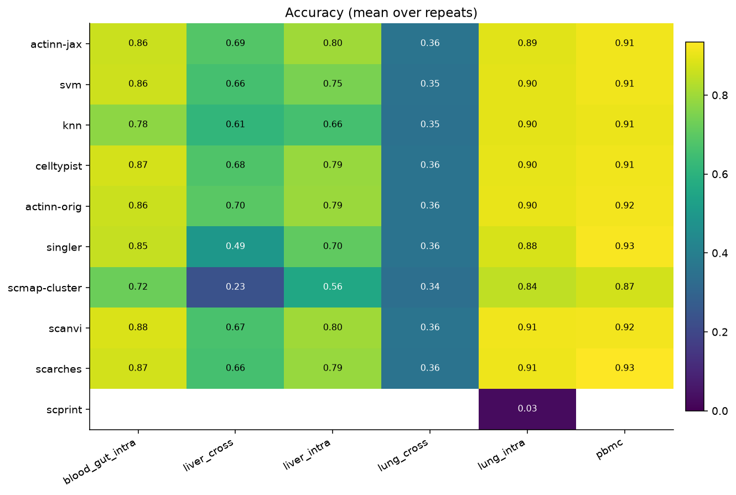
Accuracy by method (rows) and dataset (columns), in-house panel.
Mean accuracy across the five shared-vocabulary datasets (lung_cross excluded — its exact accuracy is a vocabulary artifact, see the † note below; means over all six are ~0.08 lower for every method with the identical ranking):
method | mean acc (5 datasets) | mean macro-F1 (6) | mean ontology (6)
scANVI | 0.835 | 0.701 | 0.812
original ACTINN | 0.834 | 0.691 | 0.815
scArches | 0.833 | 0.700 | 0.809
actinn-jax | 0.831 | 0.683 | 0.811
CellTypist | 0.831 | 0.697 | 0.807
SVM | 0.816 | 0.688 | 0.797
SingleR | 0.770 | 0.652 | 0.750
kNN | 0.770 | 0.624 | 0.769
scmap-cluster | 0.646 | 0.550 | 0.771
The top five methods (scANVI, original ACTINN, scArches, actinn-jax, CellTypist) are a statistical tie on accuracy — spread of 0.004 — and actinn-jax is joint-top on ontology-aware concordance (0.811). Per dataset (accuracy):
dataset | actinn-jax | best method (acc)
lung_intra (46 types) | 0.894 | scANVI 0.913
lung_cross (cross-dataset)† | 0.358 exact / 0.749 ontology | scANVI 0.360 / 0.767
liver_intra (36 types) | 0.802 | scANVI 0.802 (tied #1)
liver_cross (cross-study) | 0.686 | original ACTINN 0.695 (actinn-jax #2, top cluster)
blood_gut (86 types) | 0.860 | scANVI 0.880
pbmc (8 types) | 0.913 | scArches 0.934
actinn-jax is tied-#1 on the richer within-dataset liver data and in the top cluster on the hard cross-study split; it trails the deep methods by 1–2 points on the high- cardinality and small-n sets. scmap-cluster is consistently the weakest (0.24 macro-F1 on liver_cross).
† lung_cross exact accuracy (~0.35 for every method) is a label-vocabulary artifact, not a transfer failure. HCLA (reference) and Krasnow (query) were annotated independently and share only 20 of 46 cell-type names; 26 of Krasnow’s types are absent from HCLA’s vocabulary, so no classifier can emit the exact string. The mismatch is granularity: HCLA’s finer taxonomy has alveolar / elicited / lung macrophage but no generic macrophage (CL:0000235), while Krasnow labels many cells generic macrophage — so an HCLA-trained model predicts lung macrophage (CL:1001603) for them, exact-wrong but ontology-correct (lung macrophage is-a macrophage); likewise Krasnow’s generic endothelial cell (CL:0000115) has no HCLA counterpart. Ontology-aware concordance — which credits a same-lineage call — is 0.75–0.77 for every method, so cross-dataset transfer actually works; exact-match just conflates classifier error with vocabulary/granularity mismatch. This is precisely why we report ontology concordance, and it is a general benchmarking pitfall: cross-dataset exact accuracy between independently-annotated atlases is not a meaningful accuracy signal. The other five datasets use a single shared label vocabulary for reference and query (a split of one atlas, or HLiCA’s harmonized annotations), so their exact scores are unaffected.

Speed and memory
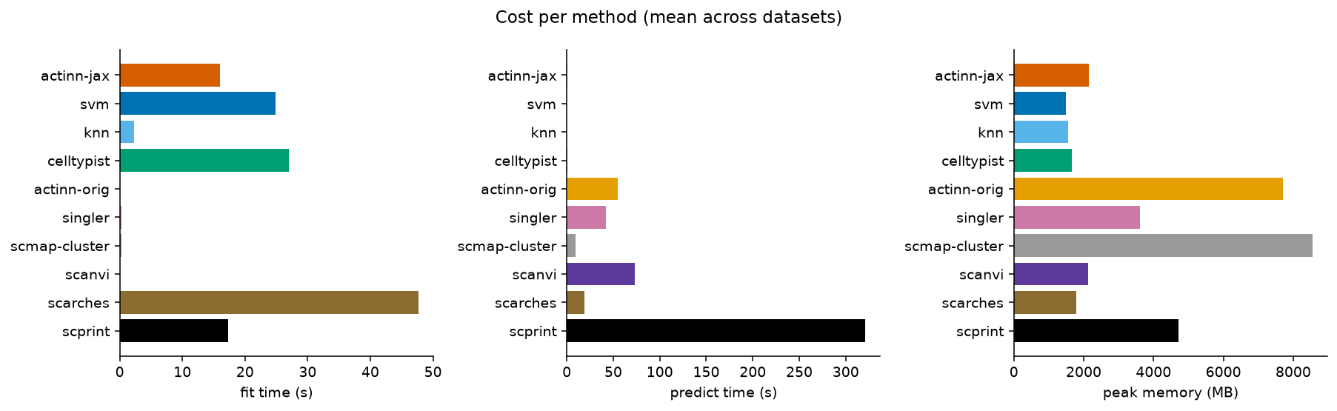
Per-query inference time and peak memory by method (in-house panel).
The accuracy tie hides a two-order-of-magnitude spread in cost. Mean per query across datasets:
method | fit (s) | predict (s) | peak mem (MB)
SVM | 24.9 | 0.10 | 1480
kNN | 2.3 | 0.24 | 1546
actinn-jax | 16.0 | 0.37 | 2145
CellTypist | 27.0 | 0.63 | 1661
scmap-cluster | 0.2 | 9.0 | 8550
scArches | 47.7 | 18.7 | 1783
SingleR | 0.2 | 42.4 | 3621
original ACTINN | 0.1* | 54.5 | 7708
scANVI | 0.0* | 73.1 | 2118
(*original ACTINN and scANVI do most work in a single train+predict pass, attributed to predict.) The four fast methods — SVM, kNN, actinn-jax, CellTypist — predict in well under a second; the deep/correlation/foundation tiers are 25–200× slower. actinn-jax predicts in 0.37 s vs. scANVI’s 73 s at statistically tied accuracy (~195×), and is far lighter than the memory-heavy tiers (original ACTINN 7.7 GB, scmap 8.5 GB). Of the methods that match its accuracy, none matches its speed; of the methods that match its speed (SVM, kNN), none matches its accuracy — i.e. actinn-jax is Pareto-non-dominated.

The accuracy × speed frontier
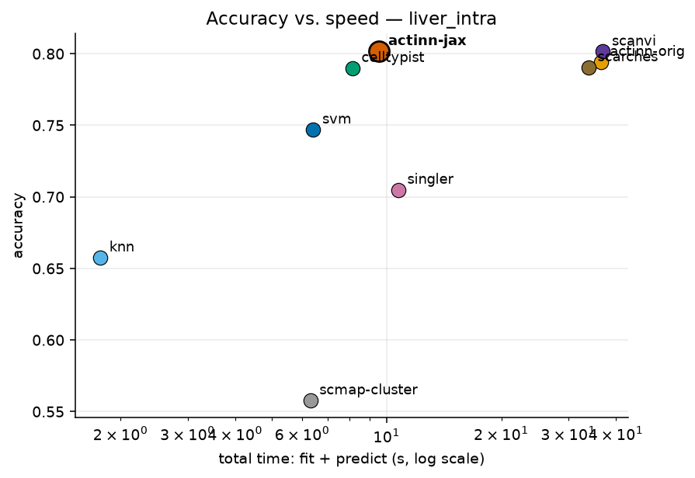
Accuracy versus total wall time (liver_intra); actinn-jax sits on the fast frontier.
Plotting accuracy against total wall time makes the frontier explicit: actinn-jax, SVM, kNN, and CellTypist form the efficient (fast) frontier, and among those actinn-jax has the highest accuracy on the richer datasets. The deep methods buy ~0.4 accuracy points on average (up to ~2 points on the 86-type blood+gut set, zero-to-negative on the liver and cross-dataset sets) at 50–200× the inference cost — the trade the frontier is meant to expose.

Scaling
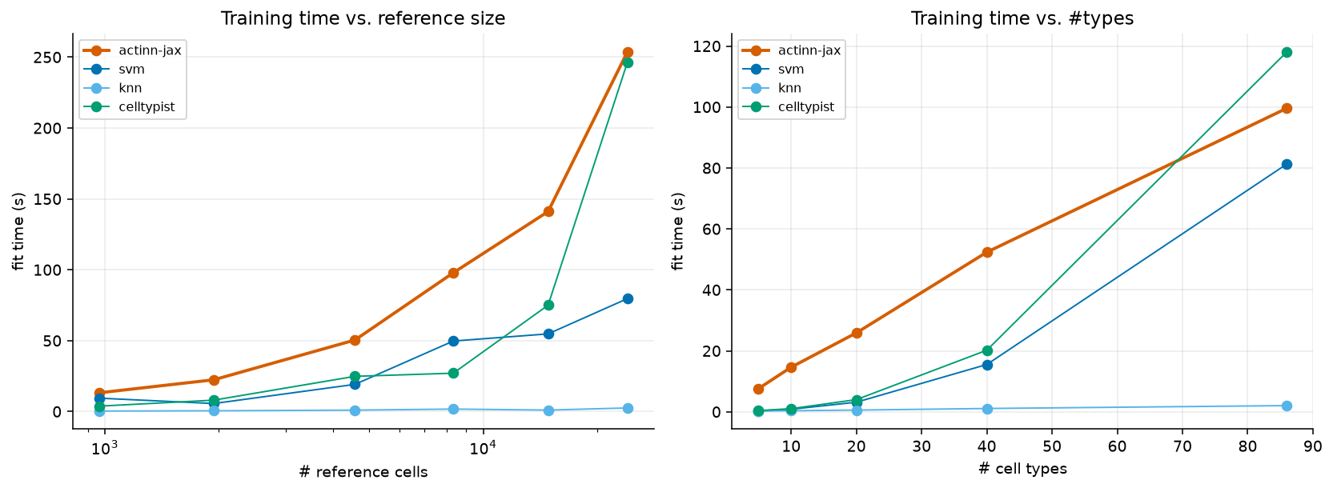
Fit and predict time versus reference size and cardinality; predict time stays flat and sub-second.
Training time grows with reference size and with #cell types for all trained methods — actinn-jax’s fit goes 13 s → 141 s → 254 s as the reference grows 965 → 14.8k → 24k cells, comparable to CellTypist (4 s → 75 s → 246 s) and somewhat above SVM (9 s → 55 s → 80 s); kNN is lazy (fit is trivial but it pays at predict and is the least accurate). The decisive result is the other axis: actinn-jax’s predict time stays flat and sub-second across the entire range — ~0.3–1.4 s whether the reference has 1k or 24k cells, or 5 or 86 types. Inference cost does not grow with reference size or cardinality, and with the train-once/map-many cache the fit cost is paid once and the flat predict cost is all that recurs — the regime that matters when a reference is reused across many queries. (The scaling script’s memory column is process-cumulative and not a clean per-size measurement; per-method peak memory is reported from the isolated-subprocess matrix in §3.2.)

actinn-jax vs. the original ACTINN
The actinn-orig row isolates the value of the reimplementation itself: same method, same data, TensorFlow-2.15 vs. JAX. Mean across the six datasets:
 | accuracy | macro-F1 | predict (s) | peak mem (MB)
original ACTINN (TF) | 0.754 | 0.691 | 54.5 | 7708
actinn-jax | 0.752 | 0.683 | 0.37 | 2145
Equal accuracy (0.752 vs. 0.754, within repeat noise), ~145× faster inference and 3.6× less memory — the reimplementation is a strict engineering win at no accuracy cost.

The large→refined annotation workflow
The most useful thing actinn-jax ships is not a single classifier but a two-tier workflow that matches how annotation is actually done: get a broad call fast, then sharpen it where it matters. Because every stage is a cached ReferenceModel with sub-second, memory-bounded inference (§3.2, §3.4), the whole workflow runs on a laptop.
Tier 1 — broad, census-scale. A shipped ~800-type human reference built from the CELLxGENE census gives any query a first-pass annotation across the whole body, with a calibrated abstain threshold so out-of-reference cells are flagged rather than force-labeled (see the smooth abstain curve of §3.7). This is the “what am I looking at” pass — broad coverage, deliberately not fine-grained.
Tier 2 — refined, tissue-focused. For the tissue the broad pass identifies, a small focused reference re-annotates at full resolution. The gain is large and it is the crux of the workflow: on held-out cross-study liver cells, the broad census model scores exact-CL 0.23 / ontology 0.58, while a focused 48-type HLiCA liver reference on the same cells reaches 0.72 / 0.86. Refinement is where fine-grained accuracy comes from; the broad model’s job is to route to it, not to be right about subtypes itself.
Supporting mechanisms. (i) A foundation-model-guided coarse→fine hierarchy: a foundation model discovers a coarse→fine structure offline, the fast CPU model uses it at inference — beats a flat classifier on 3/4 datasets, matches an expert hierarchy, beats a random-grouping control, and never depends on the foundation model at prediction time. (ii) Within-cell-type resolution: the same machinery resolves hepatocyte zonation (portal→central) at ~0.99 within-one-zone, generalizing across donors and datasets — a third tier below the cell-type label. Together these make actinn-jax a pipeline (broad → tissue → subtype/state), not just a classifier, at classical-method speed throughout.

Rejection / abstain
Holding out 9 of 36 cell types entirely from the HLiCA liver reference (so 1,350 query cells are genuinely out-of-distribution), and sweeping a confidence threshold:
threshold | actinn-jax: acc(kept) / coverage / OOD-flagged | CellTypist: acc(kept) / coverage / OOD-flagged
0.0 | 0.885 / 1.00 / 0.00 | 0.873 / 1.00 / 0.00
0.5 | 0.919 / 0.93 / 0.30 | 0.936 / 0.68 / 0.68
0.7 | 0.946 / 0.84 / 0.52 | 0.936 / 0.68 / 0.68
0.9 | 0.969 / 0.66 / 0.73 | 0.937 / 0.68 / 0.68
actinn-jax’s probability gives a smooth, tunable abstain curve — accuracy on kept cells rises 0.885→0.969 as coverage falls 1.00→0.66 and OOD-flagging climbs 0.00→0.73 — so a user can dial the precision/coverage/novel-cell-detection trade-off. CellTypist’s probabilities are saturated (near 0 or 1): the threshold jumps to 68% OOD-flagged at 0.5 and then does not move across 0.5–0.9, giving essentially one operating point rather than a tunable curve. scmap-cluster offers a single native “unassigned” decision (no sweep). The abstain knob is a concrete, practical advantage of actinn-jax’s calibrated output.

Foundation-model zero-shot (scPRINT)
scPRINT is run separately as a zero-shot predictor (no training on the reference), as a reference point for the “just use a foundation model” alternative. On the lung datasets it scored exact accuracy 0.027 / ontology concordance 0.206 in 321 s per query — vs. actinn-jax’s 0.89 in 0.2 s — so as a label predictor it is both slow (~1000× actinn-jax) and weak. Its pretrained classifier head also carries a fixed label vocabulary and requires CL ids, so it cannot emit labels outside that set; this is an inherent property of a zero-shot label head, not a defect, but it means the foundation model’s raw predictions are not a drop-in annotator. This is exactly why our two-stage workflow uses scPRINT’s embeddings — its learned structure — to shape a small trained model, never its zero-shot labels: the foundation model is valuable, its raw label predictions are not.

External validation: Open Problems label_projection
Our in-house benchmark is neutral but self-run. For an independent check, we ran actinn-jax through the community-standard Open Problems label-projection task — their 6 datasets, splits, and metrics — and slotted it into their published v2.0.0 leaderboard.
Placement. On a benchmark we did not design and cannot tune, actinn-jax places 3rd of 17 on mean accuracy (0.837), 1st among all methods that complete every dataset, beats its PCA-space mlp sibling, and posts the best accuracy of any completing method on the hardest dataset (tabula_sapiens, 160 types: 0.394 vs mlp 0.342). It is upper-mid on macro-F1 and not the top method overall — scANVI+scArches surgery and xgboost score higher on the datasets they finish, though both fail to complete tabula_sapiens, which is why they rank above actinn-jax only on a mean over the 5 easier datasets. The foundation models again land at the bottom (scgpt_zeroshot 0.639, uce 0.131 ≈ the random-labels control), reproducing §3.8 externally.
Controlled same-hardware speed & memory. Leaderboard runtimes mix hardware, so we re-ran actinn-jax and the CPU tier through OP’s own Nextflow pipeline on a single AWS r7i.8xlarge — identical hardware, harness, storage, and trace instrumentation for every method. This is the paper’s cleanest cross-method cost comparison:
method (same box) | mean acc | macro-F1 | runtime/dataset | peak RSS
actinn-jax | 0.837 | 0.655 | 165 s | 21.0 GB
mlp | 0.838 | 0.664 | 327 s | 19.9 GB
logistic_regression | 0.813 | 0.689 | 29 s | 20.0 GB
knn | 0.793 | 0.648 | 11 s | 19.5 GB
xgboost | 0.795 | 0.613 | 905 s | 80.7 GB
cellmapper_linear | 0.776 | 0.553 | 58 s | 31.5 GB
naive_bayes | 0.738 | 0.613 | 31 s | 19.5 GB
actinn-jax ties its mlp sibling on accuracy at ~2× the speed (165 vs 327 s) and beats xgboost’s accuracy at ~5.5× less runtime and ~4× less memory (165 s / 21 GB vs 905 s / 81 GB). The faster methods (knn, logistic) are less accurate; the more accurate heavyweight (xgboost) is far slower and heavier — the same Pareto-non-domination as the in-house benchmark, now on controlled hardware. (An earlier cross-hardware draft overstated the mlp speed gap as “8×”; the honest same-box figure is ~2×.)
Two cheap ablations, and their honest limits. (i) Input standardization — z-scoring genes to the reference’s frozen mean/std, a CPU-only domain-alignment inspired by scArches reference surgery — lifts mean accuracy +0.2 and macro-F1 +1.2 pt (largest on batch-shifted datasets: gtex macro-F1 +7.9). It is shipped opt-in (standardize=True) because it shifts the softmax calibration that the two-stage abstain thresholds are tuned against. (ii) Gene budget — OP feeds every method 1000 HVGs, which most starves a gene-space MLP. Widening to ~5000 HVGs lifts accuracy on 4 of 6 datasets (immune/gtex +3 pt) and there matches scANVI+scArches’s full-config leaderboard accuracy (immune 0.891 ≈ 0.892) on CPU in minutes — the gap to the top method was largely a gene-budget artifact, not the VAE. But more genes is not a universal win: it regresses tabula_sapiens by ~10 pt (its 284-cell test batch across 160 fine types overfits reference-specific genes) and saturates hypomap. Crucially, this is selectable without test labels: held-out reference cross-validation rises for the datasets that benefit and is the one signal that drops for tabula_sapiens, and a trivial query-cells-per-class check independently flags it — so the budget can be set deterministically per dataset. (iii) Negative control — a CPU-only, UCE-style protein-embedding featurization (expression-weighted mean of ESM2 gene embeddings) does not help and hurts the hardest case: the pooling discards the per-gene detail that separates fine types, so the value of a foundation model like UCE stays locked in its GPU transformer, not a portable averaging trick.
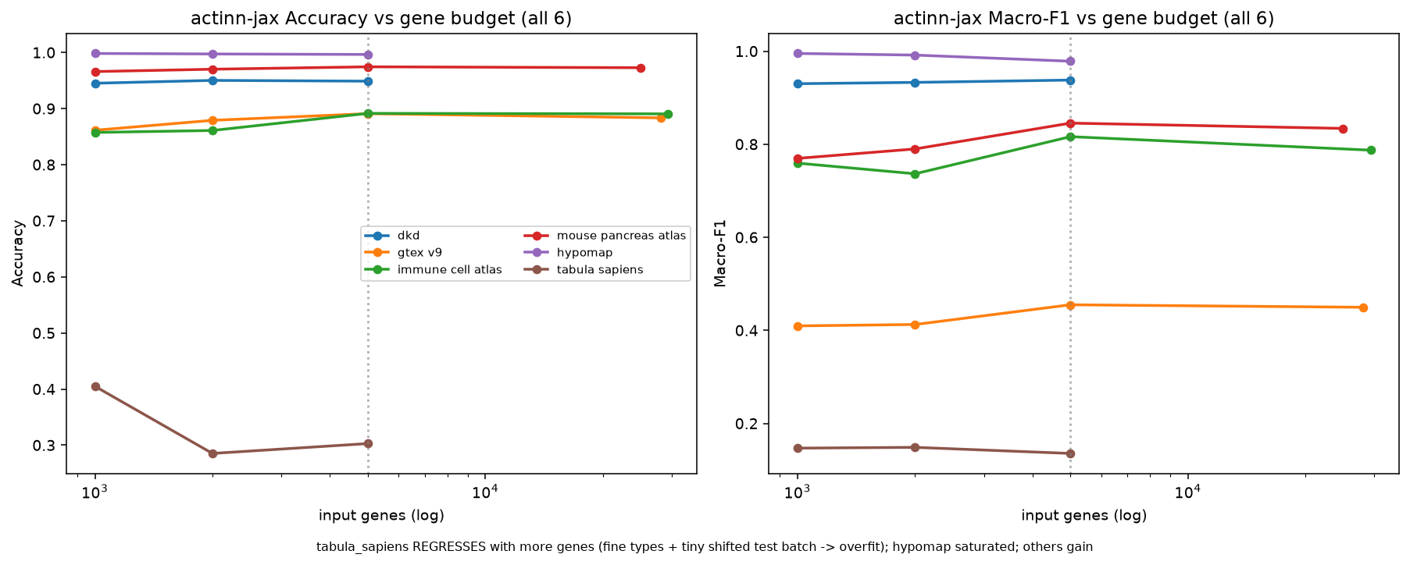
actinn-jax accuracy and macro-F1 versus input gene budget across all six Open Problems datasets. More genes help most datasets but regress the fine-grained, domain-shifted tabula_sapiens.
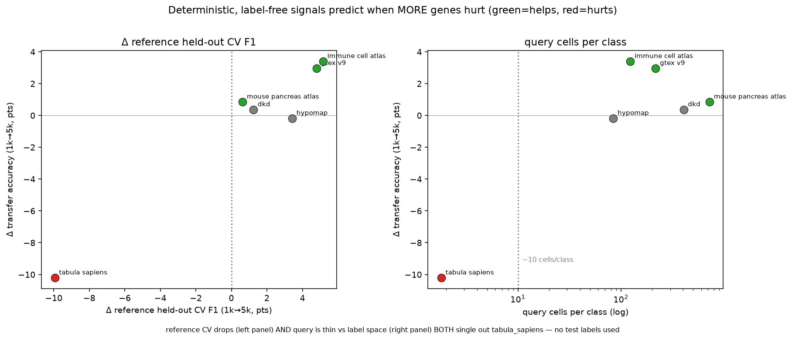
Label-free signals for setting the gene budget without test labels. Held-out reference cross-validation and query-cells-per-class both single out tabula_sapiens (where more genes hurt).

Discussion
actinn-jax is not the accuracy champion, and we do not claim it is. Deep probabilistic methods and boosted trees edge it by 1–2 points where they run, both in our panel (§3.1) and on Open Problems (§3.9); a benchmark that hid this would be wrong. What the evidence supports is narrower and, we argue, more useful: across two independent benchmarks and a controlled same-hardware rerun, no method dominates actinn-jax on both accuracy and cost, and its differentiators are the ones that decide what a working scientist runs on a laptop.
Speed and footprint. Inference is sub-second and flat — independent of reference size and cardinality (§3.4) — and peak memory sits in the lightest cluster (~2 GB in-house; ~21 GB through OP’s heavier all-layer harness, still less than half of xgboost’s 81 GB on the same box). Against methods of equal accuracy it is 2–200× faster; against methods of equal speed it is more accurate. With the train-once/map-many cache, the flat predict cost is all that recurs when a reference is reused.
The workflow is the product. The largest practical gains come not from the flat classifier but from the large→refined pipeline (§3.6): a census-scale broad model with a calibrated abstain routes a query to a small focused reference that re-annotates at full resolution (cross-study liver 0.23/0.58 → 0.72/0.86), with zonation as a further tier. Every stage keeps classical-method speed, so the whole thing runs without a GPU.
Where it loses, and why. actinn-jax trails on small references and very-few-cells-per-type sets (§3.1, §5), and — a finding from the OP analysis — it is sensitive to input budget under domain shift: more genes help most datasets but overfit a tiny, fine-grained, shifted query (tabula_sapiens). Encouragingly, the two cheapest levers are principled and label-free: standardization (a scArches-style domain alignment) and a reference-CV-guided gene budget both improve the model without peeking at test labels, and at a fair gene budget the gene-space MLP matches the leaderboard’s top method on the datasets both complete — i.e. much of the apparent gap to heavier methods is representation budget, not model class.
Foundation models. Their zero-shot labels are the weakest option in both benchmarks (scPRINT, scGPT, UCE ≈ random); their embeddings/structure are where the value lies, and our two-stage hierarchy uses exactly that. A cheap CPU shortcut to a foundation-model representation (protein-embedding pooling) did not transfer (§3.9), underscoring that the value is in the trained transformer, not a portable trick.
Practical guidance. For a one-off annotation against a small reference, SVM/CellTypist are equally good. actinn-jax pulls ahead when the reference is reused (caching), large (atlas-scale), when annotation should proceed broad→refined, or when sub-cell-type state (zonation) matters — at classical-method speed and memory throughout.

Limitations
- Single hardware family for the in-house panel (Apple Silicon); no discrete-GPU numbers there (deep/foundation tiers would be faster on CUDA — out of scope for the “runs-on-a-laptop” question). The §3.9 controlled run covers the CPU tier on one cloud box; the GPU/R methods there are reported from OP’s own cloud-CI trace (indicative). A same-hardware GPU-tier run to fold those into a single controlled table is the natural extension.
- Subsampled references (to keep the matrix tractable); the scaling section characterizes the size dependence directly.
- Human only; six datasets per benchmark; GPU foundation models beyond scPRINT/UCE (scGPT, Geneformer, popV) not run locally.
- actinn-jax needs more cells/type than linear methods to reach parity (§3.1); on very small references it trails.
- The gene budget is dataset-dependent, not a free parameter. More genes help most references but overfit a tiny, fine-grained, domain-shifted query (tabula_sapiens −10 pt); our reference-CV + cells-per-class selection rule is validated on 6 datasets with a single clean failure case, so it is directional evidence, not a tuned threshold.
- Standardization is shipped opt-in, not default, because it shifts probability calibration that the two-stage abstain thresholds are tuned against; combining the two cleanly would require re-tuning those thresholds.

Data & code availability
All configs (configs/paper*.yaml), adapters (benchmark/adapters/), result CSVs (results/paper*/, docs/results_*.csv), figure scripts, and the actinn-jax package (github.com/iandriver/actinn-jax) are in these two repositories. HLiCA data © Edgar et al. 2026 (CC-BY 4.0), [doi:10.64898/2026.06.30.735539].

References
- Ma F, Pellegrini M. ACTINN: automated identification of cell types in single cell RNA sequencing. Bioinformatics 36(2):533-538 (2020).
- Abdelaal T, et al. A comparison of automatic cell identification methods for single-cell RNA sequencing data. Genome Biology 20:194 (2019).
- Huang Q, et al. Benchmarking single-cell cell-type annotation methods. Briefings in Bioinformatics 25(5):bbae392 (2024).
- Domínguez Conde C, et al. Cross-tissue immune cell analysis reveals tissue-specific features in humans (CellTypist). Science 376:eabl5197 (2022).
- Aran D, et al. Reference-based analysis of lung single-cell sequencing reveals a transitional profibrotic macrophage (SingleR). Nature Immunology 20:163-172 (2019).
- Kiselev VY, Yiu A, Hemberg M. scmap: projection of single-cell RNA-seq data across data sets. Nature Methods 15:359-362 (2018).
- Xu C, et al. Probabilistic harmonization and annotation of single-cell transcriptomics data with deep generative models (scANVI). Molecular Systems Biology 17:e9620 (2021).
- Lotfollahi M, et al. Mapping single-cell data to reference atlases by transfer learning (scArches). Nature Biotechnology 40:121-130 (2022).
- Chen T, Guestrin C. XGBoost: a scalable tree boosting system. KDD 785-794 (2016).
- Rosen Y, et al. Universal cell embeddings: a foundation model for cell biology (UCE). Nature (2026), doi:10.1038/s41586-026-10689-z.
- Lin Z, et al. Evolutionary-scale prediction of atomic-level protein structure with a language model (ESM-2). Science 379:1123-1130 (2023).
- Open Problems for Single-Cell Analysis Consortium. Open Problems: a living benchmark for single-cell analysis. openproblems.bio (2024).
- Bradbury J, et al. JAX: composable transformations of Python+NumPy programs (2018). github.com/google/jax.
- Edgar R, et al. The Human Liver Cell Atlas (HLiCA). doi:10.64898/2026.06.30.735539.

