**Objective**

This article will give step by step walkthrough

1. How to create a basic WCF 4.0 Service?

2. How to host WCF Service in IIS 7.5?

3. Hot to test service in a client.

**Create WCF Service**

Create WCF service. Open visual studio select new project and then from WCF tab select WCF Service application to create a new WCF service.

[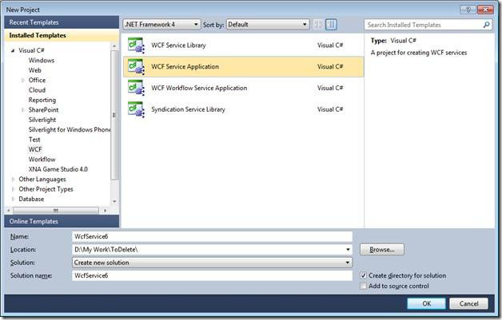](http://dhananjay25.files.wordpress.com/2010/09/clip_image0024.jpg)

Delete the default code created by WCF from **IService1** and **Service1.svc.cs**

a. So delete the data contract

b. Modify the service contract as below. Just make one operation contract to return a string .

**IService1.cs**

using System;

using System.Collections.Generic;

using System.Linq;

using System.Runtime.Serialization;

using System.ServiceModel;

using System.ServiceModel.Web;

using System.Text;

namespace WcfService5

{

    [ServiceContract]

    public interface IService1

    {

        [OperationContract]

        string GetMessage();

    }

}

**Service1.svc.cs**

using System;

using System.Collections.Generic;

using System.Linq;

using System.Runtime.Serialization;

using System.ServiceModel;

using System.ServiceModel.Web;

using System.Text;

namespace WcfService5

{

    public class Service1 : IService1

    {

        public string GetMessage()

        {

            return "Hello From WCF Service ";

        }

    }

}

Leave the default configuration created by WCF.

**Web.Config**

<?xmlversion="1.0"?>

<configuration>

  <system.web>

    <compilationdebug="true"targetFramework="4.0" />

  </system.web>

  <system.serviceModel>

    <behaviors>

      <serviceBehaviors>

        <behavior>

          <serviceMetadatahttpGetEnabled="true"/>

          <serviceDebugincludeExceptionDetailInFaults="false"/>

        </behavior>

      </serviceBehaviors>

    </behaviors>

    <serviceHostingEnvironmentmultipleSiteBindingsEnabled="true" />

  </system.serviceModel>

 <system.webServer>

    <modulesrunAllManagedModulesForAllRequests="true"/>

  </system.webServer>

</configuration>

**Host WCF Service in IIS 4.0**

**Open IIS**

a. Open the command prompt in administrator mode. To do click on Start button then type RUN in search and then in Run window type inetmgr to open IIS .

[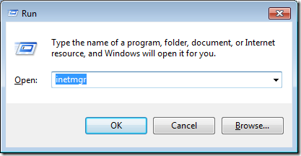](http://dhananjay25.files.wordpress.com/2010/09/clip_image0031.png)

Now you will have IIS open like below

[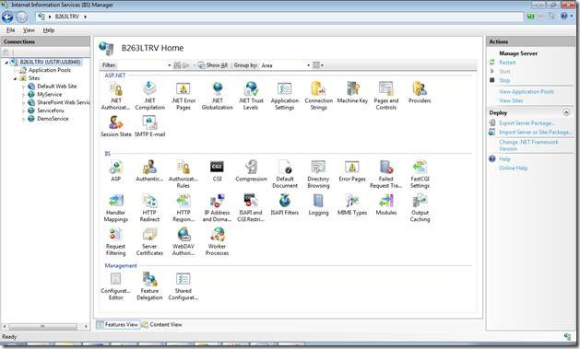](http://dhananjay25.files.wordpress.com/2010/09/clip_image0051.jpg)

b. Right click on Sites and then click Add Web Site

[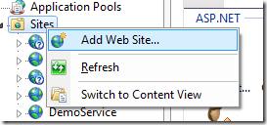](http://dhananjay25.files.wordpress.com/2010/09/clip_image0061.png)

c. Now a window will open.

[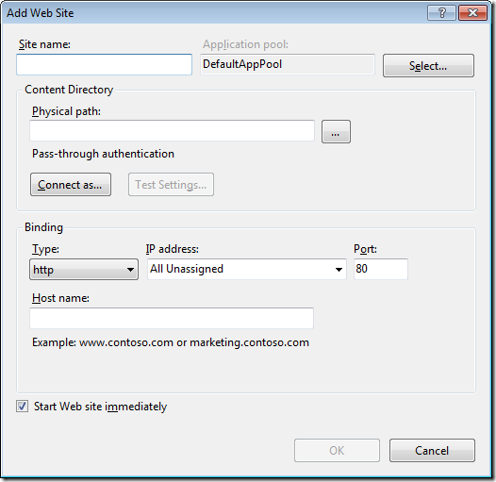](http://dhananjay25.files.wordpress.com/2010/09/clip_image0071.png)

Give any name of your choice as the site name. I am giving name here **HostedWcfService**

[](http://dhananjay25.files.wordpress.com/2010/09/clip_image0081.png)

Now click on **select** and choose ASP.Net v4.0 from the drop down.

[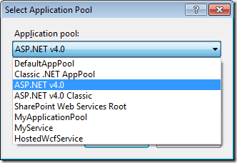](http://dhananjay25.files.wordpress.com/2010/09/clip_image0091.png)

Now in the physical path section, we need to give physical path of the service. So to get the physical path of the service, right click on the WCF Service project in visual studio and click open project in windows explorer. Open the project in windows explorer and from address bar copy the path and paste that below. Or you can browse also. Just click on browse button and navigate to project folder of the WCF Service.

[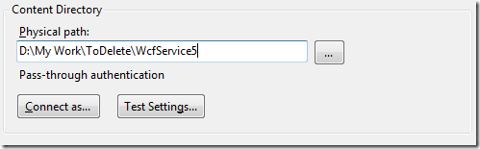](http://dhananjay25.files.wordpress.com/2010/09/clip_image010.png)

Now at the Binding section select HTTP. Give any port number. I am selecting the port as 4567

[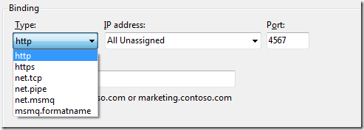](http://dhananjay25.files.wordpress.com/2010/09/clip_image011.png)

Do not give any name as host name. Leave it blank

[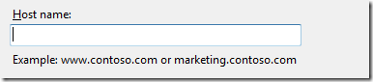](http://dhananjay25.files.wordpress.com/2010/09/clip_image012.png)

Check the check box Start Web Site Immediately.

[clip_image013](http://dhananjay25.files.wordpress.com/2010/09/clip_image0131.png)

And now click OK on the window.

d. Now open visual studio command prompt in administrator mode. Right click and select as administrator

[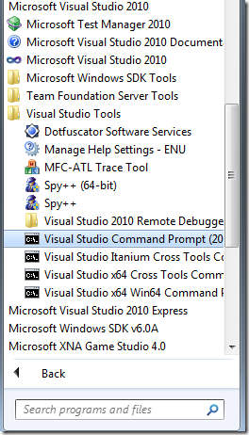](http://dhananjay25.files.wordpress.com/2010/09/clip_image014.png)

[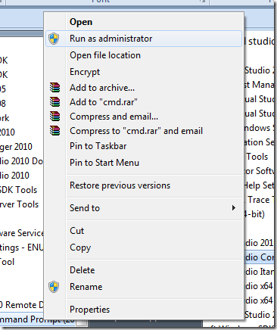](http://dhananjay25.files.wordpress.com/2010/09/clip_image015.png)

Type the below command

**aspnet\_regiis.exe /iru**

[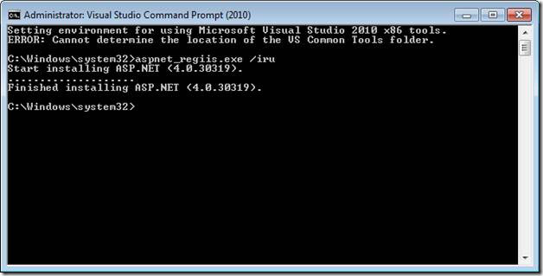](http://dhananjay25.files.wordpress.com/2010/09/clip_image0171.jpg)

You will get the message Finished Installing ASP.Net 4.0

e. Now go to **inetmgr**, you would able to see the site you just created in previous step.

[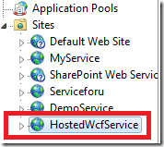](http://dhananjay25.files.wordpress.com/2010/09/clip_image018.png)

**Publishing the WCF Service**

Go back to WCF Service. Right click and select Publish

[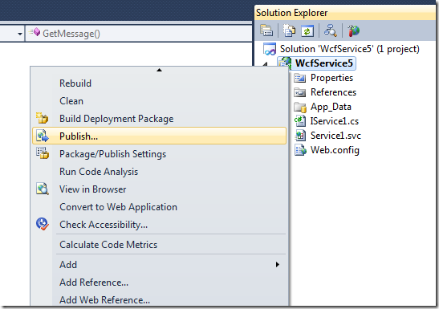](http://dhananjay25.files.wordpress.com/2010/09/clip_image019.png)

On clicking of publish a window will come.

[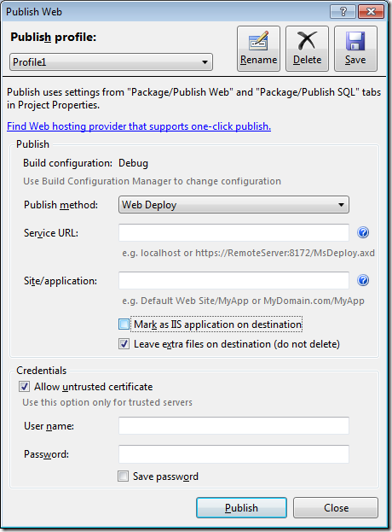](http://dhananjay25.files.wordpress.com/2010/09/clip_image020.png)

Give a Service URL. You are free to give any Service URL here. Just make sure host name is geeting resolved. In stead of localhost you can give IP address or your machine name also.

[clip_image021](http://dhananjay25.files.wordpress.com/2010/09/clip_image021.png)

Give the name of the site **HostedWcfService.** We created this site in previous step.

[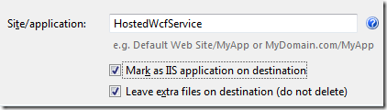](http://dhananjay25.files.wordpress.com/2010/09/clip_image022.png)

Leave the credential inactive.

[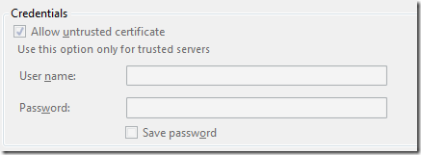](http://dhananjay25.files.wordpress.com/2010/09/clip_image023.png)

Now click on **Publish**.

[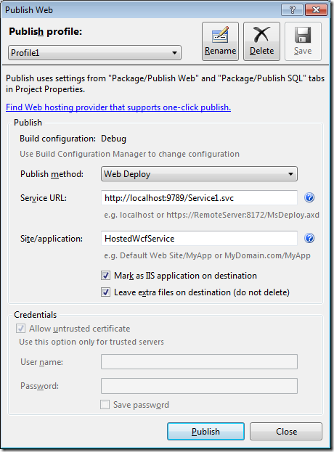](http://dhananjay25.files.wordpress.com/2010/09/clip_image024.png)

You will get the message in bottom **publish succeeded**

**Browsing the service hosted in IIS**

Open **Inetmgr** and right click on site **HostedWcfService**. Then from Manage Web Site select Browse option.

[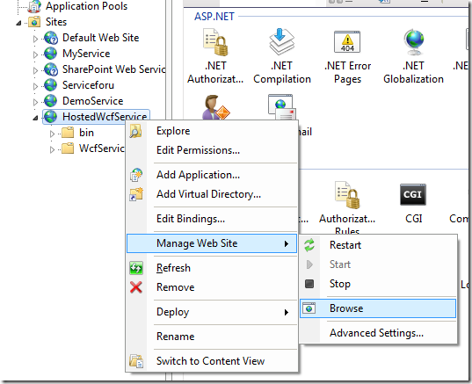](http://dhananjay25.files.wordpress.com/2010/09/clip_image0251.png)

When you click on browse site will get open in browser

[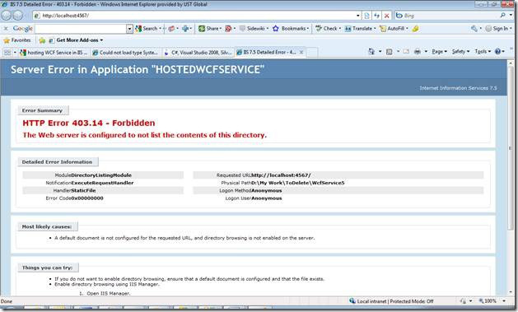](http://dhananjay25.files.wordpress.com/2010/09/clip_image027.jpg)

You will get the above error. Just in address bar append Service1.svc with the address to open the service in browser.

<http://localhost:4567/Service1.svc>

And in browser you will get the service up and running.

[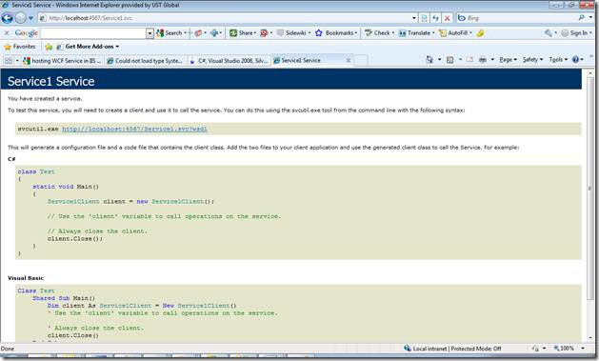](http://dhananjay25.files.wordpress.com/2010/09/clip_image029.jpg)

So now you successfully created and hosted the WCF 4.0 service in IIS 7.5