SQL Scheduling System: An Analysis

An overview of how the data points in this database actually interact

# List of Tables - Curriculum Schema

|  |
| --- |
| Cohorts |
| CourseDeletions |
| CourseHistory |
| courses |
| Curriculum |
| CurriculumCourses |
| Instructor |
| Labs |
| SectionNumbers |

# Introduction/Abstract

Having struggled with understanding the relations between the databases, I’ve decided to make this document as a reference so that future developers can work with the data worry-free. This document aims to be a text-based and semi-visual representation of the data available to me, and how each table interacts and correlates with each other table. Each article of a table herein will have three sub-article, child sections: A Brief Synopsis of correlation, An explanation of how the data correlates, and a picture and query-given example of the data being used.

# Cohorts

The cohorts table is a table the specifies a particular group of students,

Uniquely identifying them by the following columns:

CohortId, CohortStartDate, CohortSession, CurriculumId, CohortStudentCount, SectionNumber

## Synopsis

This table is one of the most important, it is the bridging factor between all other tables in this dataset. Each row represents a “Cohort” or a group of students that started at the same time, in the same curriculum. The CohortID is the identification number used to distinguish each row from each other row.

The CohortStartDate column represents the date at which that individual Cohort started their classes, this information is represented in a specific format ‘YYYYQ0’ where ‘Y’ is the year in which the end of the academic year must fall, and ‘Q’ is a number that represents the current seasonal quarter. So, for example:

For Fall, 2018(seasonal quarter 1) the date format would be:

201910

For Winter, between 2018 and 2019 it would be:

201920

The CohortSession column represents the session of class time that Cohort should be in. This is a relative datetime range, and I am unsure of its application at this time.

The CurriculumId column is where real correlation starts to occur, this field is a foreign-key that relates to the table Curriculum on the CurriculumID column, which stores the id, start-date, name, and degree-level of each curriculum.

The CohortStudentCount column simply represents the number of students in that cohort.

The SectionNumber represents the Section in which a cohort will be, which helps better identify classes. This number correlates to the field SectionNumber in CourseSections

## Examples Given

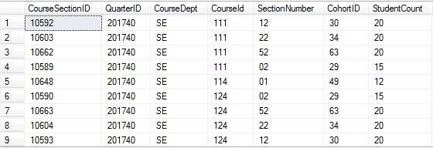

SELECT TOP 1000 [CourseSectionID]

,[QuarterID]

,[CourseDept]

,[CourseId]

,[SectionNumber]

,[CohortID]

,[StudentCount]

FROM [erik].[Curriculum].[CourseSections]

WHERE CourseDept = 'SE'

ORDER BY CourseDept, CourseId

# Courses

This table is just a list of all classes and their expanded details

## Synopsis

Textextext

## Examples Given

Kjcahljsakdj

# CourseSections