Observational Project: Photometry
AST 3Y03
Ian Fare – 001413393
January 30, 2017

Quantities needed for each image
Quantity IRAF name | How to find | obj720.fits | obj724.fits
Full Width Half fwhmpsf in datapars Max (pixels) | imexamine 'r' | 3.808 | 3.659
Read Noise readnoi in datapars (electrons) | FITS header | 3.725 | 3.725
Gain (electrons epadu in datapars per count) | FITS header | 2.425 | 2.425
Min good data datamin in datapars value (counts) | -3*read noise in counts | 8.175 | 8.175
Max good data datamax in datapars value (counts) |  | 32000 | 32000
Standard deviation sigma in datapars of background in counts | √(s + r2 ) s = sky value from imexamine 'h'; r=read noise in electrons | 17.26675 | 110.648726
Centroid algorithm calgori in centerpars |  | centroid | centroid
Size of centroid box (pixels) cbox in centerpars | 2*FWHM | 7.616 | 7.318
Inner radius of sky annulus in fitskypars annulus (pixels) | Aperture + 5 pixels | 20.232 | 19.646
Width of sky annulus (pixels) dannulu in fitskypars | 5 – 10 | 5 | 5
Size of aperture (pixels) apertur in photpars | 4*FWHM | 15.232 | 14.636

Description of procedures
For the most part, to perform photometry I followed the instructions given, and they worked pretty well. To summarize, for the first image, obj720.fits I did the following:
- Found the required quantities by looking in the image’s FITS header and using imexamine as instructed.
- Used epar phot to input these parameters for use by the daofind and phot routines.
- Used daofind to detect stars in the image, and produce as a .coo file the list of their pixel coordinates.
- Checked the resulting .coo file by superimposing the listed locations on the image, and looking for missed or false detections.
- Repeated steps 2, 3, 4, changing parameters by trial and error to minimize missed or false detections, as will be discussed after this numbered list.
- Used the phot routine to perform aperture photometry at the locations specified by the .coo file, producing a .mag file.
- Used txdump to put the useful values in the .mag file (i.e. star IDs, coordinates, and magnitudes) into an easier-to-read .phot file.
As mentioned in step 5, I had to try adjusting parameters for daofind in order to not miss too many stars, or make too many false detections. At first, using the values listed in the table above, and leaving all unspecified values as their defaults (i.e. just pressing “enter” when the routine asks for a value), I noticed that many stars were left un-detected. So, I recalled one of the parameters, which I left as its default: the detection threshold, in sigmas. I tried to keep reducing it incrementally until almost all the stars were detected (because a lower threshold means progressively dimmer stars would pass it and thus be counted), and there were very few false detections. A higher threshold means fewer false detections, but more undetected stars, while a lower threshold means more false detections, but fewer undetected stars. A good compromise was a threshold of 2.5 sigmas (the default is 4).
After performing all 7 steps, I repeated step 4 – but superimposing the existing .coo file from obj720.fits onto the other image, obj724.fits. I saw that the positions still aligned nicely with the stars in the image, so I figured that the .coo file is still valid and I’d save some time by reusing it for steps 6 and 7 for obj725.fits.
Having made a .phot file for each image, I was ready to make a colour-magnitude diagram (CMD). I read each image’s FITS header and found that obj720.fits was taken with an infrared “i” filter, and obj724.fits was taken with a visual “v” filter. I wrote a script in Python that does the following:
- Reads each file, and makes a list of the magnitudes it contains. So, two lists are produced: an infrared magnitude list, from obj720.phot, and a visual magnitude list, from obj724.phot. The first element of the infrared magnitude list and the first element of the visual magnitude list both describe the same star, the second element and the second element, and so on.
- Some of the stars in the .phot files have magnitudes of “INDEF”. I think that these are false detections, or stars that are so close to others that they can’t be resolved, or stars that are on the edge of the image so aperture photometry doesn’t work properly. So the script removes from both lists the entries corresponding to a star with an “INDEF” magnitude in either list.
- Computes each star’s colour index (i.e. its visual magnitude minus its infrared magnitude) by creating a third list. Each element in this third list is defined to be the corresponding element of the v magnitude list minus the corresponding element of the i magnitude list.
- Finally, makes a plot of all the stars’ magnitudes and colours, with v magnitude on the y-axis and the colour index on the x-axis.
I made two versions of the script; one, in addition to the steps described above, also finds the absolute magnitudes (i.e. magnitudes of stars as if they were observed from a set, constant distance), and uses those to find colour indices and plot the points, rather than the unadjusted apparent magnitudes. So at the end, I have two colour-magnitude diagrams, one with apparent magnitudes and one with absolute magnitudes!
To find absolute magnitudes, I used the equation:
with M being a star’s absolute magnitude, m being its apparent magnitude, and d being the distance to the star in parsecs, in this case 1900pc (McArthur and Kronberg, 2013).
Final colour-magnitude diagrams
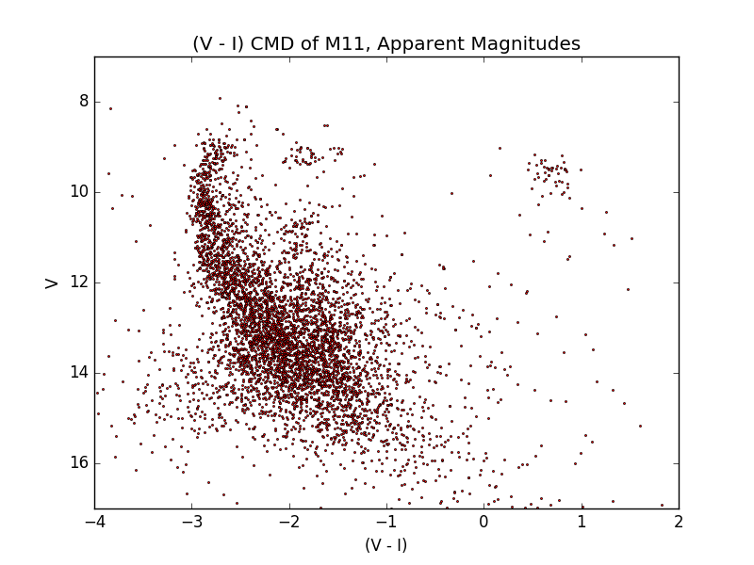
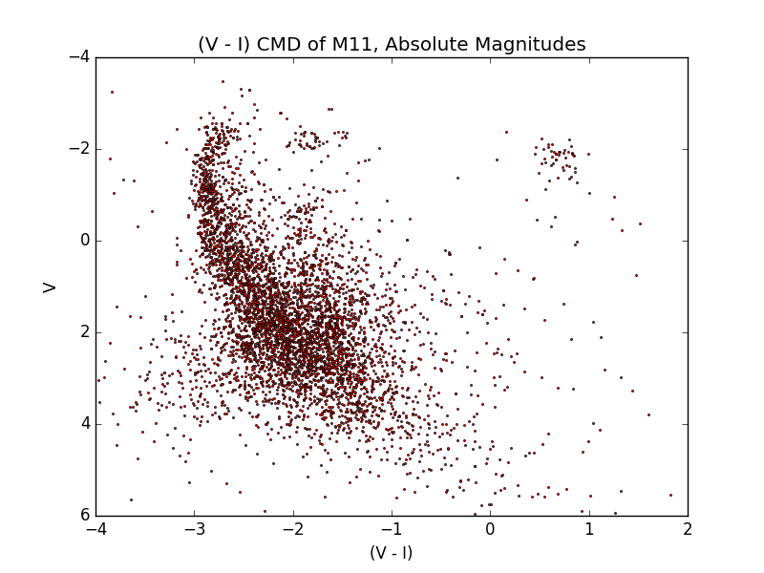
Questions
Question 1
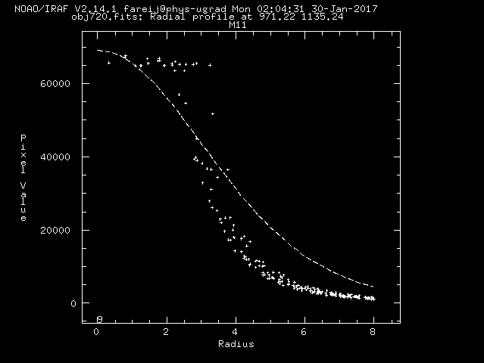
Pictured above: the radial profile of the star at (970,1137) (obtained by pressing “r”). It appears that this star has surpassed the maximum number of electrons for several pixels of the CCD, because the radial profile shows a flat horizontal line at the maximum pixel value, out to a radius of about 3. Only at around 3 pixels away do the pixel values decrease. This does not match a normal star’s psf, which would be decreasing the whole time as a well-defined psf. You can see that IRAF has a hard time fitting a psf (the dotted line) to the star, because of its oversaturation. The dotted line does not match the pixel values.

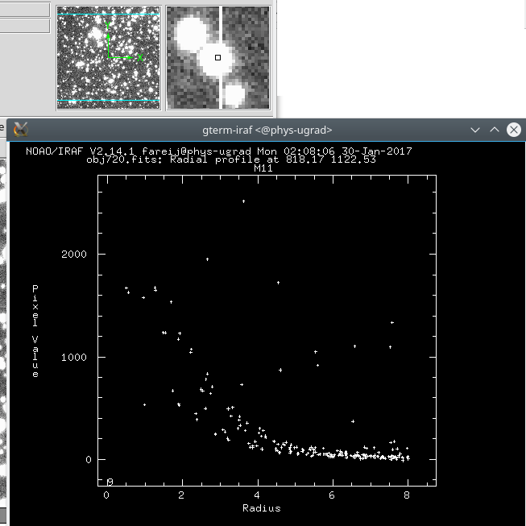
Pictured above: the radial profile (and close-up) of star at (817,1124). It has a line going through it – an artifact from an oversaturated pixel somewhere in the +y direction, probably a very bright star. The oversaturation of one pixel caused electrons to overflow into adjacent ones – all the way down to this star. From the histogram, we can see that while there is an adequate psf, there are also several points that are clearly not part of it. In the graph, there is a line of stars (I’ve traced it with a red line) that stretches all the way across the range of radii included in the profile. I think that these are the pixels from the oversaturated line, because when looking at the radial profile of a pretend “star” somerewhere else along that line, pixels in the 500-1000 range are visible there, too, along with regular background pixels near 0:
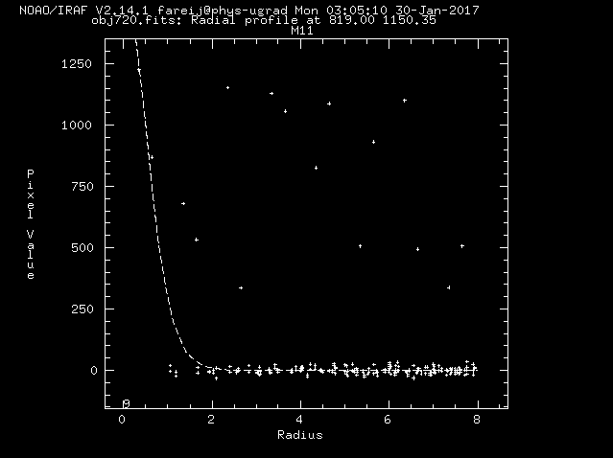
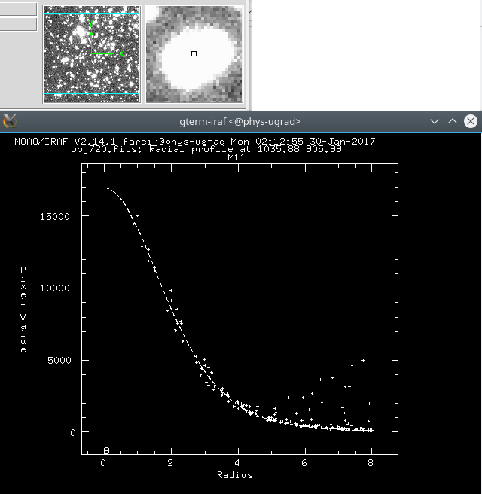\
Pictured above: the two stars at (1037,908). You can tell that there are two stars here because the close-up view shows that the object is oblong, whereas the psf of a single star should be circular. Also (more importantly), looking at the radial profile of one of the two stars, you can see a very nice psf, that is perfectly fitted – but at a radius of around 4, as can see the shape of another psf! This shows that there are two stars very close to each other, just as the visually oblong shape suggests.

Question 2
obj720.fits is taken in the infrared “i” filter, and obj724.fits is taken in the visual “v” filter. This information is from FILTER2 in the images’ FITS headers.

Question 3
The exposure time of obj720.fits is 15.000 seconds, and the exposure time of obj724.fits is 270.000 seconds. This information is from EXPTIME in the images’ FITS headers.

Question 4
The observers of both images are listed as “Welch/Webb”. I would venture to guess that these are Jeremy Webb and Dr. Welch at McMaster. This information is from OBSERVER in the images’ FITS headers.

Question 5
The photometry parameters that don’t change are the read noise, gain, min and max good data value, width of sky annulus, and centroid algorithm. The read noise, gain, and min/max good data value stay the same because they are features of the telescope and CCD. The read noise is just the noise generated as the charge on each pixel is read. That’s a property of the CCD, and shouldn’t change between images (QSI, 2008). The gain is just the conversion rate between electrons on CCD pixels and counts in the resulting image (Mirametrics, 1998). Again, this is a property of the CCD and shouldn’t change between images. The minimum good data value is just -3 * read noise. So since read noise doesn’t change between images, neither should the minimum good data value. The maximum good data value is just the maximum value that we choose for daofind, above which we assume that extremely bright pixels are the results of things other than the stars we’re interested in (a firefly passing in front of the field?). So it’s mostly just an informed human choice, I think, and it happens that 32000 works for both these images. The centroid algorithm is the same between the two images because there’s really no reason to find the centres of stars in a different way for each image. Finally, the width of the sky annulus is also the same between images, because there isn’t any reason why the width of the annulus for aperture photometry should change between images – so it might as well be left alone. So, in summary, these parameters don’t change between images because they are properties of the CCD, or informed choices that are appropriate for both images, or describe an aspect of the process that needn’t change.
The photometry parameters that do change are the full width half maximum, the standard deviation of the background, the size of the centroid box, and the inner radius of the sky annulus. We can see that these are all parameters which are, or depend on, measurements of each image – so naturally, since the data contained in each image is different, so too wlil be the parameters. The full width half maximum is different for each image. This is because each image’s full width half maximum is the average of the full width half maximum for 10 stars in the image, and those measurements simply gave different results for the two images. It might be that the atmosphere was just a little bit more turbulent (i.e. poorer seeing) when obj720.fits was taken than when obj724.fits was taken, resulting in a slightly larger fwhm (Beish, 2016). The size of the centroid box and the size of the aperture are both just scalar multiples of the full width half maximum, so naturally since it changes between images, they do too. And the inner radius of the sky annulus is a multiple of the aperture, so since aperture is just a scalar multiple of fwhm, clearly the inner radius of the sky annulus must vary in the same way. The standard deviation of the background was the most dramatically different between images. It is a function of read noise and the background sky value, and while read noise does not change between images, the sky value does. The visual filter, used for obj724.fits, appears to let more photons through than the infrared one used for obj720.fits, because all the values in the image, both for the sky background and for stars, are higher. So the value of the sky background is higher for obj724.fits, and consequently so is the standard deviation of the background. So, in summary, the things that changed between images depend on the properties of the atmosphere, and the resulting seeing, at the time the image was taken, or on the filter, which of course is different for each image.

Question 6
Here is my CMD with apparent magnitudes, again – I will be referring to it frequently.

Comparing my CMD with those attached, I firstly noticed that most of the stars tend to be towards the negative (V – I) side of the CMD, while those in the attached CMDs generally lie between 0 and 1. Then, however, I realized that the attached CMDs are all in the (B – V) system, while my CMD is in the (V – I) system. And, of course, they are of different objects. So I looked for a CMD of M11, the subject of the images, in the (V – I) system. I found one (Smecker-Hane, 2002):
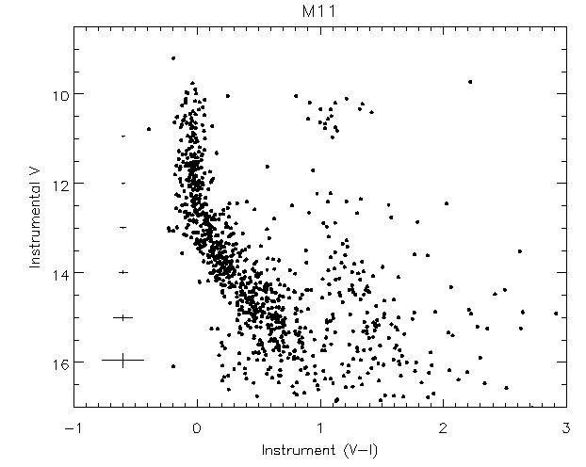

Indeed, my stars are all shifted in the negative (V – I) direction, mostly lying between -3 and -1, while this CMD’s stars lie between 0 and 2. My CMD’s stars also appear to be shifted slightly towards a lower V magnitude, relative to that CMD. I’m not sure why this is the case. Perhaps there is some property of the telescope or its environment that must be corrected for before comparing with other CMDs... I have retried the photometry a few times, fiddling with the parameters and seeing if anything would shift my stars over to match thie CMD, but nothing has done that for me.
In any case, though, I can still compare the shape of the distribution of stars in my CMD to those of the CMDs attached! Most of the stars lie along a curved main sequence, left-of-centre in both my apparent and absolute CMDs (Nave, 1999). I’ll now describe the shape of the curve. Starting at a high magnitude, at the bottom of the plot, the main sequence is linear, with (V – I) decreasing as the V magnitude decreases. Then, at the top of the plot, the main sequence forms a bit of a hook, curving towards positive (V – I) at V ≤ 10. I think that this “hook” is the main-sequence turnoff point (Bolte, 1998). Off to the right, at around (V – I) = +1, we see another clump of stars. I believe that this clump of stars is the red giant branch (Speck, 1996). The Hertzsprung gap explains the scarcity of stars between the main-sequence turnoff and the red giant branch (Hoyle, 1960).
Now, what does that all mean? Since open clusters like M11 were formed at around the same time, from the same gas cloud, they have the same age and initial composition. The only thing that varies from star to star, then, is their initial mass (McArthur and Kronberg, 2006). So the CMD of an open cluster should show the line along which stars of its (shared) age and composition lie, for all different masses. There will be some main sequence, which is a fairly straight, sloped line (okay it’s a bit curved, but not as much as, say, the turnoff point), with more massive stars being higher up (i.e. lower magnitude) on it and less massive stars being farther down. As the stars age together, a main-sequence turnoff point – the hook in my CMD – will move progressively father down the main-sequence; stars above the main-sequence turnoff point will drift rightwards (positive (V – I)) into the giant branch as they become giants (Murphy, 2006). So the stars above the turnoff point are drifting rightwards and those below it are sitting happily in the main sequence: this is what makes the angular “hook” that we see in my CMD, and that is even more pronounced in some other clusters. Clusters with lower turnoff points and more populous giant branches are older than those with higher turnoff points (or no turnoff point) and less populous (or unpopulated) giant branches (Murphy, 2006). It is apparent that most of M11’s stars are still main-sequence stars, just because most of the stars in the CMD lie along the main-sequence line. However, it does have a well-defined turnoff point, and we can see that to the right of it, M11 also has a decent population of red giant stars.
Let’s use this knowledge, along with my CMD of M11 and the attached CMDs, to compare M11’s star population with those of other clusters.
The CMD of the Pleiades shows that it currently has no red giant branch; all its stars appear to be in the main sequence, and fairly young. Its population is also quite hot (and blue). Down to V magnitudes of about 6, the CMD shows only a perfectly linear main sequence. Only at the very top of the CMD, at V magnitudes of < 6, we see it curling towards the red side (i.e. towards the right). It is a gentle curve, with a smaller curvature than the turnoff in my CMD of M11. It is probably the beginning of a main-sequence turnoff point anyways. Since this turnoff point is so high on the main sequence, with such low curvature compared to that of M11, and since the Pleiades has no giant branch, it is probably a younger cluster than M11. After guessing this, I verified that M11 is 250 milion years old (Meynet, Mermilliod and Maeder, 2017), and the Pleiades is 115 million years old (Basri, Marcy and Graham, 1996; Ushomirsky et al., 1998).
I’m not really sure what to think about the Hyades. Like the Pleiades, it looks like only a main sequence is visible. Stars are detected to a higher magnitude, so we can see how the slope of the main cluster is very steep at high V magnitudes (12 and up), before getting shallower at V magnitudes below 12. There is a very small group of stars redward of the main sequence at the top of the diagram, at a V magnitude of about 4. Perhaps the turnoff point is at a V magnitude of 4 then? This low-magnitude turnoff, and very small red giant population (assuming that’s not noise or something) would seem to indicate that the Hyades is a younger cluster than M11, which has a more pronounced turnoff at a higher magnitude. However, really, the Hyades is about 625 million years old (Perryman et al., 1997), which is older than M11’s 250 million years. So I’m not sure why I’m not seeing more of a red giant branch, or a higher-magnitude turnoff...
The CMD of NGC 2682 has all of the cool features we’re looking for. With decreasing V magnitude (from bottom to top of the CMD), we see a well-defined main sequence, which then hooks rightwards at the main-sequence turnoff point. Then, after some horizontal movement at the turnoff, we see a nice red giant branch. So, at the age shared by the stars of NGC 2682, we see stars in many different stages of stellar evolution. NGC 2682 has a larger giant population than M11 does. It is also worth noting that the main-sequence turnoff of NGC 2682 is at a much higher magnitude than that of the other clusters, including M11. NGC 2682’s main-sequence turnoff is at a V magnitude of about 13! With its larger, more well-developed population of giants, and higher-magnitude main-sequence turnoff, it looks like NGC 2682 is an older cluster than the others. Indeed, NGC 2682 is about 4 billion years old, so it looks like that inference is accurate (Meynet, Mermilliod and Maeder, 2017).
I don’t think all the stars in my CMD are from the cluster M11. There is a lot of “noise” in my CMD; if it were stars from the cluster alone, then there would be a nice, clean line like in the attached CMDs. Instead, my main sequence is a blob shape, and there are stars scattered sparsely around most of the diagram. I think that these scattered stars, and the stars that make up the “blob” of the main sequence, making it more than just a line, are foreground and/or background stars. They are just stars that were lying in front of or behind the cluster, and so showed up in the image despite not really being of interest.

Question 7
As I mentioned, I think my photometry is offset by a few magnitudes. I will suggest a few possible sources of error, although (while I’m learning more about photometry right now, of course) I’m not sure how many of these are valid:
- A bright sky background, from light pollution or morning/evening, reduced the height of stars’ values above background values, resulting in higher calculated magnitudes (dimmer) for stars. If this is the case, it could be fixed by starting observations later into the night, and ending them earlier in the morning.
- There might have been unusual amounts of atmospheric extinction, with atmospheric oxygen, ozone, and/or water absorbing photons from the stars, resulting in higher calculated magnitudes. If this is the case, it could be fixed by restricting times of observations based on weather reports, waiting for favourable conditions, or by using telescopes on mountains or in space (e.g. HST). Also, it might not have been relevant for these images, but it is good to avoid observing objects near the horizon; their light has to travel through much more atmosphere to reach a telescope, and thus will experience more atmospheric extinction.

Collaboration & Impressions
I worked on this alone. However I talked with Jen Scora a bit about the shape of our CMDs (we found that hers looks a lot more like a single blob than mine does, but we couldn’t figure out why). I spent about 15 hours on this assignment – I got stuck for a while trying to figure out how to make the CMD, because at first I tried making and using a separate .coo for each image. I was thinking the whole time that sharing a .coo would give me too many errors, but it turned out to be fine. It also took me embarrasingly long to actually interpret the CMD.
Nonetheless, I think that it was an enjoyable assignment. I really like that I’m learning research skills – and how astronomy research is actually carried out – most of my other schoolwork is of the “solving math/physics problems” variety, and while that’s of course valuable, this sort of thing is a breath of fresh air, and a bit of freedom from the strict rules of textbook problems. And I like that this could actually make me a more productive researcher. It’s very relevant to me; these are very common tools in a field that I have great interest to keep exploring.
I think that the scope of the project is appropriate for its role in the course.
Works Cited
Basri, G., Marcy, G. and Graham, J. (1996). Lithium in Brown Dwarf Candidates: The Mass and Age of the Faintest Pleiades Stars. The Astrophysical Journal, 458, p.600.

Beish, J. (2016). Obesrving the Planet Mars - Chapter 8 - "Astronomical Seeing". [online] Alpo-astronomy.org. Available at: http://www.alpo-astronomy.org/jbeish/Observing_Mars_8.html [Accessed 30 Jan. 2017].

Bolte, M. (1998). Measuring Stellar Ages. [online] Ucolick.org. Available at: http://www.ucolick.org/~bolte/AY4/notes9/node2.html [Accessed 31 Jan. 2017].

Hoyle, F. (1960). On the Main-Sequence Band and the Hertzsprung GAP. Monthly Notices of the Royal Astronomical Society, 120(1), pp.22-32.

McArthur, G. and Kronberg, C. (2006). Open Star Clusters. [online] Web.archive.org. Available at: http://web.archive.org/web/20070207223306/http://www.seds.org/messier/open.html [Accessed 31 Jan. 2017].

McArthur, G. and Kronberg, C. (2013). Messier Object 11. [online] Messier.seds.org. Available at: http://messier.seds.org/m/m011.html [Accessed 31 Jan. 2017].

Meynet, G., Mermilliod, J. and Maeder, A. (2017). New dating of galactic open clusters. Astronomy and Astrophysics Supplement Series, 98(3).

Mirametrics, (1998). CCD Camera Gain Measurement. [online] Mirametrics.com. Available at: http://www.mirametrics.com/tech_note_ccdgain.php [Accessed 30 Jan. 2017].

Murphy, R. (2006). Stars - Open Clusters. [online] Astronomyonline.org. Available at: http://astronomyonline.org/Stars/OpenClusters.asp [Accessed 31 Jan. 2017].

Nave, R. (1999). Hertzsprung-Russell Diagram. [online] Hyperphysics.phy-astr.gsu.edu. Available at: http://hyperphysics.phy-astr.gsu.edu/hbase/Astro/herrus.html [Accessed 29 Jan. 2017].

Perryman, M., Brown, A., Lebreton, Y., Gomez, A., Turon, C., de Strobel, G., Mermilliod, J., Robichon, N., Kovalevsky, J. and Crifo, F. (1997). The Hyades: distance, structure, dynamics, and age. [online] Arxiv.org. Available at: https://arxiv.org/abs/astro-ph/9707253 [Accessed 31 Jan. 2017].

QSI, (2008). Understanding CCD Read Noise. [online] Qsimaging.com. Available at: http://qsimaging.com/ccd_noise.html [Accessed 30 Jan. 2017].

Smecker-Hane, T. (2002). Cite a Website - Cite This For Me. [online] Physics.uci.edu. Available at: http://www.physics.uci.edu/~observat/cosmos/cosmos_cluster2002.html [Accessed 29 Jan. 2017].

Speck, A. (1996). The red giant branch (RGB) phase. [online] Web.missouri.edu. Available at: http://web.missouri.edu/~speckan/witch-stuff/Research/chapter2/node11.html [Accessed 31 Jan. 2017].

Ushomirsky, G., Matzner, C., Brown, E., Bildsten, L., Hilliard, V. and Schroeder, P. (1998). Light Element Depletion in Contracting Brown Dwarfs and Pre–Main‐Sequence Stars. The Astrophysical Journal, 497(1), pp.253-266.

