Observational Project: Photometry
AST 3Y03
Ian Fare – 001413393
Match 30, 2017

Description of procedures
- The first step in the construction of my model was adapting my existing Runge-Kutta integration code to solve the simplified equations of stellar structure given to us. My code was already able to take any number of ordinary differential equations in any form, and it turns out that that all worked correctly. So adapting it to solve the equations of stellar structure was as simple as defining functions for the equations, and setting up initial conditions, as described in structeqns.pdf.
- Next, I had my script parse the uvintegrations.dat file into lists of U and V values for each E.
- I also had my script evaluate, at each x value, U, V, and n+1, using equations (26)-(28) from structeqns.pdf, until it found a value of n+1 less than or equal to 2.5
- When it reaches a point where n+1 was less than or equal to 2.5, it stopped evaluating U, V, and n+1. It then plots all the U and V values it has evaluated so far, as well as the U and V values of all the envelope solutions.
- If it doesn’t find an n+1 value less than or equal to 2.5 before it reaches x=20.0, it stops and plots things anyways, as described in step 4.
- I experimented with different values of pc, in the initial conditions, as described in structeqns.pdf. I wanted to find a value of pc that causes the final point evaluated, with n+1 <= 2.5, to land very close to one of the envelope solutions in the UV plane. So, in general, I would try increasing and try decreasing the value of pc by a small amount, and see which direction brings the final value closer. I would iterate this process, and with each iteration the magnitude of the increase or decrease would be smaller than the iteration before. This is because every time I overshoot the “correct” pc value, I have found a new “high” value and a new “low” value and I know my desired pc value is between them. The magnitude of the overshoot becomes smaller and smaller, and so does the magnitude of increase or decrease, until the “high” and “low” values are very close to each other (within 11 decimal places) and I can make either one my pc value.
- I found a pc value (0.71208080006) that brought the final point closest to an envelope solution (E=7.0). To find initial conditions x₀, q₀, p₀, f₀, and t₀, I looked up, in the pdf of the 1955 paper that they’re from, the x*, q*, p*, and t* values of the point in the envelope solution that is closest in the UV plane to the final point in my solution. f*=1.0 because at the point where my model’s solution meets the envelope solution. This is because this point is where the core meets the envelope, and we know that the total luminosity L is the same as the luminosity at the outer edge of the core (since no fusion is occurring in the envelope), and the equation l=f*L relates luminosity l at some point x in the star with total luminosity L, via f* which varies with x. So, at the place where my model’s core solution meets the envelope solution, l=L, so f*=1. Then, I found the x, q, p, f, and t values of the final point in my solution. I used the relation x*=x₀x (and similar for q, p, f, and t) to calculate the initial conditions.
- Next, it was time to convert the model to physical units. Using my x*, q*, p*, and t* values, I made my script calcluate the constants C and D, following the equations (14) in structeqns.pdf.
- I rearranged the C and D equations (15) and (16) for L (they both contain L, to the power of 1), set them equal to each other, and solved the resulting equation for Solar radius R.
- With R, I had my script calculate, for each point in my model, the values of r, m, l, T, and P, following equation (8) I also had it calculate mass fraction, which is just m/M, where M is the total mass of the star, which I set to be the mass of the Sun (I looked it up online), since we are calculating these for a star of Solar mass and luminosity. I had it calculate density too, using the ideal gas equation of state given in the project procedure.
- I had my script plot density, temperature, and pressure as functions of mass fraction, one at a time. You have to exit each plot to see the plot after it.
- Next, it was time to calculate luminosity L, effective temperature T_{eff}, core temperature T_{C}, core pressure P_{C}, and radius R for the masses 0.7, 0.8, 0.9, 1, 2, 3, 4 and 5 M⊙. The first step in doing so was to define an array containing all of these masses in cgs.
- For each mass, I had the script do the following calculations:
  - Calculate radius the same way it was in step 9. Step 9 calculated Solar radius; the only difference here is that the mass is 0.7, 0.8, 0.9, 1, 2, 3, 4 and 5 M⊙, instead of just 1 M⊙.
  - Calculate effective temperature using the equation.
  - Calculate core temperature and core pressure using the T and P equations (8) in structeqns.pdf, with t* and p* being the t* and p* values calculated at the first x-value. These will be the first in their respective lists.
  - Calculate radius by solving (16) for R.
- Finally, the script needs to plot HR diagrams for the observed main sequence as well as for the theoretical results of my model. HR diagrams are plots of luminosity against temperature, with log scales for each axis, and the temperature axis reversed. I had my script parse the temperature and luminosity data from the .dat file into a list of observational T values and a list of observational L/L_{sun} values. Then, it calculated the corresponding numbers from the results of step 13.
- The very last step was to make my script plot both the observational and theoretical data as HR diagrams, on the same graph.

Plots and quantities
Here are my model and the envelope solutions in the UV plane:
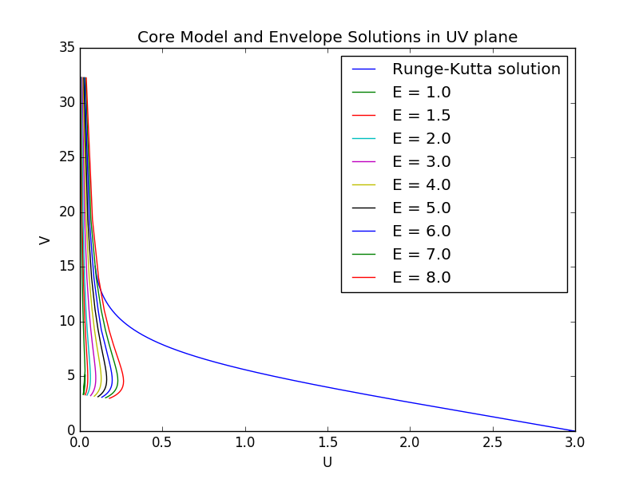
Here is a close-up view of where my model meets the E=7.0 envelope solution:
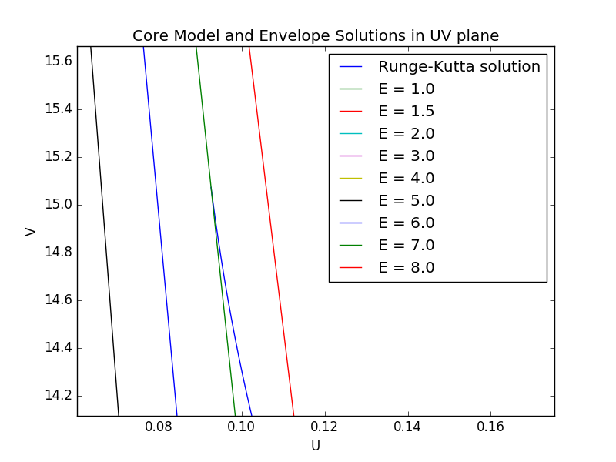
Here are the density, temperature, and pressure as functions of mass fraction:
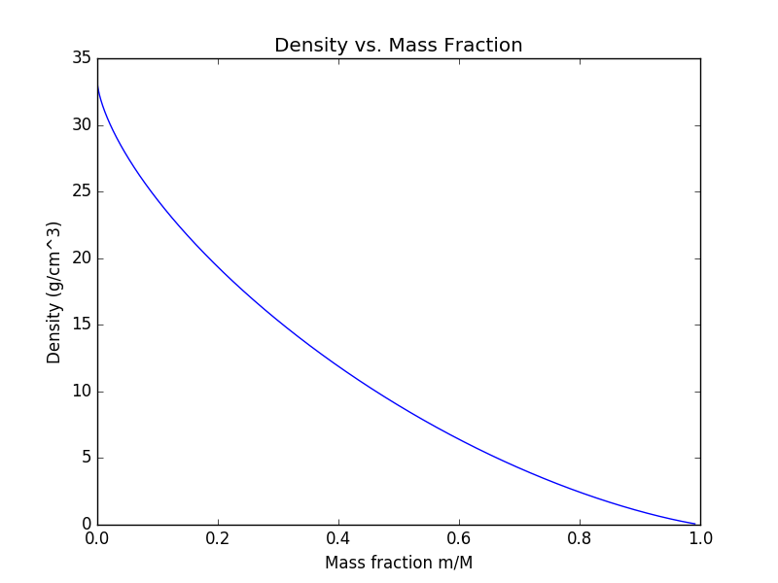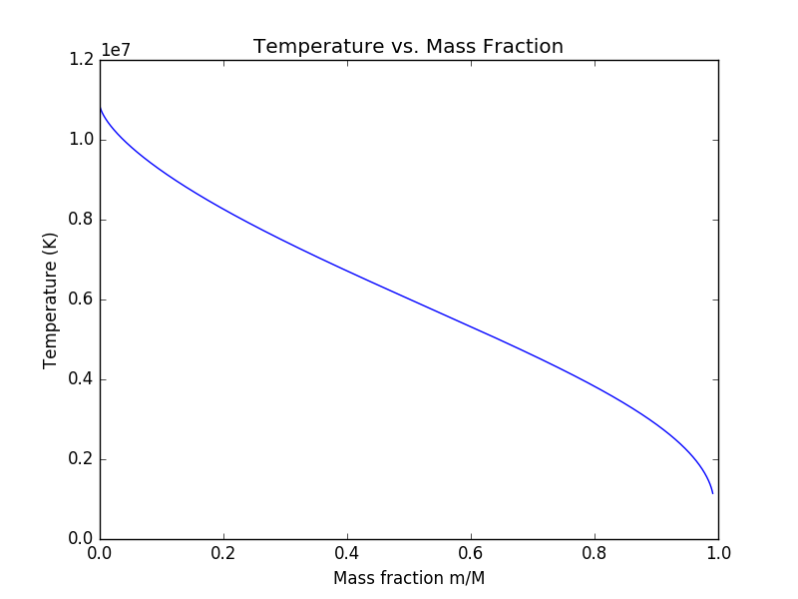
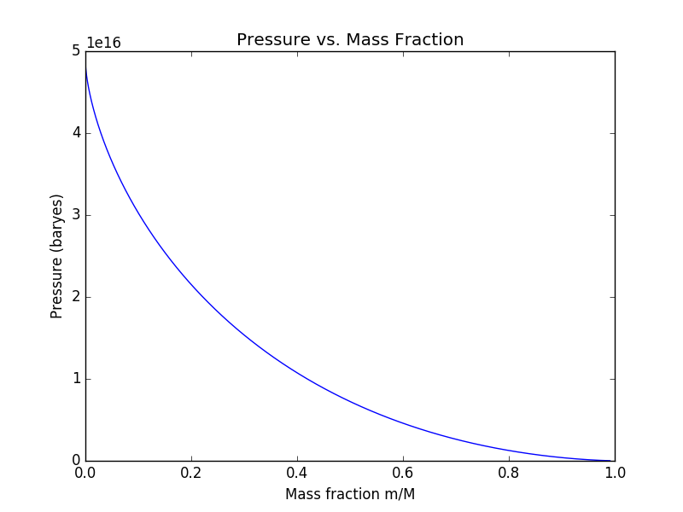

Here are the values of L, T_{eff}, T_{C}, P_{C}, R for models with masses of 0.7, 0.8, 0.9, 1, 2, 3, 4 and 5 M⊙:
0.7 Msun: R = 0.972936428832 Rsun
L = 0.020632426345 Lsun
Teff = 2148.24212378 K
Tc = 7821608.87085 baryes
Pc = 2.66086891709e+16 K
0.8 Msun: R = 0.98298158885 Rsun
L = 0.042783425344 Lsun
Teff = 2564.68529024 K
Tc = 8847633.46693 baryes
Pc = 3.33552114629e+16 K
0.9 Msun: R = 0.991928099119 Rsun
L = 0.0814042390651 Lsun
Teff = 2998.53790634 K
Tc = 9863813.1251 baryes
Pc = 4.07126625479e+16 K
1.0 Msun: R = 1.0 Rsun
L = 0.144728251609 Lsun
Teff = 3448.46810513 K
Tc = 10871326.0036 baryes
Pc = 4.86592329751e+16 K
2.0 Msun: R = 1.05476607648 Rsun
L = 6.37734945025 Lsun
Teff = 8651.07070774 K
Tc = 20613719.4701 baryes
Pc = 1.57253614318e+17 K
3.0 Msun: R = 1.08818224346 Rsun
L = 58.3941577971 Lsun
Teff = 14815.9470397 K
Tc = 29971062.4822 baryes
Pc = 3.12321030045e+17 K
4.0 Msun: R = 1.1125314761 Rsun
L = 281.01345493 Lsun
Teff = 21702.6871378 K
Tc = 39086807.8331 baryes
Pc = 5.08201582805e+17 K
5.0 Msun: R = 1.13179279115 Rsun
L = 950.615470444 Lsun
Teff = 29181.3676615 K
Tc = 48027015.5835 baryes
Pc = 7.41374379938e+17 K
Evidently something is amiss with luminosity, since for 1.0M_{sun}, there should be L = 1.0 L_{sun}. But I’ve spent some time checking and double-checking and I can’t find where I might have gone wrong.
Here are the HR diagrams for my theoretical ZAMS and the observational MS:
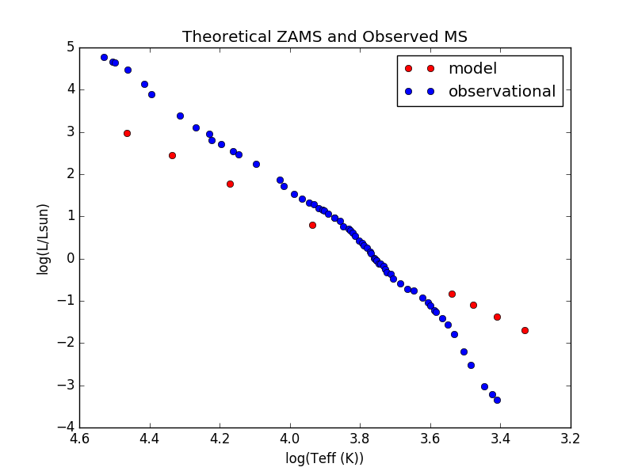
The theoretical ZAMS is a straight line with positive slope of log luminosity over log T_{eff}. The observational ZAMS, meanwhile, is a curve with a decreasing slope as T_{eff} increases. At low T_{eff}, the theoretical ZAMS has higher luminosity, while at high T_{eff}, it has lower luminosity. At higher luminosity, the two lines are almost parallel. The intersection between the theoretical and observational main sequences is at around log(T_{eff}) = 3.8 or 3.7, and log(L/L_{sun}) = 0; that is, approximately Solar temperature and luminosity.
I’m not entirely sure why this is the case. However, at around 1.3 M_{sun}, the CNO cycle becomes the dominant fusion process in stars. The energy output of the CNO cycle rises more rapidly with temperature than does the p-p chain (which is dominant at lower masses) (Salaris and Cassisi, 2005). This mostly just confuses me more, though, because according to the observational main-sequence, higher-than-Solar-mass (and higher temperature and luminosity) stars, above that point around log(L/L_{sun})=0, have a lesser slope of log(luminosity) over log(temperature) than those below that point. This is the opposite of what I would expect. So really, I’m not sure what exactly is the source of the differences between the observational and theoretical main sequences, but I think it has something to do with the CNO cycle being the dominant fusion process at 1.3M_{Sun}.

Collaboration & Impressions
I worked with Jen Scora on this project. We worked through converting our models to physical units together. We sort of went through the math steps to calculate physical things in parallel, deciding on which direction we’re supposed go to next, and then figuring out the algebra together. Sometimes we’d help each other find the values of constants in our notes or online. At each major step in the calculations, we compared answers to make sure that they were similar, and therefore probably right. We didn’t share any code, though, and we did our math in parallel but separately. Our reports are being written entirely separately. So I’m not sure if “fraction of the work” applies here, but if it does, I think she figured out what to do before I did most of the time, so maybe she did 67% of that work? (“that work” being knowing what to do next)
This project took me probably about 15 hours. I found it very interesting, because I got the chance to directly use the stellar structure equations we learned in class in a meaningful way. It was really cool to incorporate the physics we learned in class into a physically meaningful program; doing so grounded theory that otherwise might have seemed abstract unclear. I think I know the stellar structure equations and their implications much better now than I did after learning them in class. I think that this has been an appropriate project for 15% of the final mark.

Works Cited
Salaris, Maurizio, and Santi Cassisi. Evolution of stars and stellar populations. John Wiley & Sons, 2005.

