WEB DESIGN
PROJECT REPORT

PROJECT TEAM
Student No. | Student Names
15011364 | Ian Flynn

WD car showroom project

- OVERVIEW / INTRODUCTION

Motivation for the Project

This site is for a car showroom, I want for it to look and act like any homepage for a business would, it should have information customers need and be well rounded as far as looks go, while serving as an advertisement for the company.

Research

I have done some looking into other car dealership sites,
http://www.epmooney.ie/ which is very cluttered, the homepage has almost evrything on it even though there is a nav bar, and there is a lot of scrolling to find what you want. I did like their use of tabletags for opening hours.

http://www.tallaghtford.ie/ had an almost minimal homepage, everything accessible by a nav bar, and a quick menu. Using the homepage to advertise whatever deals are on at the time, and a search for used cars on carzone that they have in their showroom.
http://www.joeduffybmw.ie/ at first look, there was an annoying popup for cookies, and a horrible instant message box down the bottom right to chat to an employee. I feel this better served in a contact section as it is bad looking from the design point of view. Homepage and nav bar were very cluttered.

Technical Approach

Having gotten the spec from the client, a wireframe has been done up. Specs are covered in the wireframe, to be submitted to client for approval. Request for blue/white theme will need further detail so I will make up a shee of the types of blue I think would work for selection.

WIREFRAME

Homepage:
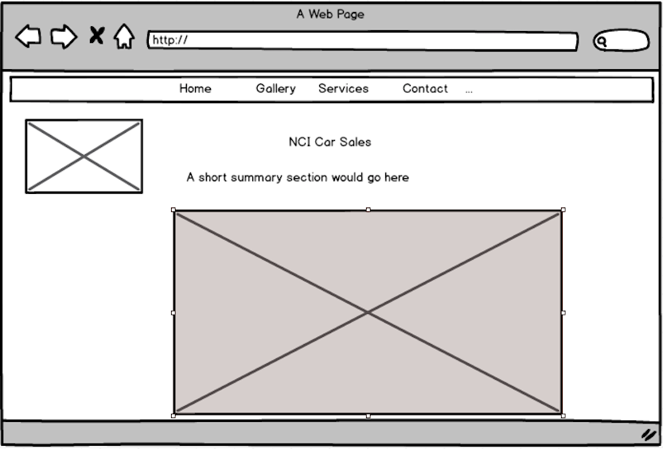
Image gallery:
This would show off the showroom, and some of the cars for sale. This could be split into a separate page for each.
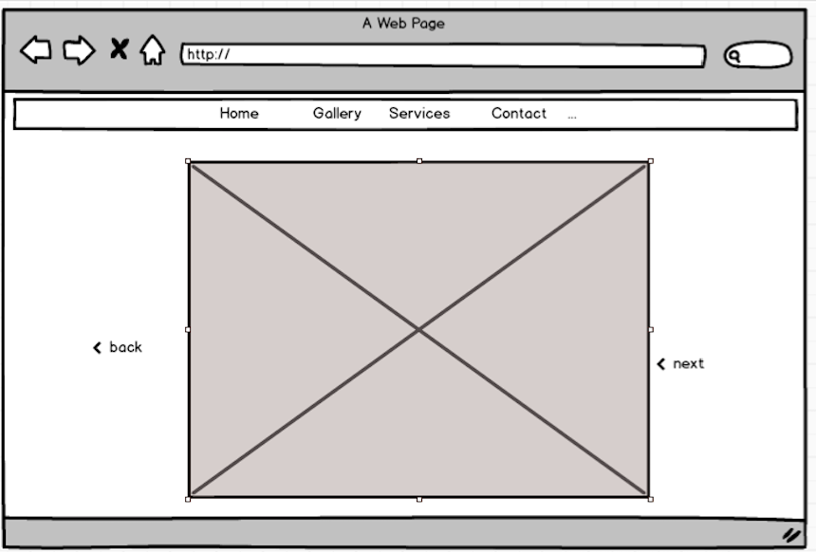
Service center:
This are would be to book your car in for a service, using list elements and button elements to have be quick for the customer, and give the department an idea of what parts would be required and time needed to be allocated
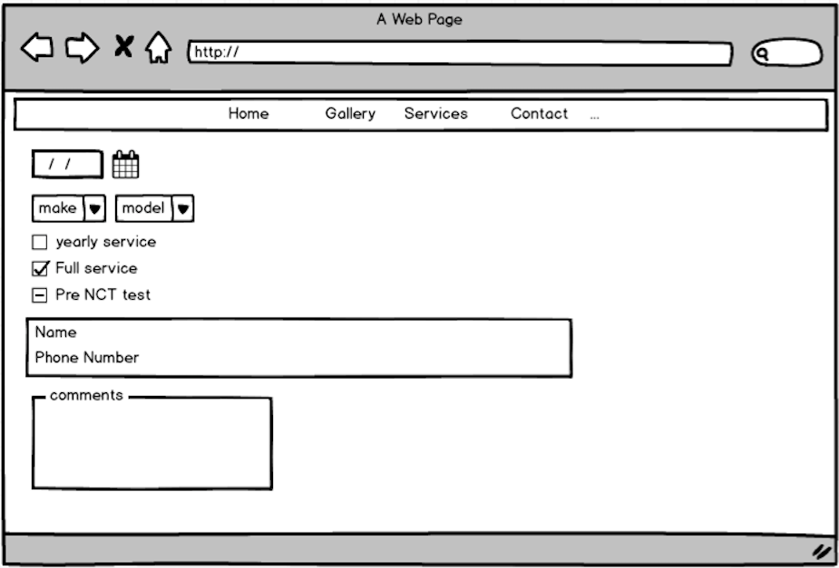

The about page would show how to locate the garage, contact information, and opening hours, contact would go above the location, I think it will just be a list with comments/mail address/name field that would use mailto in the submit, and then phone number field if the customer wishes to call. I see most sites use the embedded google maps, which is a good idea so I will leverage this here.
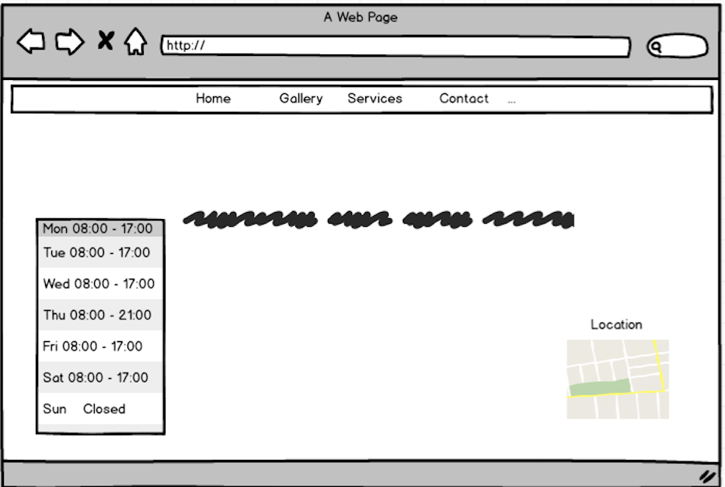

- PRODUCTION LOG

I started off just using my template I had saved, multiplied it a few times and saved as nameofpage.html as a starting point, then worked on elements that would be across all pages such as nav bar (my table/anchor implementation of it anyway, the failed attempt can be seen in the code comments!), and pasted across accordingly!
After this was done I started working on each page individually. I used photos with permission from pix.ie/taltallon for this as finding time to take my own photos is hard to come by! And not many people I know have photographed showrooms unfortunately!
The only 3rd party code used was the javascript for the google map in the contact page, taken from google.com

Validation
Got lucky here:

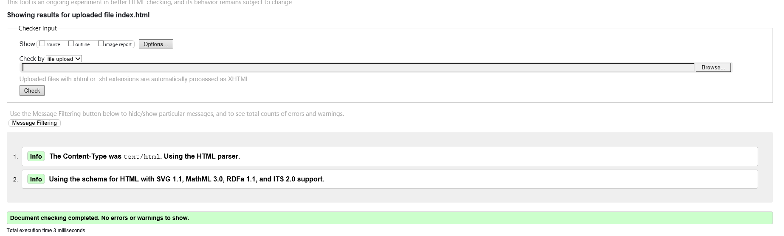
Not so lucky here:

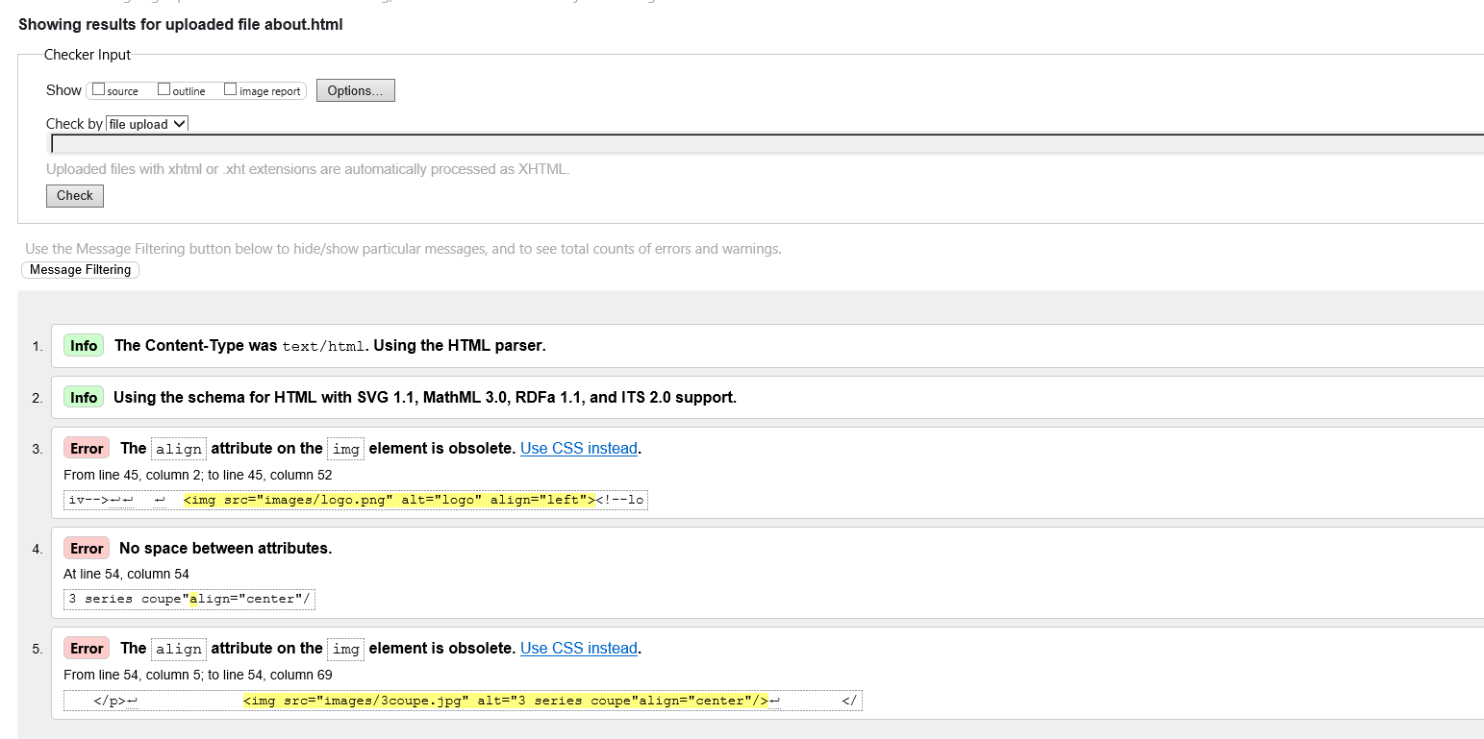
Service wasn’t as bad, just some unsupported features and some deprecated code:

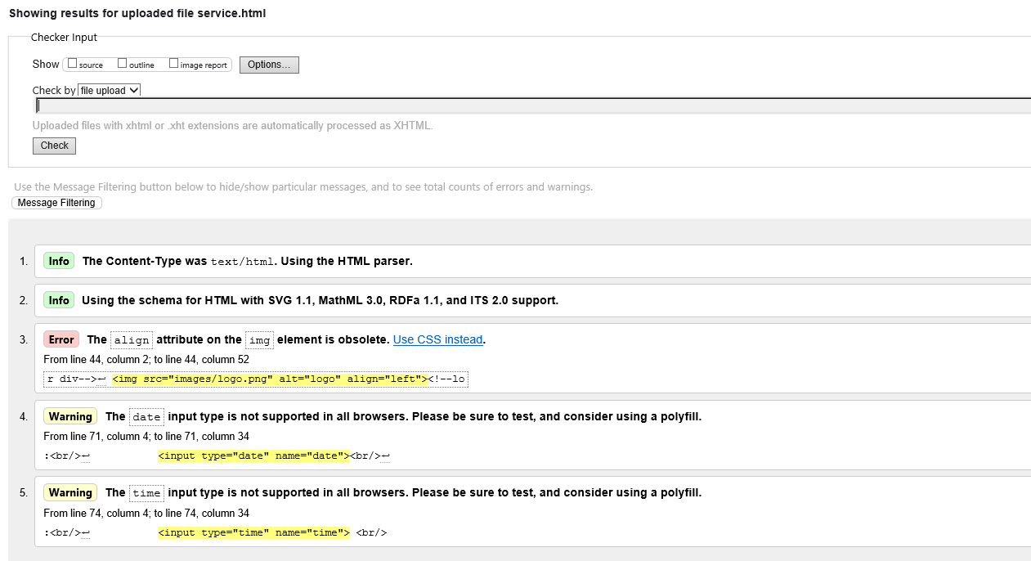
Gallery was the same:

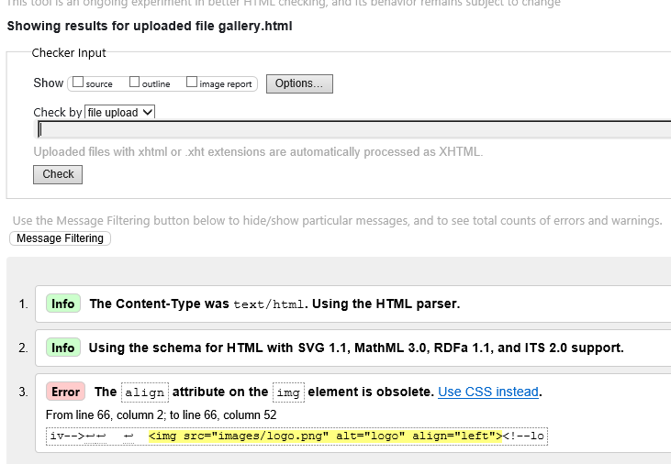
Same again for contact, but with a stray closing tag:
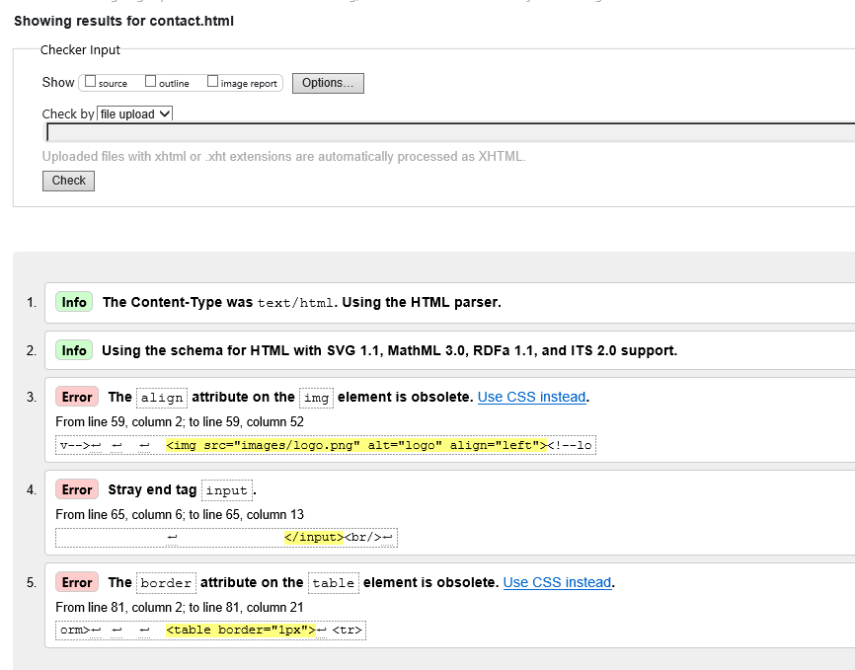

- PROJECT TEAM

Not relevant as I was a solo team

- CONCLUSION
The project went ok, I got a bit frustrated with trying to use header tags, so opted for a table with anchors instead, this was the most frustrating part! Also a combination of time management for it, trying to squeeze in a little work here and there, procrastinating didn’t really help me!
I don’t think I did achieve what I set out to do, there is a site, it could look better and be more functional however! I would have to look further into javaScript a little more, as I would have liked the buttons in the forms to actually do something!
If I had more time, I would have made the CSS better, the layout would have been better! I also would have taken some of my own photos for using, however I had a friend nice enough to let me use their photos! I also wish I knew photoshop etc better, rather than needing to just use word and snipping tool for the logo, it’s something I can work at learning though!

- REFERENCES
https://developers.google.com/maps/tutorials/fundamentals/adding-a-google-map

