|  |  |
| --- | --- |
| Understanding COVID’s impact on global transportation industry. | Group 5 Luo Wenhan A0162266E |
| Sun Weiran A0130945H |
| Zhang Chenxi A0177389H |

Since the end of 2019, Covid-19 has developed into a global pandemic with no sign of fading away. It seems to become an endless fight between the scientists inventing vaccines and the virus mutating into a more infectious and deadly form. To survive in this challenging era, many governments must impose various policies to curb the spread. These policies include but not limited to closing public facilities, shutting down borders, and enforcing social distancing.

Although these policies are effective in tackling the pandemic, they also have significant negative impacts on various industries. Transportation is one of the most severely impacted sectors in the world as domestic and international travels are strongly discouraged in most countries. Singapore Airline Group (SIA) has reported a net loss of S$3.5 billion as passenger numbers fall by 98.9% amid COVID-19. Global maritime trade plunged by 4.1% in 2020 due to the unprecedented disruption as estimated by UNCTAD in its Review of Maritime Transport 2020, released on 12 November.

Through this project, we want to visualize **the impact of Covid-19 on the global transportation industry** which might help various parties for better planning of **personal, organizational, and national future**.

# Government

Based on research done by Oxford University, 8 types of policies (School closing, Workplace closing, Cancel public events, Restrictions on gathering, Public transport closing, Stay-at-home requirements, Restrictions on internal movement, Restrictions on international travel) are implemented by various countries to fight against Covid-19. Some of these policies are frequently used together by most governments. However, due to differences in the local situation, these policies are executed in vastly different ways. Hence researchers come up with an astringency index to represent the collective enforcement level of these policies, the higher the more stringent approaches are adopted. Below are 3 samples out of many countries we have visualized.

|  |  |  |  |
| --- | --- | --- | --- |
|  | | | Countries like Japan and Korea adopt a more conservative approach and choose to implement more lenient policies. |
| France and Singapore are examples of countries that adjust their policy stringency level according to the local pandemic situation. |  | | |
|  | | China and Italy maintain stringent policies throughout the observation periods. | |

# Business Organizations

Here, we take Brazil as an example to answer the query how the transportation industry is impacted by public policies. We will then use import/export data to see which countries are recovering from Covid-19.

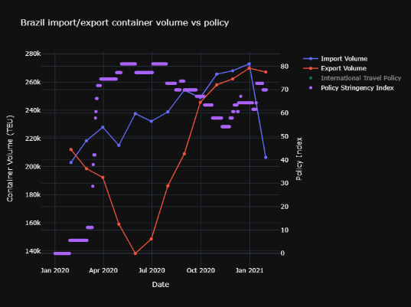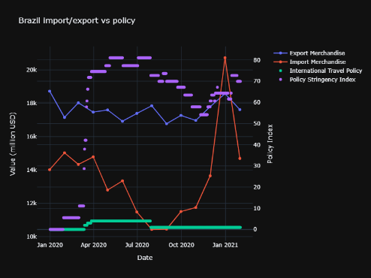

Brazil’s import merchandise is impacted by public policies especially international travel policy. However, its export merchandise is not impacted by the its public policy.

Import merchandise drops greatly measured in container volume, which indicates that the transportation industry is impacted by the public policy.

Import merchandise drops more smoothly measured in dollars compared to its container volume, which indicates that the import merchandise drop down are from the merchandise with less value but requires more capacity.

|  |  |
| --- | --- |
|  | China has its lowest point for export merchandise in Feburary, 2020, while the other countries’s are in May, 2020. There is large fluctuations in Brazil’s export merchandise.  For import merchandise, all the selected countries have similar trend. |

# General Public

To the general populace, living with COVID has mostly became the new normal. People in Singapore and around the world has mostly complied with all the restrictions put in place by the government to minimize the impact of COVID. Yet, most people would still want to gain back some freedoms from pre-COVID, such as being able to travel to other countries without the risk of infection. As such, the following visualizations would answer some potential queries that people would have and give people some hope for more freedom in the future.

|  |  |  |
| --- | --- | --- |
|  | | This chart plot the vaccination rate of all countries. Gibraltar and Israel has achieved a full vaccination percentage of more than 50%. A huge majority of the countries are still at below 5%. |
| On the same chart zoomed in to the 0-5% range, we can see that the rate of vaccination of countries in the EU are fairly clustered, which bodes well for free travel within the EU again the in the future. |  | |
|  | | For Singapore, the full vaccination percentage as of now is about 4.16%. The rate of vaccination seems to be slowly decreasing. |