Ian Hill
Software Design
March 3, 2014
Homework 5: Mining Text from the Web
PART I: Project Overview
In this project, I wanted to explore how the English language changed over time. Because Project Gutenberg has a rich variety of books published between 1800 and 1900, I chose that as my time frame using books after 1900 as my standard. I gathered a collection of 32 books in plain text format with at least two from every decade. I could have pulled the books directly from the website using python, but it wouldn't have been very efficient to download 32 books every time I wanted to run the code. My code analyzed the relative frequency of each word appearing in each decade against the relative frequency of the word as it appeared in the books published after 1900. I also considered the number of words that appeared in each decade but did not appear in the books published after 1900. Since 1900 was the standard, I hypothesized that these metrics would be more and more different the farther from 1900 a books publishing date became.

PART II: Implementation
Before I could do anything, I had to strip the extraneous text on the top and bottom of the books on Project Gutenberg, so I created a preparation function to create a new file for each book that only contains the book part of the original file. Following that, I separated the strings of books into lists of words. I calculated the frequency of each word and stored those results in a list of dictionaries. I then combined the dictionaries for the books of each individual decade such that one could imagine each decade's dictionary as having been calculated from a file containing all of the books I used from that decade. I compared each decade's dictionary to that of the standard time period (after 1900). I added up the difference in relative frequency of each word that appeared in both the decade and the standard. I called this variable the offset. For example, if the likelihood of finding the word “the” in the standard dictionary was .10 and the likelihood of finding the same word in the decade dictionary was .11, then I increased the offset by .01. In my program, the combined offset of every word that appeared in both dictionaries is the distance between the decade dictionary and the standard dictionary. I also calculated the number of words that the two dictionaries did not have in common. These two factors, the distance and the number of exclusive words, were my two metrics that I used to attempt to determine the change in language over my 100 year timespan.
In terms of my data structures, I used lists to keep track of the decades and time frames because those needed to be a particular order, and I needed to be able to easily cycle through them. I organized the word frequencies for each book in dictionaries because they hold data in a key and value system which made sense for the data that I wished to store: word : frequency. I could have stored the word : frequency pairs in tuple lists within a larger list but it would not have been as easy to reference words or use the in operator.
Here are a few simple steps to follow, if a NINJA wished to run my code:

- There is a nested list at the top of the program which contains the file names of all of the books to be analyzed. Right now, it looks something like this:
files = [
['1726','1729'],
['1812','1813'],
['1820','1823'],
['1837','1838'],
['1843','1847'],
['1851','1852','1859'],
['1865','1869'],
['1873','1874','1876'],
['1883','1884','1887'],
['1892','1895','1897'],
['1900','1902','1908','1911']
]
Each sublist represents a time period to be analyzed. In my case, each sublist represents a decade. I name each file after its publishing year so that I could more easily make sense of the data. A NINJA could simply add or remove file names from this list to change which files would be analyzed. No other code would need to be changed with regards to the files themselves as long as the files are located in the same directory as the program.

- If a new file was added, the file preparation code would have to be rerun in order to strip the extraneous text from the top and bottom of each book and produce the 'x.txt' file. Right now, the code looks like this:

#---------- Preparation Code -----------#
"""
Only needs to be run once!
"""

#filePreparation(files)
In order for the code not to run every time, I have commented out the filePreparation() function call. A NINJA would need only uncomment this line to cause the 'x.txt' files to be regenerated.

- With the files prepared, the program should run without any further adjustments. Right now, the program outputs the following:

Number of time periods to be analyzed: 11
1720:
Offset: 0.542345930518
% of words different: 0.702411744145
1810:
Offset: 0.366864456829
% of words different: 0.64005355507
1820:
Offset: 0.53334870031
% of words different: 0.663366336634
1830:
Offset: 0.500809662458
% of words different: 0.644085803906
1840:
Offset: 0.444142820283
% of words different: 0.667306650913
1850:
Offset: 0.411113706453
% of words different: 0.686154598826
1860:
Offset: 0.458775612227
% of words different: 0.664471533324
1870:
Offset: 0.389409077924
% of words different: 0.663882810058
1880:
Offset: 0.465816028883
% of words different: 0.731150827946
1890:
Offset: 0.373451987574
% of words different: 0.641021623316
1900:
Offset: 0.0
% of words different: 0.0

The print statements that output the results of the program may need to be adjusted if the names of the files to be inputed into the program do not follow the pattern of a 4 digit year.

PART III: Results
The actual data produced by the program can be seen above, but here is a more graphical representation.
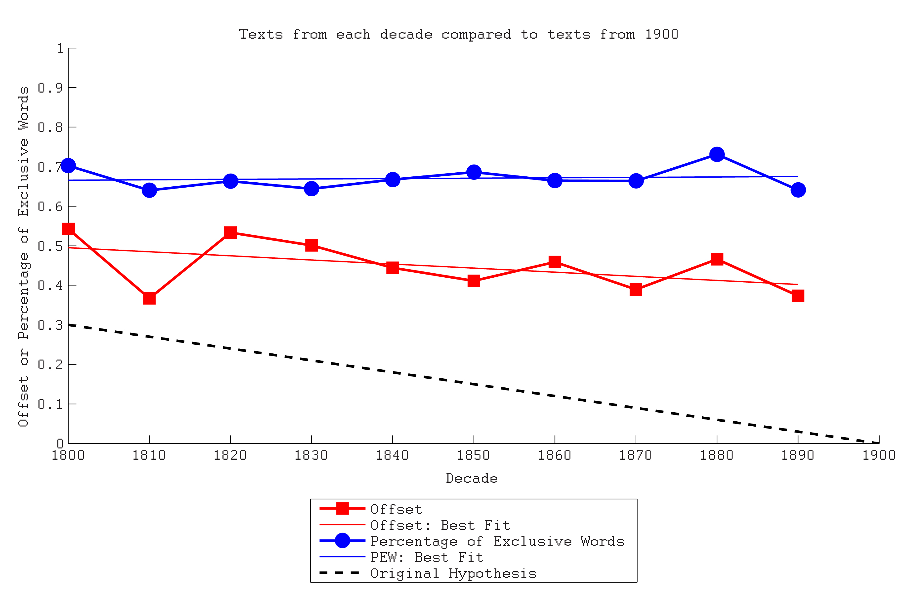
I expected the offset and the percentage of exclusive words to increase linearly away from the standard time period. However, as one can see from the lines of best fit, my hypothesis does not hold true to the extent that I expected. This would imply that the English Language did not change much over those 100 years. Perhaps I should have sampled a much larger time frame like the year 1000 to the year 2000.

PART IV: Reflection
I have a good deal to reflect on for this project. First of all, I chose not to have a partner in this project because with the number of commitments I had over this past week, I was not sure if I would have been able to schedule ample time to meet with a partner. However, I look forward to working with a group in the upcoming Video Game assignment.
I did use this opportunity to practice commenting my code and learning good habits. One might notice the copious amount of commenting in the .py file that I uploaded with this writeup.
In hindsight, this might not have been the best study I could have made with this assignment because I never really used python to mine text from a website. For me, this was more an exploration of file manipulation than web crawling. I could have mined these books from a website, but the number of texts required would have made the program less efficient, and I suspect that Project Gutenberg would have locked me out after only a few runs of the program if I were downloading 32 books each time.
Unit testing for this program was exceedingly difficult. The utility functions that appear earlier in the code took simple enough arguments and returned simple enough values that I could use print statements and a calculator to check their outputs. The functions that dealt with more complex data like the dictionaries that I used, I did test with small manageable dictionaries. However, there was no reasonable way that I could have calculated the actual word frequency dictionaries by hand.
I did run across an error in the code when I was nearly done writing it where nearly all of the frequency dictionaries appeared to be the same which they most certainly should not be, and in order to see if the frequency dictionaries were being manipulated as expected, I printed out only the frequency of the word “the” to see if the value made sense. I was able to use this information to narrow down my search without having to print each of the massive frequency dictionaries.
That being said, I still consider this assignment a success because while the results were not what I expected, they were still enlightening and worth exploring. I also gained more experience with dictionaries and nested lists. In the future I would like to spend more time exploring the graphic libraries available in python because I did not get a change to incorporate them in this project.

