Ian's Drug Trial - Analysis

Ian Handel

2017

## Introduction

Here we can write some words about the background...

## Methods

include_graphics("../images/why-R_presentation_20171130_design/why-R_presentation_20171130_design.001.png")

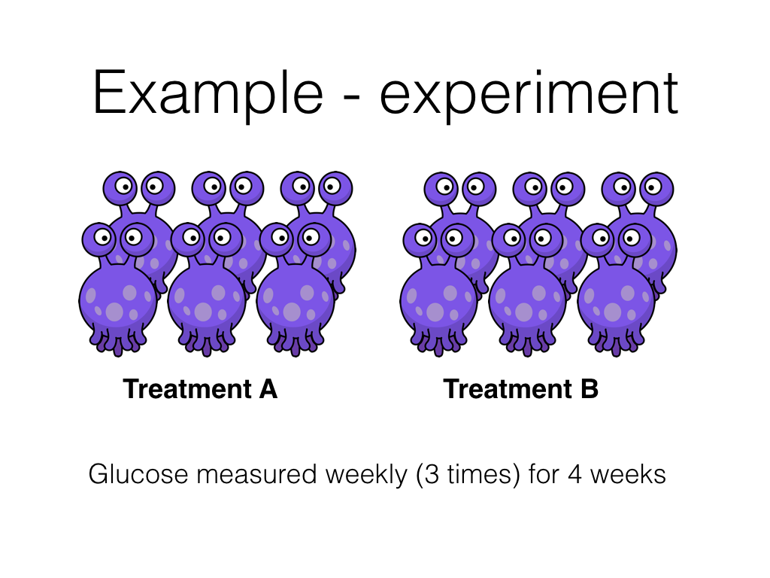

Here I can talk about this figure in an aimless fashion...

## Results

dat <- read_csv("../data/ih-trial_results_20171020_tidy.csv")

### Characteristics of treatment groups

dat %>%  
 group_by(treatment) %>%   
 summarise(n = sum(!is.na(age)),  
 mean = mean(age),  
 median = median(age),  
 sd = sd(age),  
 min = min(age),  
 max = max(age)) %>%   
 ungroup() %>%   
 map_if(is_bare_double, ~round(.x, 2)) %>%   
 as_tibble() %>%   
 kable(caption = "Age by treatment group",  
 table.attr = "style='width:30%;'") %>%   
 kable_styling(bootstrap_options = "bordered", full_width = FALSE)

Age by treatment group

|  |  |  |  |  |  |  |
| --- | --- | --- | --- | --- | --- | --- |
| treatment | n | mean | median | sd | min | max |
| A | 72 | 5.08 | 4.5 | 3.42 | 0.5 | 11 |
| B | 72 | 8.00 | 8.0 | 2.60 | 5.0 | 12 |

dat %>%  
 group_by(treatment) %>%   
 summarise(male = 100 * mean(sex == "male"),  
 n = sum(sex == "male")) %>%   
 ungroup() %>%   
 map_if(is_bare_double, ~round(.x)) %>%  
 as_tibble() %>%   
 mutate(male = paste0(n, " (",male, " %)")) %>%  
 dplyr::select(-n) %>%   
 kable(caption = "Sex by treatment group",  
 table.attr = "style='width:30%;'") %>%   
 kable_styling(bootstrap_options = "bordered", full_width = FALSE)

Sex by treatment group

|  |  |
| --- | --- |
| treatment | male |
| A | 36 (50 %) |
| B | 60 (83 %) |

### 

### Plot individual animal results

ggplot(dat) +  
 aes(week, glucose, group = paste(subject, rep), colour = treatment) +  
 geom_point() +  
 geom_line(alpha = 0.5) +  
 facet_grid(sex ~ treatment) +  
 labs(title = "Value vs time by treatment and sex",  
 subtitle = "Response greater in A than B?",  
 x = "Week",  
 y = "glucose (mg/L)") +  
 guides(colour = FALSE) +  
 theme_bw()

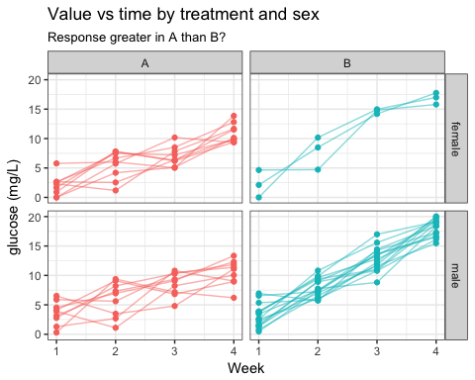

### Statistical model

mod <- lmer(glucose ~ treatment * week + age + sex + (1 | subject), data = dat)  
sjPlot::sjt.lmer(mod, digits.std = 3)$data %>%   
 as_tibble() %>%  
 select(coef.name:std.se1) %>%   
 kable(type = "text")

|  |  |  |  |  |  |  |  |
| --- | --- | --- | --- | --- | --- | --- | --- |
| coef.name | estimate1 | se1 | p-value1 | ci.lo1 | ci.hi1 | std.beta1 | std.se1 |
| (Intercept) | -0.01 | 0.69 | .984 | -1.37 | 1.35 | -0.00 | 0.00 |
| treatmentB | -2.62 | 0.85 | .003 | -4.27 | -0.96 | -0.25 | 0.08 |
| week | 2.57 | 0.20 | <.001 | 2.16 | 2.97 | 0.55 | 0.04 |
| age | 0.02 | 0.06 | .795 | -0.10 | 0.14 | 0.01 | 0.04 |
| sexmale | 0.55 | 0.42 | .193 | -0.27 | 1.37 | 0.05 | 0.04 |
| treatmentB:week | 2.44 | 0.29 | <.001 | 1.87 | 3.01 | 0.69 | 0.08 |