Ian's Drug Trial

Ian Handel

2017-12-03

Run on Thu Dec 7 13:45:39 2017

## Data cleaning

The anaysis script calls the data cleaning script here.

The data cleaning script reads data from Excel, cleans and tidies then writes out a csv file.

library(tidyverse)  
library(stringr)  
library(forcats)  
library(readxl)  
library(knitr)  
  
dat <- read_excel("../data/ih-trial_results_20171020.xlsx",  
 sheet = 1) %>%   
 fill(sex, age, treatment) %>%   
 mutate(subject = str_c("A", str_pad(subject, 3, "left", "0"))) %>%  
 mutate(sex = case_when(sex == "female nneutered" ~ "fn",  
 sex == "male entire" ~ "me",  
 sex == "MN" ~ "mn",  
 TRUE ~ sex)) %>%   
 separate(sex, c("sex", "neuter_status"),sep = 1) %>%   
 mutate(sex = fct_recode(sex,  
 male = "m",  
 female = "f"),  
 neuter_status = fct_recode(neuter_status,  
 neutered = "n",  
 entire = "e")) %>%  
 mutate(age = case_when(  
 str_detect(age, "month") ~ parse_number(age) / 12,  
 TRUE ~ parse_number(age))) %>%  
 gather("week", "glucose", `week 1`:`week 4`) %>%   
 mutate(week = parse_number(week)) %>%   
 mutate(glucose = case_when(subject == "A006" &  
 week == 1 &  
 rep == 2 ~ 1.62,  
   
 subject == "A012" &  
 week == 2 &  
 rep == 2 ~ 7.76,  
   
 subject == "A012" &  
 week == 3 &  
 rep == 1 ~ 11.78,  
   
 subject == "A003" &  
 week == 4 &  
 rep == 2 ~ 9.35,  
   
 subject == "A004" &  
 week == 4 &  
 rep == 1 ~ 16.54,  
   
 TRUE ~ glucose))  
   
write_csv(dat, "../data/ih-trial_results_20171020_tidy.csv")

## Introduction

Here we can write some words about the background...

This is an experiment to look at the effect of treatments A & B on blood glucose levels in aliens over time...

## Methods

Here's an image to describe the experiment (from a file in this project)...

include_graphics("../images/why-R_presentation_20171130_design/why-R_presentation_20171130_design.001.png")

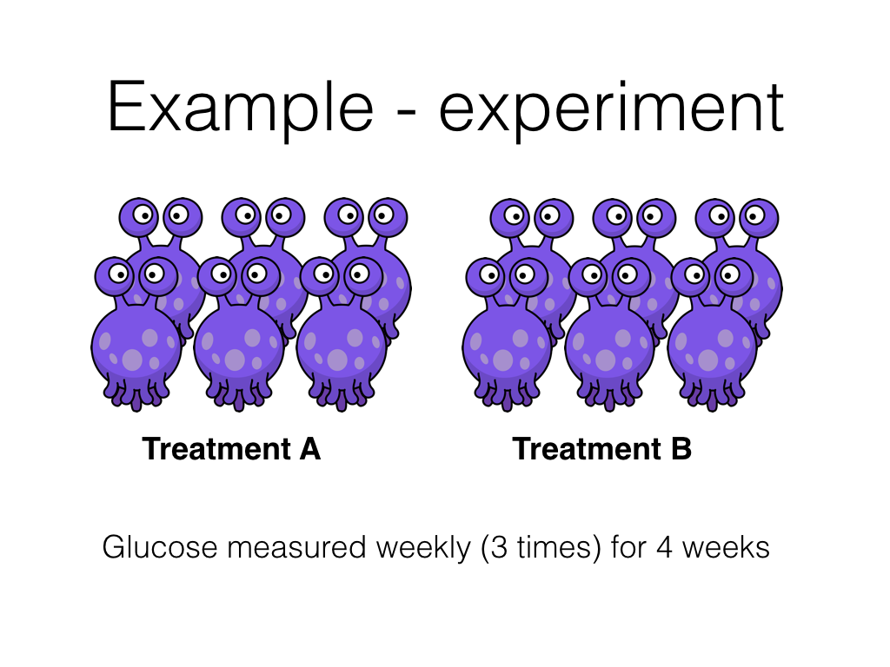

Here I can write some more words about these hypoglycaemic aliens...

I can say how we recruited them.

I can list exclusion criteria.

We measured the blood gluocse with a special machine.

We used Excel to store the data and R to run the analysis.

We fitted a mixed effects model to deal with the repeated measures (but remember this is an R rather than stats example!)

## Results

dat <- read_csv("../data/ih-trial_results_20171020_tidy.csv")

### Characteristics of treatment groups

dat %>%  
 select(subject, treatment, age) %>%  
 distinct() %>%  
 group_by(treatment) %>%   
 summarise(n = sum(!is.na(age)),  
 mean = mean(age),  
 median = median(age),  
 sd = sd(age),  
 min = min(age),  
 max = max(age)) %>%   
 ungroup() %>%   
 map_if(is_bare_double, ~round(.x, 2)) %>%   
 as_tibble() %>%   
 kable(caption = "Age by treatment group",  
 table.attr = "style='width:30%;'") %>%   
 kable_styling(bootstrap_options = "bordered", full_width = FALSE)

Age by treatment group

|  |  |  |  |  |  |  |
| --- | --- | --- | --- | --- | --- | --- |
| treatment | n | mean | median | sd | min | max |
| A | 6 | 5.08 | 4.5 | 3.72 | 0.5 | 11 |
| B | 6 | 8.00 | 8.0 | 2.83 | 5.0 | 12 |

dat_sex <- dat %>%  
 select(subject, sex, treatment) %>%   
 distinct() %>%   
 group_by(treatment) %>%   
 summarise(male = 100 * mean(sex == "male"),  
 n = sum(sex == "male"),  
 N = sum(!is.na(sex))) %>%   
 ungroup() %>%   
 map_if(is_bare_double, ~round(.x)) %>%   
 as_tibble()

In the study 3 male aliens received treatment **A** and 5 male aliens received treatment **B**. The experiment ran for 4 weeks and each week the experiment was repeated 3 times. There were 0 missing glucose measurements. *The results in this paragraph are generated from the data set - so numbers will update with new data*.

### Plot individual animal results

ggplot(dat) +  
 aes(week, glucose, group = paste(subject, rep), colour = treatment) +  
 geom_point() +  
 geom_line(alpha = 0.25) +  
 stat_summary(fun.data = "mean_cl_boot",  
 geom = "pointrange",  
 size = 0.5,  
 fatten = 0.2,  
 colour = "black",  
 group = 1) +  
 facet_grid(sex ~ treatment) +  
 theme_bw() +  
 guides(colour = FALSE) +  
 labs(title = "Value vs time by treatment and sex",  
 subtitle = "Response greater in A than B?",  
 x = "Week",  
 y = "glucose (mg/L)")

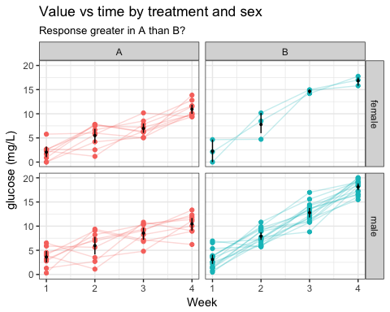

### Statistical model

mod <- lmer(glucose ~ treatment * week + age + sex + (1 | subject), data = dat)  
sjPlot::sjt.lmer(mod, digits.std = 3)$data %>%   
 as_tibble() %>%  
 select(coef.name:std.se1) %>%   
 kable(type = "text")

|  |  |  |  |  |  |  |  |
| --- | --- | --- | --- | --- | --- | --- | --- |
| coef.name | estimate1 | se1 | p-value1 | ci.lo1 | ci.hi1 | std.beta1 | std.se1 |
| (Intercept) | -0.01 | 0.69 | .984 | -1.37 | 1.35 | -0.00 | 0.00 |
| treatmentB | -2.62 | 0.85 | .003 | -4.27 | -0.96 | -0.25 | 0.08 |
| week | 2.57 | 0.20 | <.001 | 2.16 | 2.97 | 0.55 | 0.04 |
| age | 0.02 | 0.06 | .795 | -0.10 | 0.14 | 0.01 | 0.04 |
| sexmale | 0.55 | 0.42 | .193 | -0.27 | 1.37 | 0.05 | 0.04 |
| treatmentB:week | 2.44 | 0.29 | <.001 | 1.87 | 3.01 | 0.69 | 0.08 |