Ian’s Drug Trial

Ian Handel

2017-12-03

## Data cleaning

Warning in strptime(x, format, tz = tz): unknown timezone 'zone/tz/2017c.1.0/  
zoneinfo/Europe/London'

## Introduction

Here we can write some words about the background…

## Methods

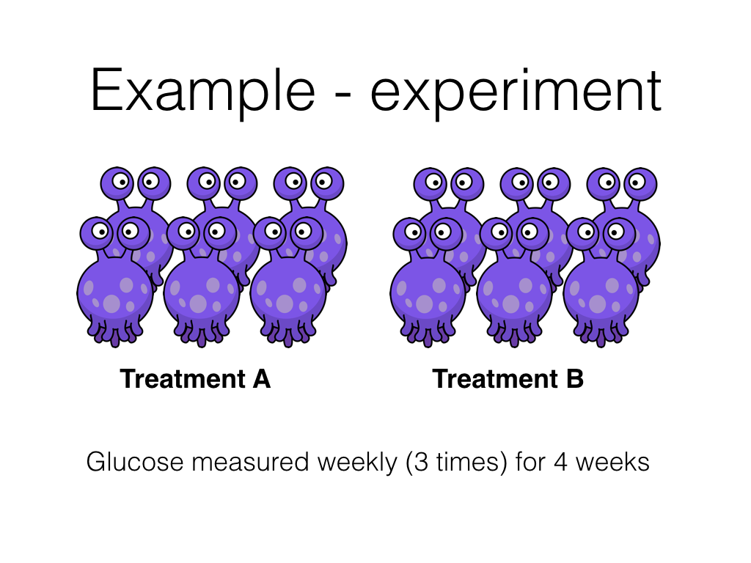

Here I can write some more words about these hypoglycaemic aliens…

## Results

### Characteristics of treatment groups

Age by treatment group

|  |  |  |  |  |  |  |
| --- | --- | --- | --- | --- | --- | --- |
| treatment | n | mean | median | sd | min | max |
| A | 6 | 5.08 | 4.5 | 3.72 | 0.5 | 11 |
| B | 6 | 8.00 | 8.0 | 2.83 | 5.0 | 12 |

In the study 3 male aliens received treatment **A** and 5 male aliens received treatment **B**. The experiment ran for 4 weeks and each week the experiment was repeated 3 times. There were 0 missing glucose measurements. *The results in this paragraph are generated from the data set - so numbers will update with new data*.

### Plot individual animal results

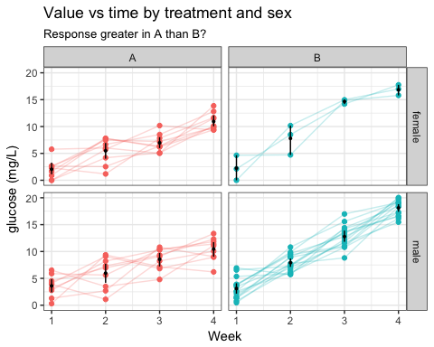

### Statistical model

|  |  |  |  |  |  |  |  |
| --- | --- | --- | --- | --- | --- | --- | --- |
| coef.name | estimate1 | se1 | p-value1 | ci.lo1 | ci.hi1 | std.beta1 | std.se1 |
| (Intercept) | -0.01 | 0.69 | .984 | -1.37 | 1.35 | -0.00 | 0.00 |
| treatmentB | -2.62 | 0.85 | .003 | -4.27 | -0.96 | -0.25 | 0.08 |
| week | 2.57 | 0.20 | <.001 | 2.16 | 2.97 | 0.55 | 0.04 |
| age | 0.02 | 0.06 | .795 | -0.10 | 0.14 | 0.01 | 0.04 |
| sexmale | 0.55 | 0.42 | .193 | -0.27 | 1.37 | 0.05 | 0.04 |
| treatmentB:week | 2.44 | 0.29 | <.001 | 1.87 | 3.01 | 0.69 | 0.08 |