Exp 1

Although typically used as a testing task, the IATs were used as training tasks here. As such, descriptive statistics for accuracy and latency performances on the IAT are reported but data from this task is not otherwise analyzed. Performances on the IAT (*M*RT = 827, *SD* = 188, *M*Accuracy = 0.93, *SD* = 0.07) and SC-IAT (*M*RT = 693, *SD* = 137, *M*Accuracy = 0.93, *SD* = 0.05) were typical of that found in previous studies using these tasks.

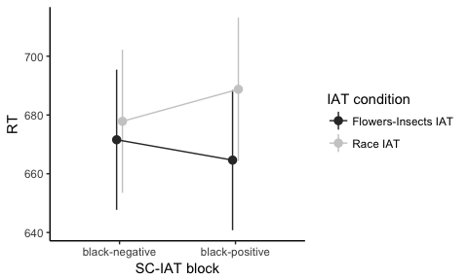

*Figure 1.* Estimated marginal means on the SC-IAT

Exp 2

Performances on the IAT (*M*RT = 837, *SD* = 159, *M*Accuracy = 0.93, *SD* = 0.06) and AMP (*M*RT = 543, *SD* = 194) were typical of that found in previous studies using these tasks. For the purpose of the mixed effects models,

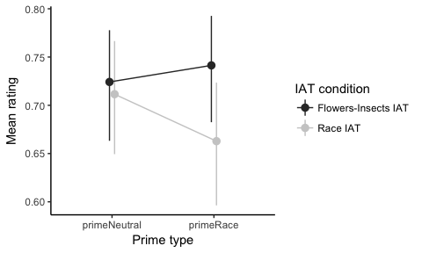

*Figure 2.* Estimated marginal means on the AMP

Exp 3

Performances on the IAT (*M*RT = 894, *SD* = 222, *M*Accuracy = 0.94, *SD* = 0.05) and Shooter Bias task (*M*RT = 626, *SD* = 57, *M*Accuracy = 0.89, *SD* = 0.09) were typical of that found in previous studies using these tasks.

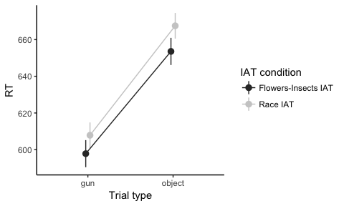

*Figure 3.* Estimated marginal means for the Shooter Bias task

Marginal predicted means are illustrated in Figure 4.

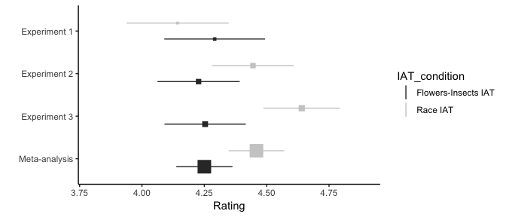

*Figure 4.* Estimated marginal means for the self-report evaluations