Appendix A

*Figure 1*. Schematic illustration of the two types of trials during the acquisition phase of Experiment 1. During the first half of the trial (*left*) the neutral target and two source stimuli were presented in white. During the second half of the trial (*right*) the target and one of the sources changed to the same color whereas the second source stimulus changed to a different color.

**HELL**

**STRUAN**

**SMILE**

**CANCER**

**MORAG**

**JOY**

**CANCER**

**MORAG**

**JOY**

**HELL**

**STRUAN**

**SMILE**

*Figure 2*. Schematic illustration of the two types of trials during the acquisition phase of Experiments 2-3. During the first half of the trial (*left*) the neutral target and two source stimuli were presented in the same color. During the second half of the trial (*right*) the target and one of the sources remained the same color whereas the second source changed to a different color.

**HELL**

**STRUAN**

**SMILE**

**CANCER**

**MORAG**

**JOY**

**CANCER**

**MORAG**

**JOY**

**HELL**

**STRUAN**

**SMILE**

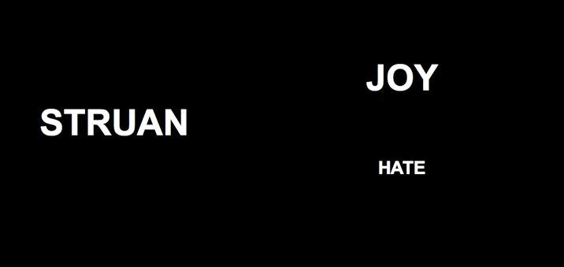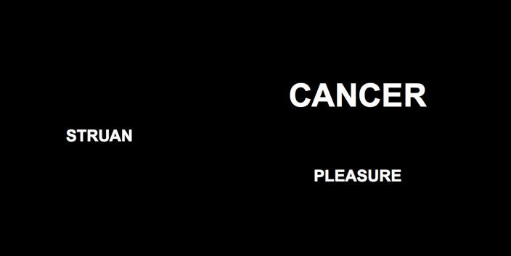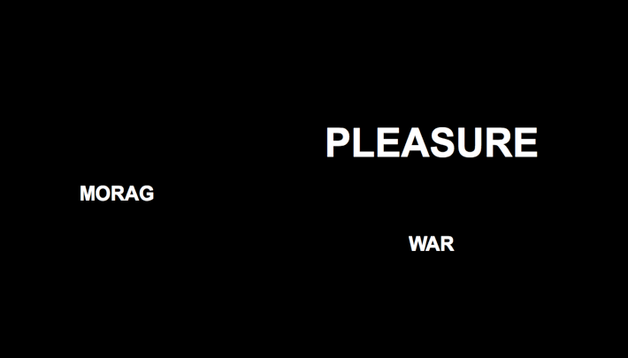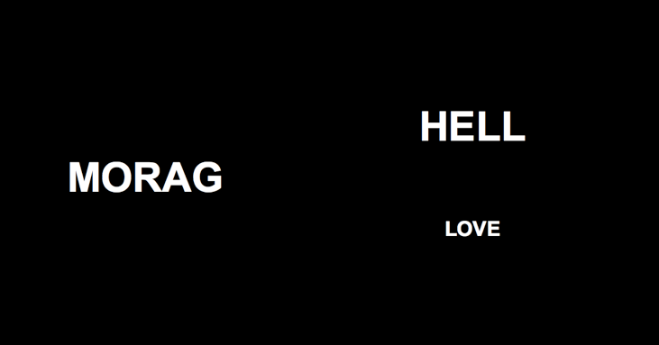

*Figure 3*. Schematic illustration of the two types of trials during the acquisition phase of Experiment 4. During one type of trial (*left*) a neutral target and negative sources were presented in the same size (sometimes in large and other times in small font). During a second type of trial (*right*) another target and positive sources were presented in the same size.

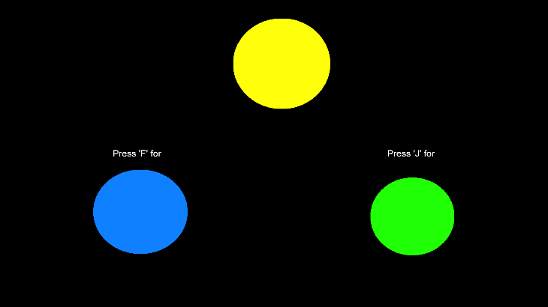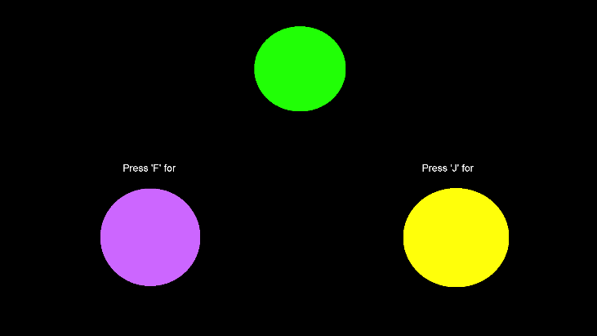

*Figure 4*. Schematic illustration of the two types of trials during the color training phase of Experiment 5. Selecting blue in the presence of yellow, or purple in the presence of green (and vice-versa) was reinforced and any other color relation punished.

*Figure 5*. Schematic illustration of the two types of trials during the acquisition phase of Experiment 5. During one type of trial (*left*) a neutral target and positive sources were presented in colors that had previously been symbolically matched. During a second type of trial (*right*) a second target and negative sources were presented in colors that had also been symbolically matched during the color training phase.

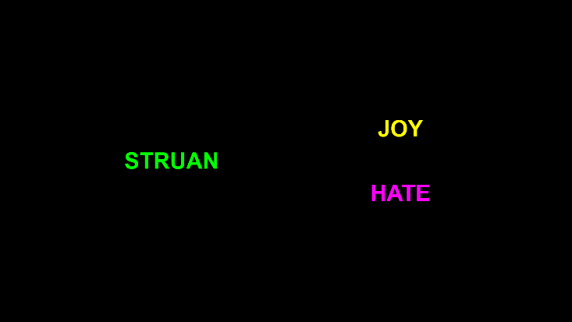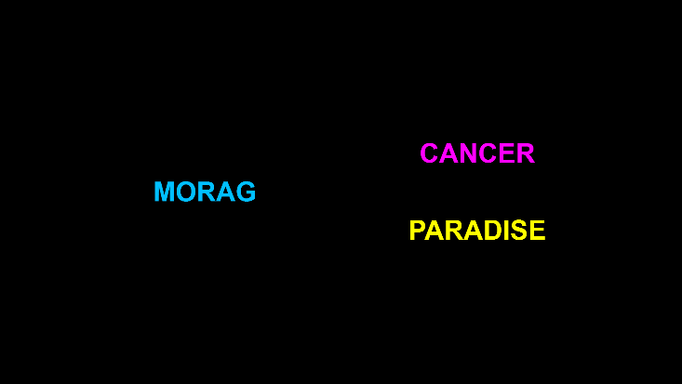

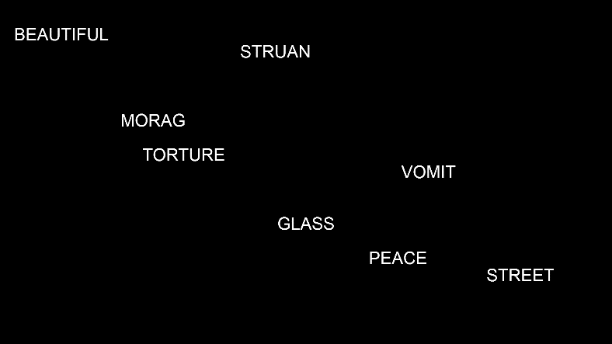

**MORAG**

**PEACE**

*Figure 6*. Schematic illustration of the trial progression during the acquisition phase of Experiment 6. During the first half of the trial (*left*) all eight stimuli (two positive sources, two negative sources, two neutral sources, and two neutral targets) were presented in the same color. During the second half of the trial (*right*) one of the targets (‘Morag’) and a positive source (‘Peace’) changed to a similar color.

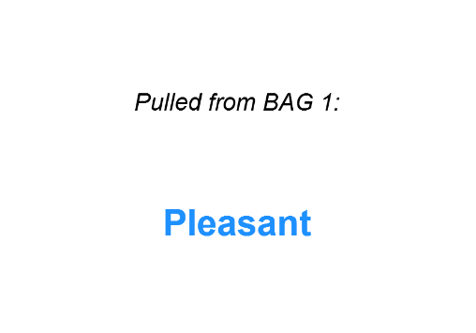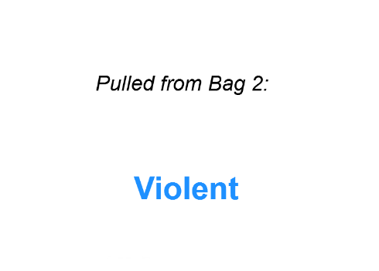

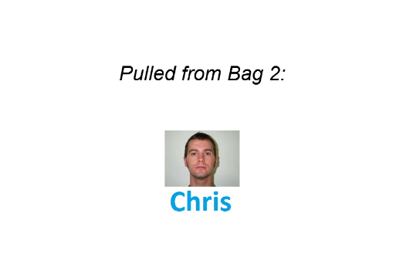

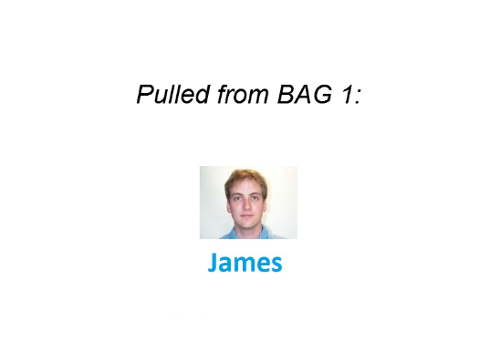

*Figure 7*. Example of the four trial-types encountered during block 1 of the acquisition phase in the shared features and random conditions. Those in the no-contiguity condition encountered a similar procedure (but with no information concerning the bag from which a stimulus was pulled).