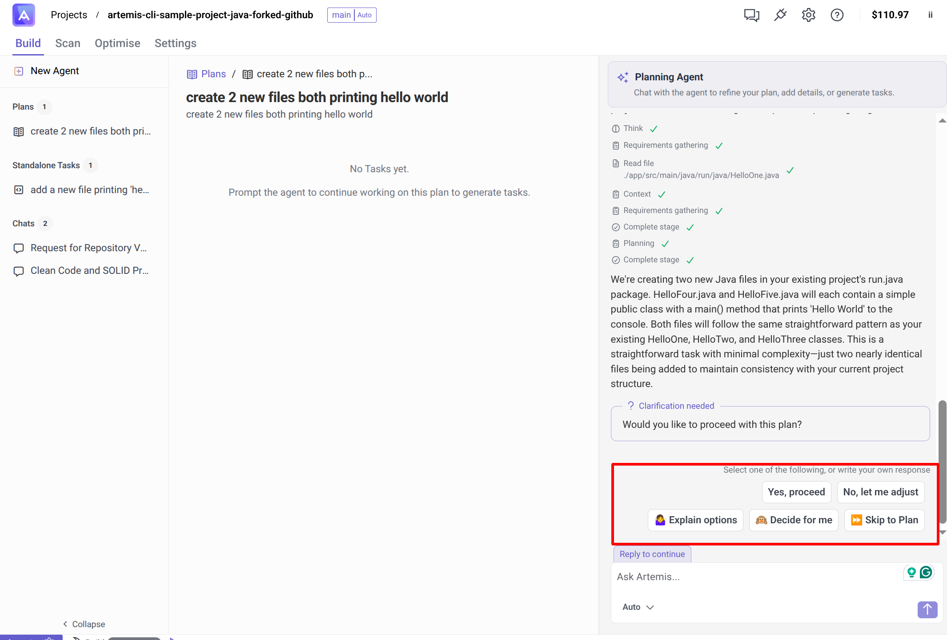
This is the options that exist in the Plan
#
In the task the user is able to code directly a file

in the chat the user can chat with an agent

