Frontend Software Engineer Home Test

The purpose of this test is to evaluate your technical abilities in a few aspects of software engineering. It allows common grounds for discussion in the interview that takes place after you complete the test. The test is a home test and you are encouraged to use any resource within reason at your disposal - online or consulting friends, etc. You will be asked to explain your solution in the interview, emphasizing on correctness, design and coding decisions. Please submit your final code as attachments in the email, or as a <http://jsfiddle.net/> link

Objective

To create an algorithm written in JavaScript that replaces the **top 25 most common words** based on their frequency with their count inline. Your code should be pasteable and runnable in the browser console.

Requirements

● Page to process and run your code on: <https://en.wikipedia.org/wiki/Programming_language>

● A word may not include HTML tags, JavaScript code, numbers, spaces or punctuation.

● A word may not be from the top 100 common words in english and you may **not hardcode these into the source code** https://en.wikipedia.org/wiki/Most_common_words_in_English

● Also please remove common words “are”, “is”, “where”, “was” and any single characters

● You may use JQuery and standard JavaScript but no other third party library

● Your code should be runnable on recent Chrome or Firefox browser.

Example

1. Open Chrome and navigate to Open the developer tools in chrome and paste in your JavaScript

2. The page should update to look like the following. It is okay if your counts are off by a few.

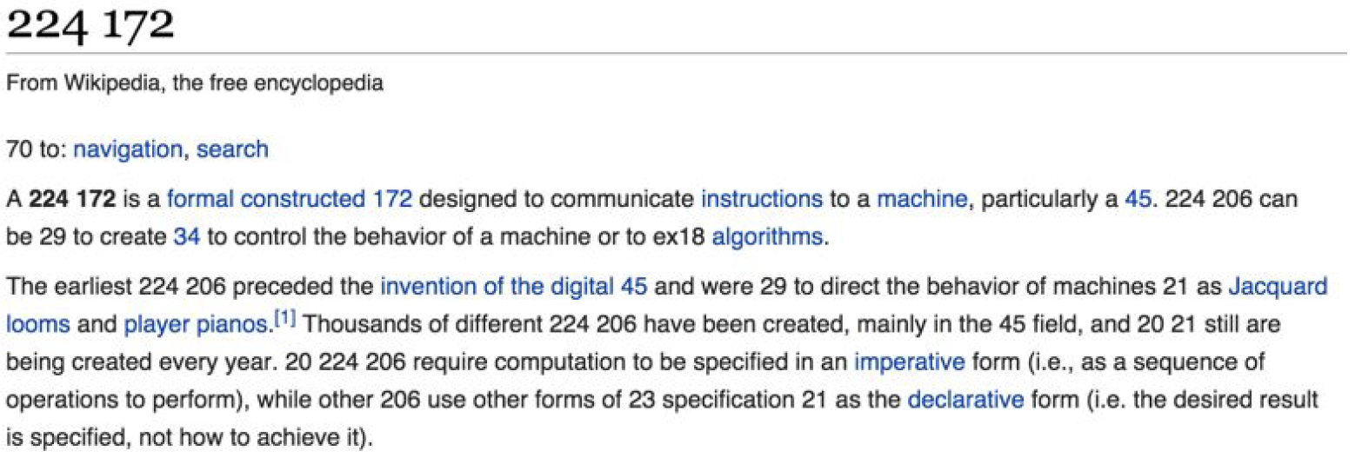

This test should take approximately 3-6 hours. If you find yourself taking longer than that try to take a step back and check your approach. Please provide your solution within 5 days, contact us if you need more time.